Testing Log for Chess Project
Travis Schultz
The purpose of this document is to keep track of all the testing (manual or via a test suite) that you’ve performed on your chess game to ensure it works correctly. Use the below grid as you go to record each thing you tested. You should be sure to test all functions as fully as possible!

Manual Tests:
Name of function you’re testing | Action taken | Expected Response | Pass/Fail | Screen shot
Board constructor | Press “start” button | A board is displayed on the screen with a white square in the top left corner and a checkerboard pattern across the rest of the 8 rows/columns. | Pass | 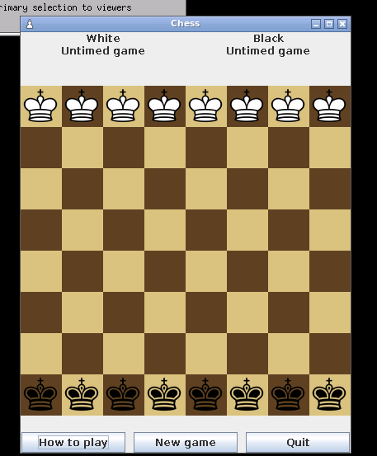
Initializing pieces | Press “start” | The top row is filled with white kings and bottom row with black kings. | Pass | 
Mouse released | mouse button released | If the piece is the correct color, and the move the piece is released on is legal, the piece is moved to the square in that location and is removed from its previous location | Pass | 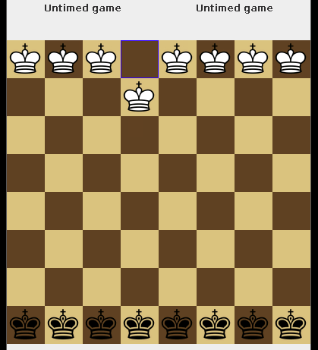
Mouse dragged | Whenever the mouse button is held, dragging the piece | The piece shouldn’t be shown in its actual location, instead following the cursor, while the controlled squares’ borders are highlighted in yellow. | Pass | 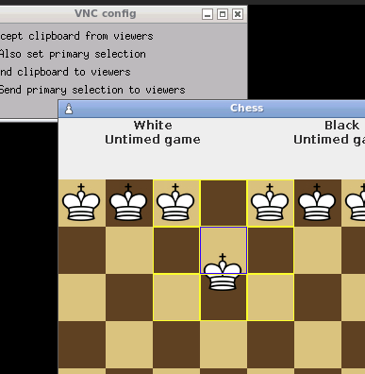

Code tests (optional):
Highlighting borders of legal moves:
ArrayList<Square> moves = currPiece.getLegalMoves(this, fromMoveSquare);
for(Square s: moves){
s.setBorder(BorderFactory.createLineBorder(Color.red)); // highlights red to show legal moves
}
Highlighting borders of controlled squares:
for(Square s: currPiece.getControlledSquares(board, fromMoveSquare)){
s.setBorder(BorderFactory.createLineBorder(Color.yellow)); // highlights yellow to show controlled squares
}

