C2C Travis Schriner

Capt Branchflower

ECE 383

Prelab

1. 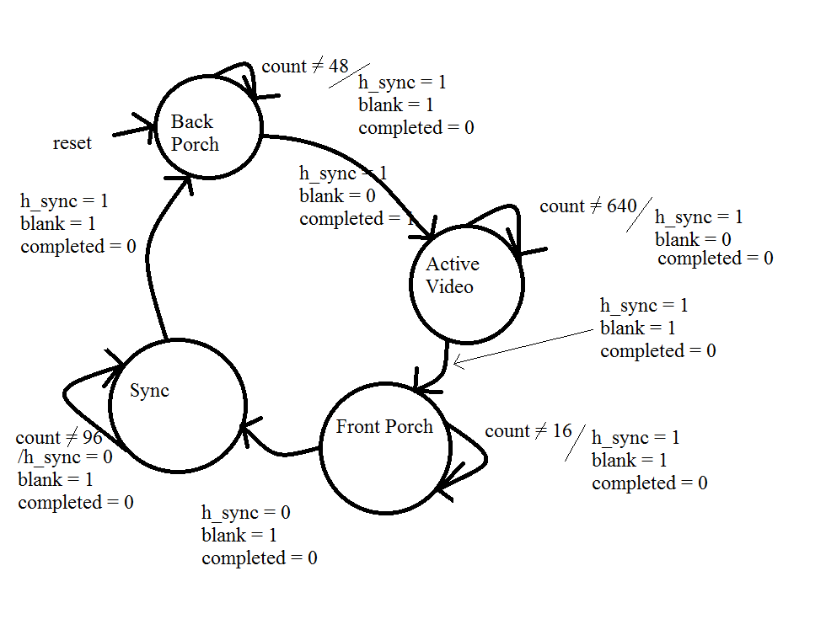
2. 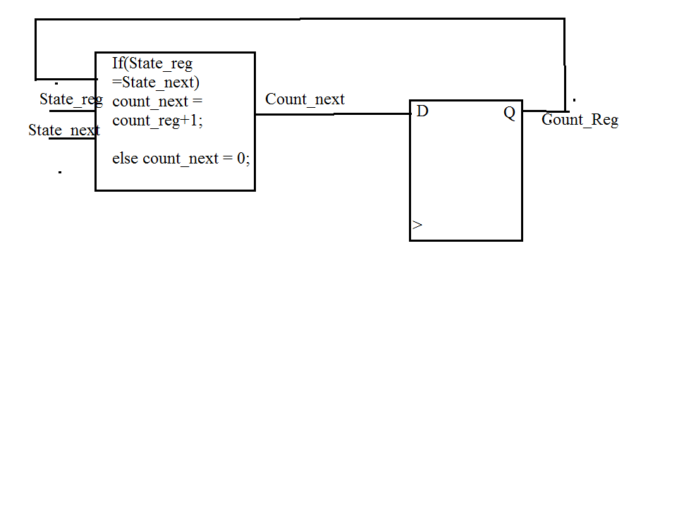
3. If (Blank = 1) and (H_Sync = 1) and (count_reg = 33) then (completed =1);