A. Main screen

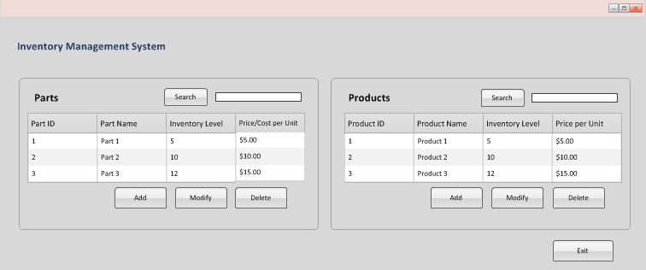

B. “Add Part” screen

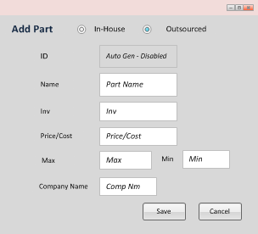

The user has the option to select “In-House” or “Outsourced” to categorize the part. If the user selects “Outsourced,” the “Company Name” field is available.

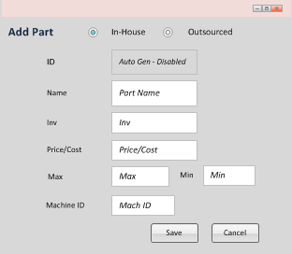

If the user selects “In-House,” the “Machine ID” field is available.

C. Modify Part

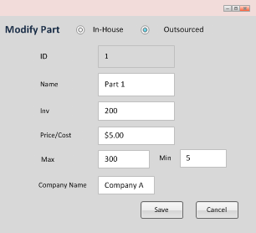

The user has the option to select “In-House” or “Outsourced” to categorize the part. If the user selects “Outsourced,” the “Company Name” field is available. The “Modify Part” screen has the same functionality as the “Add Part” screen, but the fields are populated with data that was previously entered and saved.

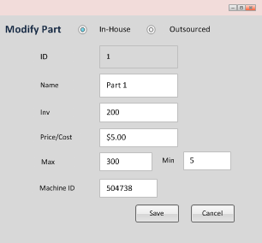

If the user selects “In-House,” the “Machine ID” field is available.

D. Add Product

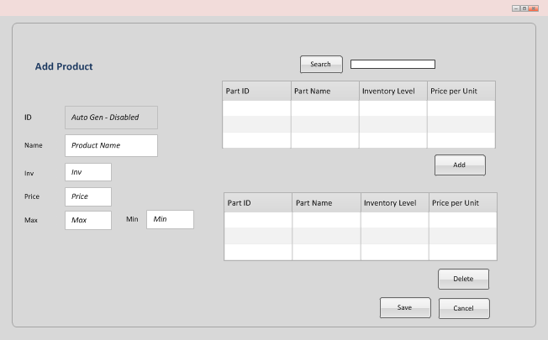

E. Modify Product

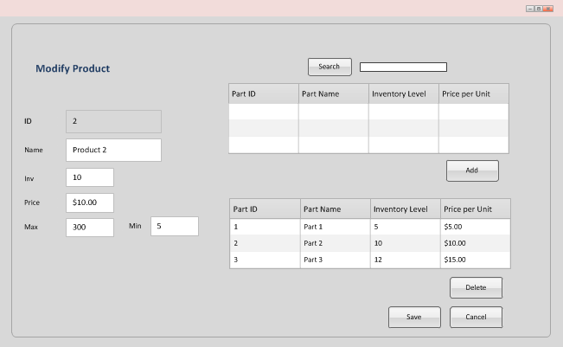

The “Modify Product” screen has the same functionality as the “Add Product” screen, but the parts and fields are populated with data that was previously entered and saved.