GEMS
Graphical Environment Management System
Travis L. Seymour, PhD 2019

Goal

Create interactive virtual environments defined by a series of static images and various interactions and dynamics.

GEMSedit

The editor allows one to create or edit GEMS environments. Environments are made of a views, which is a viewpoint onto anything that can be depicted. E.g, a view might depict a doorway, or what it looks like inside a room. It might also depict a closeup of an object, or a depiction of what it’s like inside that object. It can literally be anything that one can create an image of, including a bunch of text if you want – although that might not be too exciting. To define an environment, photograph, draw, or otherwise create or obtain an image that corresponds to all of the views you want to exist within the environment and stitch them together using the GEMSeditor. Another important thing one does with the GEMSeditor is to define objects, which are rectangular sub-regions of view images. Although typically, objects specify meaningful objects that are depicted in the view images (e.g., a book, a cup, or a door), objects may also define areas or sub-areas of a view image not necessarily tied to specific physical objects within that view (e.g., a doorway, a hallway, the left side of a room, or the top of an painting). Last, but not least, the GEMSeditor is used to definite various environmental actions, interactions, and consequences of those actions or interactions.

Actions. Actions are events that can occur in the environment as a result of some action and optionally if some condition is met. For example, you could specify that a sound effect (the action) if the user left-clicks (the trigger) the mouse on a previously defined object (the target object). Some actions are environmental, e.g., the passage of a certain amount of time, and others are based on user actions (keyboard presses or mouse actions). Although user actions are typically with regard to user-defined objects within some view, there are special navigational actions as well. For example, you can define what happens when the user clicks the left edge of the screen, e.g., you might be taken to a new view. Objects with actions that lead to a view change are called portals, and are typically with regards to some user defined objects. But the left and right side of the screen are special implicit objects one can design as triggers for some actions. Although they are customarily used to allow the users to turn left or right within some implied space, they don’t have to be used this way.

Interactions. Interactions are really just normal actions that trigger as a result of one object being dragged (using the mouse left-button) onto another object. This is a great way to increase the richness of actions in the environment. For example, one could drag a key object onto a locked door. This door could be specified to open or portal to another view if clicked on after it has had the key dropped onto it. Of course, this would require the environment to be able to keep track of such occurrences. This is one of the uses for variables within GEMS. An interaction like dragging a key onto a door might result in setting the value of a new variable called “door_unlocked” to True. Clicking the door could be set up to open (i.e, portal to another view) if and only if there exists a variable called “door_unlocked” that currently has the value True.

All actions have 3 required parts and 1 optional parts:
- Trigger. These define the event (environmental or user-action) that is required before an action will fire. An example of one environmental trigger is TotalTimePassed(Seconds) : This trigger fires when at least <Seconds> seconds has passed since the current GEMS environment was started. An example of a user-action trigger is MouseClick() : This trigger fires whenever the mouse is left-clicked.
- Action. These define the action that occurs when a trigger occurs. For example, a common action portals the user to another view: PortalTo(View) : This action causes GEMS to load another view with the view ID of <View>. If there is a working internet connection, you can cause text to be spoken with this action: SayText(Message) : This action causes GEMS to speak the given <Message> using the Google’s text-to-speech API.
- Enabled. This is either the value True or False. Setting this to False, allows an action to stay defined but not activated.
Actions can also have conditions, which are environmental states that must be met in order for the action to be considered. Conditions are optional, so if no condition is defined, then only the action’s trigger determines when it activates. One common condition is ViewTimePassed(Seconds) : This condition returns True if at least <Seconds> seconds has passed since the current view was displayed. Another common condition is VarValueIs(Variable, Value) : This condition returns True if the user created token <Variable> exists and currently has the value <Value>.

GEMS actions and interactions can be specified at various levels.

Environment Actions. Sometimes it is useful to specify some conditions, triggers, and actions at the environmental level. These are actions that occur no matter which view is currently active. There are only 2 triggers at this level: TotalTimePassed(Seconds) : This condition returns True if at least <Seconds> seconds has passed since the current GEMS environment was started, and KeyPress(Key) : This trigger fires when <Key> is entered on the keyboard.

View and Object Actions. There are many actions that can be defined in GEMS. Technically, the only real view-only action is one that triggers on the ViewTimePassed. Otherwise, all actions are essentially based on object-level actions and interactions. You can see a list of all the conditions, actions, and interactions in the appendix.

What you can do with objects in GEMS. Remember that an object in GEMS is just a rectangular region that the designer had designated as such. There is no obligation to define everything in a view that is visible as an object, but doing so allows some trigger (clicking, hovering, dragging, etc) relative to that object to have an effect (play a song, portal to another view, speak some text, make some object disappear). When you create a view, you have to at least specify a foreground picture and a background picture. In some cases, these will be the same image. However, if they are not the same, interesting possibilities arise. For example, consider these foreground and background images:
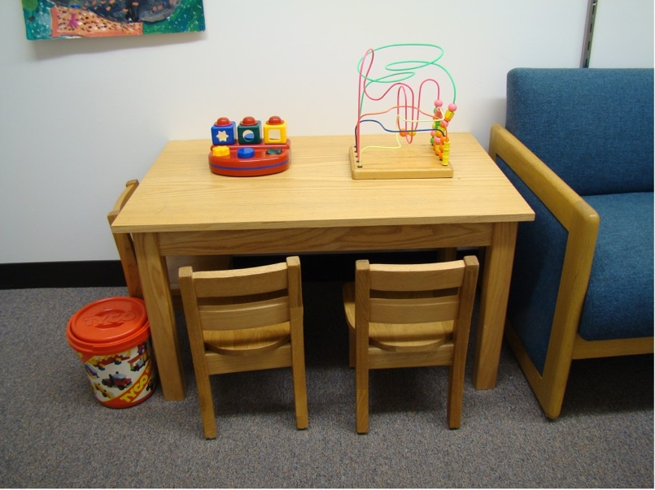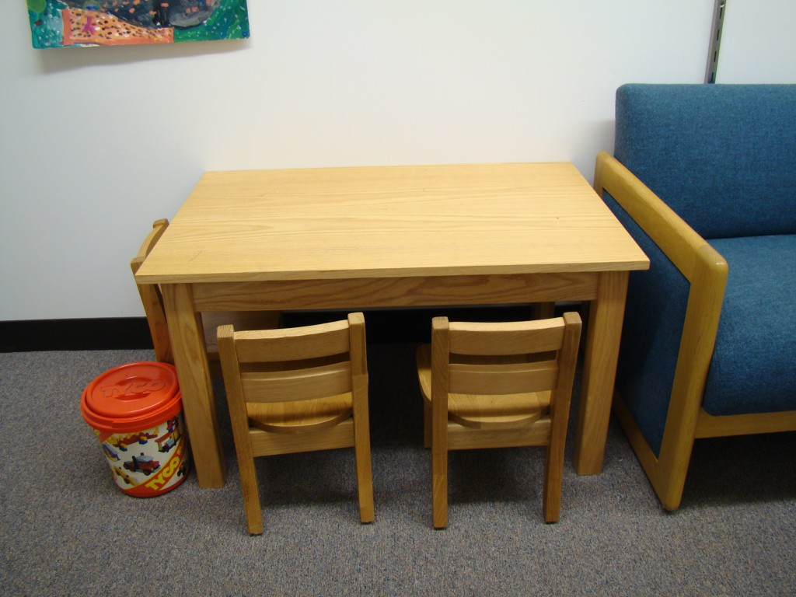
If the designer specifies a foreground image that has some objects depicted and a background image that is identical, except that those objects are missing, then in the environment, several things become possible. One is that the object can be specified as visible or hidden and be revealed or hidden later as a result of some action or interaction. In addition, if an object defined this way is dragged with the mouse, it will appear as if it has been picked up and moved across the screen. This illusion is created because when the object is dragged, the location in which it was defined is quickly replaced with the same region from the background. Note that for an object to be “takeable”, it has to be specifically specified as such in GEMSedit. Otherwise users won’t be able to move it with the mouse. However, it could still be hidden or revealed. Another powerful that that results from using the on/off design for foreground and background images and specifying an object as takeable is that it can be dragged a) onto other objects, and b) into your pockets.

One of the many triggers available for objects is what happens if a specific other object is dragged onto it. Making an object takeable allows the designer to create interesting interactive possibilities. For example, you might specify that if a toy is dragged onto a bin, it disappears from the table. Thus, allowing users to clean up organize objects. Programmatically, the object has just be marked as non-visible as a result of an interaction type action. At the environment level, several global options can be specified. One is how many (including 0) pockets will be available. Pockets are icons that show up in the bottom left corner of the display that look like denim jeans back pockets, e.g.:
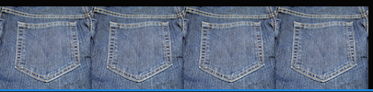
If a takeable object is dragged to a pocket, it will appear as if it is dragged out of the environment and into the pocket:
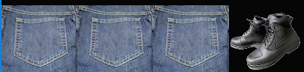
Pockets allow users to collect objects and move them from one view to another. Right clicking a pocketed object will cause it to return to it’s original location. If you wanted the user to drag the boots into a box depicted in a view, you couldn’t change the foreground picture so that it looked like the boots were now in it. However, you could do one of 2 things: One you could have a depiction of the boots in the box in the background image and (critically) within the same exact rectangular space, have a version of the box without the shoes in the foreground image. This way, dragging the shoes onto the empty box could be made to result in the box object disappearing, revealing the boots-in-box region on the background. One possible action in GEMS is to place an image from the computer as an overlay of sorts on top of the foreground image. Thus, another approach would be to specify that if the boots are dragged onto the box object, that area could be covered by a small image just depicting the boots in the box. Either way, the effect for the user looks as if they have dragged the boots out of their pocket and into the box, e.g.:
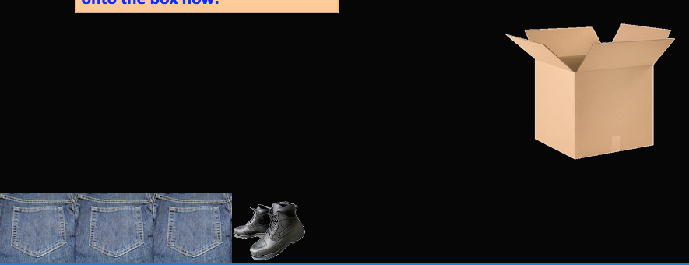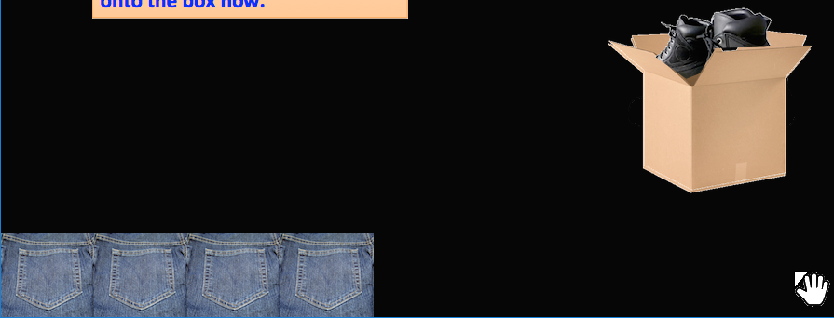

Automatically Portaling. Most often, moving from one view to another happens a result of some user-initiated action or interaction. However, portaling can also occur as a result of global timed events, or view-level timed events. One use for global timed portals may be to institute a deadline for interaction with a GEMS environment. For example, maybe you want to take the user to a view with the words TIME’S UP after 30 minutes. View level timers can be used to make things happen relative to entering a view. For example, maybe after 2 minutes, if some action has not been taken by the user, you could show a textbox containing a clue, or portal to another view. Sometimes we use view-level timed portaling to quickly move the user through a sequence of views to establish a crude animation. This can be used to give the user the sense of moving over a long distance, or be used to establish the layout of a space. If, each of several views contained a ViewTimePassed trigger set to go off .25 seconds after the view is entered that fires a PortalTo action, then you could fly the user from one point in a room to another. E.g.:
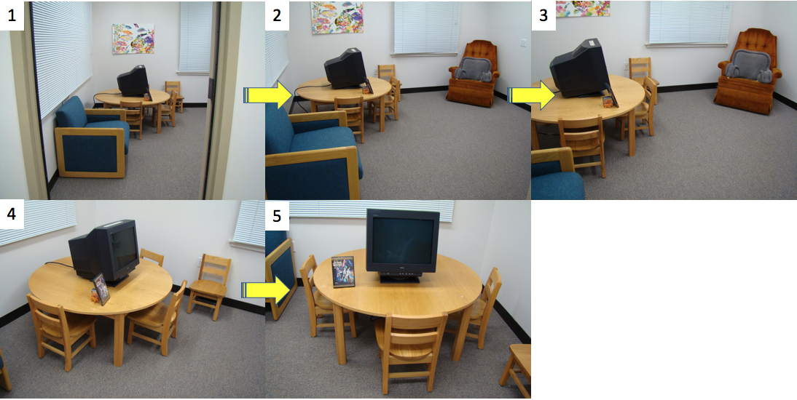
Left clicking on view #1 could automatically portal you through the subsequent views until you stopped at view 5. This is animated in a way that feels as if you are flying from the door, around the room, to the table.
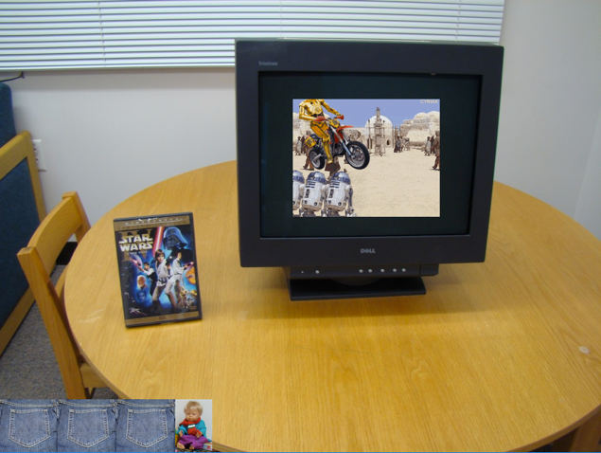
In the test environment depicted above, an interaction is defined in view 5. If the dvd cover (which is not takeable in this case – we forgot to take a picture without the dvd) is dragged onto the monitor, a little video plays. Note that although the dvd is not takeable it is still draggable. The downside of this arrangement is that the dvd will not look as if it is being dragged, but the interaction will still work.

Using GEMSedit

Loading an existing GEMS Environment. Gems environments consist of a folder that contains a environment database file (e.g., kidsroom.db) and a folder of media (pictures and audio files), named [ENVNAME]_media, e.g., kidsroom_media. To open an environment, press the OPEN ICON, navigate to an environment folder, and choose the database file.
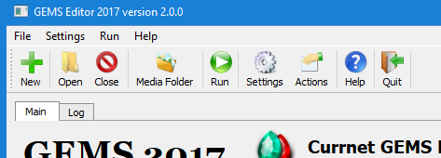

Global Environment Settings. There are several global settings.
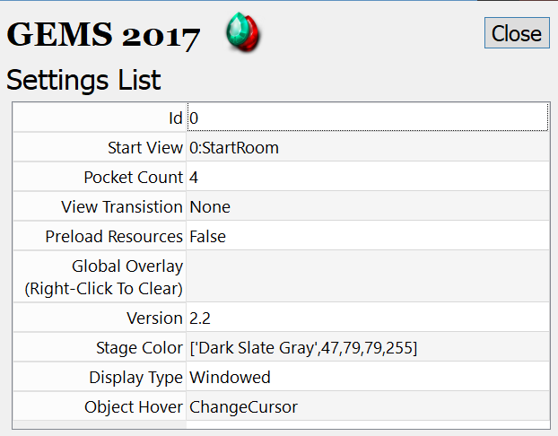
Id: Hmm…I don’t kjnow what this is?!
Start View: This defines the first view that will be loaded when the environment starts. You change this to any existing view in the environment.
Pocket Count: The number of pockets to feature in the environment
View Transition: This allows you to specify how GEMS transitions from one view to the other. For now, this does nothing – views transition via jump. Later, I hope to add a Fade transition and possibly others.
Preload Resources: This is a currently non implemented feature to load all project media into memory for fast environment navigation. At the moment this is not practical and has been disabled no matter what is specified here.
Global Overlay: If a picture is specified here, it will be overlayed onto the upper left corner of the environment for every view. This cannot be changed while the environment is running and may have limited use cases. For a flexible overlay, you’ll notice that when designing view, you can specify a view-level overlap that can be different from one view to the next. We’ve used this for a dynamically updating map of where one is in an environment. E.g.:
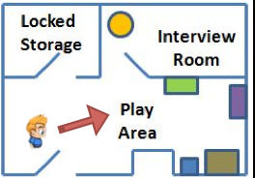
Version: This field will go away soon. Ignore it.
Stage Color: Hopefully you won’t have to deal with this. The size of the environment is dictated by the StartView’s foreground picture. Any subsequent view that uses foreground/background smaller than this will result in a colored background showing the extend of the area not used. This setting specifies the color of that region. Make all of your view images the same size to avoid this situation!
Display Type: Can be either Windowed or FullScreen. Windowed mode is nice for designing because one will also need to manage media files. However, for a more immersive experience, switch to FullScreen. Note: The most recent version of GEMS needs significant testing in FullScreen mode – it has mostly been set to Windowed for development and testing.
Object Hover: This dictates what happens when someone hovers over a region defined as an object. The options are ChnageCursor (the cursor switches from white to yellow alerting the user that this object is defined), FrameObject (draws a yellow rectangle around the boundaries of the object), and ShowName (puts the objects name in yellow at the bottom left of its bounding box). The Object Hover option also allows combinations such as Frame+Cursor, Name+Cursor, and Cursor+Frame+Name. Most of these permutations were created for designing environments, but ChangeCursor may be a useful user facing ui choice.

Running a GEMS Environment. To run a loaded environment, just click on the run icon:
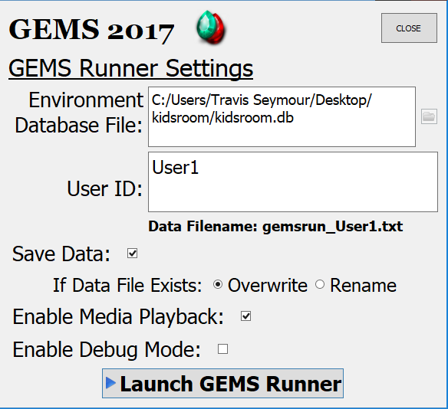
The Environment Database File is not editable and will be set to whatever environment is currently loaded into the editor. GEMS is designed to save data about everything that happens during a run, a user id can be used to distinguish data from multiple users. If this is left at its default, it will always use “User1” as the user id. You can toggle whether to actually save the data and whether to overwrite or rename an existing data file for a particular user. Media playback can be disabled when quiet operation is desired. Debug mode use helpful during environment design because it shows the current status of any defined environment variables. E.g.:
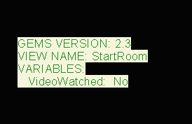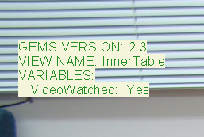
This information floats in the upper left hand corner when Debug Mode is enabled.
Finally, press the Launch GEMS Runner button to start. To stop, press ESCAPE (e.g., in FullScreen Mode) or click the red close-window icon (e.g., in Windowed Mode).

Creating a New GEMS Environment.

- Press the NEW button
- Navigate to where you want the environment folder to be created (e.g., Desktop) and type in a name of your project (no extention). For example, enter “MyEnvironment” and press SAVE.
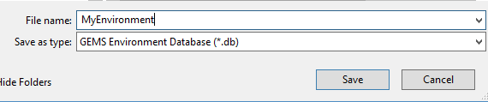
- You will notice that GEMS creates a new environment with 2 default views (StartRoom and EndRoom). A couple of objects and interactions have been defined. You can delete these and specify your own environment.
- Click the MediaFolder icon to open your media folder.
- Do not bother the files already here. Some of them are needed for GEMS operation. Dump all the images and sound files (e.g., .png or .jpg image files, and .mp3 or .ogg audio files. Many formats are supported). You will need for your environment here. Then you will be ready to stitch them all together to form your environment.
- I suggest you plan out your environment on paper first. Which views will you use and to which other views could a user portal from each view.
- Next it’s time to take pictures. Use a tripod and try to have as little difference as possible (i.e., no difference) between the camera position when taking foreground and background images for a particular view. You want to avoid lighting differences as well – keep track of how your own location in the room alters the light. Planning is key, if you have to go back later to get another shot, the lighting may be very different.
- If you already know which sounds you want obtain them or record them to .wav or .mp3 and copy them to your media folder as well. Note: All pictures and sound files go into the root of your media folder. Don’t create any sub-folders.
- Once you have a plan, and your media, you’re ready to edit your environment.

Defining and Editing Views

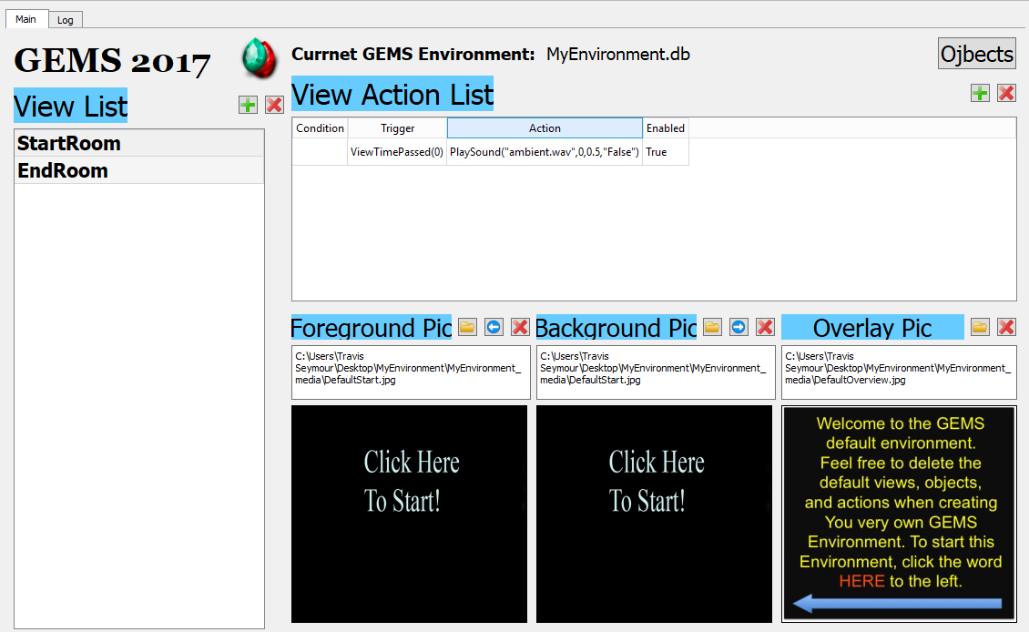
8
5
7
4
3
2
6
1

- These icons allow you to create a new empty view, or delete the currently selected view in the list, respectively. Be careful with deleting views – this cannot be undone. Also make sure you have selected the view you really want to delete. Adding a new view requires only a new view name. It is possible to have multiple views with the same name – we do not recommend this.
- The folder icon lets you specify a foreground picture from those in your media folder. The arrow icon copies the value from the current background picture. The red X deletes the current picture entry (this does not affect the image file on disk).
- Same as #2, but for the background picture. The blue arrow will make the current background the same image currently used for the foreground. Please ensure that all view foreground and background pictures the exact same dimensions or odd things can result. In a few use cases, this might be desirable, but not usually.
- Select or delete an overlay picture. This picture will be displayed relative to the upper right corner of the view. This overlay could be as large as the foreground and background pictures, but for many use cases, it will be somewhat smaller. E.g., a map, or special message.
- All the windows on this row show a depicture of which image is currently selected. If you click on this window, you will be able to view a full size version. Hit the ENTER key to return.
- Click the green plus to create a new empty action. All cells will initially turn red to indicated that now enough information has been supplied for it to actually work. This will change when you’re entered at least a trigger, action (the condition is optional). The red X will permanently delete the currently selected action. Please be careful that you have selected the appropriate view action and that you really want to delete it. This cannot be undone. It may be wiser to disable an action than to delete it if you think you may want to use re-enable it later.
- Clicking on either the Condition, Trigger, Action, or Enabled cells allows you to specify their contents for that action. This occurs via dialogs that pop up when you click each cell. For example, clicking the Condition, Trigger, and Action cells will pop up dialogs like these:
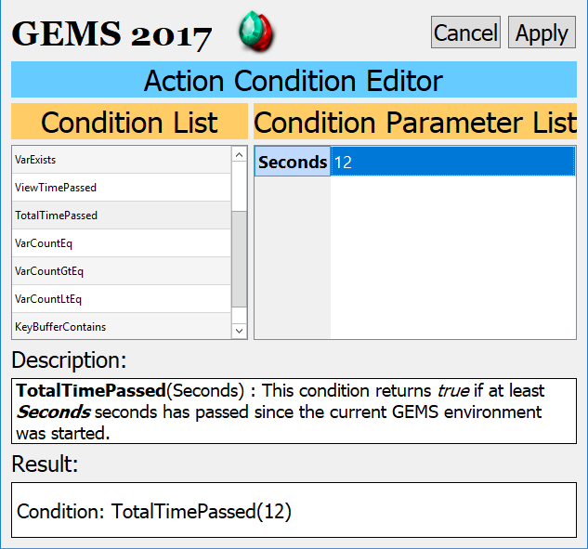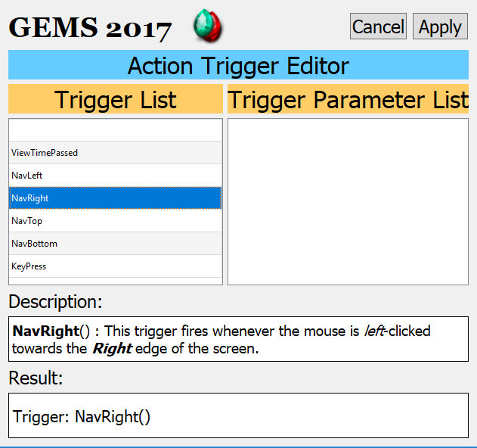
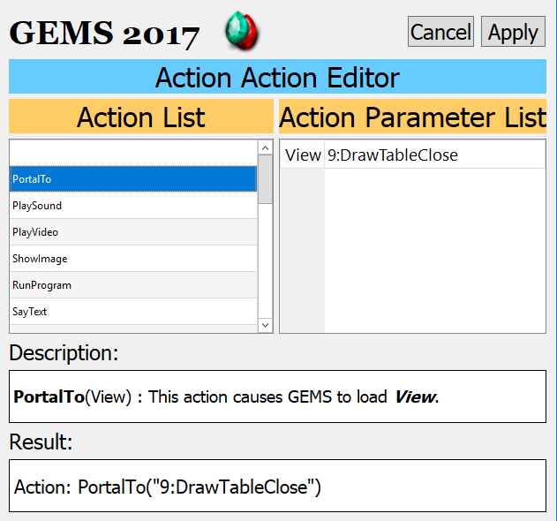
- This button is used to open a new screen that allows the design and specification of objects for this view. Make sure you have specified your foreground and background pictures before creating objects.

Defining and Editing View Objects

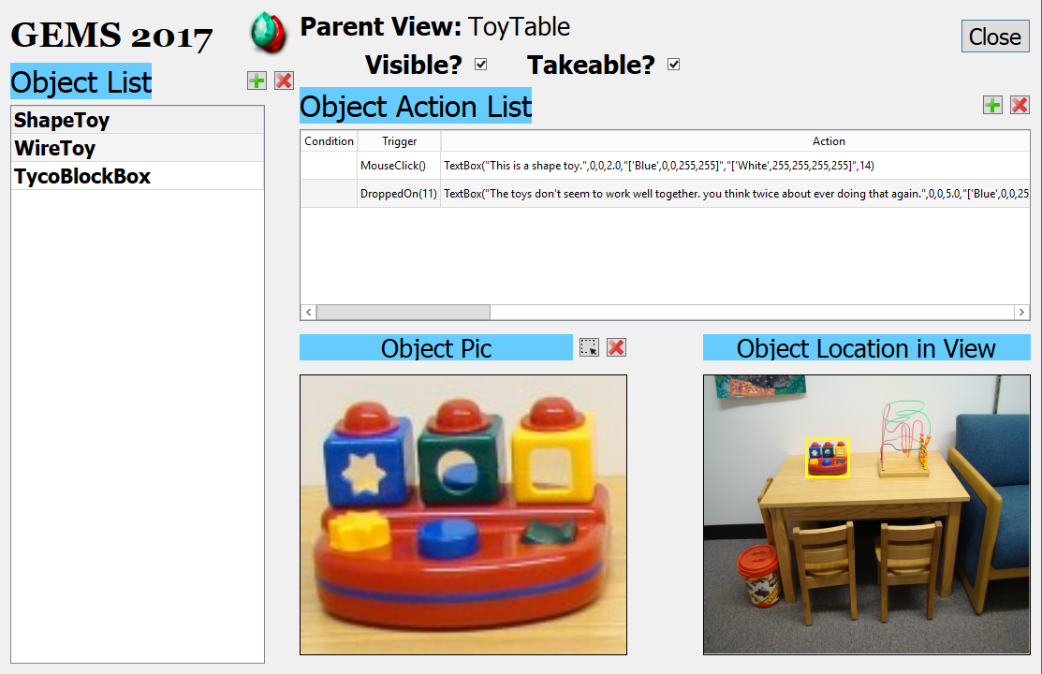
2
6
5
4
3
1

- Similar to with the view editor, these buttons allow you to add define new objects, or remove previous object definitions. Be careful, deletions cannot be undone.
- Objects are simply sub-regions of your existing foreground image. So clicking the laso tool here allows you to define your object as a rectangular. The two image regions below #2 and to the right of it (Object Location View) show you the selected region in context and in a magnified fashion. Pressing the red X button will allow you to clear out the object picture selection.
- This checkbox determines whether this object will be marked as visible, and thus whether it will show up when the environment is run. Actions and interactions can result in this being toggled.
- “Takeable” refers to whether or not this object is mean to be removed from its default location and potentially dragged to the pockets for transport across views. If you define an object as takeable, you really should make sure that it is not visible in the background image. This will lead to the most natural effect when users drag it out of position within the environment. An exception to this may be a stack of paper where you want the user to appear to have taken a sheet of paper while leaving the stack in place.
- Just like at the view level, these buttons allow you to add or remove actions.
- Just like at the view level (and using the same dialogs shown above), this list allows you to manipulate the conditions, triggers, and consequences of each defined action.

Other Thoughts

- You don’t have to save anything…all changes are saved to you environment database immediately.
- If you want to move around or share your environment, everything will be in your project folder. Essentially your xxxxxx.db file and the xxxxxx_media folder.
- You may need to learn about basic photo editing to manage images that are too big, or are of different sizes. Same idea for basic audio editing for controlling volume and cropping.

APPENDIX

CONDTIONS

- Blank : No condition is set.
- VarValueIs(Variable,Value) : This condition returns true if the user created token Variable exists and currently has the value Value.
- VarValueIsNot(Variable,Value) : This condition returns true if the user created token Variable currently does not have the value Value or does not exist.
- VarExists(Variable) : This condition returns true if the user created token Variable currently exists.
- ViewTimePassed(Seconds) : This condition returns true if at least Seconds seconds has passed since the current view was displayed.
- TotalTimePassed(Seconds) : This condition returns true if at least Seconds seconds has passed since the current GEMS environment was started.
- VarCountEq(Count) : This condition returns true if the number of user created variables equals Count.
- VarCountGtEq(Count) : This condition returns true if the number of user created variables is greater than or equal to Count.
- VarCountLtEq(Count) : This condition returns true if the number of user created variables is less than or equal to Count.
- KeyBufferContains(String) : This condition returns true when the keyboard buffer contains the characters in Keys. Use only these characters: [a-zA-Z0-9 -_./]It is recommended that the action ClearKeyBuffer() precede use of this condition.

TRIGGERS

- Blank : No trigger is set.
- ViewTimePassed(Seconds) : This trigger fires when at least Seconds seconds has passed since the current view was displayed.
- TotalTimePassed(Seconds) : This trigger fires when at least Seconds seconds has passed since the current GEMS environment was started.
- MouseClick() : This trigger fires whenever the mouse is left-clicked.
- DroppedOn(Object) : This trigger fires when Object is dragged and then dropped onto the associated object.
- KeyPress(Key) : This trigger fires when Key is entered on the keyboard.
- NavLeft() : This trigger fires whenever the mouse is left-clicked towards the Left edge of the screen.
- NavRight() : This trigger fires whenever the mouse is left-clicked towards the Right edge of the screen.
- NavTop() : This trigger fires whenever the mouse is left-clicked towards the Top edge of the screen.
- NavBottom() : This trigger fires whenever the mouse is left-clicked towards the Bottom edge of the screen.

ACTIONS

- Blank : No action is set.
- PortalTo(View) : This action causes GEMS to load View.
- PlaySound(SoundFile,Start,Volume,Loop) : This action instructs GEMS to play the audio in SoundFile. The soundfile beings playing at Start seconds [Default = 0 = beginning] and plays at the desired Volume [0.0 to 1.0]. If Loop is "True" [default = "False"], the soundfile will loop continually.
- PlayVideo(VideoFile,Start,Left,Top,WithinObject) : This action instructs GEMS to play the video in VideoFile at position (Left,Right). The soundfile beings playing at Start seconds [Default = 0 = beginning]. If WithinObject refers to a currently visible object, the video will play within that object\s boundary. Otherwise, the video will play fullscreen. [broken…only audio plays?!]
- ShowImage(ImageFile,Left,Top,Duration,Clickthrough) : This action loads and displays ImageFile at (Left,Top) for Duration seconds [default = 0 = forever]. The image is removed when the view is changed. If Clickthrough is "True" [default = "False"], clickable objects <em>under</em> the image will continue to fire associated actions. Note: ShowImage can play animated gif images!
- RunProgram(Application,Parameters) : This action caused GEMS execute Application with the optional Parameters.
- SayText(Message) : This action causes GEMS to speak the given Message using the default voice.
- TextBox(Message,Left,Top,Duration,FontColor) : This action causes GEMS to draw a textbox over the view containing the text in Message. The message will be positioned at Left pixels from the left and Top pixels from the top of the view. After Duration seconds [default = 0 = forever], the textbox will be removed. Set FontColor as desired.
- TextDialog(Message) : This action causes GEMS to display an input dialog box containing Message. The dialog box will remain until the user presses the SUBMIT button.
- InputDialog(Prompt,Variable) : This action causes GEMS to display an input dialog box containing the query Prompt. The dialog box will remain until the user presses the SUBMIT button. The entered text will be associated with the user variable Variable
- ShowURL(URL) : This action shows a custom browser window and loads the page at the supplied URL. The window remains atop the GEMS environment until dismissed by the user (close button).
- HideObject(Object) : This action causes GEMS to make invisible the object identified as Object.
- ShowObject(Object) : This action causes GEMS to make visible the object identified as Object.
- AllowTake(Object) : This action causes GEMS to make takeable the object identified as Object.
- DisallowTake(Object) : This action causes GEMS to remove the takeable property of the object identified as Object.
- ChangeCursor(Cursor) : This action causes GEMS to change the mouse cursor to Cursor.
- SetVariable(Variable,Value) : This action set the user created token Variable to Value. If Variable does not exist, it will be created first.
- DelVariable(Variable) : This action removes the user created token Variable.
- ClearKeyBuffer() : This action clears all characters in the keyboard buffer.
- Quit() : This action terminates the current GEMS environment.
- HideMouse() : This action hides the mouse cursor.
- UnhideMouse() : This action unhides the mouse cursor. [does this work?!]
- HidePockets() : This action hides all active pockets.
- ShowPockets() : This action unhides all active pockets.

