1.What does critical consideration represent? In terms of software engineering.

The functionalities of an application that are critical to the success of the end application. Takes into consideration of the types of technologies used in the application. Also consider all of the bugs that could potentially go wrong. Consider the funding and business requirements of the application.

Task-1

1.Produce one extra task for Instructor that you feel is critical and is missing from the document. Justify yourself.

Instructor can post an announcement that will notify all students.

2.Produce one extra task for student that you feel is critical and is missing from the document. Justify yourself.

A student can view their course plan of classes needed to graduate and classes taken

Task-2

1.Once Instructor and students sign up or sign in, How does their main page look like?

2.Design it on the paper provided to you. For online class, just create a simple picture of the home page and submit it as part of the file.

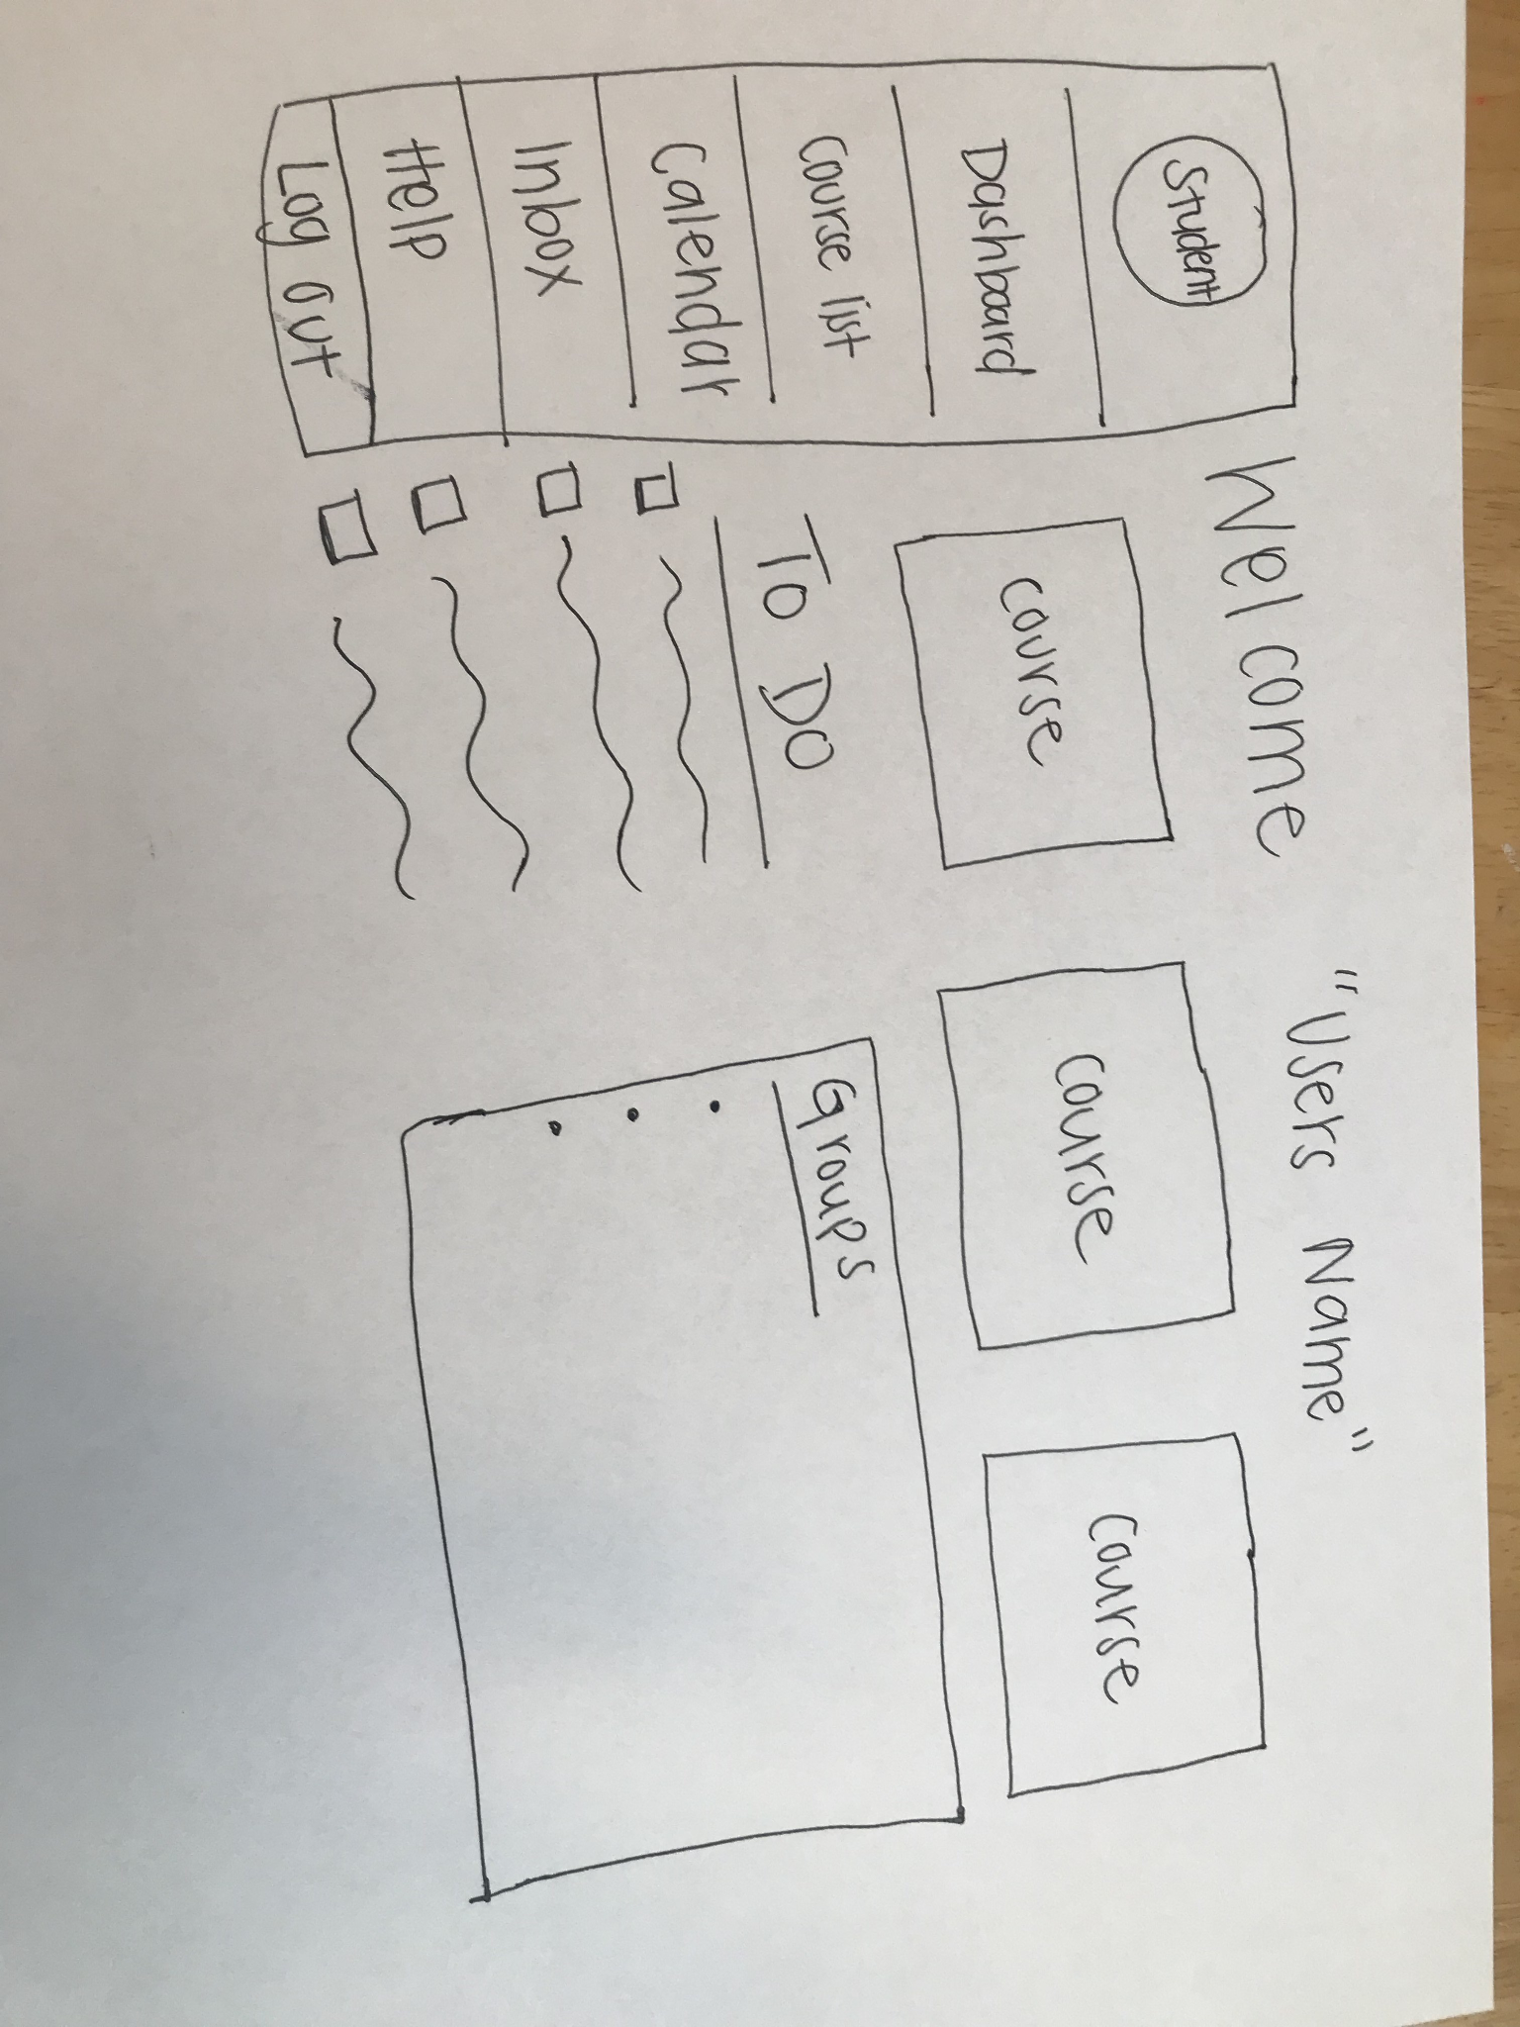

3.Justify the choices that you make.

It gives a visual representation of the application. It will give users an easier transition when switching between canvas and our new application.

Task-3

1.Design a general navigation scheme for both instructors and students. Remember that the system should be intuitive to even the first-time users.

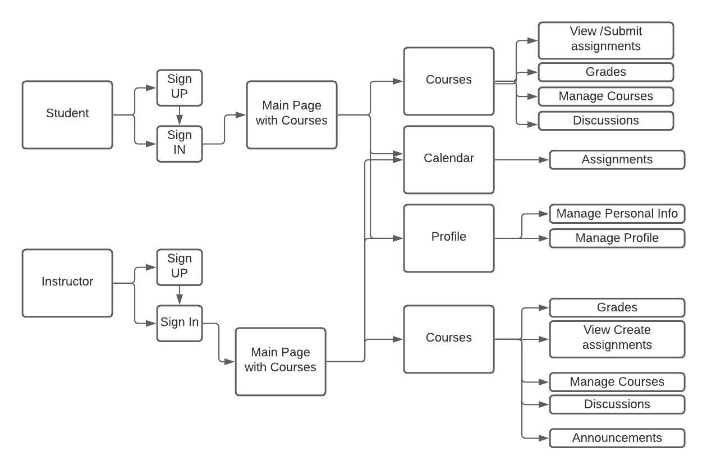

2.What choices you made? Justify them.

We made a sign up and sign in for the instructor and student. They will have different profiles so they will need different paths. The main page is how they navigate to every other functionality they will need. The main page is the first page they will be brought to after logging in. We used 3 categories, one for the courses so they can see / submit. Edit assignments. One for the calendar so they can see the upcoming assignments. We also did a place to manage the profile so they can update their profile information as needed.

Task-4

1.How will you guarantee that your main page and navigation scheme will look and act same across browsers?

We will do thorough testing on our webpage in all the browsers so that we can find any bugs that may come up on the different browsers.

Task-5

1.How will you guarantee that LMS does not contain any showstopper or annoying bugs?

We will designate someone on our team to be like a quality assurance engineer. They will go through our LMS and try to find bugs / break whatever they can to make sure that we are aware of any bugs so that we can get them fixed.

Task-6

•Are there any functionality that is shared between Student and Instructor? So that you can write it once and share across both the users.

Sign UP and Sign In

Account management

View Courses

Task-7

•What kind of notifications should be available to both set of users?

* emergency alerts

- school notifications / announcements

- Notification on the day that assignments are due

- Assignment has been graded

•When and How will you trigger these notifications?

* After an instructor has graded an assignment, a student will receive it
* Calendar events triggered once within a certain time frame
* Instructors can create notifications to send to students

•Do certain notifications trigger immediately?

* School announcements
* When an assignment is graded
* Emergency alerts

•Can we hold certain notifications for a later time?

* Notification on the day assignments are due

Task-8

•How will you guarantee that we are compliant to FERPA?

Make sure the accounts are secure and make sure that other users do not have access to the other user’s information.

•What kind of security features would you like to have for the system?

* Hash users password
* Option two factor authentication
* Profile can become locked out after a certain amount of log out attempts