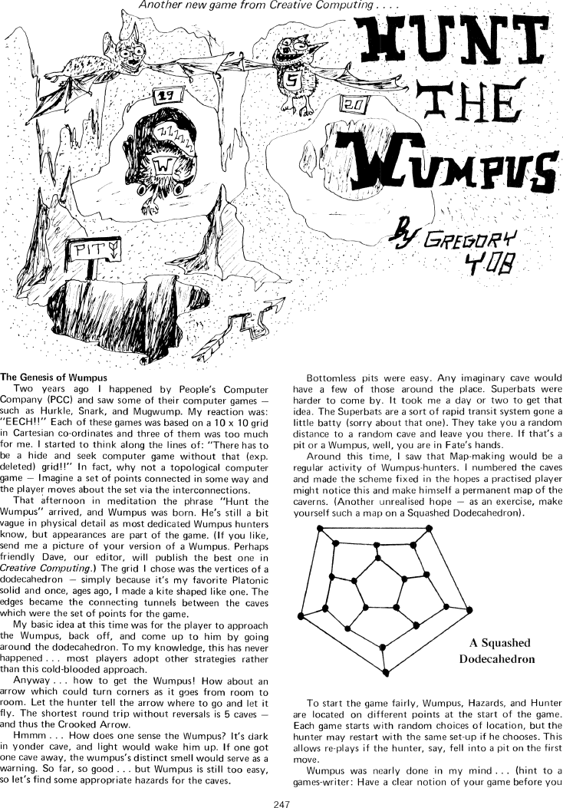

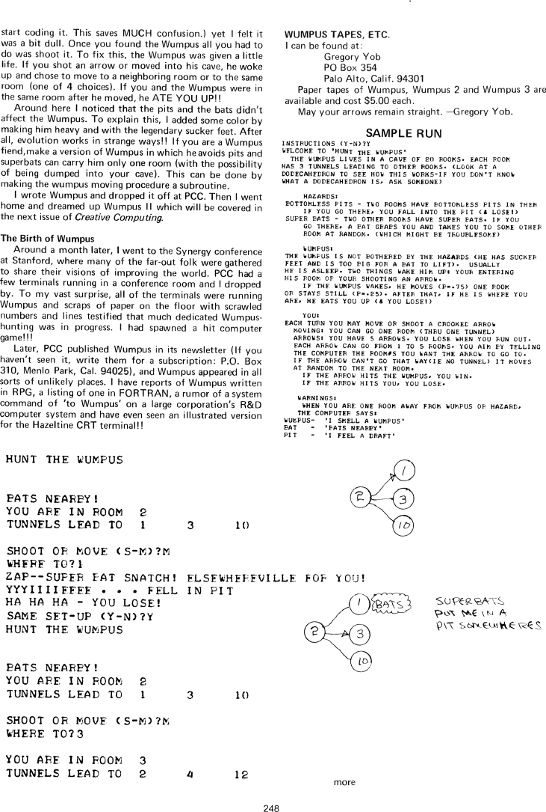

*Warning: The original ideas above have been interpreted in many ways.*

*You will feel the same urge, and that is okay. Just get as close as you can to the user stories that follow.*

**CSc 335 Project #4: Hunt The Wumpus with Strategy and Observer**

**Collaboration: Team of four CSc335 students using a source code repository**

You are asked to fulfill the original intentions of the author (Gregory Yob) for one of the first computer games (Hunt the Wumpus) that has influenced so many others. You are asked to use good object-oriented design, at least two design patterns—Strategy and Observer—and an event driven program with a graphical user interface (back then, everything was printed to green and white lined paper).

Let us begin to do this by showing the fixed map of cave rooms and tunnels with the hunter, the wumpus, the bats, and the bottomless pits set in fixed locations for testing purposes. Once everthing is tested, the hunter and all hazards will be placed randomly. Trust that we will not ask you to allow for varying cave rooms, connecting tunnels.

Legend *hunter, bats, pit, wumpus*





**User Stories (a.k.a requirements)**

#### 

* Each cave room has 3 tunnels that lead to other cave rooms
* The cave maze is modeled after a squashed dodecahedron that does not change: 20 rooms numbered as above, with the same connections always (BTW: this need not be drawn)
* The game will eventually have bats, pits, hunter, and the wumpus in random yet unique locations. The hunter may smell the wumpus immediately, but can not be in the same cave room for example.
* The hunter can walk through one tunnel per turn
* The hunter is warned when a cave room has a tunnel that directly connects to a bottomless pit, a room full of bats, or to the cave room with the one and only wumpus. The hunter
  + - feel a draft (from the pits)
    - hear squeaking (of the bats)
    - smell something foul (the wumpus)
* Upon the hunter entering a cave room with a bottomless pit, the hunter loses
* Upon the hunter entering a cave room with bats, the bats may transport the hunter to another random cave room with the bats flying back to their original cave room
  + 25% of the time, the bats can not notice the hunter and the hunter remains
  + If the hunter is carried away to a bottomless pit, the hunter loses and the game is over
  + If the hunter is carried away to the wumpus, the wumpus wins
* Upon the hunter entering the cave room where the wumpus sleeps:
  + The wumpus may move to any adjoining cave room or stay in the current cave room 25% of the time. This means the hunter loses only 25% of the time after accidentally traveling to the wumpus room
  + The wumpus is impervious to bottomless pits because it has sticky feet and can not fall
  + The wumpus is too heavy for the bats, so moving to a cave room with bats results in no flight to another room.
  + In short, the Wumpus remains in the original cave room or a connecting room only
* The hunter must be able to shoot arrows:
  + The hunter starts with 3 arrows
  + If the hunter tries to shoot an arrow wth none left, the hunter loses
  + The path of an arrow must be requested in the order of rooms to follow. If not possible, the arrow fails
  + If the wumpus is hit with an arrow, the hunter wins
  + Crooked arrows can shoot to 1, 2, 3, 4, or 5 rooms specified as a list such as [10, 11] or [9, 20, 7], or as much as five rooms: [3, 4, 14, 15, 16] for example
  + Hunters can actually shoot themselves. Consider the path for 5 rooms when the Hunter is in room 2: [3, 12, 11, 10, 2]. In this case, the hunter loses
  + To shoot an arrow, the hunter must reveal each room in order. The rooms must be connected. If one move is not possible because the list does not match a possible path, the arrow goes into a wall and can do no further damage
* The game has two swappable views:
  + Something close the the old-fashioned view where the player enters textual input in response to textual prompts (Google it).
  + A graphical view that shows the cave room with the three tunnel numbers, plus any hints about the hazards. Input comes from clicks on any of the tunnel choices (labeled with the room numbers), or allowing the user to click to shoot an arrow. This graphical view must have animations.
  + Each view can be selected by using a menu selection.
  + Swapping the views while playing the game should present the current state of the game
  + In both views, the user will be informed of actions such as arrows missing, and if there is a winner or loser.
* A game begins with the hunter, wumpus, two bat cave rooms, two pit rooms, in random locations. All must be in separate rooms

**Technical requirements to fulfill CSc 335 Course Requirements**

* Your HuntTheWumpus Project must utilize the Strategy Pattern to handle what happens when the hunter enters the room. Each cave room must have a strategy to handle the entering hunter. This may include an interface, and classes implementing that interface with names such as WumpusInCaveRoom, PitsInCaveRoom, BatsInCaveRoom, NoHazardInCaveRoom.
* Your HuntTheWumpus Project must utilize the Observer design pattern. The model must remember a list of observers (do not use Java's Observer class). This allows any and all views to be notified at the appropriate time by the game after user input changes the model. Employ Model View Controller (MVC).

1. A text view that shows an introduction, give prompts, and prints important information such as "Hear the bats" or "Arrow strikes wumpus. You win!". User input comes from a JTextField. Output shown in a JTextArea.
2. A graphical view that shows an introduction, gives prompts, shows images of the cave room, and reports important information. This view must include animations and sound somehow at whatever time you want (hunter loses, hunter wins, hunter moves, arrow flies…).
   * Important Note: This graphical view will be specified with more details later.

**Dues Dates**

**Analysis and Design Artifacts: Due Tuesday 26-Feb at 4:45 pm**

**Competed Project: Sunday March 23rd @ 9:00pm**