|  |
| --- |
| Travis Peters Western Washington University Math 419: Historical Perspectives of Mathematics |
| Principles & Problems |
| A comparison of the significance and conceptual mathematics of Cavalieri’s Principle & Buffon’s Needle Problem |

|  |
| --- |
| Travis Peters  7/13/2012 |

## Introduction

Have you ever heard the phrases “don’t judge a book by its cover” and “it’s like comparing apples and oranges…”? Have you ever asked yourself how to avoid doing the former and finding a way of relating the latter? In the writing that follows, we will quite literally open the book and turn the pages of history as we look at two very different, but significant ideas from the field of mathematics. To begin, we explore a concept that has been buried away, deep down in one of the richest subcategories of mathematics: Calvalieri’s Principle and how it relates to geometry and calculus. Secondly, we will experience a collision of probability, geometry and trigonometry as we investigate a problem which is known as one of the most interesting problems in probabilistic geometry to date. To close, a more directed discussion will be made with regards to the two ideas presented in an effort to ultimately answer the ambiguous question: “which idea is more important?”

## Cavalieri’s Principle

When the word “calculus” is mentioned in a classroom, famous mathematicians like Newton and Leibniz are credited with grand discoveries and idolized as the great inventors of this area of mathematics. However, this will not be the case here – this is an opportunity to look a little further back in history at the person whose shoulder’s people like Newton and Leibniz stood on to achieve some of their great success; Bonaventura Cavalieri (1598 – 1647), depicted to the right, is one such man. In fact, Cavalieri’s work was considered so progressive and successful that Galileo wrote to a patron of the University of Bologna about Cavalieri saying “few, if any, since Archimedes, have delved as far and as deep into the science of geometry.” [1]

Cavalieri, born in Milan, Italy, was a geometer, physicist, and theologian. Cavalieri is especially well known for his work on the concept of indivisibles, which is the idea of treating a region in the plane as being made up of infinitely many parallel lines (e.g. infinitely thin rectangles that were smaller than any possible positive number – thus making them impossible to divide any further). This was done so that one could think of areas of a region or under a curve as the sum of these rectangles! (*Sounds quite a bit like infinitesimal calculus, right?*). Cavalieri is also well known for his status as a friend and student of Galileo. However, even with these known facts, Cavalieri remains somewhat mysterious to us today. There are no actual records of Cavalieri’s exact birth date, or his actual first name; we do know that Cavalieri entered a monastic order at an early age and adopted the first name Bonaventura as his religious name. In 1616, Cavalieri established himself in a monastery in Pisa, Italy (Monasteries in this time were known as centers of learning, and allowed Cavalieri to interact with some of the greatest minds of his time). Making the best of his role as a cleric, Cavalieri had access to the classic texts of Euclid, Archimedes, and Apollonius [1].

Immediately following this time (1620 – 1623), Cavalieri actually began his work on the method of indivisibles. The inspiration for his work, Archimedes, proposed the notion that “indivisibles could be used to determine areas, volumes, and centers of gravity.” [2] Cavalieri’s work, exploring this notion and deriving verifiable results, resulted in the following mathematical principle:

***Cavalieri’s Principle:***

*If two solids have equal altitudes, and if sections made by planes parallel to the bases and at equal distances from the bases always have a given ratio, then volumes of the solids have the same ratio to each other. [2]*

Though the language above may not make this immediately obvious, Cavalieri’s Principle can be applied within two-dimensional space to determine areas just as easily as it can be applied within three-dimensional space. One example of how this principle can was used can be seen in everyday objects that you are most likely familiar with! Below, as you can see, are everyday CDs and pennies. Draw your attention first, however, to the image in the center which is a useful illustration of Cavalieri’s Principle in two-dimensional space. Both regions have “equal altitude” and each region is made up of equal distance sections that are made by parallel lines that intersect both regions. Therefore, because of Cavalieri, we can conclude that the areas must be the same! This picture shows us that the shape on the “crooked tower” on the right is nothing more than various sections of a rectangle displaced to the left or right. By pushing all of the sections back together so that they all line up, we can reform the rectangle, for which we can compute the area easily!

|  |  |  |  |
| --- | --- | --- | --- |
|  |  |  |  |

Now that we have looked at the two dimensional case, we can begin to see how Cavalieri’s Principle can also be applied in three-dimensional space to determine volumes. In fact, the images of stacked CDs and pennies are essentially equivalent to the stacked rectangles in the two-dimensional case! Since these cases are very similar and we have a handle on how this principle can be used to determine areas and volumes, we can now look at a slightly different, but more interesting, application. Before moving on thought, take special note that the language used in the principle does not say that areas or volumes are actually computed as a result of the principle, but rather it suggests that they can be *compared* to known regions or shapes. Thus, the results are still meaningful because what Cavalieri’s Principle really allows us to do is relate the volume (area) of an unknown object (region) to one or more objects (regions) for which we can determine the volume (area). [2]

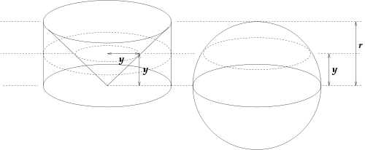

Our more “interesting” application in $R^{3}$ uses Cavalieri’s Principle to show that the volume of a sphere is in fact (${4πr^{3}}/3$), using only the fact that we know the volume of a cone is ($1/3$) $bh$. To begin, consider a sphere with radius $r$ and a cylinder with both radius and height $r$ (illustrated above). Notice that within the cylinder, there is a cone whose apex is at the bottom of the cylinder (coincidently, this is equivalent to having the apex of the cone touch the center of the sphere). Also notice that the bottom of the cylinder and the equator of the sphere lie on the same plane, thus creating circles of equal size where the shapes are intersected by the plane – obviously this orientation *is* important. Now, by constructing a plane that is $y$ units “up” and parallel to the great circle of the sphere as well as the base of the cylinder, we can use the Pythagorean Theorem1. Notice that when the plane intersects the sphere, the radius of the sphere at that slice now has radius (*r*2 − *y*2) and the area of that circle is *π*(*r*2 − *y*2). That same intersecting plane, when intersected with the cylinder and the cone that lies within the cylinder, creates a smaller cone having a base with radius *y*2 and area *π*(*y*2). Since the area of the plane's intersection with the part of the cylinder that is *outside* of the cone is *π*(*r*2 − *y*2), we have now identified volumes of the shape that have the same ratio. Since we know that the volume of the cylinder outside of the cone, which is $2/3$ the volume of the cylinder, we conclude that the volume of the upper half of the sphere has the same volume! We can now more concisely say,

$$V_{cylinder}=bh=\left(πr^{2}\right)\left(r\right)= πr^{3}$$

$$\left(\frac{2}{3}\right)V_{cylinder}=V_{outside of cone}=V_{top hemisphere}=\frac{2πr^{3}}{3}$$

If you multiply this quantity by two in order to account for both the bottom and top hemispheres, you arrive at the desired result! [3] Also notice that, as in our previous example, you can almost imagine pushing the volume outside of the cone (within the cylinder) over *into* the sphere, allowing it to mold to the shape of the sphere. This was easier to see with rigid objects like the CDs, but the action is, in principle, the same.

*1  If one erects similar figures on the sides of a right triangle, then the sum of the areas of the two smaller ones equals the area of the larger one.*

*The basic idea behind this generalization is that the area of a plane figure is proportional to the square of any linear dimension, and in particular is proportional to the square of the length of any side. Thus, if similar figures with areas A, B and C are erected on sides with lengths a, b and c then:*

*By the Pythagorean Theorem, a2 + b2 = c2, so A + B = C. [4]*

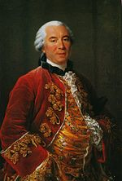

## Buffon’s Needle Problem

As a mathematician yourself, or at least someone who has enough interest to read about note-worthy ideas in mathematics, do you ever find yourself feeling as if you are doing the same thing over and over again? Maybe you change a variable here, or divide a number there, and apply some definition, but then it is back to the same algorithm. Do you ever ask yourself “why?” This was precisely the approach of Georges Louis Leclerc, Count of Buffon (1707 – 1788), for the derivation and solution of his famous problem, Buffon’s Needle Problem [5]. The problem, defined in detail later, involved dropping a needle numerous times and investigating the probabilistic nature of the drop of a needle and its intersection with parallel lines.

Buffon, though a French naturalist, mathematician, cosmologist, and author of numerous encyclopedic volumes, may not be someone you have studied in the classroom, but even in this day it is has been said that he was “the father of all thought in natural history in the second half of the 18th century" [7]. Before Buffon was recognized for his contributions to the sciences, he spent over a year traveling extravagantly through Europe with the young English Duke of Kingston. Throughout this time it was rumored that Buffon was involved in duels, abductions, and secret trips to England. In fact, before this time, Buffon wasn’t even known by that name! During his travels with the Duke that Georges Louis Leclerc added “de Buffon” to his own name. It was these scandalous adventures that eventually led Buffon to Paris where he made the acquaintance of intellectuals such as Voltaire, and made his mark in the field of mathematics [5].

Buffon’s Needle Problem is a problem that we may have never heard of, yet it is recognized as one of the best-known problems of geometric probability [8]. My assumption is that the problem is not covered in mathematics classes focusing on probability today because the problem and results, though interesting and fun, yield results that are a bit of a “dead end” in regards to applicability, which seem to dominate the majority of course curriculum. The lack of exposure for this problem in classes today might also be due to the fact that the problem lies within the area of geometric probability, of which there are few (or zero) classes for students at the high school and undergraduate collegiate level. Geometric probability might sound like some hybrid, or even made-up, area of mathematics but rest assured you have encountered this before. One example could be throwing darts at a dart board. By dividing the dartboard into two different circles (the entire dartboard and the smaller sub-circle making up the “bullseye”) one can solve for the areas of each of the circles and compute the probability of hitting a bullseye when playing darts.

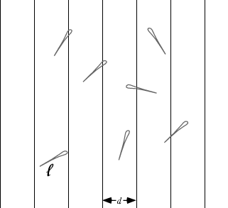

Buffon’s Needle Problem, illustrated above, can be framed in a similarly straightforward manner: find the probability that a needle of length $l$ will land on a line, given a floor with equally spaced parallel lines a distance $d$ apart [6]. Clearly the probability of the needle intersecting one of the lines depends on the relationship between the length, $l$ and the distance, $d$. We can define a *size* parameter as follows:

$$x=\frac{l}{d}$$

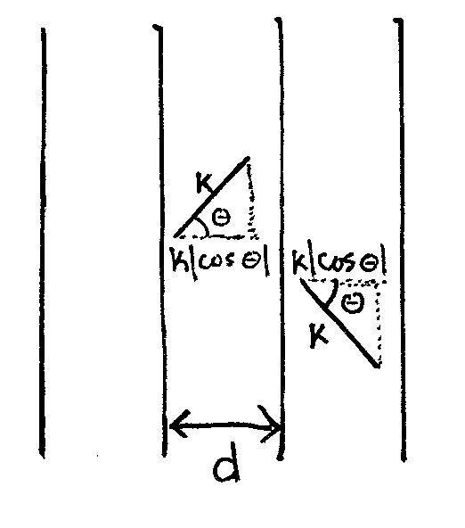By realizing that each drop of the needle is an independent event, Buffon used probabilistic facts coupled with integral calculus and trigonometry to explore the intersection of the needle and the parallel lines. By fixing the needle at its midpoint and rotating the needle about that point, a circle can be created (depicted to the right). From here, it was possible to find the angle(s) of the needle with respect to an arbitrarily drawn x-axis drawn perpendicular to the parallel lines, and determine the probability of intersection based on some values for $l$ and $d$. The setup and derivation for a short needle (i.e. $l/d<1)$ follows:

$$P\left(x\right) = \int_{0}^{2π}{\frac{l\left|cosθ\right|}{d}\frac{dθ}{2π}} = \frac{2l}{πd}\int_{0}^{\frac{π}{2}}{cosθ dθ} = \frac{2l}{πd} = \frac{2x}{π}$$

So, for example, when $x=l/d=1,$

$$P\left(x=1\right)=2/π=0.636619…→ π=3.141596…$$

which appears to be a fairly remarkable estimate for $π$. A much more complicated derivation exists for a long needle (i.e. $l/d>1$) but is not included. Sparing the reader more tedious derivations, the conclusion of Buffon’s needle problem is a means of approximating the value of $π$! In fact, after some work, Buffon found:

$$\hat{π}=\frac{1}{\hat{θ}}=\frac{2xn}{N}$$

where $\hat{θ}$ is a point estimator, $n$ is the total number of needle tosses, and $N$ is the number of line crossings. This estimator, as a result of Buffon’s Needle Problem, is known as Buffon’s estimator (for $π$). The precise details from the past statement are, again, beyond the scope of this paper, but the preceding information captures the essence of the Buffon’s Needle Problem and its direct conclusion. The reader is now highly encouraged to attempt to carry out a small example of this problem to investigate the accuracy of the estimate of $π$. The diagram below captures five independent series of tosses of a *short* needle for one million tosses in each trial where $x=l/d=1/3$. Notice how the simulation does approximate a general neighborhood of the exact value of $π$, but that the “accuracy” comes as a result of very large simulations [6]. 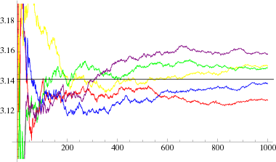

## Direct Comparison & Conclusion

When we ask questions like “what is the importance of …” or “what is *more* important,” we are hasty to draw conclusions about that which is immediately apparent. True *answers* to these sorts of questions come only as a result of moving past the surface level. Surely we can look at both Cavalieri’s Principle and Buffon’s Needle Problem, taking note of the relative merit of each topic, but, what does it mean to really evaluate the importance of either of these mathematical ideas that have ranked among a list of the 100 most important ideas in mathematics?

To begin, we ought to define the domain in which we are comparing these mathematical ideas. If we hold the ideas presented thus far in either hand, Cavalieri’s Principle in one and Buffon’s Needle Problem in the other, and choose to compare these mathematical ideas and their significance to the world as a whole (outside of mathematics), neither seems to offers something so extraordinary to the world that would set it apart as a clearly more important or useful idea. On the one hand, Cavalieri’s Principle has a very specific application to conceptual mathematics in the study of geometry with regards to areas and volumes, and there are even some applications in the real world. However, real world applications, by definition, would have to be extremely precise in constructing the environment in order to ensure that areas/volumes were “accurate”. On the other hand, Buffon’s Needle Problem has proved to be a note-worthy exercise, but the problem itself yielded an approximation for a value which is more easily and accurately calculated by other means. Carrying out a real world simulation of the problem is, in itself, purely academic and appears to be more tedious than worthwhile. In comparing these two mathematical ideas with regard to the world outside of mathematics, it would seem that inspecting them further from different perspectives will continue to shed light on the answer(s) we are seeking.

Let us now restrict the domain in which we are considering these ideas to compare the people behind the two ideas in question. Buffon, a man of adventure and persistence, contributed not just as a mathematician, but also as a proficient author and evolutionist. Buffon is credited with being the one who raised new questions and brought forth new ideas to the scientific community. Thus, there is no doubt that, as a person, Buffon served his time and history as a whole, well. Cavalieri, a man of faith with a truly academic spirit, is known for the time he took to appreciate the people that came before him. Working the majority of his life within the church and in a university, Cavalieri dedicated his life to the others and to the advancement of mathematics. Noting this, as well as some of their pasts depicted in the text above, it is fairly apparent that both men did all that they could to impact the world that we know today.

Finally, we can further restrict the lens by which we are comparing these ideas, and, given that these ideas stand on the foundation of thousands of years of mathematics, we can consider it meaningful to investigate if or how these ideas “paid it forward” in a sense and further helped to develop the expansion of mathematics. Cavalieri, with his study of indivisibles and his resulting principle, truly developed the progression of thought towards breaking areas or volumes up into infinitely many regions. I say “developed the progression” only because his work was not flawless, and his work was in fact a subset of how we view indivisibility today. A commonly known implication of Cavalieri’s work is the Riemann Sum which is almost identical to the ideas put forth by Cavalieri. Also worthy of recognition is the fact that Cavalieri contributed to laying the ground work for calculus which has become a rich area of study in itself, and has also found applications in areas such as business, architecture, biology, and engineering. On the other hand we have Buffon. Extensions of his problem exist for variable shapes and other abstractions, but the result of this problem seems to yield interesting problems in a very limited subset of mathematics. In line with this point, I find it hard to find real-world mathematical applications of this problem or its immediate results. This leads me to the conclusion that, in terms of mathematical significance, the interesting nature of Buffon’s Needle problem does not suffice to compete with the equally interesting yet applicable and versatile significance of Cavalieri’s Principle as well as its direct results.

Both mathematical ideas and the mathematicians behind the ideas certainly bring quite a diverse set of accomplishments and contributions forward. Although it would almost seem fair to “call it a draw,” I cannot help but feel that the hero of this paper has been none other than Cavalieri! Both as a mathematician and as person his work has unraveled mysteries of great magnitude and changed the world for the better.

## Works Cited

[1] Young, Robyn V. *Notable Mathematicians: From Ancient times to the Present*., pg. 105-106. Detroit, MI: Gale, 1998. Print.

[2] "Stereologist's Blog." *Stereologist's Blog*. WordPress.com, 18 Apr. 2012. Web. 5 July 2012. <http://stereologist.wordpress.com/2012/04/18/137/>.

[3] "Cavalieri's Principle." *ENotes*. ENotes.com, n.d. Web. 6 July 2012. <http://www.enotes.com/topic/Cavalieri%27s_principle>.

[4] "Pythagorean Theorem." *ENotes*. ENotes.com, n.d. Web. 6 July 2012. <http://www.enotes.com/topic/Pythagorean_theorem>.

[5] "Buffon's Needle." *Wikipedia.com*. Wikipedia, n.d. Web. 3 July 2012. <http://en.wikipedia.org/wiki/Buffon%27s_needle>.

[6] Weisstein, Eric W. "Buffon's Needle Problem." *MathWorld*. Wolfram, 2 July 2012. Web. 5 July 2012. <http://mathworld.wolfram.com/BuffonsNeedleProblem.html>.

[7] Mayr, Ernst. *The Growth of Biological Thought*. Boston: Cambridge: Harvard, 1981. 330. Print.

[8] Klain, Daniel A., and Gian-Carlo Rota. "Chapter 1: The Buffon Needle Problem." *Introduction to Geometric Probability*. Cambridge: Cambridge, 1997. 1-5. Print.