Arizona Random Forest Flood Mapping

Travis Zalesky

2025-03-31

Abstract

Federal Emergency Management Administration 100-year flood risk maps are expanded across the state of Arizona using a random forest, machine learning classification utilizing eight topographic explanatory variables.

Table of contents

# 1. Arizona Random Forest Flood Mapping

Federal Emergency Management Administration 100-year flood risk maps are expanded across the state of Arizona using a random forest, machine learning classification utilizing eight topographic explanatory variables.

# 2. Background

A critical component of the Arizona Department of Water Resources (ADWR) Tri-University Recharge Project (TURP, a.k.a ATUR) is a state wide assessment of flooding potential. Initial efforts focused on a traditional suitability analysis approach, using the analytical hierarchy process (AHP) for multi-criterion decision making, largely based on the work by Aloui et al. (2024). These methods saw initial success, and are continuing to be developed and refined. However, it became apparent that there were a number of shortcomings inherent in this analysis which are not easily addressed.

Firstly, the results of such an analysis are intrinsically linked to the data layers used, and the weighting schema determined by the AHP. As additional data sets became available, and alternate weighting schemas were tested we generated multiple versions of mapped flood potential which did not necessarily agree with each other. In the absence of high quality ground-truthed data it was difficult to validate these results and it was not clear to the project team which version was the best. This underscores the need for expert involvement at every stage in these AHP based analysis. While there is a wealth of hydrological expertise within the larger ATUR project, method development and implementation has largely been conducted by a GIS technician with marginal hydrologic knowledge, and it has been difficult to foster sustained buy-in from team members on this portion of the project.

Furthermore, it was extremely difficult to develop a single generalized model that would be effective across the whole state. Because of the wide array of ecological and geologic conditions that are present across the state variables that are important for flood risk in one region may not apply in other regions. Lastly, even if these technical issues could be overcome, there was still gaps in the input data layers, resulting in unclassified regions.

While the traditional suitability analysis methods of assessing flood potential is still valuable to the project, and will be retained and developed further, the reality of these challenges lead us to reevaluate our overall approach and consider alternate methods. Work by Mudashiru et al. (2021) summarized the various methods used by other researchers in this field, which includes AHP based methods as well as physical modeling and machine learning applications. The machine learning methods utilized by Tehrany et al. (2019) appeared to be particularly relevant and applicable. In particular, their use of topographic data **only** was particularly intriguing. These data sets are fully calculable from a digital elevation model (DEM), which are readily available, easily accessible, and have full coverage over the study area. These findings lead to a renewed initiative to apply a machine learning based method towards the objective of a state wide flooding potential map.

# 3. Data & Methods

All explanatory variables for the model were derived from the NASA Shuttle Radar Topography Mission (SRTM) 30-m DEM. Slope, aspect, curvature, stream power index (SPI), topographic wetness index (TWI), and sediment transport index (STI) were all calculated in ArcGIS Pro (3.4.3). Slope, aspect and curvature were calculated using the Surface Parameters tool (Spatial Analyst). SPI, TWI, and STI were calculated as per Tehrany et al. (2019) using the Raster Calculator according to Equations 3.1-3.3

where As is catchment area (m) and ß is slope (radians).

Similarly, Topographic Roughness Index (TRI) was calculated as per Tehrany et al. (2019) using a custom R (4.4.1) function with the package terra (1.7-78) according to Equation 3.4

where χij is the elevation at coordinates (i, j) and χ00 is the elevation at coordinates (0, 0) for a 3x3 focal neighborhood. The code used to calculate TRI is available on [GitHub](https://github.com/travisz09/TopographicRoughnessIndex).

Flood data used for training the model was obtained from the Federal Emergency Management Administration (FEMA) National Flood Hazards Layer, which provides 100-year flood maps for many areas of the US. The data was manually downloaded for each county in AZ from the FEMA [data viewer](https://hazards-fema.maps.arcgis.com/apps/webappviewer/index.html?id=8b0adb51996444d4879338b5529aa9cd) (accessed 3/15/2025). Data layers were merged in ArcGIS Pro (3.4.3), and the vector data was converted to a raster with a 10 m resolution. Additionally, the FEMA data was reclassified to a binary output, either flooded or not flooded (during a 100-year flood event), eliminating details such as survey methods and flow depth.

The machine learning model was performed in Google Earth Engine (GEE). The SRTM elevation data was access and clipped to the study area natively through GEE servers, all other data layers, including the study area shapefile, were uploaded as an asset to GEE prior to model implementation.

Prior to modeling, the collinearity of the explanatory variables was explored using a series of pair-wise linear regression plots shown in **?@sec-appendix** Figures **?@fig-floodElev**-**?@fig-triSti**. For collinearity analysis 5,000 points were randomly sampled across the study area, the maximum number of points which can be plotted in GEE. The collinearity of each pair-wise regression is summarized visually in Figure 3.1 using the R-squared statistic of each comparison.

|  |
| --- |
| Figure 3.1: Color coded R-squared statistic for each pair-wise linear regression (green = high, red = low), representing the collinearity of each variable used for modeling. |

# 4. Conclusion

# References

Aloui, S., Zghibi, A., Mazzoni, A., Elomri, A., & Al-Ansari, T. (2024). *Identifying suitable zones for integrated aquifer recharge and flood control in arid qatar using GIS-based multi-criteria decision-making*. *25*, 101137. <https://doi.org/10.1016/j.gsd.2024.101137>

Mudashiru, R. B., Sabtu, N., Abustan, I., & Balogun, W. (2021). Flood hazard mapping methods: A review. *Journal of Hydrology*, *603*, 126846. <https://doi.org/10.1016/j.jhydrol.2021.126846>

Tehrany, M. S., Jones, S., & Shabani, F. (2019). Identifying the essential flood conditioning factors for flood prone area mapping using machine learning techniques. *CATENA*, *175*, 174–192. <https://doi.org/10.1016/j.catena.2018.12.011>

# Appendix A — Pair Wise Regressions

# Appendix A — Appendix

**Flooding** 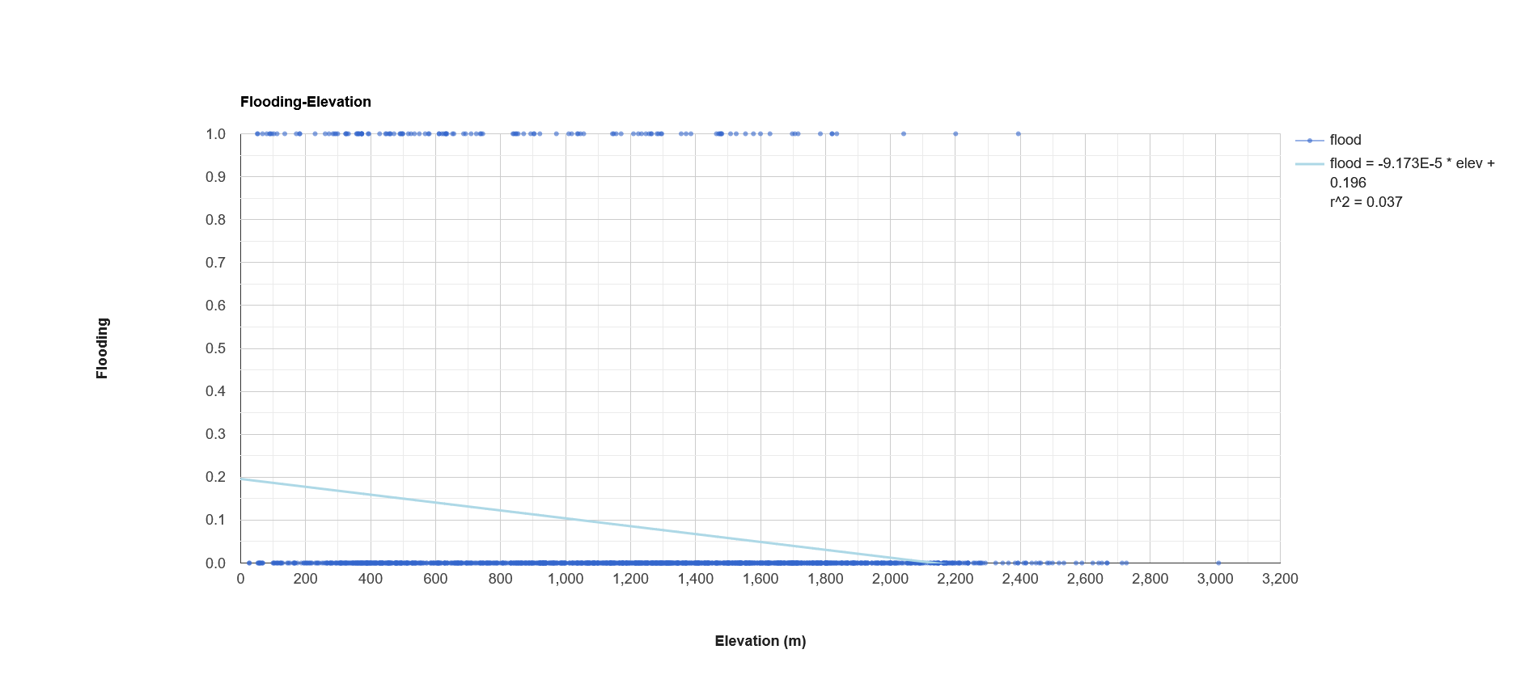

|  |
| --- |
| Figure B.1: Linear regression analysis of flood risk (binary) and slope (°) for 5,000 randomly sampled points across the full study area, encompassing Arizona. |

|  |
| --- |
| Figure B.2: Linear regression analysis of flood risk (binary) and aspect (°) for 5,000 randomly sampled points across the full study area, encompassing Arizona. |

|  |
| --- |
| Figure B.3: Linear regression analysis of flood risk (binary) and curvature for 5,000 randomly sampled points across the full study area, encompassing Arizona. |

|  |
| --- |
| Figure B.4: Linear regression analysis of flood risk (binary) and stream power index (SPI) for 5,000 randomly sampled points across the full study area, encompassing Arizona. |

|  |
| --- |
| Figure B.5: Linear regression analysis of flood risk (binary) and topographic wetness index (TWI) for 5,000 randomly sampled points across the full study area, encompassing Arizona. |

|  |
| --- |
| Figure B.6: Linear regression analysis of flood risk (binary) and topographic roughness index (TRI) for 5,000 randomly sampled points across the full study area, encompassing Arizona. |

|  |
| --- |
| Figure B.7: Linear regression analysis of flood risk (binary) and sediment transport index (STI) for 5,000 randomly sampled points across the full study area, encompassing Arizona. |

**Elevation** 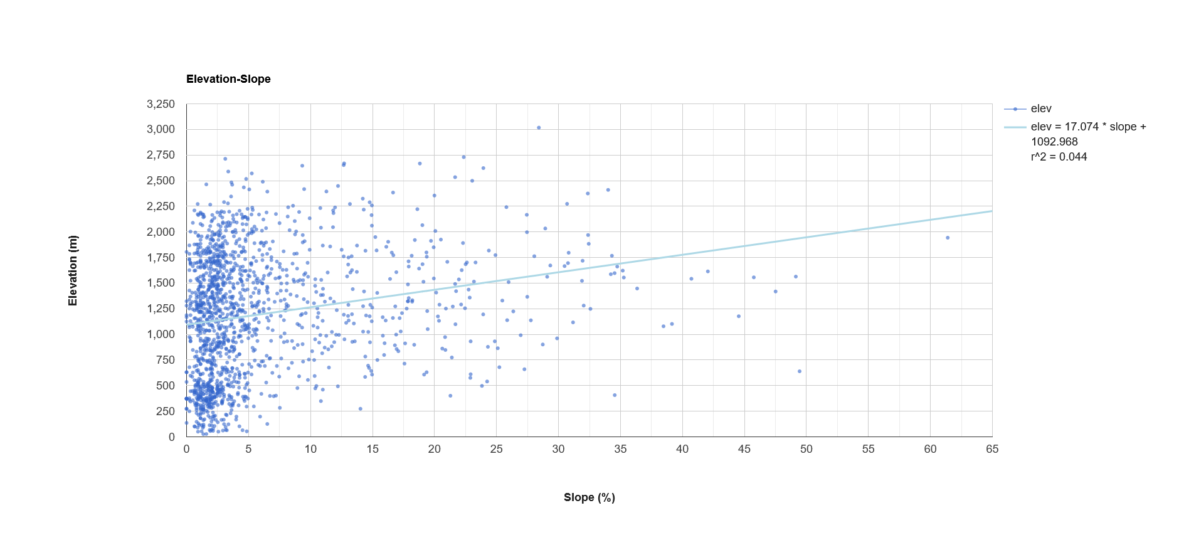

|  |
| --- |
| Figure B.8: Linear regression analysis of elevation (m) and aspect (°) for 5,000 randomly sampled points across the full study area, encompassing Arizona. |

|  |
| --- |
| Figure B.9: Linear regression analysis of elevation (m) and curvature for 5,000 randomly sampled points across the full study area, encompassing Arizona. |

|  |
| --- |
| Figure B.10: Linear regression analysis of elevation (m) and stream power index (SPI) for 5,000 randomly sampled points across the full study area, encompassing Arizona. |

|  |
| --- |
| Figure B.11: Linear regression analysis of elevation (m) and topographic wetness index (TWI) for 5,000 randomly sampled points across the full study area, encompassing Arizona. |

|  |
| --- |
| Figure B.12: Linear regression analysis of elevation (m) and topographic roughness index (TRI) for 5,000 randomly sampled points across the full study area, encompassing Arizona. |

|  |
| --- |
| Figure B.13: Linear regression analysis of elevation (m) and sediment transport index (STI) for 5,000 randomly sampled points across the full study area, encompassing Arizona. |

**Slope** 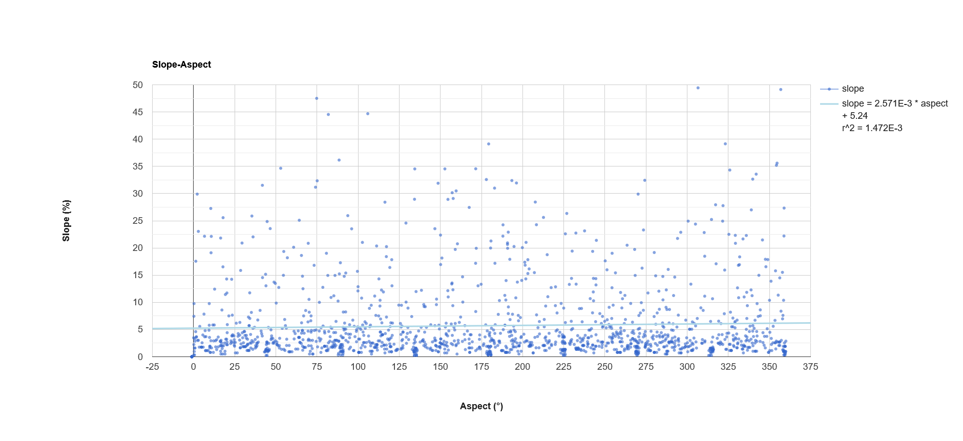

|  |
| --- |
| Figure B.14: Linear regression analysis of slope (°) and curvature for 5,000 randomly sampled points across the full study area, encompassing Arizona. |

|  |
| --- |
| Figure B.15: Linear regression analysis of slope (°) and stream power index (SPI) for 5,000 randomly sampled points across the full study area, encompassing Arizona. |

|  |
| --- |
| Figure B.16: Linear regression analysis of slope (°) and topographic wetness index (TWI) for 5,000 randomly sampled points across the full study area, encompassing Arizona. |

|  |
| --- |
| Figure B.17: Linear regression analysis of slope (°) and topographic roughness index (TRI) for 5,000 randomly sampled points across the full study area, encompassing Arizona. |

|  |
| --- |
| Figure B.18: Linear regression analysis of slope (°) and sediment transport index (STI) for 5,000 randomly sampled points across the full study area, encompassing Arizona. |

**Aspect** 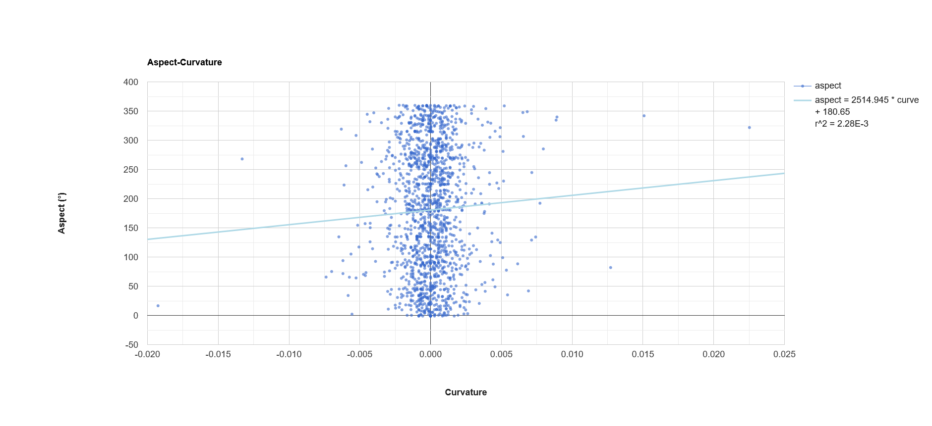

|  |
| --- |
| Figure B.19: Linear regression analysis of aspect (°) and stream power index (SPI) for 5,000 randomly sampled points across the full study area, encompassing Arizona. |

|  |
| --- |
| Figure B.20: Linear regression analysis of aspect (°) and topographic wetness index (TWI) for 5,000 randomly sampled points across the full study area, encompassing Arizona. |

|  |
| --- |
| Figure B.21: Linear regression analysis of aspect (°) and topographic roughness index (TRI) for 5,000 randomly sampled points across the full study area, encompassing Arizona. |

|  |
| --- |
| Figure B.22: Linear regression analysis of aspect (°) and sediment transport index (STI) for 5,000 randomly sampled points across the full study area, encompassing Arizona. |

**Curvature** 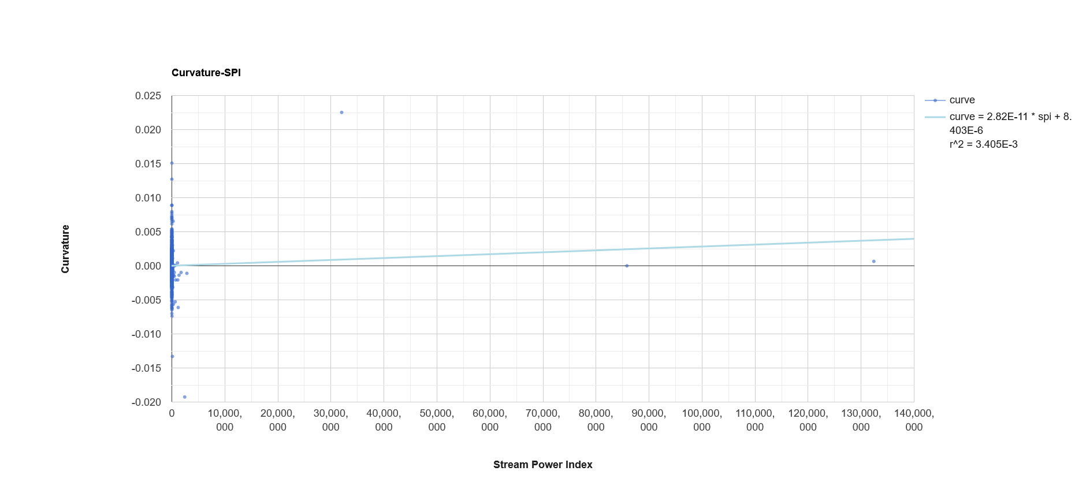

|  |
| --- |
| Figure B.23: Linear regression analysis of curvature and topographic wetness index (TWI) for 5,000 randomly sampled points across the full study area, encompassing Arizona. |

|  |
| --- |
| Figure B.24: Linear regression analysis of curvature and topographic roughness index (TRI) for 5,000 randomly sampled points across the full study area, encompassing Arizona. |

|  |
| --- |
| Figure B.25: Linear regression analysis of curvature and sediment transport index (STI) for 5,000 randomly sampled points across the full study area, encompassing Arizona. |

**Stream Power Index** 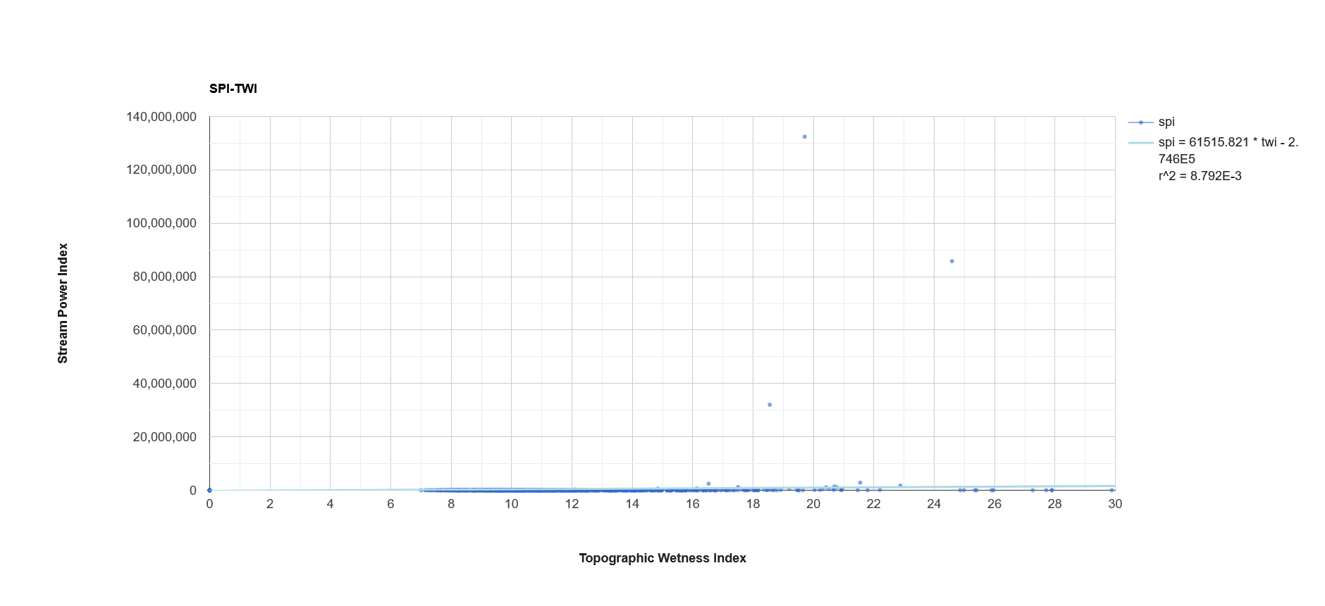

|  |
| --- |
| Figure B.26: Linear regression analysis of stream power index (SPI) and topographic roughness index (TRI) for 5,000 randomly sampled points across the full study area, encompassing Arizona. |

|  |
| --- |
| Figure B.27: Linear regression analysis of stream power index (SPI) and sediment transport index (STI) for 5,000 randomly sampled points across the full study area, encompassing Arizona. |

**Topographic Wetness Index** 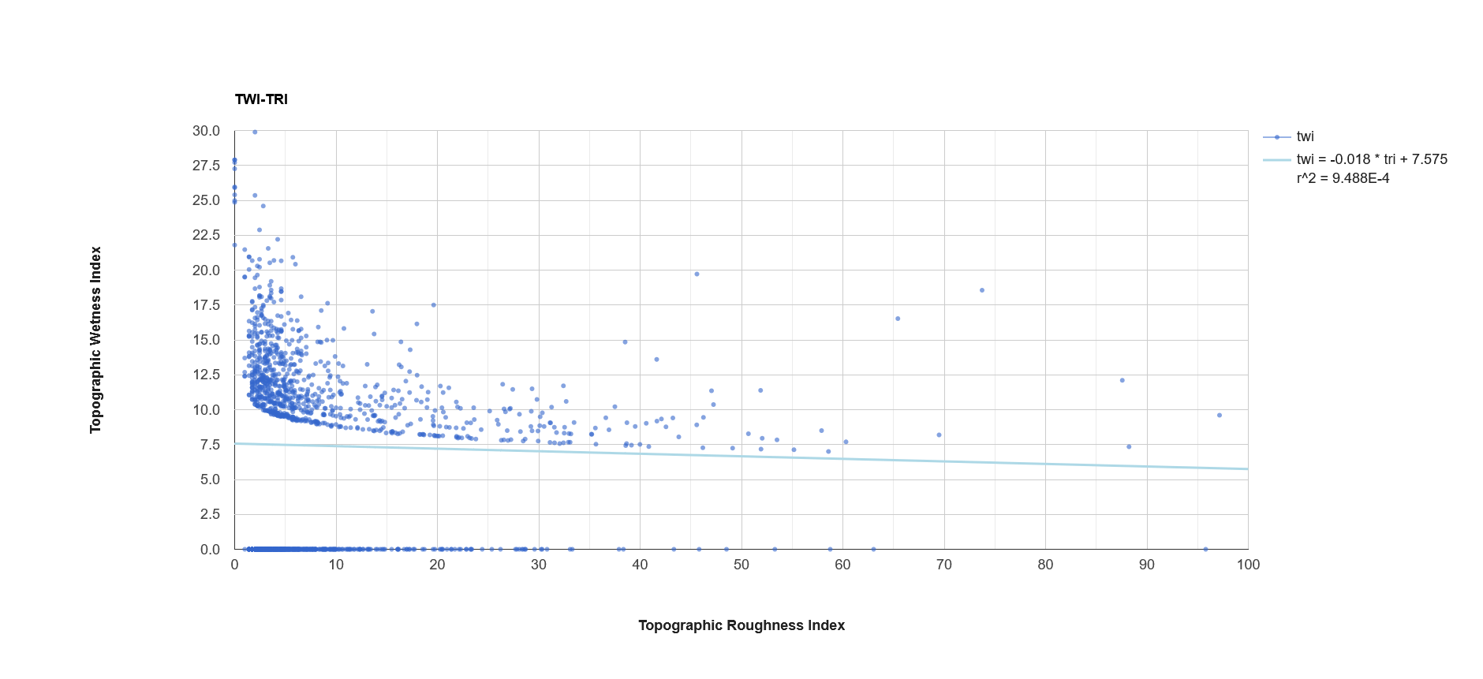

|  |
| --- |
| Figure B.28: Linear regression analysis of topographic wetness index (TRI) and sediment transport index (STI) for 5,000 randomly sampled points across the full study area, encompassing Arizona. |

**Topographic Roughness Index** 