# Design

## User Interface Design

## Overview

I am designing a web-application in which users can log in and create poker tables, where they can play live poker against other players. In each table, there is also a chat, in which the players can interact. The users can then also view their total money and stats and compare them against other players in the leader board.

## The Django Framework

The fundamentals of Django:

* models.py – Defines your data model and contains the fields and behaviours of the data you are storing. Each model maps to a database table and each attribute a field.
* urls.py – Uses regular expressions to capture URL patterns to retrieve a view.
* views.py – Called when a specific URL is accessed. Takes the web request and returns a web response. When rendering a web page, it can pass a dictionary of variables to the template
* templates.py – Renders the web page.

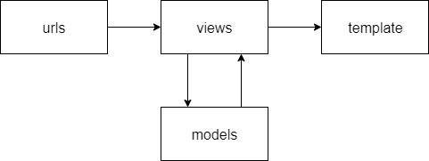

Django Channels

A socket library for Django. Its base features work very similarly to Django.

* The templates JavaScript creates a web socket at a specific web socket address
* routing.py – uses regex to capture the web socket address retrieves a consumer
* consumer.py – can create web socket groups for to send data to multiple users e.g. the community cards, chat. Has connect disconnect and receive functions that are called when such events happen
* templates JavaScript also contains a send function along with onmessage and onclose functions, that run when such an event is reached.

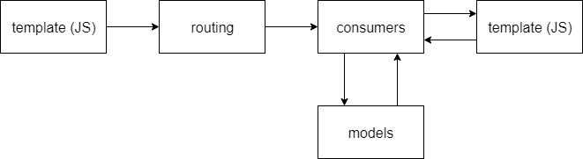

## The Poker Algorithm

### Game view

login required to access

Function game

if users money >= tables buy in and players in table < max players in table

start daemon thread on poker main function

return game.html render

return redirect index

### Adding player to table

Function main

get Room object for Table

add player to Room

if Room does not exist

create Room object

add player to Room

startGame()

### Finding hand strengths

hand <- pocket cards and community cards

hand <- reverse sort hand

Function pairThree

strength <- 0

numPairs <- number of pairs in hand

three <- bool if hand contains three of a kind

four <- bool if hand contains three of a kind

if four

strength <- 7

if numPairs = 1

if three

strength <- 6

else

strength <- 1

elif numPairs = 2

strength <- 2

if three and strength < 3

strength <- 3

orderHand <- [cards included in final strength]

Function straightFlush

if 5 of same suit in hand and strength < 5

strength <- 5

orderHand <- [cards of the same suit]

append aces to hand as 1s

if 5 consecutive cards

if strength < 4

strength <- 4

orderHand <- [consecutive cards]

if consecutive cards are of same suit

strength <- 8

orderHand <- [consecutive cards]

if strength <- 8 and head of orderHand is ace

strength <- 9

### Dealing with split pots

Function clash, splitWork

splitted <- []

win <- [players sorted by hand strength]

BinarySort win

if items are equal

firstItem <- [items]

otherItems <- ''

splitted += [items]

Function winStack

for player in win

if player in splitted

add splitted players at player position

delete all splitted players from list

delete splitted[players]

### Determining the winner

Function winner

a <- 0

winners <- []

playerWin <- list of players sorted by hand strength

while pot != 0

for player in playerWin[a]

if player has not folded

maxPrize <- amount of money the player put in

winners += [player, maxPrize]

add money from pot equally to each player in winners up to their maxPrize

a+=1

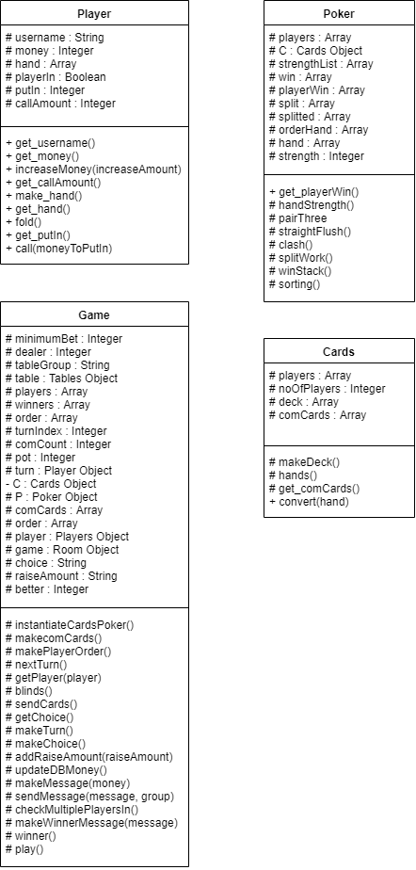

DB

