Improving Development for United States Donors for Hire Heroes USA

**Authors**

Abie Kanu

Virginia Commonwealth University

[kanuah@vcu.edu](mailto:kanuah@vcu.edu)

Informations Systems

Undergraduate

Mohammed Al-khori

Virginia Commonwealth University

[khoorimn@vcu.edu](mailto:khoorimn@vcu.edu)

Information Systems

Undergraduate

Meredith Lee

Virginia Commonwealth University

[leemt4@vcu.edu](mailto:leemt4@vcu.edu)

Information Systems

Undergraduate

Lucia Traweek

Virginia Commonwealth University

[traweekl@vcu.edu](mailto:traweekl@vcu.edu)

Accounting

Undergraduate

# **Faculty Advisor**

*Joseph Cipolla, Information Systems, jcipolla@vcu.edu*

**Summary**

This project aims to answer some questions related to the donors in the United States. Hire Heroes USA uses donations to help Veterans and Military spouses find work, therefore, it is important to observe some data about them. The data that was given was cleaned, then we used Excel and Tableau to find that donations were mostly given around major metropolitan spots. These tools were also used to find what the average lifespan of monthly donors are, the frequency of unsolicited donors on a monthly basis, and the average gift amount from these donors specifically. The conclusion of our project is that Hire Heroes USA needs to invest in high-quality data mining resources so that this nonprofit firm can maximize the number of donations received so as to increase the potential they have to help people.

**1)** **Problem and Motivation**

For Hire Heroes USA, we are focusing on the business development portion of this challenge by using analytics to learn from the donor data provided. In general, we seek to find information on the geographic location of individual donors, the average donation lifespan of monthly donors, and the frequency of unsolicited donors. The significance of this data is that our outcomes could be beneficial to Hire Heroes USA, in that our analytics could potentially provide beneficial insights that could lead to profitable returns. Locating the areas of the U.S. where most individual donors reside could help concentrate Hire Heroes USA’s marketing to save the company time, resources, and help them reach their most valuable demographic. Learning the average time frame a donor will donate throughout his or her life is a telling component in regards to whether the donations have increased over the years or if there are gaps (e.g. in years) in payments. Lastly, learning the frequency in which donations from unsolicited donors are received from month-to-month, as well as their amount and consistency from donors, can guide Hire Heroes USA in their efforts to understand their donors, improve upon their marketing plans, and bring about more donations in the future.**2)** **Approach** The first task was to brainstorm ideas to answer the question. We decided to use the tools we used from our Data Mining class, such as Excel, Tableau, and TableuPrep because we were familiar with their interface and methods. We also decided that the best way to tackle this problem was to scan through the fields given to us and look at the context of each field. If the field pertained to a question we kept it, otherwise throwing it out.  
 The second thing we did was clean the data given to us by the competition. Perhaps the most important step in the process, cleaning the data entailed going through the data and deleting any discrepancies that might affect our results. The first thing we did was open up SalesForce_Contact in Excel. Any entries in the SalesForce_Contact database that were not donors were removed since this did not affect our research. We also deleted unnecessary columns that we would not use in our analysis. We then combined the SalesForce_Contact database with the SalesForce_Opportunity and SaleForce_Account database based on AccountId in Tableau, then downloaded it as an Excel file. Finally, we combed through the geographic locations (State and ZipCode) and deleted any rows with blanks in them. A couple of items were fixed and then moved into Tableau.  
 To address the first question, we used Tableau to create a heat map to show where donors are located. The filters used were only for the United States and Individual donors. We summed up the number of donors in each and sized each dot accordingly. This is found in Figure 1 in our results section. We also summed the number of individual donors for each state which can be found in Figure 2 in our results section below.  
 To address the second question, we used Excel to sort the monthly donors from annual donors using the Type column either one time or recurring. Next, we deleted columns with no data for the type of donation and also removed individual donors, give-away, grants, sponsorships and services rendered as we were only interested in looking at recorded monthly vs yearly donors. Next, we made a PivotTable to see the recency of what years recurring donors who made a more than once monthly payment. Along the rows of the table, we had the years included in the last activity date columns and the rows were the type of donors (recurring). The values within the table consisted of the average of donations based on the type of donor and year.  
 To address the frequency of unsolicited donors question, we first had to use the Hire Heroes Data Dictionary to find the specific “API names” that would be useful to us. Unsolicited (individual) donations are specifically collected by a tool called “Classy”, therefore, this led us to the columns we needed in order to collect the data. Using “Donation_type_c” and “stayclassy__Raw_Donation_Gross_Amount__c”, and “Type”, we created a PivotTable in Excel to see which donors were sending their payments to Classy and how often. Next, we looked at: “Stayclassy__Sc_Total_Donations__C”, which is the column that allows us to see the frequency in which Classy donations were received. We used this column for another PivotTable and we then sorted the chart using “Recurring_Donation_Frequency__c” so that we could see this data within the context of month-to-month. To calculate the average gift amount from unsolicited donors, we filtered the data to find the individual donors from API name: “Donor_ type”. Next, we sorted the data based on “Account_ID”. After that, we removed the duplicates so that we could calculate the average gift of individual donors.   
**3)** **Datasets  
4)** **Tools and Analytics**We used Microsoft Excel to clean and sort through data. After combining tables to better suit our focus on development for Hire Heroes, we created PivotTables to see selected data more clearly. Sorting our PivotTables helped us narrow our data scope even more so, as well as color coding for easier visualization. Additionally, Tableau was used to sort through data, display heatmaps, and analyze the data. Tableau allowed us to visually display our geographic findings while still maintaining a quantitative approach, by using the appropriate filters to extract the specific donors we needed to analyze, as well as their donation totals.   
**5)** **Results**

We noticed a lot of donations concentrated around cities, especially from the East Coast. There were also a sizeable amount of donations coming from the Northern West Coast, and from Texas. The highest amount of donors from a State is Georgia, which has 1,777 individual donors. However, most individual donors by zip code are from Hartland, Wisconsin with 397 donors. We do not see a lot of donors from states from the midwest such as Wyoming, North Dakota and South Dakota. This could be due to concentrations of people, which there are more of in cities and more populous states. However, there is no individual state where someone has not given.

To calculate the average lifespan or donor lifetime average we took the number of months each specific recurring donor donated from our PivotTable and then summed up all the months for each recurring donor. We then took that value and divided it by the total number of recurring donors and multiplied it by 12. We got an average lifespan value of recurring donors who donate monthly to be 2.4 months. Referencing the RFM model (recency, frequency, monetary) we first looked at the recency of our data to see within the recurring donors how recent they made their last donation. A general study done by Qgiv, a software company, found that monthly donors give 42% more in one year than one-time donors. It is also known that a donor who has recently donated is more likely to donate again. From the data the most recent year recurring monthly donors gave a donation was 2019 with an average donation amount of $20.66. For frequency, we see that the recurring donors that made monthly payments seem to give few times a month within a year and then for the next year increase the number of times they give and then lapse back into giving a few times for the next year. They also give less amount of money from month to month compared to one-time donors who give a large amount that one time. In 2017 the average donation amount was $10.63 and then in 2018, it jumped to $101.83 and then fell back down to $20.66 in 2019. For one-time donors, the average donation amounts increased mostly from 2017 to 2019 with the biggest average donation amount in the most recent year of 2019 at $112. We recommend Hire Heros to use this recency and frequency data to try new marketing tactics when recurring monthly donors are donating smaller amounts in certain months. This could be things like targeted emails, blogs or events that the donors can participate in. A study done on non-profit organizations show that only 14% of organizations prompt donors to upgrade to a monthly gift. Hire Heroes can also convert one-time donors to recurring monthly donors by targeting the one-time donors with thank you letters/emails, incentivized gifts like tote bags, hats, and mugs and prompting them to upgrade to a monthly donor sooner.

The frequency of unsolicited donors results came as a surprise in a couple of aspects. Firstly, our PivotTable in Excel we created to see the frequency in donations resulted in more monthly individual and corporate donors than quarterly or annually. There were 1,102 total monthly donations from the two groups in total, as opposed to 59 combined annual and quarterly donations. Hire Heroes can take advantage of this fact in the future and place even more of an emphasis on the importance of monthly giving, through tailored advertisements and emails, etc. Only about half (625) of these individual and corporate donors are recurring, meaning the rest of these donors are only donating once. Perhaps, if Hire Heroes incorporated some sort of reward system to encourage unsolicited donors to donate more frequently with low-cost rewards, like stickers or water bottles, they could cultivate a stronger connection with their donors. Lastly, the average gift amount from the unsolicited donors came out to be $188--this average accounts for one-time and recurring donors.

*Figure 1. Heatmap of the United States where Individual Donors are Counted by Zip Code*

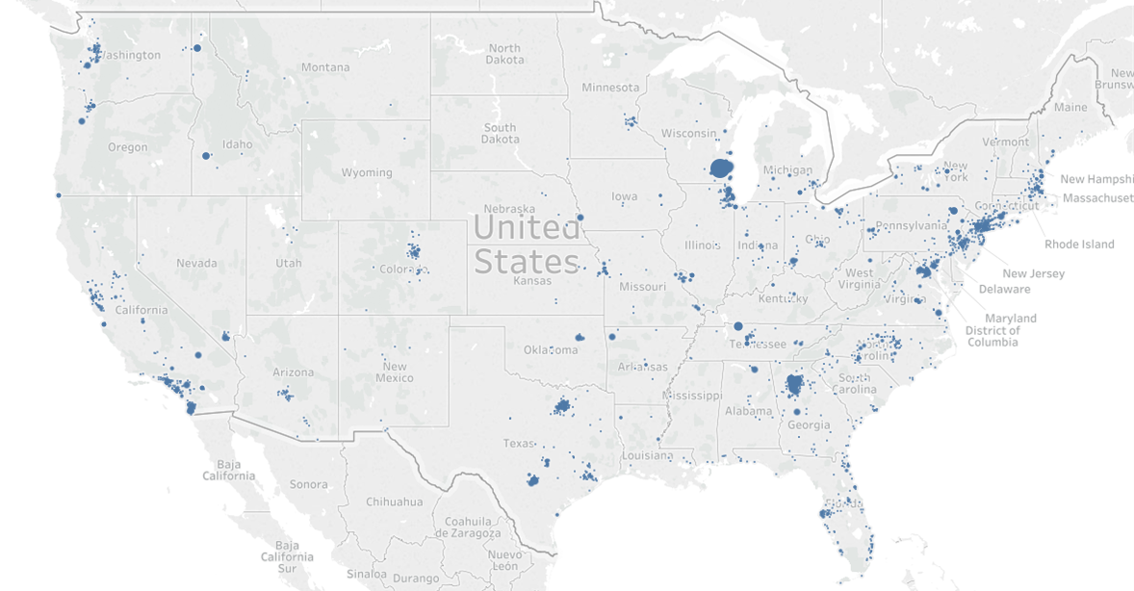

*Figure 2. Heatmap by State of the Count of Individual Donors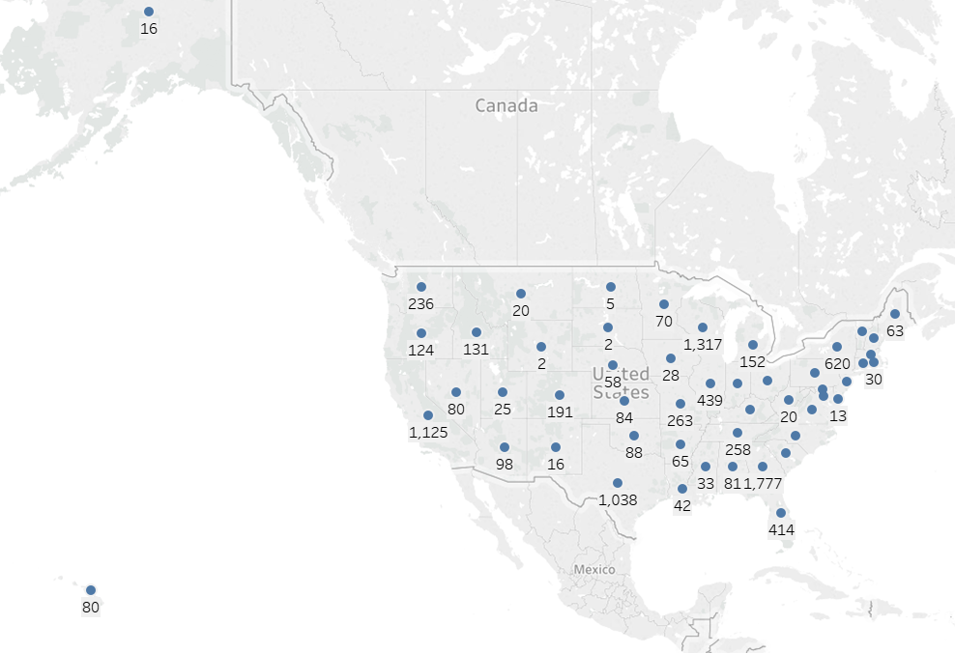***6)**  **Presentation:** [**https://docs.google.com/presentation/d/1FogsJ7TM5Wd6qH3Zavp8AGFVdR0Pu7nSb68SwqkRVJQ/edit#slide=id.g58f8f77ac4_0_81**](https://docs.google.com/presentation/d/1FogsJ7TM5Wd6qH3Zavp8AGFVdR0Pu7nSb68SwqkRVJQ/edit#slide=id.g58f8f77ac4_0_81)  
**7)**  **References:**

Jarvis, Abby. “Fundraising Statistics: Incredible Insights to Raise More.” *Qgiv Blog*, Qgiv, 18 May 2017, www.qgiv.com/blog/fundraising-statistics/#sources.