FTC Programming Software Installation

Before coming to the Programming class, you need to install the required software on your laptop. Please do this at home before coming to class. We do not want to dedicate class time to install software because they are time consuming and require downloading gigabytes of data from the Internet which would overwhelm our Internet bandwidth if all students are downloading at the same time. Therefore, please make sure you finish these tasks at home before coming to class.

The target audience of this Programming class is for students who already have basic knowledge of the Java language. Since the class is focused on teaching our TRC Library which is shared between FTC and FRC, you should be able to write code for both FTC and FRC robots with some minor differences.

In this document, we will talk about installing Source Control Software as well as FTC Software Components.

# Source Control Software

We use GitHub Desktop as our source control software that stores our source code on the Internet at GitHub.com (GitHub repositories). Follow these instructions to set up and install software to access our GitHub repositories.

* Create a GitHub account if you do not already have one ([GitHub.com).](https://github.com/)
* Download and install the GitHub Desktop software from [here.](https://desktop.github.com/)
* Start GitHub Desktop, click File->Clone repository...
* Select the URL tab and enter the repository URL:  
  https://github.com/trc492/FtcTemplate.git
* Enter the local path to clone the repository into. Please note that Windows may suggest cloning into your OneDrive folder. Unless you pay for huge storage on OneDrive, we recommend you change it to your local hard drive (e.g. C:\Users\<You>\Document\GitHub).  
  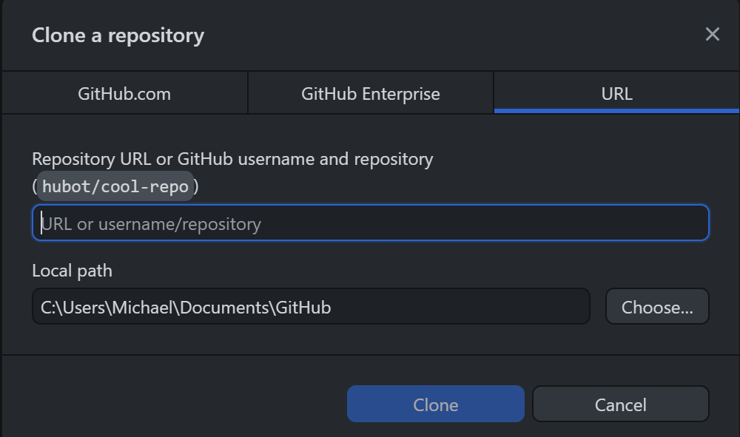
* Click the Clone button.
* Congratulations! You have now successfully cloned the FtcTemplate repository.

# FTC Software Components

To develop code for an FTC robot, you need to install the following software components:

1. **Android Studio**: Integrated Development Environment (IDE)
2. **Git Command Line Tools**: Git command line tools (plug-in for Android Studio)

# Android Studio

To download and install Android Studio, go to this [website](https://developer.android.com/studio). Click the download Android Studio button and agree to their terms and conditions. Once the installer is downloaded, open it to start the installation. Generally, you can take all the default options it suggested unless you know what you are doing and want to customize the installation. Click “Finish” to start Android Studio. In the “Welcome to Android Studio” window, click the “Open” button and select the Ftc2024CenterStage folder where you cloned the GitHub repository.

# Git Command Line Tools

Git command line tools allow you to perform Git operations within Android Studio Code. You can download and install them from [here](https://git-scm.com/downloads). During the installation, it will ask you to select a lot of choices, just take all the defaults unless you know what you are doing.