1. Tao table tren DynamoDB cua AWS:

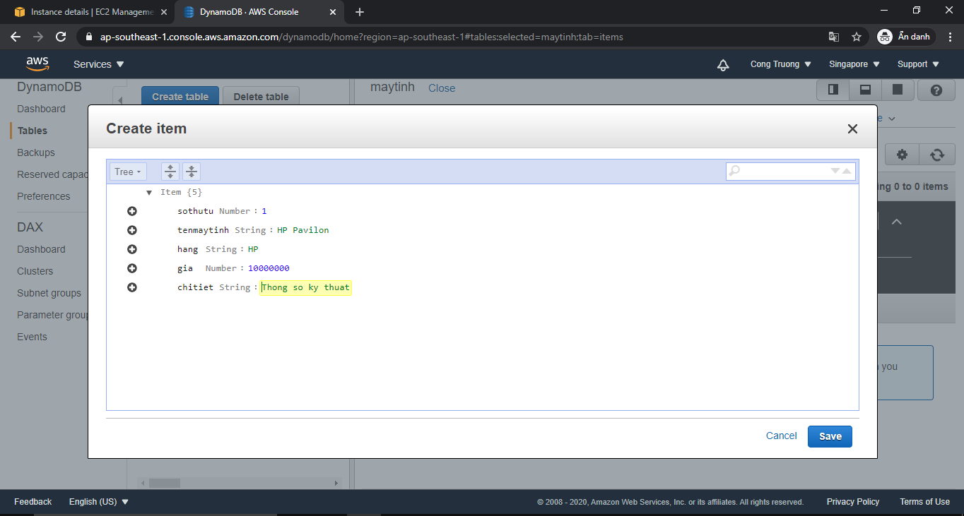

Table “maytinh” sau khi tao thanh cong.

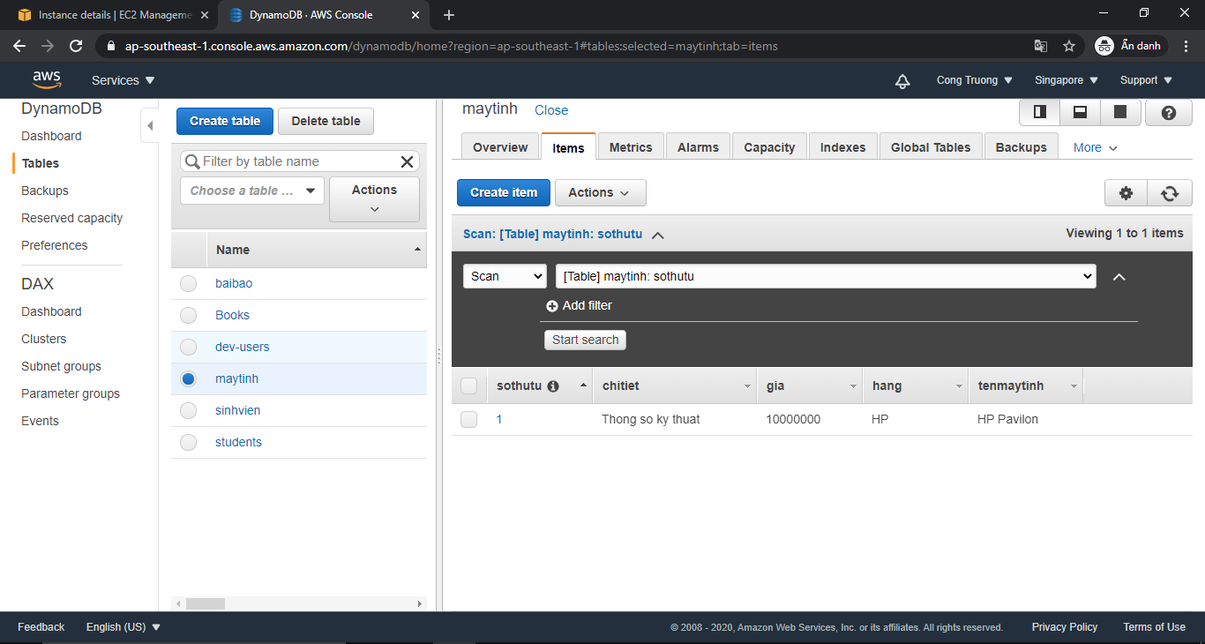

1. Danh sach may tinh (Hien thi tren local):

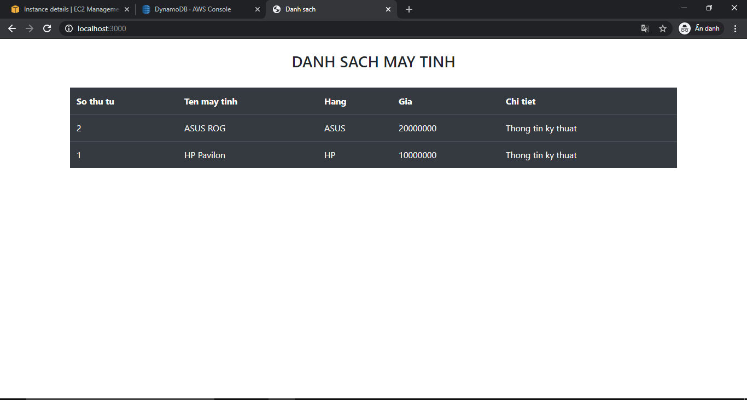

1. Ket noi voi EC2 cuar AWS:

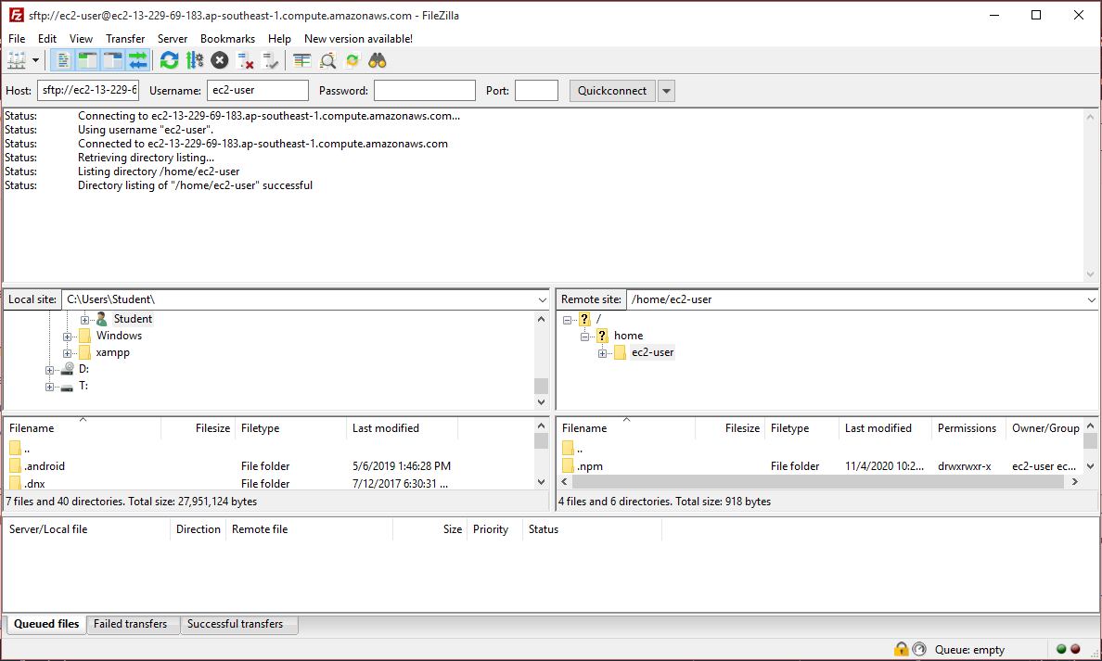

Ket noi thanh cong, deploy project len EC2 thanh cong.

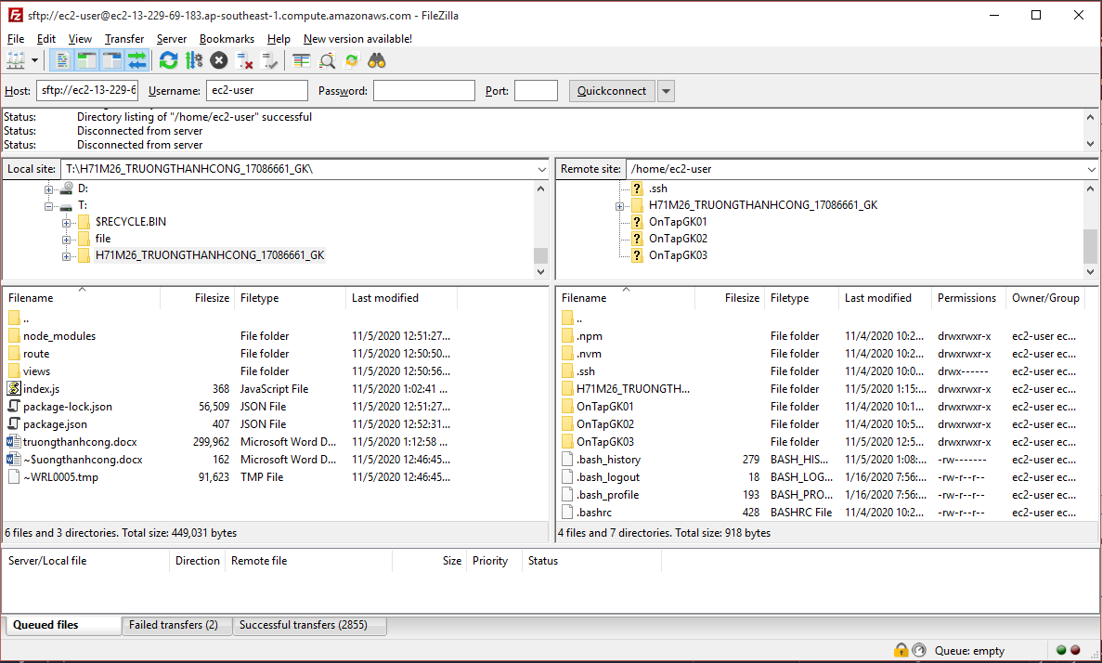

1. Danh sach may tinh (hien thi tren AWS)

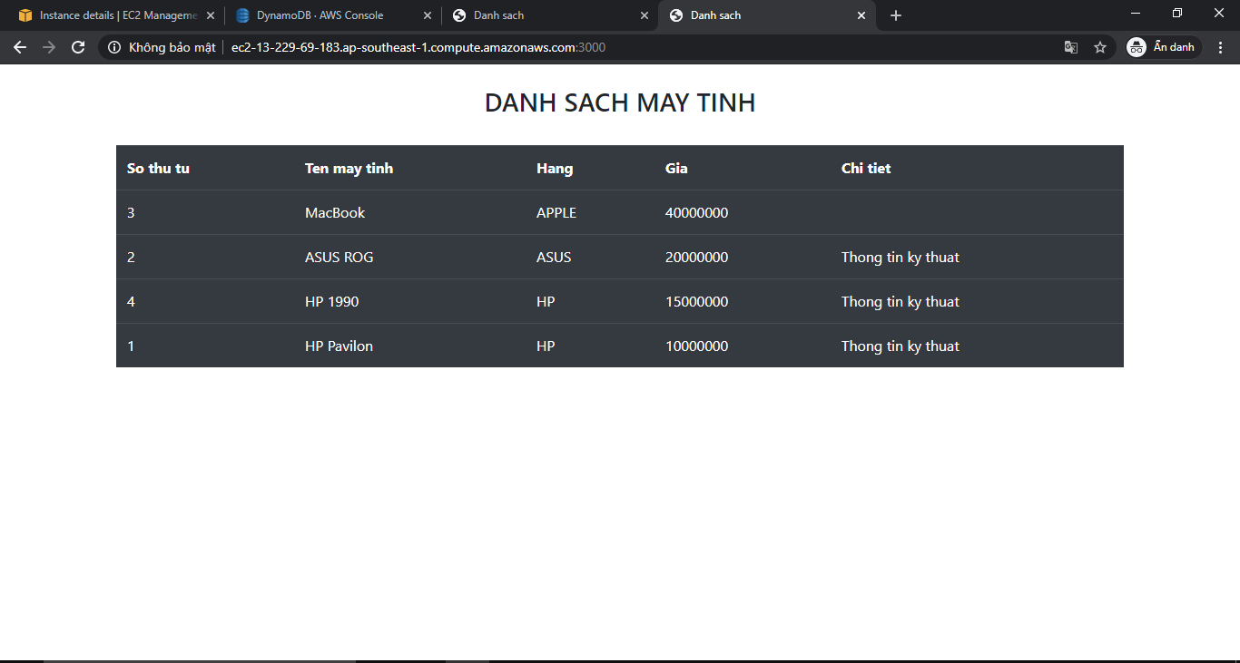

1. Cac buoc chay project tren EC2:

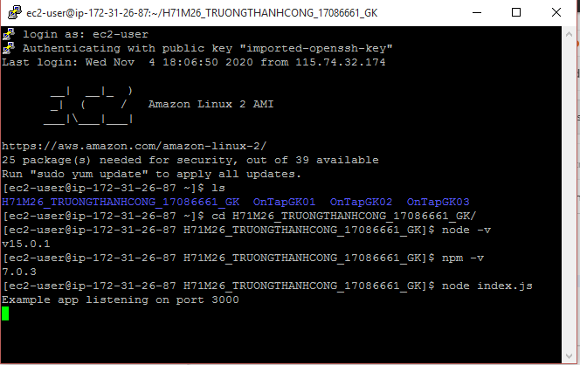

1. Them may tinh moi bang Postman:

