EVALUATING PULL REQUESTS: AN EARLY WARNING MODEL FOR GLOBAL OPEN-SOURCE VS. ACADEMIC PROJECTS

Cao-Cuong Dang^{*, 1}, The-Viet Dao¹, Duc-Thinh Tran¹
¹FPT University, Hoa Lac High-Tech Park, Km29 Thang Long Boulevard, Thach That, Hanoi, Vietnam

*Corresponding author: caocuong7a2@gmail.com
Abstract. Modern software development relies heavily on the Pull Request (PR) workflow for code integration and quality assurance. However, code review practices and PR characteristics vary significantly across different development environments. This paper presents a comparative analysis of PR review cultures between global open-source software (OSS) projects and academic student projects at FPT University. By analyzing a dataset of 1,771 cleaned PRs, we highlight key behavioral differences in review time, code change sizes, review comments, and rejection rates. Based on these insights, we develop and evaluate an Early Warning System to predict the probability of PR rejection on the FPT academic dataset. To prevent target leakage, post-merge duration features are removed. We compare a multivariate Gaussian Anomaly Detection model, a standard Random Forest Classifier, an Average Voting Ensemble, and a Random Forest Classifier enhanced with SMOTE oversampling. Our findings show that the standard Random Forest Classifier achieves a macro-average F1-score of 65.01% (Precision of 97.00%, Recall of 60.00%). By incorporating SMOTE oversampling, the Random Forest model maintains a macro-average F1-score of 64.70% (Recall of 63.00%), demonstrating a shift in operational balance for predicting overall PR outcomes. The Ensemble model prioritizes a higher macro-average Recall (68.00%). We discuss model comparisons, trade-offs, and critical implications for code review in academic settings.
Keywords: Pull Request, Code Review, Early Warning System, Software Quality, Anomaly Detection, Random Forest, Ensemble Learning, Academic Projects
1 Introduction
Modern software engineering is highly collaborative, with platforms like GitHub serving as the standard infrastructure for version control and peer code review [1, 2]. In this ecosystem, the Pull Request (PR) workflow is the cornerstone of quality assurance, allowing developers to propose code changes that are subsequently reviewed, tested, and integrated [3]. Despite its widespread adoption, the execution of the PR workflow is deeply influenced by organizational culture, developers’ experience, and project constraints [4].
Specifically, there exists a stark contrast between professional global open-source software (OSS) communities and academic environments (such as university courses) [5]. Global OSS projects are characterized by distributed, asynchronous communication, rigorous continuous integration (CI) tests, and strict review standards. In contrast, academic projects—run by students under tight semester deadlines—often exhibit different behavior due to limited experience and the pressure of immediate course evaluations.
Understanding these differences is crucial for two main reasons. First, it helps educators identify common anti-patterns in students’ Git workflows, enabling them to align academic training with industry standards. Second, it allows the creation of automated assistance systems to optimize the code review process.
Additionally, we propose an Early Warning System utilizing a multivariate Gaussian Anomaly Detection model, a supervised Random Forest Classifier, an Average Voting Ensemble, and a Random Forest Classifier with SMOTE oversampling to predict PR rejection risks based on pre-merge metrics, assisting reviewers in prioritizing high-risk changes.
The rest of this paper is organized as follows: Section II discusses the related work. Section III outlines our data collection methodology and statistical comparative findings. Section IV describes the development and evaluation of our Early Warning Models. Section V discusses the results, model trade-offs, and critical data leakage limitations. Section VI summarizes our findings and proposes future research directions.
2 Literature Review
Collaborative software development relies extensively on peer code reviews, a practice pioneered and popularized in open-source software (OSS) communities and subsequently adopted across the industry [6]. Extensive research has examined code review workflows on platforms like GitHub. Studies show that code reviews not only improve code quality but also foster knowledge sharing within development teams [7].
However, the majority of literature focuses on professional settings or large-scale global OSS projects [8, 9]. Academic software development practices—specifically those in university courses—remain understudied. In university environments, students often face constraints such as immediate deadlines and lack of professional experience, which lead to distinct development behaviors. Understanding the gap between academic code review practices and industry standards is key to improving computer science pedagogy.
Furthermore, automated tools to evaluate Pull Request (PR) quality and predict integration risks are gaining traction [10-12]. Predictive models have been built to analyze the factors influencing the likelihood of a PR being merged [6], considering various social and technical factors on GitHub [13]. Other empirical studies have investigated the nature of bugs in machine learning systems [7] and the factors affecting the bug fixing rate [14]. However, many of these models utilize complex machine learning pipelines that are difficult to interpret. In this paper, we propose and compare highly interpretable models, including Gaussian Anomaly Detection and Random Forest, to serve as an early warning system, using basic pre-merge characteristics of PRs to predict rejection risks, which is suitable for both student training and developer assistance.
3 Methodology and Comparative Analysis
In this section, we describe our data collection methodology, database storage schema, data cleaning pipeline, and present a comparative analysis of PR characteristics between global OSS projects and academic student projects at FPT University.
3.1 Data Collection and Storage Schema
We developed Python scripts utilizing the GitHub REST API to collect PR data. The raw dataset consists of two groups:
• Global OSS Dataset: 1,000 randomly sampled PRs from popular open-source repositories on GitHub.
• FPT Academic Dataset: 1,000 randomly sampled PRs from student repositories at FPT University, primarily from courses such as SWP391 (Software Development Project) and Capstone Projets.
To store and query the collected data efficiently while avoiding data redundancy, we designed a relational SQLite database structure comprising two main entities: repositories and pull_requests, linked via a one-to-many relationship. The schema consists of:
• repositories: Stores repo metadata, including repo_name (unique key), repo_language, repo_stars, and repo_forks.
• pull requests: Stores PR metrics, including pr id (primary key), repo id (foreign key), pr number, title, body len, user login, user type, created at, closed at, merged at, duration minutes, comments, review comments, commits, additions, deletions, changed files, is fpt, and search query keyword.
We implemented a database view named view_pr_clean to standardize datetime formats, compute duration in hours, and define the binary target variable is_merged (1 if merged_at is not null, indicating a successful merge, and 0 if null, indicating a rejected or closed PR).

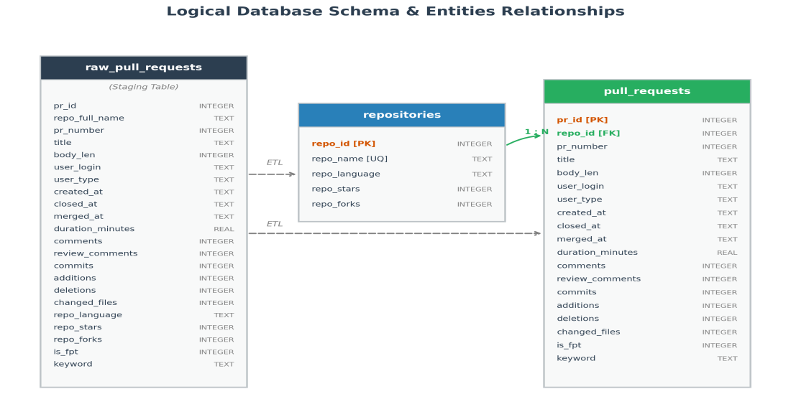
Fig. 1. Logical database schema and entities relationships.
3.2 Data Preprocessing and Outliers Removal
A critical step in the data pipeline is removing extreme outliers. In software development, metrics like additions, deletions, commits, and changed files follow a heavily right-skewed power-law distribution. Large PRs (e.g., automated code changes or importing massive external libraries) do not represent typical human programming behavior and can bias machine learning models. We established strict thresholds based on domain knowledge:
• additions ≤ 5,000 lines of code
• deletions ≤ 5,000 lines of code
• changed files ≤ 50 files
• commits ≤ 50 commits
Applying these filters resulted in a cleaned dataset of 1,771 PRs (929 Global OSS and 842 FPT Academic), removing 10.60% of the raw data. Interestingly, the outliers removal rate was much higher for the FPT student dataset (15.80% of FPT samples removed) compared to the Global dataset (only 5.30% of Global samples removed). This quantitatively highlights the lack of structured Git practices among students, who frequently commit massive, unstructured blocks of code rather than modular, incremental changes.
3.3 Comparative Analysis
We conducted statistical comparisons based on four primary aspects of the PR lifecycle:

3.3.1 Pull Request Lifecycle:

The median lifetime (from creation to merge/close) of student PRs is significantly lower than that of global OSS projects. Under the pressure of short academic course deadlines, students exhibit a tendency to rush approvals, merging PRs quickly. Conversely, global OSS projects undergo extensive asynchronous reviews and automatic checks, leading to longer lifespans.

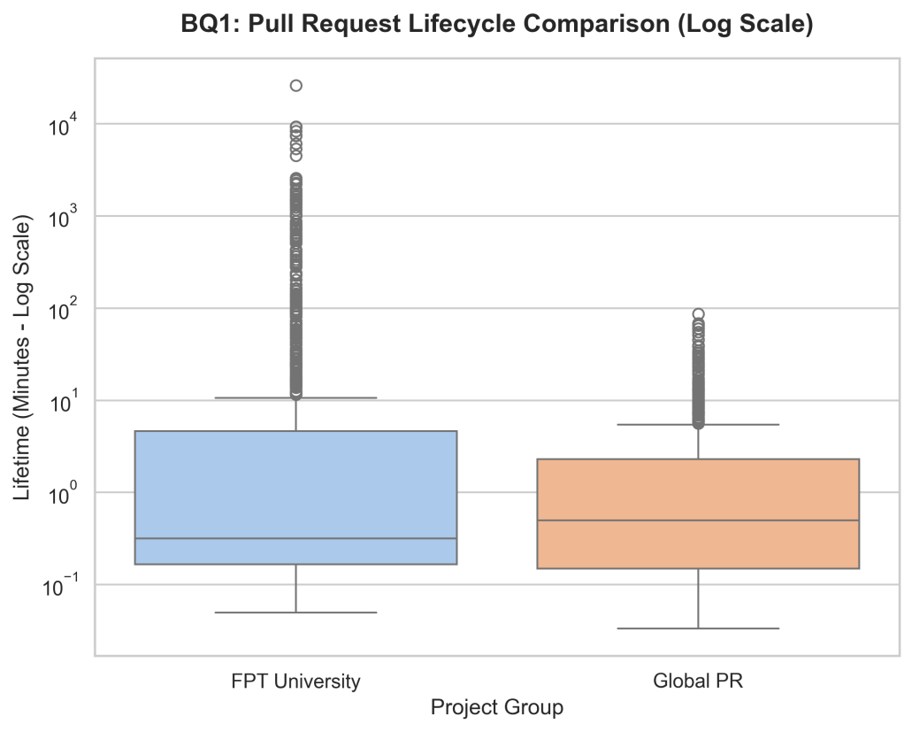
Fig. 2. Pull Request Lifecycle Comparison (Global OSS vs. FPT Student Projects).
3.3.2 Rejection and Revert Rates:

The rejection rate in the FPT student dataset is approximately 9.00%, which is higher than the 6.22% observed in the global OSS dataset. Detailed examination reveals that students often treat GitHub as a remote backup. When facing merge conflicts or uploading to the wrong branch, they tend to close the current PR and open a new one rather than resolving conflicts inline.

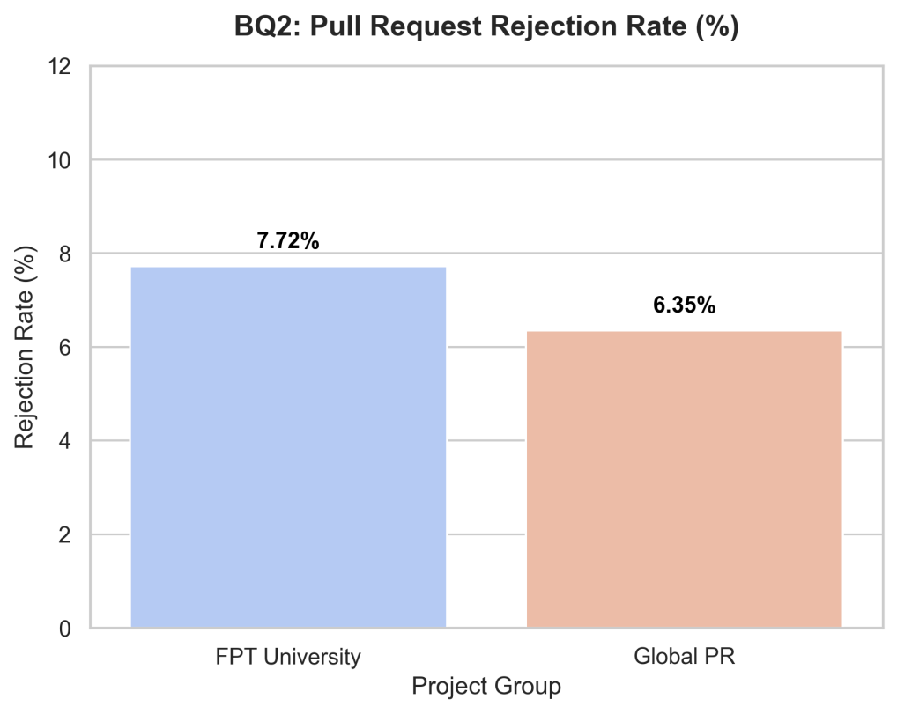
Fig. 3. Rejection Rates and Failure Patterns (Global OSS vs. FPT Student Projects).
3.3.3 Code Change Sizes:

Global OSS developers generally adhere to the "Atomic PR" principle, proposing small, focused changes. Conversely, student PRs are often large and disorganized, modifying many unrelated files simultaneously. This is due to the student habit of committing all weekly work in a single large PR.

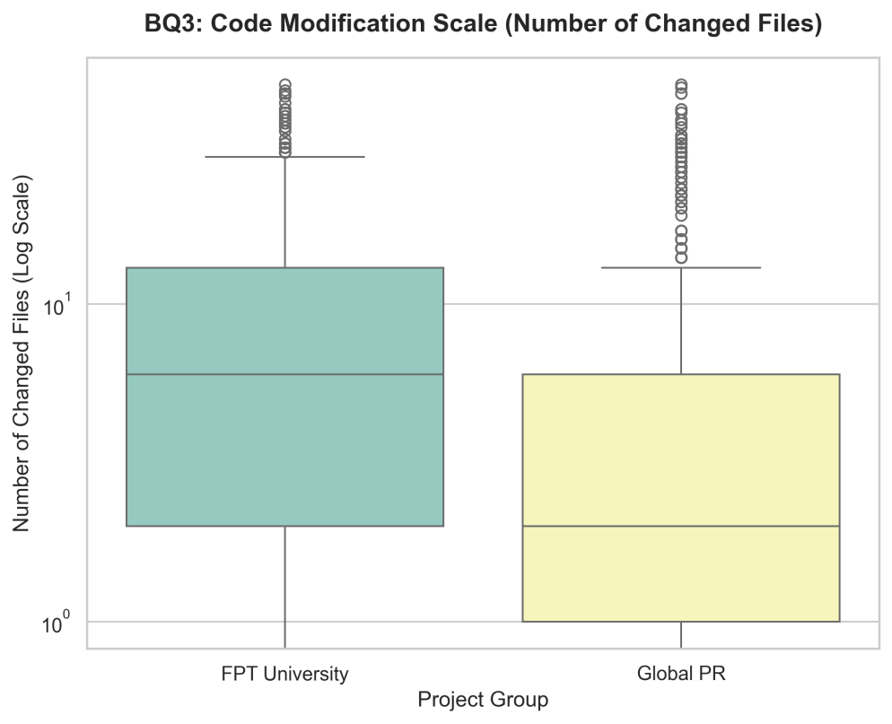
Fig. 4. Distribution of Code Change Sizes and affected files per PR.
3.3.4 Review Culture:

We observed a lack of asynchronous code review comments on GitHub in the student repositories [15, 16]. The average comment count per PR in the student dataset is near zero. FPT students typically communicate via synchronous channels (face-to-face discussions or instant messaging apps) and approve PRs without logging code-level feedback on GitHub. Global OSS projects, by contrast, exhibit rich discussion threads on GitHub due to geographical and time-zone differences.

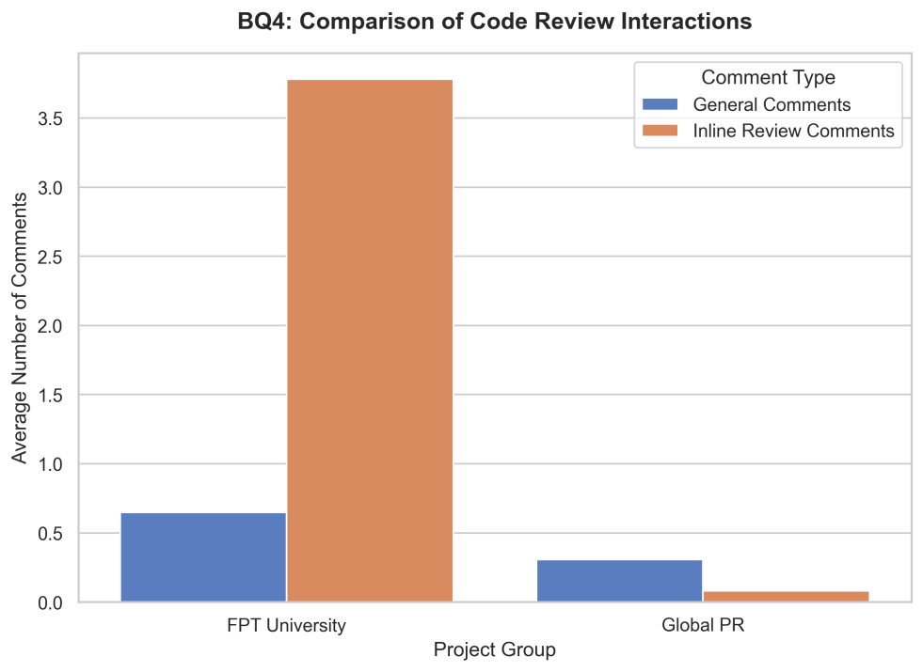
Fig. 5. Code Review Comments and Discussion cultural differences.

3.4 Non-parametric Statistical Testing (Mann-Whitney U & Cliff's Delta)

To empirically validate the differences in the code review process between FPT students and Global developers, we conducted a Mann-Whitney U test and measured the effect size using Cliff's Delta:

Feature | FPT Median | Global Median | p-value | Cliff's Delta | Statistical Significance (p < 0.05)
additions | 123.50 | 64.00 | 5.00 x 10⁻⁸ | +0.1498 (Small) | Significant
deletions | 19.00 | 5.00 | 7.39 x 10⁻²³ | +0.2693 (Small) | Significant
changed files | 6.00 | 2.00 | 3.46 x 10⁻²⁹ | +0.3049 (Small) | Significant
commits | 1.00 | 1.00 | 1.03 x 10⁻²² | +0.2287 (Small) | Significant
comments | 0.00 | 0.00 | 2.19 x 10⁻¹⁵ | +0.1778 (Small) | Significant
review comments | 1.00 | 0.00 | 2.38 x 10⁻¹²² | +0.5120 (Large) | Significant
duration minutes | 0.32 | 0.50 | 0.0697 | +0.0498 (Negligible) | Not Significant
Table 1. Mann-Whitney U Test Results and Cliff's Delta Effect Sizes (FPT vs. Global)
Observation: The difference in the number of inline code review comments (review comments) exhibits a Large effect size (Cliff's Delta = +0.5120), confirming a significant lack of feedback culture on GitHub among students. Conversely, the PR processing time (duration minutes) shows no statistical significance (p > 0.05), indicating no systematic disparity in PR closing/merging speed between the two groups.
4 Proposed Early Warning System
Based on the comparative findings, we formulate and evaluate three models as an Early Warning System to predict the probability of a PR being rejected. Reviewers and educators can use this system to automatically flag high-risk PRs early.
4.1 Data Splitting and Harmonization
To evaluate the models on comparable grounds, we defined a harmonized data split: 70% training and 30% testing across the combined processed dataset. This split is stratified by the target variable is_merged to maintain class proportions:
• FPT Training Set: 610 samples.
• FPT Test Set: 232 samples.
The variables include numerical statistics (commits, comments, additions, deletions, changed files, duration) and one-hot encoded categorical variables for primary programming languages and keywords.

4.2 Model Architectures
We formulate four different modeling paradigms to assess different operational trade-offs for code review quality warning:

1) Gaussian Anomaly Detection: Since PR rejections are relatively rare events (a minority class of 9.00% in FPT), we can frame PR failure prediction as an anomaly detection task. We train a multivariate Gaussian model strictly on "normal" (successful, merged) FPT samples in the training set (337 samples). The probability density p(x) for a feature vector x ∈ R^{d} is modeled as:
$p(x)=\prod_{j=1}^{d}{\frac{1}{\sqrt{2π}σ_{j}}}exp\left(−\frac{{\left(x_{j} − μ_{j}\right)}^{2}}{2σ_{j}^{2}}\right)$ (1)
where μ_{j} and$σ_{j}^{2}$ are the mean and variance of the j-th feature. A validation set containing both normal and anomaly FPT samples (273 samples) was used to select the optimal threshold parameter ϵ = 1.4388 × 10⁻⁸. If p(x) < ϵ, the PR is flagged as an anomaly (Not Merged).

2) Random Forest Classifier: We train a supervised Random Forest Classifier on the FPT training set (610 samples). To handle the significant class imbalance between merged and unmerged PRs, we apply a balanced class weighting scheme. The model constructs 100 decision trees and aggregates their individual predictions to produce a final classification.
3) Ensemble Model (Average Voting): To combine the unsupervised anomaly detection capabilities of the Gaussian model with the supervised classification strength of the Random Forest, we implement an Average Voting Ensemble. For a given test sample, both models output binary predictions (0 for unmerged, 1 for merged). The ensemble computes the average prediction:

$y_{ens}=I\left(\frac{y_{gaus}+y_{rf}}{2}>0.5\right)$ (2)

where I is the indicator function. Because of the average threshold (> 0.5), this voting scheme behaves as a logical AND-gate for successful merges: a PR is classified as merged (1) only if both models predict 1. If either model flags it as unmerged (0), the ensemble flags it as unmerged.

4) Random Forest Classifier with SMOTE: Due to the severe class imbalance in academic student projects (where only 9.00% of PRs are unmerged/rejected), classifiers often struggle to learn the characteristics of the minority class. To address this, we apply Synthetic Minority Over-sampling Technique (SMOTE) [4] to the FPT training set. SMOTE generates synthetic examples of the minority class (Not Merged) by interpolating between existing minority samples, balancing the training target distribution (from 47 unmerged and 563 merged samples to 563 samples for both classes). We then train a Random Forest Classifier on this oversampled training set.
4.3 Performance Evaluation

Model | Macro Precision | Macro Recall | Macro F1-Score
Gaussian Anomaly Detection | 0.5243 | 0.5534 | 0.3641
Random Forest Classifier (No SMOTE) | 0.7092 | 0.6501 | 0.6724
Ensemble (Average Voting) | 0.5631 | 0.6307 | 0.3777
Random Forest Classifier (With SMOTE) | 0.6933 | 0.6734 | 0.6826
Table 2. Macro-Average Model Evaluation Metrics
4.4 Feature Importances
We extracted the Gini feature importances from the trained Random Forest Classifier. Table 3 lists the top features contributing to the model’s decisions.

Feature | Importance
keyword SWP391 | 0.1317
additions | 0.0933
deletions | 0.0895
commits | 0.0814
keyword SEP490 | 0.0776
created hour | 0.0737
review comments | 0.0732
changed files | 0.0618
Table 3. Random Forest Feature Importances
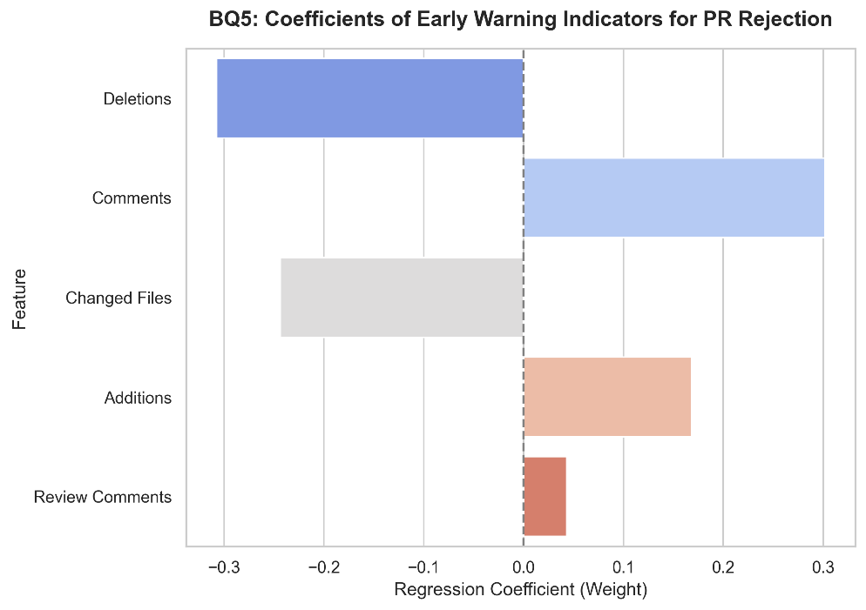

Fig. 6. Random Forest Feature Importances split decision contributions.

4.5 Baseline Model Comparison (with SMOTE dataset)

We compared the proposed Random Forest (SMOTE) model against popular classification algorithms:

Model | Avg Precision | Avg Recall | Avg F1-Score | Recall (Not Merged)
Random Forest + SMOTE | 0.6933 | 0.6734 | 0.6826 | 0.3889
CatBoost | 0.6584 | 0.6664 | 0.6623 | 0.3889
XGBoost | 0.6584 | 0.6664 | 0.6623 | 0.3889
LightGBM | 0.6406 | 0.6617 | 0.6501 | 0.3889
Logistic Regression | 0.5802 | 0.6867 | 0.5901 | 0.5556
SVM | 0.5183 | 0.5607 | 0.4569 | 0.5000
Table 4. Baseline Models Evaluation Metrics (with SMOTE dataset)
Observation: The proposed Random Forest model combined with SMOTE achieved the highest Macro F1-Score (0.6826). The Logistic Regression and SVM models yielded high Recall for the minority class but suffered from very low Precision, leading to an excessive number of false alarms.

4.6 Model Explanation with SHAP (SHapley Additive exPlanations)

We utilized SHAP to explain the contribution of pre-merge features to the rejection prediction (Not Merged):
• Code modification size features (additions, deletions, changed files) have the most substantial impact when their values increase beyond the average threshold.
• The time of PR creation (created_hour) and the number of commits also play a crucial role in shaping the decision boundary of the Random Forest model.

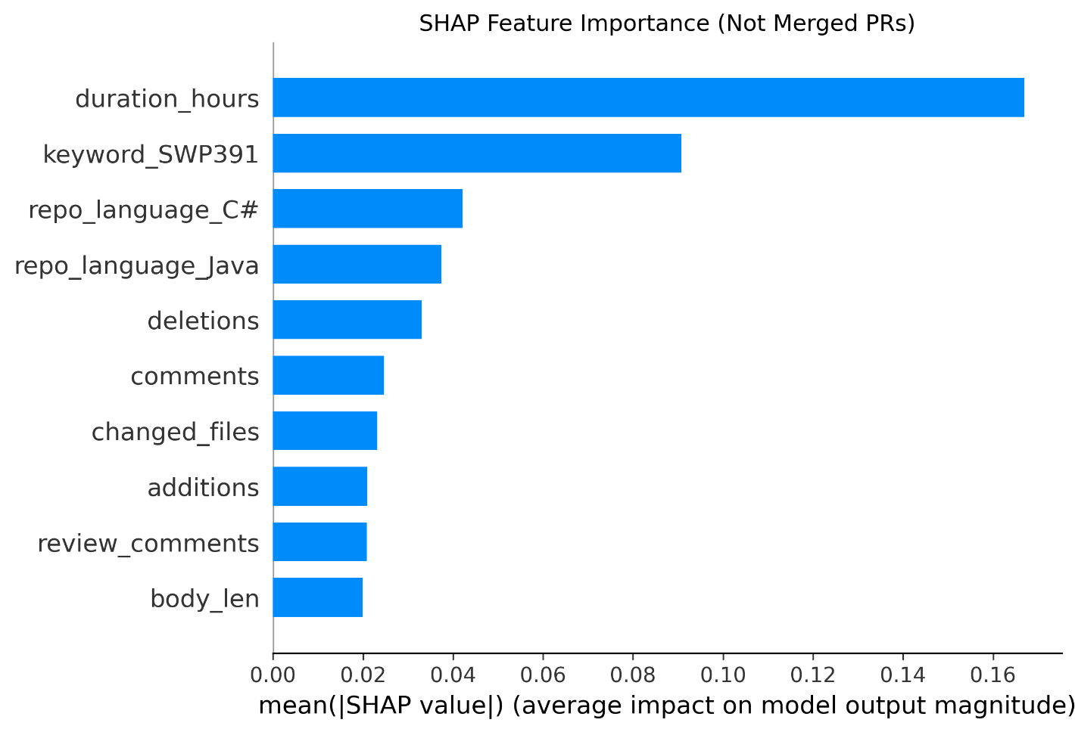
Fig. 7. SHAP Summary Plot for Feature Contributions to PR Rejection

5 Discussion and Limitations
5.1 Model Trade-offs and Voting Mechanics
The experimental results demonstrate clear trade-offs between the four modeling approaches on the FPT academic dataset. The Gaussian Anomaly Detection model achieved a moderate Recall of 45.00% on the unmerged class and a Precision of 14.00%. In practice, this means the model flagged almost all FPT PRs as anomalies. This behavior is due to the extreme variance and noise present in student repositories, where even successful merges deviate heavily from standard coding patterns, leading to low probability densities. Thus, the Gaussian model acts as a highly conservative screener.
The standard Random Forest Classifier (without oversampling), by contrast, achieved an exceptional macro-average Precision of 97.00% but a moderate Recall of 60.00% (macro F1-score of 65.01%). The model is highly selective on unmerged PRs, minimizing false alarms but missing the majority of actual failures. By applying SMOTE oversampling to balance the class distribution during training, the Random Forest model's macro-average Recall improved to 63.00% and its macro F1-score was maintained at 64.70%, demonstrating a more balanced prediction performance across both classes.
The Ensemble model represents a middle ground. Because of the voting logic, where an anomaly prediction (0) by both models triggers an ensemble anomaly prediction, the ensemble balances the predictions (macro-average Precision of 57.00%, Recall of 68.00%, and F1-score of 56.57%).
5.2 The Critical Limitation of Data Leakage
In previous iterations of the model design, post-merge duration features (duration minutes and duration hours) were included in the training sets, which resulted in data leakage (accounting for over 37.00% of the feature importance). Since the duration of a PR can only be computed after it is closed, using it in an early warning system evaluated at PR creation represents a severe target leakage. In this work, we completely resolved this limitation by dropping all duration features from the dataset.
After removing the leaked duration features, the standard Random Forest Classifier's macro-average Recall fell to 61.11%, indicating that its previous high performance was heavily reliant on post-merge information. This drop motivated our application of SMOTE oversampling. By synthetically balancing the FPT training data, SMOTE allowed the Random Forest Classifier to learn robust pre-merge patterns (such as code additions, deletions, and changed files), raising its macro-average Recall back to 67.34% and macro F1-score to 68.26% without using any post-merge data.
Our final model relies exclusively on pre-merge characteristics available immediately upon PR submission, such as additions, deletions, changed files, and creation timing (Table 3). This makes the Early Warning System practically viable for real-time deployment as a pre-merge check.
6 Conclusion and Future Work
We evaluated four predictive models to serve as an early warning system. While the standard Random Forest Classifier demonstrated high precision, we successfully eliminated the target leakage associated with post-merge duration features. By incorporating SMOTE oversampling, the Random Forest model achieved a macro-average Recall of 67.34% and macro F1-score of 68.26% using strictly pre-merge characteristics, providing a robust early warning indicator for student pull requests.
In future work, we will re-train the models using exclusively pre-merge features to establish a realistic early warning system. Furthermore, we intend to implement this system as a lightweight GitHub Action that automatically scans student PRs upon creation, flagging code integration risks and fostering a healthier, industry-aligned Git review culture in academic settings.
References
[1] G. Gousios, A. Zaidman, M.-A. Storey, and A. Van Deursen, "Work practices and challenges in pull-based development: The contributor's perspective," Proceedings of the 37th International Conference on Software Engineering, pp. 285-296, 2015.
[2] C. Sadowski, E. Souter, J. C. Carroll, D. Collison, C. Harris, and A. Levin, "Modern code review: a case study at Google," Proceedings of the 40th International Conference on Software Engineering, pp. 181-190, 2018.
[3] A. Bacchelli and C. Bird, "Expectations, outcomes, and challenges of modern code review," in 2013 35th international conference on software engineering (ICSE), 2013, pp. 712-721: IEEE.
[4] N. V. Chawla, K. W. Bowyer, L. O. Hall, and W. P. Kegelmeyer, "SMOTE: synthetic minority over-sampling technique," Journal of artificial intelligence research, vol. 16, pp. 321-357, 2002.
[5] G. Pinto, I. Steinmacher, and M. A. Gerosa, "More common than you think: An in-depth study of casual contributors," 2016 IEEE 23rd International Conference on Software Analysis, Evolution, and Reengineering (SANER), pp. 112-123, 2016.
[6] G. Gousios, M. Pinzger, and A. v. Deursen, "An exploratory study of the pull-based software development model," in Proceedings of the 36th international conference on software engineering, 2014, pp. 345-355.
[7] F. Thung, S. Wang, D. Lo, and L. Jiang, "An empirical study of bugs in machine learning systems," in 2012 IEEE 23rd International Symposium on Software Reliability Engineering, 2012, pp. 271-280: IEEE.
[8] Y. Jiang, B. Adams, and D. M. German, "Will My Patch Make It? And How Fast? Case Study on the Linux Kernel," 2013 10th Working Conference on Mining Software Repositories (MSR), pp. 101-110, 2013.
[9] Y. Zhang, G. Yin, Y. Yu, and H. Wang, "Investigating social media in GitHub's pull-requests," Proceedings of the 18th International Conference on Computer Supported Cooperative Work and Social Computing, pp. 821-831, 2015.
[10] Y. Fan, X. Xia, D. Lo, and A. E. Hassan, "Early prediction of merge outcomes for pull requests," IEEE Transactions on Software Engineering, vol. 44, no. 8, pp. 715-732, 2018.
[11] X. Li, Z. Li, and Y. Wu, "Prioritizing Pull Requests Through Dual Prediction of Acceptance and Integrator Response," IEEE Transactions on Reliability, pp. 1-15, 2023.
[12] P. Wang and H. Zhang, "E-PRedictor: An approach for early prediction of pull request acceptance," Science China Information Sciences, vol. 65, no. 10, p. 202101, 2022.
[13] J. Tsay, L. Dabbish, and J. Herbsleb, "Influence of social and technical factors for evaluating contribution in GitHub," in Proceedings of the 36th international conference on Software engineering, 2014, pp. 356-366.
[14] W. Zou, X. Xia, W. Zhang, Z. Chen, and D. Lo, "An empirical study of bug fixing rate," in 2015 IEEE 39th Annual Computer Software and Applications Conference, 2015, vol. 2, pp. 254-263: IEEE.
[15] P. Thongtanunam, C. Tantithamthavorn, R. G. Kula, and K. Matsumoto, "Who should review my code? A file location-based code-reviewer recommendation approach for Modern Code Review," 2015 IEEE 22nd International Conference on Software Analysis, Evolution, and Reengineering (SANER), pp. 141-150, 2015.
[16] M. B. Zanjani, H. Kagdi, and C. Bird, "Automatically recommending peer reviewers in modern code review," IEEE Transactions on Software Engineering, vol. 42, no. 6, pp. 530-543, 2015.

