Registration Number: 240212137

Module Details: INF6032 Big Data Analytics (SPRING 2024~25)

Number of Words: 3197

# Problems

## Question 1

The assumption states that the rows within the sentence column can be duplicated, meaning a sentence can be represented in multiple sources. This duplication happens because a sentence can be referenced multiple times in various documents. Therefore, it requires distinctive counting.

The implementation outline includes reading a large CSV file, registering it as a temporary table, and querying the number of unique sentences.

**Figure 1.1: Reading a CSV file**

**Figure 1.2: Registering a temporary table**

**Figure 1.3: Querying the number of unique sentences**

The result is 389639 unique sentences, which rejects the assumption.

**Figure 1.4: Question 1’s result**

The data is a CSV file containing a sentence and a source header. Therefore, the read.csv method of the SparkSession object is used to read the CSV file, passing the file path as a parameter. The ‘/File Store/tables/large.csv.gz’ is the path, where the ‘/File Store/tables’ is the directory, which is the Databricks file system root, and the ‘large.csv.gz’ is the file’s name. The header=True parameter indicates that the first row of the CSV file contains the column names, which are "sentence" and "source". By running this code, the CSV file will be read, and the data will be loaded into a DataFrame object called ‘large’.

The registerTempTable method is called on the large DataFrame object to register it as a temporary table, allowing it to perform SQL queries using SparkSQL. The registerTempTable method takes a table name as its argument, which is ‘large’. This table name is used to identify the DataFrame in SparkSQL. Once the DataFrame is registered as a temporary table, it can be referred to by its table name in SQL queries.

The sql method provided by the SparkSession object executes the SQL queries by taking a SQL query as a string parameter. The ‘select count(distinct sentence) large from large’ is the SQL query being executed. It selects the count of distinct sentences from a table named ‘large’ and aliases the result as ‘large’. The show method displays the result of the SQL query in tabular format.

## Question 2

The assumption states that the number of words in the 10 longest sentences is the same, which means the 10 longest sentences have the same length.

The implementation outline includes creating a new DataFrame called a large sentence, writing that DataFrame as a CSV file, reading that CSV File as a text file, splitting the words that are separated by a space, creating a list of tuples containing the number of words in a sentence and a sentence, sorting the list by the number of words in a sentence by in descending order, creating a new list of components containing only the number of words in a sentence in descending order, returning the list of components including the number of words in descending order of the 10 longest sentences.

**Figure 2.1: Creating a new DataFrame**

**Figure 2.2: Writing a DataFrame as a CSV file**

**Figure 2.3: Reading a CSV file as a text file**

**Figure 2.4: Operating an RDD**

The result includes the unique number of words in the 10 longest sentences, which rejects the assumption.

**Figure 2.5: Question 2’s result**

The sql method of the SparkSession object executes an SQL query that selects the sentence column from the large table. The result of this query is stored in a DataFrame object called large_sentence, which contains the data from the sentence column.

The large_sentence DataFrame is then written to a CSV file using the repartition method, which controls the number of output files generated. It takes a parameter of 1 to ensure that the data is written to a single output file. The write.csv method writes the DataFrame to a CSV file, taking the path where the file will be stored as a parameter. The ‘/FileStore/tables/large_sentence’ is the path, where the ‘/FileStore/tables’ is the directory, the Databricks file system root, and ‘large_sentence is the file’s name. The mode=overwrite parameter is used to overwrite an existing file.

The CSV file is read as a text file using the textFile method of the SparkContext object, which takes the path to the CSV file as a parameter. The ‘/FileStore/tables/large_sentence’ is the path, where the ‘/FileStore/tables’ is the directory, the Databricks file system root, and ‘large_sentence is the file’s name. Once the file is read, it will be represented as a distributed collection of sentences, where each sentence is a separate component.

Each sentence in the large_sentence file is split into individual words, then those words are returned to a list using the split method. The len function in a lambda expression calculates the number of particular words in a list. The map method maps the number of those individual words in a list and the sentence itself to a tuple. The sortBy method sorts the tuples based on the number of those individual words by taking x[0] as a parameter. In contrast, the ascending=False parameter indicates that the type of sorting is in descending order, which means that the largest number of those individual words will appear first.

The map method maps each tuple to its first element by taking the x[0] parameter, which is the number of those individual words. This transformation returns a list of components containing the number of individual words.

The take method is an action, an RDD’s operation that returns a list of 10 components containing the number of individual words in descending order by taking 10 as a parameter.

## Question 3

The assumption states that the number of bigrams per sentence equals the number of sentences, resulting in an average of 1.

The implementation outline includes splitting the words that are separated by a space, creating a list of components containing the number of words in a sentence that is minus 1, and creating a list of lists containing those number of words and 1, where 1 represents the sentence, summing all those number of words and all the values 1.

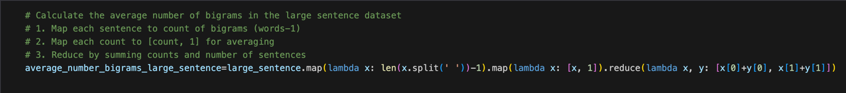

**Figure 3.1: Operating an RDD**

**Figure 3.2: Calculating the average number of bigrams per sentence**

The result is different than 1, which rejects the assumption.

**Figure 3.3: Question 3’s result**

The question is answered using the split method, which splits the sentence into a list of words, separated by spaces. The len function calculates the number of words in a list, and then the result is subtracted by one because the number of bigrams is one less than the number of words.

The map method then maps each calculated number of bigrams and the value 1 to a list.

The reduce method sums the number of bigrams and the value 1, where 1 represents the number of sentences. The result is a list containing the sum of all calculated bigram numbers and the sum of all values of 1, representing the total number of sentences.

The final list contains two elements: the total number of bigrams and the total number of sentences, where the total number of bigrams is the first element with an index of 0. In contrast, the total number of sentences is the second element with an index of 1. The average number of bigrams per sentence is calculated by dividing the first element by the second element of the list, which is the average_number_bigrams_large_sentence.

## Question 4

The assumption states that the 10 most frequent bigrams have the same frequency.

The implementation outline includes splitting the words that are separated by a space, creating a list of lists containing the words that have been divided, writing a function that loops through the lists within that list and creates bigrams by combining two consecutive words, mapping that function to the list of lists that returns a list of components containing the bigrams, creating a list of tuples containing the bigrams and the value 1 representing the number of times a bigram presents, summing all the values 1, which have the same bigrams, sorting the list by the sum of all the values 1, which represents the total number of times a bigram presenting in descending order, returning the most frequent bigrams as a list of tuples.

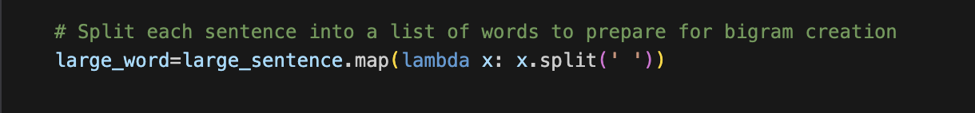

**Figure 4.1: Splitting the words that are separated by a space**

**Figure 4.2: Creating the bigrams**

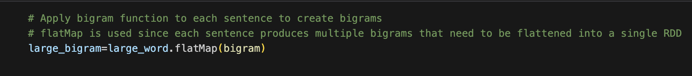

**Figure 4.3: Mapping the function**

**Figure 4.4: Operating an RDD**

The result returns the 10 most frequent bigrams with unique frequency, which rejects the assumption.

**Figure 4.5: Question 4’s result**

The split method splits each sentence into a list of words, separated by spaces, while the map method returns a list of lists.

The bigram function takes a list of lists as input and returns a list of consecutive pairs of words. It creates an empty list called my_list to store the two consecutive words. An if statement checks whether the input, which is a list of lists containing two consecutive words in a sentence, has the number of words at least two words. A for loop iterates over the list indices, from the first to the second-to-last index. The i variable represents the current index, while the j variable represents the following index, which is obtained by adding 1 to the current index i. Hence, the function only iterates to the second-to-last index. Otherwise, the value of index j will exceed the index range. Then, it appends the two consecutive words at index i and j in the list to my_list, separated by a space. Finally, it returns that list.

The list of lists containing two consecutive words is transformed using the flatMap method into a list of components, each containing two consecutive words.

The reason why the map method is used in the first place is to return a list of lists containing separated words in a sentence so that the flatMap method can apply the bigram function to the lists within the list, and then the for loop can iterate over the words within those lists. On the other hand, the flatMap method used initially will return a list of separated words in a sentence. Then, the flatMap method applies the bigram function to the words in the list. Finally, the for loop will iterate over the characters within those words.

The map method within the lambda function maps each pair of consecutive words to the value 1, representing the number of times a bigram appears in a tuple.

The map method within the lambda function maps each pair of consecutive words to the value 1, representing the number of times a bigram appears in a tuple.

The reduceByKey is a transformation, an RDD operation that sums all the values 1 that have the same bigrams, resulting in a list of tuples containing the bigrams and the total number of times each bigram appears.

The sortBy method sorts the list based on the total number of times a bigram is presented in descending order by specifying the ascending=False parameter.

The take method returns a list of tuples containing the 10 most frequent bigrams, taking 10 as the parameter.

## Question 5

The assumption states that no bigrams from the Wikipedia subset appear in the list of idioms contained in the MAGPIE subset.

The implementation outline includes reading the MAGPIE file, which formats as a JSON, registering that file as a temporary table, splitting the words that are separated by a space, creating a list of lists containing the words that have been divided, writing a function that loops through the lists within that list and creates bigrams by combining two consecutive words, mapping that function to the list of lists that returns a list of components containing the bigrams, creating a list of lists containing the bigrams, creating a DataFrame with one column named bigrams that includes the values are the bigrams within those lists, registering that DataFrame as a temporary table, querying the bigrams that have been extracted from the Wikipedia subset appear in the list of idioms contained in the MAGPIE subset.

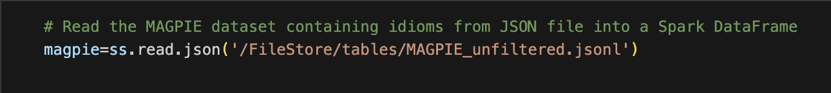

**Figure 5.1: Reading a JSON file**

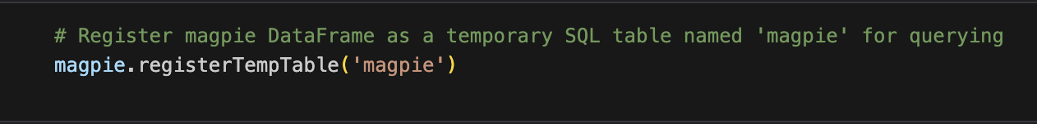

**Figure 5.2: Registering a temporary table**



**Figure 5.3: Splitting the words that are separated by a space**

**Figure 5.4: Creating the bigrams**



**Figure 5.5: Mapping the function**

**Figure 5.6: Operating an RDD**

**Figure 5.7: Querying the bigrams**

The result returns 67 bigrams extracted from the Wikipedia subset and appears in the list of idioms contained in the MAGPIE subset, which rejects the assumption.

**Figure 5.8: Question 5’s result**

The read.json method reads a JSON file and returns it as a DataFrame object.

This DataFrame object is then registered as a temporary table, allowing SQL to query the data.

The split method splits each sentence into a list of words, separated by spaces, while the map method returns a list of lists.

The bigram function takes a list of lists as input and returns a list of consecutive pairs of words. It creates an empty list called my_list to store the two consecutive words. An if statement checks whether the input, which is a list of lists containing two consecutive words in a sentence, has the number of words at least two words. A for loop iterates over the list indices, from the first to the second-to-last index. The i variable represents the current index, while the j variable represents the following index, which is obtained by adding 1 to the current index i. Hence, the function only iterates to the second-to-last index. Otherwise, the value of index j will exceed the index range. Then, it appends the two consecutive words at index i and j in the list to my_list, separated by a space. Finally, it returns that list.

The list of lists containing two consecutive words is transformed using the flatMap method into a list of components, each containing two consecutive words.

The reason why the map method is used in the first place is to return a list of lists containing separated words in a sentence so that the flatMap method can apply the bigram function to the lists within the list, and then the for loop can iterate over the words within those lists. On the other hand, the flatMap method used initially will return a list of separated words in a sentence. Then, the flatMap method applies the bigram function to the words in the list. Finally, the for loop will iterate over the characters within those words.

The map method within the lambda function maps each pair of consecutive words to the value 1, representing the number of times a bigram appears in a tuple.

The map method maps each bigram to a list, creating a list of lists that contain the bigrams. The toDF method creates a DataFrame containing one column named bigrams that contains the bigrams within those lists. That DataFrame is then registered as a temporary table named large_bigrams.

The sql method of the SparkSession object takes a string as an argument, which represents the SQL query to be executed. The ‘select count(distinct bigrams) large from large_bigrams where bigrams in (select idiom from magpie)’ is the SQL query being executed, which counts the unique bigrams within the temporary table and filters the bigrams from the Wikipedia subset that appear in the list of idioms contained in the MAGPIE subset.

The show method returns the result of the SQL query.

## Question 6

The assumption is that the bigrams appear on Wikipedia and MAGPIE. Moreover, the 10 bigrams, from rank 2500 to rank 2510, have the same frequency.

The implementation outline includes splitting the words that are separated by a space, creating a list of lists containing the words that have been divided, writing a function that loops through the lists within that list and creates bigrams by combining two consecutive words, mapping that function to the list of lists that returns a list of components containing the bigrams, creating a list of tuples containing the bigrams and the value 1 representing the number of times a bigram presents, summing all the values 1, which have the same bigrams, creating a DataFrame with two columns named bigram and frequency that contains the values are the bigrams within those tuples and the frequency of that bigram, registering that DataFrame as a temporary table, querying the 10 bigrams that appear in Wikipedia and not in MAGPIE starting from rank 2500 to rank 2510 in descending frequency order.



**Figure 6.1: Splitting the words that are separated by a space**

**Figure 6.2: Creating the bigrams**



**Figure 6.3: Mapping the function**

**Figure 6.4: Operating an RDD**

**Figure 6.5: Querying the bigrams**

The result returns the 10 bigrams with the same frequency that appear in Wikipedia but not in MAGPIE, ranked from 2500 to 2510 in descending order of frequency. This result rejects the assumption that the 10 bigrams from rank 2500 to rank 2510 appear in both Wikipedia and MAGPIE. However, it can not reject the assumption that the 10 bigrams, starting from rank 2500 to rank 2510, have the same frequency.

**Figure 6.6: Question 6’s result**

The split method splits each sentence into a list of words, separated by spaces, while the map method returns a list of lists.

The bigram function takes a list of lists as input and returns a list of consecutive pairs of words. It creates an empty list called my_list to store the two consecutive words. An if statement checks whether the input, which is a list of lists containing two consecutive words in a sentence, has the number of words at least two words. A for loop iterates over the list indices, from the first to the second-to-last index. The i variable represents the current index, while the j variable represents the following index, which is obtained by adding 1 to the current index i. Hence, the function only iterates to the second-to-last index. Otherwise, the value of index j will exceed the index range. Then, it appends the two consecutive words at index i and j in the list to my_list, separated by a space. Finally, it returns that list.

The list of lists containing two consecutive words is transformed using the flatMap method into a list of components, each containing two consecutive words.

The reason why the map method is used in the first place is to return a list of lists containing separated words in a sentence so that the flatMap method can apply the bigram function to the lists within the list, and then the for loop can iterate over the words within those lists. On the other hand, the flatMap method used initially will return a list of separated words in a sentence. Then, the flatMap method applies the bigram function to the words in the list. Finally, the for loop will iterate over the characters within those words.

The map method within the lambda function maps each pair of consecutive words to the value 1, representing the number of times a bigram appears in a tuple.

The map method within the lambda function maps each pair of consecutive words to the value 1, representing the number of times a bigram appears in a tuple.

The reduceByKey is a transformation, an RDD operation that sums all the values 1 that have the same bigrams, resulting in a list of tuples containing the bigrams and the total number of times each bigram appears.

The toDF method creates a DataFrame containing two columns, named ‘bigram’ and ‘frequency’, which store the bigrams within those tuples and their corresponding frequencies. That DataFrame is then registered as a temporary table named large_bigrams.

The sql method of the SparkSession object takes a string as an argument, which represents the SQL query to be executed. The ‘select * from (select bigram, frequency, dense_rank() over(order by frequency desc, bigram asc) rank from large_bigram where bigram not in (select idiom from magpie)) where rank between 2500 and 2510’ is the SQL query being executed, which selects the bigram, frequency, and the rank that is calculated using the dense_rank method. The dense_rank method assigns a rank to each row based on the frequency of a bigram in descending order, and the bigrams that have the same frequency are ordered based on the alphabet. The where clause filters the bigrams that appear in Wikipedia, not MAGPIE. Moreover, the other where clause filters the bigrams that rank between 2500 and 2510.

The show method displays the 10 bigrams with the same frequency that appear in Wikipedia and not in MAGPIE, starting from rank 2500 to rank 2510 in descending frequency order and alphabetical order for the bigrams with the same frequency.

# References

* Databricks. (n.d.). *Data intelligence platform*. Databricks. <https://www.databricks.com/product/data-intelligence-platform>
* Apache Software Foundation. (2025, February 23). *PySpark documentation (Version 3.5.5)*. <https://spark.apache.org/docs/latest/api/python/index.html>
* Apache Software Foundation. (n.d.). *pyspark.SparkContext — PySpark 3.5.0 documentation*. <https://spark.apache.org/docs/latest/api/python/reference/api/pyspark.SparkContext.html>
* Apache Software Foundation. (n.d.). *pyspark.sql.SparkSession — PySpark 3.5.0 documentation*. <https://spark.apache.org/docs/latest/api/python/reference/pyspark.sql/api/pyspark.sql.SparkSession.html>
* Karau, H., Konwinski, A., Wendell, P., & Zaharia, M. (2015). *Learning Spark: Lightning-fast big data analysis*. O’Reilly Media, Inc.