What is the relationship between transfer spending and team performance among English Premier League teams from 2012 to 2023?
Registration Number: 240212137
Module Details: INF6027 Introduction to Data Science (AUTUMN 2024~25)
Number of Words: 3057

Introduction
The transfer fee of players is an exciting field for analysis from the perspective of team performance in football. Tomkins et al. (2010) state that they have found a significant connection between transfer spending and success. That can explain why the owners of clubs located in Saudi Arabia, Qatar, and America immediately think that spending money will lead to success (Brandon, 2024). That thought is not entirely unreasonable; Merten (2022) determines that believing in the traditional knowledge that increased transfer spending correlates to better performance is accurate. Therefore, the project attempts to analyse the relationship between transfer spending and team performance among English Premier League teams from 2012 to 2023. By firstly recognise the correlation between transfer spending and winning in season 2023, whether it is positive, negative or neutral, and secondly looking for a trend in transfer spending and winning from 2012 to 2022 to determine whether maintaining high transfer spending in the long term is necessary to influence future performance, moreover to evaluate the contribution to the team overall performance in season 2023 of the new players from the 2023 season with those from 2012 to 2022, furthermore to discover how clubs distribute their transfer money across different positions, lastly to evaluate the contribution of the highest-cost position and other positions to team performance. Here are the research questions.
- What is the correlation between a transfer fee and winning in season 2023?
- What is the trend of a transfer fee and winning between 2012 and 2022?
- What are the differences between mean goals and assists between new and current players in season 2023?
- How are transfer fees distributed across different positions in season 2023?
- What are the differences between mean goals and assists between the highest-cost and other positions in season 2023?

Methodology

Gather the Data
The project chooses to gather data using an inductive approach, using data from the Transfermarkt, a composite dataset consisting of multiple weekly updated CSV files that provide relevant attributes on competitions, matches, clubs, players, appearances, and transfers. The primary purpose of gathering data in an inductive way is to allow insights to arise naturally from the data itself. In contrast, the deductive approach used in experimental and hypothesis-testing approaches can introduce bias and hide essential insights (Thomas, 2006). Here is the list of the datasets.
- Appearances
- Club games
- Clubs
- Competitions
- Games
- Players
- Transfers

Pre-process and Clean the Data
The project uses an automatically updated dataset from the Transfermarkt website with real-world data issues. Pre-processing involves stages to access and improve data quality to make it suitable for analysis. Here are the stages that the project takes to pre-process the data.
- Data integration
- Data cleaning
- Data transformation
- Data reduction

Data Integration
The project requires combining datasets, which involves a technique known as join. Join is a way of connecting each row in one dataset to one or more rows in other datasets by only looking for matched values in a shared column known as a key. Join can be classified into two main categories: inner join and outer join. Furthermore, outer join can be subdivided into three types: left join, right join, and full join. However, the inner join reduces the unmatched row, while the outer join does not reduce the unmatched row but fills it with a null value. Therefore, this project primarily focuses on using inner join. Below are examples of datasets that have already been combined.
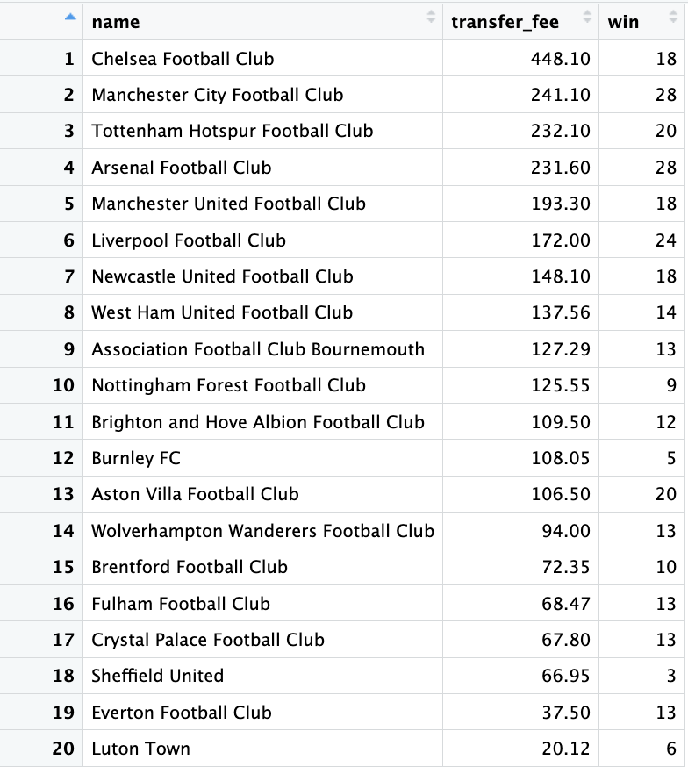
Figure 1: Transfer Spending and Winning (2023)
Figure 1 shows the clubs' transfer spending during the 2023 season, alongside the number of wins they achieved. This figure highlights a positive correlation between transfer spending and victories.
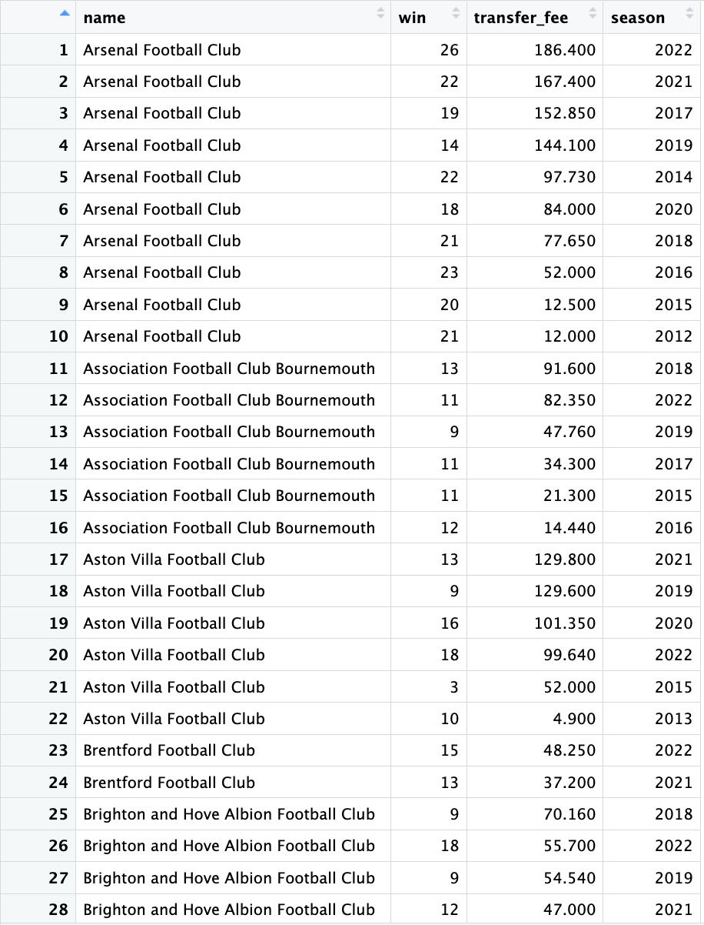
Figure 2: Transfer Spending and Winning (2012-2022)
Figure 2 presents 28 out of 199 rows illustrating clubs' transfer spending, wins between the 2012 and 2022 seasons, and the number of wins they achieved. This figure also highlights a positive correlation between transfer spending and the number of wins between 2012 and 2022.
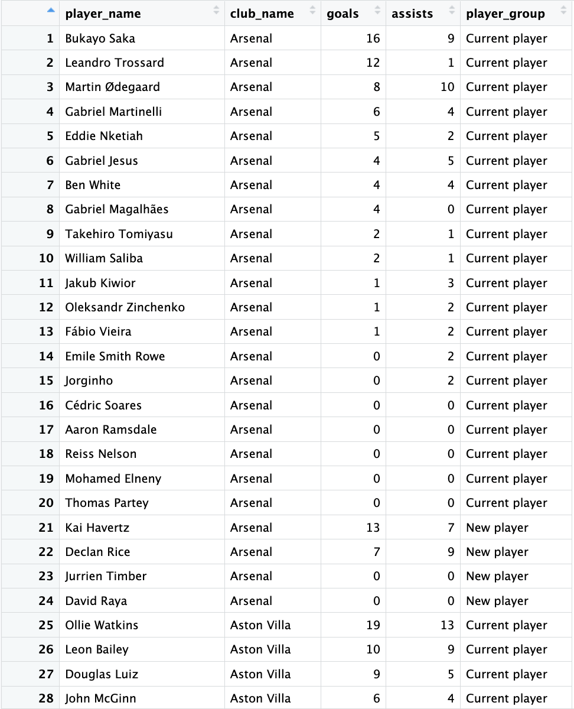
Figure 3: Goals and Assists of New and Current Players (2023)
Figure 3 presents 28 out of 585 rows illustrating the contribution in terms of goals and assists of the new and current players in season 2023. By looking at the goals and assists, it is reasonable to indicate that the current players contribute more to the club’s performance than the new players.
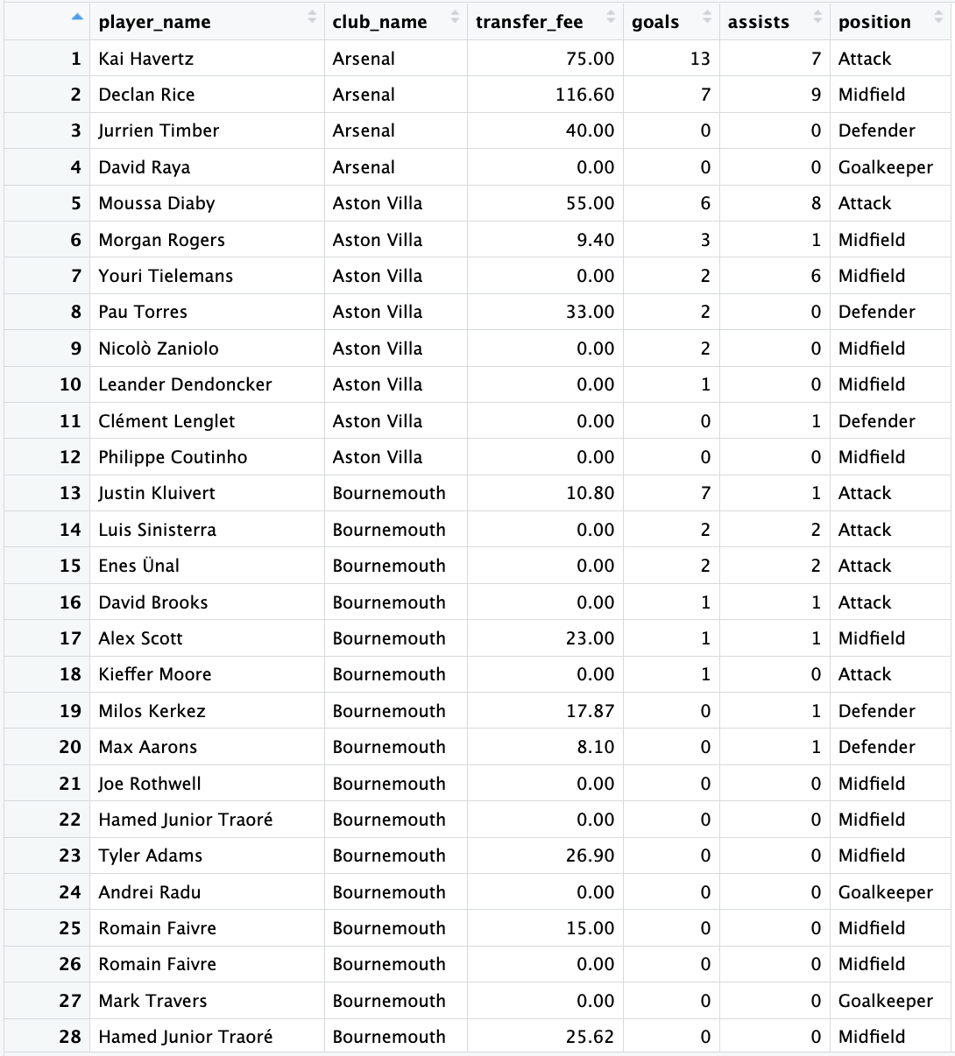
Figure 4: Goals and Assists between new Positions (2023)
Figure 4 presents 28 out of 201 rows illustrating the contribution in terms of goals and assists of the new positions alongside their transfer fee in season 2023. By looking at the goals and assists, it is reasonable to indicate that the attackers cost the clubs the most, and they contribute more to the club’s performance than the other positions.

Data Cleaning
The project primarily focuses on handling missing values. Missing values can significantly affect the conclusions drawn from the data. It is necessary to choose a technique to deal with missing values, either by deleting them, filling in the missing values manually or filling in the missing values automatically. However, it is necessary to identify types of missingness before choosing what type of techniques will be used. In general, there are three types of missingness according to the mechanisms of missingness (Salgado et al., 2016): Missing completely at random (MCAR), Missing at random (MAR) and Missing not at random (MNAR). However, due to the statistical advantage of MCAR, the analysis is not subject to bias. Although the design may reduce power, the missing data do not affect the estimated parameters (Kang, 2013). Therefore, the project assumes that the dataset's missing values are MCAR. In order to handle the missing values, the project chooses the case deletion method because of the valid inferences that the case deletion leads to when the missing data is an MCAR (Schafer, 1999), which leads to two techniques can be used: Listwise deletion and Pairwise deletion. Moreover, the Listwise deletion has become the default option for analysis in most statistical software when handling missing values. Additionally, it produces unbiased estimates and conservative results, especially when the missing data follow the MCAR assumption (Kang, 2013).

Data Transformation
The project requires a dataset that is ready for analysis, which involves these techniques:
- Aggregation: Values within the same categories are combined into a single total. For instance, in the project, the goals and assists of each player are summed together. Additionally, each club's total number of wins is calculated by counting the individual wins. Furthermore, the project aggregates the total transfer fees for each club and each player by summing these values.
- Normalisation: The values of numerical variables are scaled to a specific range. For instance, the project reduces each club's total transfer fee and each player's transfer fee by dividing the amounts by one million. This scaling helps interpret the transfer fees more easily.
- Generalisation: Specific values are organised into broader categories. For instance, players who transferred in the 2023 season are classified as “New Players,” while those who transferred in previous seasons are categorised as “Current Players.”

Data Reduction
The project reduces the redundancy by applying the technique known as where clause by filtering the records that fulfil a specified condition. For instance, the project only extracts records from the dataset where the competition is the Premier League, and matches were played in season 2023 and between the season 2012 and season 2022. Moreover, the project also extracts records of the transfers that took place between season 2012 and season 2023. Additionally, the column that contains the result of whether the clubs win or lose in a match is a binary: 1 stands for win and 0 stands for either draw or loss. Therefore, the project extracts the record where the values equal 1. Furthermore, the project applies the listwise deletion technique mentioned in the Data cleaning method by deleting the records where the transfer fee is null.

Results and Discussion

What is the correlation between a transfer fee and winning in season 2023?
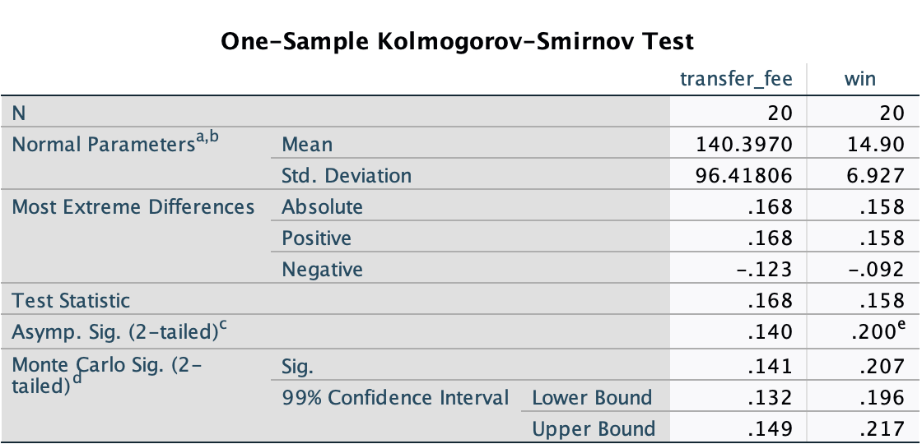
Figure 5: One-Sample Kolmogorov-Smirnov Test for Transfer Fee and Winning (2023)
Figure 5 presents the results of a One-Sample Kolmogorov-Smirnov Test, which assesses whether the data follows a normal distribution. This assessment is essential for performing the Pearson Correlation Coefficient Test.
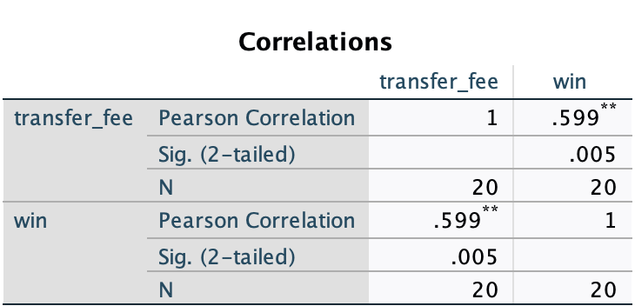
Figure 6: Pearson Correlation Coefficient Test for Transfer Fee and Winning (2023)
Figure 6 examines the relationship between transfer fees and winning during the 2023 season by conducting a Pearson Correlation Coefficient Test. The resulting correlation coefficient value is 0.599, indicating a strong relationship between transfer spending and winning in the 2023 season.
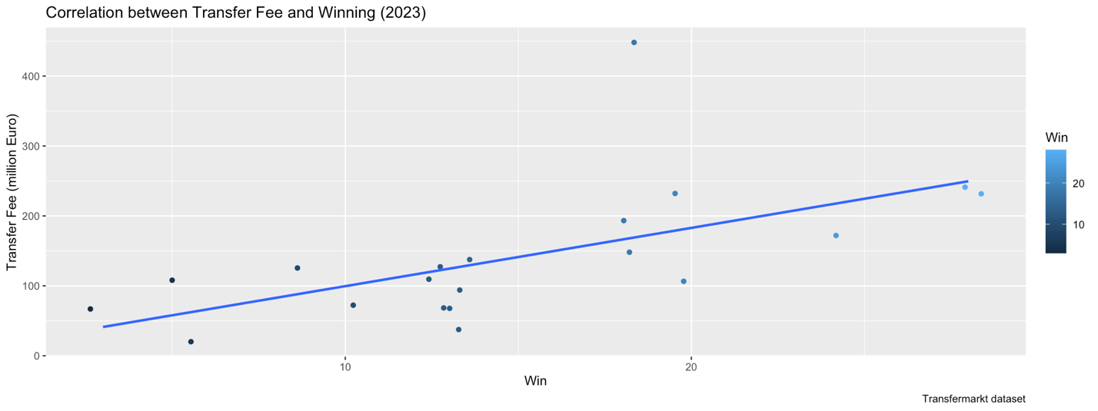
Figure 7: Correlation between Transfer Fee and Winning (2023)
Additionally, Figure 7 shows a significant positive correlation between transfer fees and team success in the 2023 season, supporting the initial belief.

What is the trend of a transfer fee and winning between 2012 and 2022?
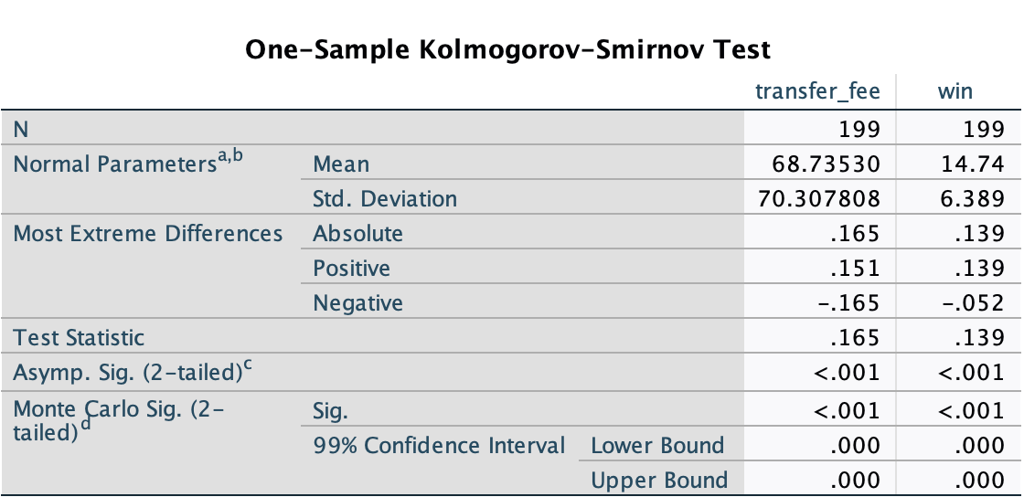
Figure 8: One-Sample Kolmogorov-Smirnov Test for Transfer Fee and Winning (2012-2022)
Figure 8 presents the results of a One-Sample Kolmogorov-Smirnov Test to assess whether the data follows a normal distribution, which is essential for conducting the Spearman Rank Correlation Coefficient Test.
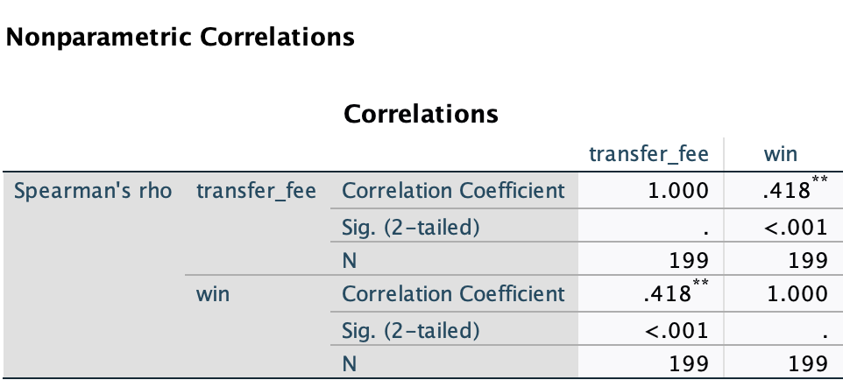
Figure 9: Spearman Correlation Coefficient Test for Transfer Fee and Winning (2012-2022)
Figure 9 examines the correlation between transfer fees and winning from the 2012 season to the 2022 season by conducting a Spearman Rank Correlation Coefficient Test. The resulting correlation coefficient is 0.418, indicating a moderate relationship between transfer spending and winning during this period.
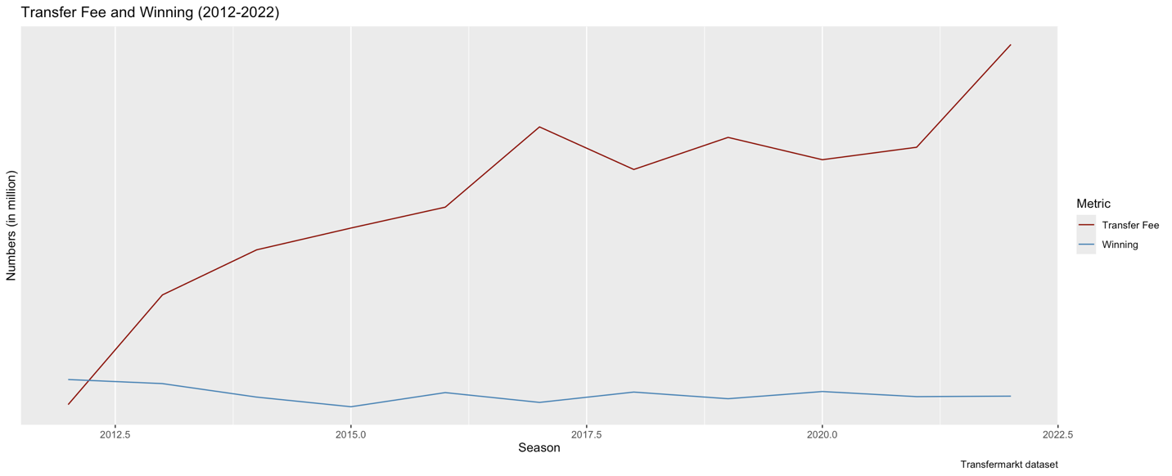
Figure 10: Transfer Fee and Winning (2012-2022)
Figure 10 shows the relationship between transfer fees and winning from 2012 to 2022. While the trend is not linear, maintaining high transfer spending over the long term is essential to influence future performance.

What are the differences between mean goals and assists between new and current players in season 2023?
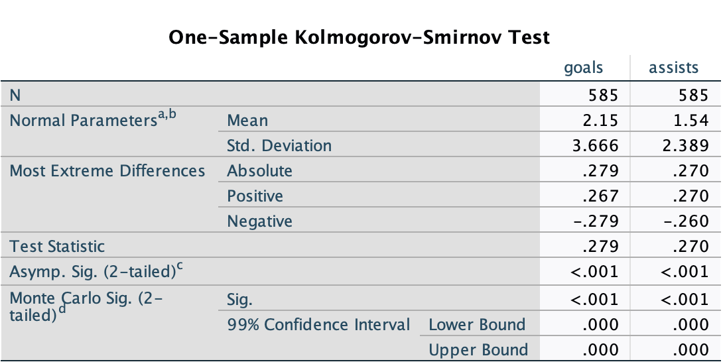
Figure 11: One-Sample Kolmogorov-Smirnov Test for Goals and Assists between New and Current Players
Figure 11 shows the One-Sample Kolmogorov-Smirnov Test, which evaluates whether the data follows a normal distribution. This assessment is necessary for conducting the Mann-Whitney Test.
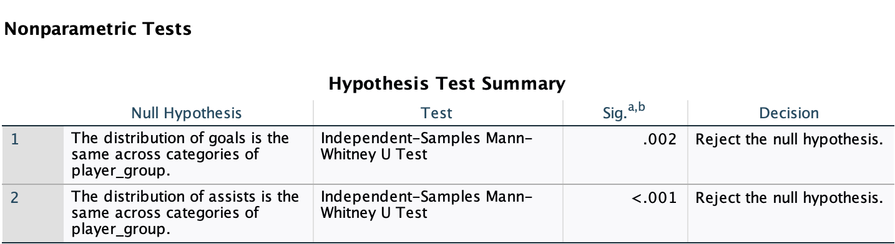
Figure 12: Mann-Whitney Test for Goals and Assists between New and Current Players
A Mann-Whitney test compared new and current players' mean goals and assists in the 2023 season. The p-values obtained were 0.002 for goals and less than 0.001 for assists, which are smaller than 0.05. This result confirms a significant difference in the mean goals and assists between new and current players in the 2023 season.
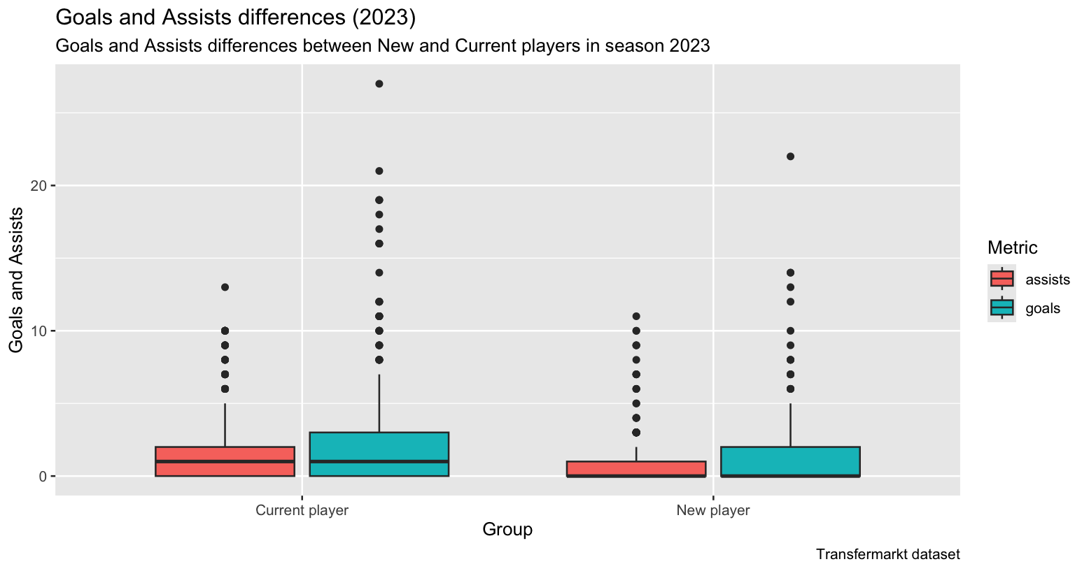
Figure 13: Goals and Assists differences (2023)
Additionally, as illustrated in Figure 13, the current players significantly impact the club's overall performance more than the new players.

How are transfer fees distributed across different positions in season 2023?
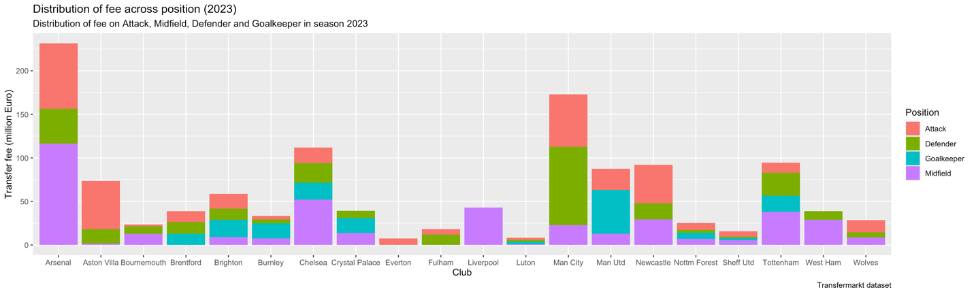
Figure 14: Distribution of fees across positions (2023)
Figure 14 shows that only half of the teams in the English Premier League allocate their transfer fees across all four positions. Among these positions, attackers are the highest-cost, with 17 out of 20 teams investing in them, excluding Crystal Palace, Liverpool, and West Ham. Arsenal is the highest-spending team on attackers, while Bournemouth spends the least. Defenders and midfielders rank equally as the second-highest-cost positions, with 17 out of 20 teams also investing in them. The exceptions are Everton, Liverpool, and Manchester United, which do not purchase defenders. On the other hand, Brentford, Everton, and Fulham do not invest in midfielders. Manchester City spends the most on defenders, while Sheffield United spends the least. Arsenal also leads in spending on midfielders, whereas Luton spends the least in this category. Additionally, goalkeepers represent the lowest-cost position in football, with only 10 out of 20 teams acquiring players in this area. Manchester United spends the most on goalkeepers, while Sheffield United spends the least. Consequently, it is not surprising that Sheffield United and Luton are the lowest-spending teams, and both were relegated at the end of the 2023 season, hence supporting the belief.

What are the differences between mean goals and assists between the highest-cost and other positions in season 2023?
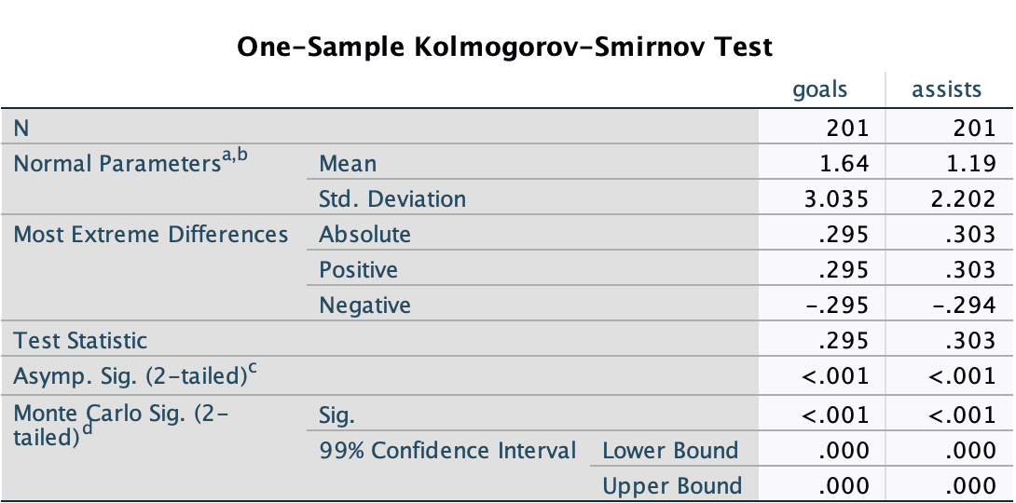
Figure 15: One-Sample Kolmogorov-Smirnov Test for Goals and Assists between Highest-Cost and Other Positions
Figure 15 presents a One-Sample Kolmogorov-Smirnov Test to assess whether the data follows a normal distribution, which is essential for conducting the Kruskal-Wallis Test.
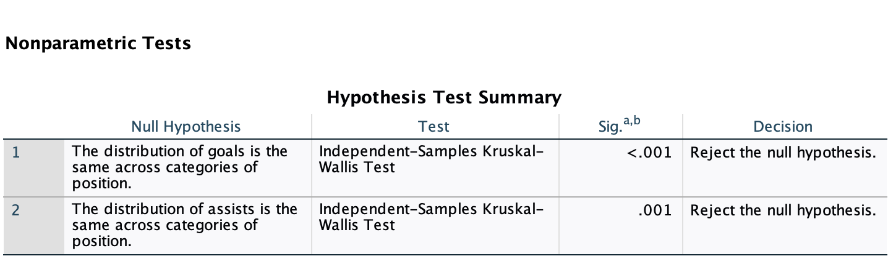
Figure 16: Kruskal-Wallis Test for Goals and Assists between Highest-Cost and Other Positions
A Kruskal-Wallis test was conducted to analyse the differences in mean goals and assists between the highest-cost and other positions in the 2023 season. The p-values obtained were less than 0.001 for goals and 0.001 for assists, both below the significance level of 0.05. This result confirms a significant difference in the mean goals and assists between the highest-cost and the other positions for the 2023 season.
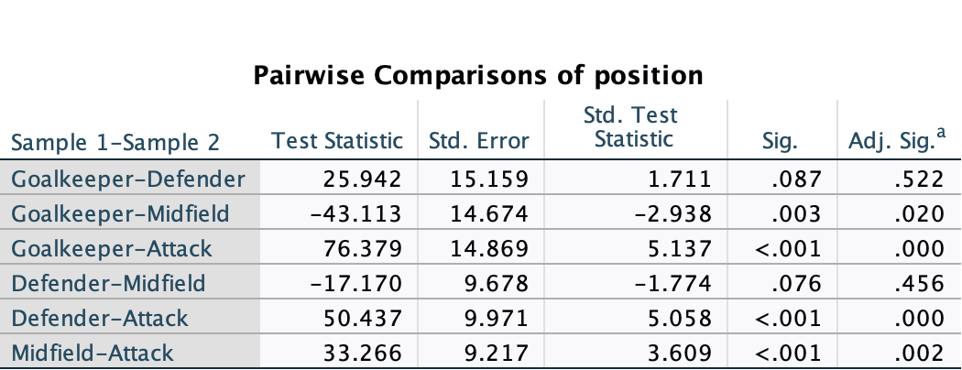
Figure 17: Pairwise Comparisons of Position for Goals between Highest-Cost and Other Positions
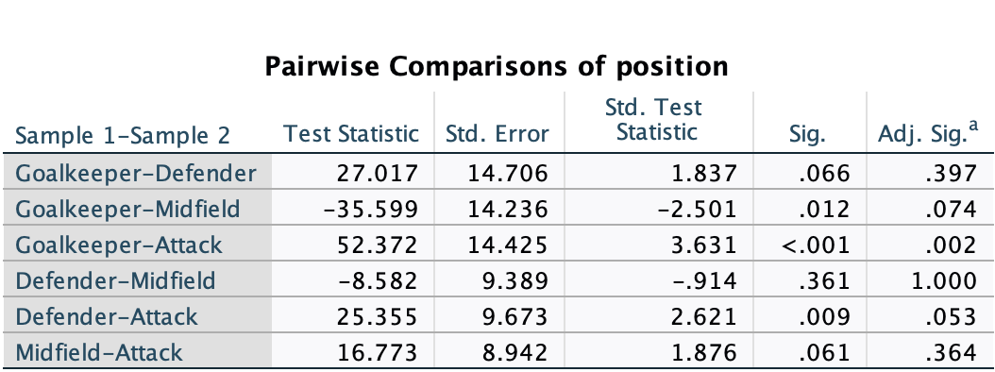
Figure 18: Pairwise Comparisons of Position for Assists between Highest-Cost and Other Positions
The p-value for goals was obtained through Pairwise Comparisons of Categories involving the attacker, goalkeeper, defender, and midfielder, showing values less than 0.001 (see Figure 17). For assists, the p-values from Pairwise Comparisons of Categories between the attacker and the goalkeeper and the attacker and defender were less than 0.001 and 0.009, respectively. However, the p-value for assists when comparing the attacker and the midfielder was 0.061 (see Figure 18), greater than 0.05. Therefore, there are no significant differences in mean goals and assists between the highest-cost positions and the midfield for the 2023 season in the Pairwise Comparisons of Categories.
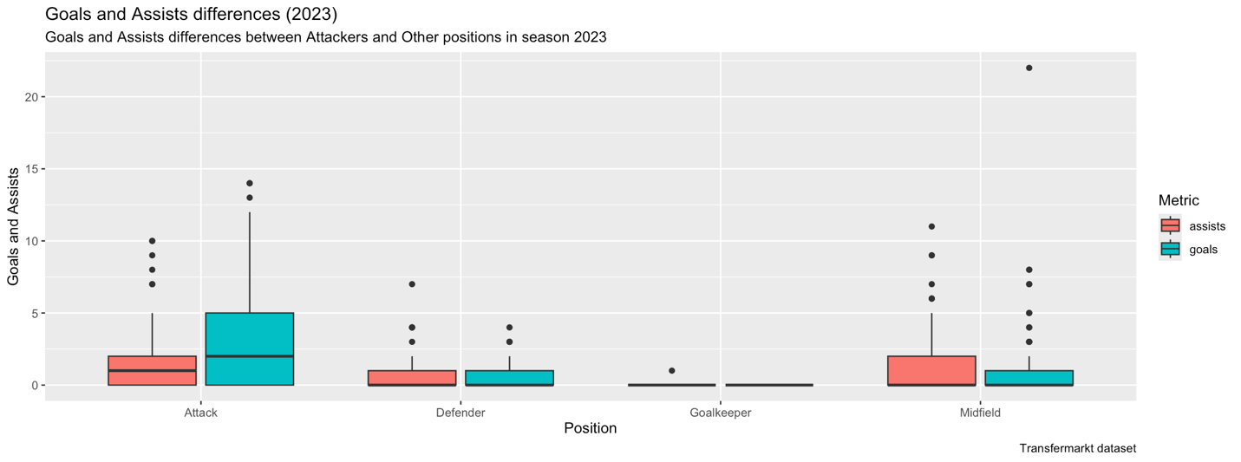
Figure 19: Goals and Assists differences between Highest-Cost and Other Positions
In addition, Figure 19 clearly illustrates that the attacker is the most expensive position on the team. Remarkably, this role also is critical in improving the club's overall performance, making it a vital investment for success.

Conclusion
The Pearson Correlation Coefficient test indicates a strong correlation between transfer spending and winning in season 2023. This impression supports Tomkins et al. (2010) theory that there is a significant connection between transfer spending and success. In order to support the Merten (2022) theory that maintaining high transfer spending in the long term is necessary to influence future performance, the Spearman Rank Correlation Coefficient was performed, indicating that there is a moderate correlation between the transfer spending and winning between season 2012 and 2022. Moreover, the project evaluates the contribution to the team's overall performance in season 2023 of the new players from the 2023 season with those from 2012 to 2022 by running a Mann-Whitney test to conclude that the current players contribute more to the club’s performance than the new players. Furthermore, the project discovers that not all the clubs distribute their transfer fee across all positions, and the position that costs the clubs the most is attackers. Besides these findings, another finding supports the initial belief: Sheffield United and Luton are the lowest-spending teams, and both were relegated at the end of the 2023 season. Finally, the Kruskal-Wallis test indicates that the highest-cost position's overall contribution to team performance significantly differs from the other positions regarding goals and assists. However, there is no difference in contribution to team performance regarding assists between the highest-cost position and midfield. In contrast, the project also has limitations. Firstly, the project only examines players' contribution to team performance through goals and assists. However, it only makes sense when the highest-cost position is either attacker or midfielder. It is more reasonable to look at the goal conceded if the highest-cost position is either defender or goalkeeper. Secondly, the project only highlights the highest and lowest spenders for the same position. However, it does not assess the contributions to team performance, such as goals and assists, from the players in that position. This lack of comparison makes determining whether the transfer decisions are justified is difficult. Thirdly, the project's scope only examines the English Premier League teams from 2012 to 2023. Therefore, there might be different results if an investigation into different leagues is conducted. Fourthly, there is another crucial aspect, which also has a relationship with how team performance that the project does not mention, which is player wages. Kuper and Szymanski (2009) state that the more a club pays its players wages, the higher it will finish. However, what clubs pay them in transfer fees does not make much difference. Lastly, the project assumes that the dataset's missing values are MCAR. However, the project does not provide any evidence to prove the assumption. Therefore, the dataset's missing values can follow another type of missingness, leading to a better method than the case deletion to handle the missing values.

R code, GitHub pages
The folders containing this project's source code in SQL and R, the raw and cleansed data, and the report are available on GitHub. For more information, please refer to the Readme.md file.

References
- Tomkins, P. (2010). Pay as you play: The true price of success in the Premier League era. GPRF Publishing.
- Kuper, S., & Szymanski, S. (2009). Soccernomics: Why England loses, why Germany and Brazil win, and why the US, Japan, Australia, Turkey—and even Iraq—are destined to become the kings of the world’s most popular sport. Nation Books.
- Brandon, B. (2024). Does money really buy success? Empirical analysis of money spent effect on English Premier League team’s performances/success: A panel data analysis. Applied Economics. Bryant University. Retrieved from https://digitalcommons.bryant.edu/cgi/viewcontent.cgi?article=1233&context=eeb
- Merten, B. (2022). The impact of transfer spending in expediting improvement of on-field performance of English Premier League clubs. Senior Theses. University of South Carolina – Columbia. Retrieved from https://scholarcommons.sc.edu/cgi/viewcontent.cgi?article=1518&context=senior_theses
- VanVoorhis, C. R. W., & Morgan, B. L. (2007). Understanding power and rules of thumb for determining sample sizes. Tutorials in Quantitative Methods for Psychology, 3(2), 43–50. https://doi.org/10.20982/tqmp.03.2.p043
- Salgado, C. M., Azevedo, C., Proença, H., & Vieira, S. M. (2016). Missing data. In C. P. Secondary (Ed.), Secondary analysis of electronic health records (pp. 143–162). Springer. https://doi.org/10.1007/978-3-319-43742-2_13
- Kang, H. (2013). The prevention and handling of missing data. Korean Journal of Anesthesiology, 64(5), 402–406. https://doi.org/10.4097/kjae.2013.64.5.402
- Schafer, J. L. (1999). Multiple imputation: A primer. Statistical Methods in Medical Research, 8(1), 3–15. https://doi.org/10.1177/096228029900800102
- Thomas, D. R. (2006). A general inductive approach for analysing qualitative evaluation data. American Journal of Evaluation, 27(2), 237–246. https://doi.org/10.1177/1098214005283748

