New Weekly Report

Tony Dunsworth, PhD

2025-09-04

Table of contents

## 1 Introduction

This is the weekly report for week 35 covering the period from August 25, 2025, through August 31, 2025. The report will include analyses of the data to emphasize different information that is contained within the data and may be pertinent to both operations and management.

For this week, there were a total of 1348 calls for service. And example of the data is shown below:

# A tibble: 10 × 50  
 Master_Incident_Number Response_Date WeekNo DOW Day Hour Shift  
 <chr> <dttm> <fct> <ord> <fct> <fct> <chr>  
 1 25-071089 2025-08-24 00:07:06 35 SUN 24 0 C   
 2 25-020296 2025-08-24 00:15:27 35 SUN 24 0 C   
 3 25-071093 2025-08-24 00:23:30 35 SUN 24 0 C   
 4 25-071094 2025-08-24 00:27:29 35 SUN 24 0 C   
 5 25-071095 2025-08-24 00:33:54 35 SUN 24 0 C   
 6 25-071097 2025-08-24 00:39:50 35 SUN 24 0 C   
 7 25-071100 2025-08-24 00:57:22 35 SUN 24 0 C   
 8 25-071101 2025-08-24 00:58:54 35 SUN 24 0 C   
 9 25-071105 2025-08-24 01:02:40 35 SUN 24 1 C   
10 25-071106 2025-08-24 01:03:38 35 SUN 24 1 C   
# ℹ 43 more variables: Day_Night <chr>, ShiftPart <chr>, Agency <chr>,  
# Problem <chr>, Priority_Number <ord>, Call_Reception <chr>,  
# Call_Taker <chr>, Dispatcher <chr>, Incident_Start_Time <dttm>,  
# TimeCallViewed <dttm>, Incident_Queue_Time <dttm>, Time_To_Queue <dbl>,  
# Elapsed_PS_Queue <chr>, Time_To_Queue_Diff <dbl>,  
# Incident_Dispatch_Time <dttm>, Time_To_Dispatch <dbl>,  
# Elapsed_Queue_Disp <dbl>, Time_To_Disp_Diff <dbl>, …

[1] "Master_Incident_Number" "Response_Date"   
 [3] "WeekNo" "DOW"   
 [5] "Day" "Hour"   
 [7] "Shift" "Day_Night"   
 [9] "ShiftPart" "Agency"   
[11] "Problem" "Priority_Number"   
[13] "Call_Reception" "Call_Taker"   
[15] "Dispatcher" "Incident_Start_Time"   
[17] "TimeCallViewed" "Incident_Queue_Time"   
[19] "Time_To_Queue" "Elapsed_PS_Queue"   
[21] "Time_To_Queue_Diff" "Incident_Dispatch_Time"   
[23] "Time_To_Dispatch" "Elapsed_Queue_Disp"   
[25] "Time_To_Disp_Diff" "Incident_Phone_Stop"   
[27] "Phone_Time" "Elapsed_PS_CTD"   
[29] "Phone_Time_Diff" "TimeFirstUnitDispatchAcknowledged"  
[31] "Processing_Time" "Elapsed_Processing"   
[33] "Diff_Proc_Time" "Incident_Enroute_Time"   
[35] "Rollout_Time" "Elapsed_Rollout"   
[37] "Diff_Rollout_Time" "Incident_Arrival_Time"   
[39] "Transit_Time" "Elapsed_Transit"   
[41] "Diff_Transit_Time" "TimeFirstCallCleared"   
[43] "Incident_First_Close_Time" "Call_Reopened"   
[45] "First_Reopen_Time" "Final_Closed_Time"   
[47] "Total_Call_Time" "Elapsed_Call_Time"   
[49] "Diff_Total_Call_Time" "Disposition"

## 2 Data Cleaning

In order to have a good dataset for analysis, some data cleaning was performed. The first step is to check for missing values in the dataset.

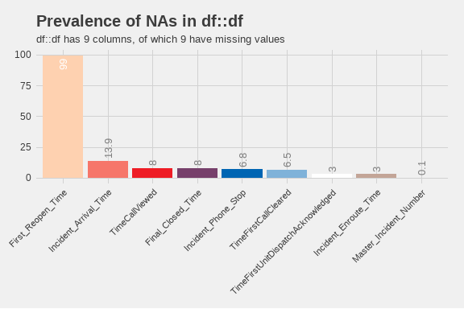

Prevalence of missing values. Only columns with missing data are shown.

From this plot, we can see that there are only 9 values with missing data. Of those, the column with the largest number of missing values is First_Reopen_Time. That is something that we would like to see because that means that most of our calls are closed once and left that way. Later, we will look deeper into those calls to see if there are any patterns to those calls. The number of missing values in Incident_Arrival_Time may be something we wish to focus on in future because it shows that we have calls to which we never arrived. We will want to correlate those with their disposition to see if they were cancelled. Where there are calls that were not cancelled but we did not arrive, we will want to look into those further to see what happened. Additionally, nearly 7% of calls did not have a recorded time that the call stopped. We will have to determine if they were cancelled or how many of those were mutual aid calls where we did not receive a phone call.

## 3 Exploratory Analysis

One of the first analyses is to break down different factor elements to see what we have in the dataset. Starting with the day of the week, the barchart below shows the number of calls for service by day of the week.

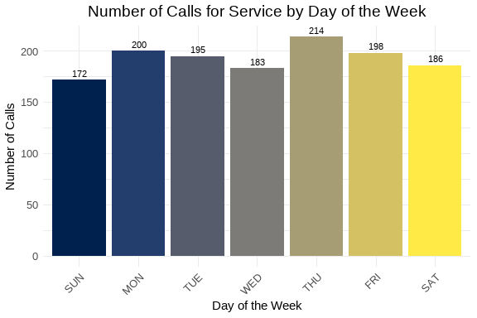

Number of calls for service by day of the week.

From this chart, we can see that Thursday was the busiest day of the week with 214 service calls, and the slowest day was Sunday with 172 calls for service. We can also create a similar chart for the hour of the day.

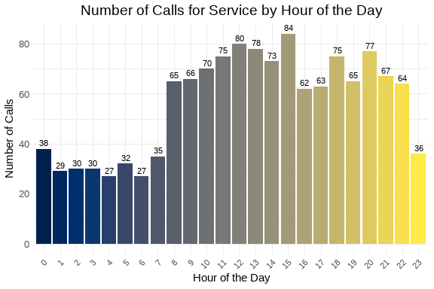

Number of calls for service by hour of the day.

From this chart, we can see that the busiest hour of the day was 1500 hours, with 84 calls for service. 0400 and 0600 were the slowest hours of the day with 27 calls each. The overall pattern appears similar to what we expect with a jump corresponding to the late part of the morning rush hour and falling off later in the evening. Next, we can examine the number of calls by priority level in the chart below.

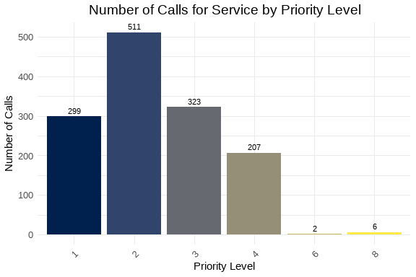

Number of calls for service by priority level.

The majority of calls received were Priority 2 calls. This is followed by Priority 3 and Priority 1 calls. Next, we can look at the nuber of calls per discipline. The chart below covers that information. Priority 2 calls are 37.9 percent of the total number of calls, while Priority 1 calls are 22.2 percent of the total number of calls.

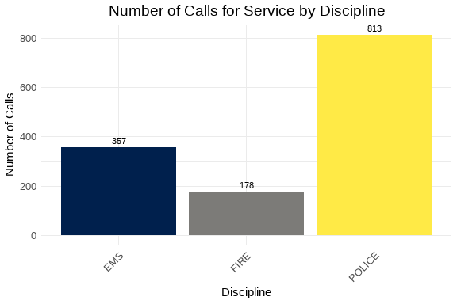

Number of calls for service by discipline.

As expected, the majority of calls are for APD. They represent 60.3 percent of the total number of calls. This is fairly consistent with previous analyses. We can also examine the way in which we are receiving the calls by looking at the Call_Reception column. That chart is below.

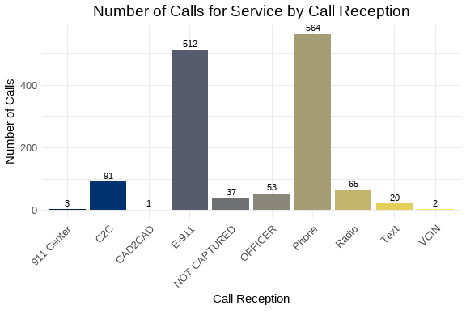

Number of calls for service by call reception.

Most of the calls arrived by phone with the next largest method coming in as E-911 calls. There were 37 calls where we did not indicated how the service call was received. Since this is only 2.7 percent of the total number of calls, this may be something to watch over time.

The following is a chart of the top 10 call types. The data is limited to ensure visual clarity and legibility of the information.

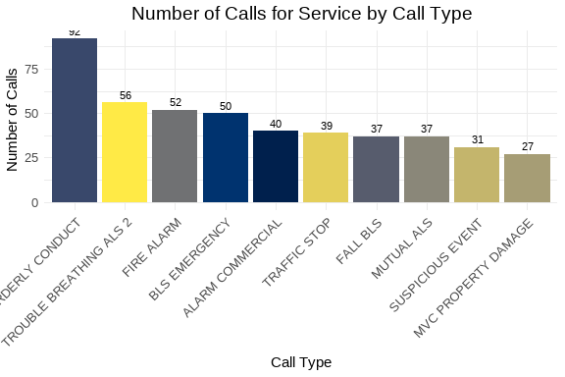

Number of calls for service by call type.

This week, the most common problem nature was Disorderly Conduct. For AFD, the most common was Trouble Breathing. Over time, we will reveiw these results with other weeks to observe any emergent trends. This can also be used with our partners to assist them in their planning.

We can also look at the number of calls taken by telecommunicators. Again, like the problem types, we will limit the chart to the top 10 telecommunicators to ensure visual clarity and legibility of the information.

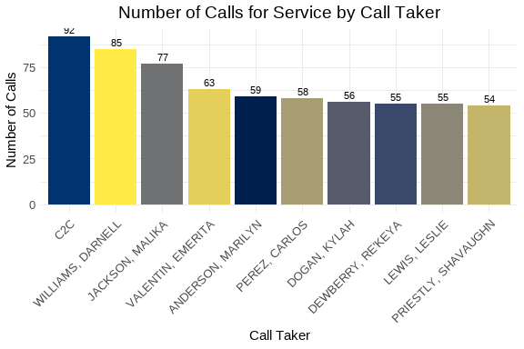

Number of calls for service by telecommunicator.

It is interesting to note that the top “call taker” is CAD2CAD. This may represent an unexpected trend, so we can follow this in future iterations.

#### 3.0.1 Call Distribution: Hour by Day of Week

The following visualization shows the distribution of calls throughout the day (by hour) for each day of the week. This helps identify patterns in call volume across different days and times.

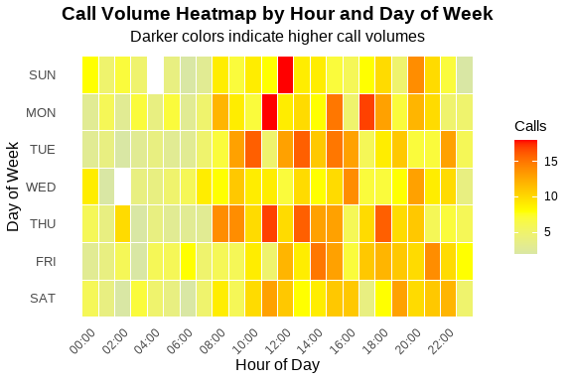

Call Volume by Hour and Day of Week

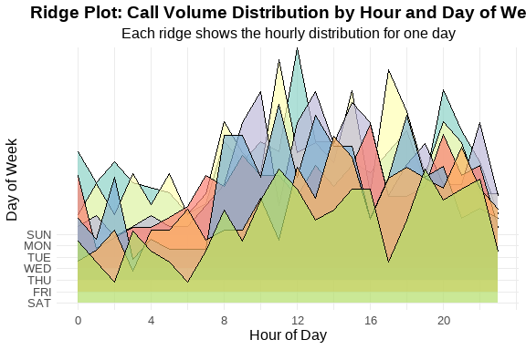

Ridge Plot Alternative - Calls per Hour by Day of Week

Table 1: Call Volume Summary by Day of Week

Peak hours and average calls per hour

| Day of Week | Total Calls | Peak Hour | Avg Calls/Hour |
| --- | --- | --- | --- |
| THU | 214 | 11 | 8.9 |
| MON | 200 | 11 | 8.3 |
| FRI | 198 | 14 | 8.2 |
| TUE | 195 | 10 | 8.1 |
| SAT | 186 | 11 | 7.8 |
| WED | 183 | 16 | 7.6 |
| SUN | 172 | 12 | 7.2 |

These visualizations show that the bulk of our calls are concentrated between 1000 hours and 1400 hours for the week.

### 3.1 Summary statsitcs and analyses

In this section, we will analyse the continuous variables that represent the elapsed time for various segments of the call process. The variables of interest include: Time_To_Queue, Time_To_Dispatch, Phone_Time, Processing_Time, Rollout_Time, Transit_Time, and Total_Call_Time. They are defined as follows:

* Time_To_Queue
* The time from the start of the call to the time it is released to queue for dispatch.
* Time_To_Dispatch
* The time from the time the call is released for dispatch to the time the first unit is assigned.
* Phone_Time
* The time from the start of the call to the time the phone call ended.
* Processing_Time
* The time from the start of the call until the first unit is assigned.
* Rollout_Time
* The time from the assignment of the first unit to the first unit marking en route to the call.
* Transit_Time
* The time from the first unit marking en route to the call to the first unit arriving on scene.
* Total_Call_Time
* The total time from the start of the call to the time the call was closed. If the call is re-opened, then this clock stops with the first closure.

Table 1: Weekly Elapsed Time Summary Table

Statistical summary of call processing times

| Time Metric | Min | Mean | Median | Std Dev | Skew | Kurt |
| --- | --- | --- | --- | --- | --- | --- |
| Time To Queue | 0.00 | 68.92 | 49.00 | 143.75 | 22.39 | 670.53 |
| Time To Dispatch | 0.00 | 1,009.79 | 26.00 | 11,888.43 | 32.56 | 1,131.07 |
| Phone Time | 0.00 | 250.94 | 162.00 | 416.93 | 7.56 | 82.85 |
| Processing Time | 0.00 | 1,078.70 | 96.00 | 11,896.24 | 32.51 | 1,128.80 |
| Rollout Time | 0.00 | 35.70 | 8.00 | 181.69 | 33.50 | 1,178.96 |
| Transit Time | 0.00 | 406.67 | 274.00 | 1,001.22 | 12.06 | 175.80 |
| Total Call Time | 38.00 | 3,818.03 | 2,269.50 | 4,838.55 | 4.01 | 26.27 |

The values from this table describe operations for the week being analyzed. In this case, the median time for a call to be placed in queue is 49 seconds. This puts our operations on good footing to meet the NENA and NFPA guidelines for dispatching emergency calls. The median time for calls to sit in queue is 26 seconds. The overall phone processing time is 96 seconds which is in range for dispatching emergency service calls. Additional analyses can be performed to look more deeply into how well emergency service calls were processed. The difference between the mean and median values for these time intervals indicates that there are some outliers that skewed the data. The skewness and kurtosis values also indicate that the data is not normally distributed and indicate a long right tail with a very sharp peak. These characteristics can be viewed in the histograms below.

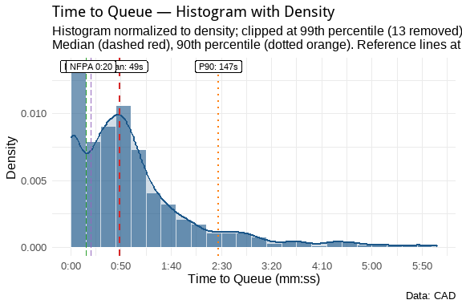

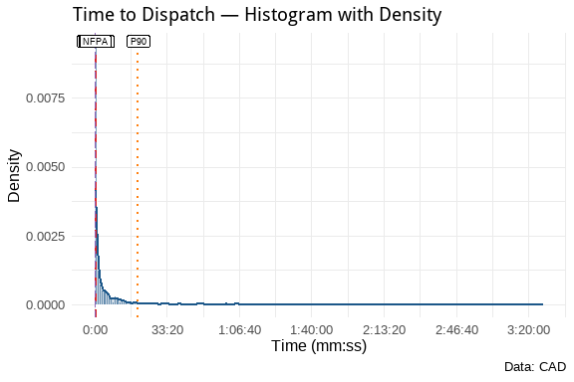

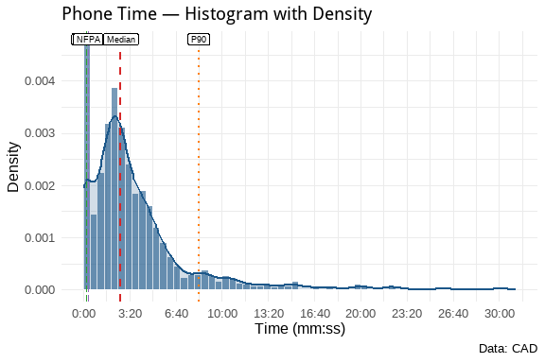

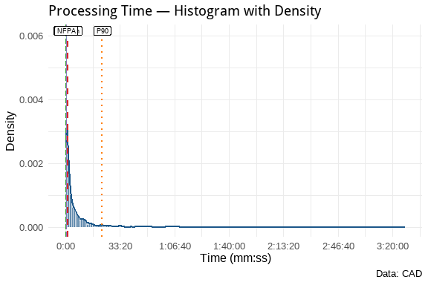

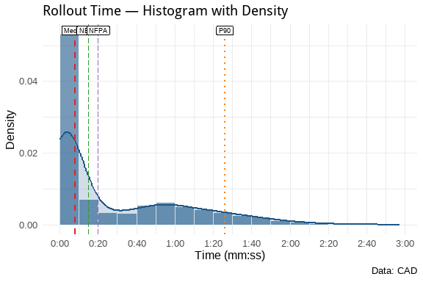

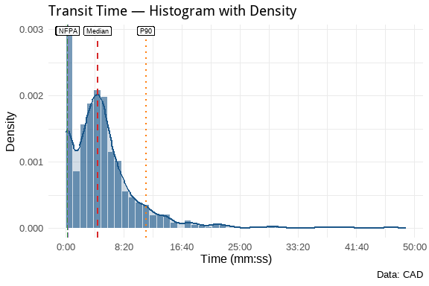

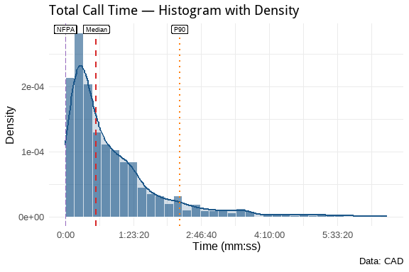

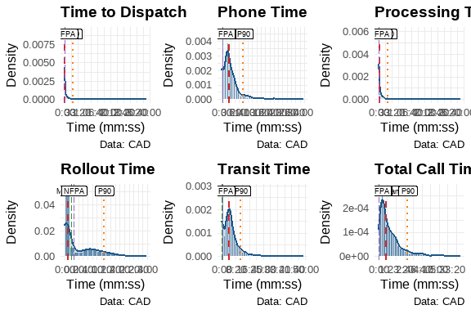

**Plot Key:**

| Line Type/Color | Meaning |
| --- | --- |
| Dashed Red | Median |
| Dotted Orange | 90th Percentile (P90) |
| Longdash Green | NENA 0:15 Standard |
| Longdash Purple | NFPA 0:20 Standard |

These show that the processing times for DECC are well within the NENA and NFPA guidelines. This is good operational data to show how well we are performing with repsect ot those guidelines. Over time, we can track these metrics to ensure that we continue to meet or exceed those standards.

## 4 Additional Analyses.

As discussed earlier, we can create additional subsets from this data to look at specific areas of interest. We will create several new datasets from this weekly set for futher analysis. The first will be a dataset that combines APD Priority 1 calls with AFD Priority 1 and 2 calls and evaluates those as emergency calls. We will also create specific datasets for law, fire, and EMS for specific analyses of the disciplines. We will also create datasets that identify calls that exceed certain parameters that have been defined from other reports. Finally, because we have been evaluating Cardiac Arrest calls for some time, we’ll create and analyze that dataset.

By defining these datasets, we can now add to our analyses. For example, we can reuse the same information from above to drill down into APD and AFD calls. Starting with APD calls for service, we can examine everything as we did above.

### 4.1 APD Analyses

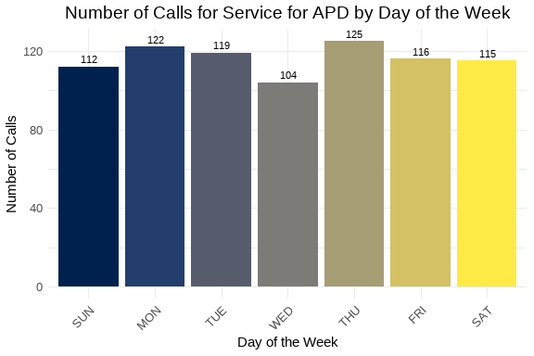

Number of calls for service by day of the week.

Since the majority of service calls are for APD, Thursday should be the expected busiest day of the week, which it is by three calls over Monday. Wednesday appears to be the lightest day of the week for APD service calls. With a differnce of only 24 calls from the highest volume to the lowest, the week was remarkably consistent for service calls.

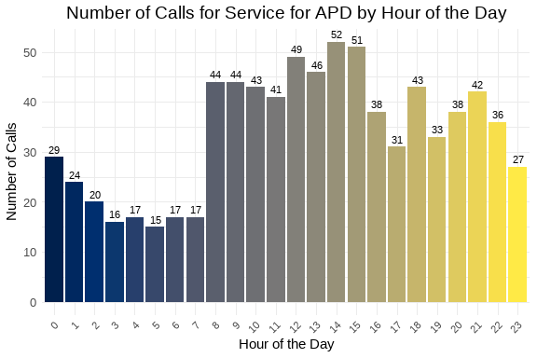

Number of calls for service by hour of the day.

The busiest time of the week for APD calls is from 1200 to 1600 hours. That also is in keeping with the results found for the week overall.

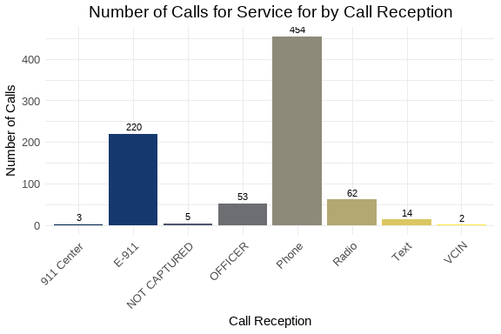

Number of calls for service by call reception.

As can be seen, the majority of calls came through telephone. This comports to the call reception results for the week overall.

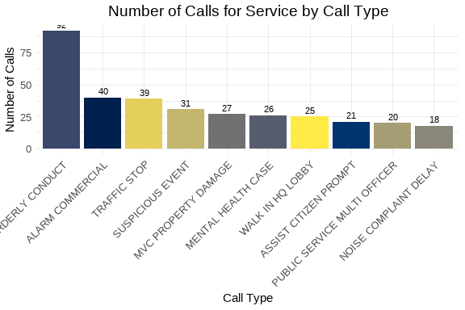

Number of calls for service by call type.

The largest call type was for Disorderly Conduct, which was also the largest call type for the week overall. This could be something to monitor over time to see how the trend changes over time.

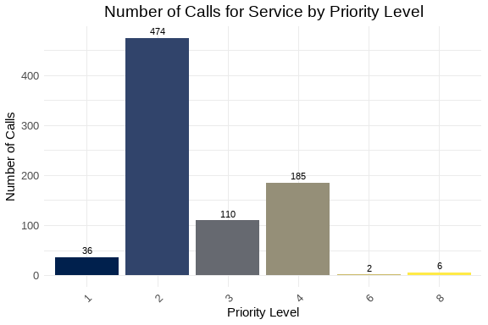

Number of calls for service by priority level.

As expected, the largest number of calls werew Priority 2 calls which represent 58.3 percent of all APD calls. Again, this comports with the overall weekly trends.

Table 1: Weekly Elapsed Time Summary Table

Statistical summary of call processing times

| Time Metric | Min | Mean | Median | Std Dev | Skew | Kurt |
| --- | --- | --- | --- | --- | --- | --- |
| Time To Queue | 0.00 | 85.47 | 56.00 | 179.51 | 18.78 | 449.65 |
| Time To Dispatch | 0.00 | 1,672.56 | 204.00 | 15,275.71 | 25.32 | 683.07 |
| Phone Time | 0.00 | 266.03 | 156.00 | 466.74 | 7.36 | 75.59 |
| Processing Time | 0.00 | 1,758.04 | 319.00 | 15,283.91 | 25.29 | 681.92 |
| Rollout Time | 0.00 | 16.57 | 3.00 | 231.56 | 27.41 | 759.08 |
| Transit Time | 0.00 | 470.43 | 255.00 | 1,281.98 | 9.44 | 106.35 |
| Total Call Time | 38.00 | 4,595.37 | 2,328.00 | 5,905.42 | 3.29 | 17.03 |

This table shows that overall, we have a median time on the phones of about 2.5 minutes and it takes about double that for a call to start and be dispatched. Some of that difference is going to be due to having to hold Priority 4 and above calls until there is a unit available. Since the P4 calls are 22.8 percent of APD calls, this could have a measureable impact on service times for DECC staff.

### 4.2 AFD FIRE Analyses

Because AFD calls for service can be split into two distinct disciplines, fire-related calls and medical-related calls, DECC has, historically, separated the two disciplines for analytical purposes. So this section will look at fire-related calls for service for the week.

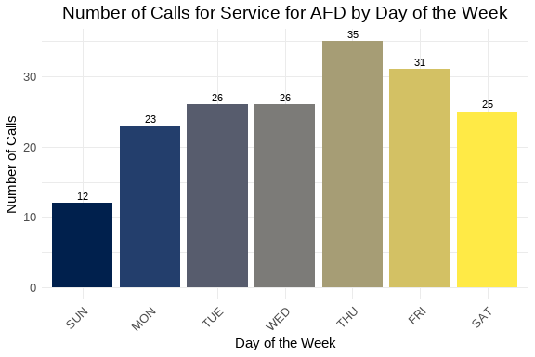

Number of calls for service by day of the week.

It is interesting to note that Thursday was also the busiest day of the week for fire-related calls. Friday followed closely behind, while Sunday and Monday were the lightest days of the week. Sunday had only 12 fire-related calls which is very interesting to note. With football season in full swing, I might have expected more fire-related calls for barbecues and get togethers on Sunday. There could be room to see if there are any correlations between football season and the number of service calls that arrive during the week. For example, if the Commanders play on a day other than Sunday, is there movement in the number of calls for that day?

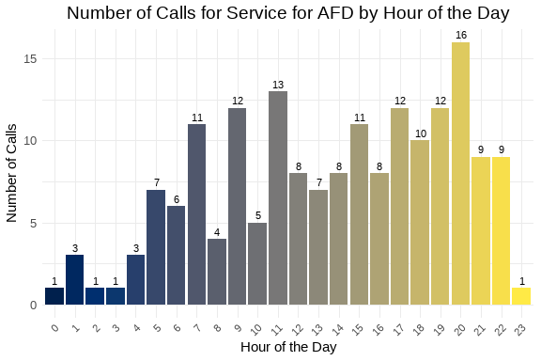

Number of calls for service by hour of the day.

Fire-related calls are much more spread out through the day as can be seen in the graph above. However, the 2000 hour stands out as the hour where the most calls were received for the week. Future reports can determine if this is an anomaly or if there is a trend to more fire-related calls at some point in the evening after most people have returned to their residence for the evening.

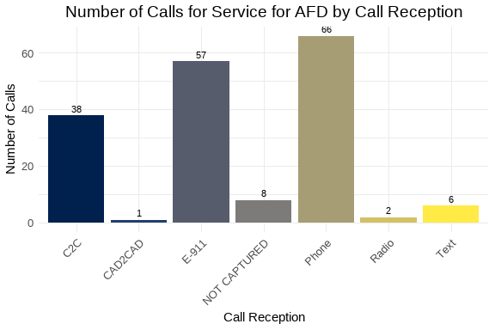

Number of calls for service by call reception.

Like APD calls, most fire-related calls for service came in via Phone. However the numbers for Mutual Aid and E-911 were larger percentages of the overall volume. In this case, Phone, not necessarily E-911 represented 37.1 percent of all fire-related service calls received.

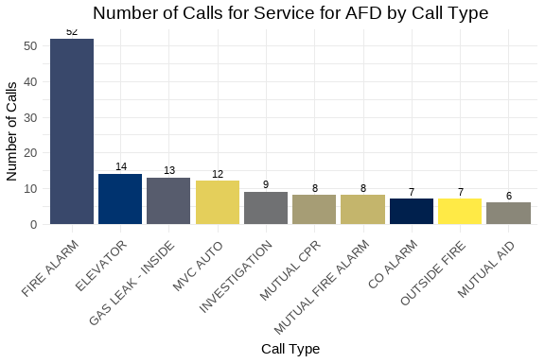

Number of calls for service by call type.

The greatest number of fire-related service calls were for Fire Alarms. That is an interesting observation and should be watched through the future. I do note that MUTUAL-CPR is listed as a “fire-related” call. That will be corrected in future reports.

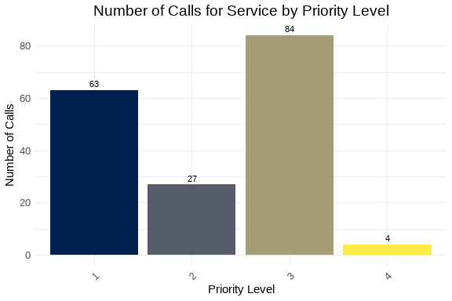

Number of calls for service by priority level.

It is interesting to note that Priority 3 represents the highest number of calls for service. That would correlate to the Fire Alarm call type being the most used.

Table 1: Weekly Elapsed Time Summary Table

Statistical summary of call processing times

| Time Metric | Min | Mean | Median | Std Dev | Skew | Kurt |
| --- | --- | --- | --- | --- | --- | --- |
| Time To Queue | 0.00 | 40.74 | 32.50 | 49.19 | 2.50 | 8.67 |
| Time To Dispatch | 0.00 | 3.33 | 2.00 | 20.38 | 12.88 | 168.69 |
| Phone Time | 0.00 | 183.16 | 130.00 | 250.34 | 4.79 | 30.54 |
| Processing Time | 0.00 | 44.07 | 35.00 | 55.70 | 2.96 | 12.11 |
| Rollout Time | 0.00 | 65.01 | 65.00 | 29.30 | -0.06 | -0.20 |
| Transit Time | 0.00 | 322.63 | 288.00 | 182.97 | 2.16 | 7.59 |
| Total Call Time | 74.00 | 1,424.45 | 1,061.50 | 1,344.66 | 2.63 | 8.80 |

Overall, DECC operations appear to be very efficient at getting fire-related service calls out to the field. The median processing time was only 35 seconds. This shows that we can easily be in compliance with all necessary NENA and NFPA guidelines. The median time on the phone was just over 2 minutes. The mean time was just over 3 minutes which is still amazing.

### 4.3 AFD EMS Analyses