Weekly Report: Week 36 (2025-09-01 to 2025-09-07)

Tony Dunsworth, PhD

2025-09-04

Table of contents

## 1 Introduction

This is the weekly report for week 35 covering the period from August 25, 2025, through August 31, 2025. The report will include analyses of the data to emphasize different information that is contained within the data and may be pertinent to both operations and management.

For this week, there were a total of 1263 calls for service. And example of the data is shown below:

# A tibble: 10 × 50  
 Master_Incident_Number Response_Date WeekNo DOW Day Hour Shift  
 <chr> <dttm> <fct> <ord> <fct> <fct> <chr>  
 1 25-073342 2025-08-31 01:13:04 36 SUN 31 1 D   
 2 25-020863 2025-08-31 01:26:26 36 SUN 31 1 D   
 3 25-073345 2025-08-31 01:41:09 36 SUN 31 1 D   
 4 25-073346 2025-08-31 01:44:59 36 SUN 31 1 D   
 5 25-073347 2025-08-31 01:56:42 36 SUN 31 1 D   
 6 25-073348 2025-08-31 01:59:41 36 SUN 31 1 D   
 7 25-073350 2025-08-31 02:01:38 36 SUN 31 2 D   
 8 25-073351 2025-08-31 02:03:53 36 SUN 31 2 D   
 9 25-020864 2025-08-31 02:17:29 36 SUN 31 2 D   
10 25-020865 2025-08-31 02:27:43 36 SUN 31 2 D   
# ℹ 43 more variables: Day_Night <chr>, ShiftPart <chr>, Agency <chr>,  
# Problem <chr>, Priority_Number <ord>, Call_Reception <chr>,  
# Call_Taker <chr>, Dispatcher <chr>, Incident_Start_Time <dttm>,  
# TimeCallViewed <dttm>, Incident_Queue_Time <dttm>, Time_To_Queue <dbl>,  
# Elapsed_PS_Queue <chr>, Time_To_Queue_Diff <dbl>,  
# Incident_Dispatch_Time <dttm>, Time_To_Dispatch <dbl>,  
# Elapsed_Queue_Disp <dbl>, Time_To_Disp_Diff <dbl>, …

[1] "Master_Incident_Number" "Response_Date"   
 [3] "WeekNo" "DOW"   
 [5] "Day" "Hour"   
 [7] "Shift" "Day_Night"   
 [9] "ShiftPart" "Agency"   
[11] "Problem" "Priority_Number"   
[13] "Call_Reception" "Call_Taker"   
[15] "Dispatcher" "Incident_Start_Time"   
[17] "TimeCallViewed" "Incident_Queue_Time"   
[19] "Time_To_Queue" "Elapsed_PS_Queue"   
[21] "Time_To_Queue_Diff" "Incident_Dispatch_Time"   
[23] "Time_To_Dispatch" "Elapsed_Queue_Disp"   
[25] "Time_To_Disp_Diff" "Incident_Phone_Stop"   
[27] "Phone_Time" "Elapsed_PS_CTD"   
[29] "Phone_Time_Diff" "TimeFirstUnitDispatchAcknowledged"  
[31] "Processing_Time" "Elapsed_Processing"   
[33] "Diff_Proc_Time" "Incident_Enroute_Time"   
[35] "Rollout_Time" "Elapsed_Rollout"   
[37] "Diff_Rollout_Time" "Incident_Arrival_Time"   
[39] "Transit_Time" "Elapsed_Transit"   
[41] "Diff_Transit_Time" "TimeFirstCallCleared"   
[43] "Incident_First_Close_Time" "Call_Reopened"   
[45] "First_Reopen_Time" "Final_Closed_Time"   
[47] "Total_Call_Time" "Elapsed_Call_Time"   
[49] "Diff_Total_Call_Time" "Disposition"

## 2 Data Cleaning

In order to have a good dataset for analysis, some data cleaning was performed. The first step is to check for missing values in the dataset.

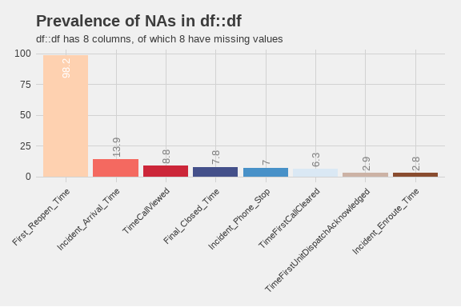

Prevalence of missing values. Only columns with missing data are shown.

From this plot, we can see that there are only 9 values with missing data. Of those, the column with the largest number of missing values is First_Reopen_Time. That is something that we would like to see because that means that most of our calls are closed once and left that way. Later, we will look deeper into those calls to see if there are any patterns to those calls. The number of missing values in Incident_Arrival_Time may be something we wish to focus on in future because it shows that we have calls to which we never arrived. We will want to correlate those with their disposition to see if they were cancelled. Where there are calls that were not cancelled but we did not arrive, we will want to look into those further to see what happened. Additionally, nearly 7% of calls did not have a recorded time that the call stopped. We will have to determine if they were cancelled or how many of those were mutual aid calls where we did not receive a phone call.

## 3 Exploratory Analysis

One of the first analyses is to break down different factor elements to see what we have in the dataset. Starting with the day of the week, the barchart below shows the number of calls for service by day of the week.

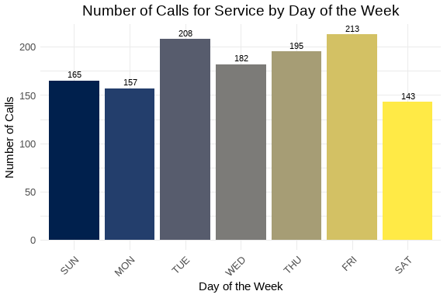

Number of calls for service by day of the week.

From this chart, we can see that Thursday was the busiest day of the week with 214 service calls, and the slowest day was Sunday with 172 calls for service. We can also create a similar chart for the hour of the day.

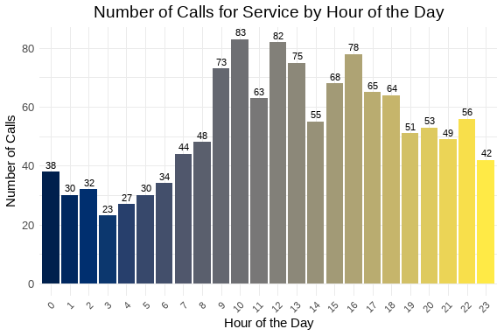

Number of calls for service by hour of the day.

From this chart, we can see that the busiest hour of the day was 1500 hours, with 84 calls for service. 0400 and 0600 were the slowest hours of the day with 27 calls each. The overall pattern appears similar to what we expect with a jump corresponding to the late part of the morning rush hour and falling off later in the evening. Next, we can examine the number of calls by priority level in the chart below.

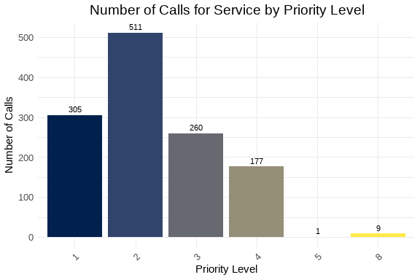

Number of calls for service by priority level.

The majority of calls received were Priority 2 calls. This is followed by Priority 3 and Priority 1 calls. Next, we can look at the nuber of calls per discipline. The chart below covers that information. Priority 2 calls are 40.5 percent of the total number of calls, while Priority 1 calls are 24.1 percent of the total number of calls.

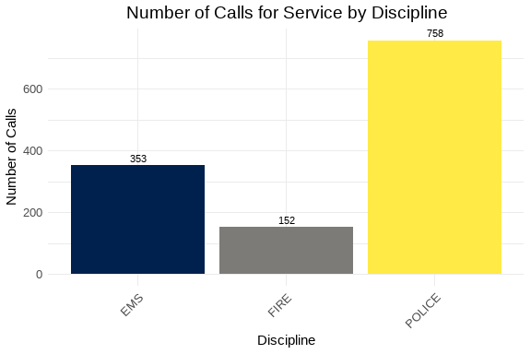

Number of calls for service by discipline.

As expected, the majority of calls are for APD. They represent 60 percent of the total number of calls. This is fairly consistent with previous analyses. We can also examine the way in which we are receiving the calls by looking at the Call_Reception column. That chart is below.

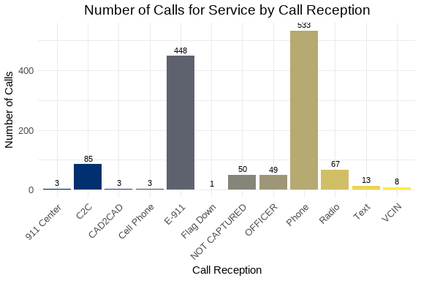

Number of calls for service by call reception.

Most of the calls arrived by phone with the next largest method coming in as E-911 calls. There were 37 calls where we did not indicated how the service call was received. Since this is only 4 percent of the total number of calls, this may be something to watch over time.

The following is a chart of the top 10 call types. The data is limited to ensure visual clarity and legibility of the information.

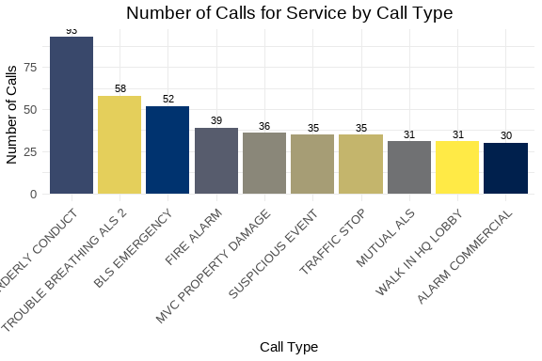

Number of calls for service by call type.

This week, the most common problem nature was Disorderly Conduct. For AFD, the most common was Trouble Breathing. Over time, we will reveiw these results with other weeks to observe any emergent trends. This can also be used with our partners to assist them in their planning.

We can also look at the number of calls taken by telecommunicators. Again, like the problem types, we will limit the chart to the top 10 telecommunicators to ensure visual clarity and legibility of the information.

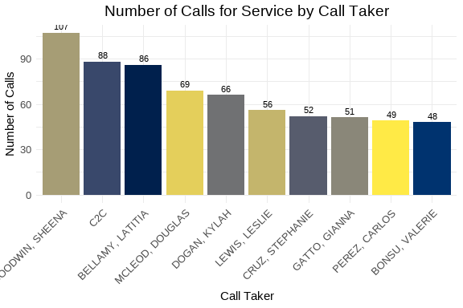

Number of calls for service by telecommunicator.

It is interesting to note that the top “call taker” is CAD2CAD. This may represent an unexpected trend, so we can follow this in future iterations.

### 3.1 Call Distribution: Hour by Day of Week

The following visualization shows the distribution of calls throughout the day (by hour) for each day of the week. This helps identify patterns in call volume across different days and times.

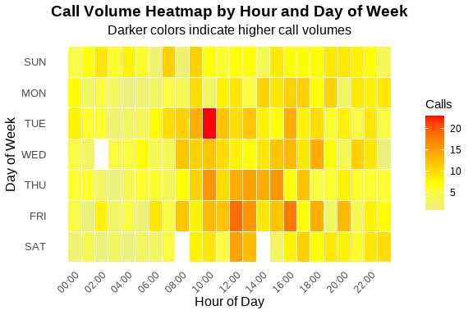

Call Volume by Hour and Day of Week

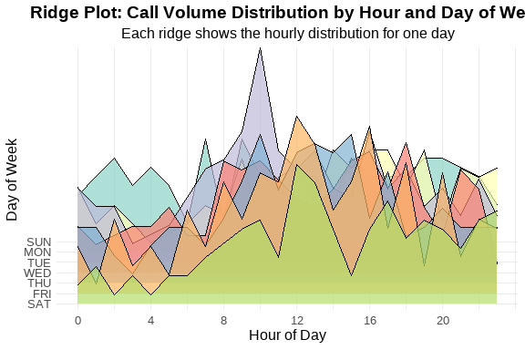

Ridge Plot Alternative - Calls per Hour by Day of Week

Table 1: Call Volume Summary by Day of Week

Peak hours and average calls per hour

| Day of Week | Total Calls | Peak Hour | Avg Calls/Hour |
| --- | --- | --- | --- |
| FRI | 213 | 12 | 8.9 |
| TUE | 208 | 10 | 8.7 |
| THU | 195 | 10 | 8.1 |
| WED | 182 | 18 | 7.6 |
| SUN | 165 | 7 | 6.9 |
| MON | 157 | 14 | 6.5 |
| SAT | 143 | 12 | 6.0 |

These visualizations show that the bulk of our calls are concentrated between 1000 hours and 1400 hours for the week.

### 3.2 Summary statsitcs and analyses

In this section, we will analyse the continuous variables that represent the elapsed time for various segments of the call process. The variables of interest include: Time_To_Queue, Time_To_Dispatch, Phone_Time, Processing_Time, Rollout_Time, Transit_Time, and Total_Call_Time. They are defined as follows:

* Time_To_Queue
* The time from the start of the call to the time it is released to queue for dispatch.
* Time_To_Dispatch
* The time from the time the call is released for dispatch to the time the first unit is assigned.
* Phone_Time
* The time from the start of the call to the time the phone call ended.
* Processing_Time
* The time from the start of the call until the first unit is assigned.
* Rollout_Time
* The time from the assignment of the first unit to the first unit marking en route to the call.
* Transit_Time
* The time from the first unit marking en route to the call to the first unit arriving on scene.
* Total_Call_Time
* The total time from the start of the call to the time the call was closed. If the call is re-opened, then this clock stops with the first closure.

Table 1: Weekly Elapsed Time Summary Table

Statistical summary of call processing times

| Time Metric | Min | Mean | Median | Std Dev | Skew | Kurt |
| --- | --- | --- | --- | --- | --- | --- |
| Time To Queue | 0.00 | 61.83 | 46.00 | 66.85 | 2.51 | 10.69 |
| Time To Dispatch | 0.00 | 991.54 | 29.00 | 5,448.67 | 18.89 | 464.69 |
| Phone Time | 0.00 | 227.68 | 161.00 | 299.12 | 5.40 | 49.17 |
| Processing Time | 0.00 | 1,053.38 | 94.00 | 5,454.47 | 18.83 | 462.32 |
| Rollout Time | 0.00 | 35.27 | 8.00 | 119.98 | 20.00 | 472.15 |
| Transit Time | 0.00 | 427.29 | 262.00 | 2,320.52 | 29.50 | 927.39 |
| Total Call Time | 41.00 | 4,018.01 | 2,601.00 | 5,012.91 | 3.48 | 18.09 |

The values from this table describe operations for the week being analyzed. In this case, the median time for a call to be placed in queue is 49 seconds. This puts our operations on good footing to meet the NENA and NFPA guidelines for dispatching emergency calls. The median time for calls to sit in queue is 26 seconds. The overall phone processing time is 96 seconds which is in range for dispatching emergency service calls. Additional analyses can be performed to look more deeply into how well emergency service calls were processed. The difference between the mean and median values for these time intervals indicates that there are some outliers that skewed the data. The skewness and kurtosis values also indicate that the data is not normally distributed and indicate a long right tail with a very sharp peak. These characteristics can be viewed in the histograms below.

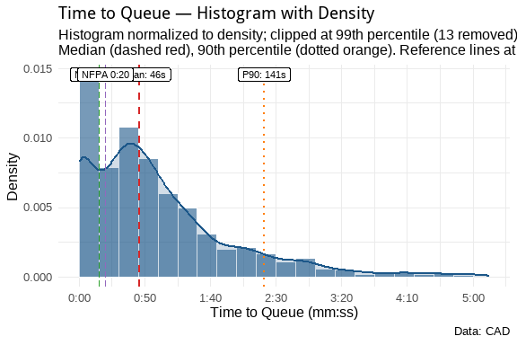

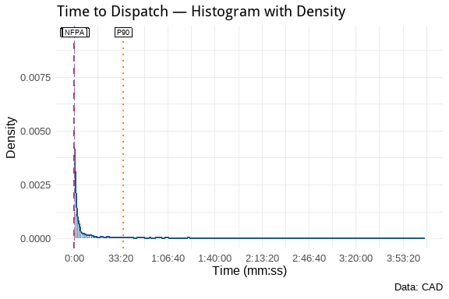

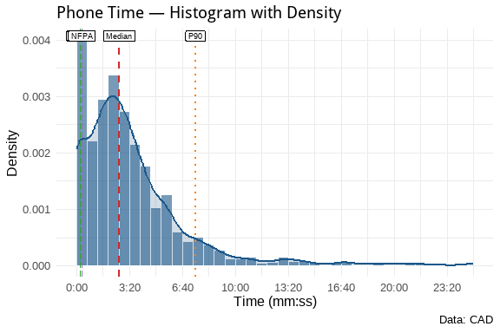

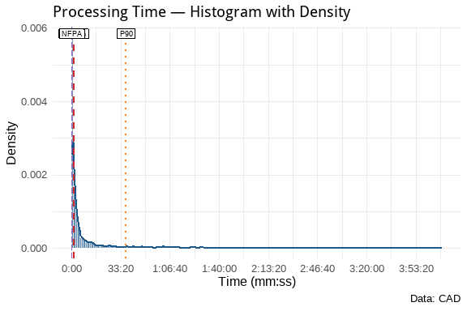

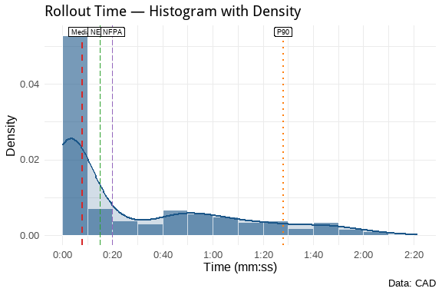

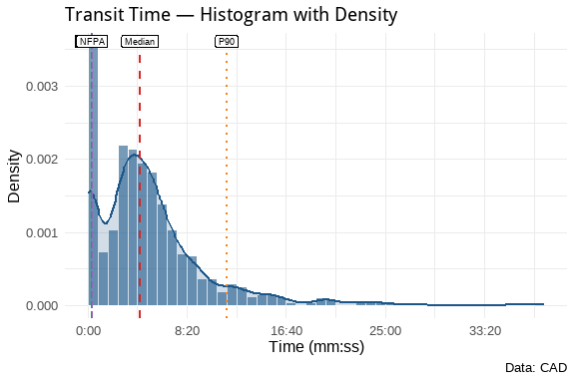

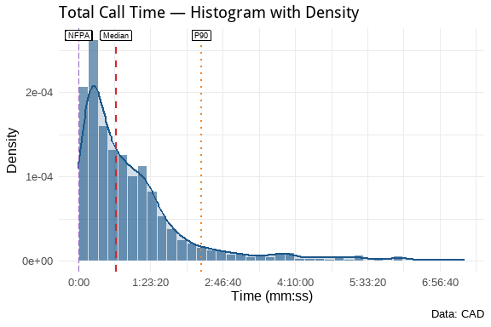

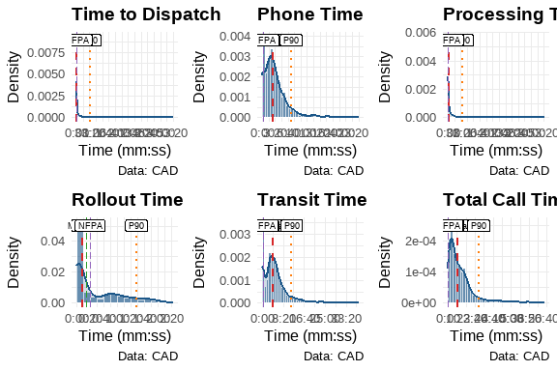

**Plot Key:**

| Line Type/Color | Meaning |
| --- | --- |
| **Dashed Red** | Median |
| **Dotted Orange** | 90th Percentile (P90) |
| **Longdash Green** | NENA 0:15 Standard |
| **Longdash Purple** | NFPA 0:20 Standard |

These show that the processing times for DECC are well within the NENA and NFPA guidelines. This is good operational data to show how well we are performing with repsect ot those guidelines. Over time, we can track these metrics to ensure that we continue to meet or exceed those standards.

## 4 Discipline Analyses

As discussed earlier, we can create additional subsets from this data to look at specific areas of interest. We will create several new datasets from this weekly set for futher analysis. The first will be a dataset that combines APD Priority 1 calls with AFD Priority 1 and 2 calls and evaluates those as emergency calls. We will also create specific datasets for law, fire, and EMS for specific analyses of the disciplines. We will also create datasets that identify calls that exceed certain parameters that have been defined from other reports. Finally, because we have been evaluating Cardiac Arrest calls for some time, we’ll create and analyze that dataset.

By defining these datasets, we can now add to our analyses. For example, we can reuse the same information from above to drill down into APD and AFD calls. Starting with APD calls for service, we can examine everything as we did above.

### 4.1 APD Analyses

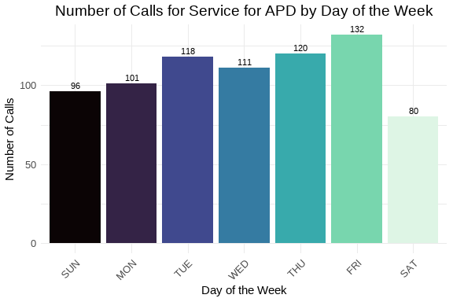

Number of calls for service by day of the week.

Since the majority of service calls are for APD, Thursday should be the expected busiest day of the week, which it is by three calls over Monday. Wednesday appears to be the lightest day of the week for APD service calls. With a differnce of only 24 calls from the highest volume to the lowest, the week was remarkably consistent for service calls.

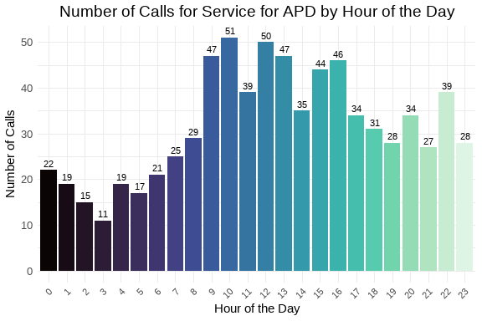

Number of calls for service by hour of the day.

The busiest time of the week for APD calls is from 1200 to 1600 hours. That also is in keeping with the results found for the week overall.

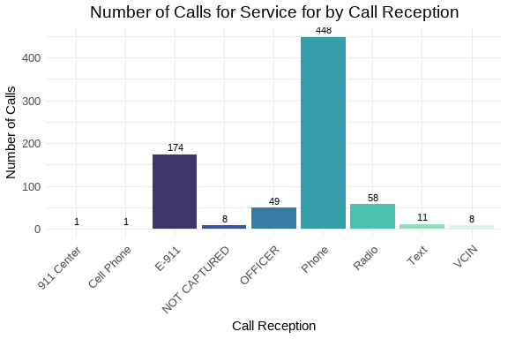

Number of calls for service by call reception.

As can be seen, the majority of calls came through telephone. This comports to the call reception results for the week overall.

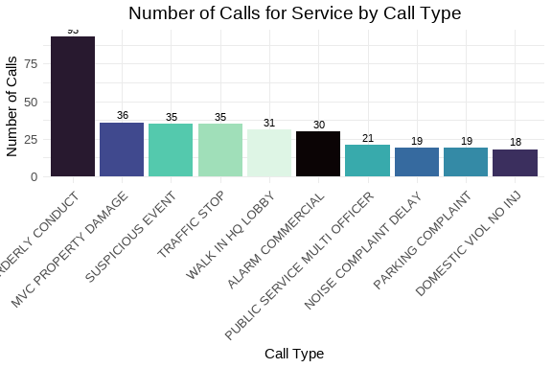

Number of calls for service by call type.

The largest call type was for Disorderly Conduct, which was also the largest call type for the week overall. This could be something to monitor over time to see how the trend changes over time.

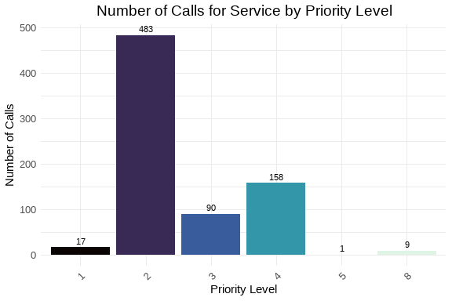

Number of calls for service by priority level.

As expected, the largest number of calls werew Priority 2 calls which represent 63.7 percent of all APD calls. Again, this comports with the overall weekly trends.

Table 1: Weekly Elapsed Time Summary Table

Statistical summary of call processing times

| Time Metric | Min | Mean | Median | Std Dev | Skew | Kurt |
| --- | --- | --- | --- | --- | --- | --- |
| Time To Queue | 0.00 | 76.10 | 55.00 | 76.73 | 2.25 | 8.06 |
| Time To Dispatch | 0.00 | 1,650.35 | 199.50 | 6,957.45 | 14.84 | 284.75 |
| Phone Time | 0.00 | 222.22 | 151.00 | 303.77 | 6.17 | 63.02 |
| Processing Time | 0.00 | 1,726.45 | 290.00 | 6,961.53 | 14.80 | 283.71 |
| Rollout Time | 0.00 | 15.84 | 3.00 | 150.31 | 17.47 | 330.76 |
| Transit Time | 0.00 | 508.30 | 234.50 | 3,000.07 | 22.84 | 554.38 |
| Total Call Time | 50.00 | 4,798.47 | 2,598.00 | 6,120.03 | 2.83 | 11.26 |

This table shows that overall, we have a median time on the phones of about 2.5 minutes and it takes about double that for a call to start and be dispatched. Some of that difference is going to be due to having to hold Priority 4 and above calls until there is a unit available. Since the P4 calls are 20.8 percent of APD calls, this could have a measureable impact on service times for DECC staff.

### 4.2 AFD FIRE Analyses

Because AFD calls for service can be split into two distinct disciplines, fire-related calls and medical-related calls, DECC has, historically, separated the two disciplines for analytical purposes. So this section will look at fire-related calls for service for the week.

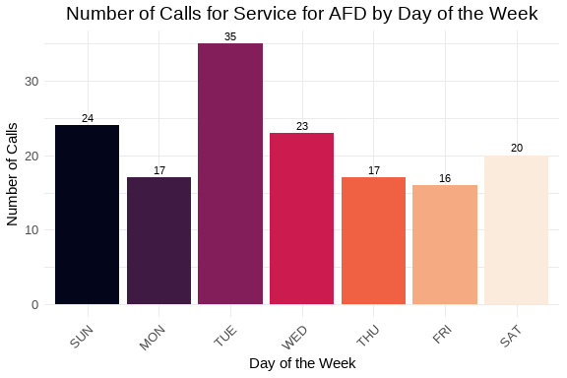

Number of calls for service by day of the week.

It is interesting to note that Thursday was also the busiest day of the week for fire-related calls. Friday followed closely behind, while Sunday and Monday were the lightest days of the week. Sunday had only 12 fire-related calls which is very interesting to note. With football season in full swing, I might have expected more fire-related calls for barbecues and get togethers on Sunday. There could be room to see if there are any correlations between football season and the number of service calls that arrive during the week. For example, if the Commanders play on a day other than Sunday, is there movement in the number of calls for that day?

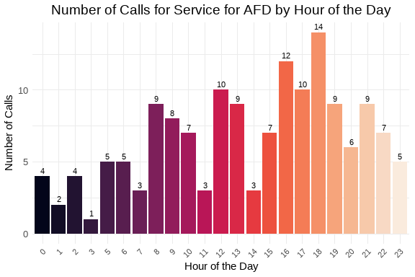

Number of calls for service by hour of the day.

Fire-related calls are much more spread out through the day as can be seen in the graph above. However, the 2000 hour stands out as the hour where the most calls were received for the week. Future reports can determine if this is an anomaly or if there is a trend to more fire-related calls at some point in the evening after most people have returned to their residence for the evening.

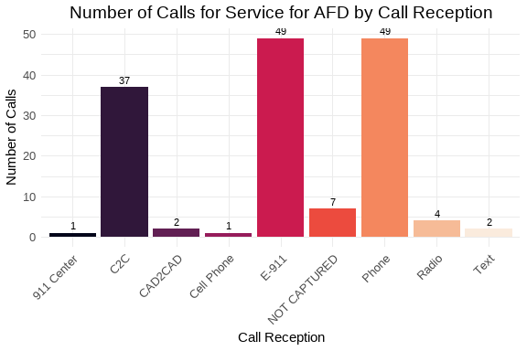

Number of calls for service by call reception.

Like APD calls, most fire-related calls came in via Phone. However the numbers for Mutual Aid and E-911 were larger percentages of the overall volume. In this case, Phone, not necessarily E-911 represented 32.2 percent of all fire-related service calls received.

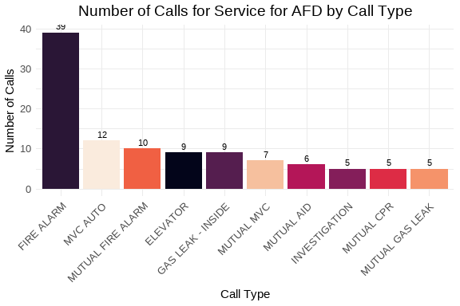

Number of calls for service by call type.

The greatest number of fire-related service calls were for Fire Alarms. That is an interesting observation and should be watched through the future. I do note that MUTUAL-CPR is listed as a “fire-related” call. That will be corrected in future reports.

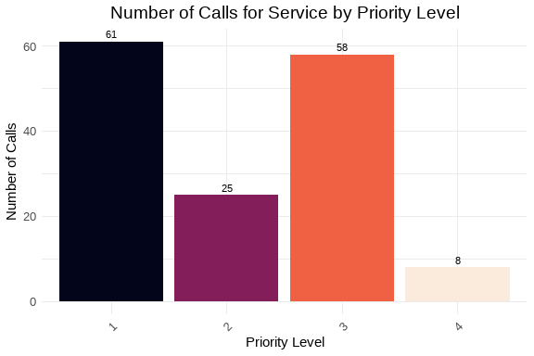

Number of calls for service by priority level.

It is interesting to note that Priority 3 represents the highest number of calls for service. That would correlate to the Fire Alarm call type being the most used.

Table 1: Weekly Elapsed Time Summary Table

Statistical summary of call processing times

| Time Metric | Min | Mean | Median | Std Dev | Skew | Kurt |
| --- | --- | --- | --- | --- | --- | --- |
| Time To Queue | 0.00 | 33.39 | 28.50 | 38.13 | 1.70 | 3.69 |
| Time To Dispatch | 0.00 | 1.89 | 2.00 | 3.88 | 9.46 | 100.44 |
| Phone Time | 0.00 | 195.10 | 135.00 | 281.01 | 5.18 | 35.14 |
| Processing Time | 0.00 | 35.29 | 31.50 | 38.59 | 1.62 | 3.42 |
| Rollout Time | 0.00 | 68.16 | 63.00 | 34.21 | 0.62 | 1.03 |
| Transit Time | 0.00 | 350.47 | 289.00 | 268.57 | 3.49 | 18.27 |
| Total Call Time | 83.00 | 1,345.20 | 1,046.50 | 1,143.05 | 1.99 | 4.96 |

Overall, DECC operations appear to be very efficient at getting fire-related service calls out to the field. The median processing time was only 35 seconds. This shows that we can easily be in compliance with all necessary NENA and NFPA guidelines. The median time on the phone was just over 2 minutes. The mean time was just over 3 minutes which is still amazing.

### 4.3 AFD EMS Analyses

Because AFD calls for service can be split into two distinct disciplines, fire-related calls and medical-related calls, DECC has, historically, separated the two disciplines for analytical purposes. So this section will look at medical-related calls for service for the week.

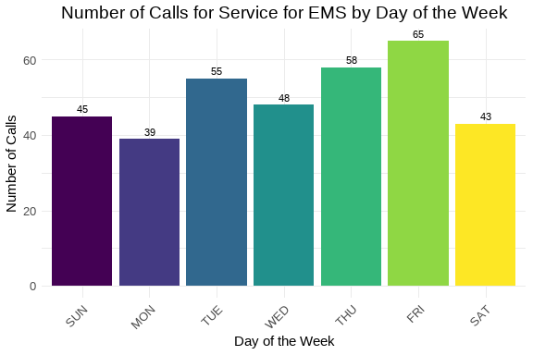

Number of calls for service by day of the week.

Medical service calls by day show a remarkable consistency throughout the week. There is only a difference of 9 service calls separating the busiest and slowest days. Unlike APD and fire-related calls for AFD, Monday was the busiest day of the week for medical service calls. Again, it will be interesting to determine if this holds true over time. Thursday was the second busiest day of the week, trailing Monday by one call.

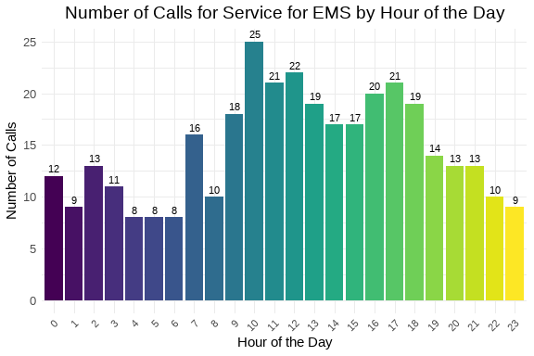

Number of calls for service by hour of the day.

The bulk of the medical service calls appear in the late morning through early afternoon, in a span from 1000 hours through the maximum ending around 1400 hours. In the late afternoon and through the evening, there are spikes where calls fluctuate. This also should be viewed over a larger time frame to see how those will settle out. When seeing how all of these break down, there will be implications as to not only how many staff are needed, but should operations management prioritize some skills at different times to better fit the needs of the City and staff?

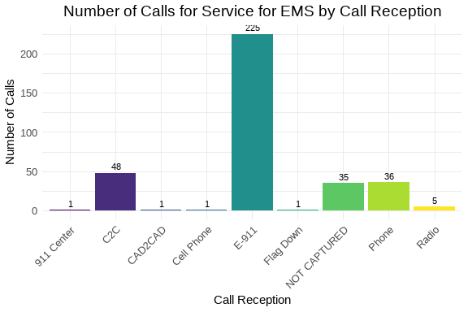

Number of calls for service by call reception.

As expected, the vast majority of medical calls arrive via 911 trunk lines. However, 10.2 percent of medical calls arrived without a method by which we recevied the call. We should track this further to see if this is a one-off or if there is some issue that needs to be addressed.

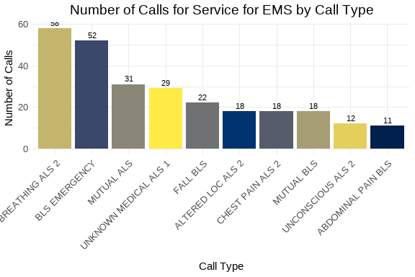

Number of calls for service by call type.

Breathing issues and BLS Emergency calls were the two most prevalent call types for the week. As we’re winding summer down and heading into autumn, we may see an increase in instances of breathing issues until we reach the first hard freeze and pollen is no longer an issues=.

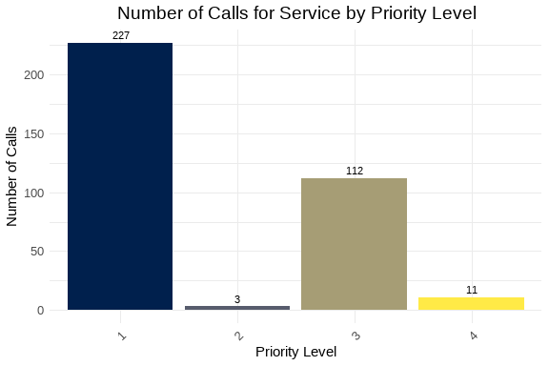

Number of calls for service by priority level.

The majority of medical service calls are P1, which is to be expected. P3 calls were the second most prevalent.

Table 1: Weekly Elapsed Time Summary Table

Statistical summary of call processing times

| Time Metric | Min | Mean | Median | Std Dev | Skew | Kurtosis |
| --- | --- | --- | --- | --- | --- | --- |
| Time To Queue | 0.00 | 43.44 | 41.00 | 40.09 | 1.18 | 2.11 |
| Time To Dispatch | 0.00 | 3.02 | 2.00 | 14.89 | 17.10 | 305.69 |
| Phone Time | 0.00 | 253.30 | 194.00 | 292.89 | 3.38 | 15.00 |
| Processing Time | 0.00 | 46.46 | 44.00 | 42.89 | 1.60 | 5.28 |
| Rollout Time | 4.00 | 61.91 | 59.00 | 31.07 | 0.23 | -0.59 |
| Transit Time | 70.00 | 292.59 | 265.00 | 183.84 | 6.43 | 72.75 |
| Total Call Time | 41.00 | 3,493.03 | 3,616.00 | 2,076.47 | 0.28 | -0.16 |

The median time to process medical calls was 49 seconds. Again, this puts us in good form when examening our operational efficiency. We take longer on the phone for medical calls than we do fire-related calls. Again this is to be expected. The triage process should take longer to ensure that we are giving the best service to our community that we can.

## 5 Additional Analyses

Earlier, for this analysis, we created some additional datasets that we can investigate in the course of our analysis. The first two are lists of calls where the elapsed time prior to release to queue or the time spent in dispatch is greater than 60 seconds for *emergency* calls. For the first, there are 74 emergency service calls where the elapsed time from call start to the call entering the queue for dispatch was over 60 seconds. There are also 4 emergency service calls where the elapsed time from entering queue to the first unit assigned was over 60 seconds.

### 5.1 Possible Service Delays

We can look at the datasets and see if there are telecommunicators who may experience more challenging calls during the week. First will be a table of telecommunicators who worked emergency calls that took longer than 60 seconds to go from start to queue. The second will be a table of dispatchers who assigned an emergency call that waited in queue longer than 60 seconds.

Frequency of Call Taker in Delayed TTQ Calls (Descending)

| Call Taker | Count |
| --- | --- |
| JACKSON, MALIKA | 7 |
| WILLIAMS, DARNELL | 7 |
| CRUZ, STEPHANIE | 6 |
| BELLAMY, LATITIA | 4 |
| BONSU, VALERIE | 4 |
| BRYANT, THEO | 4 |
| GARCIA, VILMA | 4 |
| GOODWIN, SHEENA | 4 |
| MACK, BRIANA | 4 |
| MCLEOD, DOUGLAS | 4 |
| FOSTER, KANESHA | 3 |
| LEWIS, LESLIE | 3 |
| PERALTA, ANNETTE | 3 |
| PEREZ, CARLOS | 3 |
| WALKER, JUANITA | 3 |
| DEWBERRY, RE’KEYA | 2 |
| GATTO, GIANNA | 2 |
| GRAVES, CHRISTINA | 2 |
| PICKERAL, LAUREN | 2 |
| DOGAN, KYLAH | 1 |
| FLOURNOY, ERICKA | 1 |
| SMITH, TERESA | 1 |

From this, since there are a small number of telecommunicators who have more than one call in the table above, there may not be any need for amerlioration. This, however, could be something that is included in the report template in order to monitor. Should a telecommunicator appear multiple times in this table over a period of time, additional training or mentoring may be called for.

Frequency of Dispatcher in Delayed TTD Calls (Descending)

| Dispatcher | Count |
| --- | --- |
| BONSU, VALERIE | 1 |
| LEWIS, LESLIE | 1 |
| WALKER, KAREN | 1 |
| WATSON, JOANNE | 1 |

This list is fairly short and could simply be monitored in future should the need arise.

## 6 High-Priority and Critical Calls

In this section, we will focus on the calls that are deemed high-priority or critical. This includes APD Priority 1 calls and AFD Priority 1 and 2 calls. We have identified these calls in the df_hp dataset created earlier.

### 6.1 High-Priority Call Types

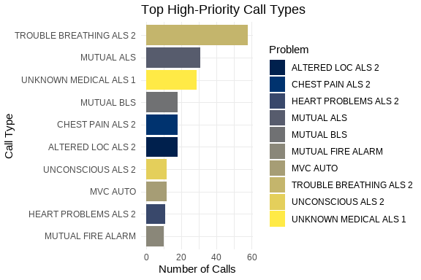

Top High-Priority Call Types

Almost all of the problem types in this graph belong to AFD and are medical calls. Based on the information above, this is to be expected.

### 6.2 High-Priority Response Times

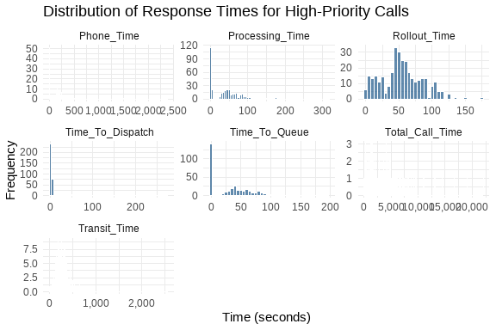

High-Priority Call Response Times

These histograms show that, overall, our record for handling these calls is excellent.

## 7 Cardiac Arrest Calls Analysis

Finally, we will look into the specific subset of calls that are related to cardiac arrests. These calls have been identified in the df_ca dataset.

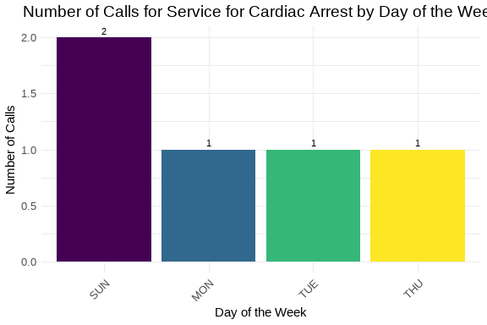

Cardiac Arrest Call Volume by Day and Hour

As we can see, with a very limited number of cardiac arrest calls for the week, the standout day was Friday with 2 calls. There were only two other days with 1 call each.

Table 1: Weekly Elapsed Time Summary Table

Statistical summary of call processing times

| Time Metric | Min | Mean | Median | Std Dev | Skew | Kurtosis |
| --- | --- | --- | --- | --- | --- | --- |
| Time To Queue | 37.00 | 61.40 | 41.00 | 48.45 | 1.07 | 0.24 |
| Time To Dispatch | 2.00 | 2.60 | 2.00 | 0.89 | 0.60 | -0.92 |
| Phone Time | 50.00 | 392.20 | 408.00 | 304.09 | 0.11 | -1.37 |
| Processing Time | 39.00 | 64.00 | 44.00 | 48.15 | 1.06 | 0.23 |
| Rollout Time | 21.00 | 54.00 | 60.00 | 19.38 | -0.81 | -0.13 |
| Transit Time | 80.00 | 197.80 | 197.00 | 108.42 | 0.00 | -1.71 |
| Total Call Time | 1,251.00 | 3,670.00 | 4,233.00 | 1,627.71 | -0.45 | -1.14 |

Cardiac Arrest Call Response Times

However, we can see that the median time to process a cardiac arrest and get the units rolling is about 42.5 seconds. The median time that we are on the phone is significantly longer, around 8.5 minutes. That is to be expected since the calltaker is likely giving T-CPR instructions while the units are en route.

### 7.1 Mental Health Analyses

With the advent of Marcus’ Law in Virginia, there has been an emphasis on how mental health calls are processed and serviced. The following analyses will focus on the mental health calls that have been defined as such after consultation with DCHS.

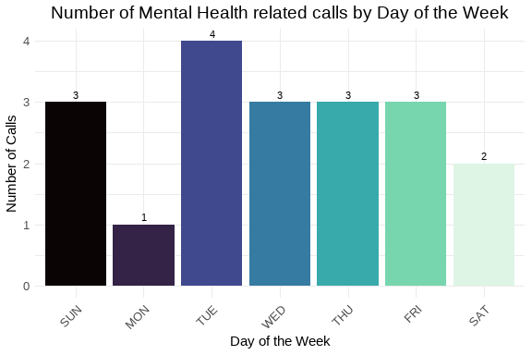

Number of calls for service by day of the week.

The number of mental health related calls appears to spike on the weekends with Sunday being the busiest. Friday and Saturday are trailing by only 1 call each. If this trend repeats over the course of several weeks, this could be useful insight that could be shared with DCHS and APD to ensure that we have resources properly staffed to address the community’s needs.

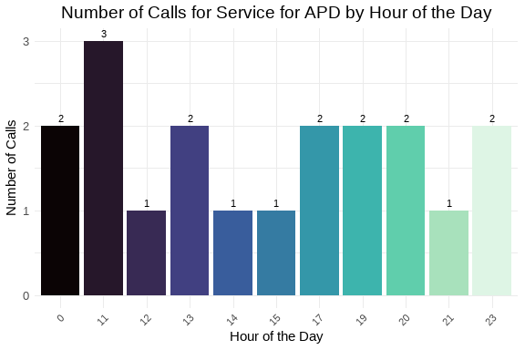

Number of calls for service by hour of the day.

Most of these calls arrived, for this past week, in the late afternoon and evenings. Midnight also appears to be a secondary volume spike. Again, should this data prove to be part of a trend, then we should adjust the availability of repsonders to address the community’s needs.

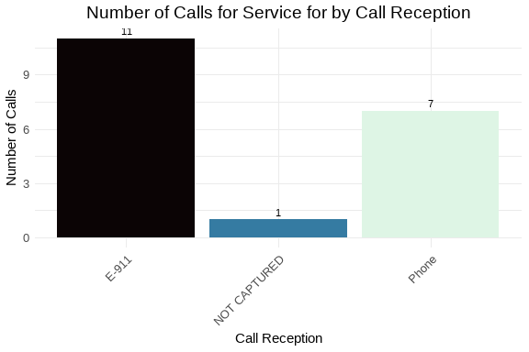

Number of calls for service by call reception.

As expected, most of the calls arrived by either phone, trunk line not defined, or from E-911 service calls. Further analysis could be understaken to determine if any of these are transfer calls from our local 988 provider partner.

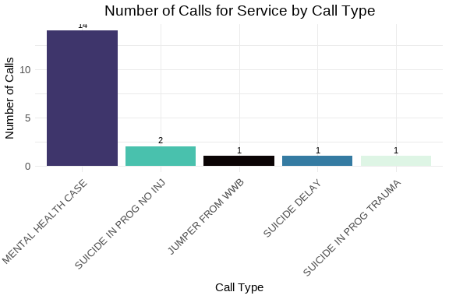

Number of calls for service by call type.

The most used call type was Mental Health Case which is expected.

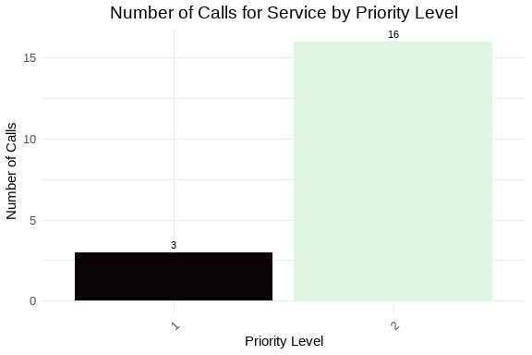

Number of calls for service by priority level.

Since Mental Health Case was the most used call type and is a P2 call, Priority 2 is the most used priority. The question, in the future, will be does these calls need to changed to a higher priority?

Table 1: Weekly Elapsed Time Summary Table

Statistical summary of call processing times

| Time Metric | Min | Mean | Median | Std Dev | Skew | Kurt |
| --- | --- | --- | --- | --- | --- | --- |
| Time To Queue | 0.00 | 101.63 | 81.00 | 92.78 | 1.12 | 0.91 |
| Time To Dispatch | 2.00 | 1,687.53 | 310.00 | 2,878.47 | 2.10 | 4.80 |
| Phone Time | 0.00 | 342.95 | 256.00 | 370.07 | 2.39 | 6.86 |
| Processing Time | 52.00 | 1,789.16 | 557.00 | 2,906.64 | 2.12 | 4.92 |
| Rollout Time | 0.00 | 9.37 | 4.00 | 15.10 | 2.10 | 3.78 |
| Transit Time | 129.00 | 453.67 | 444.50 | 224.59 | 0.65 | 0.13 |
| Total Call Time | 715.00 | 8,134.68 | 5,498.00 | 8,032.00 | 1.10 | 0.27 |

Processing times for these calls are longer, somewhere around 5.5 minutes. There are several factors that can impact this. The time to make it dispatchable was longer, implying that with these types of calls, it take calltakers longer to get the information necessary in the initial triage to accurately locate and classify the call. Another possible issue, in reviewing the dispatch times is that these calls require specialized training and skill sets on the part of the field responders. If those responders are already assigned to other calls, this could create the delay as seen here. As these values change over time, we should be able to build better pictures and determine the delay points and create strategies to ameliorate them.

## 8 Conclusion

This report has covered various aspects of the calls for service during week 35, 2025. We have analyzed the data for completeness and accuracy, explored it for insights into call patterns and trends, and focused on specific areas of interest such as high-priority calls and cardiac arrest incidents. The findings will assist in making informed decisions to improve service delivery and operational efficiency.