HW3

Part 1 A

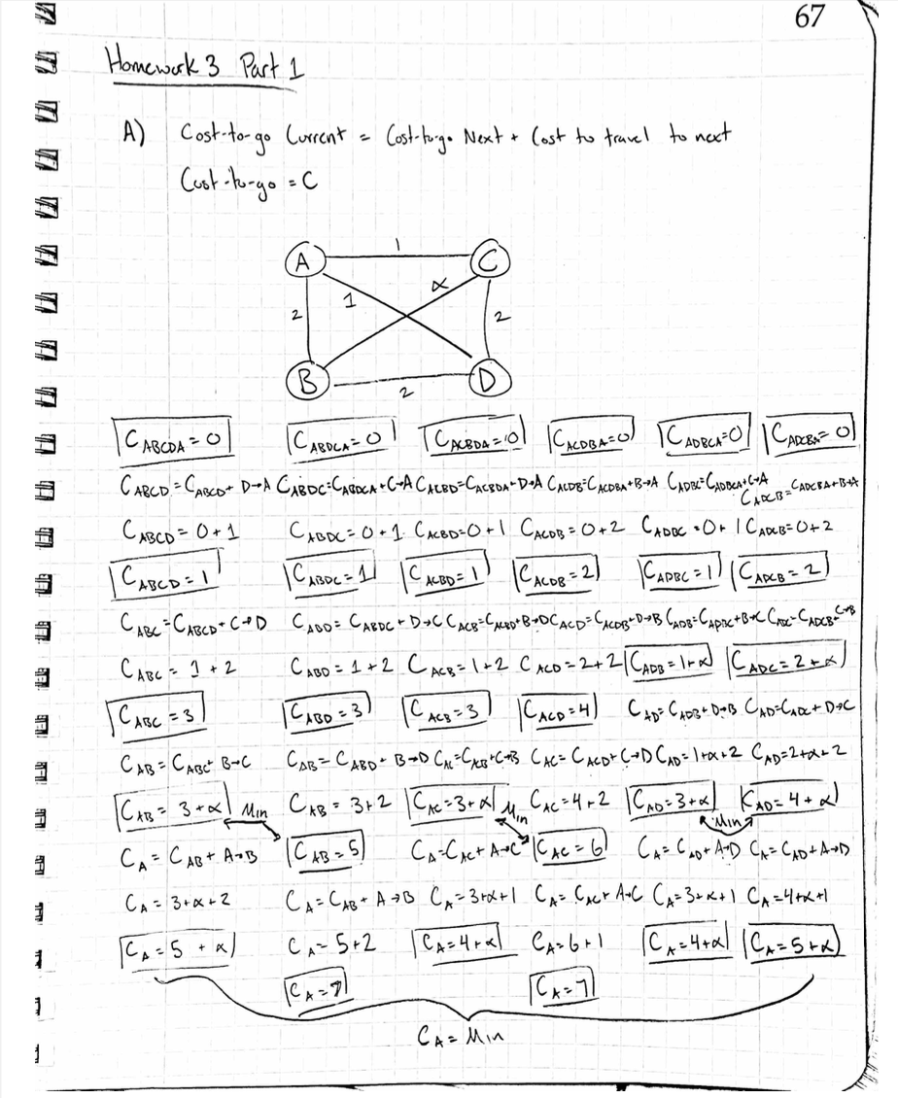

Part1B

Part2B-iii

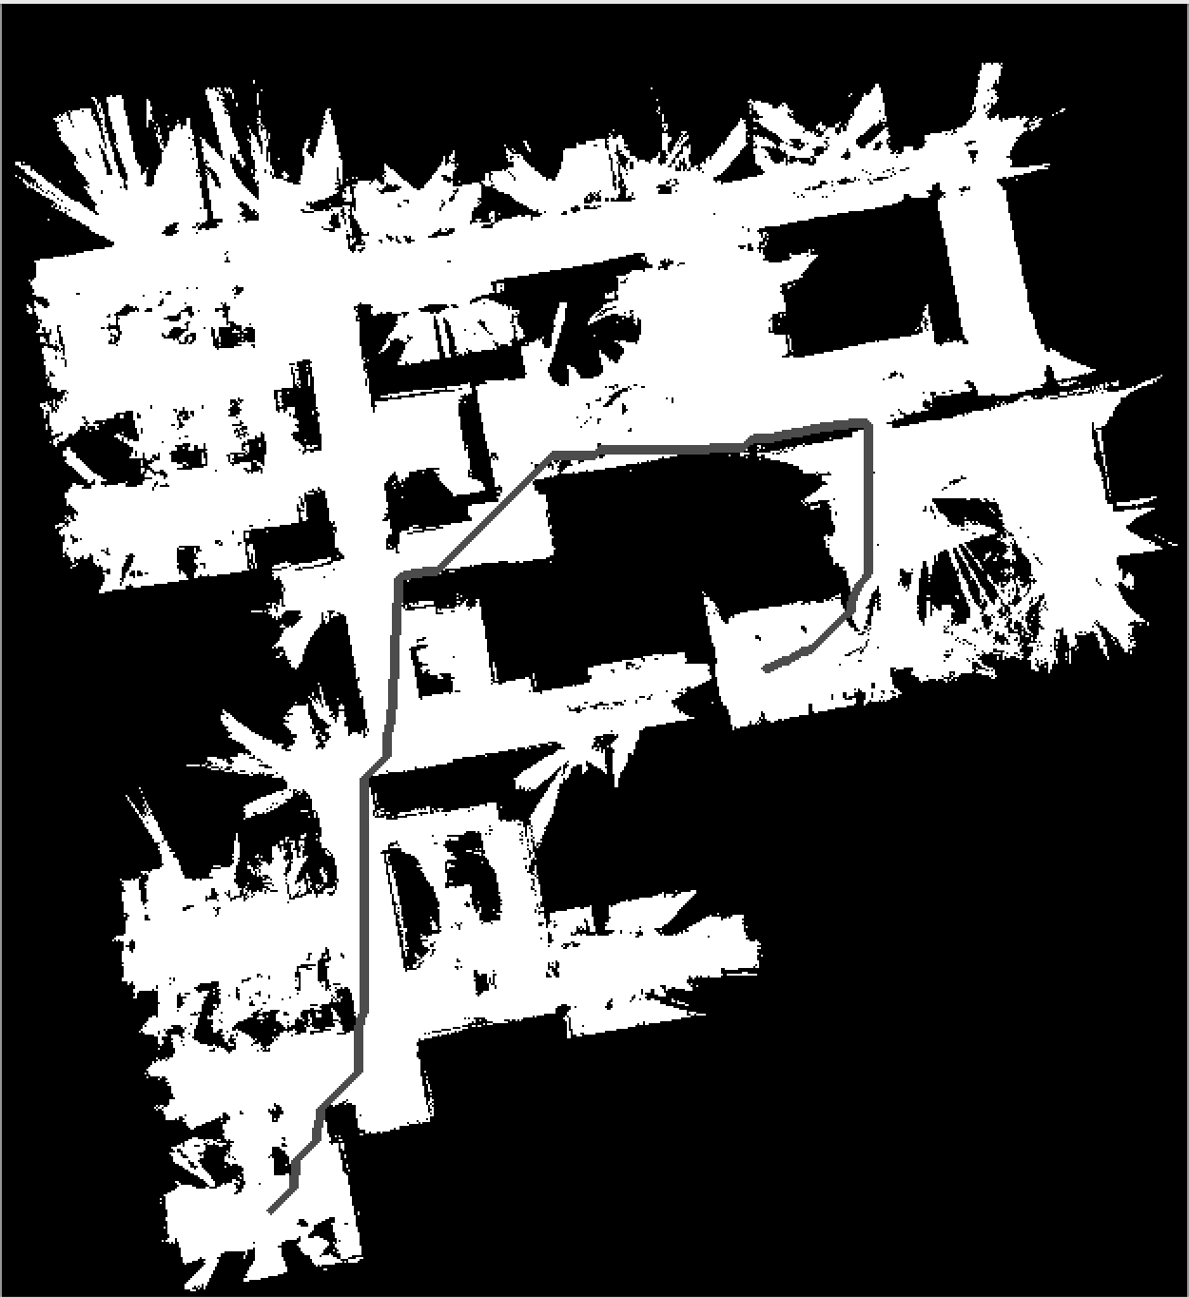

Total length: 801.7

Part2C-iv (2500 samples)

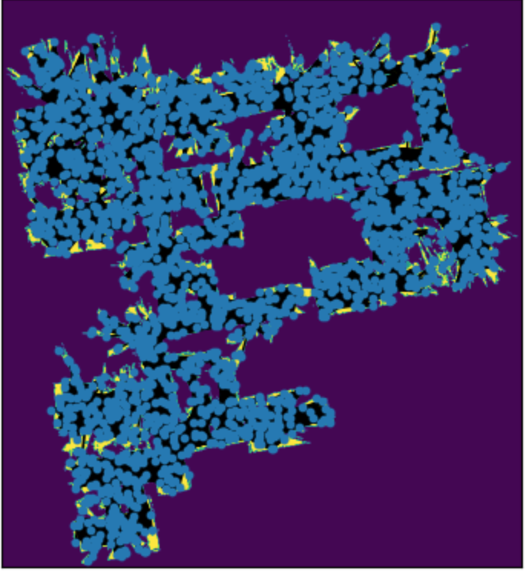

Part2C-iv (300 samples for fun)

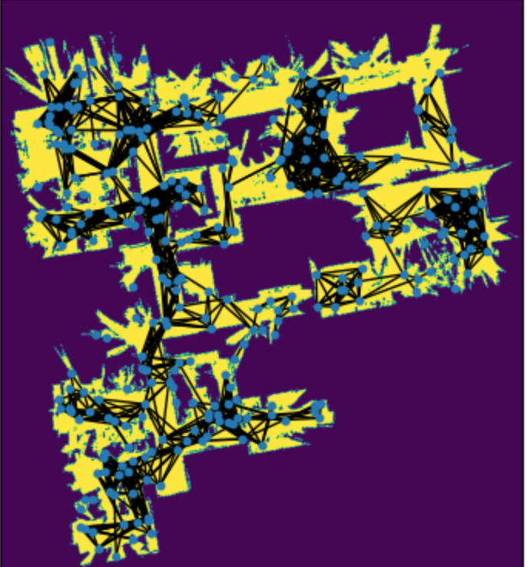

PartC-v (2500 samples)

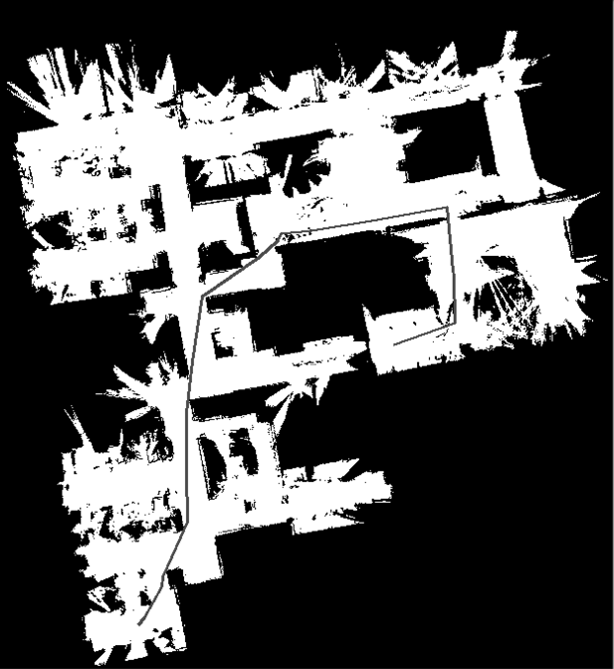

Total length = 806.41

PartC-v (300 samples for fun)

