Query Calculations – Expressions, Math, and Behavior
In my report, I’d like to use queries to pull a revenue number and cost number. Then, I’d like to divide cost by revenue.
I've got a query Storage D3 HW Non-BMC Cost from which I'm ultimately interested in the (I'm not sure if 'aggregate' is the right word, but just 1 single number -- the sum of the column, not the array of values) CY Cost Act @ PC . If I use a Query Calculation object in the page of my report with the expression [Storage D3 HW Non-BMC Cost].[CY Cost Act @ PC] it will give me that single number: 6.8M. In that Query Calculation object, I name that data-item-expression CY Cost.
Query: 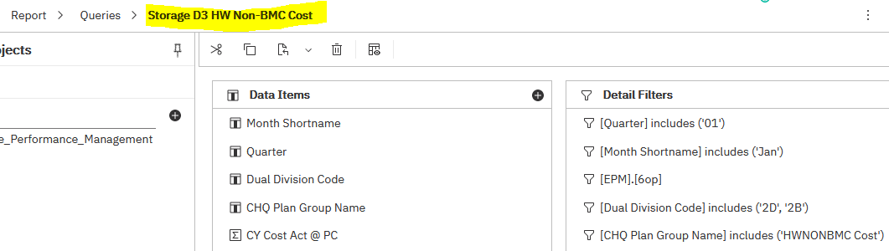
Query Calculation Expression: 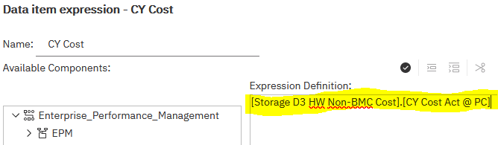
Query Calculation Result: 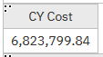

In that same fashion, I create another query Storage D3 Rev from which I'm ultimately interested in just 1 single number CY Rev Act @ PC and insert a Query Calculation object in the page of my report with the expression [Storage D3 Rev].[CY Rev Act @ PC] which returns the answer: 18.1M. In that Query Calculation object, I name the data-item-expression CY Rev.
Query: 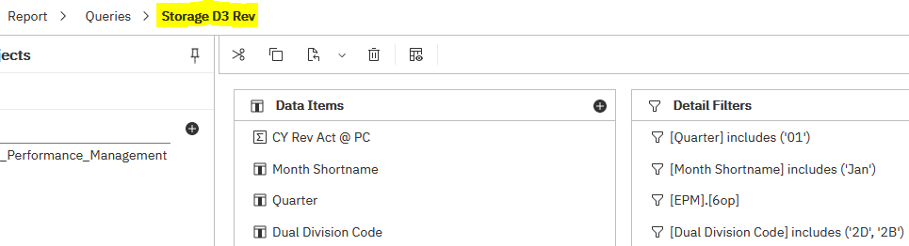
Query Calculation Expression: 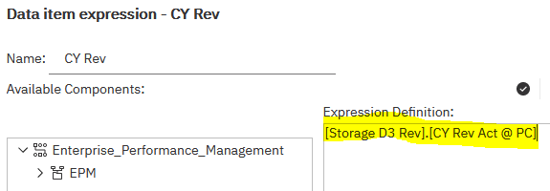
Query Calulation Result: 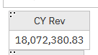
Now, I want a 3rd final Query Calculation Object. I just want it to divide the Cost by the Revenue; 6.8 / 18.1 = 0.38
You may expect that,
if the expression [Storage D3 HW Non-BMC Cost].[CY Cost Act @ PC] returns 6.8M
and the expression [Storage D3 Rev].[CY Rev Act @ PC] returns 18.1M
then, the expression
[Storage D3 HW Non-BMC Cost].[CY Cost Act @ PC] / [Storage D3 Rev].[CY Rev Act @ PC] would return 0.38
But that is not the default behavior in EPM.

Query Calculation Expression: 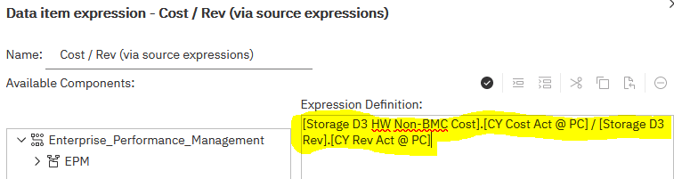
Query Calculation Result: 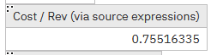

However, If I were to reference the names of the data items -- that result from those expressions -- in the two Query Calculation Objects -- whose generated queries I renamed “Cost Number” & “Rev Number” -- in my third Query Calculation’s expression -- [Cost Number].[CY Cost] / [Rev Number].[CY Rev] – it does return the 0.38 I expect.
Query Calculation Expression: 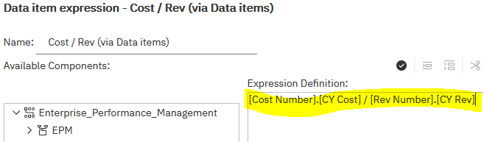
Query Calculation Result: 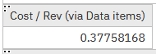
This seems somewhat ambiguous to me. It’s not exactly immediately obvious why the two expressions behave differently.
It has to do with detail granularity and aggregation.
In the first attempt -- [Storage D3 HW Non-BMC Cost].[CY Cost Act @ PC] / [Storage D3 Rev].[CY Rev Act @ PC] -- we’re performing a mathematical operation on two tables of information with different levels of granularity (the Cost query has an additional slice by CHQ Plan Group Name) which introduces unpredicatble behavior and issues. The tables will be joined and the Cost value for each row will be divided by Revenue value for each row, however, the Cost table will have more rows with Cost values because it’s more granular and those rows will not gain a Revenue value after the join, because the Revenue query doesn’t have that level of granularity and thus, the resulting answer will be senseless.
So, now we understand that it’s doing the calculation at the row level, which is not what we want. We can however still use the expression [Storage D3 HW Non-BMC Cost].[CY Cost Act @ PC] / [Storage D3 Rev].[CY Rev Act @ PC] to calculate the intended Data Item if we change the Detail Aggregation property of the Data Item in its Query Calculation to just do the operation at the Total level.
Query Calculation Expression: 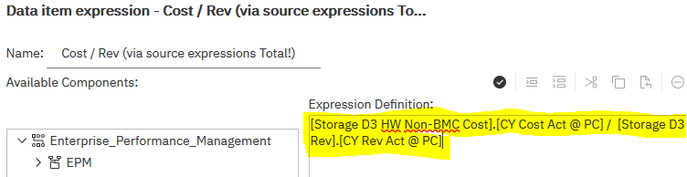
Query Calculation Expression’s Data Item Object Properties:
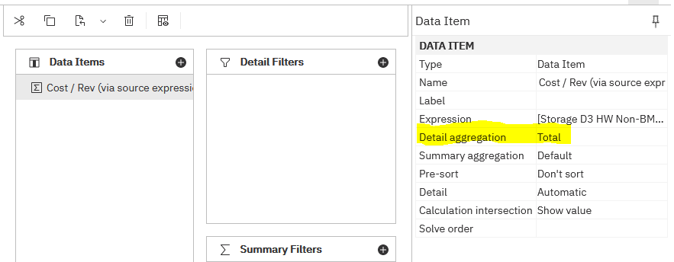
Query Calculation Result: 