WASH SURVEY REPORT
Water, Sanitation & Hygiene - Cote d'Ivoire
________________________________________
Goh & Loh Djiboua Regions | January-February 2026 | N = 1,000 households

1,000 households | 166 variables | 2 departments | 8 sub-prefectures

Section 1 - Executive Summary
This WASH survey was conducted among 1,000 households distributed across the departments of Goh (570) and Loh Djiboua (430) in Cote d'Ivoire, covering 8 sub-prefectures between January and February 2026. The data collected covers 166 indicators on water, sanitation, waste management, atmospheric pollution and natural resources availability.
1.1 Key Performance Indicators (KPIs)
1,000 | 40% | 70.9%
Households surveyed  Jan (358) + Feb (642) | Poor water quality  400 households | Untreated water  709 households
33.6% | 49.4% | 58%
No latrine  336 households | Atmospheric pollution  494 reports | Sufficient water  580 satisfied households

1.2 Key Alerts
>> CRITICAL ALERT - Water Quality: 40% of households have poor quality water and 70.9% do not treat their water before consumption. High risk of waterborne diseases.
>> CRITICAL ALERT - Sanitation: 33.6% of households have no latrines. Coverage of improved latrines remains very low (9%).
>> CONCERN - Waterborne Diseases: 27.1% of households report water-related diseases. Diarrhea dominates (~180 cases) followed by typhoid (~120 cases).
>> CONCERN - Natural Resources: 57.7% of households report resource degradation. 38.4% consider them scarce, and 16% consider them near depletion.
>> POSITIVE POINT - Water Availability: 58% of households have a sufficient quantity of water for their daily needs.

Section 2 - Context & Methodology
The 2026 WASH survey aims to assess the conditions of access to drinking water, the state of sanitation and hygiene practices in the Goh and Loh Djiboua regions. These two departments face significant challenges in terms of public health and environmental management.
2.1 Sample distribution by department
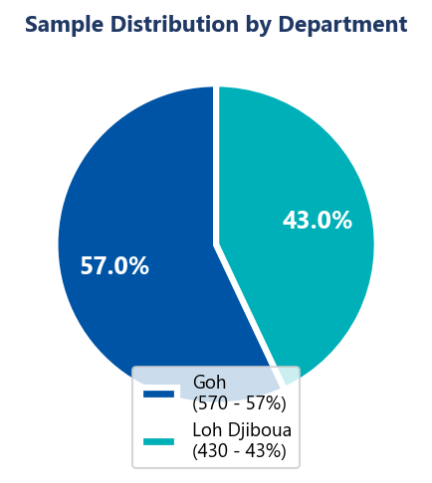
Figure 1 - Sample distribution by department (N=1000)
2.2 Distribution by sub-prefecture
Table 1 - Distribution by sub-prefecture
Sub-prefecture | Department | Surveys | % of sample
Gagnoa | Goh | ~115 | ~11.5%
Bayota | Goh | ~95 | ~9.5%
Ouragahio | Goh | ~90 | ~9.0%
Guitry | Goh | ~88 | ~8.8%
Guiberoua | Goh | ~85 | ~8.5%
Divo | Loh Djiboua | ~155 | ~15.5%
Lakota | Loh Djiboua | ~140 | ~14.0%
Hire | Loh Djiboua | ~135 | ~13.5%
TOTAL | 2 departments | 1,000 | 100%

Table 2 - Data collection tools and variables
Theme | Key variables | Type
Drinking water | Source, quality, access time, treatment | Quantitative
Water health | Water-related diseases, frequency, type | Mixed
Sanitation | Latrine type, hygiene practices | Quantitative
Waste | Disposal method, satisfaction, exposure | Quantitative
Environment | Pollution, air quality, noise nuisances | Qualitative
Resources | Availability, degradation, stewardship | Qualitative

Section 3 - Water & Sanitation
Access to drinking water is one of the major challenges identified in this survey. While 58% of households have a sufficient quantity of water, quality remains concerning with 40% poor quality water and only 29.1% of households treating their water.
3.1 Water supply sources
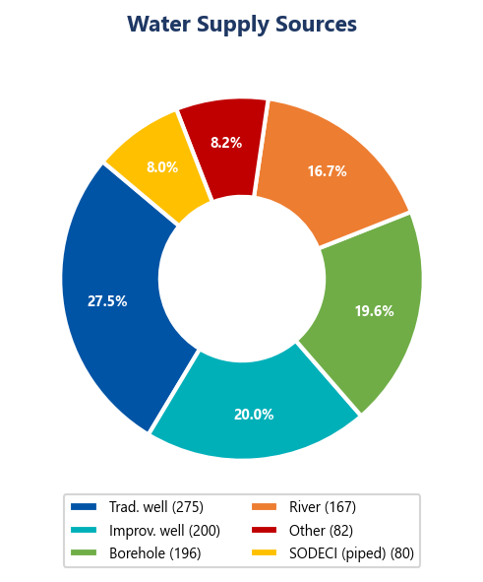
Figure 2 - Water supply sources (N=1000)
Table 3 - Water source details
Source | No. households | % | Risk
Traditional well | 275 | 27.5% | High
Improved well | 200 | 20.0% | Moderate
Borehole | 196 | 19.6% | Low
River / Spring | 167 | 16.7% | Very high
Other | 82 | 8.2% | Undetermined
SODECI (piped) | 80 | 8.0% | Low
Total | 1,000 | 100% | -

3.2 Water quality by department
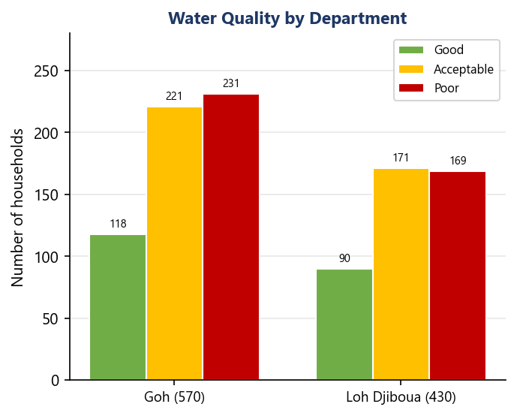
Figure 3 - Perceived water quality by department
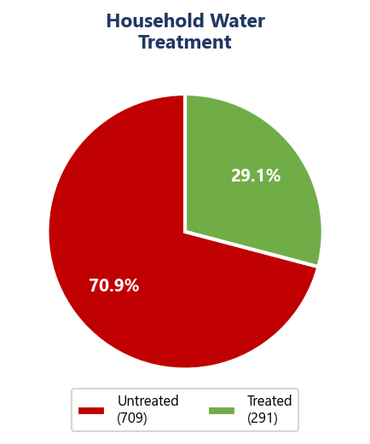
Figure 4 - Household water treatment
Table 4 - Water quality by department
Department | Good | Acceptable | Poor | Total | % poor
Goh | 118 (20.7%) | 221 (38.8%) | 231 (40.5%) | 570 | 40.5%
Loh Djiboua | 90 (20.9%) | 171 (39.8%) | 169 (39.3%) | 430 | 39.3%
Total | 208 (20.8%) | 392 (39.2%) | 400 (40.0%) | 1,000 | 40.0%

3.3 Water access and waterborne diseases
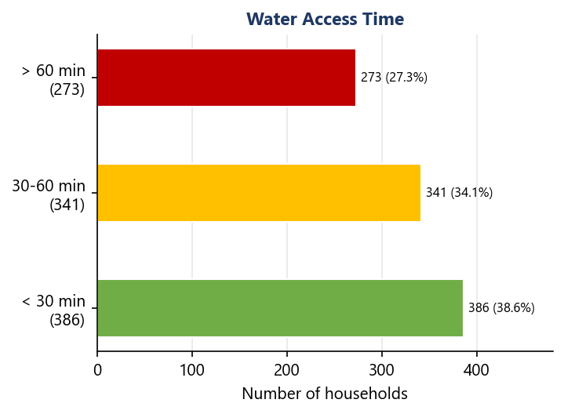
Figure 5 - Time to reach water source
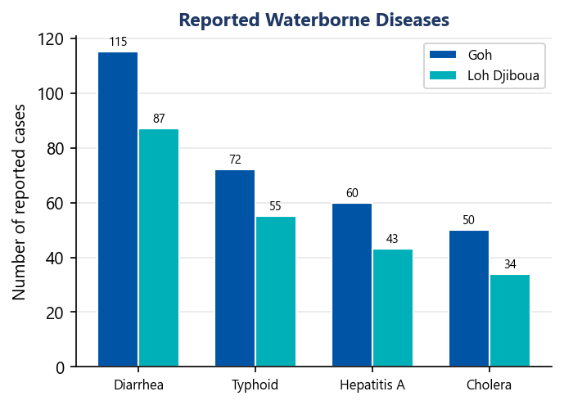
Figure 6 - Reported waterborne diseases by department
Table 5 - Water access time and implications
Time bracket | Households | % | WHO standard | Status
Under 30 minutes | 386 | 38.6% | Compliant | Acceptable
30 to 60 minutes | 341 | 34.1% | Borderline | Caution
Over 60 minutes | 273 | 27.3% | Non-compliant | Critical

Table 6 - Reported waterborne diseases
Disease | Goh | Loh Djiboua | Estimated total | Severity
Diarrhea | ~115 | ~87 | ~202 | Moderate
Typhoid | ~72 | ~55 | ~127 | High
Hepatitis A | ~60 | ~43 | ~103 | High
Cholera | ~50 | ~34 | ~84 | Very high
Total reported | ~297 | ~219 | ~516 cases | -

Section 4 - Sanitation Infrastructure
Sanitation represents a major challenge in both departments. Nearly one third of households (33.6%) have no access to latrines, and only 14.8% have improved latrines or modern toilets, far from SDG 6 targets.
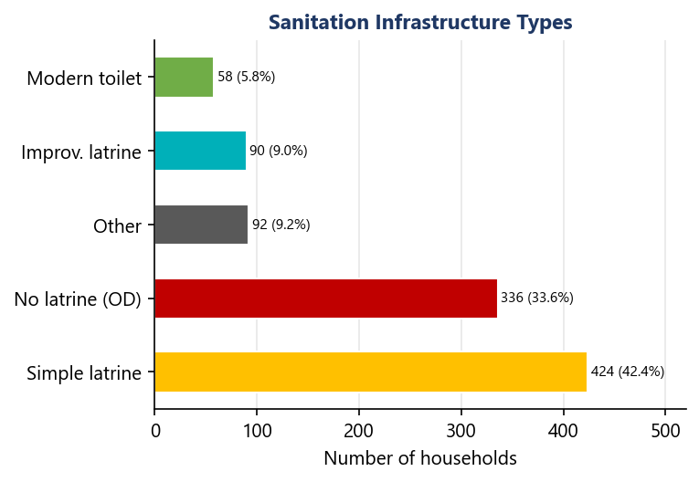
Figure 7 - Sanitation infrastructure types (N=1000)
Table 7 - Latrine types and SDG 6 compliance
Infrastructure type | No. households | % | SDG 6 compliance
Simple latrine | 424 | 42.4% | Partial
No latrine (open defecation) | 336 | 33.6% | Non-compliant
Other type | 92 | 9.2% | Undetermined
Improved latrine | 90 | 9.0% | Compliant
Modern toilet | 58 | 5.8% | Compliant
Total | 1,000 | 100% | -

Table 8 - Sanitation indicators vs SDG 6 targets
Indicator | Value | SDG 6 target | Gap
Access to latrines (all types) | 66.4% | 100% | -33.6 pts
Improved latrines + modern toilets | 14.8% | 100% | -85.2 pts
Open defecation (OD) | 33.6% | 0% | +33.6 pts
Household water treatment | 29.1% | 100% | -70.9 pts

Section 5 - Waste Management
Waste management is a complex issue in both departments. 52.3% of households are exposed to open dumps. Satisfaction remains mostly negative with 62% of households somewhat or completely unsatisfied with current management.
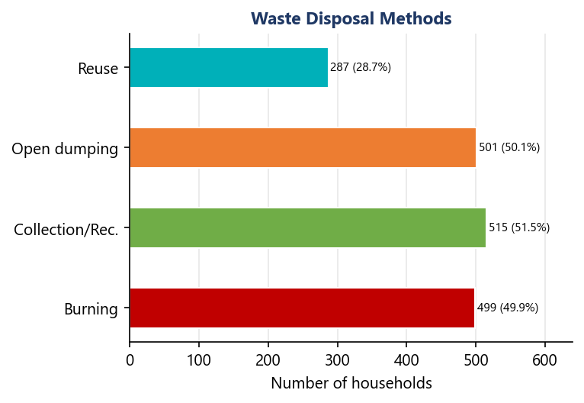
Figure 8 - Waste disposal methods
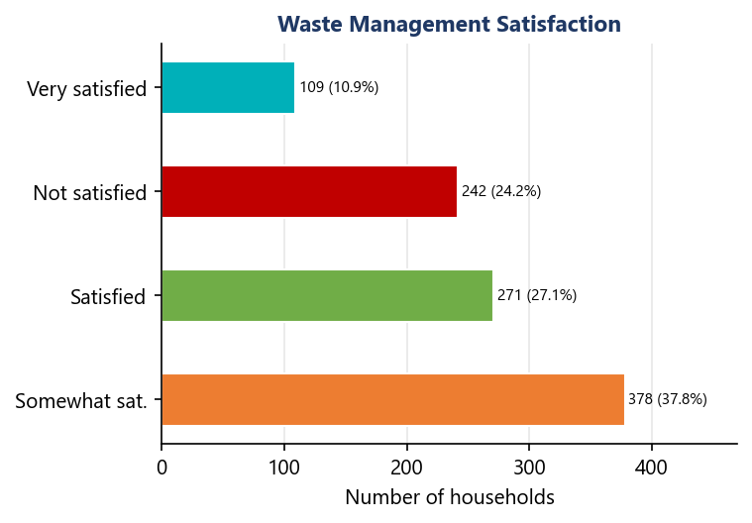
Figure 9 - Waste management satisfaction
Table 9 - Waste disposal methods
Disposal method | Households | % | Environmental impact
Collection / Recycling | 515 | 51.5% | Positive
Open dumping | 501 | 50.1% | Very negative
Burning | 499 | 49.9% | Negative
Reuse | 287 | 28.7% | Positive

Table 10 - Waste management satisfaction
Satisfaction level | Households | % | Trend
Somewhat satisfied | 378 | 37.8% | Negative
Satisfied | 271 | 27.1% | Positive
Not satisfied | 242 | 24.2% | Negative
Very satisfied | 109 | 10.9% | Positive
Total | 1,000 | 100% | -

Section 6 - Atmospheric Pollution
Atmospheric pollution is reported by nearly one household in two (49.4%). Air quality is judged poor or very poor by 51.6% of respondents. Noise nuisances also affect a majority of households (57.3%).
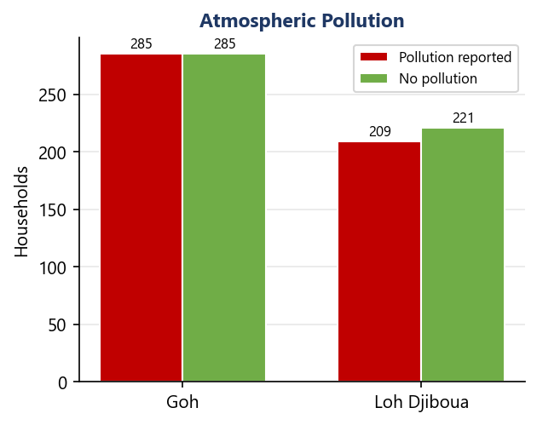
Figure 10 - Reported atmospheric pollution by department
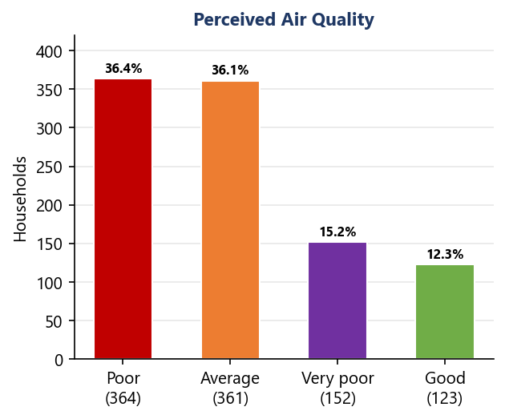
Figure 11 - Perceived air quality (N=1000)
Table 11 - Pollution and air quality indicators
Indicator | Households | % | Risk level
Atmospheric pollution reported | 494 | 49.4% | Concerning
Air quality: Poor | 364 | 36.4% | Critical
Air quality: Average | 361 | 36.1% | Moderate
Air quality: Very poor | 152 | 15.2% | Very critical
Air quality: Good | 123 | 12.3% | Acceptable
Noise nuisances | 573 | 57.3% | Concerning

Table 12 - Pollution by department
Department | Pollution reported | No pollution | Rate
Goh | 285 | 285 | 50.0%
Loh Djiboua | 209 | 221 | 48.6%
Total | 494 | 506 | 49.4%

Section 7 - Natural Resources
The natural resources situation is alarming: 57.7% of households report resource degradation, and only 12.1% consider them abundant. This situation indicates growing awareness but practices that remain insufficient to reverse the trend.
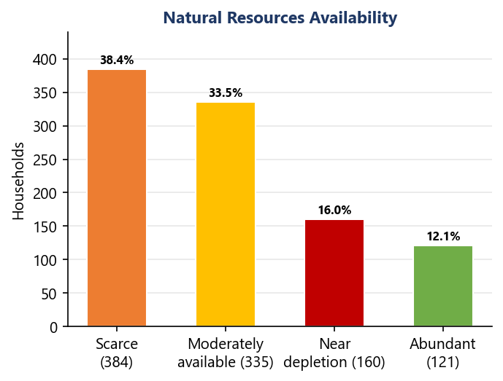
Figure 12 - Perceived natural resources availability (N=1000)
Table 13 - Natural resources availability
Availability level | Households | % | Status
Scarce | 384 | 38.4% | Critical
Moderately available | 335 | 33.5% | Precarious
Near depletion | 160 | 16.0% | Emergency
Abundant | 121 | 12.1% | Favorable

Table 14 - Natural resources and environmental stewardship indicators
Resources indicator | Value | Interpretation
Degradation reported | 57.7% (577) | Critical situation
Environmental stewardship: Strong | 35.8% (358) | Awareness present
Environmental stewardship: Moderate | 30.8% (308) | Needs reinforcement
Environmental stewardship: Very strong | 18.3% (183) | Committed minority
Environmental stewardship: Weak | 15.1% (151) | High risk

Section 8 - Comparative Analysis
The comparison of WASH indicators between the two departments reveals relatively similar profiles. The Goh department shows slightly more disease cases and a higher proportion of treated water, while Loh Djiboua shows better access within 30 minutes.
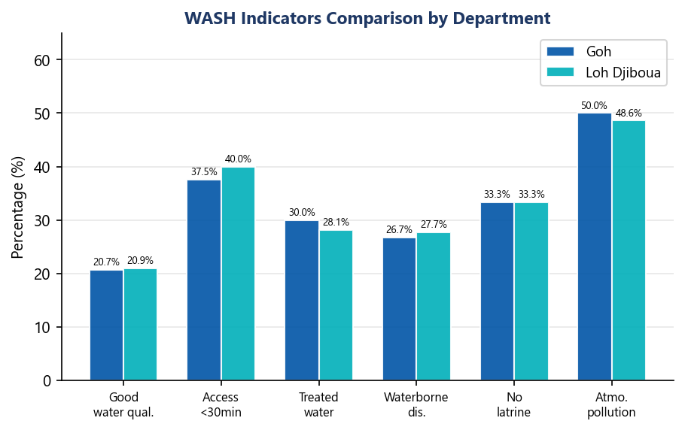
Figure 13 - Comparison of key WASH indicators by department
Table 15 - Full comparative table of WASH indicators
Indicator | Overall | Goh (N=570) | Loh Djiboua (N=430) | Gap
Good water quality | 20.8% | 20.7% | 20.9% | +0.2 pts
Poor water quality | 40.0% | 40.5% | 39.3% | -1.2 pts
Access <30 min | 38.6% | 37.5% | 40.0% | +2.5 pts
Access >60 min | 27.3% | 28.1% | 26.3% | -1.8 pts
Treated water | 29.1% | 30.0% | 28.1% | -1.9 pts
Waterborne diseases | 27.1% | 26.7% | 27.7% | +1.0 pts
No latrine (OD) | 33.6% | 33.3% | 33.3% | 0.0 pts
Atmospheric pollution | 49.4% | 50.0% | 48.6% | -1.4 pts
Scarce resources | 38.4% | ~39.0% | ~37.5% | -1.5 pts
Resource degradation | 57.7% | ~58.0% | ~57.2% | -0.8 pts
Sufficient water | 58.0% | ~58.5% | ~57.2% | -1.3 pts
Exposed to waste | 52.3% | ~53.0% | ~51.4% | -1.6 pts

Section 9 - Priority Recommendations
Based on the findings of this survey, the following recommendations are formulated, ranked in order of priority according to urgency and potential impact on public health and the environment.
Priority 1 - Water quality and treatment
>> Mass campaigns on household water treatment (chlorination, filtration, boiling)
>> Construction of additional boreholes in high-risk areas
>> Regular testing of water source quality
>> Rehabilitation of existing traditional wells

Priority 2 - Sanitation & Latrines
>> Open defecation free (ODF) elimination programme
>> Subsidies for construction of improved latrines
>> Awareness of waterborne diseases linked to lack of sanitation
>> Training local masons in latrine construction

Priority 3 - Waste management
>> Establish structured collection systems in underserved areas
>> Promote composting and organic waste recycling
>> Ban and penalise open-air burning
>> Regulated and secured transit depots

Priority 4 - Atmospheric pollution
>> Mapping and monitoring of pollution sources
>> Regulation of industrial and artisanal emissions
>> Promote improved cookstoves to reduce domestic smoke
>> Buffer zones around urban agglomerations

Priority 5 - Natural resources
>> Local sustainable natural resource management plans
>> Reforestation and degraded land restoration
>> Community awareness on environmental preservation
>> Participatory resource monitoring systems

Priority 6 - Monitoring & Governance
>> WASH indicator monitoring and evaluation systems
>> Capacity building for local authorities
>> Community involvement in infrastructure management
>> Repeat the survey every 2 years to measure progress

Section 10 - Conclusion
This WASH survey conducted among 1,000 households in the Goh and Loh Djiboua departments of Cote d'Ivoire highlights considerable challenges in drinking water, sanitation and environmental management.
The most concerning findings relate to water quality (40% poor quality), the low rate of household treatment (29.1%), and the prevalence of open defecation (33.6%). These combined factors largely explain the 27.1% of households reporting water-related diseases.
Relative to the Sustainable Development Goals (SDG 6) - ensuring access to safe water and sanitation for all - both departments remain far from targets. Targeted investments and behaviour change programmes are essential to reduce access inequalities and protect population health.
As the profiles of the two departments are very similar, interventions can be planned in a coordinated manner, while accounting for the local specificities of each sub-prefecture. A repeat survey in two years will allow progress to be measured and intervention strategies to be adapted.
Summary of key indicators
Table 16 - Summary of key indicators and priority levels
Dimension | Main indicator | Value | Priority
Water | Poor quality | 40% | Critical
Water | Untreated | 70.9% | Critical
Access | Over 60 min | 27.3% | High
Health | Waterborne diseases | 27.1% | High
Sanitation | No latrine | 33.6% | Critical
Waste | Somewhat/not satisfied | 62.0% | Moderate
Pollution | Reported | 49.4% | Moderate
Resources | Degradation | 57.7% | High
Environment | Scarce resources | 38.4% | High

