1. Author address only needs one

Approach:

This section details the framework of your project. Be specific, which means you might want to include equations, figures, plots, etc

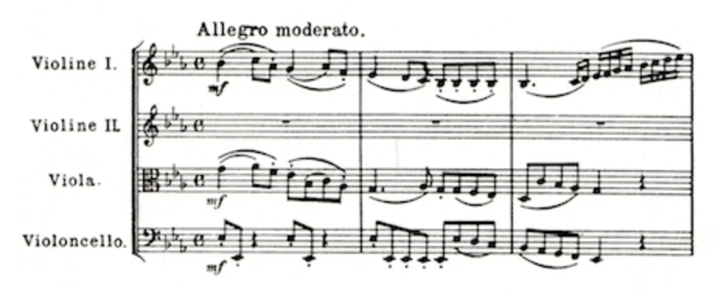

0.91873, 0.35883, …, 0.53678, 0.28423, 1, 0, 0, 0, 0 1

**Note Embedding**

**Articulation**

**/ Rhythm**

**Part**

