TreeCmp 1.5 – a tool for comparing phylogenetic trees using the Matching Split distance and other metrics - manual

Introduction

A phylogenetic tree represents historical evolutionary relationship between different species or organisms. There are various methods for reconstructing phylogenetic trees. Applying those techniques usually results in different trees for the same input data. An important problem is to determine how distant two trees reconstructed in such a way are from each other. Comparing phylogenetic trees is also useful in mining phylogenetic information databases. The TreeCmp application was designed to compute distances between arbitrary (not necessary binary) unrooted phylogenetic trees.

Input data format

The TreeCmp software was designed to support BEAST (http://beast.bio.ed.ac.uk/) and MrBayes (http://mrbayes.csit.fsu.edu/) date files, where phylogenetic trees are stored in the Newick format. Note that plain text files containing only trees in this format are supported as well.

Output data format

All output files created by the application regardless of chosen mode have similar structure. Output files are tab separated text files (TSV), which means that they can be easily read by various data analysis software (e.g. MS Excel, OpenOffice.org). An output file consists of two sections. The first section contains formatted in rows values of distances in selected metrics. The second (optional) section contains summary data computed based on all rows that appears in the first section.

Base output file structure:

Base output file format for options -s, -m, and -w

No | Tree1 | Tree2 | MetricName_1 | MetricName_2 | … | MetricName_n
Comparison number | Tree1 number | Tree2 number | Distance value | Distance value | … | Distance value

Base output file format for option –r,

Tree | MetricName_1 | MetricName_2 | … | MetricName_n
Comparison number (= tree number) | Distance value | Distance value | … | Distance value

Additional columns (-P and –S options):

After using switch –P the following three columns appear additionally in the output file.

Tree1_taxa | Tree2_taxa (or RefTree_taxa) | Common_taxa
Number of taxa in the first tree | Number of taxa in the second (or reference) tree | Number of taxa in common

After using switch –S the following two columns per each chose metric appear additionally in the output file. These columns contain the value of the distance in a particular metric divided by its empirical average value.

MetricName_toYuleAvg | MetricName_toUnifAvg
(Distance value)/(Empirical average value in the Yule model) | (Distance value)/(Empirical average value in uniform model)

Summary section format (-I option):

Name | Avg | Std | Min | Max | Count
Metric name 1 | Average value | Standard deviation value | Minimal value | Maximal value | Number of analyzed values
Metric name 2 | … | … | … | … | …
… | … | … | … | … | …
Metric name n | … | … | … | … | …

Running TreeCmp

The TreeCmp application is distributed as a zip archive. In order to unpack the file any software supporting zip compression, for example free software 7-zip (http://www.7-zip.org/), can be used. In order to run the TreeCmp application Java VM in version at least 1.5 is required.

Directory structure

Directory |  |  | Description
bin |  |  | contains main jar file: TreeCmp.jar and lib folder with necessary open source libraries: pal-1.5.1.jar (http://www.cebl.auckland.ac.nz/pal-project/) and commons-cli-1.2.jar (http://commons.apache.org/cli/)
config |  |  | contains xml configuration file
data |  |  | contains text files with precumputed data (average value and other statistics) for all the 8 metrics under the two models of generation of random binary trees: the Yule model and the uniform model.
doc |  |  | contains this manual
 | examples |  | contains subdirectories with examples
 |  | align | contains an example of creating alignments
 |  | beast | contains an example input file created using BEAST
 |  | mr_bayes | contains an example input file created using MrBayes
 |  | plain | contains an example input file with plain trees
 |  | prune | contains an example of comparing trees having different sets of taxa
 |  | ref_tree | contains an example of comparing a single tree to a set of trees
 |  | scaled | contains an example with reporting scaled values of chosen metrics
src |  |  | contains source code of this application

Command line syntax

Usage:
java -jar TreeCmp.jar -w <size>|-s|-m|-r <refTreeFile> –d <metrics> -i <inputfile> -o <outputfile> [-S] [-P] [-I] [-A|-O]

Note that options order is important.

Mandatory switches:

- The comparison mode options (only one option should be specified):
  - –s – overlapping pair comparison mode; every two neighboring trees in the input file are compared,
  - -w <size> – window comparison mode; every two trees within a window with a specified size are compared – the average distance and the standard deviation go to the output file,
  - –m – matrix comparison mode; every two trees in the input file are compared.
  - -r <refTreeFile> - single tree to all trees mode. Each tree in the input file is compared to the single referenced tree.

- The metric option (-d). At least one and at most 8 metrics can be specified. Metrics should be separated by space character.
Metrics for unrooted trees:
  - ms – the Matching Split distance [1],
  - rf – the Robinson-Foulds distance [2],
  - pd – the path difference distance [3],
  - qt – the quartet distance [4].

Metrics for rooted trees:
  - mc - the Matching Cluster metric,
  - rc - the Robinson-Foulds metric based on clusters,
  - ns - the Nodal Splitted metric with L2 norm [5],
  - tt - the Triples metric [6].
Example: -d ms rf

- IO options (both options should be specified):
- -i <inputfile> – input data file with trees in the Newick format,
- -o <outputfile> – output data file with the results of computations.

Optional switches:

- General options:
  - –S - report scaled values (based on an average value form precomputed data)
  - –P - prune compared trees if needed. This option is design to allow comparing trees having different (partially overlapping) sets of taxa. After using theis option 3 additional columns appear in the output file (see Output data format section for details).
  - –I - -include summary section in the output file.

- Matching metric specific options (only one option should be specified).
  - –A - Generate alignment files – this option should be used together with selection the MS or MC metrics. As a result additional files containing aligned splits or clusters are generated:
    - [output_file_name].out.aln_MS.txt,
    - [output_file_name].out.aln_MC.txt,
where [output_file_name] is the file name specified after –o option.
  - –O - use special implementations of MS/MC metrics optimized for similar trees.

Note that if a rooted tree (with bifurcation in the root) is compared using metrics for unrooted trees the tree will be automatically transform into unrooted one, i.e., the bifurcation will be replaced with an arbitrary trifurcation.

Types of analysis

There are four different types of available reports:
- overlapping pair comparison,
- window comparison,
- matrix comparison,
- single tree to all trees comparison.

Details of the computation of these reports are explained in the pictures below.
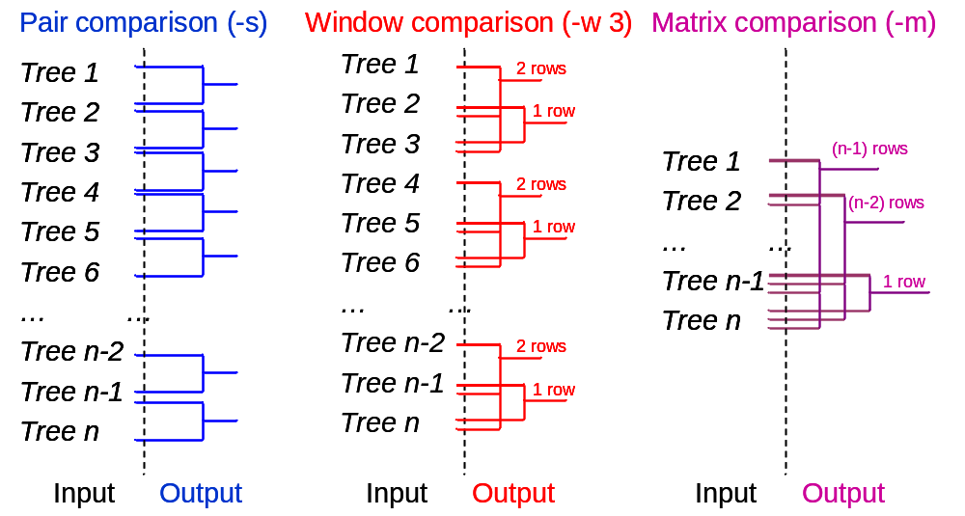

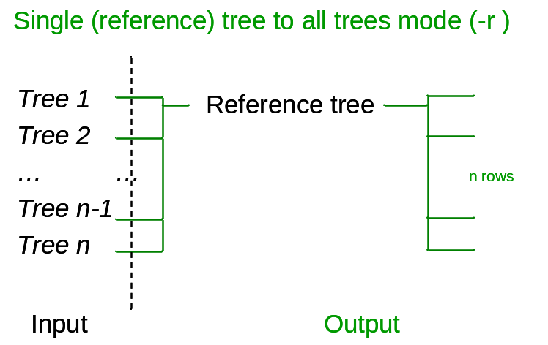

Useful Java VM parameters

In the case of an analysis of large trees the following exceptions might occur:

- Exception in thread "main" java.lang.OutOfMemoryError: Java heap space

To solve the problem increase Java heap space memory limit using JVM option –Xmx
Example:
java –Xmx700m –jar TreeCmp.jar <further options>

- Exception in thread "main" java.lang.StackOverflowError at pal.io.FormattedInput.skipWhiteSpace(FormattedInput.java:111)
at pal.io.FormattedInput.readNextChar(FormattedInput.java:131)
at pal.tree.ReadTree.readNH(ReadTree.java:81)
…..
at pal.tree.ReadTree.readNH(ReadTree.java:89)

To solve the problem increase Java thread stack size limit using JVM option –Xss
Example:
java –Xss1m –jar TreeCmp.jar <further options>

These options can be used in conjunction.

Example

Input file: \doc\examples\beast\testBSP.newick
Invocation:
java -jar TreeCmp.jar -w 2 -d ms -i testBSP.newick -o testBSP.newick_w_2.out -I
Console output:

TreeCmp version 1.5-b255

Active options:
Type of the analysis: window comparison mode (-w) with window size: 2
Metrics:
1. MatchingSplit (ms)
Input file: testBSP.newick
Output file: testBSP.newick_w_2.out
Additional options:
I - Include summary section in the output file.
-----
2011-08-27 16:03:17: Start of scanning input file: testBSP.newick
2011-08-27 16:03:17: End of scanning input file: testBSP.newick
2011-08-27 16:03:17: 11 valid trees found in file: testBSP.newick
2011-08-27 16:03:17: Start of calculation...please wait...
2011-08-27 16:03:17: 0.00% completed...
2011-08-27 16:03:17: 20.00% completed...
2011-08-27 16:03:17: 40.00% completed...
2011-08-27 16:03:17: 60.00% completed...
2011-08-27 16:03:17: 80.00% completed...
2011-08-27 16:03:17: 100.00% completed.
2011-08-27 16:03:17: End of calculation.
2011-08-27 16:03:17: Total calculation time: 62 ms.

Output file testBSP.newick_w_2.out:

No Tree1 Tree2 MatchingSplit
1 1 2 58.0000
2 3 4 24.0000
3 5 6 10.0000
4 7 8 13.0000
5 9 10 14.0000
---------
Summary:
Name Avg Std Min Max Count
MatchingSplit 23.8 17.73583942191629 10.0 58.0 5

License

Copyright (C) 2011, Damian Bogdanowicz

This program is free software: you can redistribute it and/or modify it under the terms of the GNU General Public License as published by the Free Software Foundation, either version 3 of the License, or (at your option) any later version.

This program is distributed in the hope that it will be useful, but WITHOUT ANY WARRANTY; without even the implied warranty of MERCHANTABILITY or FITNESS FOR A PARTICULAR PURPOSE. See the GNU General Public License for more details.

You should have received a copy of the GNU General Public License along with this program. If not, see http://www.gnu.org/licenses/.

References

- Bogdanowicz D, Giaro K: Matching Split Distance for Unrooted Binary Phylogenetic Trees. IEEE/ACM Trans Comput Biol Bioinform, 17 Feb. 2011. IEEE computer Society Digital Library. IEEE Computer Society, <http://doi.ieeecomputersociety.org/10.1109/TCBB.2011.38>
- Robinson DF, Foulds LR: Comparison of phylogenetic trees. Math Biosci 1981, 53:131-147.
- Steel MA, Penny D: Distributions of Tree Comparison Metrics -- Some New Results. Syst Biol 1993, 42:126-141.
- Estabrook GF, McMorris FR, Meacham CA: Comparison of Undirected Phylogenetic Trees Based on Subtrees of Four Evolutionary Units. Syst Biol 1985, 34:193-200.
- Cardona G, Llabrés M, Rosselló F, Valiente G: Nodal distances for rooted phylogenetic trees, J Math Biol 2010 61:253-276.
- Critchlow DE, Pearl DK, Qian C: The Triples Distance for Rooted Bifurcating Phylogenetic Trees, Syst Biol 1996, 45: 323-334.

