BACK NINE
Tre' Smith (sole developer)
Smith Games


‘Nine’ is intentionally mirrored
CSCE 552 · 3D Game Proposal · October 30, 2026
TABLE OF CONTENTS
1. Document Control & Metadata
2. Executive Overview
3. Gameplay & Mechanics
4. Technical Architecture
5. Architectural Diagrams & Systems Flow
6. Objects & Components
7. Asset Catalog
8. Production, Task Breakdown, and Schedule
9. Scenes & Diagrams

DOCUMENT CONTROL & METADATA
Field | Value
Document Title | Back Nine: Game Design Document
Version | 1.0 (proposal)
Author and Discipline Leads | Tre' Smith: design, programming, art, audio, and testing
Last Updated | October 30, 2026
Changelog | v1.0: first complete proposal

EXECUTIVE OVERVIEW
- Logline
  - A young caddie who has never trusted his own swing must beat three rule-bending golf champions to save his town's last public course.
- Story
  - Dez Carter, 19, caddies at Pine Hollow Municipal, a run-down public course. The wealthy Ashworth Club wants to turn it into a private resort.
  - Dez hasn’t trusted his swing since he choked on the final green of the state junior championship at 15, handing the title to Rex Dalton. Rex and the other country-club kids at school never let him forget it.
  - Under the Deed Match tradition, the Club can challenge an owner to three matches against its champions. If the Club wins any one, the land is theirs. Days before the challenge, owner Nana Ruth (Dez’s grandmother) injures her wrist in a fall at the clubhouse. Dez plays in her place, carrying his late grandfather’s bag, with his best friend Bo caddying.
  - Bo, a self-proclaimed “world’s greatest caddie,” is the comic relief. His advice is usually right; his stories never are.
  - Chapter 1, “Home Course”: Sterling Ashworth delivers the challenge. The first match is at Pine Hollow against Rex, now the Club’s junior champion, who spends every hole reminding Dez of the choke.
  - Chapter 2, “Bloom”: At Thornbrook Gardens, Dez faces Marigold Fenn, Pine Hollow’s former greenskeeper and Nana Ruth’s oldest friend. She left for the Club’s money, and Sterling has promised her the job of redesigning Pine Hollow.
  - Chapter 3, “Thorns”: After her loss, Marigold confesses that Sterling plans to bulldoze Pine Hollow, not redesign it, and that Nana Ruth’s fall was no accident: Sterling’s crew loosened the clubhouse step. Dez travels to Ashworth Links to face Sterling himself.
  - Chapter 4, “Back Nine”: On the final hole, Sterling’s wind drains Dez’s Focus. With no Clutch Shot left, Dez must trust his own swing. He wins, the deed stays with Nana Ruth, Marigold returns to Pine Hollow, and Nana Ruth tells Dez the bag is his for good.
  - Tone: goofy banter, mostly from Bo, around an earnest story about getting past a choke.
- Target Audience and Core Genre
  - Genre: 3D arcade golf adventure with a story and boss matches.
  - Target Audience: fans of approachable sports games and casual golfers.
  - Rating: ESRB E – Everyone: no violence, gambling, purchases, or crude language; no real likenesses.
  - Related Games:
    - Golf Story (Sidebar Games, 2017) pairs golf with a narrative.
    - Mario Golf: Super Rush (Camelot Software Planning, 2021) has an adventure mode with boss-style challenges.
    - What the Golf? (Triband, 2019) builds each level around one rule twist.
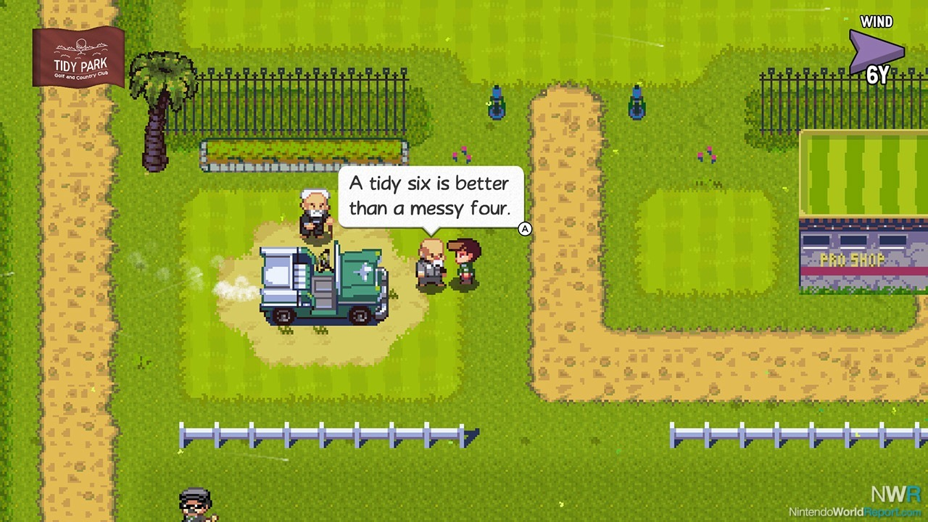
Figure 1: Golf Story (Sidebar Games, 2017)
Image source: Nintendo World Report, http://www.nintendoworldreport.com/review/45568/golf-story-switch-review (accessed October 30, 2026)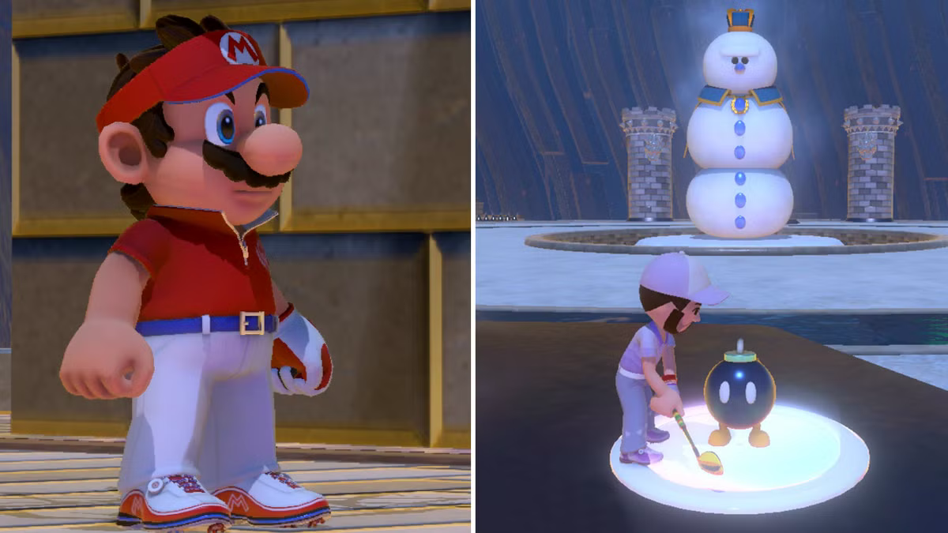
Figure 2: Mario Golf: Super Rush (Camelot Software Planning, 2021)
Image source: Game Rant, https://gamerant.com/mario-golf-super-rush-how-long-to-beat/ (accessed October 30, 2026)

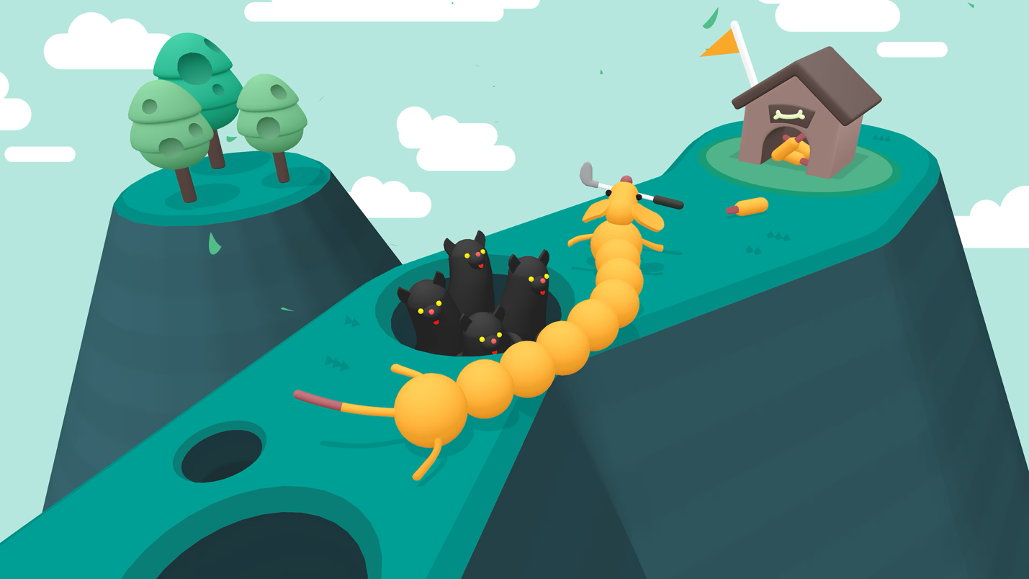
Figure 3: What the Golf? (Triband, 2019)
Image source: https://store.playstation.com/en-us/concept/10002260 (accessed October 30, 2026)

- Key Pillars / Unique Selling Points
  - Golf First: bosses change conditions, but only good shots win.
  - One Rule per Boss: one readable twist that escalates each hole.
  - A Story Worth Finishing: a small-town cast with real stakes.
- Gameplay Loop & Core Flow
  - Story: a chapter introduces the next opponent.
  - Match: three holes against the boss and their rule.
  - Reward: a win unlocks a shot shape; a loss offers a retry.
  - Repeat: three matches, then the ending.

GAMEPLAY AND MECHANICS
- Player Character and Controls
  - Aiming: the mouse or left stick rotates a dashed aim line around the ball.
  - Clubs (Q / E): Driver (250 yd), 7 Iron (160 yd), Wedge (90 yd), Putter.
  - Two-Stage Swing: drag back to set power (0–100 percent), then release inside the green accuracy window (Figure 4). A miss adds hook or slice on top of the chosen shot shape
  - Shot Shapes (1–4): Straight, Draw, and Fade from the start. High Lob (clears hedges) unlocks after Match01; Stinger (half the wind effect) unlocks after Match02.
  - Green Reading (hold Shift): shows a slope grid on the green; three reads per hole.
  - Clutch Shot (F): usable at 100 Focus; a wide accuracy window and slow-motion camera.
  - Caddie Call (C): once per hole, Bo suggests a club, shot shape, and aim. He is right about 80 percent of the time; when he’s wrong, he has an excuse ready.
  - Pause(Esc).
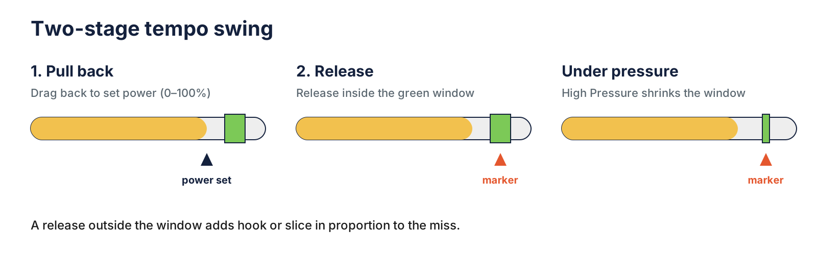
Figure 4: Two-Stage Swing
Set power, release in the window; high Pressure shrinks the window.
- Game Rules & Systems
  - Ball Physics and Lies: simulated gravity, drag, spin, and wind. Rough cuts the next shot's power 20 percent, sand 40 percent.
  - Pressure (0–100): +20 when the player loses a hole, +15 per boss taunt, −10 per good shot (a fairway hit, a green in regulation, or a release in the center of the accuracy window). Above 70, the accuracy window shrinks by 40 percent.
  - Focus (0–100): +25 for a fairway hit, +25 for a green in regulation, +50 for a putt holed from beyond 15 feet. Focus is capped at 100. A Clutch Shot spends all of it. Focus carries between holes and resets at the start of each match.
  - Match Play: all three holes are always played. Holes 1 and 2 are worth 1 point and hole 3 is worth 2. The golfer farther from the hole hits next. Fewer strokes wins a hole’s points; a tied hole is halved. The golfer with more points after hole 3 wins, and a tie goes to a closest-to-the-pin playoff from hole 3’s tee.
  - Opponent Turns: the AI picks a club and aim with the same shot planner as Bo’s Caddie Call, then adds random error set by the boss’s skill.
  - Boss Rules: every boss action is signaled one shot in advance. Boss rules target only Dez; the bosses play the course straight.
Boss | Course | Rule and Escalation | Counter
Rex Dalton (tutorial) | Pine Hollow | Taunts add +15 Pressure. Hole 1: one taunt; Hole 2: two; Hole 3: every shot. | Bank Focus; save a Clutch Shot.
Marigold Fenn | Thornbrook Gardens | Hedges grow where buds appeared one shot earlier. Hole 1: one row; Hole 2: two shifting rows; Hole 3: three rows. | High Lob, or lay up short.
Sterling Ashworth (final) | Ashworth Links | Controls the wind. Hole 1: new direction each shot; Hole 2: one mid-flight gust; Hole 3: two gusts, and Focus drains to zero at the tee (no Clutch Shot). | Stinger; read the flag.

  - Boundaries and Penalties: out of bounds or water costs one stroke and replaces the ball. Eight strokes concede the hole.
  - Resources: strokes, Focus and Clutch Shots, three green reads per hole, one Caddie Call per hole, four clubs, and unlocked shot shapes. Pressure is a negative resource to keep low.
  - Objectives: win all three matches to save Pine Hollow; in each match, win more holes than the boss.
  - Conflict: the boss, hazards, slopes, and rising Pressure.
  - Win / Loss Conditions:
    - Win a match: unlock a shot shape; Match03 leads to the ending.
    - Lose a match: retry from the Lose Screen.
  - Progression: progress saves after each chapter; Continue resumes from there.
  - Course Design: every hole offers a safe route and a marked shortcut over a hazard, rewarding risk.
- Camera Systems & Viewport
  - Tee Camera: behind the golfer, looking down the aim line.
  - Follow and Landing Cameras: follow the ball, then cut to where it lands.
  - Putting Camera: a low, close view.
  - Menu Camera: a slow orbit around the 3D backdrop.
- User Interface (UI) & HUD Flow
  - Main Menu: Continue, New Game, Settings, Quit.
  - Settings: How to Play, Audio, Controls, Credits.
  - Story Dialogue: portraits and a text box.
  - Main HUD: club, score, wind, distance, taunts, reads,, Caddie Call shot shape, and meters.
  - Pause Menu: Resume, How to Play, Restart Match, Quit to Menu.
  - Win / Lose Screens: the result plus Continue or Retry, and Main Menu.

MENU & INTERFACE CONCEPT IMAGES
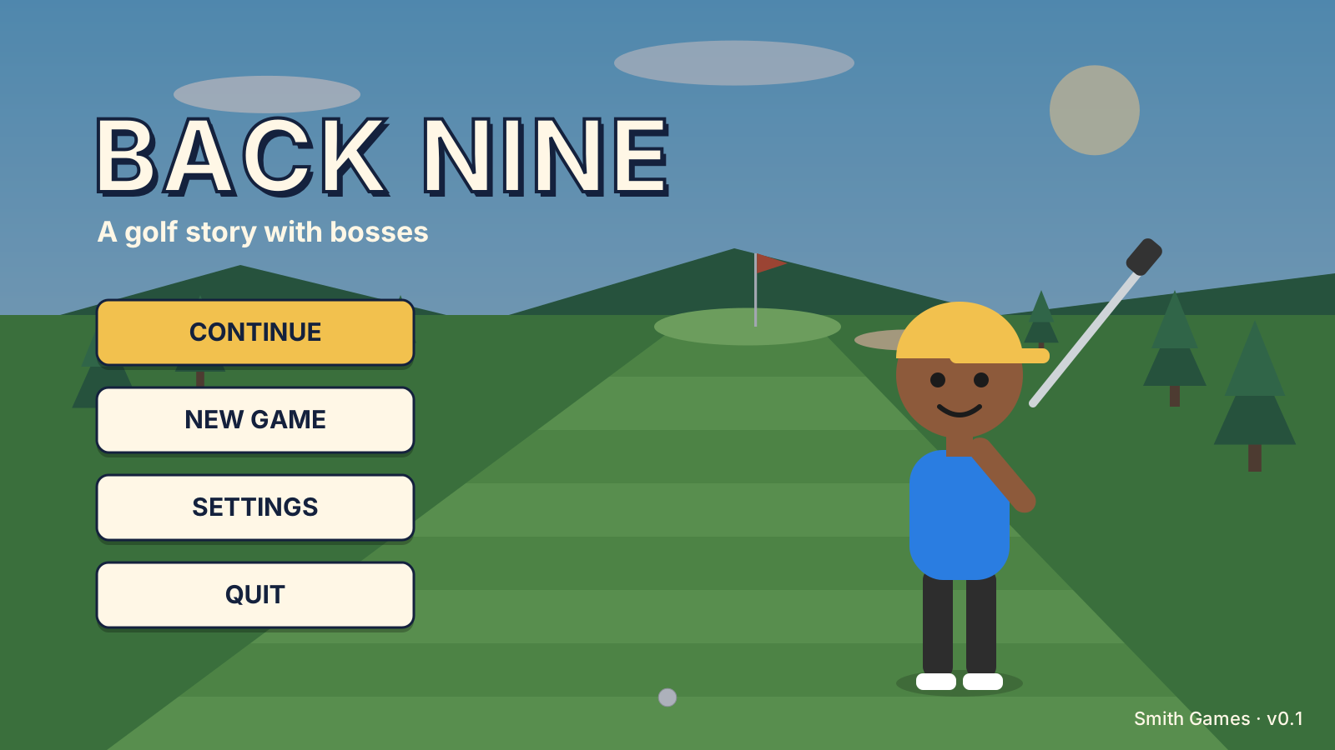
Figure 5: Main Menu
Primary buttons over an orbiting view of Pine Hollow.
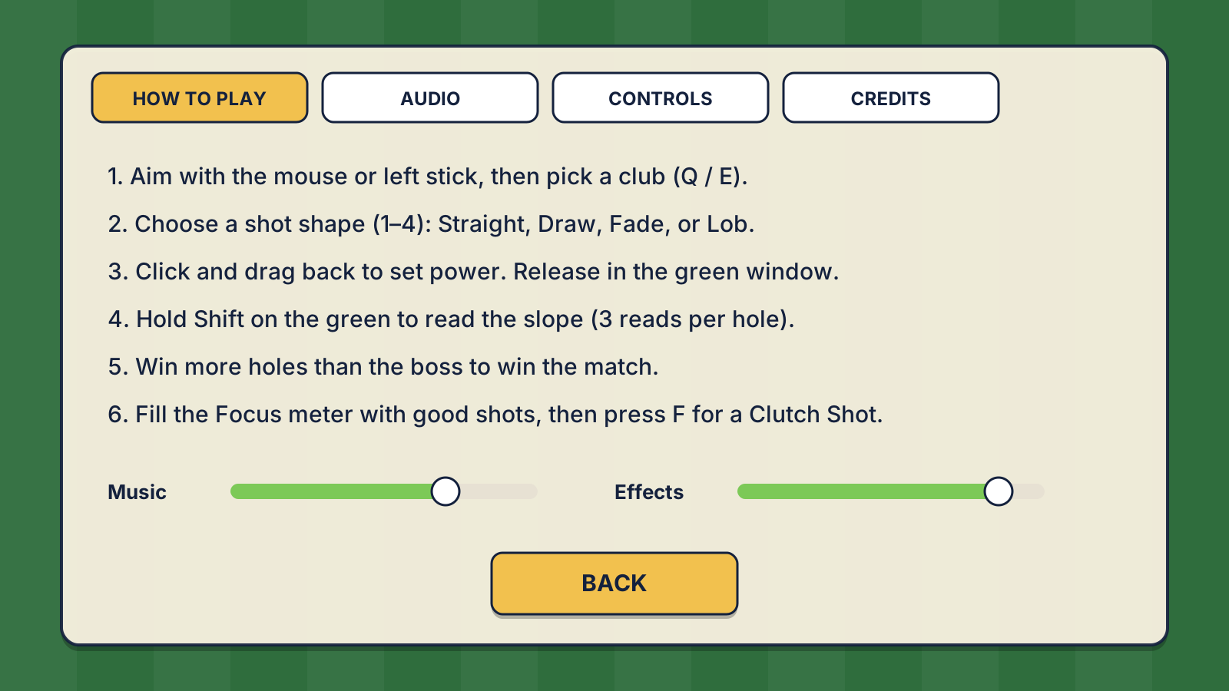
Figure 6: Settings

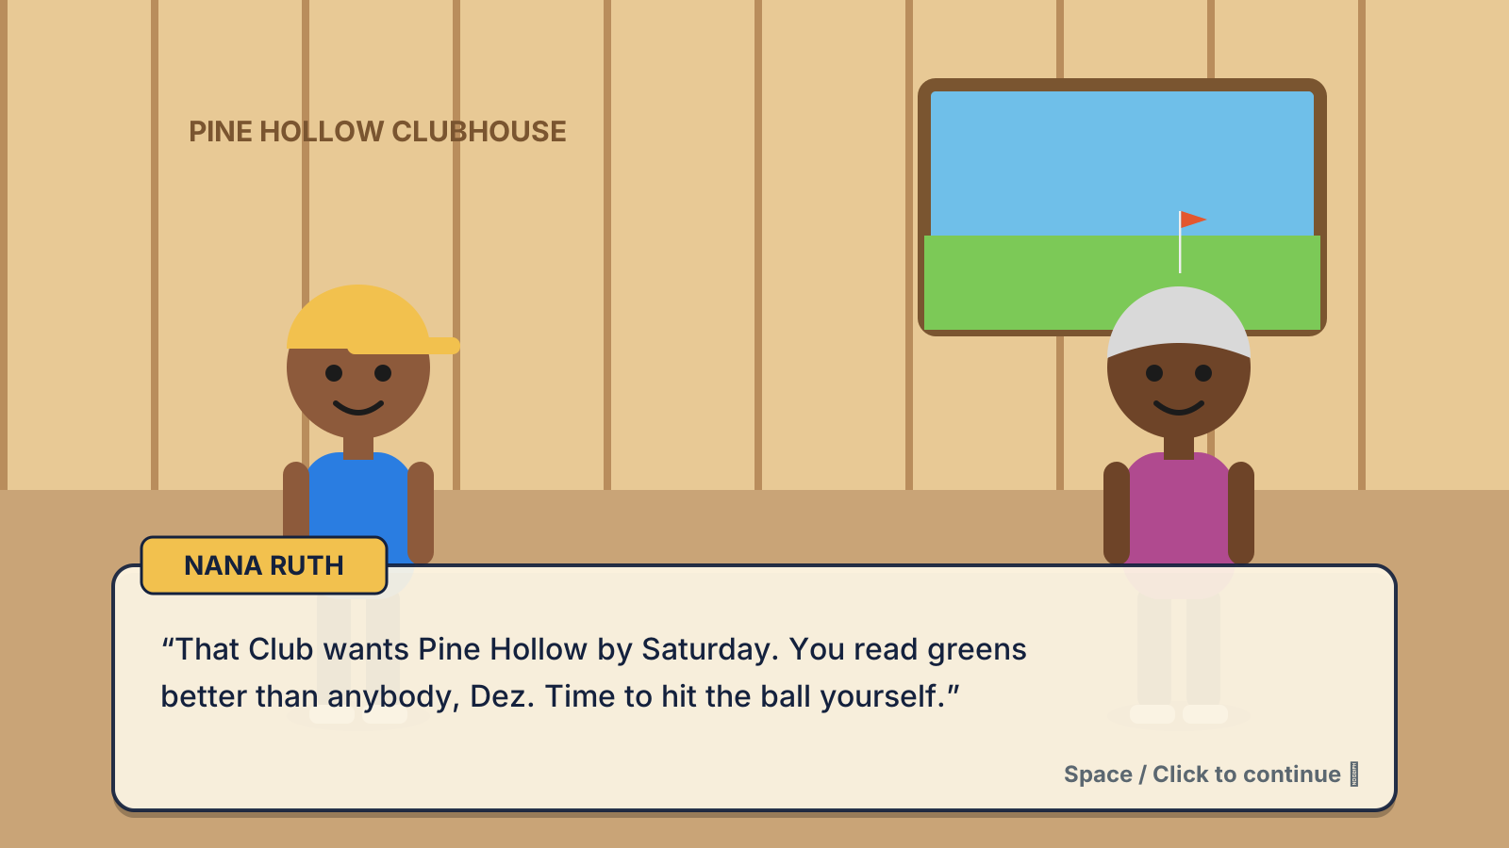
Figure 7: Story Dialogue
Nana Ruth speaking in the Pine Hollow clubhouse.
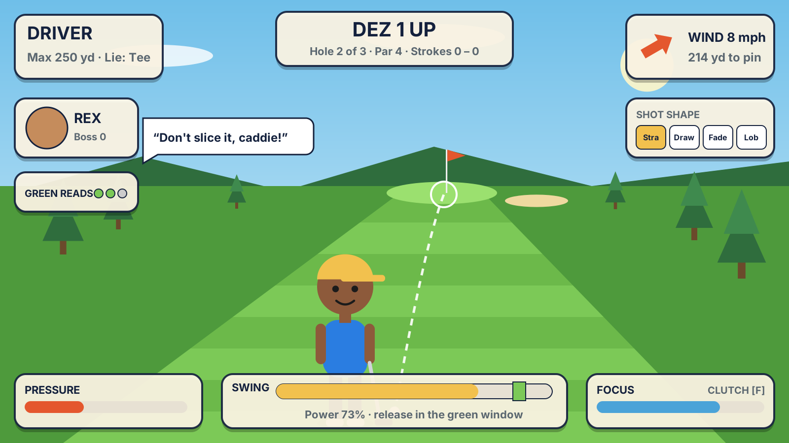
Figure 8: Main HUD
Match01 against Rex, with the swing, Pressure, and Focus meters along the bottom.
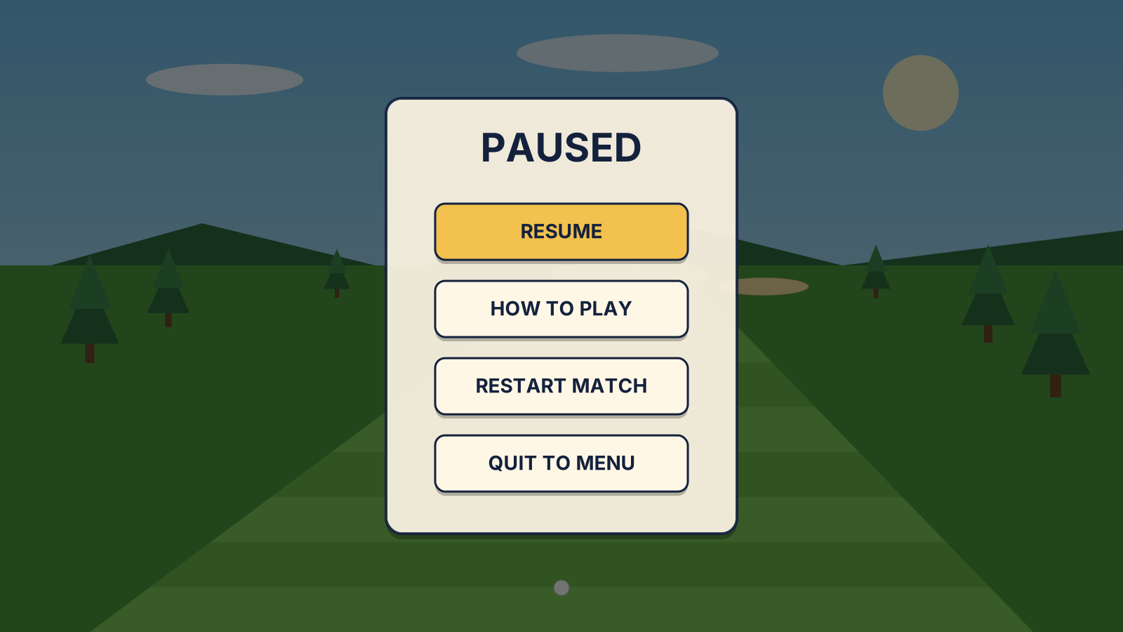
Figure 9: Pause Menu

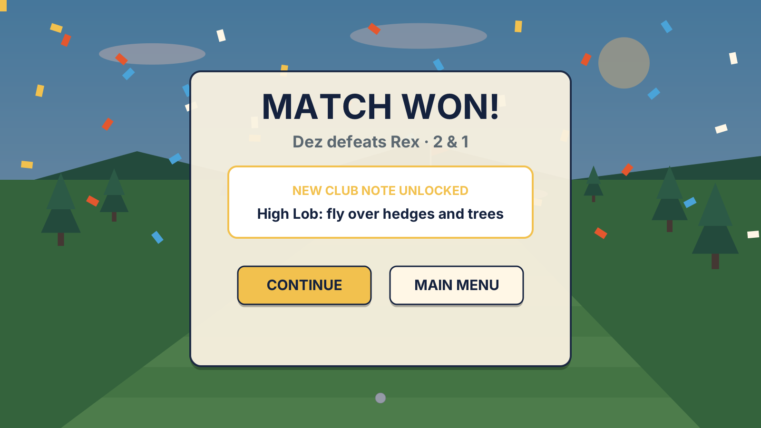
Figure 10: Match Won

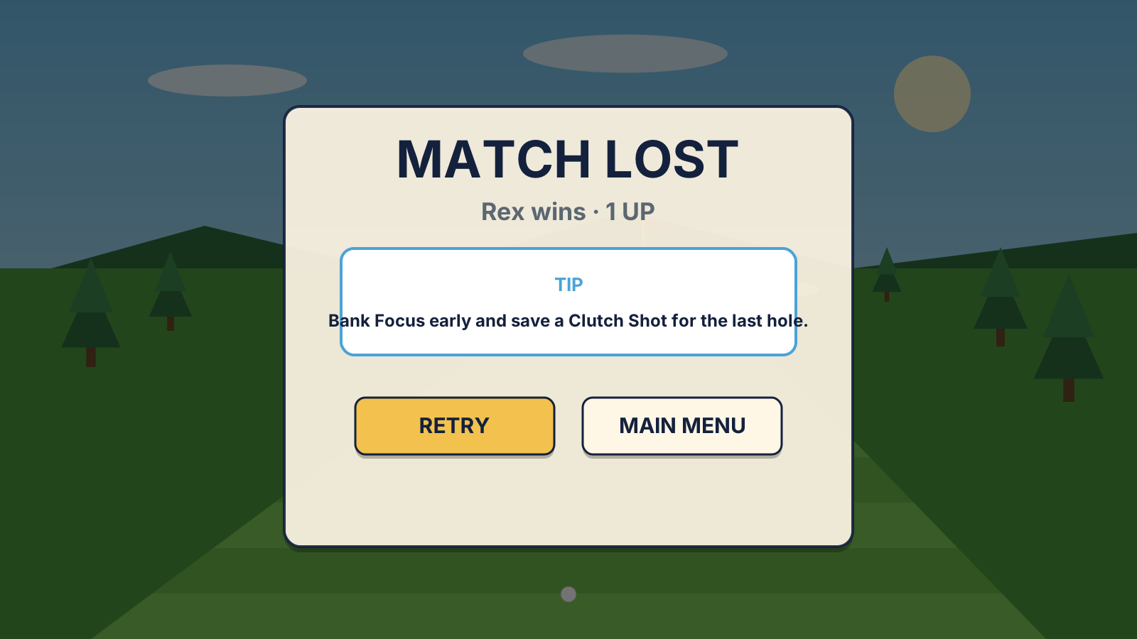
Figure 11: Lose Screen

TECHNICAL ARCHITECTURE
- Game Engine & Core Plugins
  - Game Engine: Godot Engine 4 (the latest stable 4.x release at project start), scripted in GDScript.
  - Core Plugins: none required; the game uses Godot's built-in 3D physics, animation, UI, and audio.
  - Terminology: a Game Object is a node tree, a Prefab is a saved scene (.tscn), and a Component is an engine node or custom GDScript.
- Target Platforms & System Requirements
  - PC only: a 64-bit Windows 10 or later executable, played with keyboard and mouse or a controller.
  - Any GPU supporting Vulkan or OpenGL 3.3.
- Software & Pipeline Tools
  - Blender 4: modeling, rigging, and animation; exports glTF 2.0 (.glb).
  - Krita: textures, portraits, UI art, and concept art.
  - Audacity: sound effect editing; exports WAV.
  - LMMS: music composition; exports OGG Vorbis.
  - Git, GitHub, and Git LFS: version control, with LFS for large binaries.
  - Visual Studio Code: script editing alongside the Godot editor.
  - Asset sources: Kenney and Quaternius prop packs and Freesound recordings, all CC0 and credited in game.

ARCHITECTURAL DIAGRAMS & SYSTEMS FLOW
- Scene / State Transition Diagram
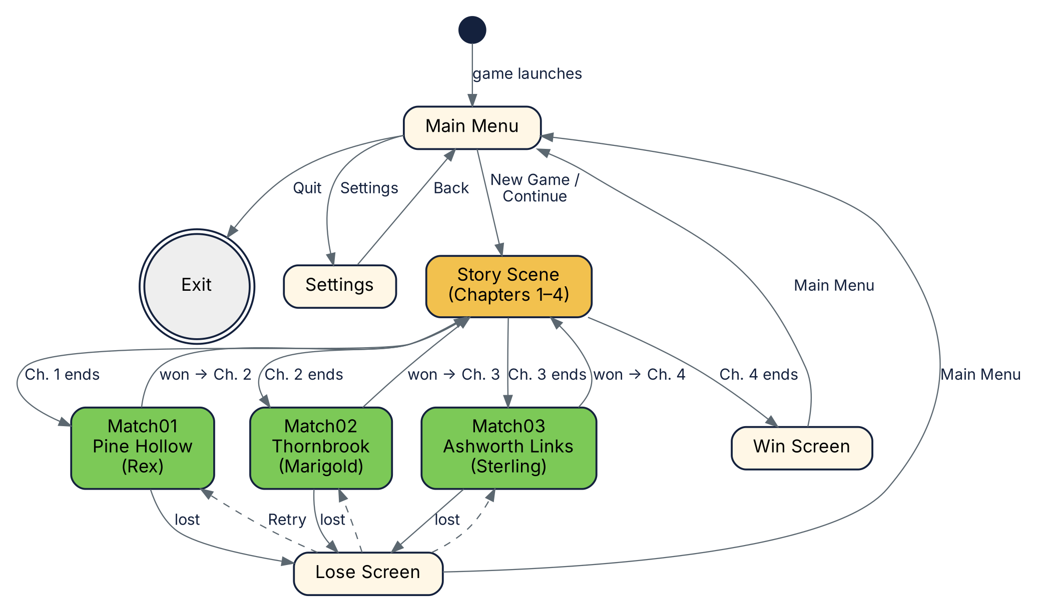
Figure 12: Scene / State Transition Diagram
Every scene and the condition that moves the player to the next one. Dashed lines are retries.

- Scene List
Scene | Objective | Outgoing Transitions
Main Menu | Start or continue a game, open Settings, or quit. | TO Story WHEN New Game or Continue.  TO Settings WHEN Settings.  TO Exit WHEN Quit.
Settings | How to play and audio volume. | TO Main Menu WHEN Back.
Story | Play the current dialogue chapter (1–4). | TO Match01, 02, or 03 WHEN Chapter 1, 2, or 3 ends.  TO Win Screen WHEN Chapter 4 ends.
Match01: Pine Hollow | Beat Rex (TauntRule). | TO Story (Ch. 2) WHEN the player wins.  TO Lose Screen WHEN Rex wins.  TO Main Menu WHEN Quit to Menu.
Match02: Thornbrook | Beat Marigold (HedgeGrowthRule). | TO Story (Ch. 3) WHEN the player wins.  TO Lose Screen WHEN Marigold wins.  TO Main Menu WHEN Quit to Menu.
Match03: Ashworth Links | Beat Sterling (WindControlRule). | TO Story (Ch. 4) WHEN the player wins.  TO Lose Screen WHEN Sterling wins.  TO Main Menu WHEN Quit to Menu.
Win Screen | Ending message and credits. | TO Main Menu WHEN Main Menu.
Lose Screen | Lost-match result and a tip. | TO the lost match WHEN Retry.  TO Main Menu WHEN Main Menu.

- Event & Data Flow
Signal | Emitted By | Received By
turn_started(golfer) | MatchManager | PlayerInput, OpponentAI
ball_landed(surface) | BallPhysics | MatchManager, CameraRig
ball_holed | CupDetector | MatchScorer
out_of_bounds | OOBDetector | MatchScorer, Ball
score_changed | MatchScorer | HUDController, PressureFocus
match_finished(result) | MatchManager | GameState
chapter_finished | DialogueRunner | GameState
shot_taken(golfer) | SwingController, OpponentAI | MatchManager, BossRule, CameraRig
hole_finished(result) | MatchScorer | MatchManager, PressureFocus, BossRule
rule_telegraphed(info) | BossRule | HUDController
wind_changed(vector) | WindSystem | BallPhysics, HUDController
pressure_changed / focus_changed | PressureFocus | HUDController, SwingController
caddie_call_used(advice) | CaddieCall | HUDController

OBJECTS AND COMPONENTS

OBJECTS
Player: Dez (Prefab)
player.tscn
Description | The golfer the user controls.
Tags | player, golfer
Required Components | - Node3D (transform)  - MeshInstance3D + Skeleton3D  - AnimationTree  - PlayerInput (custom)  - ShotAim (custom)  - SwingController (custom)  - GreenReader (custom)  - CaddieCall (custom)
Animations | See Section 7.
Related Game Objects
Parent | Match scene root
Children | Model, AimLine
Associates | Ball, Match Manager, HUD Canvas

Ball (Prefab)
ball.tscn
Description | The ball both golfers hit.
Tags | ball
Required Components | - RigidBody3D (continuous collision detection on)  - CollisionShape3D (sphere)  - MeshInstance3D  - BallPhysics (custom)  - SurfaceDetector (custom)  - AudioStreamPlayer3D  - GPUParticles3D (trail)
Related Game Objects
Parent | Match scene root
Children | N/A
Associates | Player, Opponent, Hole, Wind System, Camera Rig

Opponent: Boss (Prefab)
opponent.tscn
Description | The boss golfer.
Tags | golfer, boss
Required Components | - Node3D  - MeshInstance3D + Skeleton3D  - AnimationPlayer  - OpponentAI (custom)  - BossRule child: TauntRule, HedgeGrowthRule, or WindControlRule (custom)
Animations | Idle, Swing, Putt, Taunt, Celebrate, Disappointed.
Comments | Model, skill, and rule change per match.
Related Game Objects
Parent | Match scene root
Children | Model, BossRule
Associates | Ball, Match Manager, Hedge, Wind System, HUD Canvas

Hole (Prefab)
hole_pinehollow_01.tscn … (9 variants)
Description | One hole; three per course.
Tags | hole
Required Components | - Node3D  - StaticBody3D + CollisionShape3D (trimesh)  - MeshInstance3D  - Marker3D (tee)  - Area3D + CupDetector (custom)  - Area3D + OOBDetector (custom)  - Flagstick: MeshInstance3D + AnimationPlayer
Related Game Objects
Parent | Match scene root
Children | Tee, Cup, OutOfBounds, Water, Flagstick
Associates | Ball, Match Manager

Hedge (Prefab)
hedge.tscn
Description | A hedge that rises from the fairway in Match02.
Tags | hazard
Required Components | - AnimatableBody3D  - CollisionShape3D  - MeshInstance3D  - HedgeGrowth (custom)
Animations | Bud, Grow (1 s rise), Shift.
Related Game Objects
Parent | Hole
Children | N/A
Associates | Opponent (HedgeGrowthRule), Ball

Wind System (Prefab)
wind_system.tscn
Description | The hole's wind.
Tags | system
Required Components | - Node  - WindSystem (custom)
Related Game Objects
Parent | Match scene root
Children | N/A
Associates | Ball, HUD Canvas, Opponent

Match Manager (Prefab)
match_manager.tscn
Description | The match referee.
Tags | manager
Required Components | - Node  - MatchManager (custom)  - MatchScorer (custom)  - PressureFocus (custom)  - Timer
Related Game Objects
Parent | Match scene root
Children | N/A
Associates | Player, Opponent, Hole, HUD Canvas, GameState, AudioManager

HUD Canvas (Prefab)
hud.tscn
Description | Match HUD and Pause Menu.
Tags | ui
Required Components | - CanvasLayer  - Label, TextureRect, ProgressBar ×3  - HUDController (custom)  - Pause Menu: Control, Button ×4, PauseGame (custom)
Related Game Objects
Parent | Match scene root
Children | PauseMenu
Associates | Match Manager, Wind System

Camera Rig (Prefab)
camera_rig.tscn
Description | The view in every 3D scene.
Tags | camera
Required Components | - Camera3D  - AudioListener3D  - CameraRig (custom)
Related Game Objects
Parent | Scene root
Children | N/A
Associates | Ball, backdrops

GameState (Autoload)
game_state.gd
Description | Global progress and settings; saved to disk.
Required Components | - GameState (custom)
Related Game Objects
Parent | Root (autoload)
Children | N/A
Associates | Every manager

AudioManager (Autoload)
audio_manager.tscn
Description | Global music and UI sound.
Required Components | - AudioStreamPlayer ×2  - AudioManager (custom)
Related Game Objects
Parent | Root (autoload)
Children | N/A
Associates | Every manager

- Scene UI Objects
  - Not prefabs; each exists in one scene.
Game Object | Components | Associates
Main Menu Manager | Node, MainMenuManager (custom) | Menu Canvas, GameState, AudioManager
Menu Canvas | CanvasLayer, Control, TextureRect, Button ×4, Label | Main Menu Manager
Settings Manager | Node, SettingsManager (custom) | Settings Canvas, GameState, AudioManager
Settings Canvas | CanvasLayer, TabContainer, Label, HSlider ×2, Button | Settings Manager
Story Manager | Node, DialogueRunner (custom) | Dialogue Canvas, GameState, AudioManager
Dialogue Canvas | CanvasLayer, Panel, Label, TextureRect, AnimationPlayer | Story Manager
Menu / Clubhouse Backdrop | Node3D, MeshInstance3D, WorldEnvironment, DirectionalLight3D | Camera Rig
Environment | WorldEnvironment, DirectionalLight3D | Camera Rig
Win / Lose Screen Manager | Node, WinScreenManager or LoseScreenManager (custom) | Result Canvas, GameState, AudioManager
Result Canvas | CanvasLayer, Panel, Label, Button ×2, GPUParticles2D | Win / Lose Screen Manager

COMPONENTS
- Custom Components (written for this game)
Component | Description | Requires
GameState | Saves progress and settings; changes scenes. | None
AudioManager | Plays music and UI sounds. | AudioStreamPlayer
MainMenuManager | Handles Main Menu buttons. | Button, GameState
SettingsManager | Applies and saves volume. | HSlider, GameState
DialogueRunner | Shows a chapter's dialogue line by line. | Label, TextureRect, GameState
CameraRig | Tee, follow, landing, putting, and orbit views. | Camera3D, Ball
PlayerInput | Reads mouse, keyboard, and controller input. | Input Map
ShotAim | Rotates aim and draws the aim line. | PlayerInput, Ball
SwingController | Runs the swing meter; launches the Ball. | PlayerInput, ShotAim, PressureFocus
GreenReader | Draws the slope grid; tracks reads. | Hole, HUDController
BallPhysics | Adds drag, spin, and wind forces; detects stops. | RigidBody3D, WindSystem
SurfaceDetector | Reports the surface under the ball. | RigidBody3D
CupDetector | Signals a holed ball. | Area3D
OOBDetector | Applies out-of-bounds penalties. | Area3D, MatchScorer
MatchManager | Runs turns, holes, and the result. | MatchScorer, Player, Opponent, Hole
MatchScorer | Counts strokes; decides each hole. | None
PressureFocus | Tracks Pressure, Focus, and Clutch Shots. | MatchScorer
OpponentAI | Plans the boss's shots. | Ball, Hole
BossRule | Base class with per-shot and per-hole hooks. | MatchManager
TauntRule / HedgeGrowthRule / WindControlRule | Rex's taunts, Marigold's hedges, Sterling's wind. | BossRule; PressureFocus, Hedge, or WindSystem
HedgeGrowth | Animates a hedge rising. | AnimatableBody3D, Tween
WindSystem | Stores the wind vector. | None
HUDController | Updates the HUD from signals. | Label, ProgressBar, MatchScorer
PauseGame | Pauses the game; shows the menu. | Control, Button
WinScreenManager / LoseScreenManager | Shows the result; handles buttons. | Button, GameState
CaddieCall | Uses the AI shot planner to suggest a shot; one per hole. | OpponentAI, HUDController

- Engine-Provided Components (Godot)
Component | Description
Node / Node3D | Base node; Node3D holds the transform.
RigidBody3D / StaticBody3D | Moving physics body / unmoving collision body.
CollisionShape3D / Area3D | Collision geometry / region that detects bodies.
MeshInstance3D / Skeleton3D | Draws a mesh / bones that deform it.
AnimationPlayer / AnimationTree | Plays and blends animations.
Camera3D / AudioListener3D | The view and the "ear" of the scene.
AudioStreamPlayer / AudioStreamPlayer3D | Plays music and 3D effects.
GPUParticles3D / GPUParticles2D | Particle effects.
WorldEnvironment / DirectionalLight3D | Sky and sunlight.
Marker3D, Timer, Tween | Tee marker, timed events, value animation.
CanvasLayer, Control, Panel, Label, Button, TextureRect, ProgressBar, HSlider, TabContainer | UI nodes for menus and the HUD.
AnimatableBody3D | Collision body moved by animation that pushes physics bodies.

ASSET CATALOG

VISUAL ASSETS
Dez Carter Model
Description | The player character: a caddie in a green polo and khakis, carrying his grandfather's bag.
Type | Animated (skeletal mesh)
Format | .glb, about 4,000 triangles, 1024×1024 PNG texture, shared humanoid rig
Animation Sequences | - Idle (2.0 s loop): weight shift.  - Address (0.6 s): sets the club.  - Swing (1.2 s): an impact event launches the Ball.  - Putt (0.9 s): pendulum stroke.  - Celebrate (1.5 s): fist pump.  - Disappointed (1.5 s): head drop.
Concept Art | 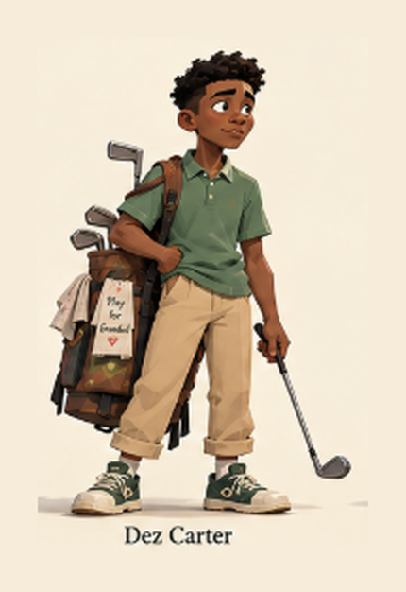

Boss Models: Rex, Marigold, Sterling
Description | The three opponents, sharing Dez's rig.
Type | Animated (skeletal mesh)
Format | .glb, 1024×1024 PNG textures
Comments | Animations: Idle, Swing, Putt, Taunt, Celebrate, Disappointed.  Base meshes and animations adapted from Quaternius CC0 character packs, re-textured per character.
Concept Art | 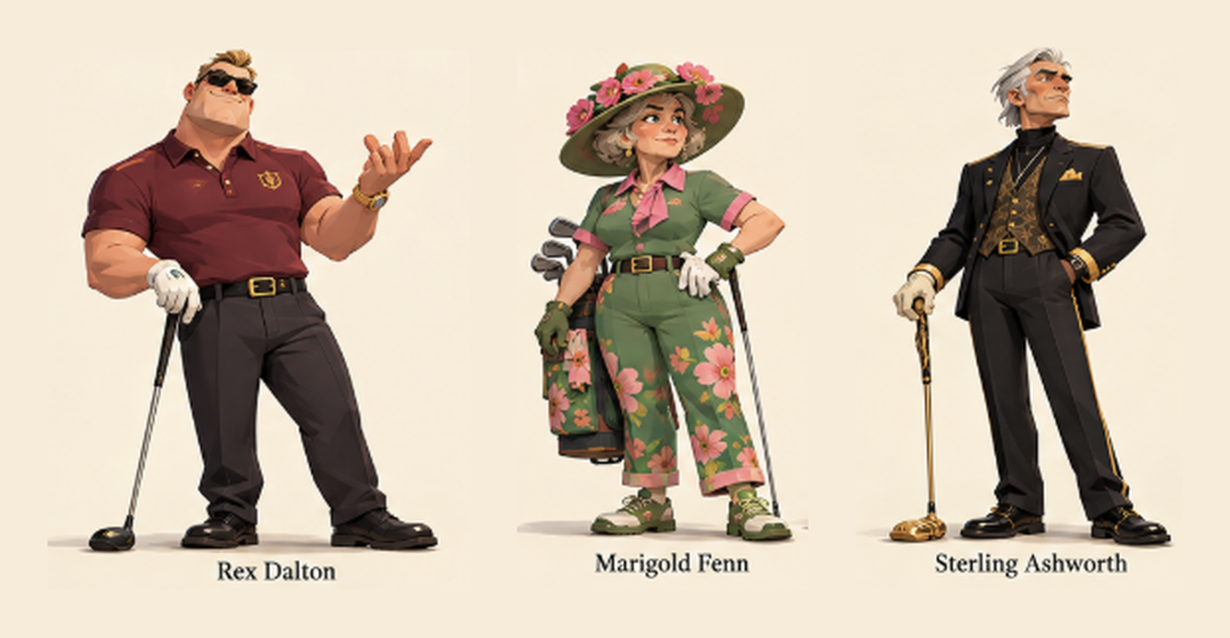

Character Portraits
Description | Dialogue portraits for Dez, Nana Ruth, Bo, Rex, Marigold, and Sterling.
Type | Static
Format | PNG 512×512 RGBA
Comments | Nana Ruth and Bo appear only as portraits.
Concept Art | 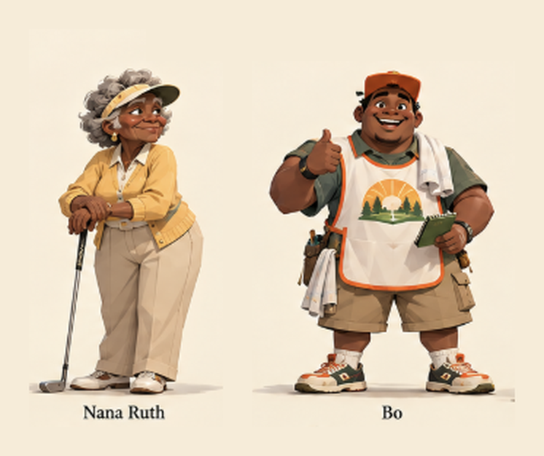

Course Terrain: Thornbrook Gardens
Description | Three holes with fairway space for growing hedges.
Type | Static (hedges animated separately)
Format | .glb with vertex colors; trimesh collision
Concept Art | 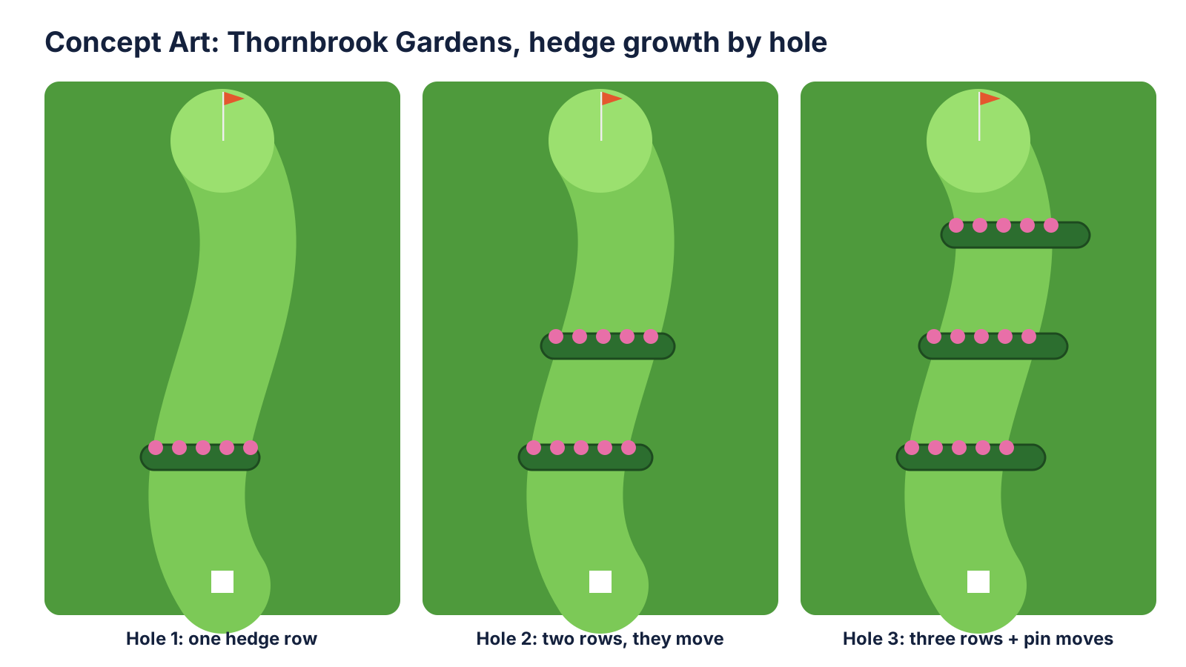

Course Terrain: Ashworth Links
Description | Three cliffside holes beside water, exposed to the wind.
Type | Static
Format | .glb with vertex colors; trimesh collision
Comments | Pine Hollow's three holes use the same format.
Concept Art | 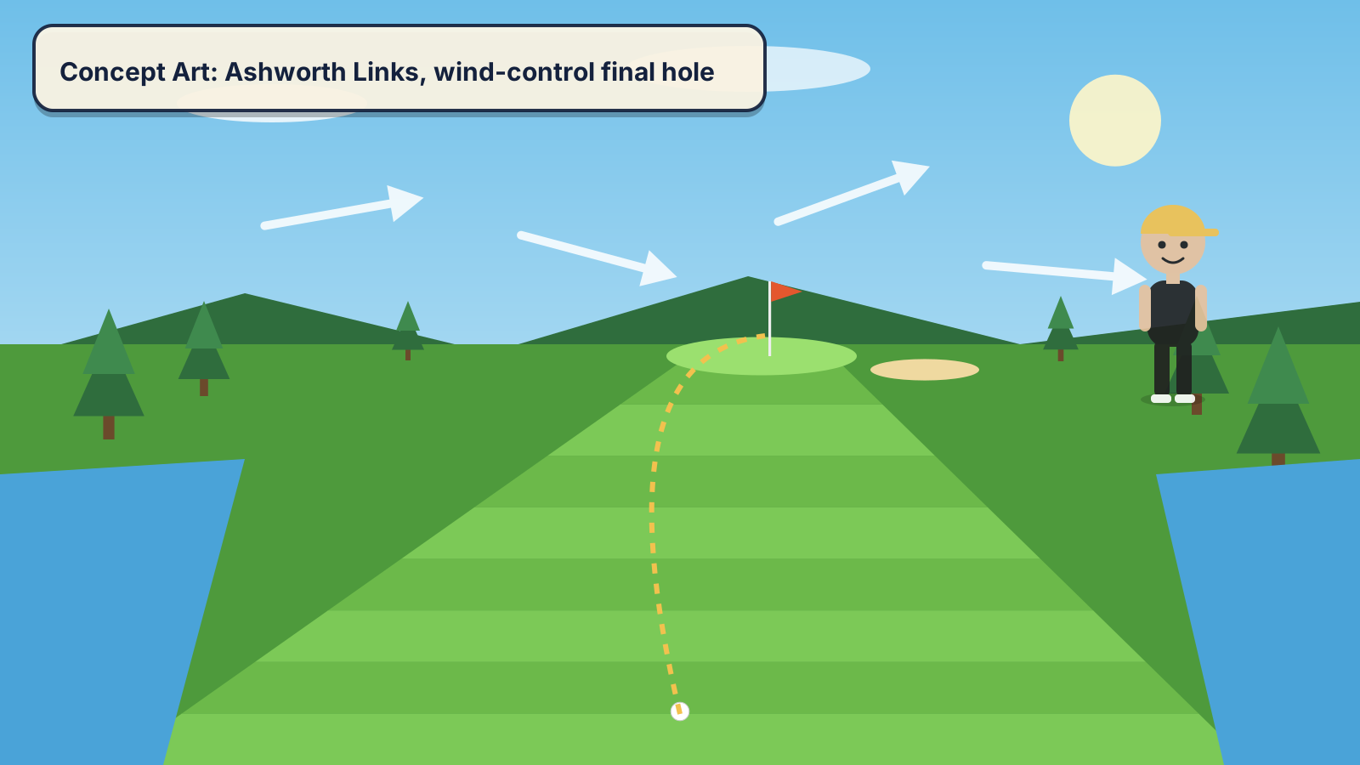

- Other Visual Assets
Asset | Type | Format | Description
Golf ball | Static | .glb, 200 triangles | White ball with a toon outline.
Flagstick and flag | Animated | .glb, wave animation | Shows wind direction.
Cup | Static | .glb | Hole liner in each green.
Hedge | Animated | .glb + Tween | Flowering hedge for Match02.
Props | Static | .glb (Kenney / Quaternius CC0) | Trees, benches, carts, stakes, clubhouse.
Terrain textures | Static | PNG 1024×1024, tileable | Fairway, rough, sand, green, water.
Logo and box art | Static | PNG 2048×2732 RGBA | Title logo and capsule.
Menu backgrounds | Static | PNG 1920×1080 RGB | Win and Lose screens.
UI kit | Static | PNG RGBA, 9-slice | Panels, buttons, meters, icons.
Aim line | Animated | In-engine scrolling shader | Dashed aim line.
Particle sprites | Animated | PNG 128×128 RGBA | Grass and sand puffs, confetti.
Font | Static | Inter .ttf (SIL OFL) | All UI and dialogue text.

AUDIO ASSETS
Asset | Type | Format | Description
Main Theme | Music | OGG | Upbeat acoustic menu theme.
Pine Hollow Theme | Music | OGG | Relaxed small-town tune.
Thornbrook Theme | Music | OGG | Playful strings.
Ashworth Theme | Music | OGG | Tense theme; extra layer on the last hole.
Victory Jingle | Music | OGG, no loop | Short fanfare.
Defeat Jingle | Music | OGG, no loop | Gentle descending tune.
Swing Whoosh | SFX | WAV | Club cutting the air.
Club Impact | SFX | WAV | Crisp strike, pitched by club.
Putt Tap | SFX | WAV | Soft putter tap.
Ball in Cup | SFX | WAV | Ball rattling into the cup.
Ball Landing | SFX | WAV | Thump on grass.
Sand Thud | SFX | WAV | Bunker landing.
Water Splash | SFX | WAV | Ball hitting water.
Hedge Rustle | SFX | WAV | Hedge growing.
Wind Gust | SFX | WAV | Rush of wind.
Crowd Cheer | SFX | WAV | Clapping when a hole is won.
Rex Taunt | SFX (voice) | WAV | Rex's friendly heckles.
UI Click | SFX | WAV | Button press.

PRODUCTION, TASK BREAKDOWN, AND SCHEDULE
- Owner
  - Every task is completed by Tre' Smith, the sole team member, by the Friday that ends its week.

SCHEDULE
Week | Team Tasks  (Tre Smith) | Programming Tasks  (Tre Smith) | Art Tasks  (Tre Smith) | Testing Tasks  (Tre Smith)
Week00  Oct 26–30 | Submit the GDD (Oct 30). | Godot project, Git/LFS repo, test scene. | Concept art; CC0 prop kits. | Windows export works.
Week01  Nov 2–6 | Progress Report 01 (Nov 6). | Ball prefab, PlayerInput, ShotAim, SwingController, Camera Rig. | Graybox Hole 1; ball, flag, cup; swing and impact SFX. | Swing, ball flight, roll, camera.
Week02  Nov 9–13 | Progress Report 02 (Nov 13). | Hole prefab, MatchManager, MatchScorer, OpponentAI, HUD, GreenReader. | Dez model, rig, core animations; Holes 2–3; HUD art. | Scoring, penalties, AI shots, HUD.
Week03  Nov 16–20  PROOF OF CONCEPT | Submit the Proof of Concept (Nov 20). | Main Menu, Settings, PressureFocus, TauntRule, PauseGame, temporary result screens. | Rex model; two themes; cup, putt, landing, click SFX. | Win and lose Match01 from the menu; pause.
Week04  Nov 23–27  Thanksgiving | Review the proof of concept. | Story scene, DialogueRunner, save/Continue, Chapters 1–2. | Portraits, dialogue UI, two more animations. | Chapter flow, save, Retry.
Week05  Nov 30–Dec 4 | Content complete. | Match02 and Match03 with their rules, shot unlocks, result managers, Chapters 3–4.  CaddieCall | Marigold, Sterling, both courses, hedge animation, remaining audio. | Hedges, wind, full playthrough.
Week06  Dec 7–11  FINAL RELEASE | Submit build, source, postmortem, video (Dec 11). | Bug fixes, balance, final build. | Polish; edit the video. | Clean-machine playthrough.

SCENES & DIAGRAMS
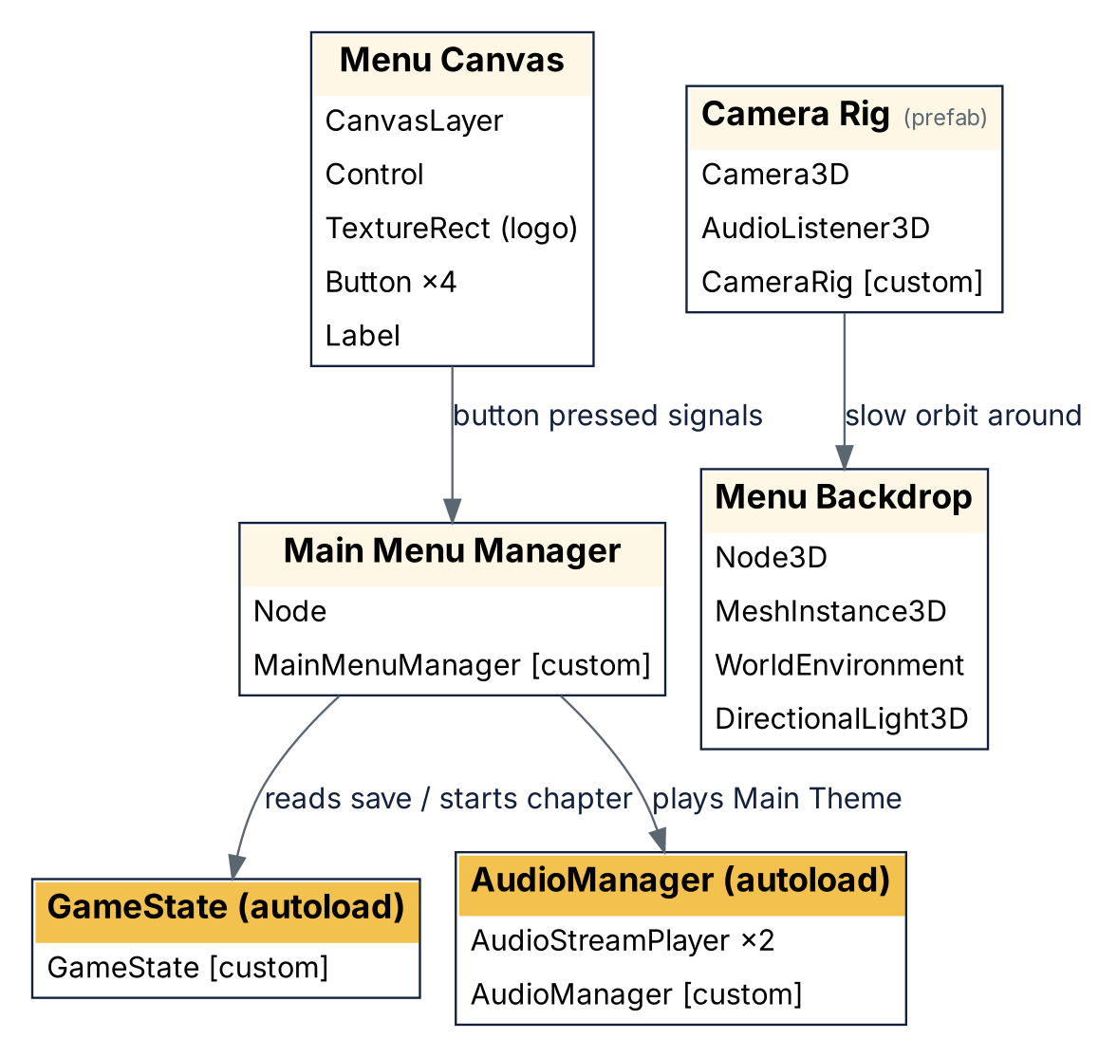
Figure 13: Main Menu Scene

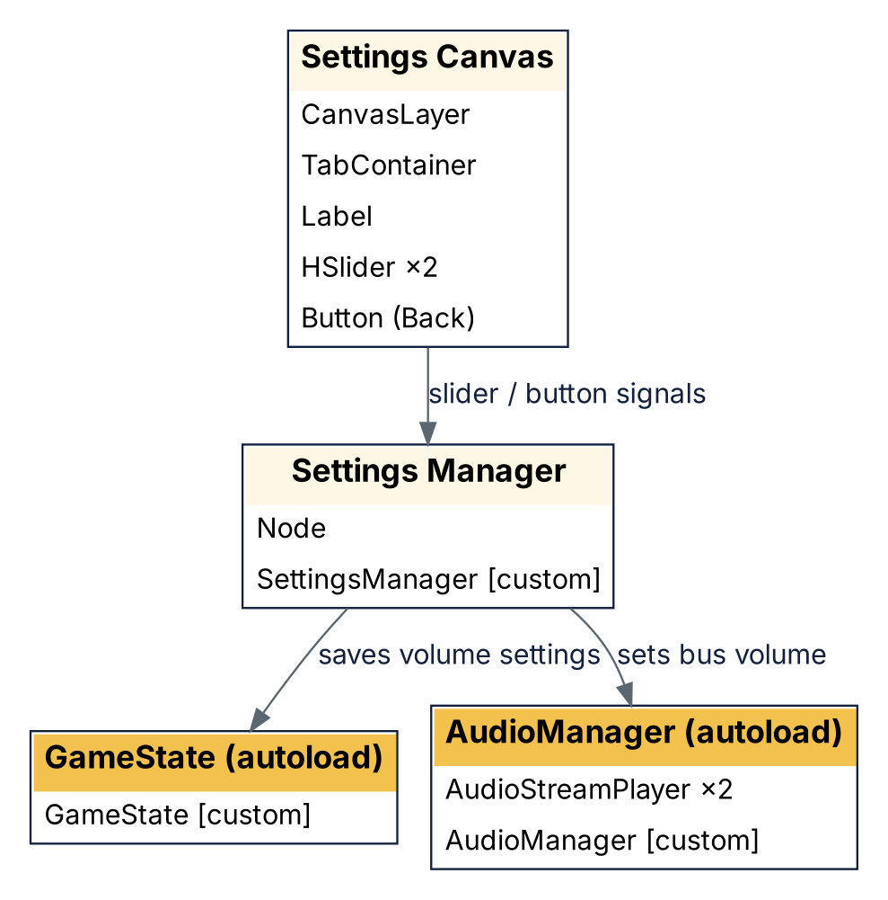
Figure 14: Settings Scene

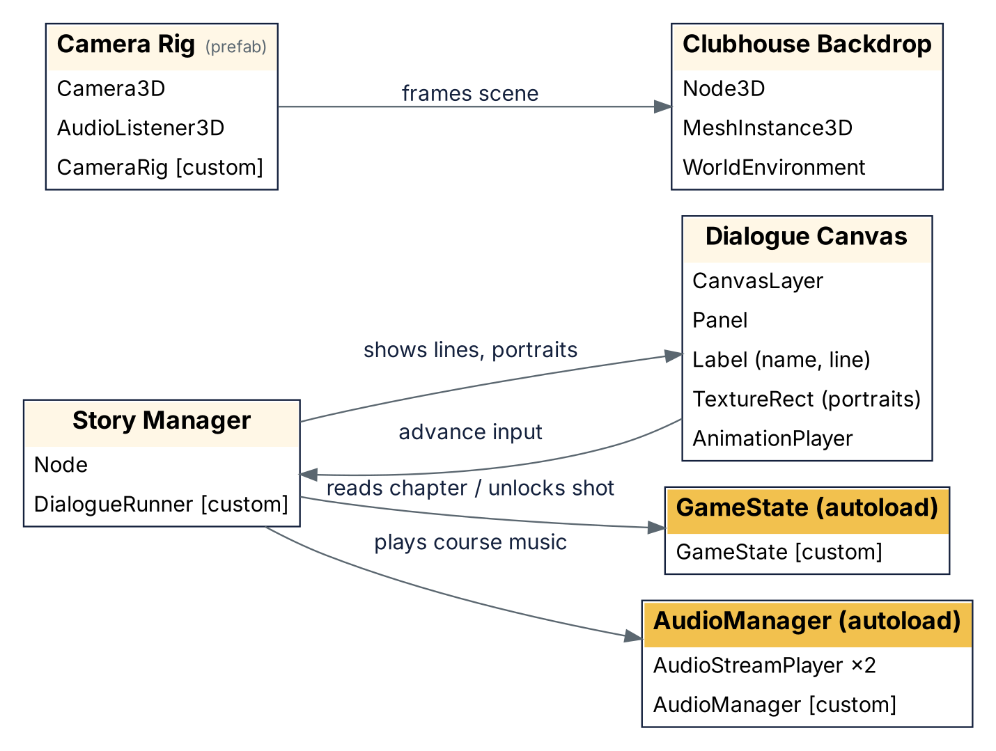
Figure 15: Story Scene

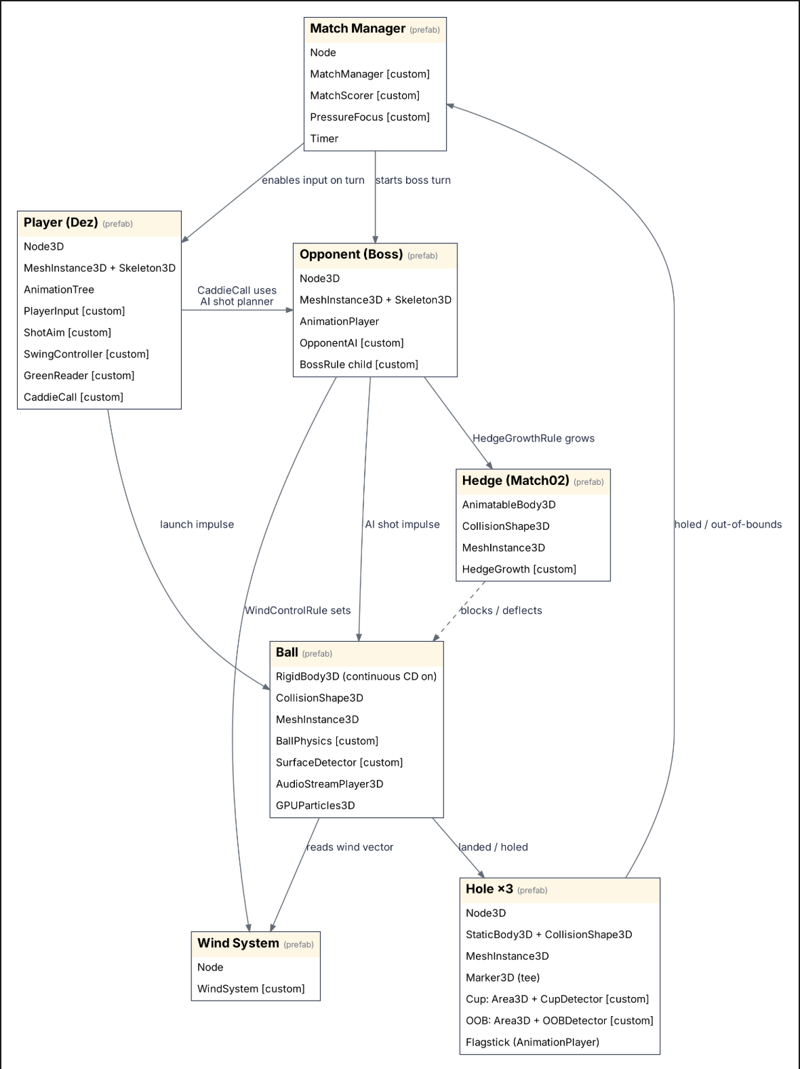
Figure 16: Match Scenes: Gameplay

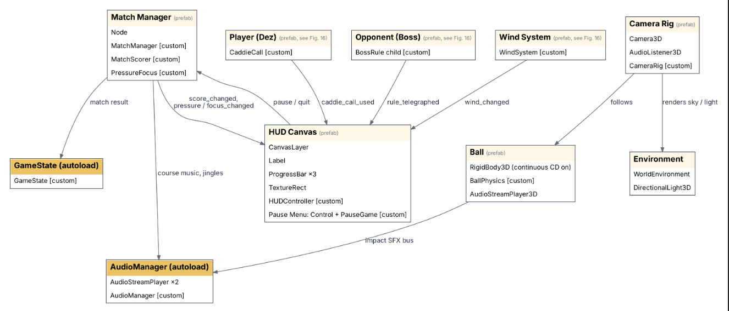
Figure 17: Match Scenes: Presentation and Globals

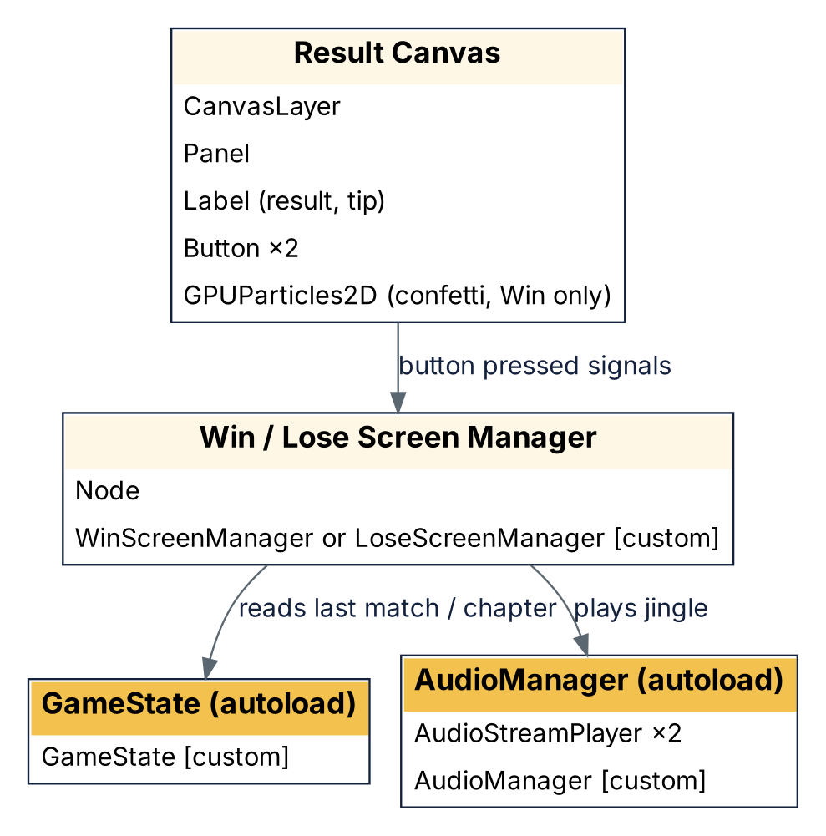
Figure 18: Win / Lose Screens

