Build and Run Python Profile screen application in Docker container:

Clone the project from the git

CMD : **git clone** [**https://github.com/treddy2/ravi-proj.git**](https://github.com/treddy2/ravi-proj.git)

**Cd to the Root Project**

**Cd ravi-proj**

**Create Dockerfile in the root directory**

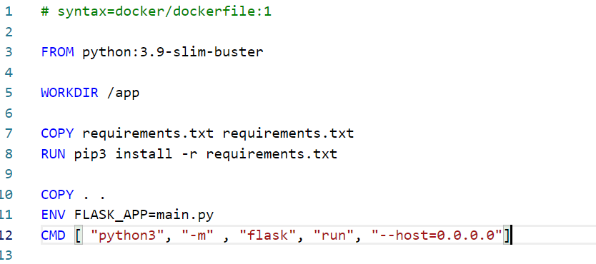

Dockerfile

2)Build Docker image using the below command

CMD: **docker build --tag hcl-psweb-app:1.0.0 .**

**3)Run Docker image In the container** using the below command

CMD : **docker run hcl-psweb-app:1.0.0**

**Note: If you get not connection with the port 8080 or any other port.Expose and run the image as given below**

CMD: **docker run –publish 8000:5000 hcl-psweb-app**



Open in the web-preview on the cloud console and provide port 8000 to serve the request, it will redirect/render the login page.

CMD : **curl localhost:8000**

And the server acknowledge as given below

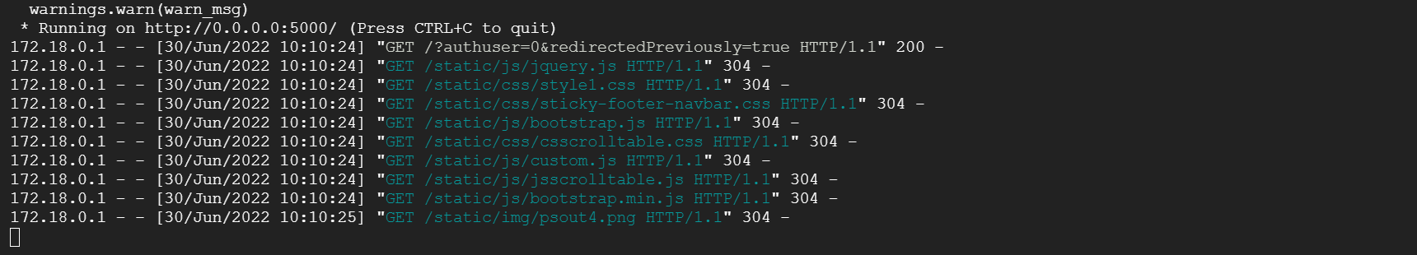

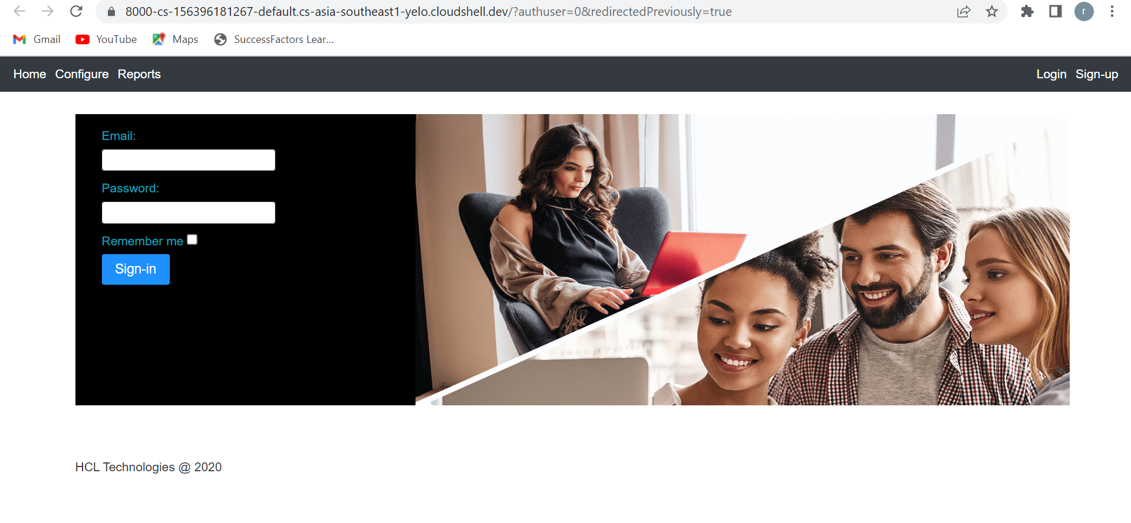

**NOTE:**

**If you want to delete the image, first delete the container that which associated.**

**1)Docker rm container_id**

**2)Docker rmi image_id**

**Some Important Commands**

You can clean up all containers. First of all, you need to stop all containers with:

**CMD : docker stop $(docker ps -aq)**

Finally, remove all containers with:

CMD : **docker rm $(docker ps -aq)**

You can do it all in one command

CMD : **docker rm $(docker stop $(docker ps -aq))**

Forcefully delete the images

**CMD : docker rmi -f image_id**

**To delete all images forcely**

docker rmi -f $(docker images -a -q)

run application locally

python3 -m flask run

1)Add Network for SQL Instance from the connection

0.0.0.0/0

2)create 3 - ssl certificates fro