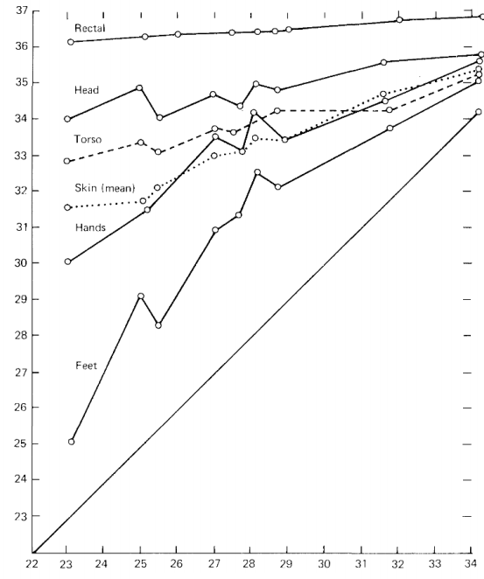
http://focus.ece.ufl.edu/wp-content/uploads/2016/12/presentation_sensor_level_privacy_for_thermal-cameras.pdf
gain, digitization, exposure time, and bias voltage

Sensor → Modificatie → Constructie Beeld
=> Beeld nooit opgenomen/opgeslagen
3 Sensor lvl opties:
- Digitalisatie => S+Hware
- Ruis => Slecht beeld
- Exposure (belichting) => +#Beelden +Meettijd

Research Groep: http://focus.ece.ufl.edu/privacy_preserving_computational_cameras/

TODO range cam+term
- Privacy masking (SW): https://www.2mcctv.com/blog/2012_08_01-masking-motion-detection-privacy-masking/
- Sensor Fusie (combinatie sensoren): https://en.wikipedia.org/wiki/Sensor_fusion
Overig Gevonden:
(Contact us…):
- https://www.instituts-carnot.eu/en/carnot-partnership-success-stories/infrared-sensor-locates-and-counts-people-respects-their-privacy
- https://peoplesense.irlynx.com/
(Privacy Gevoeligheid?):
- https://news.panasonic.com/global/press/data/2020/02/en200218-2/en200218-2.html

[ Peoplecount ]
Data opslag + stroom kosten + OpenPose: https://arxiv.org/pdf/1911.09217.pdf

