Effective coherence time enhancement by feedforward decoupling

Nitrogen-vacancy centers in diamond have astounding, phenomenal properties. Wow! Introduction missing  [1,2]

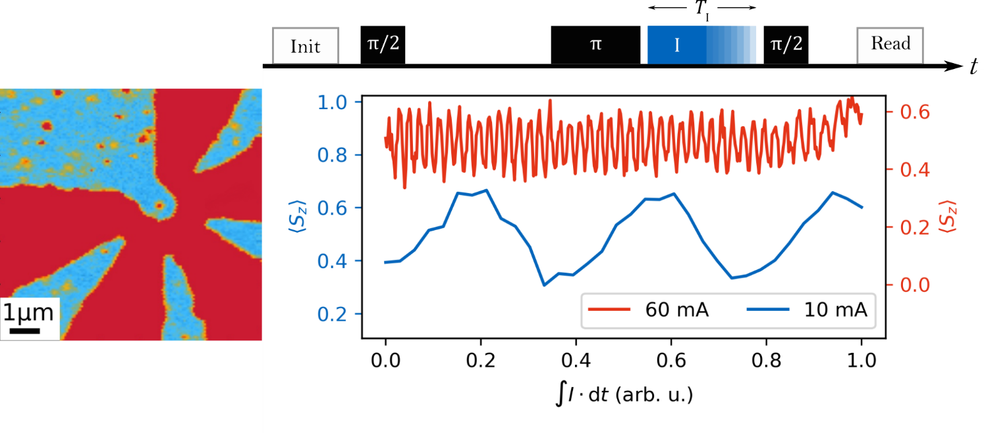

Figure 1: a) Fluorescence scan of diamond sample. A star shaped gold structure embraces a single nitrogen-vacancy center. Strom und B Feld einzeichnen? b) Altered Hahn Echo sequence (top) and measurement results (bottom). A current pulse is applied during the second free evolution time for a time TI. [2 columns]

In our experiments, we apply microwave control pulses as well as magnetic gradient generating current pulses over a star shaped gold structure, centered around a single NV center [Figure 1a]. In order to isolate the effect of the current pulses on the NV’s phase, we use a slightly altered Hahn echo sequence [Figure 1b top], where we add a current pulse during the second free evolution time. Another NV-based alteration is the projection of the phase onto the NV’s z-axis before readout with an additional -pulse.

For each shot, we measure, integrate and finally correlate the respective current to the readout result. We measure the current flow by monitoring the voltage drop at a 50 resistance that is in series with the current application structure. An oscilloscope (Spectrum M4i.4451-x8) with 500 MS/s and a 14-bit digital resolution is recording the voltage for every shot, allowing correlating each readout result with the corresponding preceding current pulse.

The current’s magnetic field at the NV position leads to a time dependent detuning

with constant and in the end to a current induced phase

proposing an oscillation of the NV center’s excitation with increasing integrated current.

The free evolution times and were fixed to 500 ns, reducing the contrast to 20 %, while the current pulse duration was swept from 10 ns to 500 ns. The results shown in Figure 1 are in great agreement with Equation xx, showing sinusoidal oscillations with a current dependent frequency. We measured the blue graph on a single NV center with a nominal 10 mA current for a well-resolved measurement. It shows more than two full oscillation periods. We recorded the red graph on another NV center, with higher current coupling and a current of nominal 60 mA, the maximum non-damage current of our structure, to determine the maximum number of full oscillations that we can achieve. We could record over 40 oscillations, not showing an obvious decay. An exponential decay fit however indicates, that the original signal drops to 1 % after over 600 full oscillations. This enables measurements with hundreds of operations, as for example in correlation measurements [xx], where knowledge of the exact evolution of a qubit over long periods is crucial. The actual integrated current varies for the two graphs of Figure 1b. We found it convenient to plot the two graphs of Figure 1b with a shared x-axis, where the value 1 for the integrated current means each corresponding maximum value, so to speak where the current was switched on during the whole second evolution time. However, due to the different current strengths, this does mean, that the actual integrated current differs for the two graphs.

In the following experiments, we focus on reconstructing the actual signal of an echo decay measurement, while it is perturbed, as before, with a current pulse during the second free evolution period [Figure 2]. The current pulses are of random duration ranging from 0 ns to and are measured for each shot. In principle, knowing the integrated current and thus the gathered phase from Figure 1 allows us to match the phase of the projection -pulse accordingly in a feedforward decoupling manner and therefore get the maximum echo signal for every measurement, independent of the actual current pulse duration. However, to perform this correction fast enough is technically so challenging, that we tried a much simpler approach, only allowing x- and y-projection pulses [Figure 2].

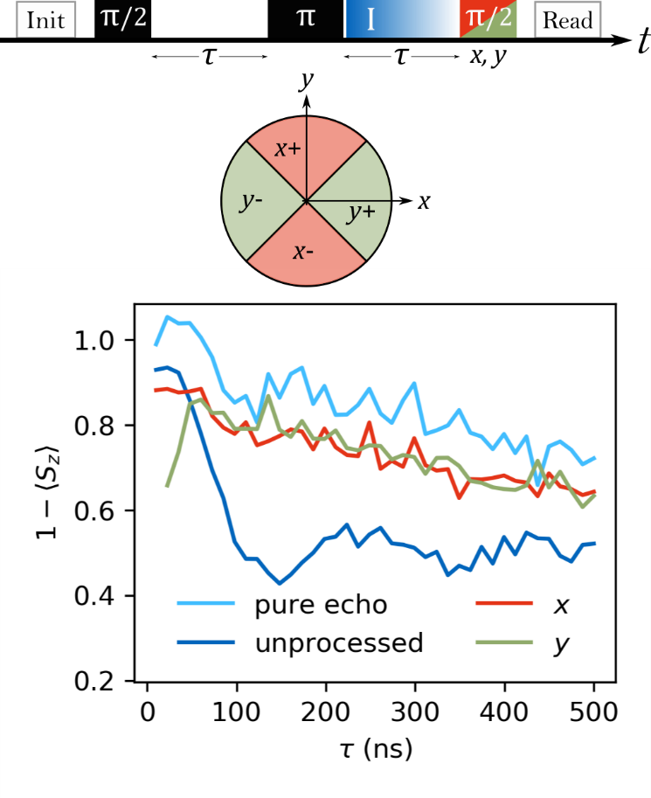

Figure : a) Measurement sequence. During the second free evolution time, a current pulse of random length is applied. The projection pulse before readout is altering in phase between x and y. b) Top view of a Bloch sphere’s equator. We divide the unit circle into four sectors, each depending on the correct projection phase to yield maximum signal amplitude. The red sectors require an x-phase projection pulse; the green ones require a y-phase projection pulse. c) Measurement results of the sequence shown in a). The light blue graph is a pure echo, without any current pulses and always projected with an x-phase pulse, decaying with constant . The dark blue graph shows the unprocessed, as-measured data, where all combinations of measured current and projection phases are taken into account, leading to the short decaying constant . The red (green) graph neglects all results but those, where an x-phase (y-phase) projection pulse was applied on the qubit system in one of the red (green) sectors of b). Both are derived from the measured data by feedforward decoupling.

From the measurements in Figure 1, we can divide the integrated current into sectors, each corresponding to one of the following cases in phase space [Figure 2]: maximum positive contrast with x-projection (*x+*), maximum negative contrast with y-projection (*y+*), maximum negative contrast with x-projection (*x-*) and maximum negative contrast with y-projection (*y*-). The projection pulse is now alternating between x- and y-projection and we only keep the measurement if the gathered qubit phase and projection pulse phase add up to maximum contrast or discard the measurement otherwise. We convert negative contrast to positive contrast by mirroring it around the line. In some sense, this matches the above-proposed feedforward decoupling, only that we are not deterministically controlling the projection pulse but post select the measurements based on integrated current and applied projection pulse. The blue graph in Figure 2 shows this measurement’s outcome without correcting for the introduced noise by the random current pulses. In that case, we did not discard any shots but rather let good-contrast shots as well as no-contrast shots contribute to the integrated signal. The result is an exponential decay with ns, which is much shorter than the measured decay of the unperturbed echo without any current pulse [Figure 2, light blue graph], where the decay constant is ns. The red and green graphs are the post-selected results of our feedforward decoupling method for x- and y-projection pulses, respectively. The method corrects the perturbing effect of the random current pulses to a good extent, increasing the coherence time sevenfold to ns, but not fully reaching the slow decay of the unperturbed measurement. This technique, only considering those measurements, where the combination of gathered phase and projection phase is beneficial to the result, leads in the end to the same result as an actual feedforward experiment, so that we found the name feedforward decoupling appropriate.

In the next step, we get rid of the sector calibration step by recording and saving the free evolution duration , the integrated current , the projection pulse phase, still only allowing *x* and *y,* and the readout result for every shot as shown in Figure 3 and finally correct the decoherent noise effect of the current in post-processing. This method spares a preceding measurement, which becomes a relevant time factor if one either performs this kind of measurement on different single NV centers or if similar measurements are performed while scanning through a very densely packed NV center ensemble. It is also capable of reconstructing a more complex signal even if the NV response depends on , which is not possible for the simple calibration procedure of the previous measurements.

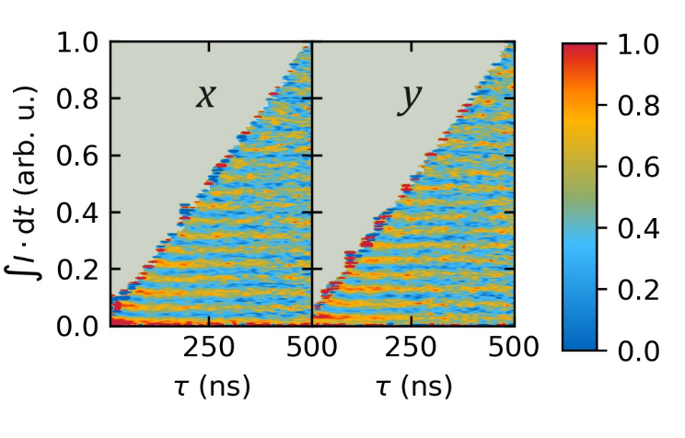

Figure : Calibrationless measurement data. Free evolution duration, integrated current and projection pulse phase is recorded for each shot to avoid preceding sector calibration. The triangular shape is based on the boundary condition . Signal reconstruction, for example feedforward decoupling, is done in postprocessing.

The triangular shape of the plots in Figure 3 is associated with the boundary condition , which limits the integrated current to low values for short . Both, the x- and y-plot show the expected echo decay along the -axis and phase oscillations along the -axis, only that they are shifted by a phase of in respect to each other. From this plot, we extracted the sector calibration post-measurement and applied the same post-selected feedforward decoupling correction. Both, the uncorrected and the as before corrected echo decay single are shown in Figure 4, displaying a coherence time improvement from ns to ns.

The sector calibration method however is flawed fundamentally, as it neglects that not all allowed combinations of gathered phase and readout phase yield maximum contrast but on average . One way of improving on that, would be dividing the the phase space in more than four sectors and equally increasing the projection pulse phase alternatives. However, as our feedforward decoupling method relies on finding beneficial combinations of gathered phase and projection phase in post-processing, this approach would also increase the neglected data and finally the measurement time.

In our case, an easy way to improve it, is fitting a sine curve to every column of the triangle plot and take the fitted amplitude for a given as the respective echo decay contrast. Amplitudes for x- and y-phase projection pulses are averaged. As expected, the sine fit method outperforms the feed forward decoupling, improving the coherence time even further to ns. On top of that, the fitting method does not neglect any data, ultimately speeding up the measurement even further.

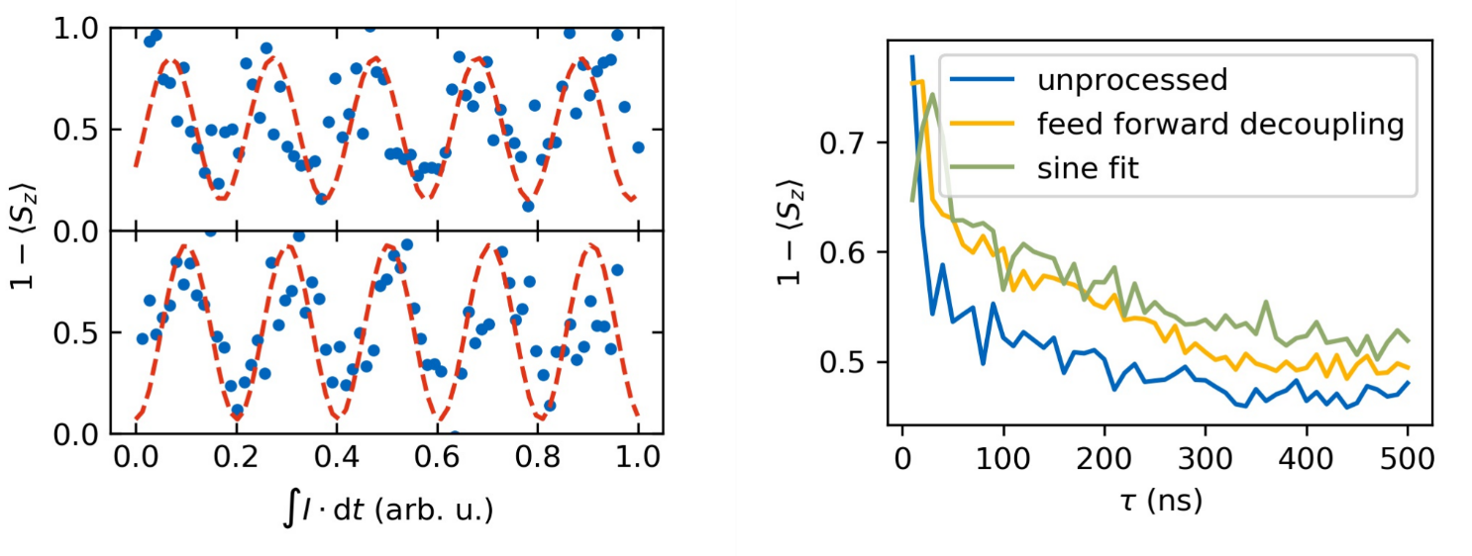

Figure : Echo signal reconstruction from the measurement shown in Figure 3. b) Reconstructed graphs. a) A column from the x-phase (top) plot in Figure 3 and the corresponding column from the y-phase (bottom) plot. Blue dots depict the measurement data, red dotted line is a sine fit to it. The amplitude for each is extracted from the sine fits and used to reconstruct the echo signal. b) Reconstructed signal graphs. The dark blue curve, as in Figure 2, is not correcting for any noise and simply shows the average of each column of the calibrationless measurement. The yellow graph is the signal reconstructed by feed forward decoupling. The green graph shows the signal reconstructed by the sine fit technique shown in a).

[1] F. Jelezko, T. Gaebel, I. Popa, A. Gruber, and J. Wrachtrup, Phys. Rev. Lett. **92**, 076401 (2004).

[2] P. Appel, E. Neu, M. Ganzhorn, A. Barfuss, M. Batzer, M. Gratz, A. Tschöpe, and P. Maletinsky, ArXiv:1604.00021 [Cond-Mat] (2016).

P.S. die Zitate sind nur Platzhalter, damit schonmal eine Bibliothek an der richtigen Stelle angelegt ist.