Table of Contents
1 R Analysis Pipeline — Raw data to figures and manuscript tables 1
1.1 1. High-level flow 2
1.2 2. Sources of truth 2
1.3 3. Data ingestion — load_tick_data() 3
1.4 4. Analytical table — build_analysis_table() 3
1.5 5. Analytical subsets 4
1.6 6. Inference helpers 4
1.7 7. Models 5
1.8 8. Summaries consumed by figures 6
1.9 9. Figure generators 6
1.10 10. Logbook entries 7
1.11 11. Manuscript tables — write_manuscript_table_files() 7
1.12 12. Prose QA — run_academic_style_qc() 8
1.13 13. Running the pipeline 8
1.14 14. Invariants the pipeline enforces 9

1 R Analysis Pipeline — Raw data to figures and manuscript tables
This document describes the analytical side of the repository only: how input.xlsx is loaded, cleaned, summarized, modelled, and turned into the figure / summary / table artifacts under figures/ and derived/manuscript_tables/. It does not cover the bookdown → pandoc → DOCX/PDF rendering step (that lives in R/build_thesis_book.R and tools/update_docx_fields.py and is intentionally out of scope here).

1.1 1. High-level flow
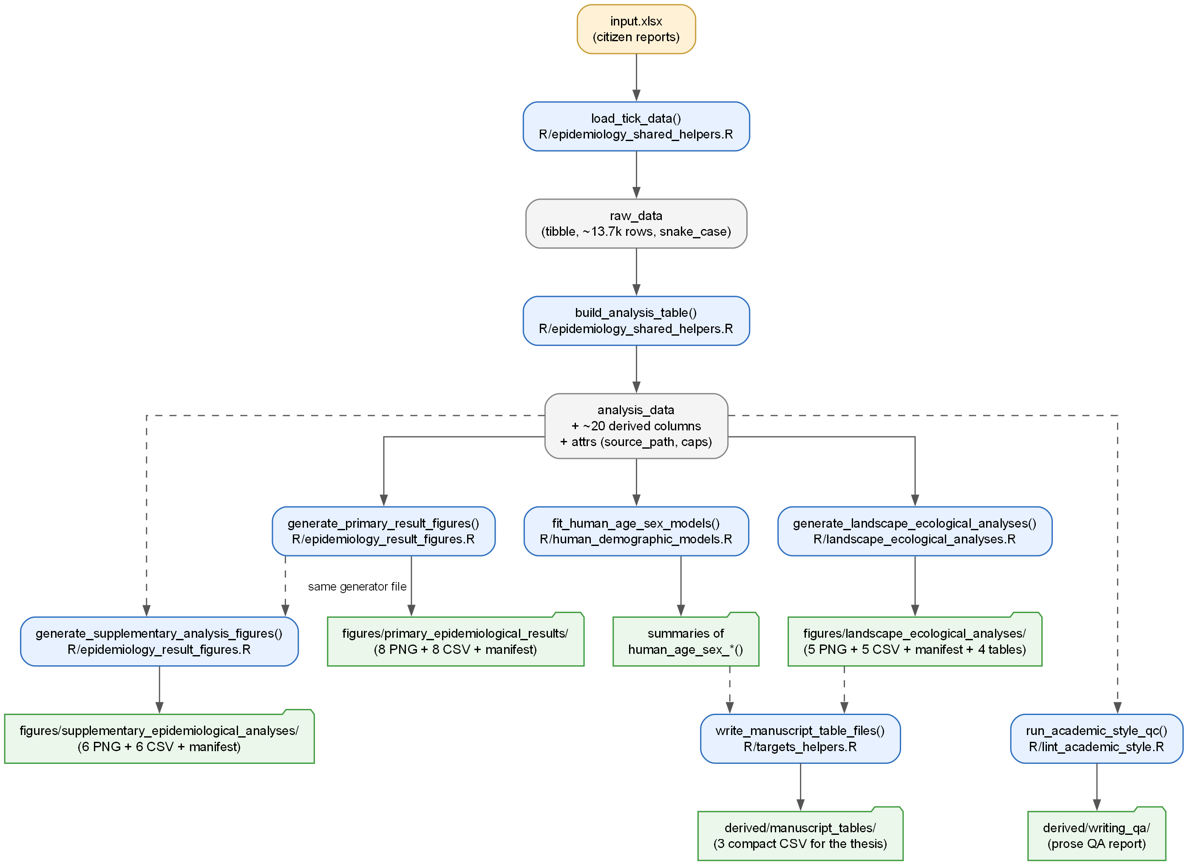
Analysis pipeline flow diagram
The diagram above is rendered from docs/diagrams/analysis_pipeline_flow.dot (Graphviz). Solid arrows are strict data-flow dependencies; dashed arrows mark a shared source file or a cross-cutting dependency (e.g. manuscript_tables needing both the model summaries and the landscape outputs).
Every orchestration step is a targets::tar_target in _targets.R, so targets::tar_make() rebuilds only what is stale. Artifact targets use format = "file" so targets fingerprints the generated PNGs / CSVs on disk and invalidates downstream steps when any of them changes.

1.2 2. Sources of truth
File | Role
input.xlsx | Raw citizen-report spreadsheet from flaatinfo.dk.
_targets.R | Pipeline graph; names every target and its dependencies.
R/epidemiology_shared_helpers.R | Loaders, cleaners, parsers, winsorization, Wilson / bootstrap CIs, spatial helpers, per-outcome summarise_* functions.
R/human_demographic_models.R | Age × sex GLMs for bite burden and rash.
R/epidemiology_result_figures.R | Figure generators for primary + supplementary collections, plus p-value helpers, themes, and significance brackets.
R/landscape_ecological_analyses.R | Landscape-specific summaries, full + sensitivity model fits, figure generator.
R/targets_helpers.R | Output-path declarations, manuscript table builders, academic QA runner, thesis-build wrapper.
R/lint_academic_style.R | Prose QA heuristics that write derived/writing_qa/.

1.3 3. Data ingestion — load_tick_data()
Defined in R/epidemiology_shared_helpers.R.
- Reads exactly one worksheet from input.xlsx via readxl::read_excel() with guess_max = 20000 and .name_repair = "minimal".
- Fails fast if the workbook contains zero or more than one sheet.
- Runs janitor::clean_names() to normalize column names to snake_case.
- Attaches attr(raw_data, "source_path") and attr(raw_data, "sheet_name") for downstream logbook entries and provenance tracking.
Required raw columns (enforced by build_analysis_table()): bite_type, age, gender, crawl, bite, rash. Optional columns used when present: bite_date, registration_date, country, characterization, temperature, humidity, latitude, longitude.

1.4 4. Analytical table — build_analysis_table()
Same file. Produces analysis_data with these derived columns (see _common.R for the full data dictionary as consumed by the thesis):
Column | Meaning
bite_type_clean, country_clean, characterization_clean, gender_clean | Lowercased / uppercased standardized categoricals.
rash_flag, rash_numeric | Boolean + 0/1 encoding for logistic models.
bite_count_raw, crawl_count_raw | Integer versions of the raw fields (accept "true (N)", "1", TRUE, etc. via parse_tick_count()).
bite_count_winsorized, crawl_count_winsorized | Counts capped at quantile(..., 0.99, na.rm = TRUE) through winsorize_upper(). Caps are exposed as attributes bite_cap_p99, crawl_cap_p99.
age_years, age_group | Parsed numeric age + ordered 9-level factor via bin_age_group().
temperature_c, humidity_pct | Numeric covariates for the models.
bite_date_parsed, registration_datetime, registration_date_parsed, bite_month_number, bite_month_label | Dates / ordered month factor used for seasonality.
report_delay_days | registration_date - bite_date.
is_crawl_only | crawl_count_raw > 0 with bite_count_raw == 0.
From this point on the pipeline never touches the raw workbook again — every summary, model, and figure is a pure function of analysis_data.

1.5 5. Analytical subsets
Defined as small filter helpers in the same file so that they are reused identically across summaries, models, and figures:
- filter_human_age_gender(analysis_data) — human reports with valid age and binary sex. This is the primary demographic subset.
- filter_human_reports(analysis_data) — human reports only.
- filter_denmark_reports(analysis_data) — Denmark-only + coordinate filter (for the spatial figures).
- filter_landscape_records(...) — Denmark + one of urban, agriculture, forest, unknown (the last toggled via include_unknown).
- filter_landscape_human_demographic_records(...) — landscape filter combined with human + valid demographics + valid covariates; this is the base subset for every adjusted landscape model.

1.6 6. Inference helpers
- Proportions → Wilson CI: wilson_ci(successes, n) — vectorized, clipped to [0, 1].
- Means → bootstrap CI: bootstrap_mean_ci(x, bootstrap_replicates = 2000L, seed = 20260319L) — resample with replacement, quantile-based CI.
- Categorical p-values in landscape context: categorical_landscape_pvalue() — chi-square, falls back to simulated p-value (B = 5000) whenever any expected count is < 5.
- Significance rendering: p_value_to_stars() → bracket text; format_p_value_label() and format_p_value_for_table() → textual labels.

1.7 7. Models

1.7.1 7.1 Human age × sex — R/human_demographic_models.R
fit_human_age_sex_models(analysis_data) returns a list with bite_model, rash_model, and the model_data used for both:
- bite_count_raw ~ age_group * gender_clean + temperature_c + humidity_pct + bite_month_label, negative binomial (MASS::glm.nb).
- rash_numeric ~ age_group * gender_clean + temperature_c + humidity_pct + bite_month_label, binomial logit.
Auxiliary:
- summarise_human_age_sex_model_estimates() — marginal predictions on a reference grid (build_human_age_sex_reference_grid()) whose covariates are fixed at median temperature / humidity and at the most frequent bite month. CIs are link-scale ± 1.96 SE, then exp() or plogis() back-transformed.
- summarise_human_age_sex_model_tests() — likelihood-ratio test of the age × sex interaction by refitting a reduced additive model and computing 2·(logLik_full − logLik_reduced) vs its df-difference chi-square.

1.7.2 7.2 Landscape associations — R/landscape_ecological_analyses.R
fit_landscape_association_models(analysis_data) — three adjusted models on the Denmark-only subset with urban as reference:
- Bite burden: bite_count_raw ~ characterization_clean + age_group + gender_clean + temperature_c + humidity_pct + bite_month_label (negative binomial).
- Rash: same RHS, binomial logit on rash_numeric.
- Crawl-only: is_crawl_only ~ characterization_clean + bite_type_clean + temperature_c + humidity_pct + bite_month_label (binomial logit). The crawl model intentionally drops demographics because the pet side of the bite-type split breaks the demographic subset.
fit_landscape_association_models_variant(...) is the parametric version of the above and is also what powers the sensitivity analysis.
fit_landscape_sensitivity_models(analysis_data) enumerates 4 count variants (raw vs winsorized × include unknown vs exclude unknown) and 2 rash / crawl variants (include vs exclude unknown) and fits all of them.
Term extraction uses broom::tidy(..., conf.int = TRUE, exponentiate = TRUE) so coefficients surface as IRRs (bite) or ORs (rash, crawl-only). The landscape-specific rows are filtered (grepl("^characterization_clean", term)) and labelled with human-friendly contrasts (e.g. "Forest vs urban").

1.8 8. Summaries consumed by figures
All summarise_* functions in R/epidemiology_shared_helpers.R and R/landscape_ecological_analyses.R are pure transforms from analysis_data to plotting-ready tibbles. Representative examples:
- summarise_mean_bite_by_age_gender() → 18-row tibble with mean, bootstrap CI, and significance-star columns.
- summarise_rash_by_age() → 9-row tibble with Wilson CIs.
- summarise_crawl_only_probability() → 2-row tibble (human vs pet).
- summarise_denmark_municipality_counts() → municipality-level sf object with report counts and rate per 100 k (spatial join through giscoR::gisco_get_lau LAU layer, EPSG:3035).
- summarise_denmark_kde_surface() → KDE density grid clipped to the country polygon (giscoR::gisco_get_countries).
- summarise_landscape_human_outcomes() → outcome × landscape table with Kruskal–Wallis / chi-square p-values injected by compute_landscape_outcome_pvalues().
- summarise_landscape_monthly_profile() → 36-row (landscape × month) normalized shares used by the seasonality figure.

1.9 9. Figure generators
Three generators produce every PNG the thesis consumes. Each of them:
- Ensures the output directory exists and calls the matching cleanup_*_outputs() so stale artifacts are removed.
- Computes summaries via the helpers above.
- Builds the ggplot objects (with shared figure_theme(), significance brackets via add_significance_bracket(), and panel tags via add_panel_tags()).
- Writes each PNG via ggplot2::ggsave() with the standard device size (typically 11 × 6.8 inches for composite panels), then writes the matching -summary.csv.
- Concludes with write_artifact_manifest(artifacts, output_dir, …) that builds the per-folder manifest CSV (title, plot path, summary path, row count).
Generator | File | Output folder
generate_primary_result_figures() | R/epidemiology_result_figures.R | figures/primary_epidemiological_results/
generate_supplementary_analysis_figures() | same file | figures/supplementary_epidemiological_analyses/
generate_landscape_ecological_analyses() | R/landscape_ecological_analyses.R | figures/landscape_ecological_analyses/
For the per-figure catalog see docs/figures.md.

1.10 10. Logbook entries
Each generator is followed by a write_*_logbook_entry() call in the respective run_*_results_target() wrapper (R/targets_helpers.R). These append a timestamped markdown entry under logbook/ that records:
- source workbook path + sheet name (pulled from attr(analysis_data, …));
- winsorization caps (bite_cap_p99, crawl_cap_p99);
- number of rows in the raw data and in each analytical subset;
- manifest path for the just-written figures.
This is how we keep a persistent audit trail of every run independently of targets’ internal cache.

1.11 11. Manuscript tables — write_manuscript_table_files()
Defined in R/targets_helpers.R. From the landscape_model_terms and human_age_sex_interaction_tests targets it writes three compact CSVs into derived/manuscript_tables/:
- landscape_effects_table.csv — the curated row subset used in the thesis’s landscape results section (build_compact_landscape_table()).
- human_age_sex_interaction_tests_table.csv — the two LR tests for the age × sex interaction, formatted for inclusion (build_interaction_tests_table()).
- figure_inventory_table.csv — automatically rebuilt counts per figure collection with manifest paths (build_figure_inventory_table()).
These tables are read back by _common.R helpers (compact_landscape_table(), interaction_tests_table(), figure_inventory_table()) when the thesis is rendered, so the figures in the manuscript and the numbers in the body text come from the same source.

1.12 12. Prose QA — run_academic_style_qc()
R/lint_academic_style.R scans the thesis markdown / Rmd sources for prose issues (overused constructions, inconsistent terminology, stop-word rules). Results are written to derived/writing_qa/:
- academic_style_summary.csv
- academic_style_issues.csv
- academic_style_report.md
The QC step is a proper targets dependency of the final thesis build so the report never goes stale.

1.13 13. Running the pipeline

1.13.1 Preferred — full dependency-aware run
targets::tar_make()

1.13.2 Selective reruns
# Rebuild the three figure collections + manifests
targets::tar_make(c(
"primary_results_files",
"supplementary_results_files",
"landscape_results_files"
))
# Rebuild the manuscript tables
targets::tar_make("manuscript_table_files")
# Only the prose QA
targets::tar_make("writing_qa_files")

1.13.3 Standalone / ad-hoc
source("R/epidemiology_shared_helpers.R")
source("R/epidemiology_result_figures.R")
source("R/landscape_ecological_analyses.R")
source("R/human_demographic_models.R")
raw_data <- load_tick_data("input.xlsx")
analysis_data <- build_analysis_table(raw_data)
# Any single generator:
generate_primary_result_figures(analysis_data)
# …or any summariser in isolation, e.g.
head(summarise_mean_bite_by_age_gender(analysis_data))

1.13.4 Inspecting what a target depends on
targets::tar_visnetwork() # graphical view
targets::tar_deps(thesis_outputs)

1.14 14. Invariants the pipeline enforces
- Deterministic: every stochastic step uses a fixed seed.
- Self-cleaning: every figure generator wipes orphan artifacts before writing new ones.
- Provenance: every figure is shipped with its exact summary CSV and is listed in a manifest; the analytical table keeps source-path attributes; the logbook records each run.
- Single source of truth: summaries drive both the figures and the manuscript tables — the prose never quotes numbers that were not exported to disk.
- No leakage of raw workbook: after build_analysis_table(), the pipeline never re-reads input.xlsx; every downstream step is a pure function of analysis_data.

