***PROJECT - 8***

***TITLE – Smart water fountain***

***~submitted by: Treeshaa A***

***PHASE 2: Put your design into innovation to solve the problem.***

***LITERATURE REVIEW:***

*This section presents the review of related literatures which includes work done on the topic by past researchers. This section will be divided into two segments as follows:*

*1. Automatic sprinkler system incorporated with ground moisture sensor and real-time clock triggering system.*

*2. Water fountain incorporated with fountain auto refill. Automatic plant watering system has become much common with advancement in technologies. There are several types of plant watering system, depending on the level of automation needed. Some important plant watering system are illustrated below.*

***A. Arduino Based Automated Plant Watering System with Message Alert:***

*The block diagram gives the short illustration of what the framework will do in this specific system.* ***Arduino microcontroller*** *is used to control the entire procedure of this Plant Watering System. The use of soil sensor circuit is straight forwardly associated with a computerized soil sensor stick with digital pins connected to Arduino. An idea for GSM module in this project is to notify the user by sending SMS.*

***BLOCK DIAGRAM***

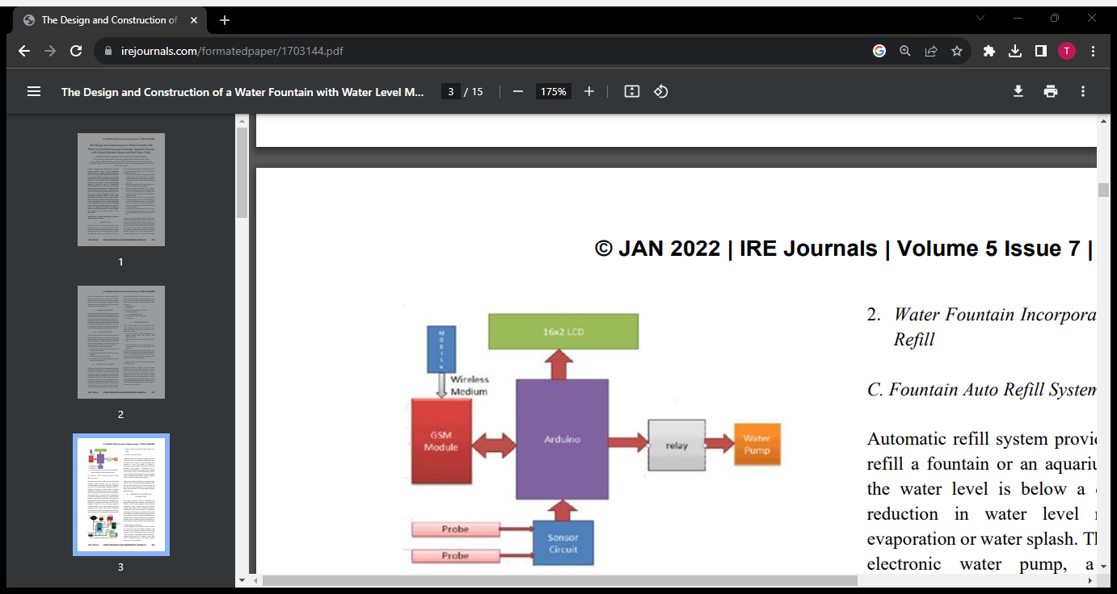

***B. Real-Time Clock Controlled Herbal Garden Watering System:***

*Hygrometer sensors are usually used in smart garden watering system. However, they are known for corroding quickly, particularly if watering is required every day. This system takes advantage of RTC to trigger the watering of an herbal garden. The major components used in this project as shown in figure 2 are: 12V power pack, real time clock, relay, buzzer, and Arduino Nano. An Arduino Nano is used because it is smaller and takes less space. The real-time clock module is connected to the Arduino. The Arduino is programmed to turn ON the pump at a designated time. The pump is connected to the relay and 12V power through a 12mm PVC tube. The water supply is enabled through a 20 litre tank, enough to keep the watering for a few weeks. A float switch is connected to the bottom of the tank, that triggers an alarm if the water level goes below a critical level for the pump [5].*

***C. Fountain Auto Refill System***:

*Automatic refill system provides a simple method to refill a fountain or an aquarium automatically when the water level is below a desired threshold. The reduction in water level might be caused by evaporation or water splash. The system consists of an electronic water pump, a float-switch and a microcontroller. When the water gets too low, the float switch sends a pulse to the microcontroller, and the microcontroller activates the pump. To operate a pump using an Arduino microcontroller, a relay is needed to switch on and off a separate power supply. Aquarium auto refill with Arduino is a simple example of how to use a float switch, small liquid pump and a relay to refill an aquarium once the water level gets too low. But this same technique can be used for pet dishes, water fountains, or any other number of similar applications.*

***METHODOLOGY (DESIGN AND CONSTRUCTION)***:

*The design procedure involves determining the appropriate materials and components to be used in the circuit as well as their properties; which includes components values, voltage ratings and maximum current ratings. These could be actualized easily by consulting the data sheet provided by component’s manufacturer. The analysis of each unit will be carried out in detail, for example, the value of capacitor in the power supply can only be determined by mathematical analysis where a formula is used and some important parameters such as total load current and frequency of mains* *voltage are used to calculate for the capacitance*.

1. ***Block Diagram of the System*** :

*The block diagram in this system is used to describe the most basic and less detailed description and operation of the automatic sprinkler and auto refill system. It shows the hardware used in the project which includes the Atmega328P microcontroller IC, real-time clock module, soil moisture sensor, float switch, submersible pump, refill pump, sprinkler pump, etc.*

***BLOCK DIAGRAM OF THE SYSTEM***

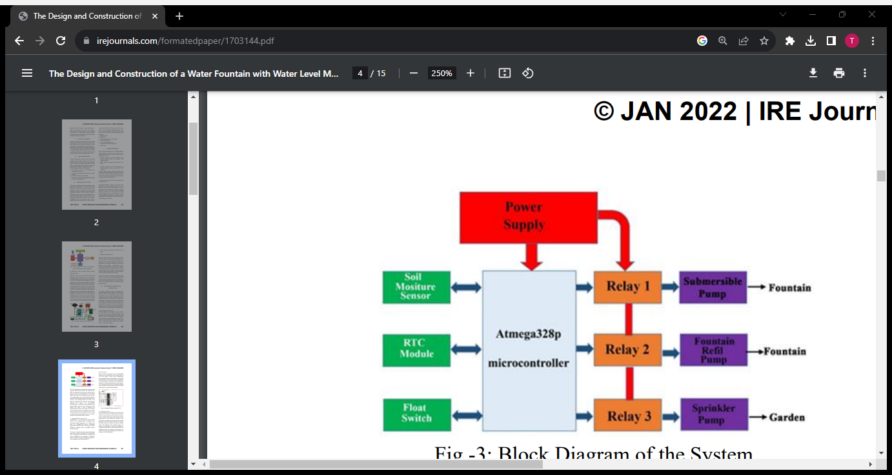

*The ATmega328P microcontroller IC is programmed using the Arduino IDE software. The function of the RTC is to keep track of the system in real time and to trigger the system at a designated time. The moisture sensor senses the level of moisture in the soil. The water pump supplies water to the plants and refills the fountain. The submersible pump is submerged in the reservoir of the fountain and moves water to the aerator or fountain piece where the water emerges. Although this project uses ATmega328P microcontroller to control the water pumps, but the microcontroller cannot be used to trigger the pump directly. The relay is used to interface the microcontroller with the water pumps. The moisture sensor measures the level of moisture in the soil and sends the signal to the microcontroller when watering is required. Water pump supplies water to the plants until the desired moisture level is reached.*

***1.ATmega328P Microcontroller IC:***

*ATmega328P is a low-power 8-bit microcontroller based on the enhanced RISC architecture. By executing powerful instructions in a single clock cycle, the ATmega328P achieves throughputs approaching 1MIPS per MHz allowing the system designed to optimize power consumption against processing speed. The device is manufactured using Atmel high density non-volatile memory technology. The ATmega328P AVR is supported with a full suite of program and system development tools including: C compilers, macro assemblers, program debugger/simulators, in circuit emulators, and evaluation kits [7].*

***PINS DESCRIPTION:***

The pictorial view of ATmega328P chip when it is used in place of the Arduino UNO or vice versa. Figure 5 below shows ATmega328P microcontroller pins and its description. The 14 digital input/output pins can be used as input or output pins by using pin Mode (), digital Write () and digital Read () functions in Arduino programming. Each pin operates at 5V and can provide or receive a maximum of 40mA current and has an internal pull-up resistor of 20-50K Ohms which are disconnected by default.

***ATmega328P Microcontroller IC 25***

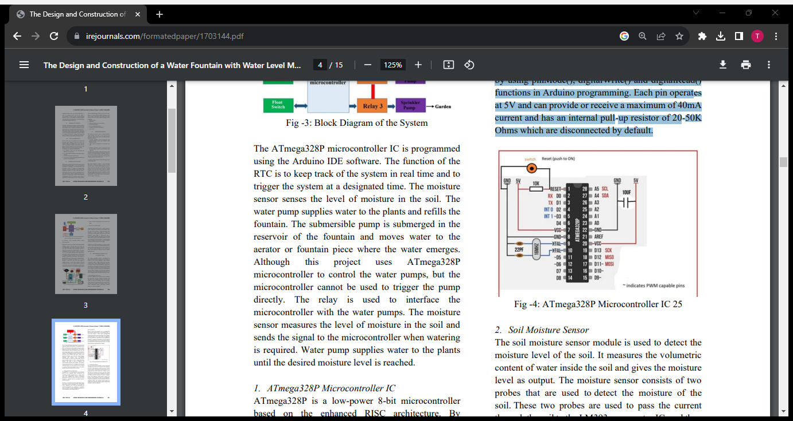

***2. Soil Moisture Sensor*** :

*The soil moisture sensor module is used to detect the moisture level of the soil. It measures the volumetric content of water inside the soil and gives the moisture level as output. The moisture sensor consists of two probes that are used to detect the moisture of the soil. These two probes are used to pass the current through the soil to the LM393 comparator IC, and then the sensor reads the resistance to get the moisture values. This Moisture sensor module consists of a moisture sensor, Resistors, Capacitor, Potentiometer, Comparator (LM393 IC), Power and Status LED in an integrated circuit. The moisture sensor probes are coated with immersion gold that protects Nickel from oxidation.*

***3. Realtime Clock (DS3231)***:

*The DS3231 is a low-cost, extremely accurate I2C real-time clock (RTC) with an integrated temperature compensated crystal oscillator and crystal. The device incorporates complementary metal oxide semiconductor (CMOS) battery to maintains accurate timekeeping when main power to the device is interrupted. The integration of the crystal resonator enhances the long-term accuracy of the device. A precision temperature-compensated reference voltage and comparator circuit monitors the status of VCC to detect power failures, to automatically switch to the backup supply when necessary and to provide a reset output signal. Additionally, the reset pin is monitored as a pushbutton input for generating a reset externally. The pictorial view of the RTC (DS3231) module.*

***REAL-TIME CLOCK (DS3231)***

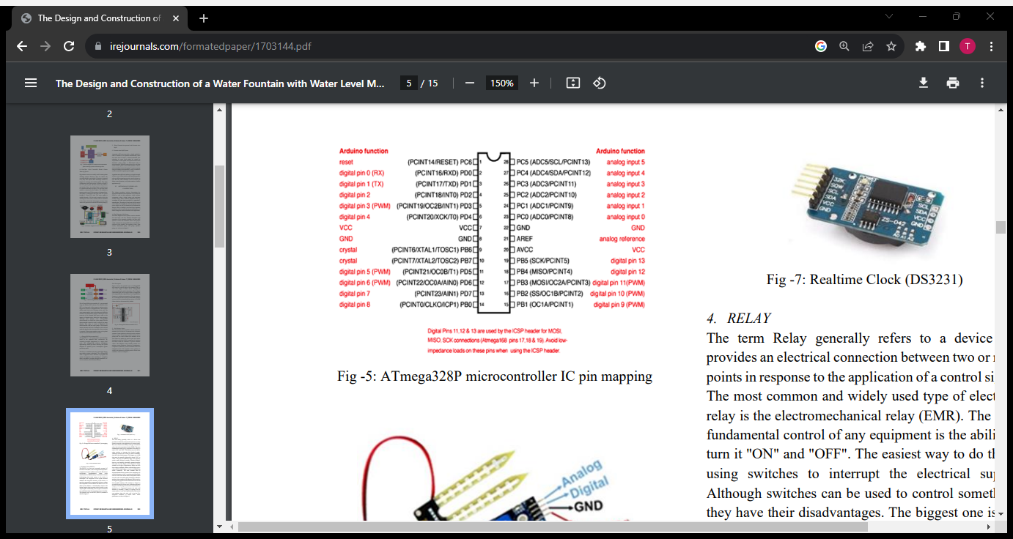

***4. RELAY:***

*The term Relay generally refers to a device that provides an electrical connection between two or more points in response to the application of a control signal. The most common and widely used type of electrical relay is the electromechanical relay (EMR). The most fundamental control of any equipment is the ability to turn it "ON" and "OFF". The easiest way to do this is using switches to interrupt the electrical supply. Although switches can be used to control something, they have their disadvantages. The biggest one is that they must be manually (physically) turned "ON" or "OFF". Also, they are relatively large, slow and only switch small electrical currents. Electrical Relays, however, are basically electrically operated switches that come in many shapes, sizes and power ratings suitable for all types of applications. Relays can also have single or multiple contacts with the larger power relays used for high voltage or current switching being called "contactors". The most common form of electromechanical relay consists of an energizing coil called the "primary circuit" wound around a permeable iron core. This iron core has both a fixed portion called the yoke, and a moveable spring-loaded part called the armature, that completes the magnetic field circuit by closing the air gap between the fixed electrical coil and the moveable armature. The armature is hinged or pivoted allowing it to freely move within the generated magnetic field closing the electrical contacts that are attached to it. Connected between the yoke and armature is normally a spring (or springs) for the return stroke to "reset" the contacts back to their initial rest position when the relay coil is in the "deenergized" condition, i.e, turned "OFF".*

***RELAY CIRCUIT***

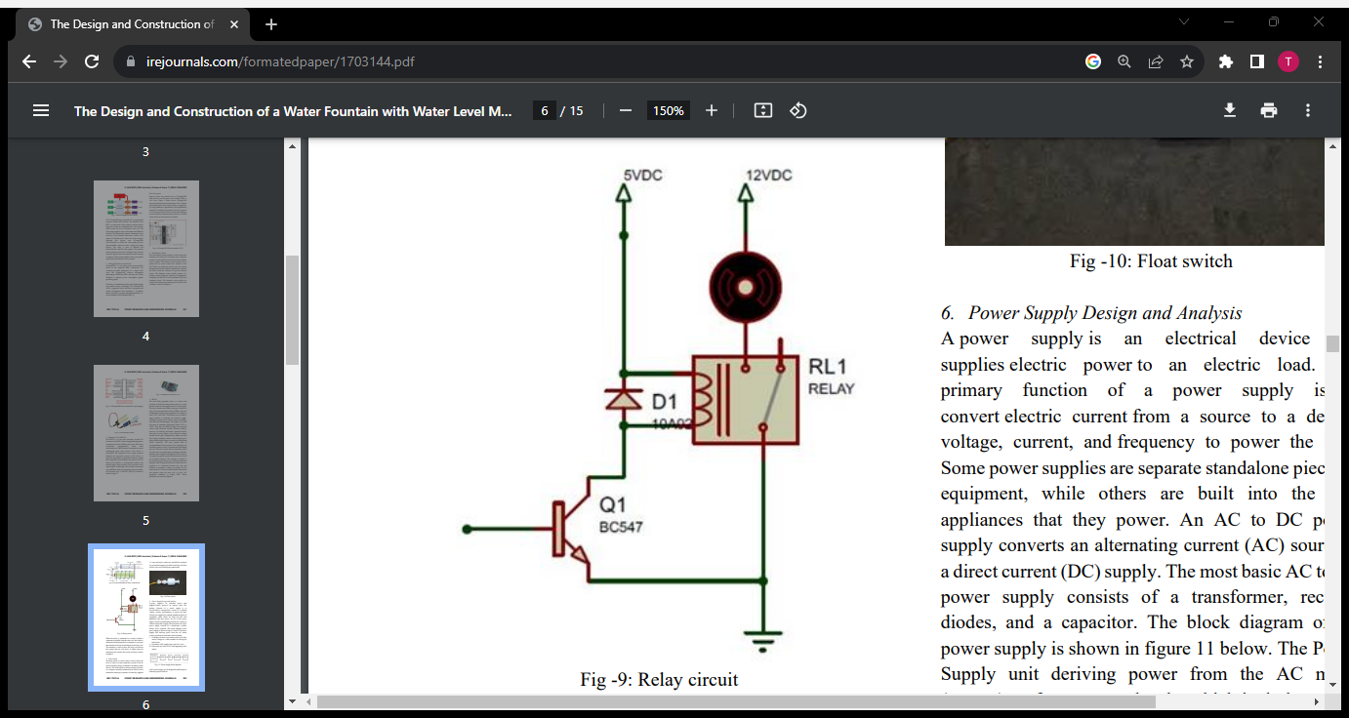

*When the relay is connected in a circuit a diode is connected in parallel with the relay coil, this diode is called the freewheeling diode, its purpose is to protect the transistor from the stored charges in the relay coil. The transistor is used to drive the relay coil because the current that the coil draws is higher than the microprocessor current, the circuit of a relay.*

***5. Float Switch:***

*The float switch is a device that is used to sense the level of water in a tank, aquarium or pond. It can be used to actuate a pump, an indicator, an alarm or other devices. The float switch as shown in figure 10 below is a compact vertically mounted device which can be mounted at either top or bottom of a tank (by supplied ‘O’ ring and nut) to either rise and fall for actuation (by an internal magnet) of sealed reed relay, the float switch is pre wired with flying output leads.*

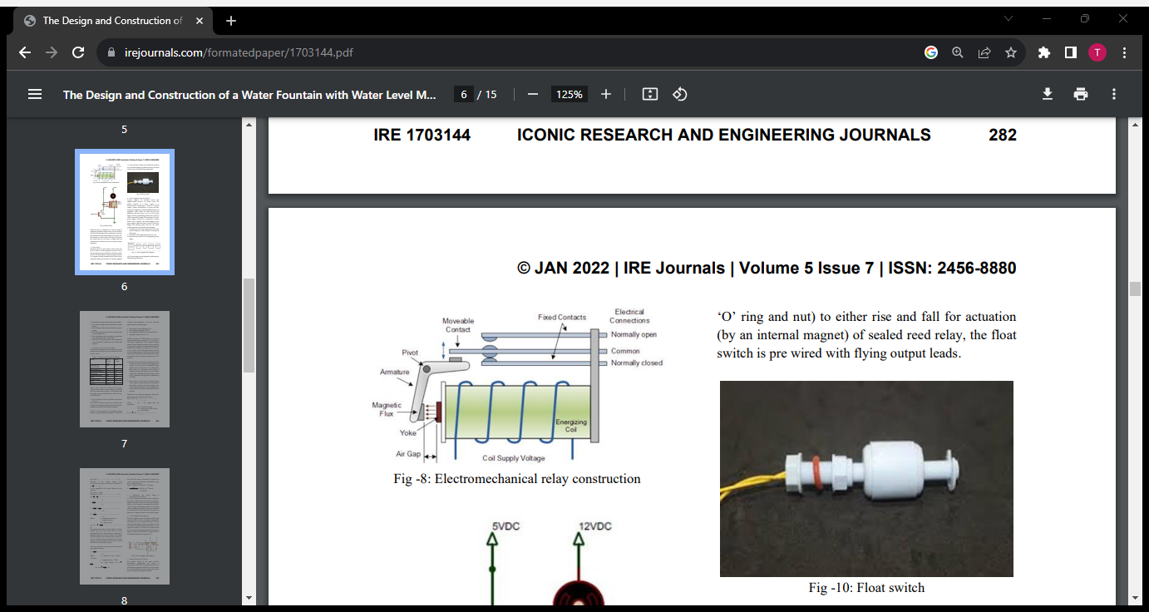

***6. Power Supply Design and Analysis:***

*A power supply is an electrical device that supplies electric power to an electric load. The primary function of a power supply is to convert electric current from a source to a desired voltage, current, and frequency to power the load. Some power supplies are separate standalone pieces of equipment, while others are built into the load appliances that they power. An AC to DC power supply converts an alternating current (AC) source to a direct current (DC) supply. The most basic AC to DC power supply consists of a transformer, rectifier diodes, and a capacitor. The block diagram of the power supply is shown in figure 11 below. The Power Supply unit deriving power from the AC mains (source) performs several tasks which includes; i. It changes (in most cases reduces) the level of the source voltage to a value suitable for driving the load circuit. ii. It produces a DC supply from a pure AC wave. iii. It prevents any form of AC from appearing at the output.*

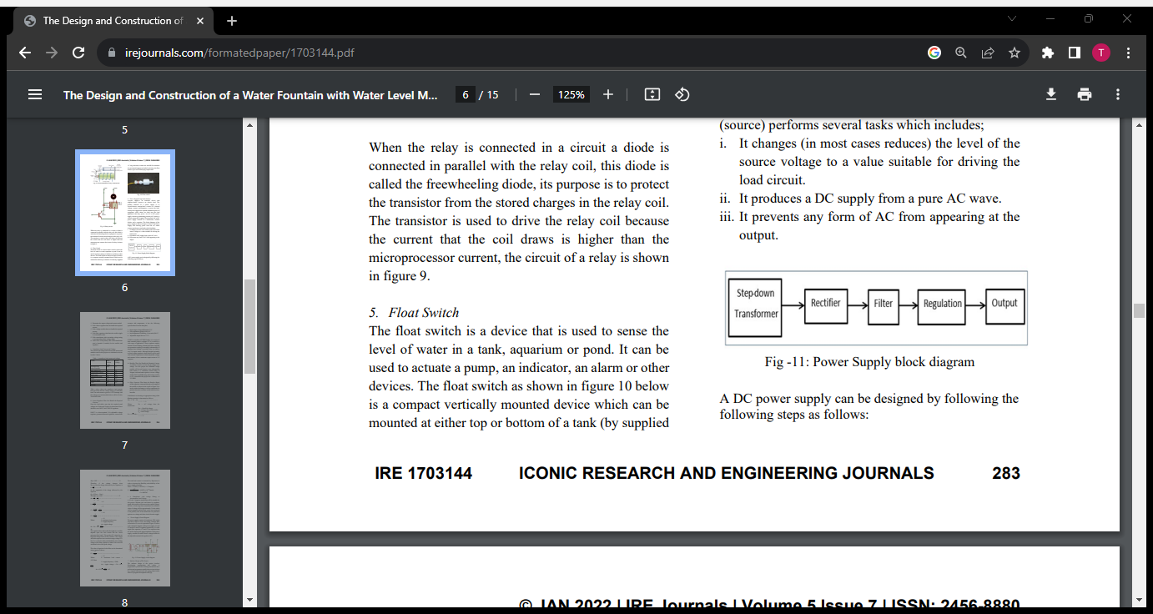

*A DC power supply can be designed by following the following steps as follows:*

*1. Determine the output voltage and current needed.*

*2. Pick a linear regulator that can handle the required current.*

*3. Pick a bridge rectifier that can handle the required current.*

*4. Pick filter capacitors that limit the rectifier ripple to a reasonable value.*

*5. Pick a transformer with a secondary voltage rating to accommodate all the voltage drops.*

*6. Add a fuse to the primary side of the transformer (and a heatsink if needed) for the rectifier and regulator.*

***POWER SUPPLY CIRCUIT DIAGRAM***

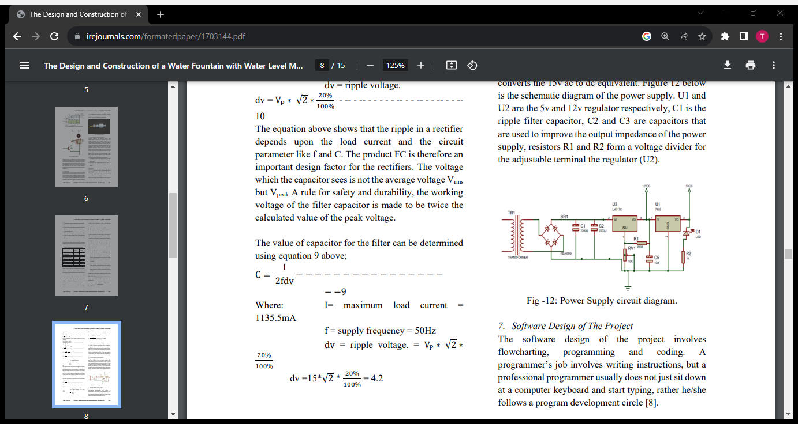

***STEPS ARE REQUIRED TO SMART WATER FOUNTAIN:***

***Step 1******Determine the effect desired***

* *Consider the size of the effect in relation to the size of the pool, the site and surroundings.*
* *Most fountain pools are 18″ deep, so be sure to provide a sufficient volume of water to produce the satisfactory effect.*

***Step 2******Define size, shape & depth of your pool***

* *This planning should involve such factors as the pool configuration most suitable for the site.*
* *Pool location and orientation.*
* *Materials you wish to use.*
* *Available water supply, etc.*

***Step 3******Choose the proper pump and piping***

* *The nature of the effect, elevations, piping distances, fittings and valves will determine the size of the pump required.*
* *Large fountains normally use centrifugal turbines or flooded end pumps, while less expensive, easier to install submersible pumps are specified for smaller effects.*

***Step 4******Choose your filters***

* ***Water Clarity:****Water clarity and condition are important in all fountains, and most foutains use a small recirculating pump and sand filters, with skimmers or floor drains returning with water to the filters. This action can be independent of the water effect.*
* ***Sand Filter:****A high-rate sand filter area for each 1000 cubic feet of pool area, is normally recommended for larger fountains, with the filter supplied by an independent pump. For filters 30″ in diameter or less, this is usually included.*
* ***Pump Filter Screen:****Many smaller fountains rely on the pump filter screen for water clarity, and are simply drained when necessary.*
* ***Chemical Addition:****When chemical addition is desirable, metering pumps with hypochlorite systems may be used. A reliable pool service to monitor and maintain water clarity and chemistry is often the simplest answer to water treatment concerns.*
* ***Pool or Reservoir:****The size of a pool or reservoir and the size of its water effect are interrelated. The pool must contain a sufficient volume of water to meet the requirements of the effect, and be large enough to contain the splash or wave action it produces. This splash pattern will be approximately as wide as its height, so the pool’s minimum diameter should be twice the height of the effect. In addition, jets, fountains and waterfalls require that both flow rates and pressures be adequate to produce the visual effect desired.*
* ***Waterfalls:****Waterfalls have unique flow requirements. A weir depth of 1/4″ requires a* *flow of 10 GPM per linear foot of weir. A depth of 1/2″ needs 20 GPM; and a depth of 3/4″* *needs 30 GPM. The total height of a weir should not exceed the distance from its base to the pool’s edge.*

## *Step 5 Define and locate plumbing for pump and filter systems; locate sensors, lights and junction boxes to be in the pool*

* *Pumping systems often need anti-vortex plates for inlet lines, shut-off and flow control valves, and strainers.*
* *Filter systems include antivortex plates, inlet fittings, skimmers and vacuum fittings.*
* *The electrical systems normally include underwater junction boxes, low water cut-off sensors, water make-up and wind sensors, times and lighting fixtures.*

## *Step 6 Determine your lighting requirements*

* *Lighting may provide overall pool lighting, illuminate key elements and create visual contrast between elements.*
* *Underwater units should be located about 2″ below the water surface, and may up-light jets, spray rings, cascades, etc.*
* *Flood lights accent above-water elements or provide safe area illumination.*

***Step 7******Define the controls***

* *Controls may include such elements as timers for pumping, lighting and filtering operations, as well as motor starters for the pump, water make-up, low water cut-offs and various valves.*
* *Weigh the merits of both electro-mechanical and microprocessor controls in this respect.*

## *Step 8 Consolidating & locating the equipment*

* *Simple fountains with submersible pumps require a small panel mounted in any suitable location.*
* *Larger water effects, pumps, timers, microprocessor controls, electrical panels, fuses, filtration and water conditioning elements and other controls are consolidated and installed in a small building or vault, or on a fenced pad.*
* *Local building codes govern location, ventilation, access, etc.*

***Embedded Systems –****Once the basic fountain design is settled, systems to produce and maintain the display must be worked out. These systems include:*

* ***The Pumping Systems:***

*The pumping systems with the jets or water diffusion plates to create the effect; plus the pump water inlet and the required valves and plumbing.*

* ***The Electrical Systems:***

*The electrical systems with sensors to maintain water levels and shut* down electrical equipment when water levels are inadequate. Sensors can also shut down or reduce the size of water effects in high winds. Mechanical or microprocessor controls, timers, motor starters, contactors and underwater lighting units are also included.

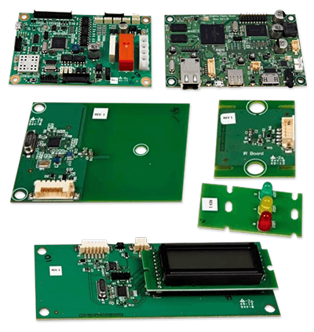

***Fit for the future:***

*Across the world, it is clear that more emphasis is now being placed on****the quality of the built environment in cities****, particularly in terms of wellbeing and sustainability. It’s great news for all of us that it is no longer good enough to just “build, build, build” without any consideration of the liveability of an area, or ensuring that it is fit for the future.*

*Water fountains and other aquatic facilities have much to offer by****enhancing the environment in any urban innovation and development project****. They can beautify a previously unremarkable space, enhance the cooling of the surrounding area, and boost the local economy by promoting tourism.*

***THANK YOU***