SMART WATER FOUNTAIN

By,

Treeshaa A

**PHASE 04-** Design the platform to receive and display real-time water fountain data, including water flow rate and malfunction alerts.

**INTRODUCTION:**

"Smart Water Fountain" integrated with IoT (Internet of Things) technology represents an innovative approach to managing and enhancing the functionality of traditional water fountains. This integration involves using sensors, data communication, and real-time data processing to create a more efficient, user-friendly, and environmentally sustainable water fountain system.

**IOT SENSOR:**

Smart water fountains are equipped with various sensors, such as water flow sensors, water quality sensors, temperature sensors, and more. These sensors continuously collect data about the fountain's performance and the quality of the water.

**HTML CODE:**

<!DOCTYPE html>

<html>

<head>

<title>Water Fountain Status</title>

</head>

<body>

<h1>SMART WATER FOUNTAIN</h1>

<section id="water-flow">

<h2>Water Flow Rate</h2>

<p id="flow-rate">Loading...</p>

</section>

<section id="malfunction-alert">

<h2>Malfunction Alert</h2>

<p id="alert-status">No Alerts</p>

</section>

</body>

</html>

**JAVASCRIPT CODE:**

// Function to update water flow rate function updateFlowRate() { fetch('water-fountain-api/flow-rate')

.then(response => response.json())

.then(data => { document.getElementById('flow-rate').textContent = data.flowRate + ' GPM'; // Gallons per minute

}); }

// Function to update malfunction alerts function updateAlertStatus() { fetch('water-fountain-api/alert-status')

.then(response => response.json())

.then(data => { document.getElementById('alert-

status').textContent = data.alert ? 'Alert' : 'No Alerts';

});

}

// Update data every 5 seconds setInterval(updateFlowRate, 5000); setInterval(updateAlertStatus, 5000);

**REAL TIME DATA:**

The sensors capture real-time data, including water flow rates, water temperature, and water quality parameters. This data is constantly updated and transmitted to a central system or cloud platform.

**OUTPUT FOR THE PLATFORM:**

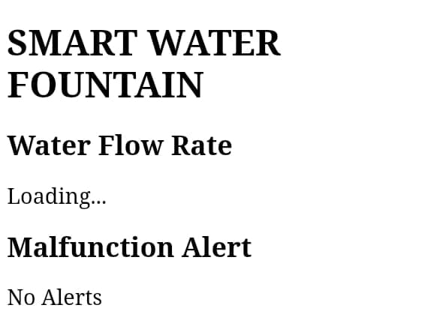

**CONCLUSION:**

Smart water fountains are becoming increasingly popular in public spaces, offices, and homes, offering advanced features, improved user experiences, and environmentally conscious operation. By integrating IoT technology, these fountains provide a more efficient and sustainable way to access safe and clean drinking water while reducing operational costs and conserving resources.

THANK YOU