**PROJECT - 8**

**TITLE – Smart water fountain**

**~submitted by:** Treeshaa A

**PHASE 1: Problem definition and design thinking**

**PROBLEM STATEMENT :** Our goal is to design and implement a smart water fountain that can monitor the water quality and automatically replace water when polluted(not healthy) or running out. Common quality measurement factors include temperature, pH -value, conductance, turbidity and hardness.

**EXPLANATION :**

## Background:

There have been quite a lot of water fountain products on the market, while most of them have only filtration as an extra function besides providing running water. The size of the water fountain limits the capacity of the water source that most water fountains cannot store enough water for multiple pets to drink in several days.

# Sensor unit:

The block contains the four types of sensors. The data acquired from the sensors will be transmitted to the control unit. Control unit will then have some logic designed to send corresponding signals to control other blocks of the water fountain. At the same time the display screen on the water fountain will display the readings along with the determined water quality level and remaining water quality.

# Temperature sensors:

A water -proof temperature sensor is going to be used. This temperature sensors is compatible with a relatively wide range of power supply from 3.0V to 5.5V. The measured temperature ranges from -55 to +125celsius degrees. Between -10 to +85 degrees, the accuracy is up to +- 0.5 degrees. This sensor can fulfil all requirements needed for this project.

# PH- value:

It is the valued indicator of water quality. This PH -sensors works with 5V, which is also compatible with the temperature sensor.

**PROBLEM SOLUTIONS :**

Checking the water supply and water quality: Ensure there is enough water in the reservoir. If the water level is low, it can affect the fountain’s performance.

Filtration of the water: Water fountain is also designed to self- filter the water every time when water is pumped through the submersible water pump.

**PROJECT DEFINITION:**

The project aims to enhance public water fountains by implementing IOT sensors to control water flow and detect malfunctions. This project includes defining objectives , designing the IOT sensor system, develop the water fountain status platform, and integrating them using the IOT technology and python.

**DESIGN THINKING :**

The block diagram below is a general design of our solution. We divide our design into four modules, including Power Supply, Control Unit, External Control, and Mechanical Unit. Details of each unit is presented in the diagram and described in the next section.

**BLOCK DIAGRAM OF A DESIGN SMART WATER FOUNTAIN**

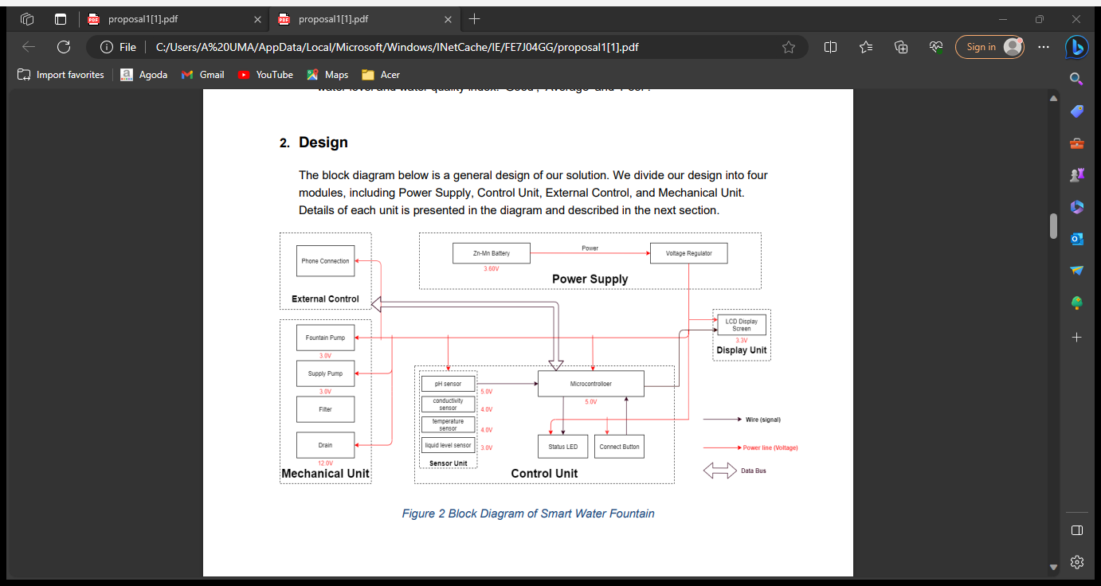

**DESIGN FEATURES**

* Fountain wirelessly communicate with base stations.
* Base stations collect and transmit usage, filter, and system health information to the cloud via ethernet.
* Wireless communications use a low-power unlicensed band for improved security and power savings.

**PROJECT OBJECTIVES:**

* Real -time water fountain monitoring.
* Efficient water usage.
* Malfunction detection.
* Resident awareness.

REAL- TIME WATER FOUNTAIN MONITORING:

Real -time water fountain monitoring involves continuously tracking and analyzing various aspects of a water fountain’s performance to ensure its optimal operations. Here are some key components and objectives of real- time water fountain monitoring are;

FILTER STATUS: checking the condition of filters and alerting when they need replacement to maintain water quality.

USAGE DATA: Collecting data on when and how frequently the fountain is being used. This information can help in maintenance scheduling and resources allocation.

# IOT SENSOR DESIGN:

**Sensor deployment is performed to achieve objectives like increasing coverage, strengthening connectivity, improving robustness, or increasing the lifetime of a given WSN. Therefore, a sensor deployment method must be carefully designed to achieve such objective functions without exceeding the available budget.** **For the PH-value sensor, temperature sensor and conductivity sensor, values will be retrieved and calculated to determine the overall water quality level. When poor water quality is determined, the water replacement procedures will take place. The weight sensor readings will be used to determine the amount of fresh water left in the water tank.**

Liquid Level Sensor:

This sensor is responsible for reflecting how much freshwater is left in the water tank. When the water level is low, fresh water will be pumped to the water tank to ensure the water fountain keeps running with fresh water. For water level from 0 to 9 inches, the corresponding sensor outputs readings from 0 to 1.6. From that, the quantity of freshwater left can be determined.

**Integration Approach: Determine how IoT sensors will send data to the water fountain status platform.**

**The data collected by the sensors is then shared via the cloud and integrated with software. The software then analyzes and transmits the data to users via an app or website.**

IOT works like this:

* **Devices have hardware, like sensors, that collect data.**
* **The data collected by the sensors is then shared via the cloud and integrated with software.**
* **The software then analyzes and transmits the data to users via an app or website.**

**Smart devices connect to an IOT platform, described by the experts at IOT for all as “the support software that connects everything in an IOT system.” There are hundreds of IOT platforms The Internet of Things is largely made possible by technologies that connect devices and enable them to communicate with one another. Connectivity options have a range of pros and cons with some more suitable for certain use cases like smart homes while others may be more appropriate for IOT applications like industrial automation. These technologies can be divided into two categories**

[**IOT data protocols**](https://www.allaboutcircuits.com/technical-articles/internet-of-things-communication-protocols-iot-data-protocols/)**that allow information to be exchanged between devices even without an internet connection and**[**IOT network protocols**](https://www.allaboutcircuits.com/technical-articles/internet-of-communication-communication-protocols-network-protocols/)**that link devices to one another and to the internet.**

**some COMMON IOT COMMUNICATION PROTOCOL**

* **WIFI**
* **ZIG BEE**
* **BLUETOOTH**
* **CELLUAR**

**“THANK YOU”**