**Student Report**

**Software Requirements Document**

**V 1.0**

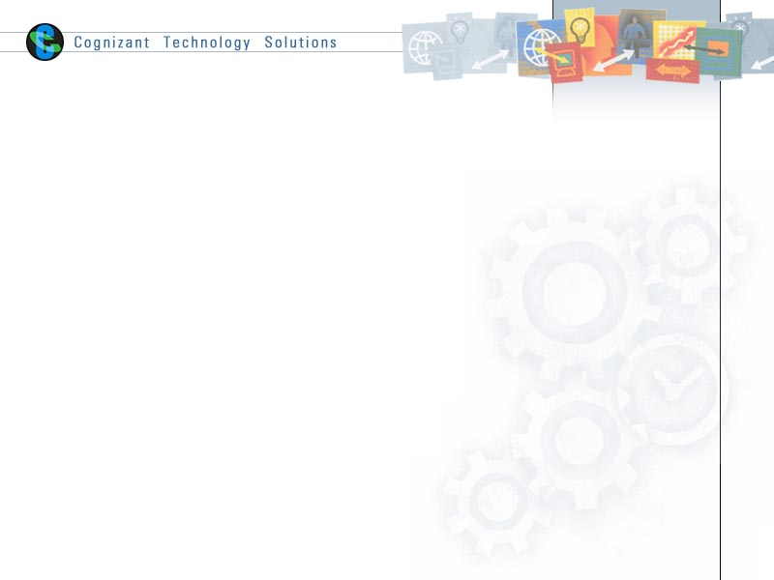

|  |  |  |  |
| --- | --- | --- | --- |
|  | **Prepared By** | **Reviewed by** | **Approved By** |
| **Name** | Praveen Kumar V V |  |  |
| **Role** | Team member | Project Leader/ Team Leader/ Team Member | Project Manager/ Team Leader |
| **Signature** |  |  |  |
| **Date** |  |  |  |

Table of Contents

1 Introduction 3

1.1 About this document 3

1.1.1 Purpose & Scope of the document 3

1.1.2 Intended Audience 3

1.2 About the Software System 3

1.2.1 Scope of the system 3

1.2.2 Exclusions 3

1.2.3 Architecture diagram 4

1.2.4 Source Files 4

1.2.5 Target Definitions 4

1.2.6 Assumptions, Risks / Constraints 5

1.2.7 Design Constraints 5

2 System Requirements 6

2.1 Functional Requirements 6

2.2 Non Functional Requirements 7

3 Terms and conditions 8

4 Change Log 8

# Introduction

## About this document

### Purpose & Scope of the document

The purpose of the software requirements document is to systematically capture requirements for the project and the system “Student report” to be developed. Functional requirements of this system are captured in this document. It also serves as the input for the project scoping.

The scope of this document is limited to addressing the requirements from a user, quality, and non-functional perspective. It is recommended that design aspects are not added in this document

### Intended Audience

Project Team

## About the Software System

The software system is used to load a sample Data Warehouse for an Educational institution. Data from the source system are provided in a flat file extract and to be loaded to Data Warehouse in a relational Database. The educational institution will be using the data loaded in to Data Warehouse for their decision making.

### Scope of the system

The scope of the system is to create and populate Data Warehouse tables.

### Exclusions

1. The system will operate only on the modules discussed above and will not include any additional functionality.
2. Disaster recovery and failure recovery are not part of the scope
3. Any future changes to the source and target structures are not in scope

### Architecture diagram

#### 

### Source Files

Attached below are the source extract from Source Systems. Use the files as delimited(tab) source files for ETL process



### Target Definitions

Attached below is the excel file with target table definitions. Define the data type and length for columns as per the source system data found in source files.



### Assumptions, Risks / Constraints

* All source files will be available in specified format
* Target database will be available to create Data Warehouse tables
* Informatica server will be able to connect to Data Warehouse database
* The system will not be available if there are any outages to Data Warehouse Database

### Design Constraints

* All source files should be ‘tab’ delimited files
* All target should be Data Warehouse Tables
* Every Dimension, Fact and Aggregate tables should be loaded using individual non-reusable sessions
* All session loading Data Warehouse tables should be present in one single workflow
* All sessions should be connected in a sequential manner in workflow.
* If there are any failure to one of the session, then following sessions should not run
* Workflow should succeed only if all sessions have completed successfully

# System Requirements

## Functional Requirements

|  |  |
| --- | --- |
| Data Warehouse Table load Logic |  |
| Department Dimension Table | Department Dimension table should be loaded from Department Details source file as a one-to-one load |
| Student Dimension Table | Student Dimension table should be loaded from Student Details and Student Address source files  Postal code column should be cleansed to remove any extra space and special characters  Phone Number column should be validated for valid 10 digit phone number, if there are any invalid number found then phone number has to be loaded as NULL  All characters in address column has to be converted to upper case. |
| Marks Fact Table | Marks Fact table should be loaded from Student Details, Student Address and Student marks source files  Total has to be calculated as sum of all subject marks  Average column has to be calculated as average of all marks  Result has to be calculated as Pass or Fail, Students scoring 50 and above marks in all subjects are termed as Pass |
| Subject Average Aggregate Table | Subject Average Aggregate Table should be loaded from Department Details and Student Marks table  Table should contain average marks scored by students in all subjects by department |
| Subject Pass Percentage Aggregate Table | Subject Pass Percentage Aggregate Table should be loaded from Department Details and Student Marks table  Table should contain pass percentage for each subject by department |

## Non Functional Requirements

* System should perform in a optimal speed so that it can be usable by end users
* Data load should be scheduled to be run every week
* No manual intervention is expected to complete the data load or update any parameters and variables
* System should not affect the target Data Warehouse Database performance in any manner

# Terms and conditions

GenCs shall be solely responsible for all its acts and omissions under this program. GenCs will comply at all times with all applicable laws. GenCs shall not use Cognizant’s name, logo and trademark in any promotional materials or other communications with third parties without the prior written consent of Cognizant. Any materials used by GenCs in relation to program will not infringe the copyrights, trademarks, patents, trade secrets or other intellectual property rights, privacy or similar rights of any person or entity. GenCs agrees not to post, draw, make, display any content that is threatening, libelous, obscene, defamatory, abusive, pornographic, or advocates/encourages any conduct that could constitute a criminal offence or give rise to any civil liability. Cognizant its associates’ personal details including but not limited to name, address, contact number shall not be shared or forwarded to any third party, without prior written consent of Cognizant, its associates. All intellectual property provided by Cognizant as part of program shall be owned exclusively by Cognizant. Intern shall indemnify, defend and indemnify Cognizant its associates, officers, directors from and against any claims, demands, loss, damage, liability, causes of action, judgments, or costs and expenses of every nature (including attorney’s fees and expenses) incurred by Cognizant based on any claim that any breach of terms and conditions of this program.

# Change Log

Please note that this table needs to be maintained even if a Configuration Management tool is used.

|  |  |  |  |  |
| --- | --- | --- | --- | --- |
| Version Number | Changes made | | | |
| V1.0 | First version developed by Praveen Kumar VV on June 17, 2014. | | | |
| V1.1 | *<If the change details are not explicitly documented in the table below, reference should be provided here>* | | | |
| Page no | Changed by | Effective date | Changes effected |
|  |  |  |  |
|  |  |  |  |
|  |  |  |  |
|  |  |  |  |
| V1.2 | *<If the change details are not explicitly documented in the table below, reference should be provided here>* | | | |
| Page no | Changed by | Effective date | Changes effected |
|  |  |  |  |
|  |  |  |  |
|  |  |  |  |