A | 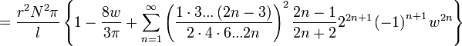  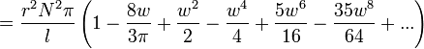for w << 1  for w >> 1
B | 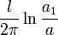
C | 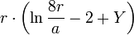
D | 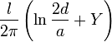
E | 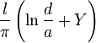

N: Number of turns
r: Radius
l: Length
w = r/l
m = 4w²
E,K: Elliptic integrals
a₁: Outer radius
a: Inner radius
l: Length

