TOSS-UP

1. BIOLOGY; Multiple Choice: What class of immunoglobulin is secreted in breast milk?

(W) IgA

(X) IgD

(Y) IgE

(Z) IgG

ANSWER: W—IgA

BONUS

1. BIOLOGY; Short Answer: Use the image to answer the following two questions.

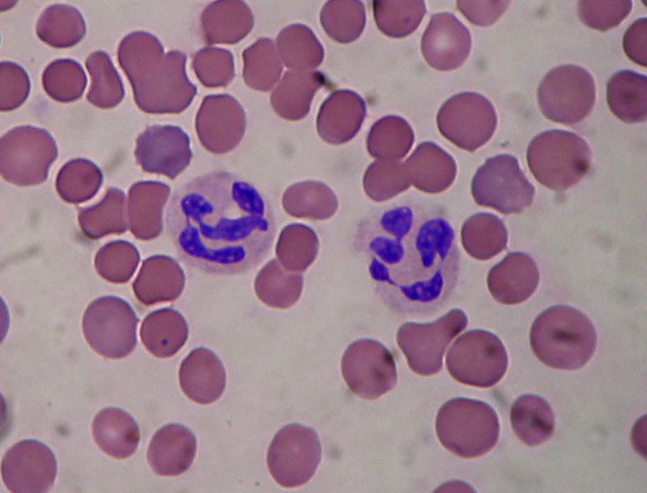

1. Name the type of cell shown in blue.
2. These cells use hydrogen peroxide and a free radical mechanism to degrade molecules of foreign origin. Name this process that is specific to this cell type.

ANSWER: A. NEUTROPHIL; B. OXIDATIVE BURST

TOSS-UP

2. CHEMISTRY; Short Answer: What is the general term for a benzene ring bonded to a hydroxyl group?

ANSWER: PHENOL

BONUS

1. CHEMISTRY; Short Answer: Use the image to answer the following three questions.

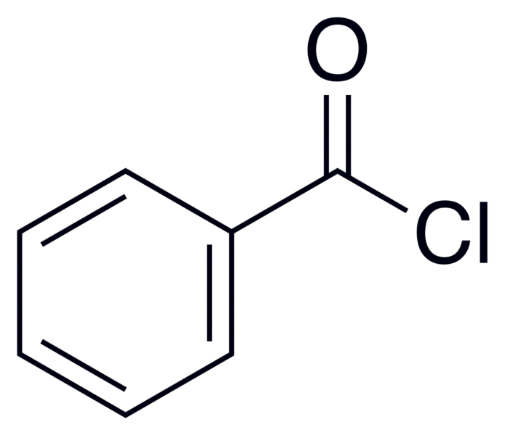

1. Give the molecular formula for this compound.
2. Give the IUPAC name for this compound.
3. If hydrolyzed, this compound will produce what two new compounds?

ANSWER: A. C7H5ClO; B. BENZOYL CHLORIDE; C.HYDROCHLORIC ACID, BENZOIC ACID

TOSS-UP

1. PHYSICS; Short Answer: In the standard model of particle physics, what general term denotes particles that are force carriers?

ANSWER: GAUGE BOSON

BONUS

1. PHYSICS; Short Answer: Use the image to answer the following two questions.

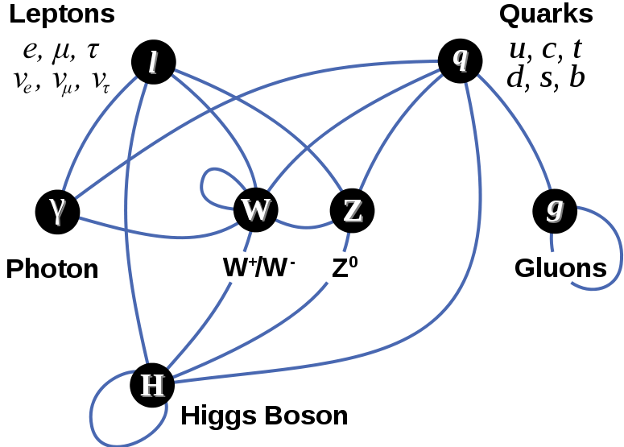

1. Which given particles in the diagram do not possess mass?
2. Which given particles in the diagram possess a spin of 1?
3. Name and give the symbol of the particle that should fill the empty box

ANSWER: A. PHOTON; GLUONS, B. PHOTONS, GLUONS, WEAK BOSON, W+ BOSON, W- BOSON, Z BOSON

TOSS-UP

4. ERSCI/SPSCI; Short Answer: This mineral is the most important lead ore mineral. It possesses a lead gray streak and has a metallic luster. It has a Mohs hardness scale reading of about 2.5. When crystallized, it shows octahedral forms. Its molecular formula is PbS. Name this mineral.

ANSWER: GALENA

BONUS

4. ERSCI/SPSCI; Short Answer: Order the following minerals from greatest to least number on the Mohs hardness scale: talc, apatite, diamond, topaz, corundum, gypsum.

ANSWER: DIAMOND, CORUNDUM, TOPAZ, QUARTZ, APATITE, GYPSUM, TALC

TOSS-UP

5. MATH; Short Answer: Find the intervals along which the following function is increasing and decreasing: f(x) = x^2 – 9x + 18

ANSWER: DECREASING: (-infinity, 4.5), INCREASING: (4.5, infinity)

BONUS

5. MATH; Short Answer: Find the critical numbers of the following function: f(x) = 2x^3 + 3x^2 – 12x.

ANSWER: C = -2, 1

TOSS-UP

1. ENERGY; Short Answer: What is the molecular formula for semiheavy water?

ANSWER: HDO

BONUS

6. ENERGY; Multiple Choice: Approximately what percentage of the world’s electricity came from nuclear power in 2009?

(W) 5%

(X) 15%

(Y) 25%

(Z) 35%

ANSWER: X—15%

TOSS-UP

7. BIOLOGY; Multiple Choice: The natural selection of traits that are population density-dependent over traits that are not population density-independent is known as

(W) Q-selection

(X) K-selection

(Y) r-selection

(Z) b-selection

ANSWER: Y—K-SELECTION

BONUS

1. BIOLOGY; Short Answer: Use the image to answer the following two questions.

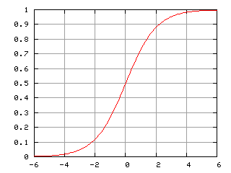

Relative Popula-tion Level

Relative Time

1. What type of population growth possesses this characteristic growth curve?
2. At what time does the population reach its carrying capacity?
3. At what time does the curve reach a point of inflection?

ANSWER: A. LOGISTIC GROWTH CURVE, B. 6, C. 0.

TOSS-UP

8. CHEMISTRY; Short Answer: A substance of pH 3 is how many more times acidic than a substance of pH 9?

ANSWER: ONE MILLION

BONUS

8. CHEMISTRY; Multiple Choice: What is the term for a substance that can act as either an acid or a base?

(W) Pluripotent

(X) Totipotent

(Y) Amphipathic

(Z) Amphoteric

ANSWER: Z—AMPHOTERIC

TOSS-UP

1. PHYSICS; Multiple Choice: A 4.0-kg meatball is moving with a speed of 6.0 m/s directly toward a 2.0 kg meatball which is at rest. The two meatballs collide and stick together. What is their velocity immediately after the (inelastic) collision?

(W) 2.0 m/s

(X) 2.5 m/s

(Y) 3.5 m/s

(Z) 4.0 m/s

ANSWER: Z—4.0 m/s

BONUS

1. PHYSICS; Short Answer: M1 denotes the mass of the first object, M2 denotes the mass of the second object, V1,i denotes the initial velocity of the first object, V2,i denotes the initial velocity of the second object. Find an expression using these variables that can be used to find the final velocity of the system if a perfectly inelastic collision has occurred.

ANSWER: \mathbf v_f=\frac{m_1 \mathbf v_{1,i} + m_2 \mathbf v_{2,i}}{m_1 + m_2}

TOSS-UP

10. ERSCI/SPSCI; Short Answer: What is the term for tides that occur around the first and last quarter moons and usually possess waves of the smallest amplitude?

ANSWER: NEAP TIDES

BONUS

10. ERSCI/SPSCI; Multiple Choice: Which of the following is true of the Coriolis Effect?

(W) It steers waves to the left in the Northern Hemisphere

(X) It is a true force that is proportional to the velocity of the object it acts upon

(Y) It acts perpendicularly to the velocity of the object it acts upon

(Z) It does not affect the rotation of large cyclones

ANSWER: Y—IT ACTS PERPENDICULARLY TO THE VELOCITY OF THE OBJECT IT ACTS UPON

TOSS-UP

11. MATH; Multiple Choice: Two circles both of radii 6 have exactly one point in common. If *A* is a point on one circle and *B* is a point on the other circle, what is the maximum possible length for the line segment *AB*?

|  |  |
| --- | --- |
|  |  |

(W) 12

(X) 18

(Y) 20

(Z) 24

ANSWER: Z—24

BONUS

11. MATH; Short Answer: A cube has a surface area of fifty-four square centimeters. In liters, what is the volume of the cube?

ANSWER: .027 L

TOSS-UP

12. ENERGY; Short Answer: "If *A* and *C* are each in thermal equilibrium with *B*, *A* is also in thermal equilibrium with *C*." What law of thermodynamics states this?

ANSWER: ZEROETH LAW OF THERMODYNAMICS

BONUS

12. ENERGY; Multiple Choice: Which of the following best describes why evolution does not violate the second law of thermodynamics?

(W) The more evolutionarily complicated an organism is, the more feces it produces

(X) Geological disasters periodically decimate life on Earth before it violates the second law of thermodynamics

(Y) Organisms produce wasteful heat as a metabolic by-product

(Z) Evolution does not exist

ANSWER: Y—ORGANISMS PRODUCE WASTEFUL HEAT AS A METABOLIC BY-PRODUCT

TOSS-UP

13. BIOLOGY; Multiple Choice: Which of the following organelles produces lipids?

(W) Smooth endoplasmic reticulum

(X) Nucleus

(Y) Mitochondria

(Z) Plastid

ANSWER: W—SMOOTH ENDOPLASMIC RETICULUM

BONUS

13. BIOLOGY; Short Answer: What are the three components of the central dogma of biology?

ANSWER: DNA, RNA, PROTEIN

TOSS-UP

14. CHEMISTRY; Short Answer: Name the second stage of mitosis.

ANSWER: METAPHASE

BONUS

14. CHEMISTRY; Multiple Choice: Which of the following most accurately describes meiosis?

(W) The division of one cell into two cells in one step

(X) The division of one cell into four cells in one step

(Y) The division of one cell into two cells in two steps

(Z) The division of one cell into four cells in two steps

ANSWER: Z—THE DIVISION OF ONE CELL INTO FOUR CELLS IN TWO STEPS

TOSS-UP

15. PHYSICS; Short Answer: What biome covers the greatest amount of the earth’s surface area?

ANSWER: TAIGA

BONUS

15. PHYSICS; Multiple Choice: Which of the following has the greatest net primary productivity?

(W) The Pacific Ocean

(X) The Great Plains

(Y) The Great Barrier Reef

(Z) The Andes

ANSWER: W—THE PACIFIC OCEAN

TOSS-UP

16. ERSCI/SPSCI; Short Answer: What is the scientific name of the infection of the bone by bacteria?

ANSWER: OSTEOMYELITIS

BONUS

16. ERSCI/SPSCI; Multiple Choice: In humans, the atlas is what number cervical vertebra?

(W) First

(X) Second

(Y) Third

(Z) Fourth

ANSWER: W—FIRST

TOSS-UP

17. MATH; Multiple Choice: Which of the following is not a genetically inherited disease?

(W) Phenylketonuria

(X) Sickle Cell Anemia

(Y) Polio

(Z) Juvenile Diabetes

ANSWER: Y—POLIO

BONUS

17. MATH; Short Answer: Name the disease in which immune cells destroy the myelin sheaths of axons.

ANSWER: MULTIPLE SCLEROSIS (ACCEPT: MS)

TOSS-UP

18. ENERGY; Multiple Choice: Strands of DNA wrapped around globules of protein are known as

(W) Osteons

(X) Histones

(Y) Flagellates

(Z) Kinetochores

ANSWER: X—HISTONES

BONUS

18. ENERGY; Short Answer: What is the diploid number of humans?

ANSWER: 46 (ACCEPT: 2N EQUALS 46)

TOSS-UP

19. BIOLOGY; Multiple Choice: Which of the following plant hormones causes fruit to ripen?

(W) Auxin

(X) Gibberellin

(Y) Abscisic acid

(Z) Ethylene gas

ANSWER: Z—ETHYLENE GAS

BONUS

19. BIOLOGY; Short Answer: Use the image to answer the following three questions.

1) What type of tropism displayed by the plant?

2) What plant hormone allows the plant to display this tropism?

3) Under what family does this plant fall into?

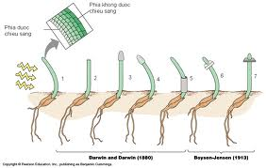

ANSWER: 1) PHOTOTROPISM, 2) AUXIN, 3) POACEAE

TOSS-UP

20. CHEMISTRY; Short Answer: What organic compound is used as a reference to determine chemical shift in proton nuclear magnetic resonance?

ANSWER: TETRAMETHYLSILANE (TMS)

BONUS

20. CHEMISTRY; Short Answer: Use the image to answer the following three questions.

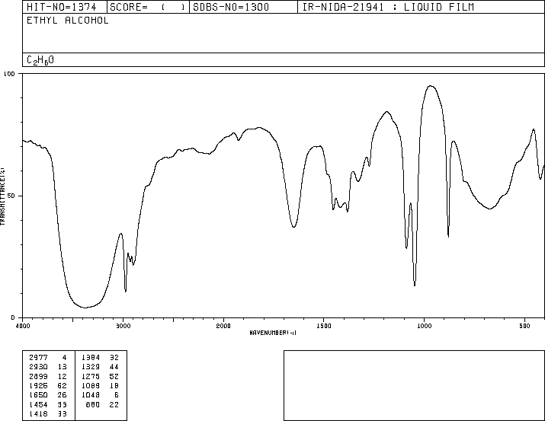

1. What is this image called?
2. What is the name of the region from about 1500 to 900 cm-1 that is very distinctive and unique for different organic compounds?
3. What functional group is represented by the large concave upward parabola between 3200 and 3500 cm-1?

TOSS-UP

21. PHYSICS; Short Answer: A virus that infects bacteria is known as what?

ANSWER: BACTERIOPHAGE

BONUS

21. PHYSICS; Multiple Choice: Koch’s postulates are used to determine which of the following?

(W) The cause of an infectious disease

(X) The mechanism of seed dispersal

(Y) The compatibility of blood types in a transfusion patient

(Z) The likelihood of a graft-versus-host response

ANSWER: W—THE CAUSE OF AN INFECTIOUS DISEASE

TOSS-UP

22. ERSCI/SPSCI; Short Answer: In humans, T cells complete their development in what organ?

ANSWER: THYMUS

BONUS

22. ERSCI/SPSCI; Multiple Choice: The colostrum confers what type of immunity to a baby?

(W) Passive

(X) Active

(Y) Secondary

(Z) Tertiary

ANSWER: W—PASSIVE

TOSS-UP

23. MATH; Short Answer: What type of alcohol is the drinking alcohol found in liquor?

ANSWER: ETHANOL

BONUS

23. MATH; Multiple Choice: What is the waste product produced by human muscle cells when they undergo anaerobic respiration?

(W) Ethanol

(X) Butanol

(Y) Lactic Acid

(Z) Fumarate

ANSWER: Y—LACTIC ACID

TOSS-UP

24. ENERGY; Multiple Choice: Which of the following is not a kingdom of life?

(W) Bacteria

(X) Animalia

(Y) Plantae

(Z) Monera

ANSWER: W—BACTERIA

BONUS

24. ENERGY; Short Answer: Halophiles are members of what domain?

ANSWER: ARCHAEA

TOSS-UP

25. BIOLOGY; Short Answer: What is the name of the term in which two pollen grains fertilize one ovule?

ANSWER: DOUBLE FERTILIZATION

BONUS

25. BIOLOGY; Multiple Choice: Which of the following best describes perennial plants?

(W) Their life cycles are one year

(X) Their life cycles are seasonal

(Y) Their life cycles are several years

(Z) Their life cycles are biannual

ANSWER: Y—THEIR LIFE CYCLES ARE SEVERAL YEARS