TOSS-UP

1. BIOLOGY; Multiple Choice: What class of immunoglobulin is secreted in breast milk?

(W) IgA

(X) IgD

(Y) IgE

(Z) IgG

ANSWER: W—IgA

BONUS

1. BIOLOGY; Short Answer: Use the image to answer the following two questions.

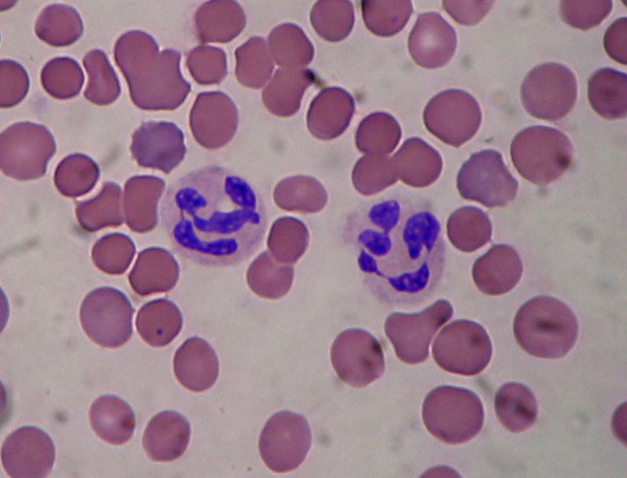

1. Name the type of cell shown in blue.
2. These cells use hydrogen peroxide and a free radical mechanism to degrade molecules of foreign origin. Name this process that is specific to this cell type.

ANSWER: A. NEUTROPHIL; B. OXIDATIVE BURST

TOSS-UP

2. CHEMISTRY; Short Answer: What is the general term for a benzene ring bonded to a hydroxyl group?

ANSWER: PHENOL

BONUS

1. CHEMISTRY; Short Answer: Use the image to answer the following three questions.

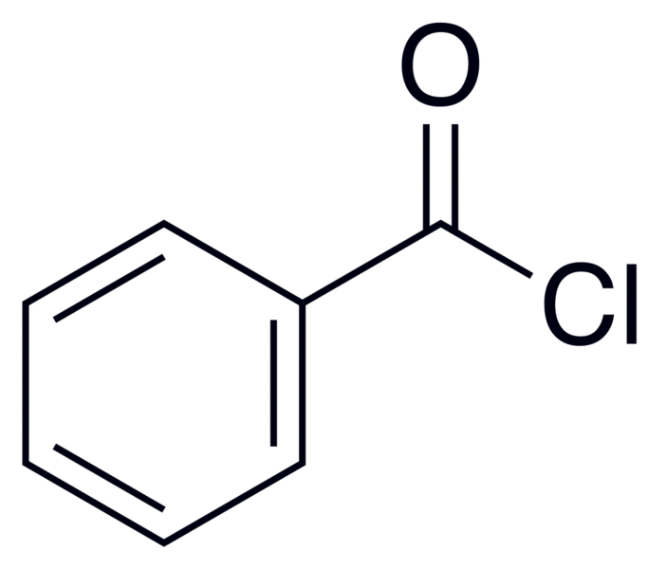

1. Give the molecular formula for this compound.
2. Give the IUPAC name for this compound.
3. If hydrolyzed, this compound will produce what two new compounds?

ANSWER: A. C7H5ClO; B. BENZOYL CHLORIDE; C.HYDROCHLORIC ACID, BENZOIC ACID

TOSS-UP

1. PHYSICS; Short Answer: In the standard model of particle physics, what general term denotes particles that are force carriers?

ANSWER: GAUGE BOSON

BONUS

1. PHYSICS; Short Answer: Use the image to answer the following two questions.

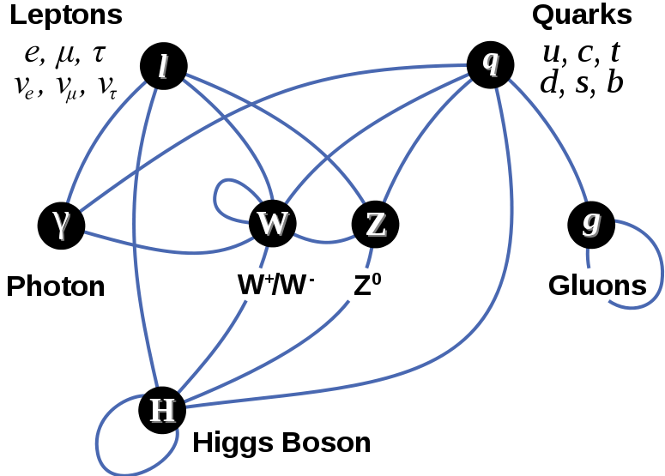

1. Which given particles in the diagram do not possess mass?
2. Which given particles in the diagram possess a spin of 1?
3. Name and give the symbol of the particle that should fill the empty box

ANSWER: A. PHOTON; GLUONS, B. PHOTONS, GLUONS, WEAK BOSON, W+ BOSON, W- BOSON, Z BOSON

TOSS-UP

4. ERSCI/SPSCI; Short Answer: This mineral is the most important lead ore mineral. It possesses a lead gray streak and has a metallic luster. It has a Mohs hardness scale reading of about 2.5. When crystallized, it shows octahedral forms. Its molecular formula is PbS. Name this mineral.

ANSWER: GALENA

BONUS

4. ERSCI/SPSCI; Short Answer: Order the following minerals from greatest to least number on the Mohs hardness scale: talc, apatite, diamond, topaz, corundum, gypsum.

ANSWER: DIAMOND, CORUNDUM, TOPAZ, QUARTZ, APATITE, GYPSUM, TALC

TOSS-UP

5. MATH; Short Answer: Find the intervals along which the following function is increasing and decreasing: f(x) = x^2 – 9x + 18

ANSWER: DECREASING: (-infinity, 4.5), INCREASING: (4.5, infinity)

BONUS

5. MATH; Short Answer: Find the critical numbers of the following function: f(x) = 2x^3 + 3x^2 – 12x.

ANSWER: C = -2, 1

TOSS-UP

1. ENERGY; Short Answer: What is the molecular formula for semiheavy water?

ANSWER: HDO

BONUS

6. ENERGY; Multiple Choice: Approximately what percentage of the world’s electricity came from nuclear power in 2009?

(W) 5%

(X) 15%

(Y) 25%

(Z) 35%

ANSWER: X—15%

TOSS-UP

7. BIOLOGY; Multiple Choice: The natural selection of traits that are population density-dependent over traits that are not population density-independent is known as

(W) Q-selection

(X) K-selection

(Y) r-selection

(Z) b-selection

ANSWER: Y—K-SELECTION

BONUS

1. BIOLOGY; Short Answer: Use the image to answer the following two questions.

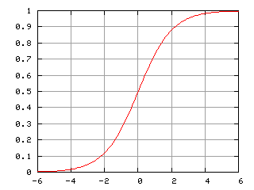

Relative Popula-tion Level

Relative Time

1. What type of population growth possesses this characteristic growth curve?
2. At what time does the population reach its carrying capacity?
3. At what time does the curve reach a point of inflection?

ANSWER: A. LOGISTIC GROWTH CURVE, B. 6, C. 0.

TOSS-UP

8. CHEMISTRY; Short Answer: A substance of pH 3 is how many more times acidic than a substance of pH 9?

ANSWER: ONE MILLION

BONUS

8. CHEMISTRY; Multiple Choice: What is the term for a substance that can act as either an acid or a base?

(W) Pluripotent

(X) Totipotent

(Y) Amphipathic

(Z) Amphoteric

ANSWER: Z—AMPHOTERIC

TOSS-UP

1. PHYSICS; Multiple Choice: A 4.0-kg meatball is moving with a speed of 6.0 m/s directly toward a 2.0 kg meatball which is at rest. The two meatballs collide and stick together. What is their velocity immediately after the (inelastic) collision?

(W) 2.0 m/s

(X) 2.5 m/s

(Y) 3.5 m/s

(Z) 4.0 m/s

ANSWER: Z—4.0 m/s

BONUS

1. PHYSICS; Short Answer: M1 denotes the mass of the first object, M2 denotes the mass of the second object, V1,i denotes the initial velocity of the first object, V2,i denotes the initial velocity of the second object. Find an expression using these variables that can be used to find the final velocity of the system if a perfectly inelastic collision has occurred.

ANSWER: \mathbf v_f=\frac{m_1 \mathbf v_{1,i} + m_2 \mathbf v_{2,i}}{m_1 + m_2}

TOSS-UP

10. ERSCI/SPSCI; Short Answer: What is the term for tides that occur around the first and last quarter moons and usually possess waves of the smallest amplitude?

ANSWER: NEAP TIDES

BONUS

10. ERSCI/SPSCI; Multiple Choice: Which of the following is true of the Coriolis Effect?

(W) It steers waves to the left in the Northern Hemisphere

(X) It is a true force that is proportional to the velocity of the object it acts upon

(Y) It acts perpendicularly to the velocity of the object it acts upon

(Z) It does not affect the rotation of large cyclones

ANSWER: Y—IT ACTS PERPENDICULARLY TO THE VELOCITY OF THE OBJECT IT ACTS UPON

TOSS-UP

11. MATH; Multiple Choice: Two circles both of radii 6 have exactly one point in common. If *A* is a point on one circle and *B* is a point on the other circle, what is the maximum possible length for the line segment *AB*?

|  |  |
| --- | --- |
|  |  |

(W) 12

(X) 18

(Y) 20

(Z) 24

ANSWER: Z—24

BONUS

11. MATH; Short Answer: A cube has a surface area of fifty-four square centimeters. In liters, what is the volume of the cube?

ANSWER: .027 L

TOSS-UP

12. ENERGY; Short Answer: "If *A* and *C* are each in thermal equilibrium with *B*, *A* is also in thermal equilibrium with *C*." What law of thermodynamics states this?

ANSWER: ZEROETH LAW OF THERMODYNAMICS

BONUS

12. ENERGY; Multiple Choice: Which of the following best describes why evolution does not violate the second law of thermodynamics?

(W) The more evolutionarily complicated an organism is, the more feces it produces

(X) Geological disasters periodically decimate life on Earth before it violates the second law of thermodynamics

(Y) Organisms produce wasteful heat as a metabolic by-product

(Z) Evolution does not exist

ANSWER: Y—ORGANISMS PRODUCE WASTEFUL HEAT AS A METABOLIC BY-PRODUCT