1. Toss-Up; Chemistry Short Answer

This chemical is a liquid at room temperature and a known carcinogen, it is also the precursor to many drugs, rubbers and plastics. What is this chemical?

Answer : Benzene

Bonus; Chemistry Visual Short Answer

The following picture contains 2 polymers that are formed from benzene.

1. Name the polymers as specifically as possible
2. By identifying the functional groups that are circled in white, classify these polymers
3. Name the company that first synthesized these polymers in 1935

Answer: 1. Nylon 6 and Nylon 6,6 2. Polyamides 3. Dupont

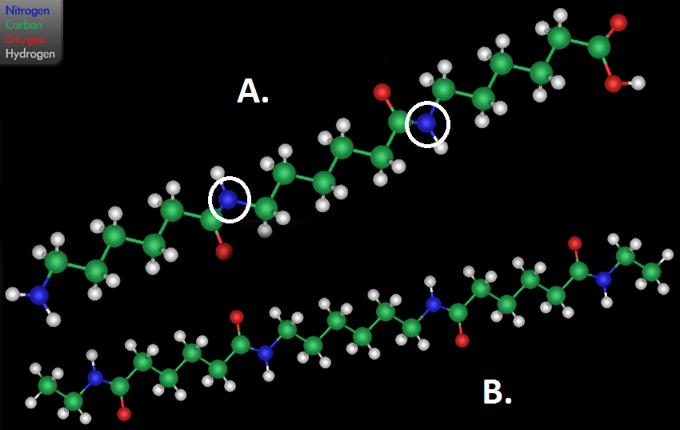

1. Toss-Up; Biology Short Answer

What is the biological name for a compound in which a central metal atom is surrounded by two planar cyclopentadienyl ligands?

Answer: Heme Unit

Bonus; Biology Short Answer

This disease results in a decreased rate of synthesis of globin chains of hemoglobin, this causes Anemia, what is the name of this disease

Answer: Thalassemia

1. Toss-Up; Earth and Space Science Short Answer

What is the name of the German Meterologist who first proposed the theory of Continental Drift?

Answer: Alfred Wegener

Bonus; Earth and Space science Short answer

In support of Wegener’s theory, the Appalachian mountains and what northern European mountain range appear discontinuous in modern geography but form one complete mountain belt when applied to Pangea

Answer: Caledonian Mountains

1. Toss-Up; Energy Multiple Choice

Which of the following is NOT part of a Bomb Calorimeter:

w. Stirrer

x. Firing Leads

y. Piston

z. Thermometer

Answer: y. Piston

Bonus; Energy Multiple choice

Which of the Following systems is Isolated:

w. a polystyrene cup containing hot coffee

x. a bomb calorimeter used for combustion of Benzene

y. a manometer filled with helium gas

z. a plastic water bottle

Answer: x. a bomb calorimeter used for combustion of benzene

1. Toss-Up; Physics Multiple Choice

Which of the following probability distributions can be used to model the behavior of electrons in a lattice structure?

w. Bose-Enstein function

x. Gaussian distribution function

y. Maxwell-Boltzmann function

z. Fermi-Dirac function

Answer: z. Fermi-Dirac function

Bonus; Physics Short answer

What quantum mechanical principle do electrons in a lattice structure obey that makes the Fermi-Dirac function suitable for simulating them, but NOT the Maxwell-Boltzmann function?

ANSWER: The Pauli Exclusion Principle

1. Toss-Up; Math Short Answer

Log5=0.6989 and Log6=0.7782 Find Log30 and Log300

Answer: 1.4771, 2.4771

Bonus; Math

What is the perimeter and area of a right triangle with leg lengths of 3 and 4?

Answer: 12 and 6 units squared

1. Toss-Up; Chemistry Short answer

What is the name of the industrial process that forms Phenol and Acetone from Benzene and Propylene?

Answer: Cumene Process

Bonus; Chemistry Visual

Pictured are 4 of the 6 elementary reactions from the mechanism of the Cumene Process

1. These reactions are out of order, re-order them
2. What type of Alkylation is occurring in reaction B, what is being alkylated and what is it being alkylated with
3. Name the species circled in blue in reaction C

Answer: 1. BDAC 2. Friedel-Crafts Alkylation of benzene with propylene 3. Carbocation

1. Toss-Up; Biology Multiple Choice

In a mitochondrion, where would would one expect to find considerable amounts of ATP synthase?

w. The crista space

x. Inter membrane space

y. Within the matrix

z. Attached to the outer membrane

Answer: y. within the matrix

Bonus; Biology Short answer

At the end of Glycolysis what molecule will ultimately be formed

Answer: Glyceraldehyde-3-Phosphate

1. Toss-Up; Earth and Space Science Short Answer

What class of minerals are silicates which have highly perfect basal cleavage and sheet-like hexagonal arrangement of atoms?

Answer: Micas

Bonus; Earth and Space Science Short Answer

Mica’s have basal cleavage, what are the five other types of cleavage that can occur in minerals?

Answer: Cubic, Octahedral, Dodecahedral, Rhombohedral, Prismatic cleavage

1. Toss-Up; Energy

What is the name given to the specific mass of fissile material needed to sustain a nuclear chain reaction?

Answer: Critical Mass

Bonus; Energy

Name three properties that Critical mass could depend upon

Answer: Any three of: density, shape, enrichment, purity, temperature and surrounding

1. Toss-up; Physics Short Answer

What is the name of the physicist who first published a solution to the “Ultraviolet Catastrophe” in 1900?

Answer: Maxwell Planck

Bonus; Physics

Maxwell Planck is well-known for his work on the photoelectric effect. Who eventually won Nobel Prize for his work in the photoelectric effect?

Answer: Albert Einstein

1. Toss-up; Math Multiple Choice

When the sum of a list of prices is divided by the average (arithmetic mean) of the prices, the result is *k*. What does *k* represent?

w. The sum of the prices

x. Half of the sum of the prices

y. The average of the prices

z. The number of prices

Answer: z. The number of prices

Bonus; Math Multiple choice

The number that results when an integer is multiplied by itself CANNOT end in which of the following digits?

w. 4

x. 5

y. 6

z. 8

Answer: z. 8