MATH5007 2026 Semester 2: A1P1: Intro to Optimisation and AMPL

Name: ___________
Student ID: _____________

Naming of Files: All files must start with your student ID, the semester, and A1P1 for Assignment 1 Part 1, e.g. “123456_S1_2026_A1P1” (called FILE in the following). Use this worksheet for your answer (use a different colour), rename it to FILE_answer.docx. AMPL files should have the format FILE.SUFFIX with SUFFIX being mod (model), dat (data), or run (run-script). If you submit multiple files, please create a zip file containing all files and name it FILE.zip.

Submission: TO BE ANNOUNCED ON BLACKBOARD

IMPORTANT: IN YOUR WORDS implies that you do not use the words from the lecture(r), slides, or online sources, but explain this in YOUR OWN words. Especially the use of AI for the final answers is not allowed.

Question 1: General (27 Marks)

The part is a short, general question for understanding and exploration.
- What course are you enrolled in? Is this unit elective or mandatory for your course? (2M)

WORKS. This is the answer to Question 1.1. No real text, more about extraction.

- What are you expecting to learn in this unit? (5M)
Could you imagine the impact on your chances of securing an industry position?
Note: Answers need to be justified. There is no expectation for a positive answer; instead, be honest and argue your case.

WORKS. This is the answer to Question 1.2. No real text, more about extraction.

- Explain the following terms (4 MARKS):
Model, Abstraction, Constraint, Infeasible Solution
Use your own words and provide a short example.

WORKS. This is the answer to Question 1.3. No real text, more about extraction.

- Write a short statement about AMPL and its application in the industry, using information on their Website and Google. What is your (educated) opinion of the product? (6M)

WORKS. This is the answer to Question 1.4. No real text, more about extraction.

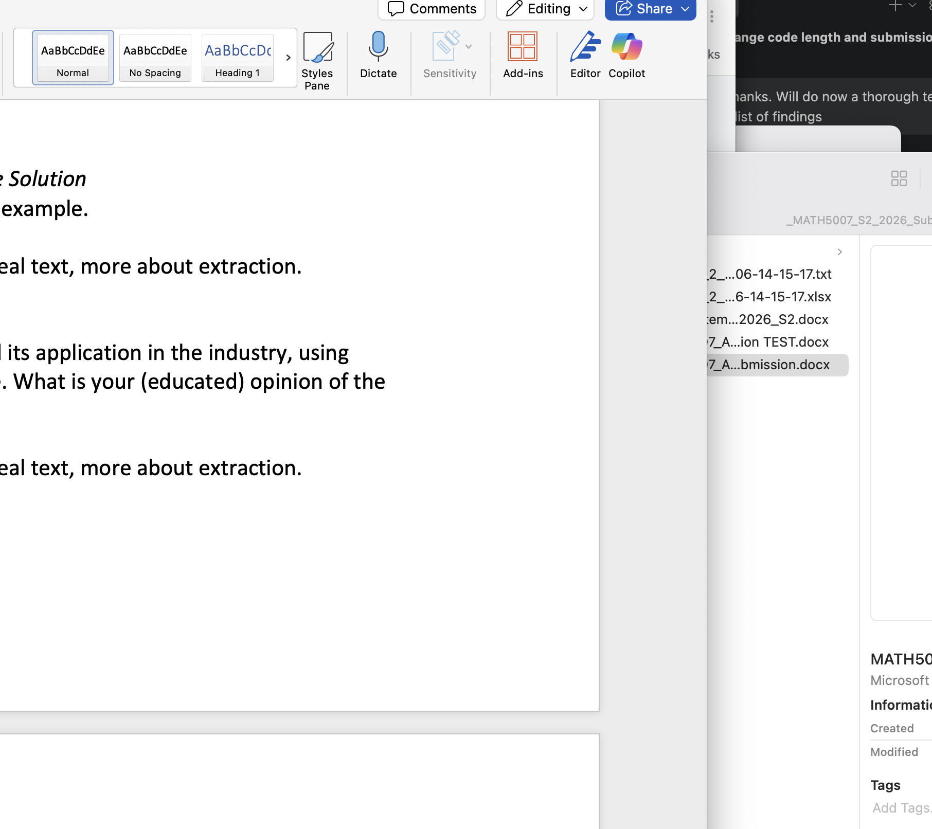

- Given are the inequalities 2x1+3x2<=10 and 3x1+5x2<=20. Visualise the solution area considering X1>=0 and X2>=0. Find the best solution assuming the objective function 15x1+10x2. Describe how you found the best solution visually and mathematically (under consideration, you know the visualisation of the solution space).
Include an image (photo, scan, screenshot) of the graph in this document (10M)

WORKS. This is the answer to Question 1.5. No real text, more about extraction.

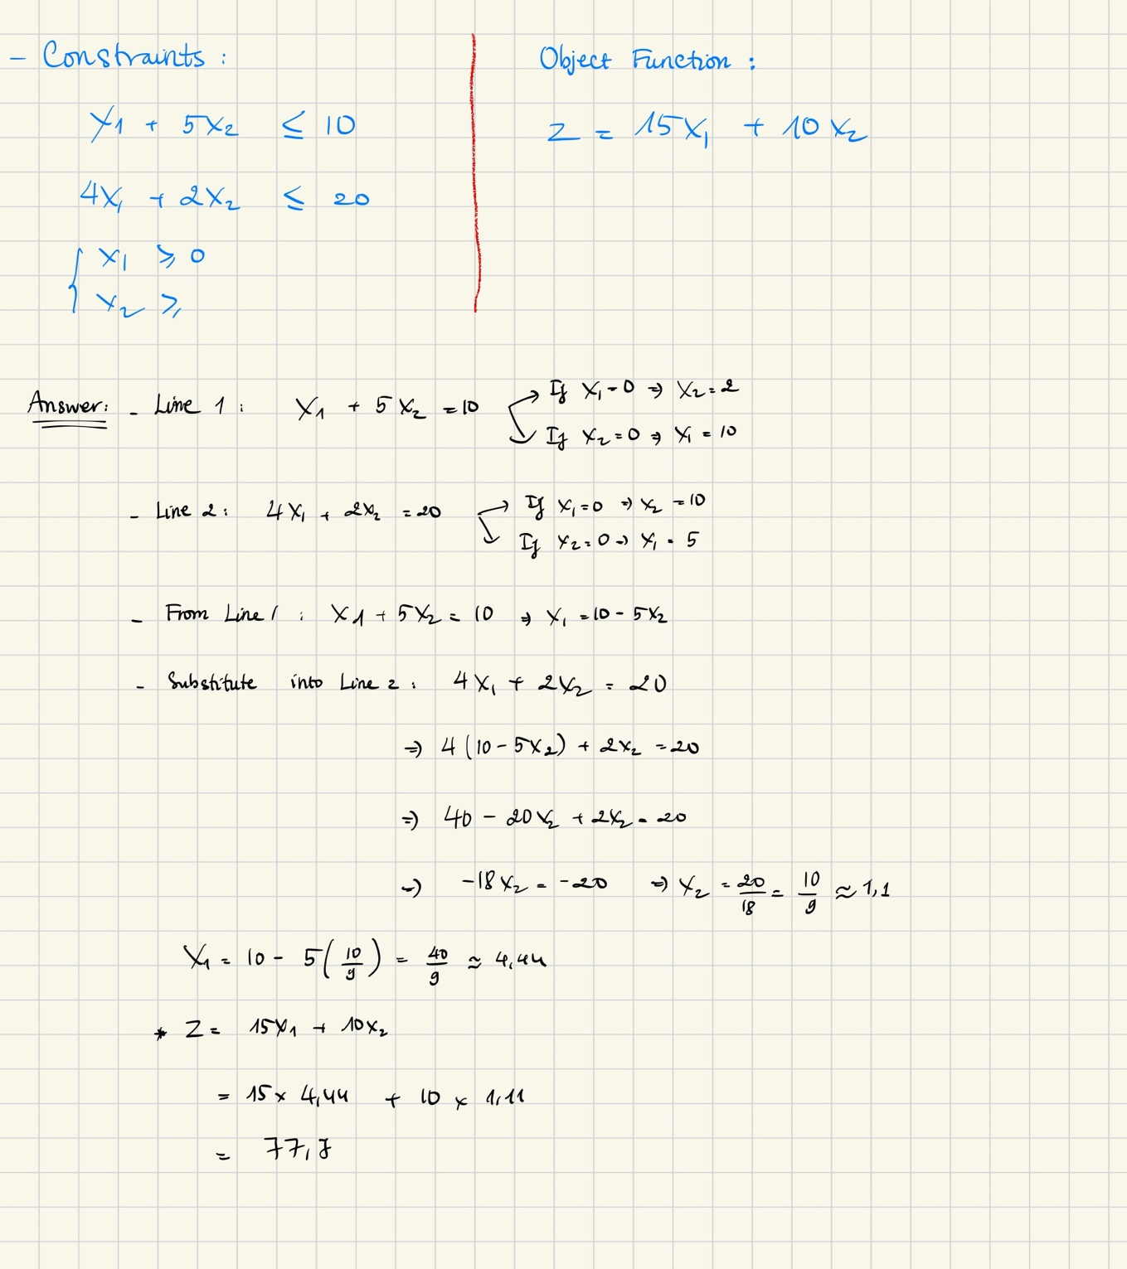

Question 2: Optimisation Model (23 Marks)

Please consider reimplementing the CitrusWA example even if this is not required here.

- Due to environmental restrictions, only a certain number of boxes may be transported on the connections. Explain and implement the required constraint(s) and changes to the model and data to represent these limits. Make assumptions about the capacity limits and demonstrate your implementation. (10M)

WORKS. This is the answer to Question 2.1. No real text, more about extraction.

- Add an overall capacity limit for shipments to the processing plants (i.e., the total number of boxes received by the processing plants from all suppliers is limited to MAXPROCESS). Demonstrate the impact of the constraint with an example. (10M)

WORKS. This is the answer to Question 2.2. No real text, more about extraction.

- What could be a further extension of the model?
(Note: Multiple products, multiple vehicles, and cross-docks are already part of the lecture. Be creative. And no implementation is required here. (3M)

WORKS. This is the answer to Question 2.3. No real text, more about extraction.

