Problem solving project

Lucian Trestioreanu & Nina Çaushi

* Brief Introduction of the problem “ Minimum Makespan Minimization”

Job scheduling is an optimization problem in which N jobs with certain processing times are assigned to M machines. The goal is to find the best assignment of the jobs to the machines such that the completion time of the last job (all jobs have finished processing) is minimized.

Two constraints on this problem are that a job can be scheduled only on a single machine and the makespan is the maximum completion time for all machines. This is an NP hard problem.

* Coding section

Lucian – to do , also using this:

As we understand from the execution of the code we see in the output a binary sequence 0 and 1 of one dimensional table plus the maximum execution time. We have to modify the code in order to solve the minimum makespan scheduling problem of 16 machines and 512 tasks using this genetic algorithm by minimizing the execution time. I use comments with parentheses in some classes where I describe the changes I make. We firstly change [(1) in the code of Algorithm class and (2) in Chromosome class] binaries to integers by adding 16 machines. I didn’t erase anything in the code to see later the comparisons and the output of the modifications but I commented the part of the code I don’t use. Secondly, we change the execution steps to find the optimal execution time for instance I used 5000 steps [(3) in Exe class]. As we increase steps also time increases for finding the best minimized solution. Then we create a new instance of the problem by opening the file [(4) in Exe class]. In [InstanceParserClass (5)] we swap all commas with the empty symbol in order all commas to be erased from the file and then we remove all spaces from the file in order our file to be displayed correctly [InstanceParserClass (6)]. In the same class [InstanceParserClass (7)] we erase the first column numbers in our file too. Using [Population Class (8)] we also change the value of bestf to maximum (as worst case) in order to obtain the minimized one. Finally we create a new class in order to ensure that our modifications work and I created [MyproblemMMSP] where we override the evaluate method by using an integer table with 16 machines. Then we calculate the maximum execution time of each gene in [MyproblemMMSP (9)]. Summarizing, we calculate the minimum execution time of each gene by adding a minus on the generating maximum value [MyproblemMMSP (10)]. Below in the screenshot is the minimized execution time among 5000 steps.

* Description of your algorithms

o Parameters Tuning

o Operators (Crossover, Mutation, etc.)

o **Important! Please justify your implementation**

To solve the minimum makespan problem, the genetic algorithm was used. There are three main parameters in GA: crossover probability, mutation probability and population size. Also different search could be used (Local Search: Gradient, etc.) Crossover randomly selects one or two points in the parents’ chromosomes and interchanges the two parents chromosomes at this point(s) to produce two new offsprings in hopes of producing better chromosomes. A crossover probability is between 0.6 and 1. After crossover, a mutation might happen which means that part of the offsprings chromosome might change in order to introduce diversity within the population. The probability of mutating a particular bit is typically between 0.001 and 0.1. Population size says how many individuals are in the population. For the instance: **u_s_hihi_512_16.txt** we only tuned the parameters Pm and Pc and ran 9 possible combinations. For the crossover probability we chose the values 0.6; 0.8 and 1 while for the mutation probability we chose the values 0.001953125; 0.00390625 and 9.765625E-4. For the instance: **u_s_lohi_512_16.txt** the population size was also changed this the values 512; 1024; 2048. For the mutation probability we used the values 0.001953125; 0.009765625 and 0.01953125 and for the crossover probability we still kept the values 0.6; 0.8 and 1. This means that 27 possible algorithms were tested.

* Use ANOVA or Non-parametric analysis to study the effect of tuned parameters in your

algorithms (regarding the performance) on two specific instances; **u_s_hihi_512_16.txt** and **u_s_lohi_512_16.txt** (You only have to perform statistical analysis on these two instances)

* Explain the outcome from statistical analysis

For the instance: **u_s_hihi_512_16.txt:**

We have tuned the parameters crossover and mutation probabilities, for three values each, which results in 9 possible algorithms.

Algorithm 1: pc=0.8, pm=0.001953125 (1/512)

Algorithm 2: pc=0.6, pm=0.001953125 (1/512)

Algorithm 3: pc=1.0, pm=0.001953125 (1/512)

Algorithm 4: pc=1.0, pm=0.00390625 (1/512)

Algorithm 5: pc=0.6, pm=0.00390625 (2/512)

Algorithm 6: pc=0.8, pm=0.00390625 (2/512)

Algorithm 7: pc=0.8, pm=9.765625E-4 (0.5/512)

Algorithm 8: pc=0.6, pm=9.765625E-4 (0.5/512)

Algorithm 9: pc=1.0, pm=9.765625E-4 (0.5/512)

We ran each algorithm 50 times and collected the following results.

|  |  |  |  |  |  |  |  |  |  |
| --- | --- | --- | --- | --- | --- | --- | --- | --- | --- |
|  | Alg1 | Alg2 | Alg3 | Alg4 | Alg5 | Alg6 | Alg7 | Alg8 | Alg9 |
| 1 | 26594395 | 25827243 | 26342091 | 26401053 | 26692129 | 27252061 | 27386220 | 25268109 | 26730117 |
| 2 | 27033346 | 26691659 | 25133489 | 25686431 | 24325386 | 26317239 | 27072528 | 26551773 | 26188261 |
| 3 | 27364718 | 27041751 | 25504343 | 27218389 | 25069822 | 27342290 | 27192246 | 26904594 | 25939730 |
| 4 | 25889296 | 25813770 | 25871440 | 26833533 | 26814483 | 26833017 | 25328776 | 25415389 | 25989096 |
| 5 | 26474980 | 26745896 | 26672764 | 26693418 | 27364920 | 27010498 | 26768679 | 26046592 | 24866368 |
| 6 | 27095611 | 26664714 | 26476074 | 27280296 | 25848873 | 25112606 | 26004897 | 27230748 | 27062763 |
| 7 | 26493422 | 27119310 | 26506886 | 27842227 | 26594802 | 26438128 | 26890947 | 27509745 | 26993575 |
| 8 | 26897736 | 27100301 | 27281816 | 25904689 | 26744623 | 26326812 | 25926142 | 27514051 | 27000559 |
| 9 | 25965540 | 27171977 | 26202433 | 26462369 | 26752628 | 27086764 | 26801473 | 27332045 | 26901126 |
| 10 | 26066978 | 27451665 | 25371683 | 26829451 | 26472045 | 27415848 | 26818930 | 27098449 | 25678367 |
| 11 | 26454109 | 26927610 | 27137803 | 26110625 | 27480172 | 26538533 | 26292431 | 26937334 | 26024443 |
| 12 | 26438318 | 26730249 | 27151746 | 26183676 | 26306641 | 26685167 | 25939838 | 26403717 | 26983695 |
| 13 | 26451776 | 26682255 | 27006431 | 26327865 | 25578294 | 25860777 | 26231173 | 26851887 | 26790041 |
| 14 | 25926304 | 26807010 | 27533559 | 26759405 | 26796393 | 27443000 | 27066550 | 25378799 | 26563600 |
| 15 | 25631190 | 27240909 | 25978881 | 25182339 | 27910700 | 25908068 | 26723136 | 26346249 | 26294140 |
| 16 | 26273749 | 27467896 | 26704479 | 26747855 | 26908168 | 26486038 | 25844965 | 26807232 | 26132867 |
| 17 | 26742412 | 27127287 | 25157040 | 26273839 | 26800916 | 26707223 | 27239953 | 26488256 | 25763326 |
| 18 | 25589119 | 27008843 | 26709634 | 26571189 | 27257358 | 26419142 | 27227354 | 26073602 | 24538806 |
| 19 | 26711424 | 27317566 | 26562414 | 26937609 | 27307220 | 26606427 | 26511442 | 26531662 | 26532324 |
| 20 | 26872270 | 27318356 | 26157490 | 26589493 | 26568873 | 26697749 | 25896742 | 26335463 | 25090882 |
| 21 | 26466776 | 26458811 | 26190578 | 25723812 | 25525759 | 27150187 | 26310043 | 26743261 | 25556788 |
| 22 | 26177981 | 26472676 | 26157050 | 26706725 | 27214120 | 25633757 | 25971090 | 27022907 | 27023630 |
| 23 | 26399450 | 26080163 | 26731043 | 26763806 | 26236101 | 26309618 | 27293115 | 27106528 | 26589459 |
| 24 | 27107922 | 27215332 | 26995136 | 26481351 | 26945347 | 26063753 | 26075752 | 26543842 | 26887636 |
| 25 | 26266433 | 26440883 | 26200569 | 27016693 | 26834188 | 26957698 | 26107975 | 26737263 | 25484291 |
| 26 | 26780305 | 27197957 | 26787494 | 25964798 | 26470691 | 26830400 | 26681135 | 26872360 | 26273723 |
| 27 | 26029602 | 26452449 | 25936509 | 25985569 | 27004891 | 26200262 | 26322213 | 26346221 | 26795384 |
| 28 | 25539606 | 26646493 | 25883356 | 25440559 | 26495150 | 25885208 | 25742487 | 26992738 | 26259833 |
| 29 | 26488870 | 25652329 | 26253236 | 25561647 | 26410444 | 27068430 | 26930466 | 26799551 | 27035400 |
| 30 | 25907675 | 26865274 | 26813952 | 26398826 | 27632668 | 25981114 | 26867838 | 27471605 | 26187471 |
| 31 | 26622681 | 26220706 | 26127958 | 26092832 | 25634536 | 27317033 | 27548241 | 26783840 | 26319888 |
| 32 | 26898313 | 26476630 | 26450020 | 27180858 | 26635996 | 26886612 | 26307371 | 26592434 | 26449263 |
| 33 | 26424556 | 26842881 | 26142145 | 24935552 | 26568479 | 27167194 | 26639652 | 26796633 | 27089516 |
| 34 | 25870696 | 27060088 | 25714339 | 26111659 | 26647930 | 26403835 | 26821342 | 26980971 | 26637698 |
| 35 | 25735548 | 26473513 | 25794663 | 26864925 | 26341157 | 26998252 | 26962944 | 25350776 | 26625280 |
| 36 | 27326426 | 26203892 | 26130670 | 26760895 | 25858973 | 26969864 | 26075493 | 26427182 | 26376142 |
| 37 | 26808832 | 26739519 | 25962969 | 24978156 | 27785568 | 26059265 | 26164432 | 25586427 | 26353374 |
| 38 | 25789128 | 26421911 | 27049981 | 26399742 | 26908697 | 26815110 | 26399459 | 25871406 | 26566075 |
| 39 | 25522315 | 26507885 | 26639062 | 26234438 | 26792049 | 26220877 | 26497170 | 27523824 | 26253296 |
| 40 | 26740842 | 26765608 | 26444165 | 26741555 | 26228519 | 27146296 | 26727608 | 27555155 | 26877820 |
| 41 | 26096419 | 26981057 | 26074336 | 25819799 | 26548532 | 27247522 | 26860832 | 26902932 | 26545780 |
| 42 | 24686216 | 26369027 | 25921481 | 26161220 | 26672685 | 26125063 | 27422401 | 27747923 | 25134235 |
| 43 | 27090203 | 27199209 | 26208430 | 26018638 | 26434046 | 27023816 | 26454344 | 25253503 | 26254867 |
| 44 | 26669205 | 27114238 | 26472156 | 25964060 | 25072897 | 25840173 | 26288524 | 27289602 | 26470600 |
| 45 | 25302155 | 25741969 | 26860805 | 26561732 | 26475937 | 27387669 | 25693190 | 27479792 | 26822716 |
| 46 | 26080895 | 25854347 | 26587446 | 26610997 | 26228505 | 26315194 | 27058614 | 26837980 | 25997518 |
| 47 | 26477969 | 27102455 | 26266558 | 26164946 | 26843446 | 26715690 | 26800452 | 27065513 | 25722062 |
| 48 | 27601653 | 26573529 | 24923826 | 25697051 | 26949602 | 26479819 | 26688299 | 26890964 | 26095462 |
| 49 | 26554091 | 26436355 | 26935687 | 25168551 | 26216639 | 26804592 | 27698261 | 25174993 | 27320377 |
| 50 | 25644571 | 26434335 | 26256067 | 26034195 | 27080384 | 26512473 | 26500259 | 27274382 | 26577638 |

We processed the results in Matlab, with the Kruskal-Wallis test which tests the hypothesis that all samples have the same mean or not (meaning the sample data from each column come from the same distribution or not).

**[pval, kwtab, stats] = kruskalwallis([Alg1, Alg2, Alg3, Alg4, Alg5, Alg6, Alg7, Alg8, Alg9])**

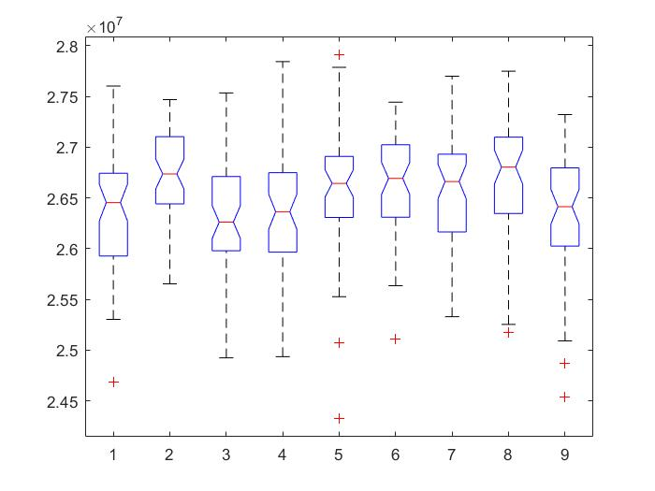

The Kruskal-Wallis test returns a stats structure which we further used to perform a follow-up multiple comparison test.

**Multcompare(stats)**

The p values per pairs of algorithms:

|  |  |  |  |  |  |
| --- | --- | --- | --- | --- | --- |
| Alg A | Alg B | **lower** | **mean difference** | **upper** | P Value |
| 1 | 2 | -158.8948 | -78.2200 | 2.4548 | 0.0658 |
| 1 | 3 | -71.6348 | 9.0400 | 89.7148 | 1.0000 |
| 1 | 4 | -69.6948 | 10.9800 | 91.6548 | 1.0000 |
| 1 | 5 | -131.8348 | -51.1600 | 29.5148 | 0.5666 |
| 1 | 6 | -139.0148 | -58.3400 | 22.3348 | 0.3776 |
| 1 | 7 | -126.5548 | -45.8800 | 34.7948 | 0.7061 |
| 1 | 8 | -156.5148 | -75.8400 | 4.8348 | 0.0849 |
| 1 | 9 | -81.5948 | -0.9200 | 79.7548 | 1.0000 |
| 2 | 3 | 6.5852 | 87.2600 | 167.9348 | 0.0226 |
| 2 | 4 | 8.5252 | 89.2000 | 169.8748 | 0.0176 |
| 2 | 5 | -53.6148 | 27.0600 | 107.7348 | 0.9820 |
| 2 | 6 | -60.7948 | 19.8800 | 100.5548 | 0.9978 |
| 2 | 7 | -48.3348 | 32.3400 | 113.0148 | 0.9469 |
| 2 | 8 | -78.2948 | 2.3800 | 83.0548 | 1.0000 |
| 2 | 9 | -3.3748 | 77.3000 | 157.9748 | 0.0727 |
| 3 | 4 | -78.7348 | 1.9400 | 82.6148 | 1.0000 |
| 3 | 5 | -140.8748 | -60.2000 | 20.4748 | 0.3331 |
| 3 | 6 | -148.0548 | -67.3800 | 13.2948 | 0.1904 |
| 3 | 7 | -135.5948 | -54.9200 | 25.7548 | 0.4652 |
| 3 | 8 | -165.5548 | -84.8800 | -4.2052 | 0.0304 |
| 3 | 9 | -90.6348 | -9.9600 | 70.7148 | 1.0000 |
| 4 | 5 | -142.8148 | -62.1400 | 18.5348 | 0.2898 |
| 4 | 6 | -149.9948 | -69.3200 | 11.3548 | 0.1604 |
| 4 | 7 | -137.5348 | -56.8600 | 23.8148 | 0.4147 |
| 4 | 8 | -167.4948 | -86.8200 | -6.1452 | 0.0239 |
| 4 | 9 | -92.5748 | -11.9000 | 68.7748 | 1.0000 |
| 5 | 6 | -87.8548 | -7.1800 | 73.4948 | 1.0000 |
| 5 | 7 | -75.3948 | 5.2800 | 85.9548 | 1.0000 |
| 5 | 8 | -105.3548 | -24.6800 | 55.9948 | 0.9901 |
| 5 | 9 | -30.4348 | 50.2400 | 130.9148 | 0.5916 |
| 6 | 7 | -68.2148 | 12.4600 | 93.1348 | 0.9999 |
| 6 | 8 | -98.1748 | -17.5000 | 63.1748 | 0.9991 |
| 6 | 9 | -23.2548 | 57.4200 | 138.0948 | 0.4005 |
| 7 | 8 | -110.6348 | -29.9600 | 50.7148 | 0.9661 |
| 7 | 9 | -35.7148 | 44.9600 | 125.6348 | 0.7289 |
| 8 | 9 | -5.7548 | 74.9200 | 155.5948 | 0.0934 |

P values < 0.05 mean that we have statistically significant differences with 95% confidence.

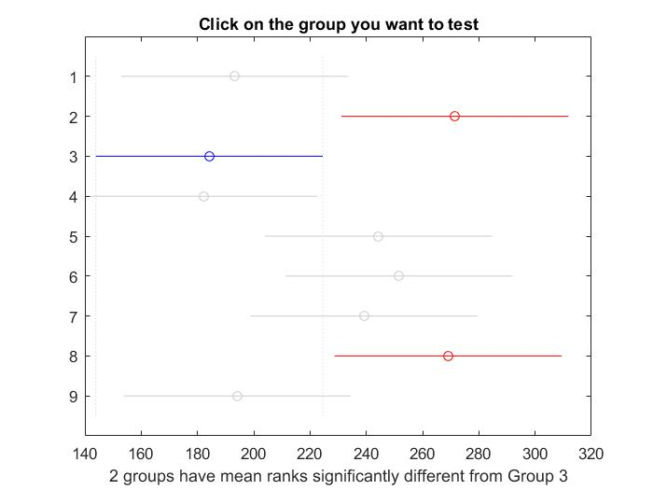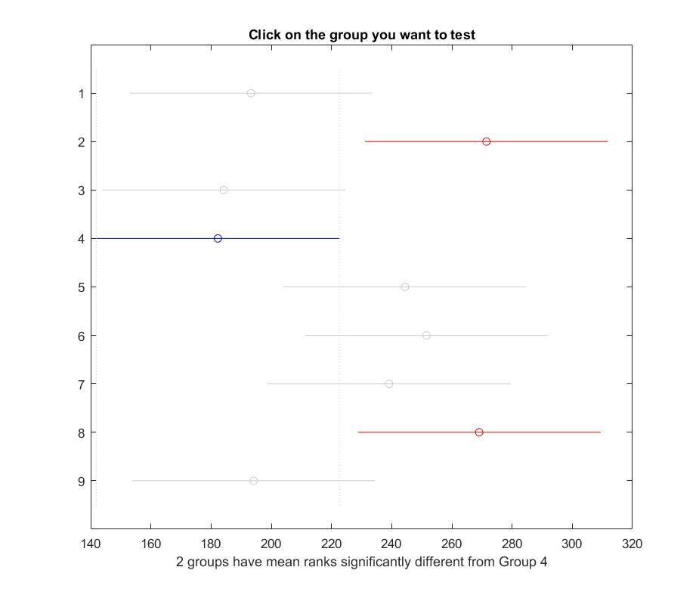

The results in the picture above indicate that there is a difference between algorithm 4 and 42 so the test rejects the hypothesis that the data in these two groups come from the same distribution. The same is true for algorithm 4 and 8. However, the test does not reject the hypothesis that algorithm 4 and the remaining six come from the same distribution. Therefore, these results suggest that the data from algorithms 1, 3, 4, 5, 6, 7, 9 come from the same distribution and the algorithms 2 and 8 come from a different distribution.

In other words, in some situations it is possible that Alg 1,3,4,5,6,7,9 will give same result and for sure, Alg2 and 8 will never give a similar result to Alg 3,4. So if we look at the group Alg1,3,4,5,6,7,9, any of these could give a similar result, but because 3 and 4 have the best chances to give small makespans and in the same time different from Alg 2, 8, we decide that our best candidates are either Alg 3 or 4.

Based on the information gathered we have chosen to go ahead with algorithm 3 for this instance of the problem.

For the instance: **u_s_lohi_512_16.txt:**

We tuned the parameters crossover, mutation probabilities, and population size for three values each, which results in 27 possible algorithms.

Alg1: pc=1.0, pm=0.001953125 (1/512), popsize=512

Alg2: pc=1.0, pm=0.001953125 (1/512), popsize=1024

Alg3: pc=1.0, pm=0.001953125 (1/512), popsize=2048

Alg4: pc=1.0, pm=0.009765625 (5/512), popsize=512

Alg5: pc=1.0, pm=0.009765625 (5/512), popsize=1024

Alg6: pc=1.0, pm=0.009765625 (5/512), popsize=2048

Alg7: pc=1.0, pm=0.01953125 (10/512), popsize=512

Alg8: pc=1.0, pm=0.01953125 (10/512), popsize=1024

Alg9: pc=1.0, pm=0.01953125 (10/512), popsize=2048

Alg10: pc=0.8, pm=0.001953125 (1/512), popsize=512

Alg11: pc=0.8, pm=0.001953125 (1/512), popsize=1024

Alg12: pc=0.8, pm=0.001953125 (1/512), popsize=2048

Alg13: pc=0.8, pm=0.009765625 (5/512), popsize=512

Alg14: pc=0.8, pm=0.009765625 (5/512), popsize=1024

Alg15: pc=0.8, pm=0.009765625 (5/512), popsize=2048

Alg16: pc=0.8, pm=0.01953125 (10/512), popsize=512

Alg17: pc=0.8, pm=0.01953125 (10/512), popsize=1024

Alg18: pc=0.8, pm=0.01953125 (10/512), popsize=2048

Alg19: pc=0.6, pm=0.001953125 (1/512), popsize=512

Alg20: pc=0.6, pm=0.001953125 (1/512), popsize=1024

Alg21: pc=0.6, pm=0.001953125 (1/512), popsize=2048

Alg22: pc=0.6, pm=0.009765625 (5/512), popsize=512

Alg23: pc=0.6, pm=0.009765625 (5/512), popsize=1024

Alg24: pc=0.6, pm=0.009765625 (5/512), popsize=2048

Alg25: pc=0.6, pm=0.01953125 (10/512), popsize=512

Alg26: pc=0.6, pm=0.01953125 (10/512), popsize=1024

Alg27: pc=0.6, pm=0.01953125 (10/512), popsize=2048

We ran each algorithm 50 times and collected the results which can be found in a separate Excel sheet: Project_GA\Data\u_s_lohi_512_16\data_u_s_lohi_512_16.xlsx

These results were further processed in Matlab, with the Kruskal-Wallis test like for the previous instance.

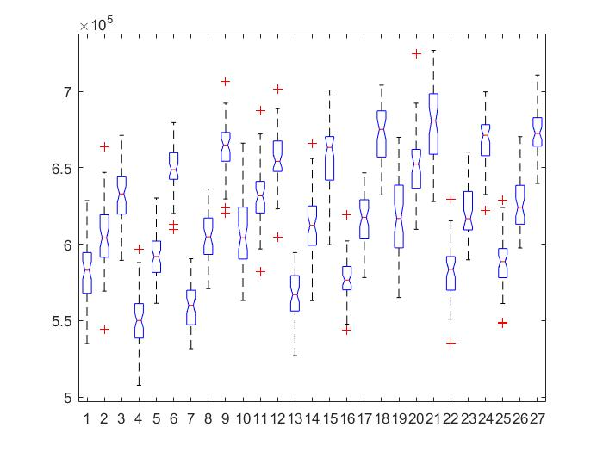

We have chosen algorithm 4 to be the best because it is clear from the above picture of distributions that it provides the lowest results and is statistically different from those algorithms that provide higher values.

For obtaining the lower bound though, we have used a larger population size (1024/2048) and a high number of steps - ran the code for a long time in order to better explore the solution space.

////////////Comment///////On a second thought I think for a popsize 2048 should have used algorithm 3 for finding the best chromosome. ////////////Have to see further: Lucian/////////////////////////////

Next, we performed a follow-up multiple comparison test comparing each algorithm with one another. The results are shown in the table below.

|  |  |  |  |  |  |  |  |  |  |  |  |
| --- | --- | --- | --- | --- | --- | --- | --- | --- | --- | --- | --- |
| **A** | **B** | **lower** | **mean difference** | **upper** | **P Value** | **A** | **B** | **lower** | **mean difference** | **upper** | **P Value** |
| 1 | 2 | -509.69359 | -221.48000 | 66.73359 | 0.46062 | 8 | 23 | -449.81359 | -161.60000 | 126.61359 | 0.94995 |
| 1 | 3 | -799.61359 | -511.40000 | -223.18641 | 0.00000 | 8 | 24 | -912.92359 | -624.71000 | -336.49641 | 0.00000 |
| 1 | 4 | -83.33359 | 204.88000 | 493.09359 | 0.63437 | 8 | 25 | -115.82359 | 172.39000 | 460.60359 | 0.90279 |
| 1 | 5 | -380.93359 | -92.72000 | 195.49359 | 0.99999 | 8 | 26 | -517.08359 | -228.87000 | 59.34359 | 0.38697 |
| 1 | 6 | -970.20359 | -681.99000 | -393.77641 | 0.00000 | 8 | 27 | -961.20359 | -672.99000 | -384.77641 | 0.00000 |
| 1 | 7 | -110.65359 | 177.56000 | 465.77359 | 0.87225 | 9 | 10 | 282.00641 | 570.22000 | 858.43359 | 0.00000 |
| 1 | 8 | -508.86359 | -220.65000 | 67.56359 | 0.46916 | 9 | 11 | 12.76641 | 300.98000 | 589.19359 | 0.02821 |
| 1 | 9 | -1,087.95359 | -799.74000 | -511.52641 | 0.00000 | 9 | 12 | -226.73359 | 61.48000 | 349.69359 | 1.00000 |
| 1 | 10 | -517.73359 | -229.52000 | 58.69359 | 0.38073 | 9 | 13 | 642.98641 | 931.20000 | 1,219.41359 | 0.00000 |
| 1 | 11 | -786.97359 | -498.76000 | -210.54641 | 0.00000 | 9 | 14 | 221.06641 | 509.28000 | 797.49359 | 0.00000 |
| 1 | 12 | -1,026.47359 | -738.26000 | -450.04641 | 0.00000 | 9 | 15 | -228.58359 | 59.63000 | 347.84359 | 1.00000 |
| 1 | 13 | -156.75359 | 131.46000 | 419.67359 | 0.99662 | 9 | 16 | 567.46641 | 855.68000 | 1,143.89359 | 0.00000 |
| 1 | 14 | -578.67359 | -290.46000 | -2.24641 | 0.04535 | 9 | 17 | 166.35641 | 454.57000 | 742.78359 | 0.00000 |
| 1 | 15 | -1,028.32359 | -740.11000 | -451.89641 | 0.00000 | 9 | 18 | -357.93359 | -69.72000 | 218.49359 | 1.00000 |
| 1 | 16 | -232.27359 | 55.94000 | 344.15359 | 1.00000 | 9 | 19 | 143.10641 | 431.32000 | 719.53359 | 0.00001 |
| 1 | 17 | -633.38359 | -345.17000 | -56.95641 | 0.00288 | 9 | 20 | -177.22359 | 110.99000 | 399.20359 | 0.99979 |
| 1 | 18 | -1,157.67359 | -869.46000 | -581.24641 | 0.00000 | 9 | 21 | -372.75359 | -84.54000 | 203.67359 | 1.00000 |
| 1 | 19 | -656.63359 | -368.42000 | -80.20641 | 0.00073 | 9 | 22 | 515.36641 | 803.58000 | 1,091.79359 | 0.00000 |
| 1 | 20 | -976.96359 | -688.75000 | -400.53641 | 0.00000 | 9 | 23 | 129.27641 | 417.49000 | 705.70359 | 0.00003 |
| 1 | 21 | -1,172.49359 | -884.28000 | -596.06641 | 0.00000 | 9 | 24 | -333.83359 | -45.62000 | 242.59359 | 1.00000 |
| 1 | 22 | -284.37359 | 3.84000 | 292.05359 | 1.00000 | 9 | 25 | 463.26641 | 751.48000 | 1,039.69359 | 0.00000 |
| 1 | 23 | -670.46359 | -382.25000 | -94.03641 | 0.00031 | 9 | 26 | 62.00641 | 350.22000 | 638.43359 | 0.00216 |
| 1 | 24 | -1,133.57359 | -845.36000 | -557.14641 | 0.00000 | 9 | 27 | -382.11359 | -93.90000 | 194.31359 | 0.99999 |
| 1 | 25 | -336.47359 | -48.26000 | 239.95359 | 1.00000 | 10 | 11 | -557.45359 | -269.24000 | 18.97359 | 0.10802 |
| 1 | 26 | -737.73359 | -449.52000 | -161.30641 | 0.00000 | 10 | 12 | -796.95359 | -508.74000 | -220.52641 | 0.00000 |
| 1 | 27 | -1,181.85359 | -893.64000 | -605.42641 | 0.00000 | 10 | 13 | 72.76641 | 360.98000 | 649.19359 | 0.00115 |
| 2 | 3 | -578.13359 | -289.92000 | -1.70641 | 0.04643 | 10 | 14 | -349.15359 | -60.94000 | 227.27359 | 1.00000 |
| 2 | 4 | 138.14641 | 426.36000 | 714.57359 | 0.00002 | 10 | 15 | -798.80359 | -510.59000 | -222.37641 | 0.00000 |
| 2 | 5 | -159.45359 | 128.76000 | 416.97359 | 0.99754 | 10 | 16 | -2.75359 | 285.46000 | 573.67359 | 0.05626 |
| 2 | 6 | -748.72359 | -460.51000 | -172.29641 | 0.00000 | 10 | 17 | -403.86359 | -115.65000 | 172.56359 | 0.99957 |
| 2 | 7 | 110.82641 | 399.04000 | 687.25359 | 0.00010 | 10 | 18 | -928.15359 | -639.94000 | -351.72641 | 0.00000 |
| 2 | 8 | -287.38359 | 0.83000 | 289.04359 | 1.00000 | 10 | 19 | -427.11359 | -138.90000 | 149.31359 | 0.99248 |
| 2 | 9 | -866.47359 | -578.26000 | -290.04641 | 0.00000 | 10 | 20 | -747.44359 | -459.23000 | -171.01641 | 0.00000 |
| 2 | 10 | -296.25359 | -8.04000 | 280.17359 | 1.00000 | 10 | 21 | -942.97359 | -654.76000 | -366.54641 | 0.00000 |
| 2 | 11 | -565.49359 | -277.28000 | 10.93359 | 0.07890 | 10 | 22 | -54.85359 | 233.36000 | 521.57359 | 0.34485 |
| 2 | 12 | -804.99359 | -516.78000 | -228.56641 | 0.00000 | 10 | 23 | -440.94359 | -152.73000 | 135.48359 | 0.97394 |
| 2 | 13 | 64.72641 | 352.94000 | 641.15359 | 0.00185 | 10 | 24 | -904.05359 | -615.84000 | -327.62641 | 0.00000 |
| 2 | 14 | -357.19359 | -68.98000 | 219.23359 | 1.00000 | 10 | 25 | -106.95359 | 181.26000 | 469.47359 | 0.84716 |
| 2 | 15 | -806.84359 | -518.63000 | -230.41641 | 0.00000 | 10 | 26 | -508.21359 | -220.00000 | 68.21359 | 0.47587 |
| 2 | 16 | -10.79359 | 277.42000 | 565.63359 | 0.07845 | 10 | 27 | -952.33359 | -664.12000 | -375.90641 | 0.00000 |
| 2 | 17 | -411.90359 | -123.69000 | 164.52359 | 0.99869 | 11 | 12 | -527.71359 | -239.50000 | 48.71359 | 0.29126 |
| 2 | 18 | -936.19359 | -647.98000 | -359.76641 | 0.00000 | 11 | 13 | 342.00641 | 630.22000 | 918.43359 | 0.00000 |
| 2 | 19 | -435.15359 | -146.94000 | 141.27359 | 0.98395 | 11 | 14 | -79.91359 | 208.30000 | 496.51359 | 0.59872 |
| 2 | 20 | -755.48359 | -467.27000 | -179.05641 | 0.00000 | 11 | 15 | -529.56359 | -241.35000 | 46.86359 | 0.27612 |
| 2 | 21 | -951.01359 | -662.80000 | -374.58641 | 0.00000 | 11 | 16 | 266.48641 | 554.70000 | 842.91359 | 0.00000 |
| 2 | 22 | -62.89359 | 225.32000 | 513.53359 | 0.42177 | 11 | 17 | -134.62359 | 153.59000 | 441.80359 | 0.97211 |
| 2 | 23 | -448.98359 | -160.77000 | 127.44359 | 0.95271 | 11 | 18 | -658.91359 | -370.70000 | -82.48641 | 0.00064 |
| 2 | 24 | -912.09359 | -623.88000 | -335.66641 | 0.00000 | 11 | 19 | -157.87359 | 130.34000 | 418.55359 | 0.99703 |
| 2 | 25 | -114.99359 | 173.22000 | 461.43359 | 0.89824 | 11 | 20 | -478.20359 | -189.99000 | 98.22359 | 0.77789 |
| 2 | 26 | -516.25359 | -228.04000 | 60.17359 | 0.39500 | 11 | 21 | -673.73359 | -385.52000 | -97.30641 | 0.00025 |
| 2 | 27 | -960.37359 | -672.16000 | -383.94641 | 0.00000 | 11 | 22 | 214.38641 | 502.60000 | 790.81359 | 0.00000 |
| 3 | 4 | 428.06641 | 716.28000 | 1,004.49359 | 0.00000 | 11 | 23 | -171.70359 | 116.51000 | 404.72359 | 0.99951 |
| 3 | 5 | 130.46641 | 418.68000 | 706.89359 | 0.00003 | 11 | 24 | -634.81359 | -346.60000 | -58.38641 | 0.00266 |
| 3 | 6 | -458.80359 | -170.59000 | 117.62359 | 0.91218 | 11 | 25 | 162.28641 | 450.50000 | 738.71359 | 0.00000 |
| 3 | 7 | 400.74641 | 688.96000 | 977.17359 | 0.00000 | 11 | 26 | -238.97359 | 49.24000 | 337.45359 | 1.00000 |
| 3 | 8 | 2.53641 | 290.75000 | 578.96359 | 0.04477 | 11 | 27 | -683.09359 | -394.88000 | -106.66641 | 0.00014 |
| 3 | 9 | -576.55359 | -288.34000 | -0.12641 | 0.04973 | 12 | 13 | 581.50641 | 869.72000 | 1,157.93359 | 0.00000 |
| 3 | 10 | -6.33359 | 281.88000 | 570.09359 | 0.06538 | 12 | 14 | 159.58641 | 447.80000 | 736.01359 | 0.00000 |
| 3 | 11 | -275.57359 | 12.64000 | 300.85359 | 1.00000 | 12 | 15 | -290.06359 | -1.85000 | 286.36359 | 1.00000 |
| 3 | 12 | -515.07359 | -226.86000 | 61.35359 | 0.40653 | 12 | 16 | 505.98641 | 794.20000 | 1,082.41359 | 0.00000 |
| 3 | 13 | 354.64641 | 642.86000 | 931.07359 | 0.00000 | 12 | 17 | 104.87641 | 393.09000 | 681.30359 | 0.00015 |
| 3 | 14 | -67.27359 | 220.94000 | 509.15359 | 0.46617 | 12 | 18 | -419.41359 | -131.20000 | 157.01359 | 0.99672 |
| 3 | 15 | -516.92359 | -228.71000 | 59.50359 | 0.38851 | 12 | 19 | 81.62641 | 369.84000 | 658.05359 | 0.00067 |
| 3 | 16 | 279.12641 | 567.34000 | 855.55359 | 0.00000 | 12 | 20 | -238.70359 | 49.51000 | 337.72359 | 1.00000 |
| 3 | 17 | -121.98359 | 166.23000 | 454.44359 | 0.93236 | 12 | 21 | -434.23359 | -146.02000 | 142.19359 | 0.98521 |
| 3 | 18 | -646.27359 | -358.06000 | -69.84641 | 0.00137 | 12 | 22 | 453.88641 | 742.10000 | 1,030.31359 | 0.00000 |
| 3 | 19 | -145.23359 | 142.98000 | 431.19359 | 0.98881 | 12 | 23 | 67.79641 | 356.01000 | 644.22359 | 0.00154 |
| 3 | 20 | -465.56359 | -177.35000 | 110.86359 | 0.87359 | 12 | 24 | -395.31359 | -107.10000 | 181.11359 | 0.99989 |
| 3 | 21 | -661.09359 | -372.88000 | -84.66641 | 0.00056 | 12 | 25 | 401.78641 | 690.00000 | 978.21359 | 0.00000 |
| 3 | 22 | 227.02641 | 515.24000 | 803.45359 | 0.00000 | 12 | 26 | 0.52641 | 288.74000 | 576.95359 | 0.04887 |
| 3 | 23 | -159.06359 | 129.15000 | 417.36359 | 0.99742 | 12 | 27 | -443.59359 | -155.38000 | 132.83359 | 0.96798 |
| 3 | 24 | -622.17359 | -333.96000 | -45.74641 | 0.00536 | 13 | 14 | -710.13359 | -421.92000 | -133.70641 | 0.00002 |
| 3 | 25 | 174.92641 | 463.14000 | 751.35359 | 0.00000 | 13 | 15 | -1,159.78359 | -871.57000 | -583.35641 | 0.00000 |
| 3 | 26 | -226.33359 | 61.88000 | 350.09359 | 1.00000 | 13 | 16 | -363.73359 | -75.52000 | 212.69359 | 1.00000 |
| 3 | 27 | -670.45359 | -382.24000 | -94.02641 | 0.00031 | 13 | 17 | -764.84359 | -476.63000 | -188.41641 | 0.00000 |
| 4 | 5 | -585.81359 | -297.60000 | -9.38641 | 0.03296 | 13 | 18 | -1,289.13359 | -1,000.92000 | -712.70641 | 0.00000 |
| 4 | 6 | -1,175.08359 | -886.87000 | -598.65641 | 0.00000 | 13 | 19 | -788.09359 | -499.88000 | -211.66641 | 0.00000 |
| 4 | 7 | -315.53359 | -27.32000 | 260.89359 | 1.00000 | 13 | 20 | -1,108.42359 | -820.21000 | -531.99641 | 0.00000 |
| 4 | 8 | -713.74359 | -425.53000 | -137.31641 | 0.00002 | 13 | 21 | -1,303.95359 | -1,015.74000 | -727.52641 | 0.00000 |
| 4 | 9 | -1,292.83359 | -1,004.62000 | -716.40641 | 0.00000 | 13 | 22 | -415.83359 | -127.62000 | 160.59359 | 0.99785 |
| 4 | 10 | -722.61359 | -434.40000 | -146.18641 | 0.00001 | 13 | 23 | -801.92359 | -513.71000 | -225.49641 | 0.00000 |
| 4 | 11 | -991.85359 | -703.64000 | -415.42641 | 0.00000 | 13 | 24 | -1,265.03359 | -976.82000 | -688.60641 | 0.00000 |
| 4 | 12 | -1,231.35359 | -943.14000 | -654.92641 | 0.00000 | 13 | 25 | -467.93359 | -179.72000 | 108.49359 | 0.85793 |
| 4 | 13 | -361.63359 | -73.42000 | 214.79359 | 1.00000 | 13 | 26 | -869.19359 | -580.98000 | -292.76641 | 0.00000 |
| 4 | 14 | -783.55359 | -495.34000 | -207.12641 | 0.00000 | 13 | 27 | -1,313.31359 | -1,025.10000 | -736.88641 | 0.00000 |
| 4 | 15 | -1,233.20359 | -944.99000 | -656.77641 | 0.00000 | 14 | 15 | -737.86359 | -449.65000 | -161.43641 | 0.00000 |
| 4 | 16 | -437.15359 | -148.94000 | 139.27359 | 0.98092 | 14 | 16 | 58.18641 | 346.40000 | 634.61359 | 0.00269 |
| 4 | 17 | -838.26359 | -550.05000 | -261.83641 | 0.00000 | 14 | 17 | -342.92359 | -54.71000 | 233.50359 | 1.00000 |
| 4 | 18 | -1,362.55359 | -1,074.34000 | -786.12641 | 0.00000 | 14 | 18 | -867.21359 | -579.00000 | -290.78641 | 0.00000 |
| 4 | 19 | -861.51359 | -573.30000 | -285.08641 | 0.00000 | 14 | 19 | -366.17359 | -77.96000 | 210.25359 | 1.00000 |
| 4 | 20 | -1,181.84359 | -893.63000 | -605.41641 | 0.00000 | 14 | 20 | -686.50359 | -398.29000 | -110.07641 | 0.00011 |
| 4 | 21 | -1,377.37359 | -1,089.16000 | -800.94641 | 0.00000 | 14 | 21 | -882.03359 | -593.82000 | -305.60641 | 0.00000 |
| 4 | 22 | -489.25359 | -201.04000 | 87.17359 | 0.67358 | 14 | 22 | 6.08641 | 294.30000 | 582.51359 | 0.03826 |
| 4 | 23 | -875.34359 | -587.13000 | -298.91641 | 0.00000 | 14 | 23 | -380.00359 | -91.79000 | 196.42359 | 0.99999 |
| 4 | 24 | -1,338.45359 | -1,050.24000 | -762.02641 | 0.00000 | 14 | 24 | -843.11359 | -554.90000 | -266.68641 | 0.00000 |
| 4 | 25 | -541.35359 | -253.14000 | 35.07359 | 0.19133 | 14 | 25 | -46.01359 | 242.20000 | 530.41359 | 0.26932 |
| 4 | 26 | -942.61359 | -654.40000 | -366.18641 | 0.00000 | 14 | 26 | -447.27359 | -159.06000 | 129.15359 | 0.95804 |
| 4 | 27 | -1,386.73359 | -1,098.52000 | -810.30641 | 0.00000 | 14 | 27 | -891.39359 | -603.18000 | -314.96641 | 0.00000 |
| 5 | 6 | -877.48359 | -589.27000 | -301.05641 | 0.00000 | 15 | 16 | 507.83641 | 796.05000 | 1,084.26359 | 0.00000 |
| 5 | 7 | -17.93359 | 270.28000 | 558.49359 | 0.10383 | 15 | 17 | 106.72641 | 394.94000 | 683.15359 | 0.00014 |
| 5 | 8 | -416.14359 | -127.93000 | 160.28359 | 0.99777 | 15 | 18 | -417.56359 | -129.35000 | 158.86359 | 0.99736 |
| 5 | 9 | -995.23359 | -707.02000 | -418.80641 | 0.00000 | 15 | 19 | 83.47641 | 371.69000 | 659.90359 | 0.00060 |
| 5 | 10 | -425.01359 | -136.80000 | 151.41359 | 0.99394 | 15 | 20 | -236.85359 | 51.36000 | 339.57359 | 1.00000 |
| 5 | 11 | -694.25359 | -406.04000 | -117.82641 | 0.00007 | 15 | 21 | -432.38359 | -144.17000 | 144.04359 | 0.98749 |
| 5 | 12 | -933.75359 | -645.54000 | -357.32641 | 0.00000 | 15 | 22 | 455.73641 | 743.95000 | 1,032.16359 | 0.00000 |
| 5 | 13 | -64.03359 | 224.18000 | 512.39359 | 0.43319 | 15 | 23 | 69.64641 | 357.86000 | 646.07359 | 0.00138 |
| 5 | 14 | -485.95359 | -197.74000 | 90.47359 | 0.70627 | 15 | 24 | -393.46359 | -105.25000 | 182.96359 | 0.99992 |
| 5 | 15 | -935.60359 | -647.39000 | -359.17641 | 0.00000 | 15 | 25 | 403.63641 | 691.85000 | 980.06359 | 0.00000 |
| 5 | 16 | -139.55359 | 148.66000 | 436.87359 | 0.98137 | 15 | 26 | 2.37641 | 290.59000 | 578.80359 | 0.04509 |
| 5 | 17 | -540.66359 | -252.45000 | 35.76359 | 0.19572 | 15 | 27 | -441.74359 | -153.53000 | 134.68359 | 0.97224 |
| 5 | 18 | -1,064.95359 | -776.74000 | -488.52641 | 0.00000 | 16 | 17 | -689.32359 | -401.11000 | -112.89641 | 0.00009 |
| 5 | 19 | -563.91359 | -275.70000 | 12.51359 | 0.08404 | 16 | 18 | -1,213.61359 | -925.40000 | -637.18641 | 0.00000 |
| 5 | 20 | -884.24359 | -596.03000 | -307.81641 | 0.00000 | 16 | 19 | -712.57359 | -424.36000 | -136.14641 | 0.00002 |
| 5 | 21 | -1,079.77359 | -791.56000 | -503.34641 | 0.00000 | 16 | 20 | -1,032.90359 | -744.69000 | -456.47641 | 0.00000 |
| 5 | 22 | -191.65359 | 96.56000 | 384.77359 | 0.99998 | 16 | 21 | -1,228.43359 | -940.22000 | -652.00641 | 0.00000 |
| 5 | 23 | -577.74359 | -289.53000 | -1.31641 | 0.04723 | 16 | 22 | -340.31359 | -52.10000 | 236.11359 | 1.00000 |
| 5 | 24 | -1,040.85359 | -752.64000 | -464.42641 | 0.00000 | 16 | 23 | -726.40359 | -438.19000 | -149.97641 | 0.00001 |
| 5 | 25 | -243.75359 | 44.46000 | 332.67359 | 1.00000 | 16 | 24 | -1,189.51359 | -901.30000 | -613.08641 | 0.00000 |
| 5 | 26 | -645.01359 | -356.80000 | -68.58641 | 0.00147 | 16 | 25 | -392.41359 | -104.20000 | 184.01359 | 0.99993 |
| 5 | 27 | -1,089.13359 | -800.92000 | -512.70641 | 0.00000 | 16 | 26 | -793.67359 | -505.46000 | -217.24641 | 0.00000 |
| 6 | 7 | 571.33641 | 859.55000 | 1,147.76359 | 0.00000 | 16 | 27 | -1,237.79359 | -949.58000 | -661.36641 | 0.00000 |
| 6 | 8 | 173.12641 | 461.34000 | 749.55359 | 0.00000 | 17 | 18 | -812.50359 | -524.29000 | -236.07641 | 0.00000 |
| 6 | 9 | -405.96359 | -117.75000 | 170.46359 | 0.99942 | 17 | 19 | -311.46359 | -23.25000 | 264.96359 | 1.00000 |
| 6 | 10 | 164.25641 | 452.47000 | 740.68359 | 0.00000 | 17 | 20 | -631.79359 | -343.58000 | -55.36641 | 0.00315 |
| 6 | 11 | -104.98359 | 183.23000 | 471.44359 | 0.83273 | 17 | 21 | -827.32359 | -539.11000 | -250.89641 | 0.00000 |
| 6 | 12 | -344.48359 | -56.27000 | 231.94359 | 1.00000 | 17 | 22 | 60.79641 | 349.01000 | 637.22359 | 0.00232 |
| 6 | 13 | 525.23641 | 813.45000 | 1,101.66359 | 0.00000 | 17 | 23 | -325.29359 | -37.08000 | 251.13359 | 1.00000 |
| 6 | 14 | 103.31641 | 391.53000 | 679.74359 | 0.00017 | 17 | 24 | -788.40359 | -500.19000 | -211.97641 | 0.00000 |
| 6 | 15 | -346.33359 | -58.12000 | 230.09359 | 1.00000 | 17 | 25 | 8.69641 | 296.91000 | 585.12359 | 0.03401 |
| 6 | 16 | 449.71641 | 737.93000 | 1,026.14359 | 0.00000 | 17 | 26 | -392.56359 | -104.35000 | 183.86359 | 0.99993 |
| 6 | 17 | 48.60641 | 336.82000 | 625.03359 | 0.00459 | 17 | 27 | -836.68359 | -548.47000 | -260.25641 | 0.00000 |
| 6 | 18 | -475.68359 | -187.47000 | 100.74359 | 0.79926 | 18 | 19 | 212.82641 | 501.04000 | 789.25359 | 0.00000 |
| 6 | 19 | 25.35641 | 313.57000 | 601.78359 | 0.01541 | 18 | 20 | -107.50359 | 180.71000 | 468.92359 | 0.85106 |
| 6 | 20 | -294.97359 | -6.76000 | 281.45359 | 1.00000 | 18 | 21 | -303.03359 | -14.82000 | 273.39359 | 1.00000 |
| 6 | 21 | -490.50359 | -202.29000 | 85.92359 | 0.66094 | 18 | 22 | 585.08641 | 873.30000 | 1,161.51359 | 0.00000 |
| 6 | 22 | 397.61641 | 685.83000 | 974.04359 | 0.00000 | 18 | 23 | 198.99641 | 487.21000 | 775.42359 | 0.00000 |
| 6 | 23 | 11.52641 | 299.74000 | 587.95359 | 0.02987 | 18 | 24 | -264.11359 | 24.10000 | 312.31359 | 1.00000 |
| 6 | 24 | -451.58359 | -163.37000 | 124.84359 | 0.94367 | 18 | 25 | 532.98641 | 821.20000 | 1,109.41359 | 0.00000 |
| 6 | 25 | 345.51641 | 633.73000 | 921.94359 | 0.00000 | 18 | 26 | 131.72641 | 419.94000 | 708.15359 | 0.00003 |
| 6 | 26 | -55.74359 | 232.47000 | 520.68359 | 0.35301 | 18 | 27 | -312.39359 | -24.18000 | 264.03359 | 1.00000 |
| 6 | 27 | -499.86359 | -211.65000 | 76.56359 | 0.56345 | 19 | 20 | -608.54359 | -320.33000 | -32.11641 | 0.01097 |
| 7 | 8 | -686.42359 | -398.21000 | -109.99641 | 0.00011 | 19 | 21 | -804.07359 | -515.86000 | -227.64641 | 0.00000 |
| 7 | 9 | -1,265.51359 | -977.30000 | -689.08641 | 0.00000 | 19 | 22 | 84.04641 | 372.26000 | 660.47359 | 0.00058 |
| 7 | 10 | -695.29359 | -407.08000 | -118.86641 | 0.00006 | 19 | 23 | -302.04359 | -13.83000 | 274.38359 | 1.00000 |
| 7 | 11 | -964.53359 | -676.32000 | -388.10641 | 0.00000 | 19 | 24 | -765.15359 | -476.94000 | -188.72641 | 0.00000 |
| 7 | 12 | -1,204.03359 | -915.82000 | -627.60641 | 0.00000 | 19 | 25 | 31.94641 | 320.16000 | 608.37359 | 0.01107 |
| 7 | 13 | -334.31359 | -46.10000 | 242.11359 | 1.00000 | 19 | 26 | -369.31359 | -81.10000 | 207.11359 | 1.00000 |
| 7 | 14 | -756.23359 | -468.02000 | -179.80641 | 0.00000 | 19 | 27 | -813.43359 | -525.22000 | -237.00641 | 0.00000 |
| 7 | 15 | -1,205.88359 | -917.67000 | -629.45641 | 0.00000 | 20 | 21 | -483.74359 | -195.53000 | 92.68359 | 0.72751 |
| 7 | 16 | -409.83359 | -121.62000 | 166.59359 | 0.99900 | 20 | 22 | 404.37641 | 692.59000 | 980.80359 | 0.00000 |
| 7 | 17 | -810.94359 | -522.73000 | -234.51641 | 0.00000 | 20 | 23 | 18.28641 | 306.50000 | 594.71359 | 0.02174 |
| 7 | 18 | -1,335.23359 | -1,047.02000 | -758.80641 | 0.00000 | 20 | 24 | -444.82359 | -156.61000 | 131.60359 | 0.96488 |
| 7 | 19 | -834.19359 | -545.98000 | -257.76641 | 0.00000 | 20 | 25 | 352.27641 | 640.49000 | 928.70359 | 0.00000 |
| 7 | 20 | -1,154.52359 | -866.31000 | -578.09641 | 0.00000 | 20 | 26 | -48.98359 | 239.23000 | 527.44359 | 0.29351 |
| 7 | 21 | -1,350.05359 | -1,061.84000 | -773.62641 | 0.00000 | 20 | 27 | -493.10359 | -204.89000 | 83.32359 | 0.63427 |
| 7 | 22 | -461.93359 | -173.72000 | 114.49359 | 0.89544 | 21 | 22 | 599.90641 | 888.12000 | 1,176.33359 | 0.00000 |
| 7 | 23 | -848.02359 | -559.81000 | -271.59641 | 0.00000 | 21 | 23 | 213.81641 | 502.03000 | 790.24359 | 0.00000 |
| 7 | 24 | -1,311.13359 | -1,022.92000 | -734.70641 | 0.00000 | 21 | 24 | -249.29359 | 38.92000 | 327.13359 | 1.00000 |
| 7 | 25 | -514.03359 | -225.82000 | 62.39359 | 0.41680 | 21 | 25 | 547.80641 | 836.02000 | 1,124.23359 | 0.00000 |
| 7 | 26 | -915.29359 | -627.08000 | -338.86641 | 0.00000 | 21 | 26 | 146.54641 | 434.76000 | 722.97359 | 0.00001 |
| 7 | 27 | -1,359.41359 | -1,071.20000 | -782.98641 | 0.00000 | 21 | 27 | -297.57359 | -9.36000 | 278.85359 | 1.00000 |
| 8 | 9 | -867.30359 | -579.09000 | -290.87641 | 0.00000 | 22 | 23 | -674.30359 | -386.09000 | -97.87641 | 0.00024 |
| 8 | 10 | -297.08359 | -8.87000 | 279.34359 | 1.00000 | 22 | 24 | -1,137.41359 | -849.20000 | -560.98641 | 0.00000 |
| 8 | 11 | -566.32359 | -278.11000 | 10.10359 | 0.07630 | 22 | 25 | -340.31359 | -52.10000 | 236.11359 | 1.00000 |
| 8 | 12 | -805.82359 | -517.61000 | -229.39641 | 0.00000 | 22 | 26 | -741.57359 | -453.36000 | -165.14641 | 0.00000 |
| 8 | 13 | 63.89641 | 352.11000 | 640.32359 | 0.00194 | 22 | 27 | -1,185.69359 | -897.48000 | -609.26641 | 0.00000 |
| 8 | 14 | -358.02359 | -69.81000 | 218.40359 | 1.00000 | 23 | 24 | -751.32359 | -463.11000 | -174.89641 | 0.00000 |
| 8 | 15 | -807.67359 | -519.46000 | -231.24641 | 0.00000 | 23 | 25 | 45.77641 | 333.99000 | 622.20359 | 0.00535 |
| 8 | 16 | -11.62359 | 276.59000 | 564.80359 | 0.08111 | 23 | 26 | -355.48359 | -67.27000 | 220.94359 | 1.00000 |
| 8 | 17 | -412.73359 | -124.52000 | 163.69359 | 0.99854 | 23 | 27 | -799.60359 | -511.39000 | -223.17641 | 0.00000 |
| 8 | 18 | -937.02359 | -648.81000 | -360.59641 | 0.00000 | 24 | 25 | 508.88641 | 797.10000 | 1,085.31359 | 0.00000 |
| 8 | 19 | -435.98359 | -147.77000 | 140.44359 | 0.98274 | 24 | 26 | 107.62641 | 395.84000 | 684.05359 | 0.00013 |
| 8 | 20 | -756.31359 | -468.10000 | -179.88641 | 0.00000 | 24 | 27 | -336.49359 | -48.28000 | 239.93359 | 1.00000 |
| 8 | 21 | -951.84359 | -663.63000 | -375.41641 | 0.00000 | 25 | 26 | -689.47359 | -401.26000 | -113.04641 | 0.00009 |
| 8 | 22 | -63.72359 | 224.49000 | 512.70359 | 0.43007 | 25 | 27 | -1,133.59359 | -845.38000 | -557.16641 | 0.00000 |
|  |  |  |  |  |  | 26 | 27 | -732.33359 | -444.12000 | -155.90641 | 0.00001 |

After choosing algorithm 4 as the best one, we compare it with the other algorithms to see which algorithms have the same distribution as our choice. We can conclude that there are significant differences between algorithm 4 and the algorithms shown in red in the picture below. Thus, the Kruskal-Wallis test rejects the hypothesis that these algorithms come from the same distributions. However, it does not reject the hypothesis that algorithm 4 and algorithms 1, 7, 13, 16, 22, 25 might come from the same distribution because their differences are less significant.

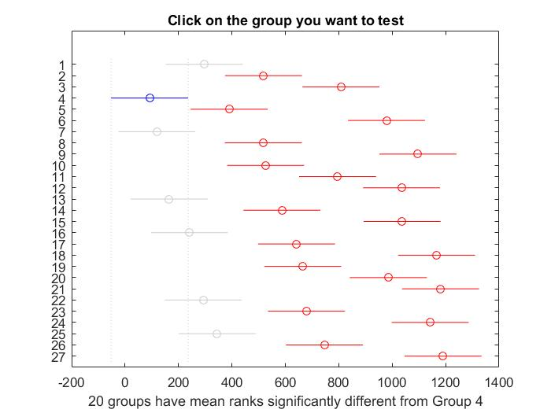

* Show average performance (from 50 independent runs) of your best algorithms on **all**

**instances** (If you have a lot of variations, state the parameter you use) e.g. Genetic Algorithm (Population: x, Crossover: x.xx%, Mutation: x.xx%, Local Search: Gradient, etc.)

Average performance for the algorithms was run on the following setup:

MakeSpans collected for 50 iterations - 100000 steps each, pc=1.0, pm=(5/512) , popsize=512.

The results are as follows:

|  |  |
| --- | --- |
| Instance | Average |
| u_c_hihi_512_16 | 15,966,430 |
| u_c_hilo_512_16 | 204,159 |
| u_c_lohi_512_16 | 529,462 |
| u_c_lolo_512_16 | 6,908 |
| u_i_hihi_512_16 | 16,662,829 |
| u_i_hilo_512_16 | 210,435 |
| u_i_lohi_512_16 | 540,188 |
| u_i_lolo_512_16 | 7,043 |
| u_s_hihi_512_16 | 15,757,344 |
| u_s_hilo_512_16 | 203,290 |
| u_s_lohi_512_16 | 481,462 |
| u_s_lolo_512_16 | 7,374 |

The table with data from all the 50 runs is in the annex \Project_GA\Data\Average_for_50_runs_all_instances\average_for_50_runs_all_instances_Excel.xlsx

• Show the lower bound of your algorithm on **all instances** and present it in a similar

fashion to the file “LowerBound_BestValue_Instances”

|  |  |  |  |  |  |
| --- | --- | --- | --- | --- | --- |
| **Instance** | **LB** | **Our Best** | **%** | **mean %** | **Comments: 1000000000 steps, pc/pm/popsize** |
| u_c_hihi_512_16.txt | 7346524 | 8478411 | 15.41% | 11.61% | pc=1.0, pm=5/512, popsize=512 |
| u_c_hilo_512_16.txt | 152700 | 167048 | 9.40% | pc=1.0, pm=5/512, popsize=2048 |
| u_c_lohi_512_16.txt | 238138 | 270916 | 13.76% | pc=1.0, pm=5/512, popsize=2048 |
| u_c_lolo_512_16.txt | 5132 | 5536 | 7.87% | pc=1.0, pm=5/512, popsize=1024 |
| u_i_hihi_512_16.txt | 2909326 | 3505029 | 20.48% | 24.07% | pc=1.0, pm=5/512, popsize=2048 |
| u_i_hilo_512_16.txt | 73057 | 90416 | 23.76% | pc=1.0, pm=5/512, popsize=2048 |
| u_i_lohi_512_16.txt | 101063 | 135997 | 34.57% | pc=1.0, pm=5/512, popsize=1024 |
| u_i_lolo_512_16.txt | 2529 | 2971 | 17.48% | pc=1.0, pm=5/512, popsize=1024 |
| u_s_hihi_512_16.txt | 4063563 | 5009057 | 23.27% | 20.11% | pc=1.0, pm=5/512, popsize=1024 |
| u_s_hilo_512_16.txt | 95419 | 110505 | 15.81% | pc=1.0, pm=5/512, popsize=1024 |
| u_s_lohi_512_16.txt | 120452 | 151330 | 25.64% | pc=1.0, pm=5/512, popsize=2048 |
| u_s_lolo_512_16.txt | 3414 | 3951 | 15.73% | pc=1.0, pm=5/512, popsize=2048 |

To obtain the lower bound we ran the corresponding algorithms for a very long time on medium-large population sizes (1024/2048) in order to better explore the search space especially in the last part of the process, when improvements are real slow.

The data, including the best chromosomes, was collected in the excel file: Project_GA\LBs.xlsx

Future Work

• Explain the future work if you were to have more time to improve the work and justify

your answer

If we were to have more time, we would like to:

- do a better research on the influence of population size on improving the search results when doing extended searches.

- study the effect of a crossover with two points cut

- implement and study the effect of a roulette versus the binary tournament