**Lo-Fi Prototype**

**Features:**

**Title: Monitor**

Description: The Monitor is an in-app dashboard that displays the patient’s location, heart rate, if the patient is awake, body temperature, and blood pressure. This information is provided through sensors built into the smartwatch worn by the patient. This feature will also alert the caregiver if there are any anomalies, for example, if the patient suddenly starts moving quickly, if they are trying to take the watch off, if their heart rate rapidly increases or if any of their vitals are abnormal. The mobile app can also remotely tune into a microphone built into the smartwatch to listen to the patient’s surrounding sounds. This feature allows caregivers to continue to monitor their patients even if they are away from each other. Caregivers can also communicate to their patients through a speaker built into smartwatch, but they are encouraged to remember that this may startle their patients. This feature can be disabled if the caregiver believes the feature would not be used.

Sketch:

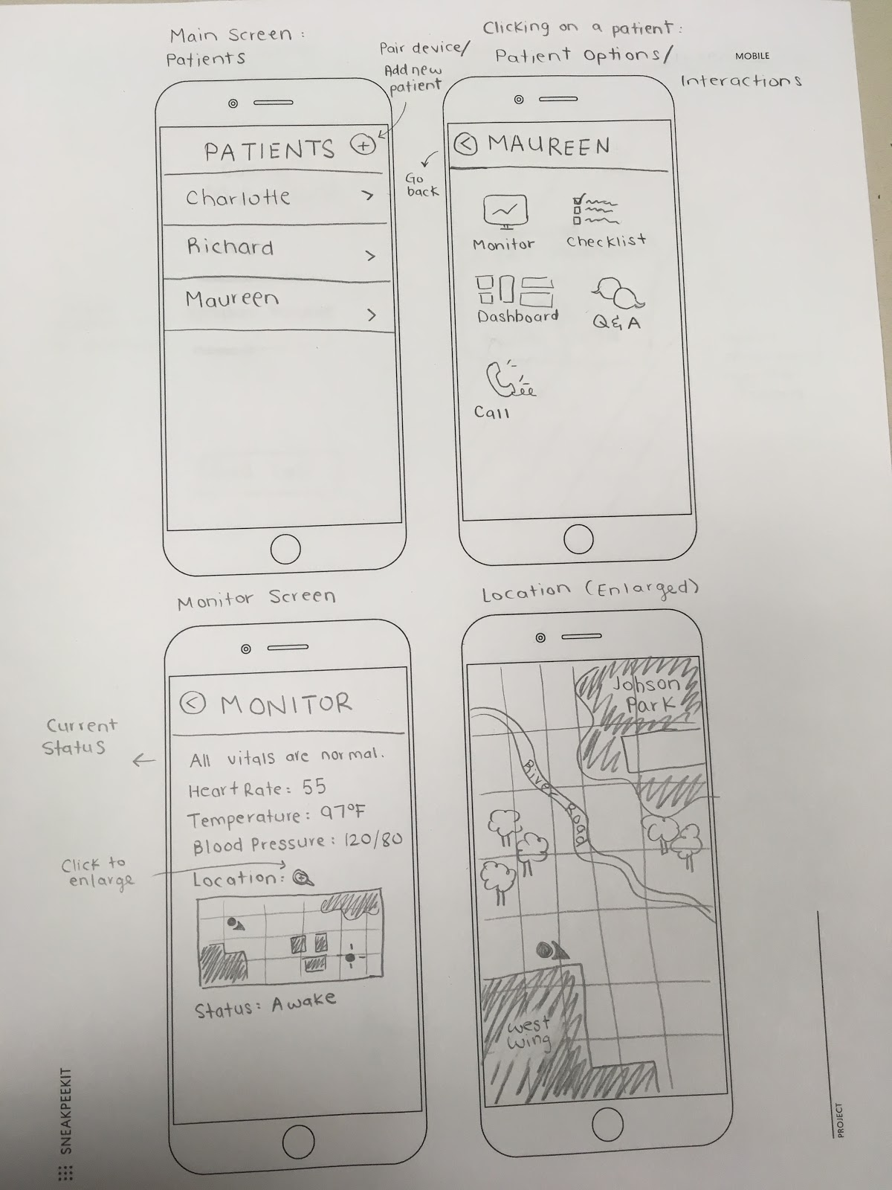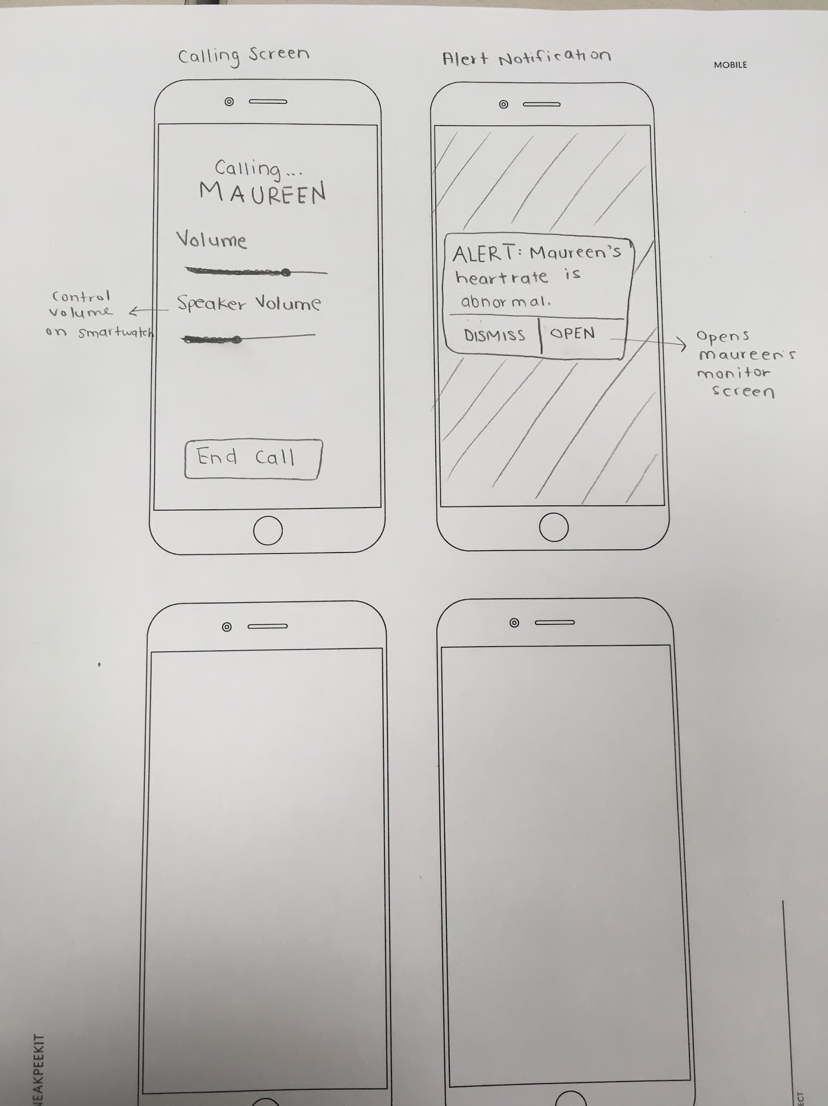

**Title: Daily Dashboard**

Description: This is a feature on the smart watch that will inform the patient of their personal information. The main objective of this feature is to be as simple as possible and intentionally constrain the patient’s ability to change this on the display. As we learned this week, constraints are important to help users understand how something works. Therefore, we only want to show the important information that the patient needs to understand what is going on. The home display will be the time, date, their name, and name of their caregiver with a small picture that they can click on to make bigger. The caregiver module will also have a “call” button that will call the caregiver if the patient needs them. There is also a “help” button at the end which will give more information about the app to the patient. The notification pop-ups will be for things like when to take a pill, when to eat, when to take a shower, and other things in their daily routine. For example, if  someone is visiting them, the appointment will pop-up on their watch and have a picture of the person, their relation to the patient, and time of the visit. We understand that each patient is different so the home page will be customizable.Each module or widget can be changed or removed depending on what the patient needs. This customization will be done on the caregiver side of the app.

Sketch:

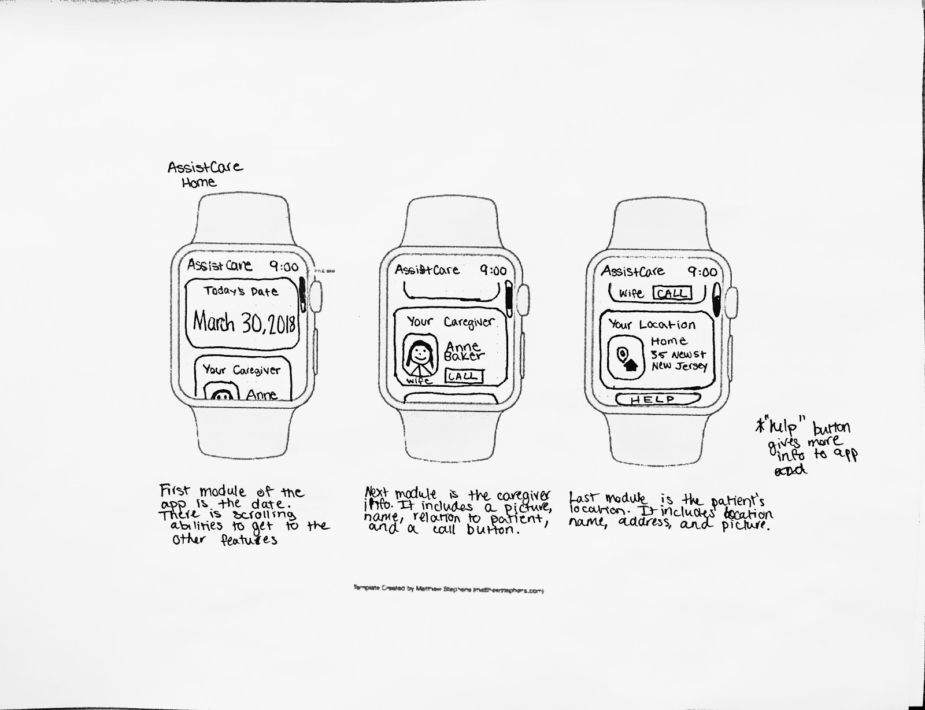

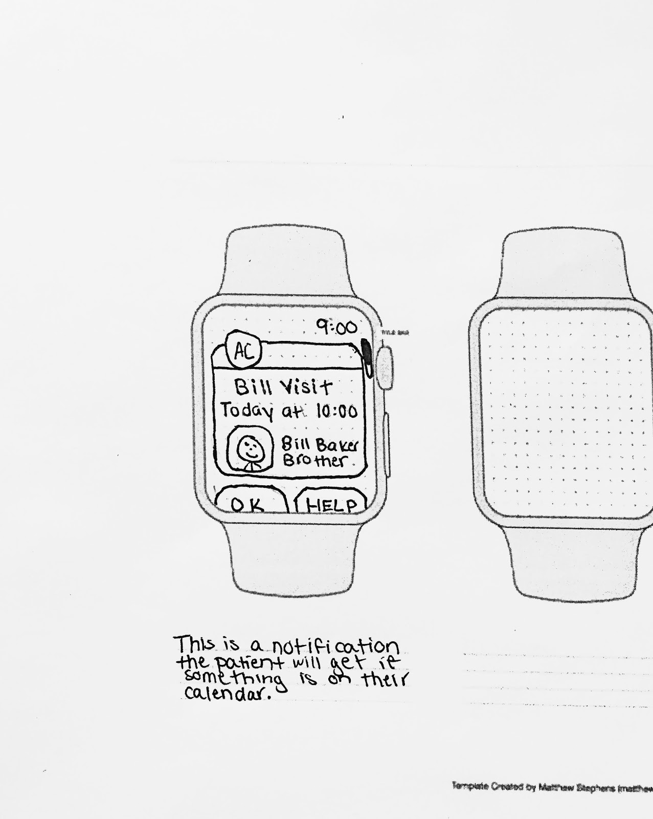

**Title: Q&A Board**

Description: The Q&A board is a community in which caregivers can post and answer questions from other caregivers. It is located inside of the mobile application. Caregivers can register an account on the board with a valid email address. After logging into the board, caregivers will be able to see the top rated questions of the day. Older posts will be displayed in pages further back, which users can also navigate through. Users can filter through posts by date, number of votes or keyword. Aside from questions, caregivers can also create discussion topics that other users can reply to. Moderators will be chosen by the community to monitor the board for inappropriate or irrelevant questions. There is also a “report” button next to every question, which allows users the ability to report any questions they deem inappropriate as well. Every question also has a “save” button, which allows users to keep track of their favorite questions. Furthermore, users will be able to create accounts and include a personal biography and their past experiences. They will also be able to add other users as friends through a button located on the user profile. The Q&A board is ultimately meant to help create a better sense of community among caregivers. It will also help assist and relieve the stress of caring for a patient by connecting caregivers to one another.

Sketch:

