**Interview Data Analysis/Affinity Diagram**

We observed that choice plays a large role in caregiver stress, health, and sense of satisfaction. When caregivers are thrown into a situation where they have to become a caregiver without being given a choice, they often feel underprepared. Caregivers also cite a lack of resources, training, and support and often feel frustrated when interacting with their patients. Being older, most caregivers and patients do not identify themselves as “tech savvy”, but are willing to learn if it will help them with caregiving. Areas that they need help in include time management (reminders for taking medicine, meals, or having more time for themselves), communicating with the patient, sharing patient information, and having a sense of community or more support. What surprised us the most, however, was the degree of negativity that some caregivers feel when they are forced into their positions. This completely alters the relationship between caregiver and patient. With busy schedules and sensitive healthcare information, we expected caregivers to be less willing to open up to us, but it was revealed during their interviews that they feel very alone and greatly appreciate having someone who is willing to listen to them. A sense of community and support is a high priority for our considerations in hoping to design a useful tool for the caregivers.

**Raw Data:**

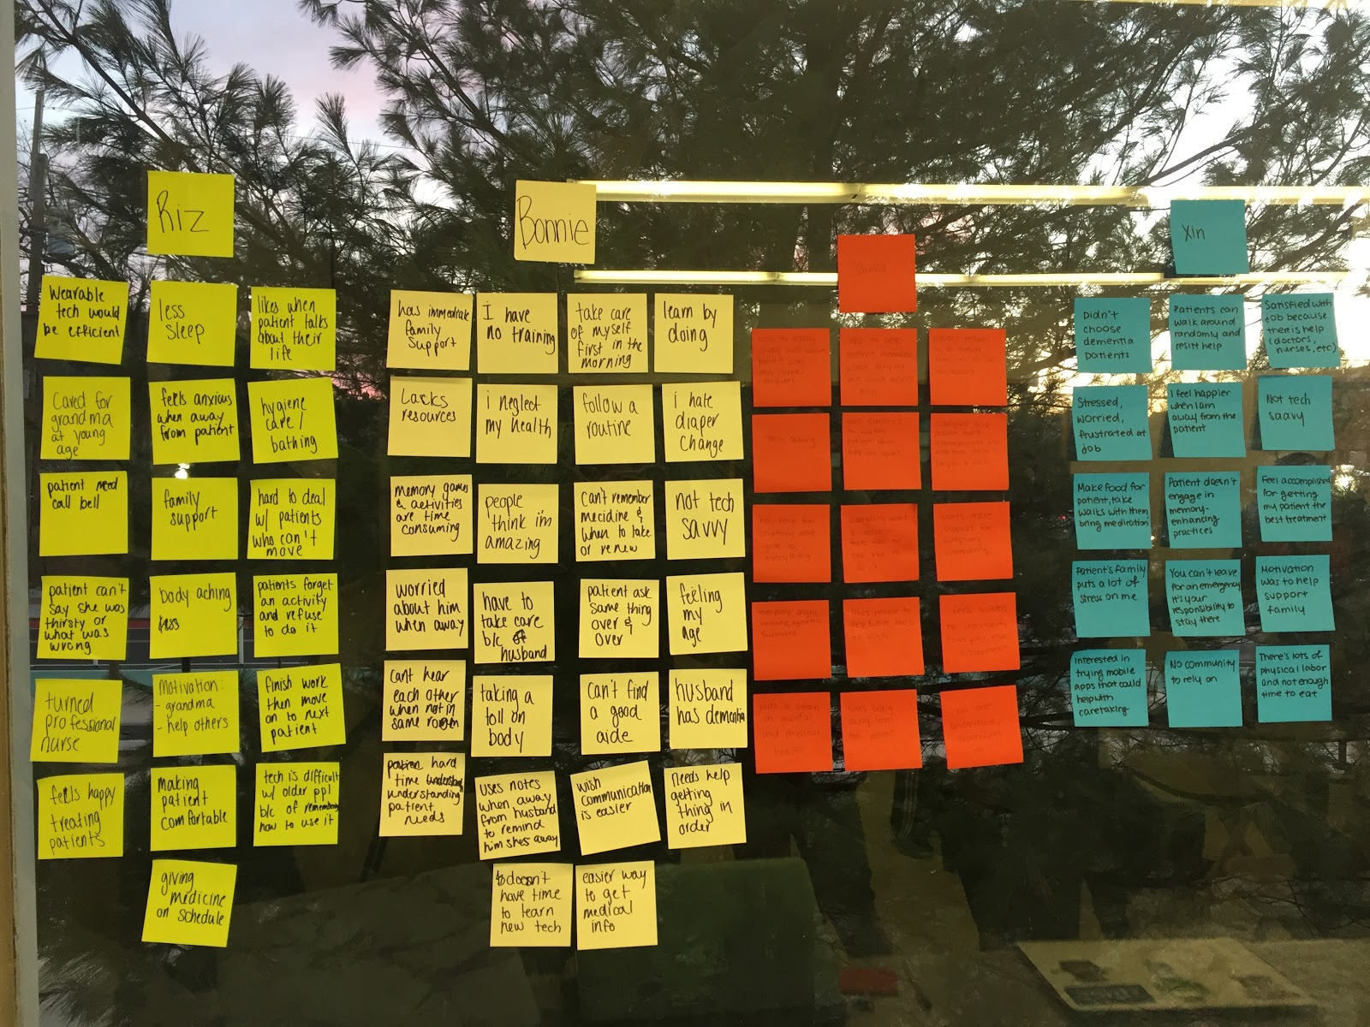

**Synthesis:**