**Survey Analysis**

1. *Visualizations*

Gender Breakdown of Participants

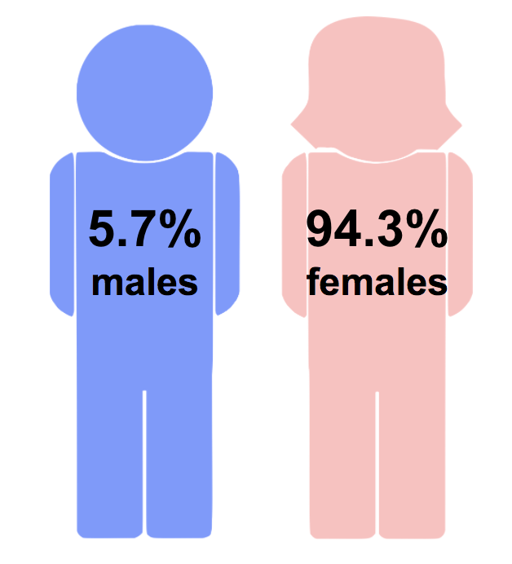

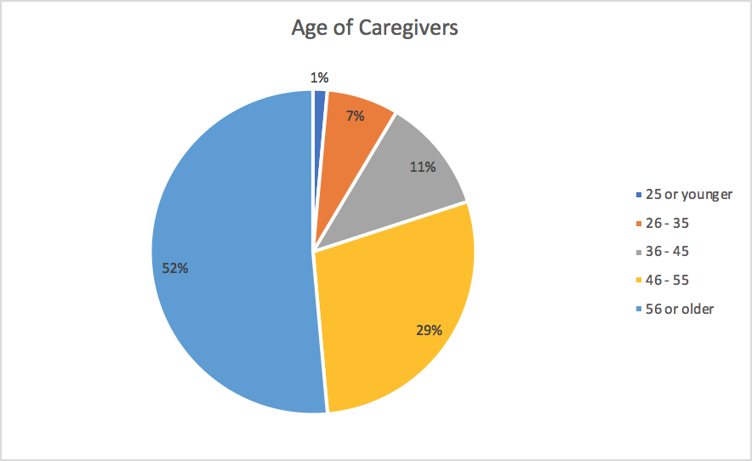

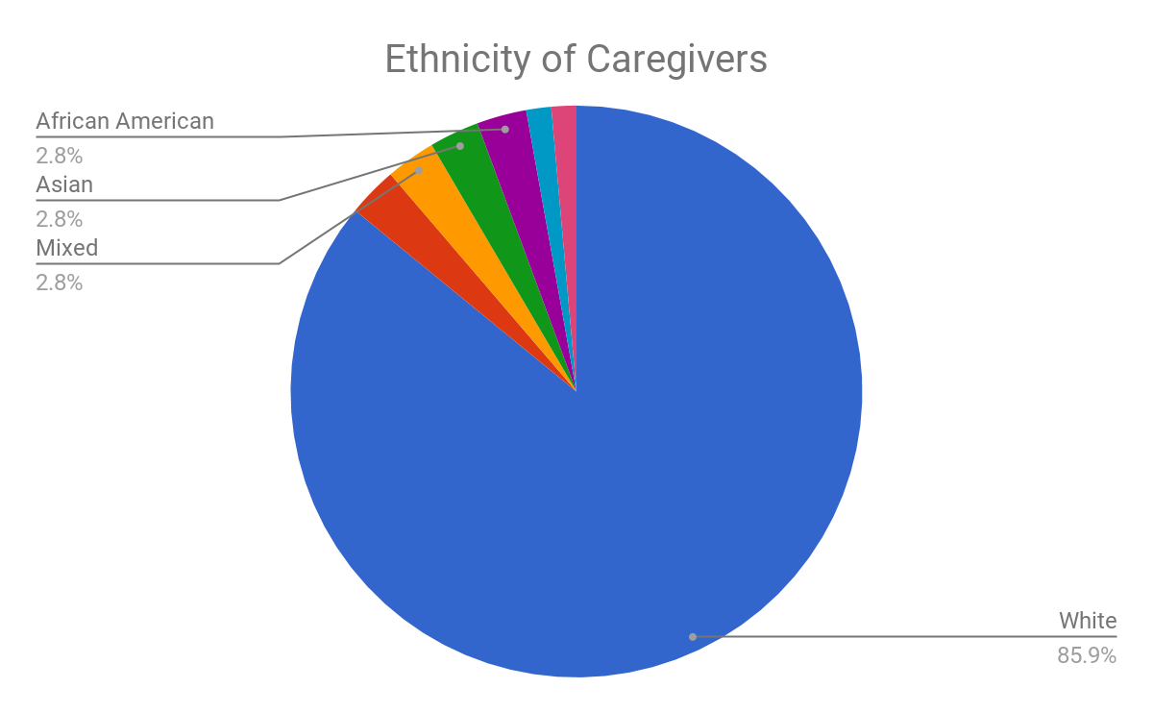

**Professionals vs Non-Professionals**

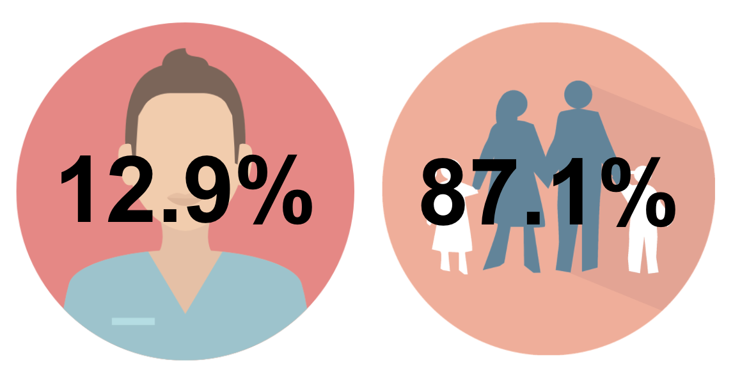

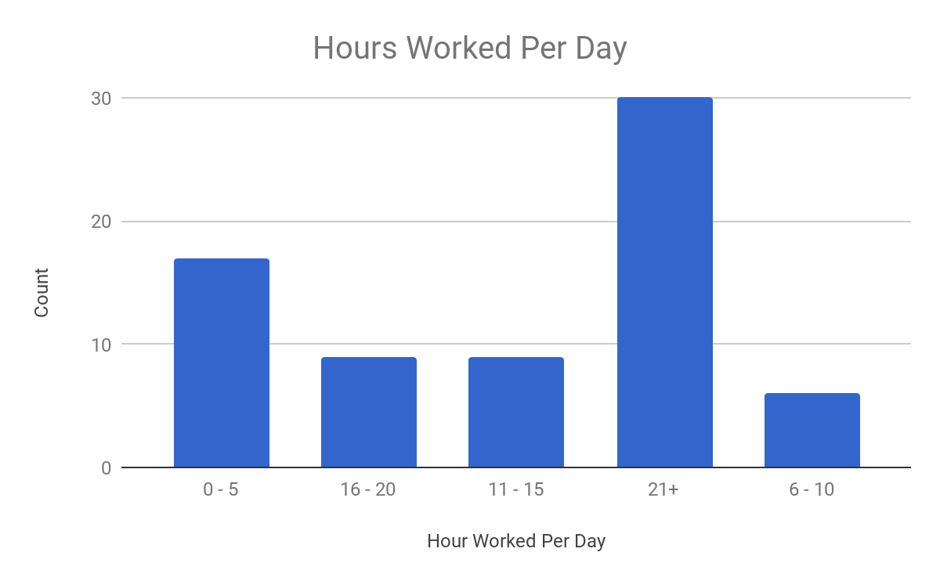

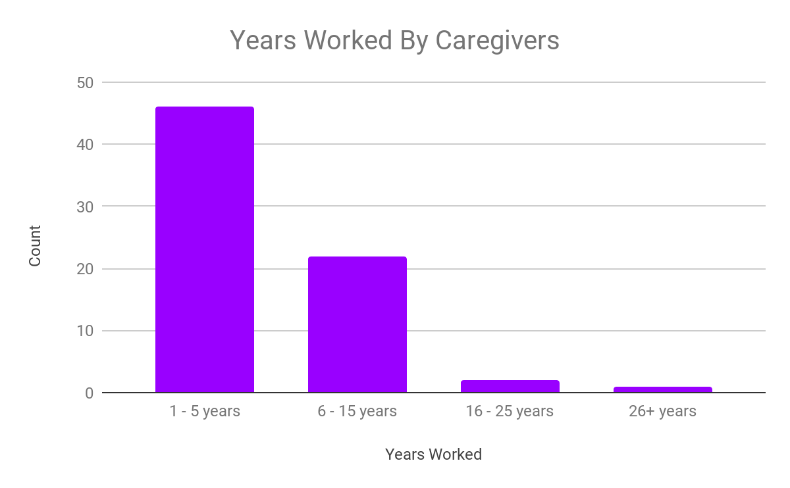

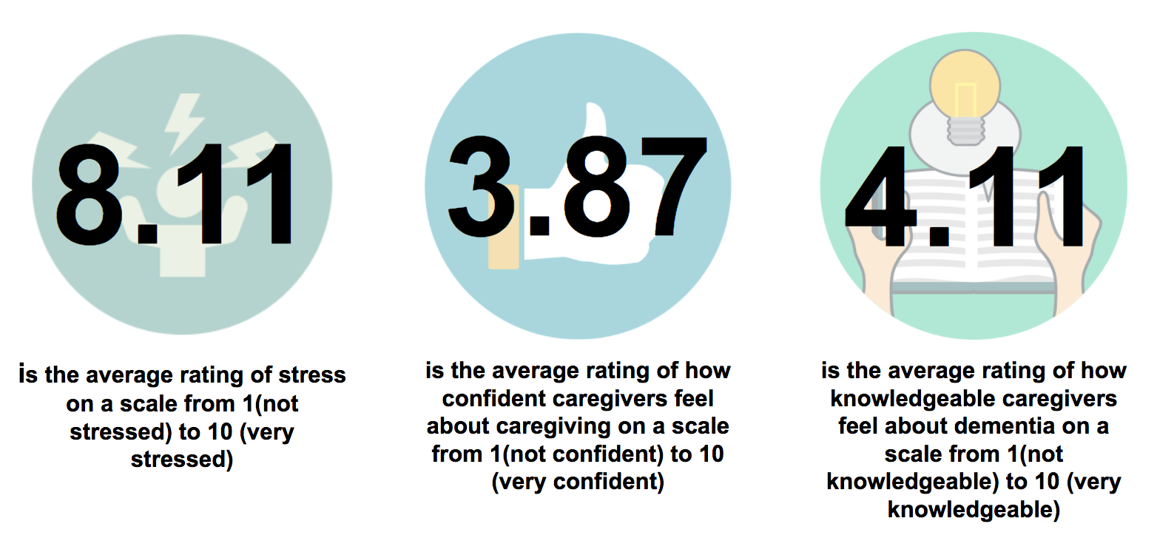

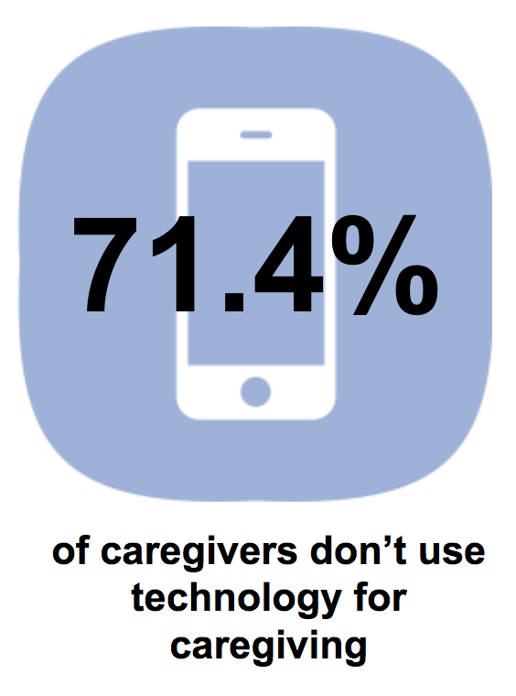

1. *Demographic Data using Descriptive Statistics*

**Gender (Count)**

Males: 4

Females: 66

**Ethnicity (Count)**

White: 62

African American: 2

Asian: 2

Hispanic: 2

Mixed:  2

**Relationship to Patient (Count)**

Spouse: 25

Child: 28

Professional Caregiver: 3

Other: Family : 12

Other: Non Family : 1

**Distance Away From Patient in Miles (Count)**

Live with Patient: 33

1 - 20 miles: 33

21 - 40 miles: 4

**How Often Caregiver Provides Care to Patient (Count)**

Daily: 62

Weekly: 7

Monthly: 1

**Number of Patients (Count)**

1 Patient: 62

2 - 3 Patients: 6

4 - 5 Patients: 1

6+ Patients: 1

**Caregiver’s Knowledge about Patient’s Condition (Scale of 1 - Not knowledgeable to 5 - Very Knowledgeable)**

Mean: 4.1

Mode: 5

Median: 4

Variance: 0.91

Standard Deviation: 0.96

**Caregiver’s Confidence in Taking Care of Patient (Scale of 1 - Not Confident to 5 - Confident)**

Mean: 3.9

Mode: 4

Median: 4

Variance: 0.87

Standard Deviation: 0.93

**Caregiver’s Average Stress Level (Scale of 1 - Not Stressed to 10 - Most Stressed)**

Mean: 7.9

Mode: 10

Median: 8

Variance: 3.7

Standard Deviation: 1.9

**Currently Using Smartphone Applications to Help with Caregiving (Percentage)**

Yes: 28.6%

No: 71.4%

**Survey Analysis**

We noticed that the majority of caregivers were either the spouses or children of patients, which could indicate why many caregivers felt that they were not given a choice to go into caregiving. This could also correlate with the statistic that most caregivers only took care of 1 patient and the statistic that most caregivers live with their patient. If they are family, they are likely close by. Currently, only about 28.6% of caregivers actually use smartphone applications while caregiving, so the use of helpful caregiving mobile applications is not widespread. Caregivers generally reported a high degree of knowledge about their patient’s condition, with an average of 4.1 on a scale of 1 (no knowledge) to 5 (very knowledgeable). Caregivers also reported a similar average in regards to having a sense of confidence in taking care of their patients. This shows that many caregivers don’t feel that they’re lacking a large amount of personal information about their patient’s condition or the best way to take care of them but could be improved by allowing caregivers to have access to a larger knowledge base of how to take better care of their patients and more information on their conditions. What was really surprising was that caregivers reported an average stress level of 7.9 on a scale from 1 to 10, where 1 indicated no stress at all and 10 indicated very stressed. This indicates that most caregivers are extremely stressed at their jobs, and this could correlate with why many tend to have negative feelings towards their work.