**Goal:**

To facilitate the interactions between caregivers and dementia patients, AssistCare is a mobile app for caregivers with a smartwatch app companion for patients that will assist caregivers with organizing daily activities and monitoring the patient, while patients get vital information of what's happening on their smart watch.

**Features:**

**Title: Monitor**

Description: The Monitor is an in-app dashboard that displays the patient’s location, heart rate, if the patient is awake, and temperature. This information is provided through sensors on smartwatch worn by the patient. This feature will also alert the caregiver if there are any anomalies, for example, if the patient suddenly starts moving quickly or if they are try to take the watch off. This feature allows caregivers to continue to monitor their patients even if they are away from each other.

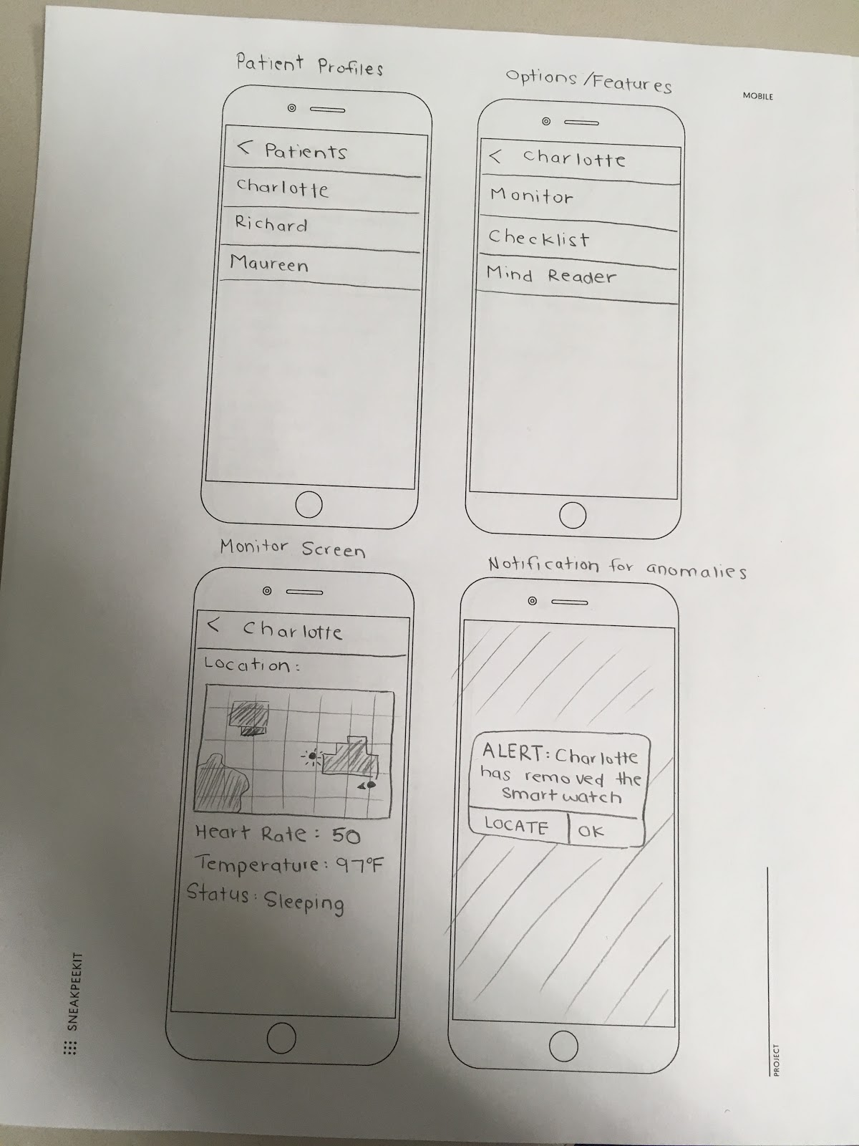

**Title: Checklist**

Description: Caregivers and patients often need help remembering if they had already taken their medication, had a meal, need to renew a prescription, etc. This is especially challenging if a caregiver is caring for multiple patients. With the Checklist feature, caregivers can set up a schedule of daily tasks and easily check them off when they are completed. If a task has a time assigned to it and hasn’t been checked off by the designated time, the app will notify the caregiver that a task is past due. Caregivers can also enter prescription fill date and amount and the app will remind the caregiver when their medication is running low.

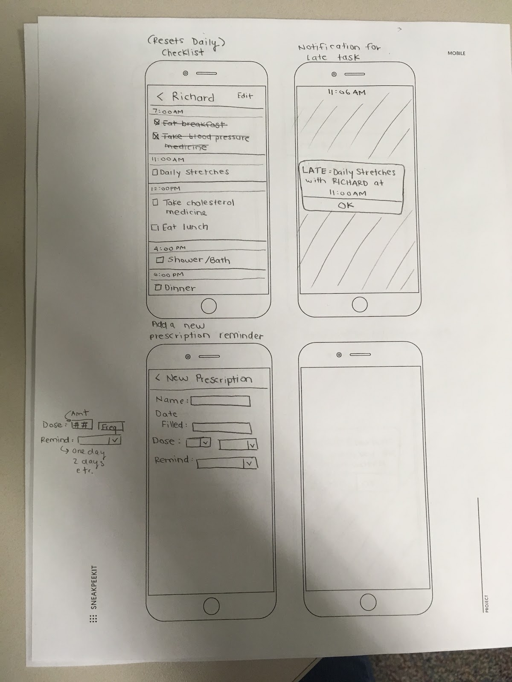

**Title: Refresher**

Description: The Refresher is a feature on the smart watch designed to help the patient remember what the app is for. If a patient has severe dementia, he or she may not be able to remember what the watch is for. For this reason, the Refresher feature will help remind the patient what the watch is for. When the watch is touched or picked up, it will pop up with a one-sentence summary explaining the app. After that, it will have a few follow-up questions to help the patient remember what is exactly going on.

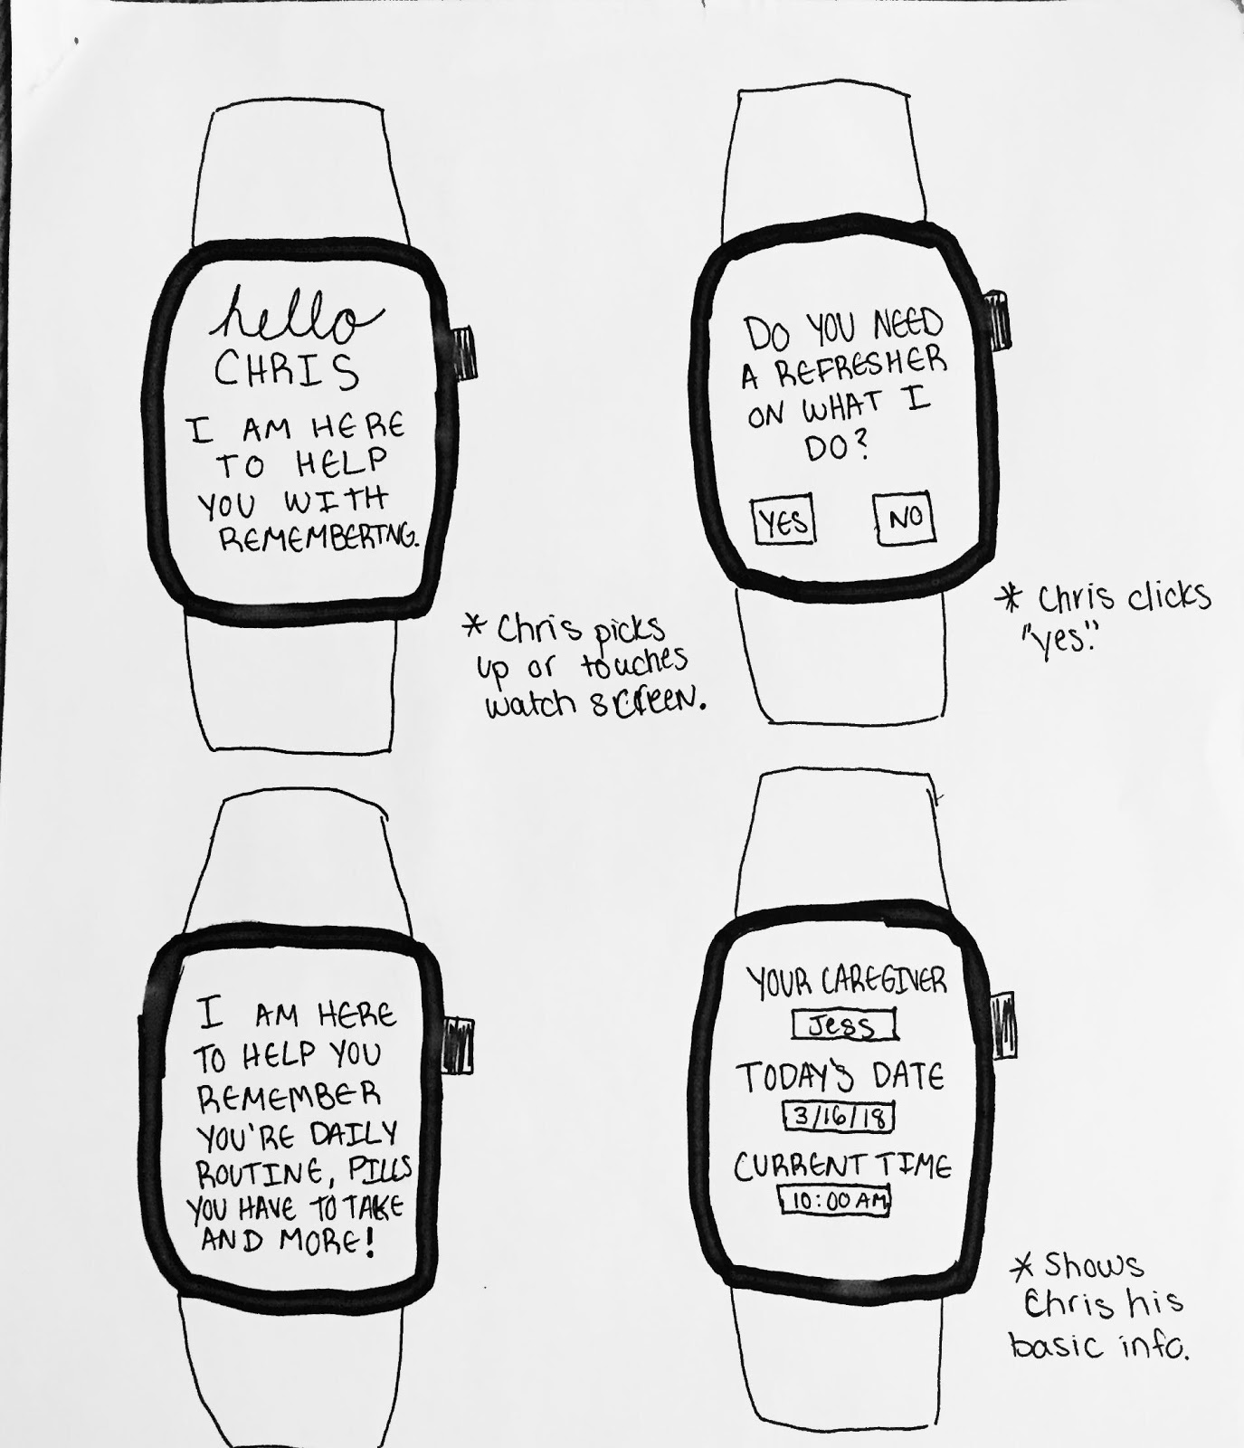

Title: Daily Dashboard

Description: The Daily Dashboard is a feature on the smart watch that will inform the patient of their personal information and routine. Since dementia can cause you to forget things like time, date, people, and, in general, that the daily routine is, this feature will have a simple display that has notification pop-ups. The home display will be the time, date, their name, and name of their caregiver with a small picture that they can click on to make bigger. The notification pop-ups will be for things like when to take a pill, when to eat, when to take a shower, and other things in their daily routine. If someone is visiting them, the appointment will pop-up on their watch and have a picture, name, and reason for visiting.

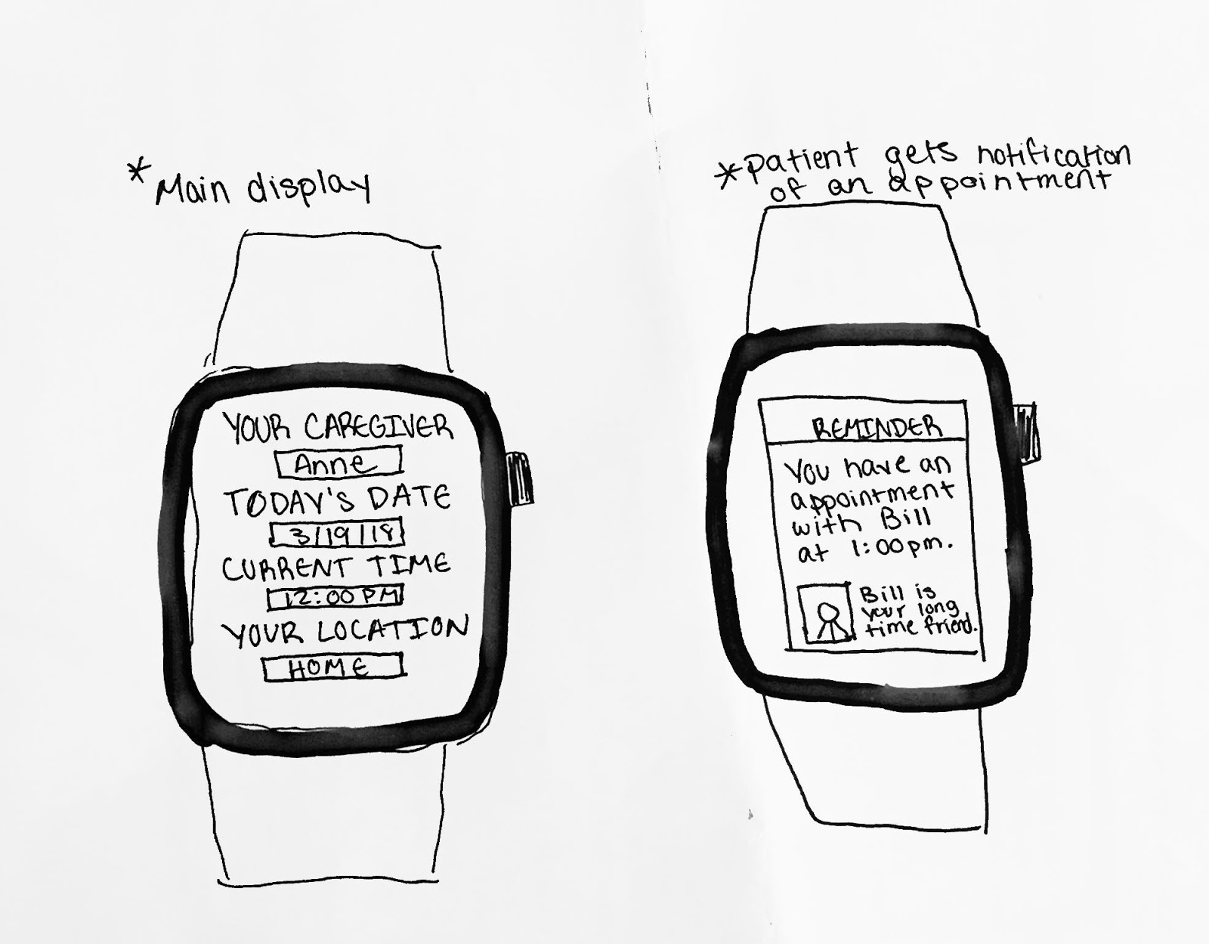

**Title: Q&A Board**

Description: The Q&A board is a community in which caregivers can post and answer questions from other caregivers. They can also create discussion topics that other users can reply to. Moderators will be chosen by the community to monitor the board for inappropriate or irrelevant questions. This is an optional feature that is a part of the mobile app, and caregivers can sign up for an account with their emails. This is meant to help create a better sense of community among caregivers. It will also help assist and relieve the stress of caring for a patient by connecting caregivers to one another.

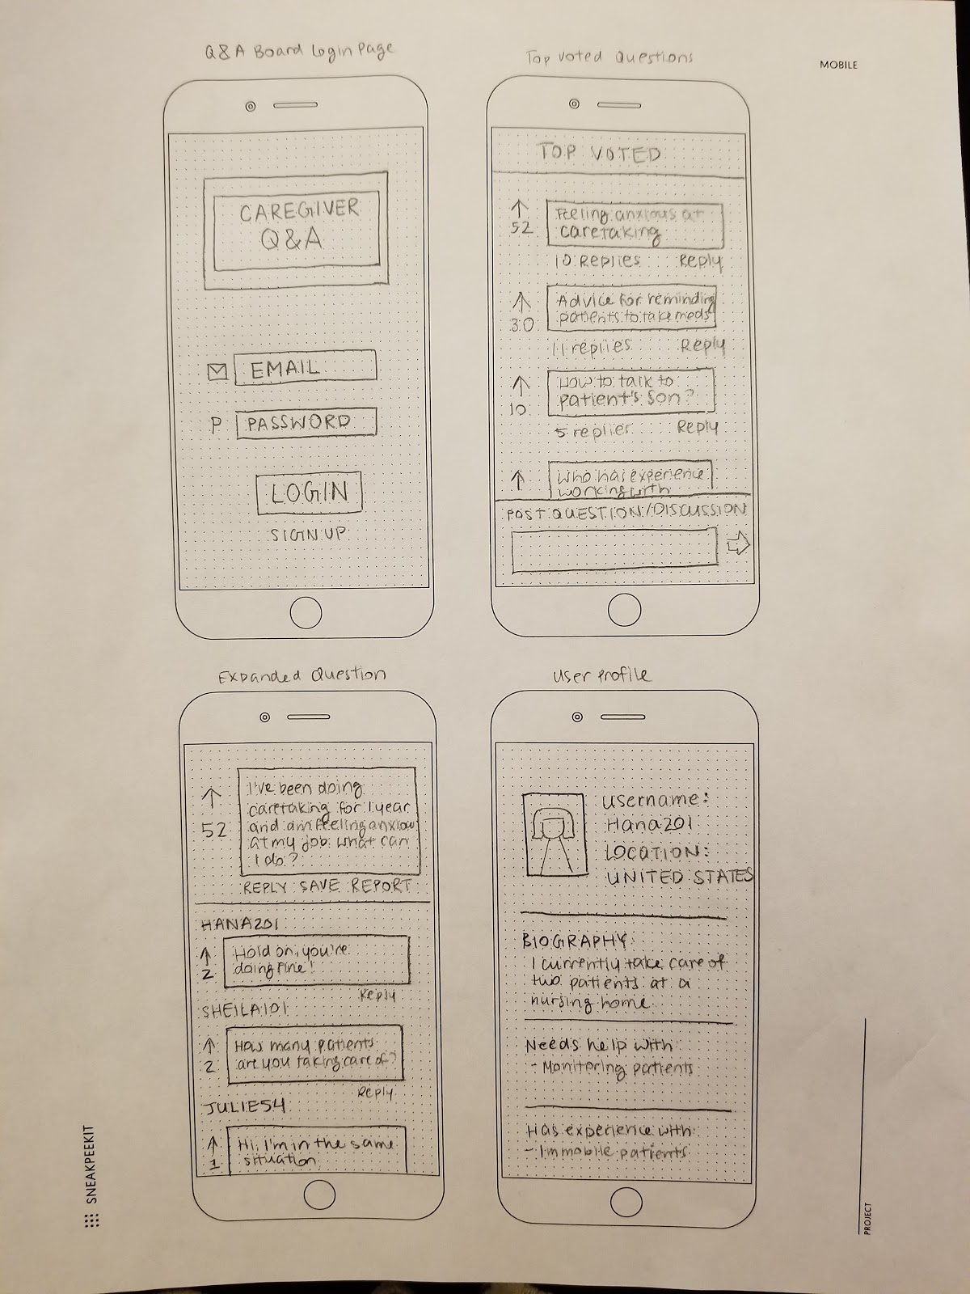

**Title: Emergency Contacts**

Description: The emergency contacts feature of the app allows caretakers to enter the contact information of family members, doctors, or other emergency contacts of their patients. This feature is meant to consolidate all emergency contact information into one place, so caretakers can quickly retrieve contact information in case of a true emergency. If the caretaker is ever incapacitated, this feature also allows other individuals to retrieve the contact information for the patient. This is meant to assist caregivers with keeping their patients safe.

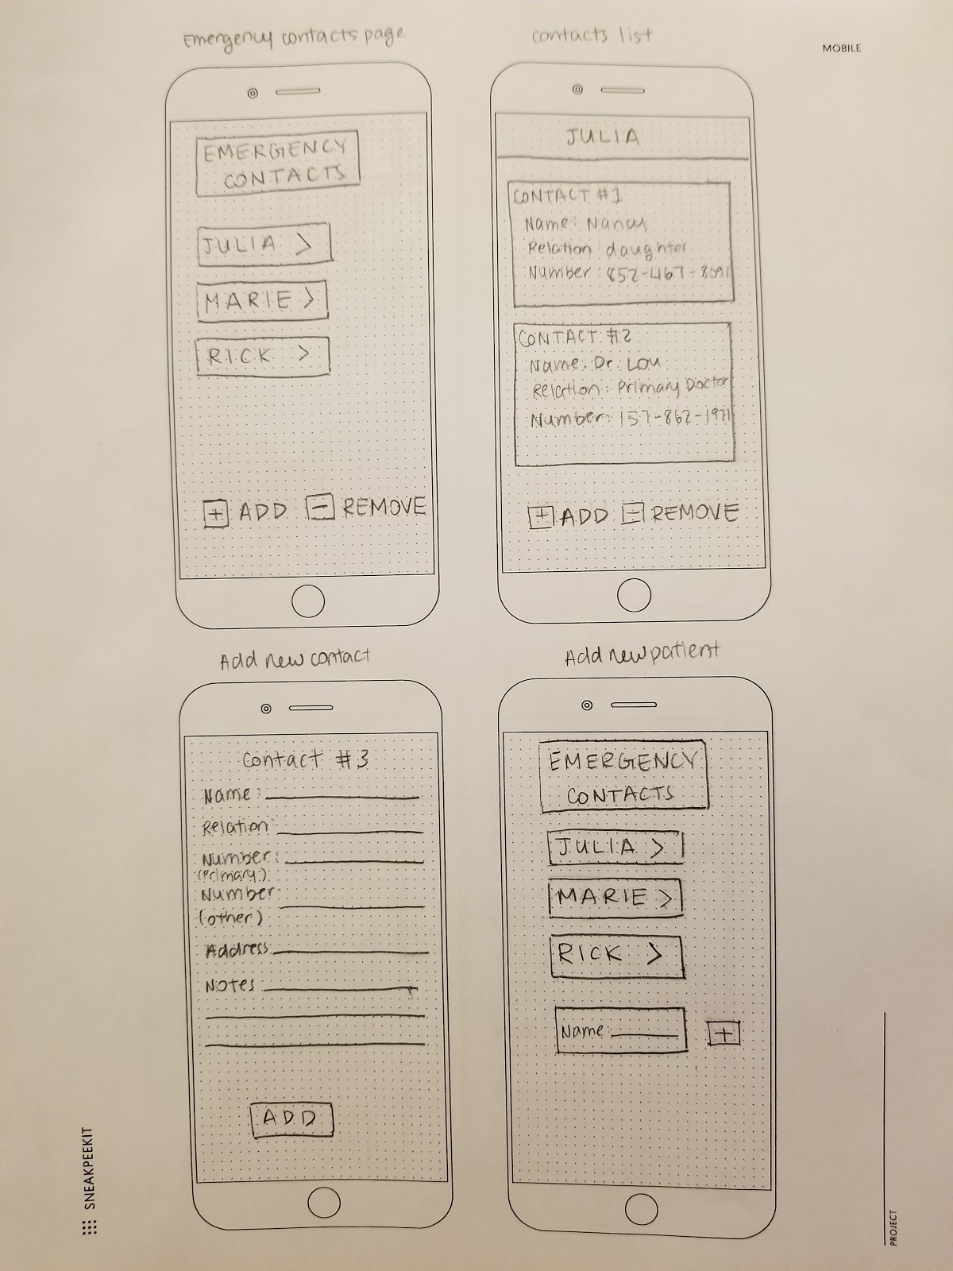

**Title: Mind Reading**

Description: Sometimes, it’s difficult for caretakers to know exactly what patients with severe dementia require. Oftentimes, these patients have limited ability to communicate, so the mind reading feature of our app was designed in response to this need. Mind reading is a feature that can be turned on in the mobile application that will sync up with a patient’s smartwatch. When it syncs, the smartwatch will read the patient’s mind, and the caretaker will receive a message indicating what the patient really needs. If the patient has several needs, these needs will be prioritized in order of how much impact they have on the patient’s health if they aren’t met, so life affecting needs (can’t breathe, can’t see, etc.) will rank higher than other needs (wants to go for walk, wants to watch tv etc.). This will assist caregivers in better understanding the needs of their patients and assist them with handling everyday activities.

