**Personas:**

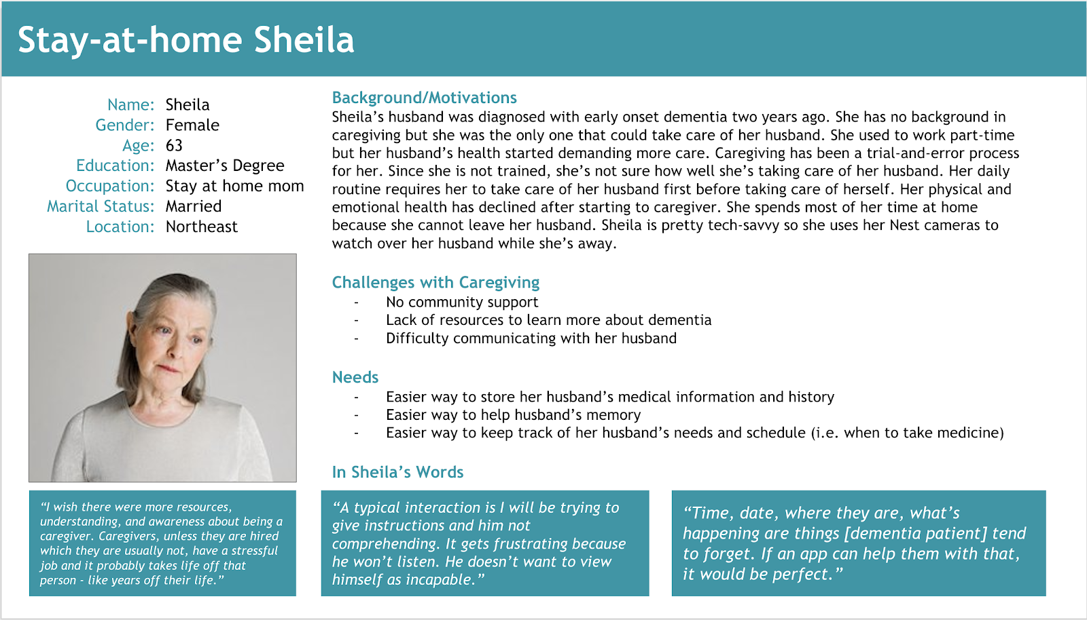

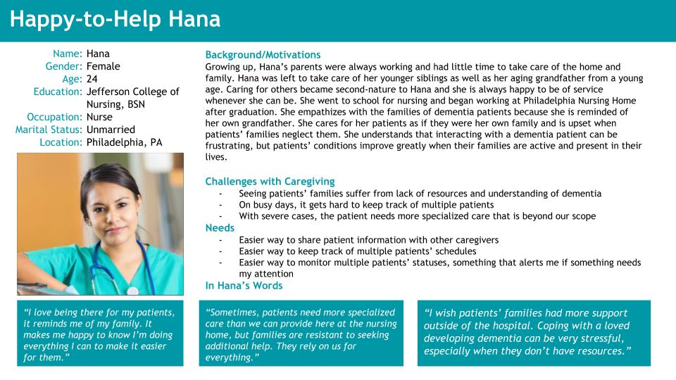

**Storyboards:**

**Hana**

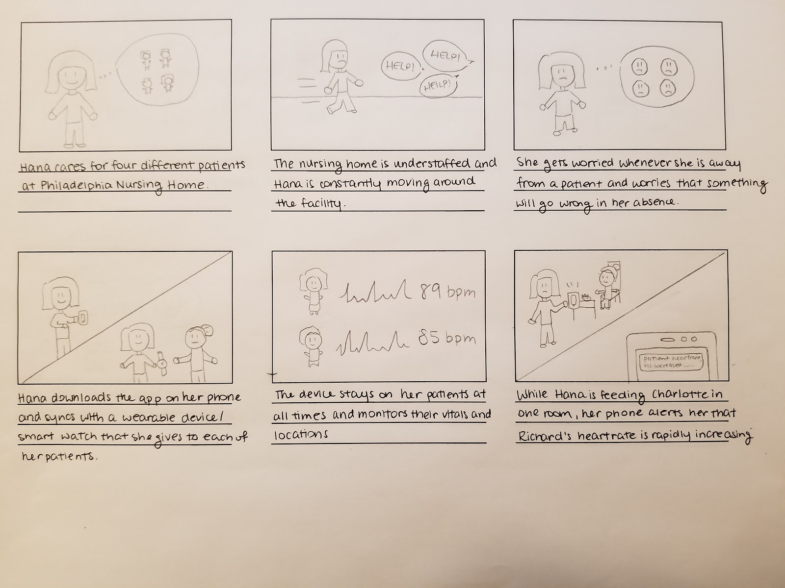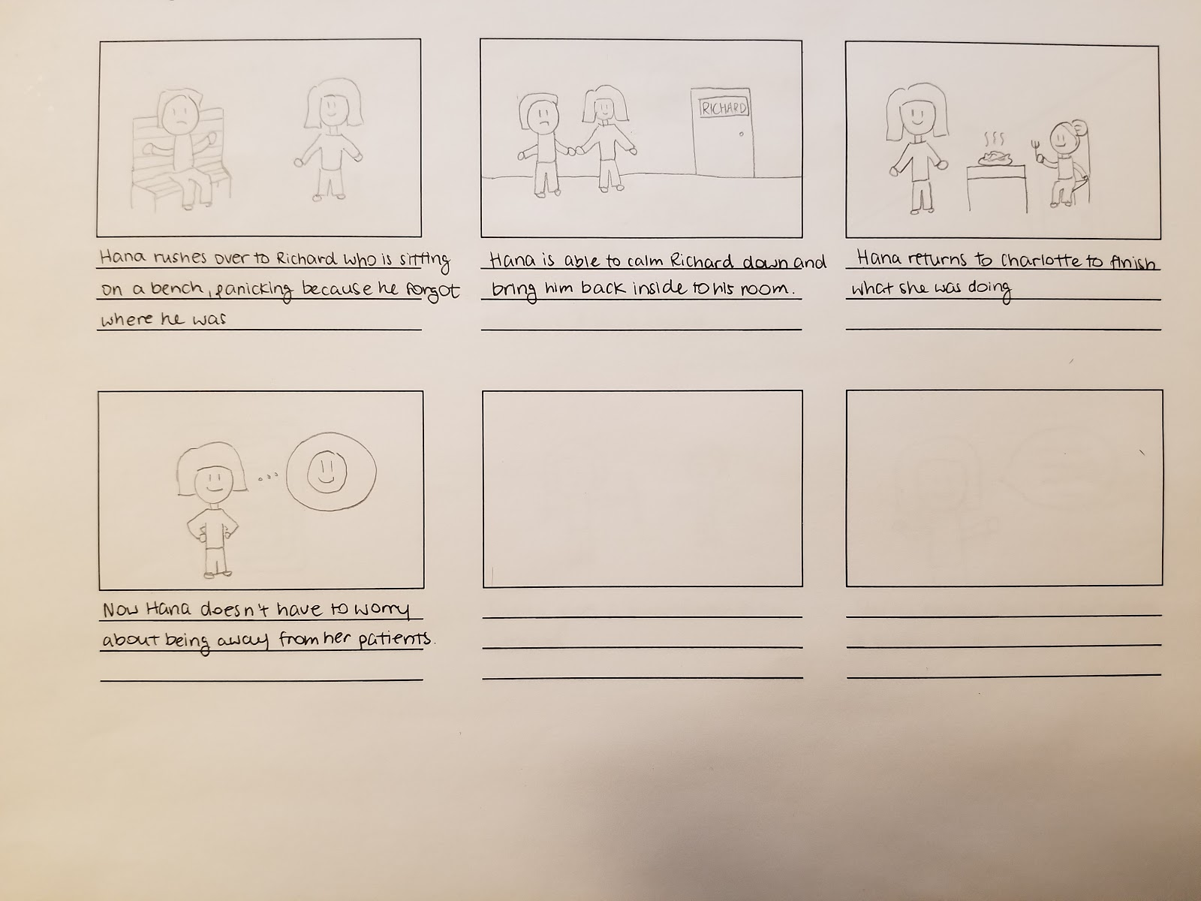**Sheila**

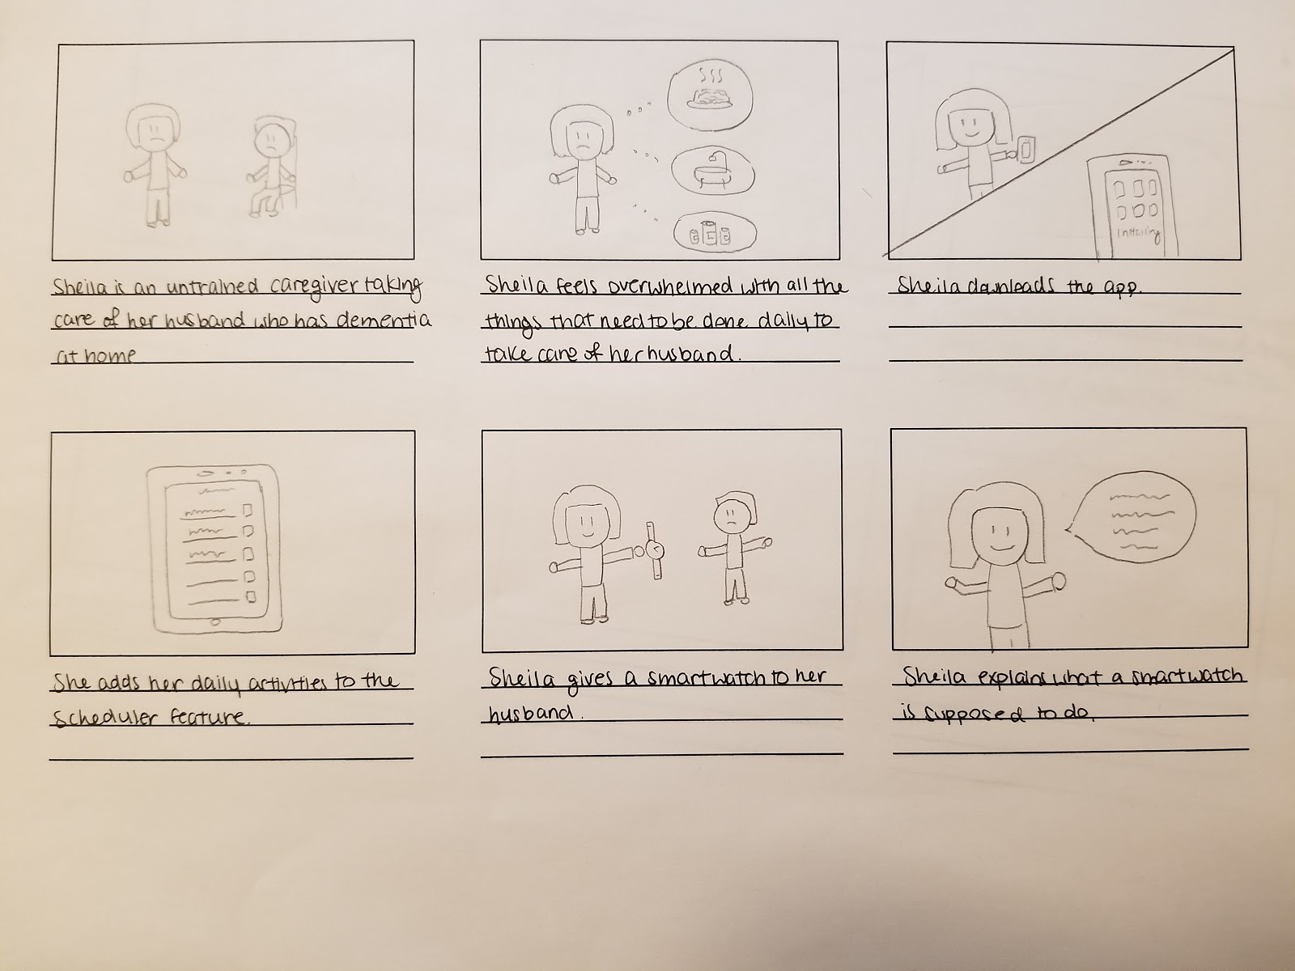

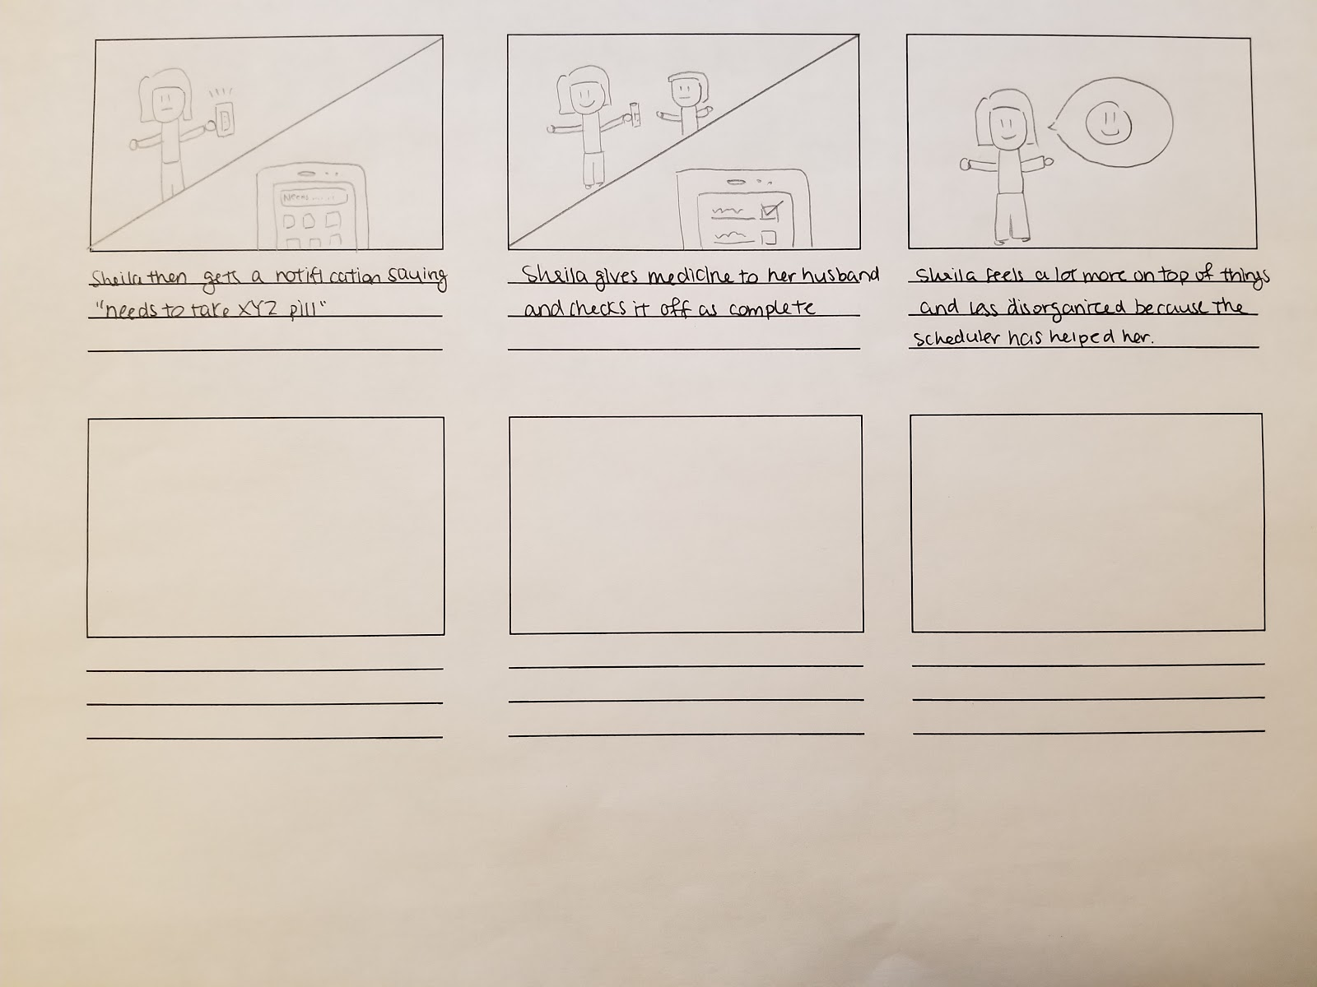

**Revised Problem Statement:**

Caregiving for a dementia patient is a huge challenge for those who are dealing with the changes in behavior and lifestyle of patients. It is estimated that there are currently over 5 million people in the United States living with dementia, and 35% of caregivers have reported that their health has gotten worse as a result of caring for elderly dementia patients. Most often, caregivers can be frustrated and overwhelmed by the care required by their patients. There remains a lack of resources for caregivers to go to in order to learn more about their patients and the best tools and resources to help them. Many caregivers also lack the proper tools to monitor their patients, such as the performance of daily tasks like taking medication or eating meals on time. In order to provide patients with the best care possible, caregivers need access to a resource that they can consult with at any time that will help them with their everyday tasks while relieving them of stress and providing them with a sense of community.

Our solution is to create a mobile application that will address many of the issues faced by caregivers, such as stress and proper monitoring of patients. The mobile application will offer information about dementia care as well as tools for watching over and monitoring a patient’s schedule. There will also be a community on the app that caregivers can turn to at any time for advice. Phones provide caregivers with the best access because they are small and portable and perfect for those who are engaged with day-to-day care. We will also introduce a smartwatch interface for dementia patients, so they won’t be likely to lose this piece of technology and caregivers can still utilize the watch to monitor their patients. Dementia patients will also have an easier time viewing this information this way if they choose to interact with the watch. This watch will help the caregiver’s job by assisting their patient in daily tasks like remember the time, date, scheduled events, important notes, and people. By increasing the availability of resources to caregivers and empowering dementia patients with some independence, we hope to facilitate the everyday hardships of caregiving for dementia patients.