**Exercise 2: Temperature and Plant Phenology**

**Question**

How do changes in climate influence plant phenology?

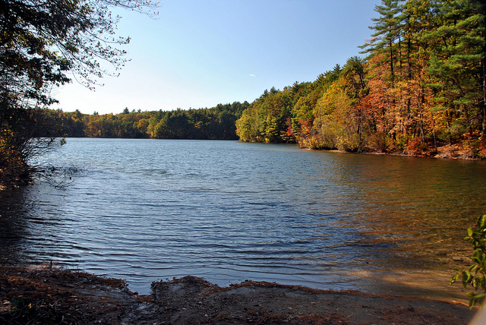**Background**

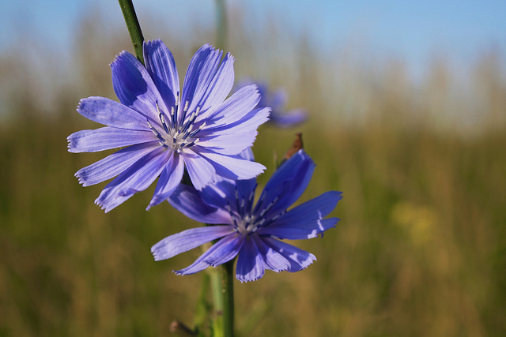In plants, the onset of developmental processes like germination and flowering is influenced by both day length and temperature. Changes in climate may lead to shifts in the seasonal timing of these processes, with substantial impacts for both natural and agricultural systems. “Phenology” refers both to the timing of these cyclic life history events and the science of studying them. In many areas of the world average temperatures have increased over 1.5°C since the late 19th century, suggesting that changes in plant phenology may be observable in the historic record.

We will be working with a dataset of climate records and the first flowering dates (FFD) of five species of plant found in Concord, Massachusetts (the site of Thoreau’s Walden Pond). The plant data were collected by two observers: Alfred Hosmer, a shopkeeper and amateur botanist who recorded FFD’s around Concord from 1893-1903; and a team from Boston University[1] who resurveyed the town roughly a century later in 2003-2006. Climate records were collected at the Blue Hill meteorological observatory in Milton, MA, which has recorded daily temperature and precipitation since 1852[2].

Top: Walden Pond. Bottom: Chicory (*Cichorium intybus*).

**Change in Temperature Over Time**

Go to the “climate” sheet. Calculate the average annual temperature for each year by taking the mean of all 12 months in a year (use the excel equation “=AVERAGE()”). Then plot the annual average temperatures as a function of time using straight-line scatter plot. Add a linear trend line (this is also known as a linear regression) and display the R2  and equation on the plot. As a reminder, The R2 is a statistical measure of how well a regression line approximates the data, ranging from 0 to 1 (with 1 being perfect fit). Include this plot with your answers. (see the next page for assistance with plotting in excel).

About how much has Concord’s average temperature increased since the 1890’s? (Hint: look at the trendline, not the raw data). Is this more or less than expected by the IPCC report?

If the current trend continues, what will the average annual temperature in Concord be in 2075?

**Excel Plotting Tips**

**Making a scatter plot:**

First, create scatter plot of *Cichorium intybus* FFD as a function of January temperatures. Hold control (or command if on a mac) and select all the cells for January temperatures and *Cichorium intybus* FFD, leaving out the top row. Now create a scatter plot by selecting charts > marked scatter from the top menu.

**Adding trend lines:**

There are two ways to add a trend line. You can right-click on the data points in the graph (not just in the graph area, but on the actual points) and select “Add Trendline”; or you can select the chart, go to “Chart Layout” in the top menu and select “Trendline > linear trendline”. To add the equation and R2, either go to “Trendline options” on the top menu or right click on the trend line and select “Format Trendline”. Click the boxes to display equation and display R2.

**Changing data sources:**

Instead of making a new chart for every month (or every species), we can keep all of our settings and change the data source to speed things up. Right click on the chart area and click “Select Data”. Go to the box for “Y Values” and select the text. You should see a dotted line around the values for *Cichorium intybus* FFD, indicating that those are the values on the Y axis of our plot. Erase the text in the “Y Values” box, and select the values for a different species. Click “OK”. The chart will update itself to reflect the new data selection (but note that the title will not change). You can now just change the title and copy/paste the chart over to a word doc for later use, instead of remaking the whole chart every time.

**Temperature and First Flowering Date**

Go to the “phenology” sheet. For chicory (*Cichorium intybus*), create separate scatter plots of FFD and average temperatures in September, January, May, and July. Add a linear trend line and include its R2 and equation on the plots. Include these plots (one for each month) with your responses.

Which month shows the strongest correlation between average temperatures and FFD, in terms of R2? Which have the largest (or most negative) slope?

Propose a hypothesis for why this is the case. What aspects of plant physiology might be impacted by temperatures at different times of year?

**Interspecific Comparisons and Ecological Impacts**

For each species, create a scatter plot of FFD as a function of average temperatures in January. Add a linear trend line and include its R2 and equation on the plots. Include these plots (one for each species) with your responses.

How many species show negative correlations between temperature and FFD (ie FFD decreases as temperature increases) ?

Which species shows the most negative relationship between FFD and temperature? The most positive?

Propose a hypothesis for why some species show higher or lower slopes in regressions of FFD and temperature.

**Synthesis and Study Design**

Consider the Miller-Rushing & Primack 2008 paper assigned for discussion (this is a subset of the data used for their analyses).

What impacts could changing FFD’s have on other species (including animals) in the ecosystem?

How could the data used in this study be improved? What other sources of data can be used to study changes in phenology or abundance of species over time?

1. Miller-Rushing & Primack 2008, *Ecology*: http://onlinelibrary.wiley.com/doi/10.1890/07-0068.1/abstract
2. Climate data can be downloaded at the National Climate Data Center: http://www.ncdc.noaa.gov/cdo-web/search