**Fusion ICA (FIT) Manual**

The FIT Documentation Team

Jan 21, 2020

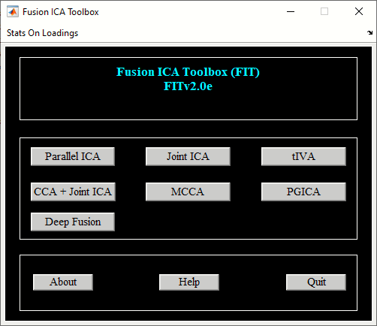

Table of Contents

2 Introduction 3

2.1 What is FIT? 3

2.2 Why Joint Analysis? 3

2.3 Joint ICA 3

2.4 Parallel ICA 4

2.5 CCA + Joint ICA 4

2.6 MCCA 4

2.7 Transposed IVA (tIVA) 5

2.8 PGICA 5

2.9 Deep Fusion 5

3 Fusion ICA Toolbox 5

3.1 Example Subjects 5

3.2 Installing FIT 6

3.3 Joint ICA Toolbox 6

3.3.1 fMRI-fMRI Fusion 7

3.3.2 fMRI-EEG Fusion 26

3.3.3 Batch Script 30

3.4 Parallel ICA Toolbox 31

3.5 CCA + Joint ICA 40

3.6 MCCA 44

3.7 Transposed IVA (tIVA) 47

3.8 Parallel Group ICA + ICA (PGICA) 50

3.9 Deep Fusion 56

3.10 Appendix 62

4 Bibliography 64

# Introduction

This manual is divided into two chapters. In the first chapter, we provide the motivation for using Fusion ICA Toolbox (FIT). In the second chapter, a detailed description of the toolbox is given.

## What is FIT?

FIT is an application developed in MATLAB and works on version R2008a and higher. FIT implements the joint ICA, CCA + joint ICA, parallel ICA, tIVA, MCCA, PGICA and Deep Fusion methods to examine the shared information across modalities.

## Why Joint Analysis?

A single individual often has data collected using multiple modalities including EEG, fMRI, sMRI and Gene. The data from these experiments are usually analyzed separately using statistical parametric mapping (SPM), independent component analysis (ICA) or sometimes directly subtracted from one another on a voxel by voxel basis. The above approach does not examine the shared information between features[1] and voxels. Existing techniques for joint information such as structural equation modeling (SEM) are only applied to certain regions of interest. SEM can be used to look at the correlational structure between regions activated by different tasks. A robust method for examining joint information over full brain is needed. Each imaging technique has a certain advantage, e.g. fMRI has good spatial resolution and EEG has good temporal resolution. A joint ICA model (V. D. Calhoun, T. Adali, K. A. Kiehl, R. Astur, J. J. Pekar and G. D. Pearlson, 2005) for example, was proposed as a technique that combines both spatial and temporal resolutions.

## Joint ICA

Joint ICA as applied to different modalities extracts maximally spatially independent maps for each task that are coupled together by a shared loading parameter. The steps in the joint ICA method are explained as follows:

* Feature Collection - Features are computed for each individual. A feature can be an activation map or EEG signal.
* Feature Normalization - Normalization is done on features using average sum of squares for each task.
* Feature Composition - The data from each feature is stacked across columns and rows represent number of subjects.
* Principal Component Analysis (PCA) - PCA will be used to reduce the data dimension from subjects to components.
* Joint ICA - Spatially independent components will be extracted from the reduced data. Each component shares a common loading or mixing parameter between the tasks.

The advantages of the joint ICA method are given below:

* Joint ICA could be used to identify an underlying disorder like schizophrenia (SZ). Brain activation patterns from SZ patients may behave similarly for multiple tasks.
* Good spatial and temporal resolution is achieved when fMRI and EEG modalities are fused together.

## Parallel ICA

Parallel ICA is an extension of ICA to accommodate the need for analyzing multiple modalities. Beginning with two modalities, it aims to find hidden factors from both modalities and connections between them. With properly controlled constraints, avoiding over fitting and under fitting caused by multiple reasons, reliable results can be obtained (J. Liu, G. D. Pearlson, A. Windemuth, G. Ruano, N. I. Perrone-Bizzozero, and V. D. Calhoun, 2007) and (J. Liu, O. Demirci, and V. D. Calhoun, 2008).

Comparing with joint ICA, where a shared mixing matrix is used for both modalities, the fundamental difference is that parallel ICA assumes the data sets are mixed in a similar pattern but not identical. That is, there is one mixing matrix per modality. They are similar but not identical. What is more, certain components from each modality are mixed in a more similar way then the others. Take the analysis of fMRI features and EEG waveforms as an example, it is reasonable to assume inter-subjects variations (the degrees of a component expressed in subjects) are very similar for some components. Contrastingly the same inter-subject variation is assumed in the joint ICA. Parallel ICA pays more attention to individual linked components and their connections, while the joint ICA in reference studies (V. D. Calhoun, T. Adali, G. D. Pearlson and K. A. Kiehl, 2006) inter-effects between EEG and fMRI as a whole.

## CCA + Joint ICA

CCA + joint ICA uses canonical correlation analysis (CCA) and ICA to extract both shared and distinct sources across features and mixing coefficients. CCA + joint ICA uses CCA as the data reduction step instead of PCA as used in joint ICA. Please see (J . Sui, T. Adali, G. D. Pearlson, V. P. Clark and V. D. Calhoun, 2009) for more information. Option is also provided to use MCCA as the data reduction step when analyzing multi modalities.

## MCCA

MCCA uses multi-modality canonical correlation analysis (MCCA) to extract both shared and distinct sources across features and mixing coefficients. Please see Section 3.6 to run the analysis.

## Transposed IVA (tIVA)

tIVA uses transposed IVA algorithms like IVA-G and IVA-GGD to extract the shared information across modalities. Please see Section 3.7 to run the analysis.

## PGICA

Parallel group ICA + ICA (PGICA) incorporates temporal information from group ICA into a parallel independent analysis framework to extract shared information between the first level fMRI and sMRI modalities. Please see Section 3.8 for more information.

## Deep Fusion

Deep fusion uses deep neural network for finding linkage or associations between the modalities. Please see Section 3.9 for more information.

# Fusion ICA Toolbox

Joint ICA, CCA + joint ICA, parallel ICA, tIVA, MCCA, PGICA and Deep fusion can be run using the graphical Fusion ICA Toolbox (FIT) as well as using a batch script. We provide a step-by-step walk through using example data. First, the example data sets and software must be installed.

## Example Subjects

Unzip *Fusion_Example_Data.zip* file and this contains three folders: *fmri_fmri*, *erp_fmri* and *fmri_gene*. fMRI-fMRI data set is used to demonstrate joint ICA and CCA + joint ICA methods whereas fMRI-gene data set is used to explain parallel ICA method. We also describe fMRI-EEG fusion using joint ICA method. fMRI-fMRI and fMRI-gene data sets consists of two groups like healthy and schizophrenics whereas EEG-fMRI data-set is from a healthy group. fMRI and EEG data were collected while participants performed either an auditory oddball or a sternberg working memory task and are more fully reported in (V. D. Calhoun, T. Adali, K. A. Kiehl, R. Astur, J. J. Pekar and G. D. Pearlson, 2005) and (V. D. Calhoun, T. Adali, G. D. Pearlson and K. A. Kiehl, 2006). The computed ”features” which are entered into the ICA analysis, are activation images computed using SPM, an event-related potential (ERP) from a centrally located electrode or SNP array. The data format for each modality is given below:

* Functional MRI (fMRI) or structural MRI (sMRI) data - 3D Analyze or 3D Nifti format.
* ERP or EEG data - ASCII format.
* SNP or Gene data - ASCII format.

## Installing FIT

Unzip *FITv2.0e.zip* file and place it in an appropriate directory. Add folder *ica_fuse* and its sub-folders on MATLAB path. You can also create a *fusion_startup.m* file for setting the path according to your needs. Type fusion at the MATLAB command prompt and this will open FIT (Figure 3.1). FIT contains user interface controls Parallel ICA, Joint ICA, CCA + Joint ICA, MCCA, tIVA, PGICA and Deep Fusion. We first discuss Joint ICA using fMRI-fMRI example data set followed by fMRI-EEG fusion example. Parallel ICA is explained using fMRI-gene example data set in Section 3.4. CCA + joint ICA is explained in Section 3.5. tIVA, MCCA, PGICA and Deep Fusion toolboxes are discussed in Sections 3.7, 3.6, 3.8 and 3.9.

## Joint ICA Toolbox

When you click *Joint ICA* button in Figure 3.1, joint ICA toolbox (JICAT) will open. You could also open JICAT by typing fusion(’jointICA’) at the MATLAB command prompt. Figure 3.2 contains user interface controls like *Setup Analysis*, *Run Analysis*, *Fusion Info*, *Display* and ”Utilities”. We explain these user interface controls using fMRI-fMRI example data set. fMRI-EEG fusion is discussed in Section.



Figure 3.1: Fusion ICA Toolbox

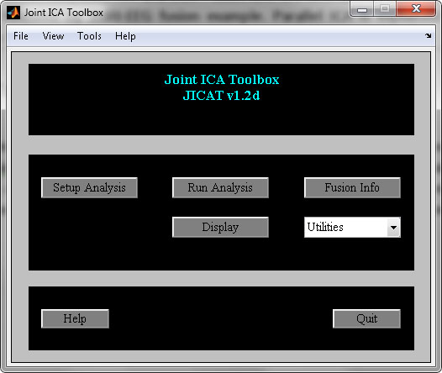

Figure 3.2: Joint ICA Toolbox

### fMRI-fMRI Fusion

***Setup ICA Analysis***

When you click *Setup Analysis* button, a figure window will open to select the directory where all the analysis information will be stored. Figure 3.3 shows the initial parameters window. The parameters in the figure window are explained below:

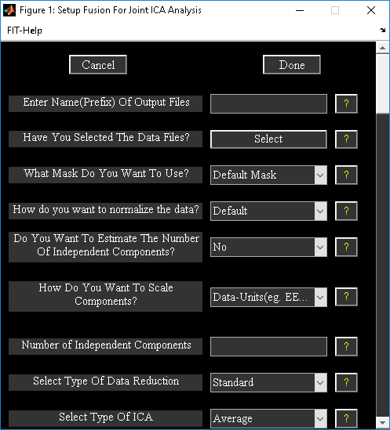

Figure 3.3: Setup ICA Analysis

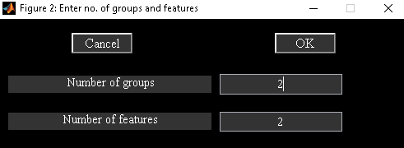

Figure 3.4: Figure window shows number of groups and features selected for the analysis.

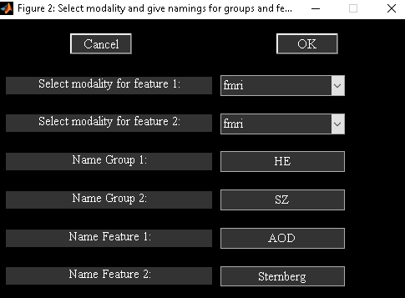

Figure 3.5: Option is provided to enter the names of groups and features

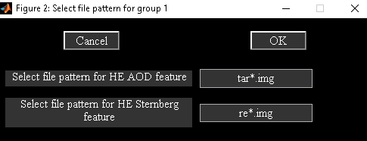

Figure 3.6: File pattern of each feature for first group.

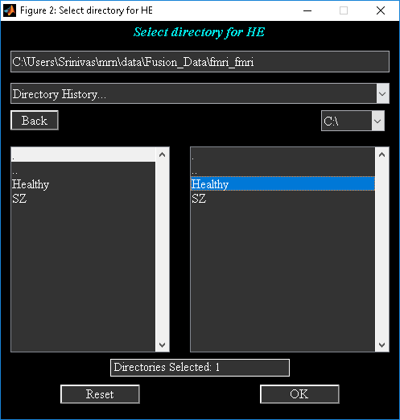

Figure 3.7: Selected directory for first group.

* Enter Name (Prefix) Of Output Files” - All the output files will be stored with this prefix.
* ”Have You Selected The Data Files?” - When you click push button Select, *figure* 2.4 will open to enter the number of groups and features for the analysis. After entering the information in Figure 3.4, Figure 3.5 will open to enter the names of groups and features. You could select the files for each group and feature manually using a file selection window or specify the filter pattern for features followed by directory selection. We demonstrate file selection using filter pattern and group directory selection. For the example data-set, the files filter pattern is the same for both groups. Enter only the file pattern (Figure 3.6) for features of first group. Since the directories where the groups are stored are separate, select ”No” for question ”Is the data organized in one group folder?” This will let you select directory for each group (Figure 3.7). After the data-sets are selected, a drop down box will show the answer ”Yes” for question ”Have You Selected The Data Files?” The data files selected for the analysis are printed to a text file with suffix *selected_data.txt*.
* ”What Mask Do You Want To Use?” - There are two options like ’Default mask’ and ’Select Mask’. Each option is explained below:
  + ’Default Mask’ - For fMRI and sMRI, the default mask includes only the voxels that are non-zero and not Nan for all the subjects. For EEG, default indices used are from global variable EEG DATA INDICES in *ica_fuse_defaults.m* file.
  + ’Select Mask’ - When you click ”Select Mask” option, a new figure window will open to select the mask. Mask for each modality can be selected by clicking the feature name in the left listbox of that figure. ”How do you want to normalize the data” - Options available are ’Default’, ’Norm2’, ’Std’ and ’None’. Normalization is done separately for each feature over groups. Default normalization uses square root of mean of squared data for all subjects.
* ”Do You Want To Estimate The Number of Independent Components?” - Minimum description (MDL) is used to estimate the components. For MRI data-sets (fMRI, sMRI) , estimation is based on Information theoretic criteria ( (Y.-O. Li, T. Adali and V. D. Calhoun, 2007))) whereas for other modalities standard MDL is used.
* ”How Do You Want To Scale Components?” - You have the option to scale components to data units or Z-scores. Each option is explained below:
  + ’Data-Units (eg. EEG-mV)’ - Regression fit is calculated by using components of a feature as model and original data of that feature as observation. Components of a feature are scaled by their respective slope or beta weight. This involves flipping of components when slope is negative. You can turn off this option by setting variable FLIP SIGN COMPONENTS in *ica_fuse_defaults.m* to 0.
  + ’Z-scores’ - Components are first converted to ’Data-Units’ and then converted to Z-scores.
* ”Number of Independent Components” - Number of independent components that will be extracted from the data.
* ”Select Type Of Data Reduction” - Options available are ’Standard’, ’Reference’, ’CCA’ and ’MCCA’.
  + Standard - Data is reduced to few components in the subject dimension using eigen decomposition on the data.
  + Reference - Information from groups is used to extract eigen vectors from the data.
  + CCA - Canonical correlation analysis is used to do data reduction. This is same as CCA + joint ICA. MCCA - Multimodality canonical correlation analysis is used to do data reduction. This is same as MCCA + joint ICA.’
* ”Select type of ICA analysis” - There are two options like ’Average’ and ’ICASSO’.
  + Average - ICA is run multiple times. Components are averaged across runs.
  + ICASSO - ICA is run multiple times using random initialization. Stable ICA run estimates are used in further calculations. ICASSO information is saved in file *\*icasso*results.mat*.
* ”Enter number of ICA runs” - Number of times you want ICA to be run on the data.
* ”Which ICA Algorithm Do You Want To Use?” - Presently there are 12 ICA algorithms implemented in the FIT like Infomax, FastICA, ERICA, SIMBEC, EVD, JADE OPAC, AMUSE, SDD ICA, CC ICA, Combi, EBM and ERBM. Figure 3.8 shows the completed parameters for data fusion analysis. When you click Done button, ICA options window will open. Presently, ICA options are available for Infomax, FastICA, SDD ICA, CC ICA and ERBM. You can use the defaults or enter values for the parameters within permissible limits that are shown in the prompt string. All the user input is stored in a MAT file having suffix *ica_fusion.mat*.

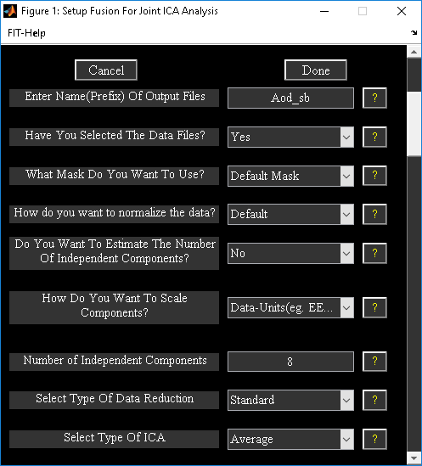

Figure 3.8: Completed parameters window

***Run Analysis***

Fusion analysis can be done through Run Analysis button or by selecting ”Run” under ”Tools” menu (Figure 3.3). Select the fusion parameter file (*ica_fusion.mat) which was created after setting up the analysis and wait for the analysis to complete. The steps involved in the analysis (Figure 3.9) are as follows:

* Principal Component Analysis (PCA) - Data will be reduced using PCA. The information about data reduction is stored in a MAT file with the suffix pca_comb. First combination is all the features stacked together in columns.
* Independent Component Analysis (ICA) - ICA will be run on the reduced data obtained from the PCA step. The information about ICA is stored in a MAT file with suffix ica_comb.
* Back Reconstruction - Components mixing matrix is multiplied with de-whitening matrix obtained from the PCA step. This will be stored as a MAT file with suffix br_comb.
* Scaling Components: The components obtained after ICA step are in arbitrary units. These will be scaled by doing a multiple regression of components (model) with the original data (observation) of the features. The sign of the component will be flipped depending on the beta weight information. This information is saved as a MAT file with suffix sc_comb.

Note:

* Output Files: Joint ICA components will be saved in output files for the respective features with the suffix joint_comp_ica_feature.
* All the analysis information is stored in a log file with suffix results.log. After the analysis is successfully done, display GUI () will open. You can turn off this option by setting variable OPEN DISPLAY WINDOW to 0 in ica_fuse_defaults.m file.
* PCA and ICA will be run on combination of features, if you set variable OPTIMIZE FEATURES to ’Yes’ in ica_fuse_defaults.m file.

You can run ICA several times by setting variable NUM RUNS ICA in defaults.

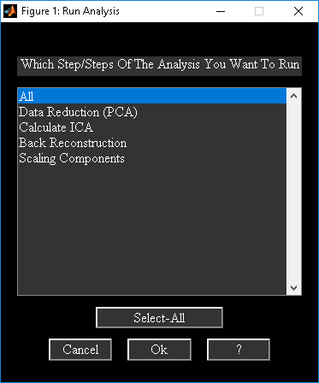

Figure 3.9: Run Analysis Window

***Fusion Info***

Fusion Info button is used to view analysis information. Figure 3.10 will open after you had selected the fusion information file. The function of each button in the figure is given below:

* Parameter Info - User input information is shown.
* Analysis Info - Analysis information is shown like how many combinations of features are run.
* Output Files - Output files information is shown.

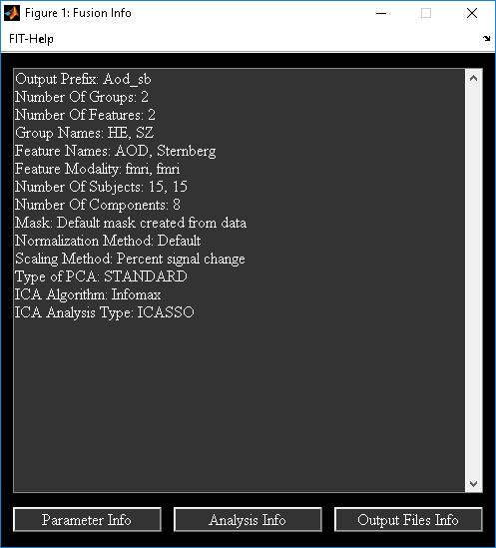

Figure 3.10: Fusion Info

***Display***

When you click *Display* button (Figure 3.2) and have selected the fusion parameter file, Figure 3.11 will be displayed. An alternative way to display Display GUI figure is to select ”Display” under ”Tools” menu. Display GUI is used to display joint ICA components. Display GUI contains main user interface controls, hidden user interface controls (display defaults) and ”Utilities” menu. Hidden user interface controls (Figure 3.12) will be displayed when you click ”Display Defaults” menu. There is an option to create ERP-fMRI (Section ) movie under ”Utilities” menu. We next explain main user interface controls followed by hidden user interface controls.

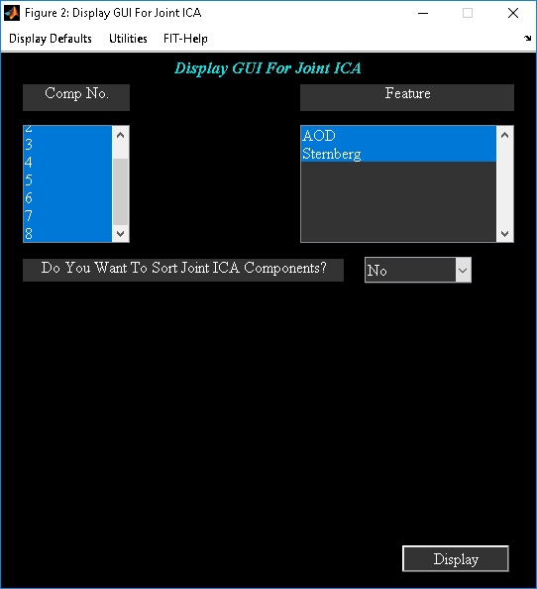

Figure 3.11: Display GUI

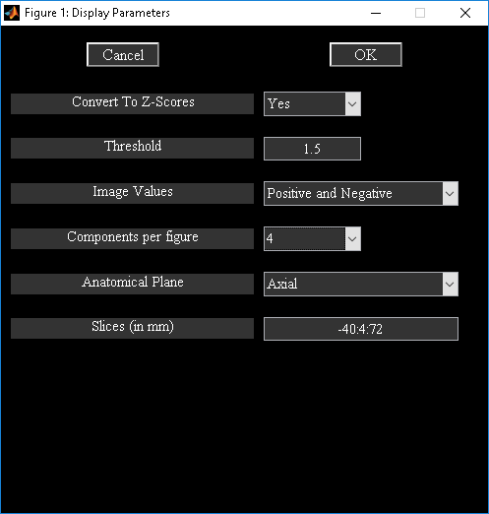

Figure 3.12: Display defaults menu

**Main User Interface Controls**

* ”Component No” - Component numbers to display. By default all components will be selected.
* ”Feature” - Features to display. By default all features will be displayed.
* ”Do You Want To Sort Components” - Sorting joint ICA components is explained in section 2.3.1.

**Hidden User Interface Controls**

* ”Convert To Z-scores” - Component images will be converted to z-scores.
* ”Threshold” - Z-threshold used for displaying images.
* ”Image Values” - Options available are ”Positive and Negative”, ”Positive”, ”Absolute” and ”Negative”.
* ”Components per figure” - Options available are ”1”, ”4” and ”9”.
* ”Anatomical Plane” - Options available are ”Axial”, ’Sagittal” and ”Coronal”.
* ”Slices (in mm)” - Slices in mm to be plotted. We selected -40:4:72 as the slices to plot.

**Note:** The defaults for these display parameters are available in ica_fuse_defaults.m file. Anatomical image used for displaying images is from variable ANATOMICAL FILE in ica_fuse_defaults.m file. After entering the display parameters, click on Display (Figure 3.11) button to display the features. Figure 3.13 shows the components in groupings of four.

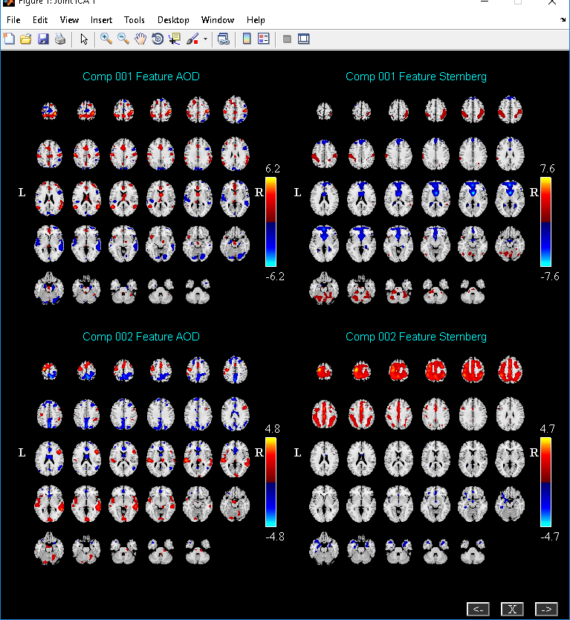

Figure 3.13: Joint ICA components

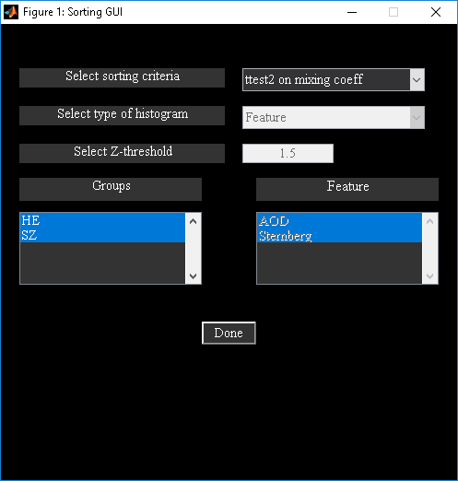

Figure 3.14: Sorting GUI

***Sorting Components***

At least two groups are required to sort joint ICA components. Select ”Yes” for ”Do You Want To Sort Joint ICA Components?” in Figure 3.11. Figure 3.14 shows the utility to sort components. The parameters in the figure are explained below:

”Select sorting criteria” - Presently there are two options like ”ttest2 on mixing coeff” and ”Spatial div”. Explanation of each option is given below:

* ”ttest2 on mixing coeff” - Two sample t-test is done on mixing coefficients between the selected groups. Figure 3.15 shows components sorted based on p-value. The results from two sample t-test are stored in a text file with suffix ttest2_mixing_coeff.txt.
* ”Spatial div” - To calculate spatial divergence between the groups, a distribution must be created for each component of a group. We use cross-task histogram as distribution for each selected group from spatial maps. You need to select the features from features listbox and groups from groups listbox. Divergence is calculated between the selected groups. Figure 3.16 shows components sorted based on spatial divergence. The results from divergence are stored in a text file with suffix divergence_groups.txt.
* ”Select Type of Histogram” - There are two types of histograms like ”Feature” and ”Component”. We explain the type of histograms below:
  + Feature - Z-threshold is applied on each component map of a feature and voxels are sorted in descending order. The resulting set of voxels is used as a mask to original data. Cross-task histogram is computed based on the selected features from features listbox.
  + ’Component - Group components are back-reconstructed based on the mixing coefficients and the original data of each feature. Cross-task histogram for each component is generated based on selected features from features listbox.
* ”Select Z-threshold” - This option is available only when you select ”Spatial div” as the sorting criteria and select ”Feature” as type of histogram.
* ”Groups” - Select at most two groups for sorting components.
* ”Features” - You can select features only when ”Spatial div” is used as the sorting criteria. When you click Done button, components are sorted based on the criteria selected.

Note:

* Options for divergence criteria are ”kl” (Kullback Leibler), ”J” (J), ”alpha” (Alpha) and ”renyi” (Renyi). For setting the appropriate divergence criteria see defaults (ica_fuse_defaults.m).
* You can change the number of bins used in calculating histogram by changing variable NUM BINS (See ica_fuse_defaults.m).
* You can open a spatial map or EEG signal when you double click or click on the corresponding axis.
* Option is provided to plot cross-task histograms when you use right click on the loading coefficients axis.

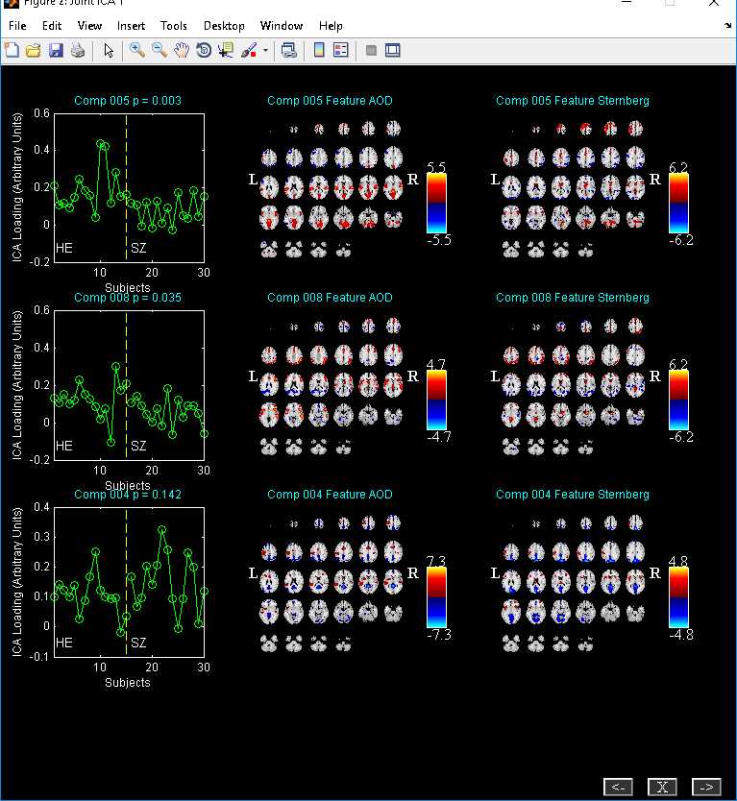

Figure 3.15: Sorted components based on two sample t-test on mixing coeffiicients

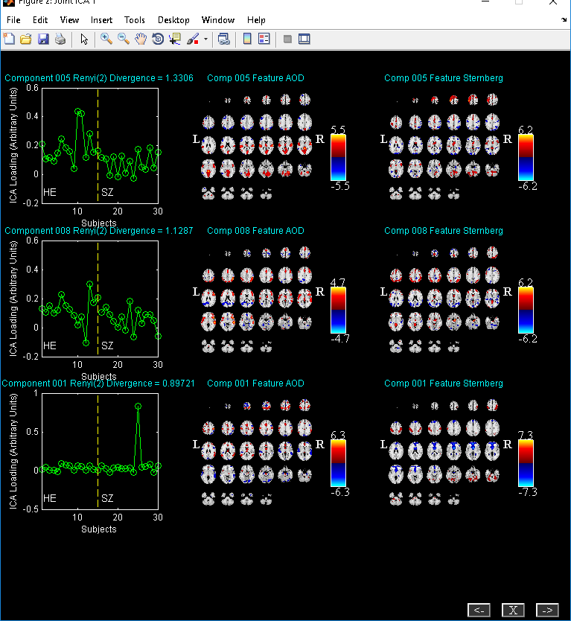

Figure 3.16: Sorting components based on renyi divergence

**Utilities**

”Utilities” drop down box in Figure 3.2 contains options like ”Optimal Features”, ”Histogram Plot” and ”Write Talairach Table”.

* ”Optimal Features” - Before running this utility, set variable OPTIMIZE FEATURES in ica_fuse_defaults.m to ’Yes’ and run analysis. This will run ICA on different combinations of features in order to identify which combination of features most differentiates the groups. After you click ”Optimal Features” in ”Utilities” (Figure 3.2) drop down box, will open. The parameters in the Figure 3.17 are as follows:
  + ”Select sorting criteria” – Best component is determined based on the sorting criteria selected. For spatial divergence sorting criteria information from ”Select type of histogram” is used.
  + ”Select type of histogram” - There are two options like ’Feature’ and ’Component’.
    - ’Feature’ - Best component voxels are sorted in descending order and Z-threshold is applied. This set of voxels is used as a mask to the original data. Cross-task histogram is constructed for each selected group.
    - ’Component’ - Cross-task histogram is constructed for each selected group using the group back-reconstructed maps.
  + ”Select Groups” - Select at most two groups. When you click Calculate button spatial divergence between the selected groups is calculated using the cross-task histograms. The default divergence criteria is ”renyi” with . Figure 3.18 shows the features ranked in descending order of their divergence.
  + ”Select Z threshold” - Z-threshold applied on ”Best” component when ’Feature’ histogram is used.
* ”Histogram Plot” - Figure 3.19 will open after you have selected the fusion information file. The parameters in the figure are as follows:
  + ”Groups” - Select at most two groups.
  + ”Features” - Select at most two features.
  + ”Component” - Select a component of interest.
  + ”Z-Threshold” - Z-threshold to be applied on spatial maps.

When you click *Done* button, Z-threshold is applied on the selected component map and voxels are sorted in descending order. This is used as a mask to the original data and cross-task histograms are generated. We calculate cross-task histogram for each subject of a group. Mean histogram is calculated for each group and a group difference histogram (Figure 3.20) is also calculated.

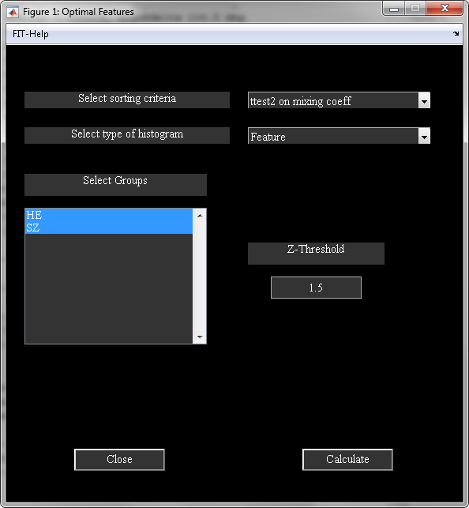

Figure 3.17: GUI for running optimal features

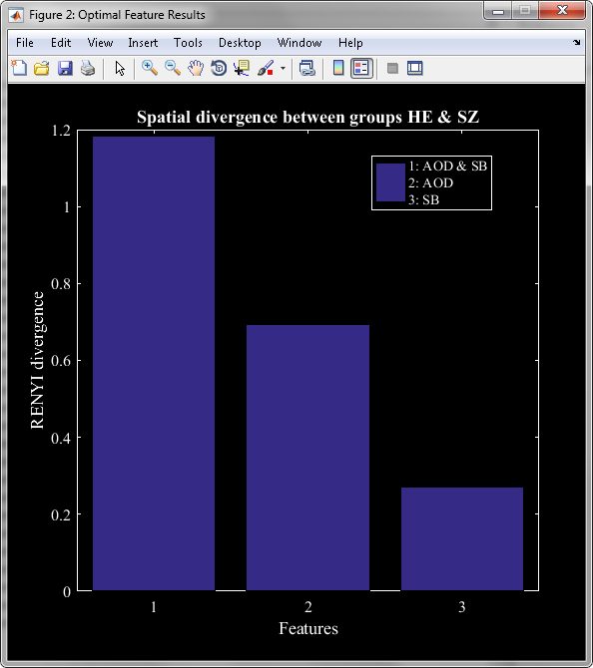

Figure 3.18: Figure shows features ranked based on spatial divergence.

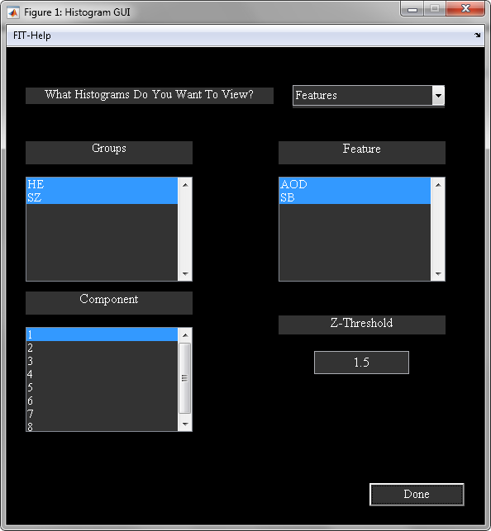

Figure 3.19: Histogram GUI

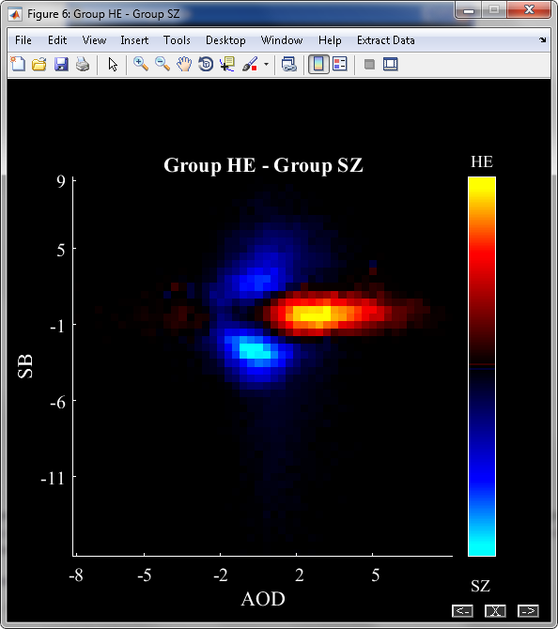

Figure 3.20: Group difference histogram

### fMRI-EEG Fusion

We used fMRI-EEG example data set to do fMRI-EEG fusion. The data set contained one group and 23 subjects. We selected 12 components to be extracted from the data. Figure 3.21 shows the joint ICA components ordered based on the peak of EEG signal. Option is provided in Figure 3.11 to create fMRI-EEG movie. Figure 3.22 will open when you select ”Create ERP-fMRI movie” from ”Utilities” menu in figure 2.12. The parameters in the Figure 3.22 are as follows:

* ”Enter output file name to save movie” - Movie in AVI format will be saved with this name.
* ”fMRI” - Select fMRI modality.
* ”EEG” - Select EEG modality.
* ”Select a group” - Select a group.
* ”Select Components” - Select the components of interest.
* ”Select Step Size” - Enter step size for time.
* ”Select Time Units” - Options are milliseconds and seconds.
* ”Select Time Range” - Enter the time range in milliseconds. Frames only within the time range will be captured.

When you click *Done* button, weighted component data is calculated by multiplying fMRI components with the EEG components. The resulting component data will be voxels by time. Figure 3.23 shows a screen shot of ERP-fMRI movie. Spatial map is plotted on left and mean EEG signal (solid yellow line) and components EEG signals are plotted on right.

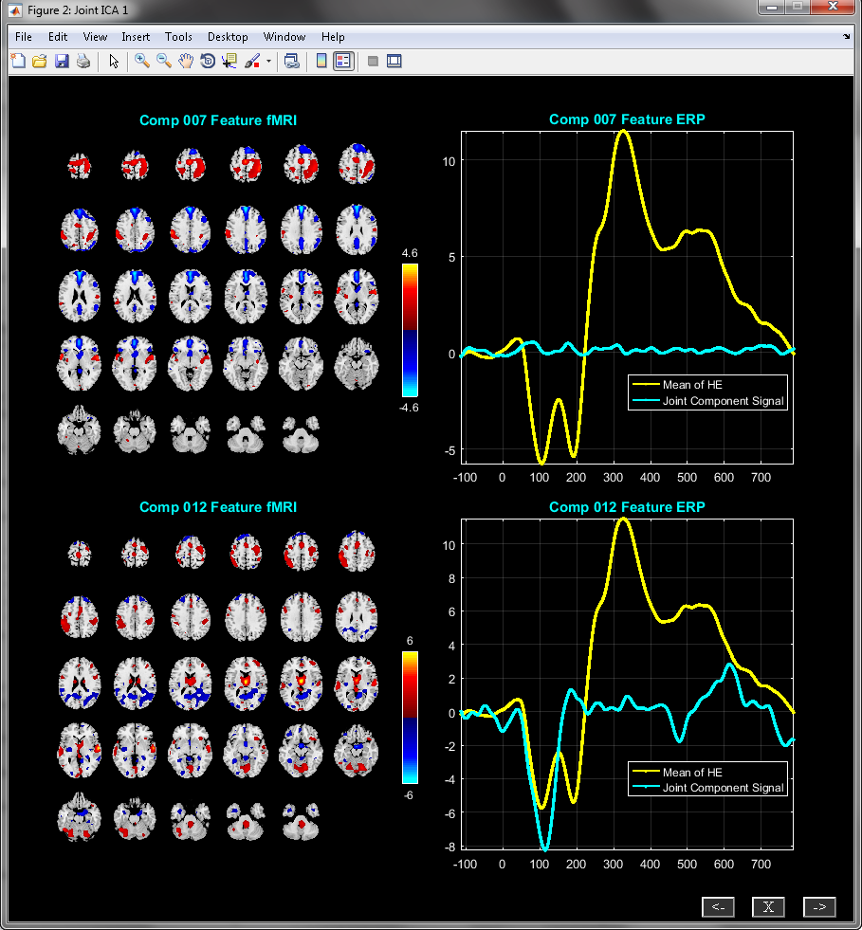

Figure 3.21: Figure shows components of fMRI-EEG fusion that are ordered based on the peak of EEG signal.

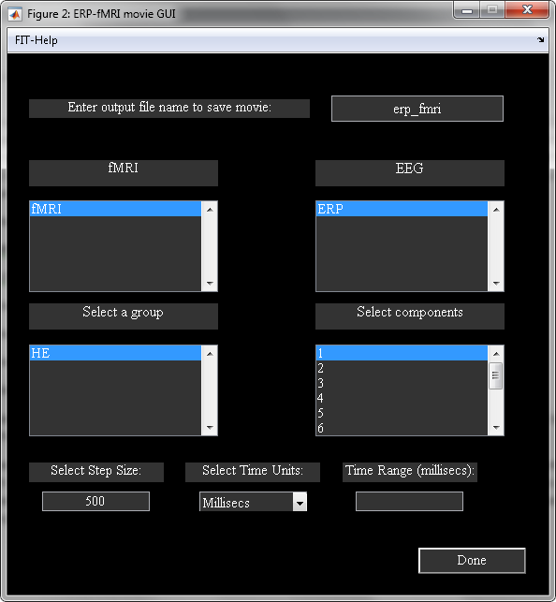

Figure 3.22: Create fMRI-ERP Movie GUI

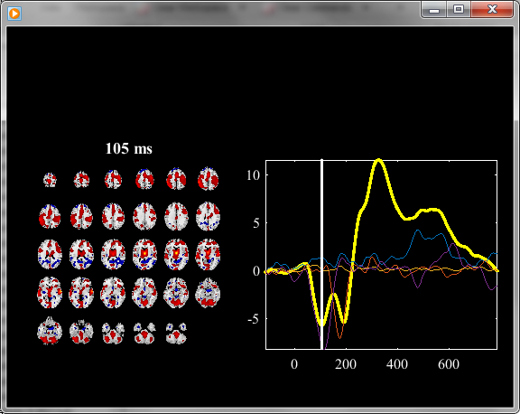

Figure 3.23: ERP-fMRI Movie

### Batch Script

Joint ICA fusion analysis can also be done using a batch file. The syntax for the function is ica_fuse_batch_file(inputFile) where inputFile variable refers to full file path of the input file. Example input files like input_data_fusion_1.m and input_data_fusion_2.m are provided in folder ica_fuse/ica_fuse_batch_files. The parameters in the input file are explained below:

* outputDir - All the results will be stored in this directory.
* prefix - Output files will have this prefix.
* maskFile - There are two options like ’Default Mask’ and ’Select Mask’.
  + ’Default Mask’ - Default mask includes non-zero and not Nan voxels for fMRI and sMRI modalities whereas for EEG modality indices in global variable EEG DATA INDICES are used.
  + ’Select Mask’ - Mask must be entered in a cell array. You need to specify full file path of the image for fMRI and sMRI modalities. For EEG modality specify indices.
* normalize - Normalization is done for each feature. There are four options like ’Default’, ’Norm2’, ’Std’ and ’None’. Default normalization uses square root of mean of squared data for all subjects.
* groupNames - All the group names must be entered in a cell array. The number of groups is determined by the length of the groupNames vector.
* featureNames - Feature names must be entered in a cell array and the number of features is determined by the length of this vector.
* modality - The modality of each feature must be entered in a cell array. The number of modalities must equal the number of features. Presently available modalities are ’fmri’, ’smri’ and ’eeg’.
* dataSelectionOption - Options are 1 and 2.
  + 1 - You need to enter the following variables to select the files:
    - answerFilePattern - The data is selected using the file pattern. Explanation of this variable is given below:
      * 1 - File pattern is the same between the groups.
      * 0 - File pattern is different between the groups.
    - group1_file_pattern - File pattern for group 1. If the file pattern is same between the groups this variable will be read. Length of this vector must equal the number of features.
    - answerDir - Value of 1 means all the data is in one folder whereas 0 means the data for each group is in a separate folder.
    - group1_dir - Enter input directory for group 1.
  + 2 - Enter the file names in a cell array in variable files. The dimensions of the cell array are number of groups by number of features.
* type_pca - Type of data reduction. Data is reduced in the subject dimension. Options are ’standard’, ’reference’, ’cca’ and ’mcca’.
  + standard - Eigen decomposition is done on the data.
  + reference - Enter group information in reference variable.
  + cca - Enter no. of components to be extracted from the data for each feature.
  + mcca - Same as cca.
* z_scores - Options are ’yes’ and ’no’. If ’no’ is selected, components are scaled to data units.
* numComp - Enter number of components to extract from the data.
* algorithm - Selected ICA algorithm. Currently, 12 ICA algorithms are available. Please type ica_fuse_icaAlgorithm at the MATLAB command prompt for the available list of ICA algorithms.

## Parallel ICA Toolbox

Parallel ICA toolbox (ParaICAT) is implemented based on parallel ICA algorithm (J. Liu, G. D. Pearlson, A. Windemuth, G. Ruano, N. I. Perrone-Bizzozero, and V. D. Calhoun, 2007). We explain ParaICAT using fMRI-gene data set. This data set consists of two folders like Healthy and SZ. There are 43 subjects in healthy group and 20 subjects in schizophrenics group. When you click on Parallel ICA button (Figure 3.1), ParaICAT (Figure 3.24) will open. You can also open ParaICAT by typing fusion(’paraICA’) at the MATLAB command prompt. The user interface controls in the Figure 3.24 are Setup Analysis, Run Analysis and Display.

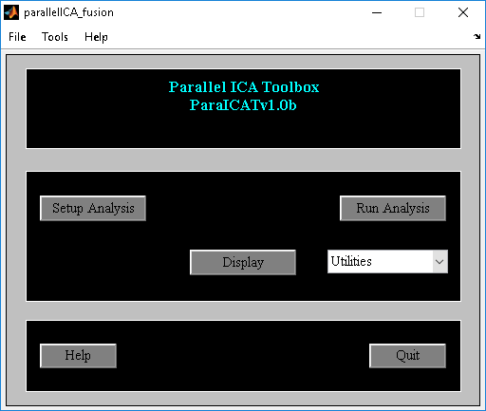

Figure 3.24: Parallel ICA Toolbox

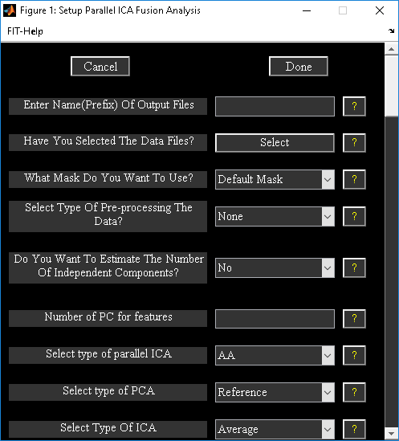

Figure 3.25: Setup ICA

***Setup Analysis***

* When you click Setup Analysis button in Figure 3.24 and had selected the output directory for analysis, Figure 3.25 will open. The parameters in the figure are as follows:
* ”Enter Name(Prefix) Of Output Files” - All the output files will be saved with this prefix.
* ”Have You Selected The Data Files?” - When you click Select button, a figure window (Figure 3.26) will open to enter the number of groups and features for the analysis. You have the option to select two or three features. Figure 3.27will open to enter names for groups and features. You could select the data files using file selection window for each feature and group or using the file pattern and the directory selection. For the example data set filter pattern is same between the groups, we selected ”yes” for question ”Is the file pattern same between the groups?” Figure 3.28 will open to enter the file patterns for features. After entering the above parameters, a figure window will open to select the directory where the data is located for groups.
* ”What Mask Do You Want To Use?” - There are two options like ”Default mask” and ”Select Mask”. The explanation for the mask is given in Section 3.3.1. We used ”Select Mask” option and selected file myMask_t3.img as mask for fMRI data and all SNP indices for gene modality.
* ”Number Of PC for features” - Enter number of principal components to be extracted from the data for features ”fMRI” and “Gene”.
* ”Select Type Of Parallel ICA” - There are two options ”AA” and ”AS”. The ”AA” option uses correlation measure between mixing coefficient of modality 1 with mixing coefficient of modality 2 whereas ”AS” option uses correlation measure between mixing coefficient of modality 1 with source of modality 2.
* ”Select type of PCA” - There are two options like ”Reference” and ”Standard”. ”Reference” option uses information from groups to project eigen vectors to that dimension. Please see (J. Liu, G. D. Pearlson, A. Windemuth, G. Ruano, N. I. Perrone-Bizzozero, and V. D. Calhoun, 2007) for more information. Figure 3.29 will open when you click ”Reference” option. We entered a value of -1 for SZ group and a value of 1 for healthy group.
* ”Select type of ICA analysis” - There are two options like ’Average’ and ’ICASSO’.
  + Average - ICA is run multiple times. Components are averaged across runs.
  + ICASSO - ICA is run multiple times using random initialization. Stable ICA run estimates are used in further calculations. ICASSO information is saved in file *icasso*results.mat.
* ”Number of times ICA will run” - Number of times you want ICA to be run on the data. Figure 3.30 shows the completed parameters for the analysis. When you click Done button, parallel ICA options will be shown in an input dialog box. After the parallel ICA options are selected, a parameter file with suffix para_ica_fusion.mat will be saved in the analysis output directory.

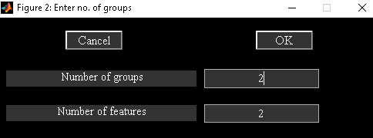

Figure 3.26: Enter number of groups and features

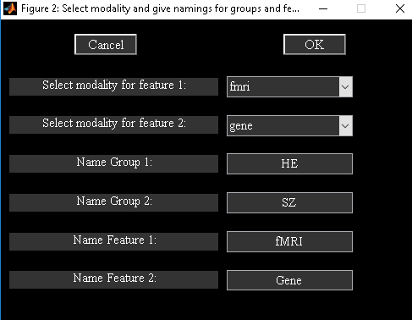

Figure 3.27: Group and feature names

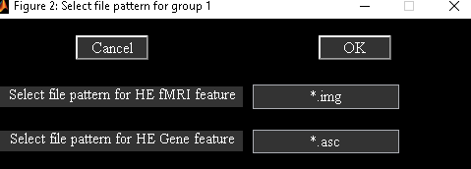

Figure 3.28: File pattern

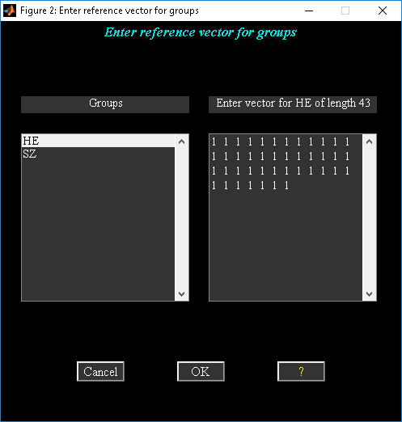

Figure 3.29: Reference Info

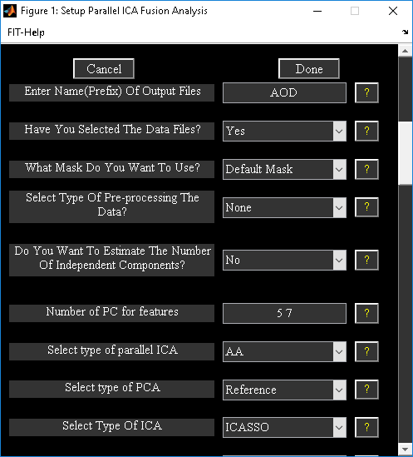

Figure 3.30: Completed parameters window

***Run Analysis***

When you click Run Analysis button (Figure 3.24) and had selected the parameter file para_ica_fusion.mat, parallel ICA will be run. The analysis steps are as follows:

Principal Component Analysis (PCA) - PCA is run on each modality separately. The number of components extracted for each modality depends on the number you have entered during Setup Analysis. PCA information is stored in a file with suffix para_ica_pca.mat.

Parallel ICA - ICA is run on each modality and a correlation measure is enforced between the modalities during the analysis. Correlation measure is dependent on the type of parallel ICA. There are two types of parallel ICA like ”AA” and ”AS”. ”AA” enforces the correlation measure between mixing coefficient of modality 1 with mixing coefficient of modality 2 whereas ”AS” uses correlation measure between the mixing coefficient of modality 1 with the source of modality 2. ICA information is stored in a file with suffix para_ica_ica.mat.

**Note:** All the analysis information is stored in a log file with suffix para_ica_results.log.

***Display***

Figure 2.34 will open after you click Display button (Figure 2.1) and had selected the parameter file. The parameters in the display GUI are as follows:

* ”Comp No:” - Component numbers to display. This is dependent on the feature you have selected in the feature listbox. This option will be disabled when you sort components.
* ”Feature:” - You can select at most one feature to display. This option will be disabled when you sort components.
* ”How do you want to sort components?” - Options are ’None’, ’Correlation between modalities’ and ’Two sample t-test on mixing coefficients’.
  + Correlation between modalities - Components are sorted based on the correlation between the modalities. Each component displayed consists of mixing matrix coefficients of each modality and source of each modality. Results are also written to file *_para_ica_correlations.txt.
  + Two sample t-test on mixing coefficients - Two sample t-test is done on the mixing coefficients of selected groups and feature. Results are also written to file *_para_ica_ttest2_results.txt.

Figure 3.31 shows the results of sorting based on correlation measure between the modalities. When you click on any axes, enlarged view of that plot is shown in a different figure.

* ”Display Defaults” - Spatial map defaults will be shown in a figure window (Figure 3.3) when you click of ”Display Defaults” menu. The display defaults shown are the same as those explained under hidden user interface controls in Section 3.3.1.
* ”Options” - There is an option to select the SNP’s locus file. We have included locus file LocusNames.txt for the example data set. Dominant SNP’s will be printed to a text file having suffix dominant_snps.txt when components are sorted based on correlation. Dominant SNP’s are determined based on Z-threshold for SNP’s. You can change Z-threshold by changing variable SNP Z THRESHOLD in ica_fuse_defaults.m file.

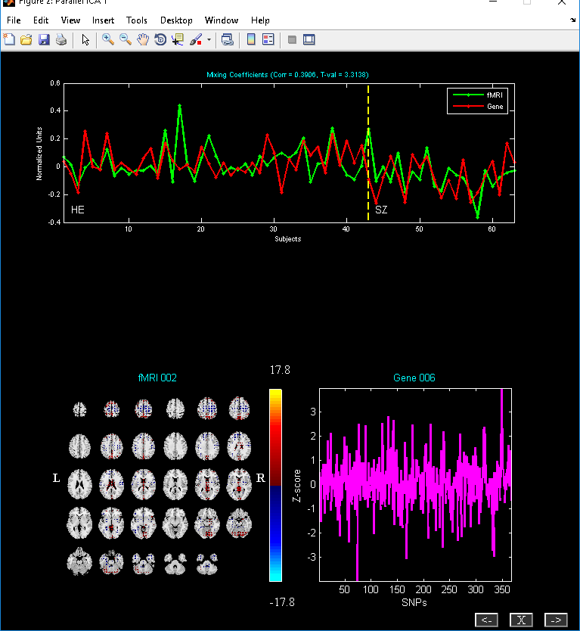

Figure 3.31: Components are sorted based on the correlation between the mixing coefficients

***Utilities***

Utilities can be accessed using ”Utilities” dropdown box or from the menu (Figure 3.24). Currently available utilities are ’SNP Dimensionality Estimation’, ’Permutation Test’, ’Preprocess SNPs’, ’Leave One Out Evaluation’, ’Run’ and ’Display’.

* SNP Dimensionality Estimation - This order selection procedure employs consistency as a criterion to locate the optimal order that results in relatively accurate components and loadings (J. Chen, V. D. Calhoun, J. Liu, 2012). At the end of the analysis, consistency maps are displayed to the screen for both the spatial maps and loading coefficients.
* Permutation Test - Subjects are randomly permuted in each modality. Resulting correlation of best linked component at each permutation is compared with the un-permuted parallel ICA analysis. At the end of the analysis, summary of correlations crossing the un-permuted parallel ICA analysis is printed. Parallel ICA results are reliable only when the percentage values are smaller.
* Leave One Out Evaluation - Parallel ICA is run N times where N is equal to the number of subjects. At each run, current subject is excluded from the analysis. Best component is determined for each run and modality based on the correlation of the best linked components in the original parallel ICA analysis. At the end, correlation matrices are printed to the screen for each modality. Correlations less than 0.6 are automatically set to zero. Subjects that are unstable correspond to blue regions in the matrix.
* Preprocess SNPs - Data collected from Illumina is preprocessed to remove the duplicate entries and convert SNP values to discrete numbers which parallel ICA can understand.

## CCA + Joint ICA

When you click CCA + Joint ICA button in Figure 3.1, CCA + joint ICA toolbox (CCA + JICA) will open. You could also open CCA + JICA by typing fusion(’ccaica’) at the MATLAB command prompt. Figure 3.32 contains user interface controls like Setup Analysis, Run Analysis, Fusion Info, Display and ”Utilities”. We highlight the differences in the GUI part from the regular joint ICA. CCA + joint ICA differs from the joint ICA approach only in the data reduction part.

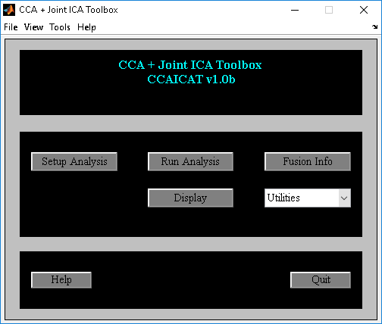

Figure 3.32: CCA + Joint ICA

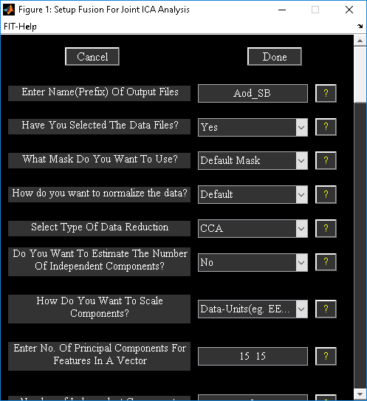

Figure 3.33: CCA Setup Analysis

***Setup Analysis***

CCA is the default data reduction step in CCA + joint ICA fusion. You need to use MCCA when the data dimensionality is different or when there are multi modalities in the analysis. CCA finds similar sources across the modalities whereas MCCA finds similar mixing coefficients across the modalities. All the other user interface controls are the same as explained in Section 3.3.1. We use fMRI-fMRI fusion data-set to demonstrate CCA + jICA fusion. Figure 3.33 shows the final setup analysis figure window.

***Display***

Figure 3.34 and Figure 3.35 show the best component obtained using CCA and MCCA.

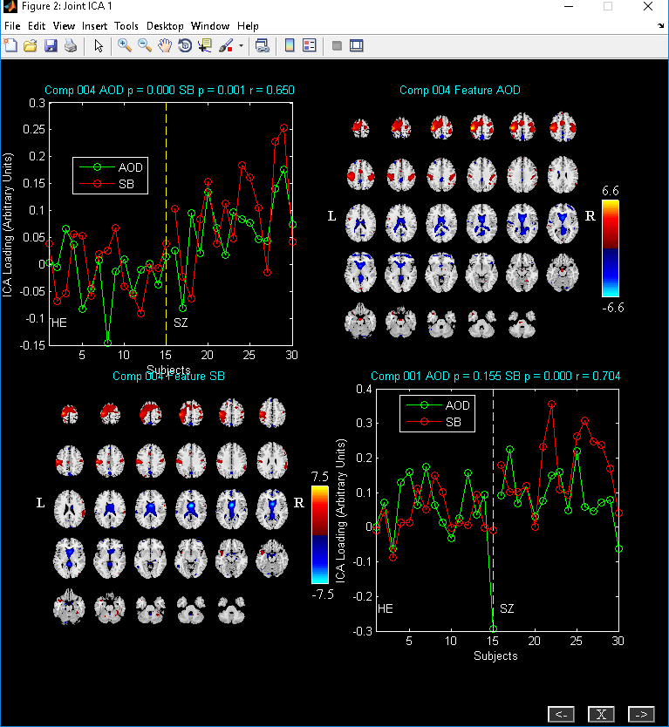

Figure 3.34: Two sample t-test is done on the mixing coefficients. T -stat on mixing coefficients and correlation measure between the modalities is displayed. CCA is used as the joint ICA approach.

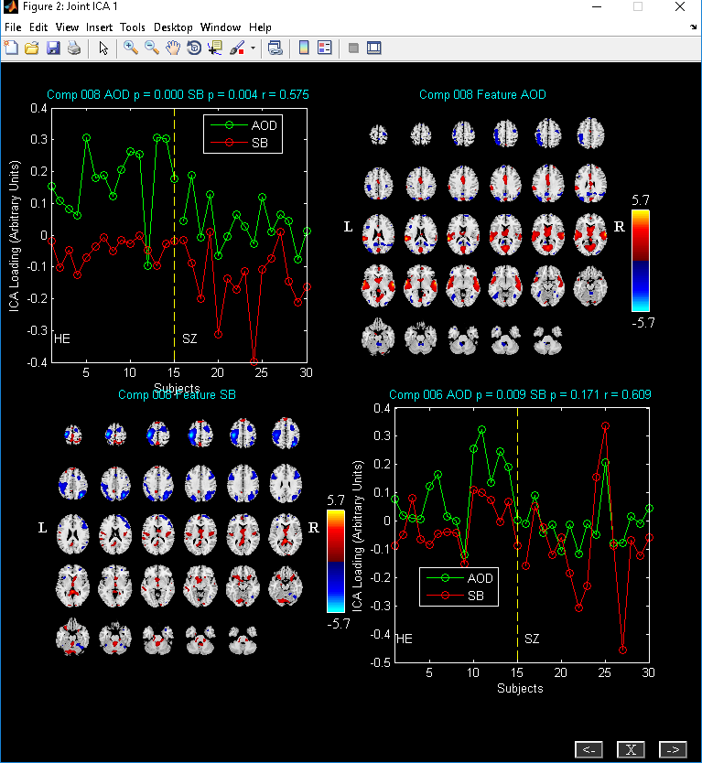

Figure 3.35: Two sample t-test is done on the mixing coefficients. T -stat on mixing coefficients and correlation measure between the modalities is displayed. MCCA is used as the joint ICA approach.

## MCCA

Multi-modality canonical correlation analysis (MCCA) is based on paper (T. Adali Y. Levin-Schwartz, Sep 2015). When you click MCCA button in Figure 3.1, MCCA toolbox will open. You could also MCCA by typing fusion(’mcca’) at the MATLAB command prompt. Figure 3.36 contains user interface controls.

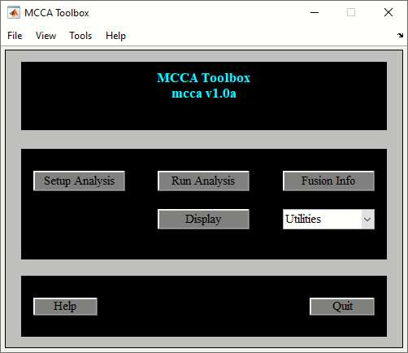

Figure 3.36: MCCA Toolbox

***Setup Analysis***

MCCA uses multi-modality canonical correlation to extract shared information between the modalities. When you click on the setup Analysis button, Figure 3.37 will open. Figure 3.37 contains options to reduce the dimensionality of each feature using PCA and number of canonical covariates to find the common mixing coefficients and sources between the modalities. All the other user interface controls are the same as explained in Section 3.3.1. We use fMRI-fMRI fusion data-set to demonstrate MCCA fusion. Figure 3.33 shows the final setup analysis figure window. When you click on the done button, an ICA parameter file will be created with the prefix *\*fusion.mat*. After you click on the run analysis button, MCCA will be computed on the data-sets and output components will be saved to the disk with the suffix *\*joint*comp\**. You have the option to change MCCA cost function by setting variable *MCCA_COST_FUNC* in *ica_fuse_defaults.m* file

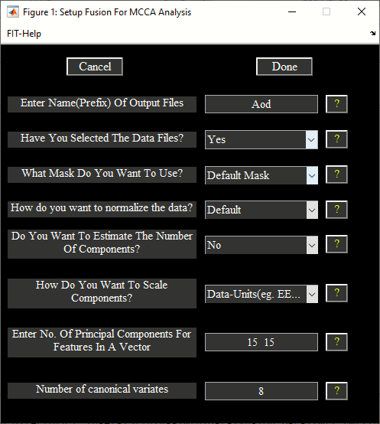

Figure 3.37: Setup analysis in the MCCA fusion toolbox

***Display***

Display button (Figure 3.36) can be used to explore components across the modalities. There are options to sort the components using the loading coefficients or computing divergence between the features. Figure 3.37 shows components sorted based on two-sample t-test on the mixing coefficients.

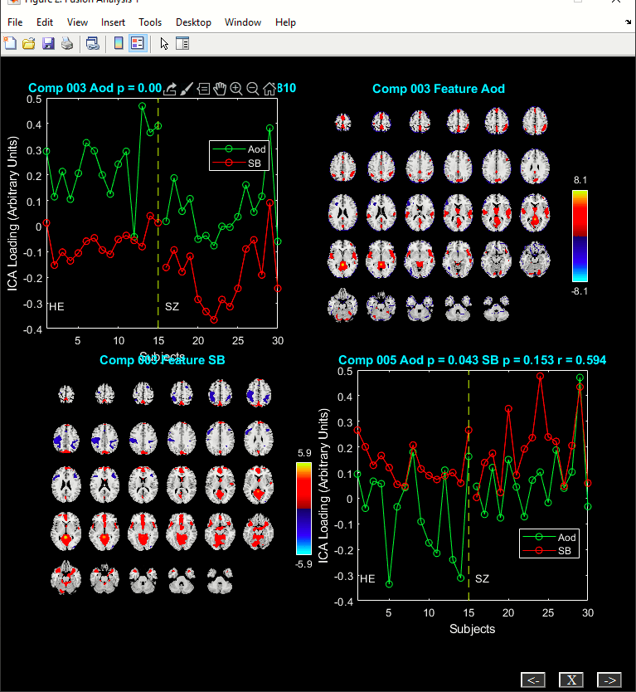

## Transposed IVA (tIVA)

Transposed IVA is based on paper (T. Adali Y. Levin-Schwartz, Sep 2015). tIVA incorporates higher order statistics in the MCCA model to extract common features across modalities. Algorithms like IVA-G and IVA-GGD are implemented in the toolbox. When you click tIVA button in Figure 3.1, tIVA toolbox will open. You could also invoke tIVA by typing fusion(’tiva’) at the MATLAB command prompt. Figure 3.32 contains user interface controls.

***Setup Analysis***

When you click on the setup Analysis button, Figure 3.37 will open. Select algorithm IVA-G or IVA-GGD under “Which ICA/IVA algorithm Do You Want To Use?” option. All the other user interface controls are the same as explained in Section 3.3.1. We use fMRI-fMRI fusion data-set to demonstrate tIVA fusion. Figure 3.38 shows the final setup analysis figure window. When you click on the done button, tIVA parameter file will be created with the prefix *\*fusion.mat.* After you click on the run analysis button, tIVA will be computed on the data-sets and output components will be saved to the disk with the suffix *\*joint*comp\**.

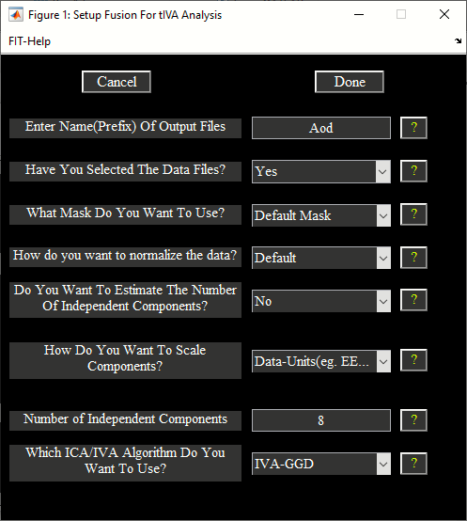

Figure 3.38: Setup Analysis (tIVA)

***Display***

Figure 3.39 shows the components sorted based on two sample t-test between the mixing coefficients.

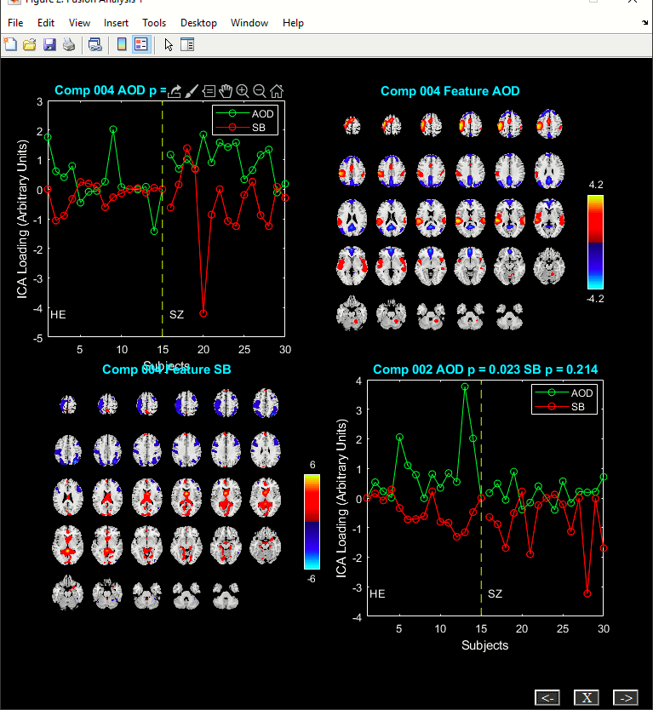

Figure 3.39: Components sorted using the two sample t-test on the loading coefficients

## Parallel Group ICA + ICA (PGICA)

PGICA approach incorporates temporal information from group ICA into a parallel ICA framework and can detect linked function network connectivity and structural covariations if first level fMRI and sMRI data-sets are used. The following GUI will open when you click on PGICA button in the Figure 3.1. User interface controls are explained in the sections Setup Analysis, Run Analysis and Display.

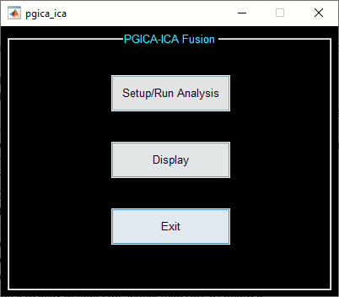

Figure 3.40: PGICA-ICA fusion toolbox

***Setup Analysis***

When you click on the setup Analysis button, option is provided to enter all subjects data for sMRI (Figure 3.41) and fMRI (Figure 3.42) modalities. After the data is selected, Figure 3.43 will open for PGICA fusion.

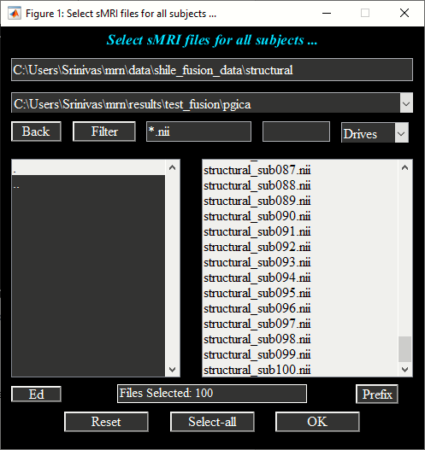

Figure 3.41: sMRI data selection

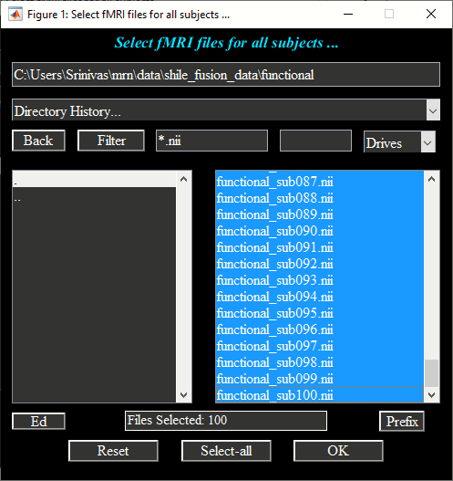

Figure 3.42: fMRI data selection

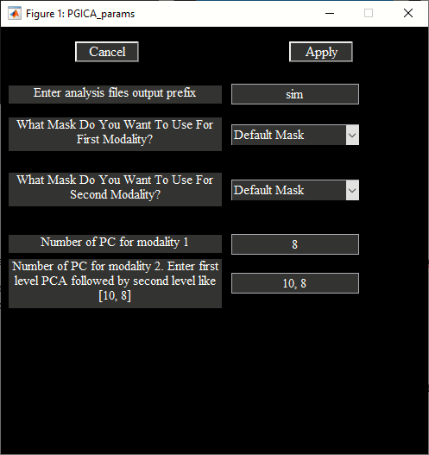

Figure 3.43: Setup Analysis (PGICA)

Each control is explained below:

* “Enter analysis files output prefix”: All the output files will be prepended with this prefix.
* “What Mask Do You Want To Use For the First Modality?” By default, average mask will be created using the individual subject masks which are obtained by selecting voxels above or equal to the mean times a multiplier.
* “What Mask Do You Want To Use For the Second Modality?” By default, average mask will be created using the individual subject masks which are obtained by selecting voxels above or equal to the mean times a multiplier. Only the first timepoint from each subject is used for fMRI data.
  + Default mask settings can be changed in the variable PGICA_ICA_DEFAULTS in file ica_fuse_defaults.m file.
  + Option is also, provided to enter a custom mask for each modality. Mask must be of the same dimensions as the original data.
* “Enter Number Of PC for modality 1” - Enter number of principal/Independent components to be extracted from the sMRI data.
* “Enter Number Of PC for modality 2” – Enter first level and second step PCA components in a vector like 10, 8 to be extracted from the data. Second step PCA components are also the number of independent components extracted from the fMRI data.

After the parameters are selected, ica options window will open to select the options for parallel ica algorithm. Session parameters are saved in file with suffix *\*pgica_ica_param_info\**mat. By default, PGICA analysis will be run on this parameter file. At the end of the analysis, components are saved with suffix *\*feature\**. Also, individual subject fMRI back-reconstructed components are saved in directory *\*backrecon*. Timecourses and spatial components are saved in GIFT format and therefore, the post-processing tools like mancova and dFNC can be computed on the group ICA output.

***Display***

Option is provided to display the components info in a HTML or PDF viewer. Figure 3.44: sMRI Component and Figure 3.45: fMRI Component show one of the sMRI and fMRI components. Linked correlations between the components is also reported in the summary.

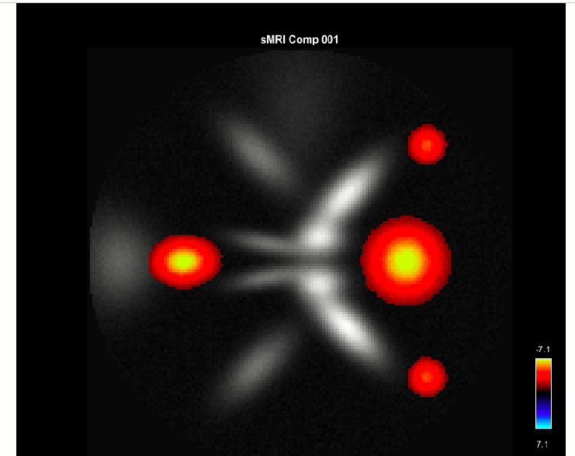

Figure 3.44: sMRI Component

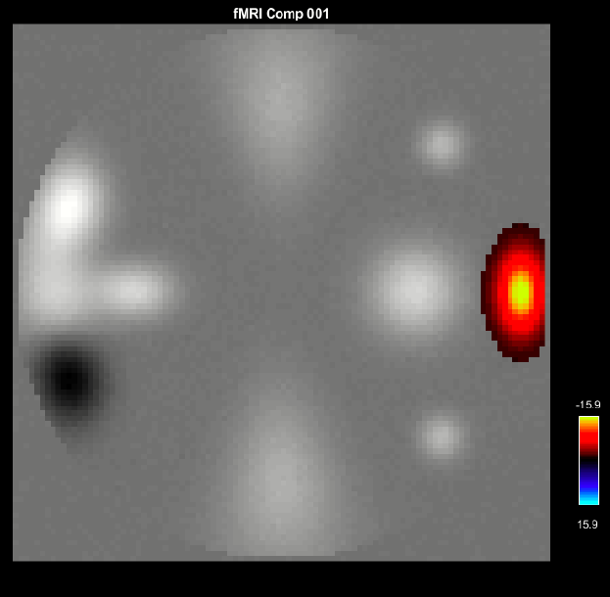

Figure 3.45: fMRI Component

## Deep Fusion

Deep fusion toolbox is based on paper (Sergey M Plis, November 2018). Deep fusion uses deep neural network for finding association between multimodal brain imaging data such as fMRI and sMRI. When you click on Deep Fusion button (Figure 3.1: Fusion ICA Toolbox), GUI will open (Figure 3.46: Deep fusion toolbox). User interface controls are explained below:

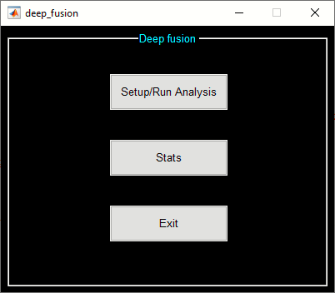

Figure 3.46: Deep fusion toolbox

**Setup Analysis**

It is assumed that you have run Source Based Morphometry (SBM in Group ICA Toolbox) and Dynamic Functional Connectivity (dFNC) analyses on the same subjects data before proceeding through deep fusion analysis. Python 2.7 is required and needs to be on system environment path and the corresponding libraries like *numpy, scipy, mkl, mkl-service, libpython, m2w64-toolchain* need to be installed using anaconda installation. To install these packages, use anaconda install:

*conda install numpy scipy mkl mkl-service libpython m2w64-toolchain*

*conda install -c conda-forge blas*

Here are the path definitions that needs to be on the environment variable PATH:

*C:\Users\Sr\Anaconda2*

*C:\Users\Sr\Anaconda2\Library\bin*

*C:\Users\Sr\Anaconda2\Library\mingw-64\bin*

*C:\Users\Sr\Anaconda2\Library\usr\bin*

*C:\Users\Sr\Anaconda2\bin*

*C:\Users\Sr\Anaconda2\Scripts*

*C:\Users\Sr\Anaconda2\condabin*

After the variables are set, invoke deep fusion toolbox using fusion command. When you click on setup analysis, a figure window will open to select the SBM parameter file (Figure 3.47) and the dFNC parameter file (Figure 3.48).

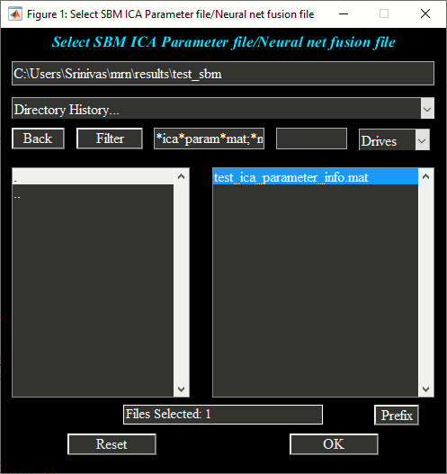

Figure 3.47: SBM parameter file selection

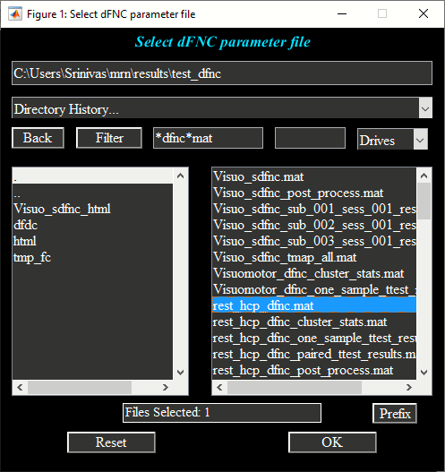

Figure 3.48: dFNC parameter file

After that select neural net fusion or deep fusion analysis output directory. Deep fusion parameters screen will open (Figure 3.49) and are explained below:

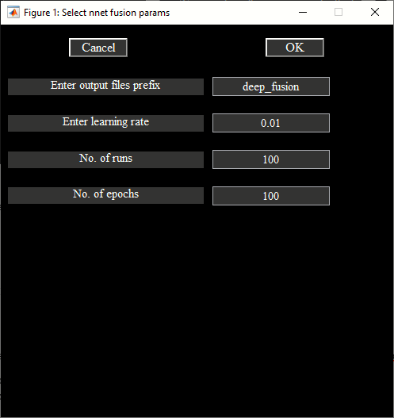

Figure 3.49: Deep Fusion parameters

* “Output files prefix”: All the output files will have this prefix.
* “Enter learning rate”: Learning rate parameter which is used in the neural net.
* “No runs”: Number of times algorithm is random initialized. The final alignments are averaged across runs.
* “No. of epochs”: Number of times algorithm is iterated to find the optimal solution.

At the end of the analysis, session parameters are saved in *\*neural_net_fusion.mat* file. Alignments or associations between the modalities are saved in file *\*alignments.mat*. The following are the variables in the MAT file:

* *alignmentInfo* – Cell array of length equal to the number of times algorithm is run. Each cell contains Number of dfnc windows by smri components by subjects variable.
* *states*_all – Number of dfnc states by smri components. All the alignments are averaged across runs for each dfnc state and smri component pair.
* *subject_alignments* – Subject specific alignments of dimensions number of subjects by dfnc states by smri components. Group statistics are performed on this variable.

**Stats**

Statistics are performed on the subject specific alignments given the group information. When you click on stats button and select groups, the following GUI will open:

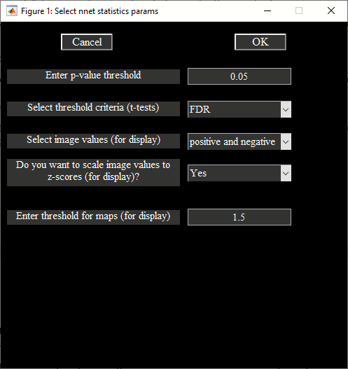

Figure 3.50: Stat parameters

In the above figure, you have options to specify p-threshold and threshold criteria for doing stats on the alignments between the groups. Options are provided for selecting sMRI component specific display parameters like threshold and scaling images to z-scores. Results are shown in the figures Figure 3.51 and Figure 3.52. Please note that statistics information is stored in *statsInfo* variable in *\*stats.mat* file.

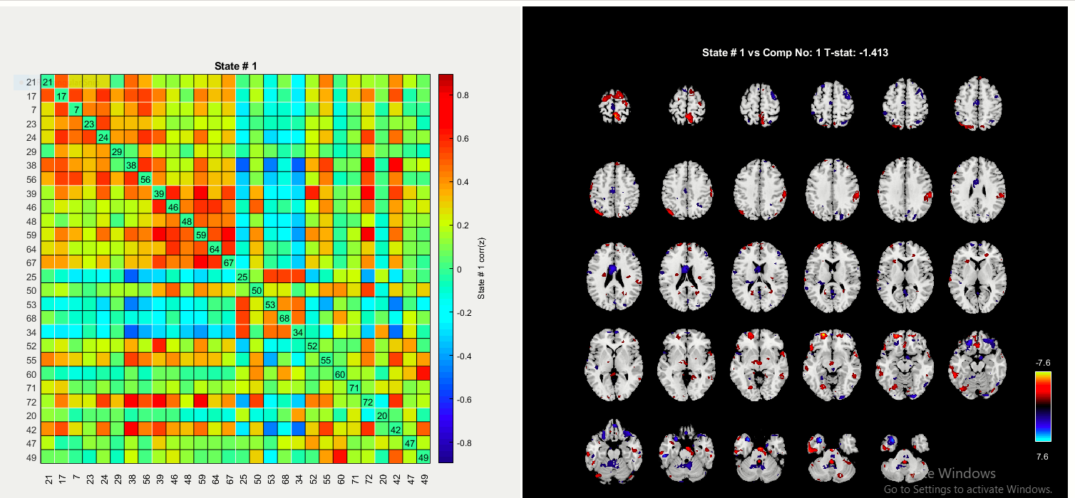

Figure 3.51: T-test is computed for each state and sMRI component

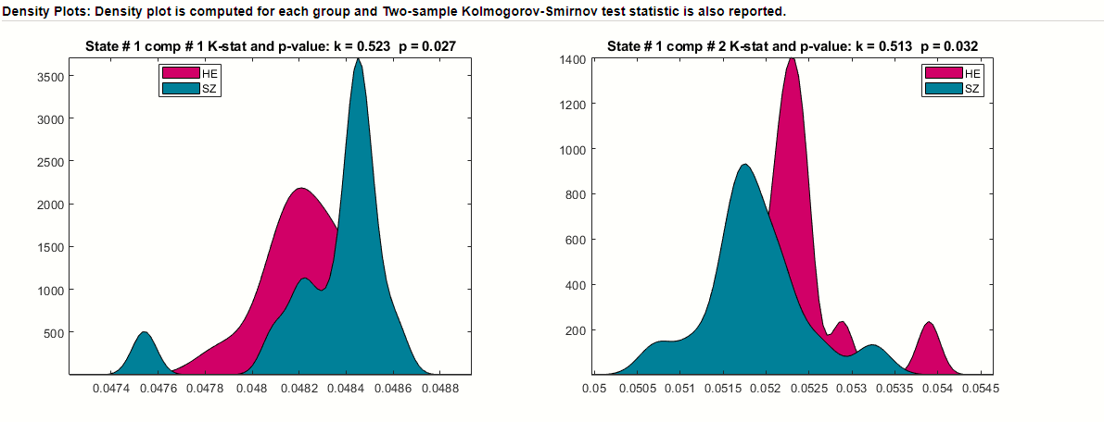

Figure 3.52: Kstest2 is computed for each state and sMRI component and density plots are shown.

## Appendix

***Defaults***

We explain some of the defaults used in FIT. The defaults file (ica_fuse_defaults.m) is in folder ica_fuse.

* Colors: Colors are RGB values. The colors used for figure and user interface controls are as follows:
  + FIG BG COLOR: Figure background color.
  + FIG FG COLOR: Figure foreground color.
  + UI BG COLOR: All user interface controls except push button have the same background color.
  + UI FG COLOR: All user interface controls except push button have the same font color.
  + BUTTON BG COLOR: Push button background color.
  + BUTTON FG COLOR: Push button font color.
  + AX COLOR: Axes background color.
  + LEGEND COLOR: Legend color
* Font defaults are as follows:
  + UI FONT NAME: Font name.
  + UI FONT UNITS: Font units.
  + UI FONT SIZE: Font size.
* Display defaults: Display defaults for spatial maps are as follows:
  + CONVERT TO Z: Convert images to Z-scores. Options are ’Yes’ and ’No’.
  + Z THRESHOLD: Z threshold for spatial maps. Default value is 1.5.
  + IMAGE VALUES: Option is provided to display activations (’Positive’), activations and de-activations (’Positive’ and ’Negative’), absolute value (’Absolute’) and de-activations (’Negative’).
  + IMAGES PER FIGURE: Number of images plotted in one figure. Options are ’1’, ’4’ and ’9’.
  + ANATOMICAL FILE: Anatomical file used for overlaying components.
  + ANATOMICAL PLANE: Options are ’Axial’, ’Sagittal’ and ’Coronal’.
* OPTIMIZE FEATURES: Option is provided to run ICA on different combinations of features. You can turn off this option by setting a value of ’No’.
* FWHM VALUE: Smoothness factor used for dimensionality estimation.
* DIVERGENCE PARAMETERS: Divergence criteria and number used when calculating spatial divergence.
* Options are ’kl’ (Kullback Liebler), ’j’ (J), ’alpha’ (Apha), ’renyi’ (Renyi). Kullback Liebler and J divergence doesn’t need a number.
* EEG DATA INDICES: Default mask used for EEG modality. Default value is [50:500].
* NUM RUNS ICA: Number of times you want ICA to be run. Default value is 1.
* STANDARDIZE SUBJECTS: This option lets you convert feature data of each subject to Z-scores.
* Z THRESHOLD HISTOGRAM: Z threshold applied on the selected component when calculating histograms of features.
* NUM BINS: Number of bins used for calculating histogram.
* FLIP SIGN COMPONENTS: Components will be flipped when sign of beta weight is negative with respect to a feature. You can turn off this by setting a value of 0.
* FLIP ANALYZE IM: Flip parameter for analyze images. Default value is 0.

# Bibliography

J . Sui, T. Adali, G. D. Pearlson, V. P. Clark and V. D. Calhoun. (2009). A method for accurate group difference detection by constraining the mixing coefficients in an ICA framework. *HBM*.

J. Chen, V. D. Calhoun, J. Liu. (2012). ICA Order Selection Based on Consistency: Application to Genotype Data. *EMBC*, 360-363.

J. Liu, G. D. Pearlson, A. Windemuth, G. Ruano, N. I. Perrone-Bizzozero, and V. D. Calhoun. (2007). Combining fMRI and SNP Data to Investigate Connections between Brain Function and Genetics Using Parallel ICA. *HBM*.

J. Liu, O. Demirci, and V. D. Calhoun. (2008). A Parallel Independent Component Analysis Approach to Investigate Genomic Influence on Brain Function. *IEEE Signal Proc.*, 413-416.

J. Sui, T. Adali, G. D. Pearlson and V. D. Calhoun. (2009). An ICA-based method for the identification of optimal FMRI features andcomponents using combined group-discriminative techniques. *Neuroimage*, 73-86.

J. Sui, T. Adali, G. D. Pearlson, H. Yang, S. R. Sponheim, T. White, V. D.Calhoun. (2010). A CCA+ICA Based Model for Multi-Task Brain Imaging Data Fusion And ItsApplication to Schizophrenia. *Neuroimage*, 123-124.

Sergey M Plis, M. F. (November 2018). Reading the (functional) writing on the (structural) wall: Multimodal fusion of brain structure and function via a deep neural network based translation approach reveals novel impairments in schizophrenia. *NeuroImage, 181*(1), 734-74.

T. Adali Y. Levin-Schwartz, a. V. (Sep 2015). Multimodal data fusion using source separation: Application to medical imaging. *Proc. IEEE, 103*(9), 1494-1506.

V. D. Calhoun and T. Adali. (2006). A Feature-Based Approach To Combine Functional MRI, Structural MRI and EEG Brain Imaging Data. *EMBS*.

V. D. Calhoun, T. Adali, G. D. Pearlson and K. A. Kiehl. (2006). Neuronal chronometry of target detection: Fusion of hemodynamic and event-related potential data. *Neuroimage*.

V. D. Calhoun, T. Adali, K. A. Kiehl, R. Astur, J. J. Pekar and G. D. Pearlson. (2005). A Method for Multitask fMRI Data Fusion Applied to Schizophrenia.

Y.-O. Li, T. Adali and V. D. Calhoun. (2007). Estimating the number of independent components for fMRI data. *HBM*, 1251-1266.

1. Contrast image, ICA spatial map, EEG signal or SNP array