Engl. 1102.090– Reading Literature and Culture: Hackers in Literature
Final Exam
Wednesday, Apr 26, 2017 (19:00 - 22:00) NWS S2802
David N. Wright
Douglas College

There are THREE SECTIONS to this exam. All are mandatory. The exam is out of 72.

This exam is open textbook. You may use any texts from the course reading list. You may also use a mobile device or laptop to access information on the class website.

You cannot share texts or access to laptops / mobile devices. YOU MUST BRING YOUR OWN COURSE MATERIALS AND DEVICES.

NO PERSONAL NOTES ARE ALLOWED—ONLY ACCESS TO CLASS TEXTS / MATERIALS.

THE USE OF NOTES WILL RESULT IN THE CONFISCATION OF YOUR CLASS TEXTS / MATERIALS (INCLUDING ACCESS TO THE WEBSITE) FOR THE DURATION OF THE EXAM.

Answer all questions in the exam booklet in pen or pencil. Please be sure to identify the question you are answering carefully, using the specific section and number.

If your handwriting is hard to read, double space. If not, feel free to single space.

If you write something in error, a simple, single line, crossout will tell me not to read it. Please do not use liquid paper, or “white out.”

Please do not take apart, tear, or otherwise mangle, the exam booklet. Ask for another one.

You may use a dictionary, and/or a thesaurus.

Cell phones may be used to track time, but I reserve the right to take them away if they are being used excessively or for purposes other than tracking time.

Please return the exam with your exam booklet by slipping it inside the booklet cover.

If you need to go to the bathroom, please do so.

GOOD LUCK!!

The exam has three sections: All are mandatory. The Exam is out of 72.
You may answer the questions in any order, but please precisely identify the question and section number in your answer.
Good Luck!!

Section I: Identify and define seven (7) of the terms below in their context of relevance to this course. I.e., briefly suggest for each what/who it is, major defining characteristic(s), and/or its conceptual importance to the topics we’ve been studying, and perhaps, an example.

7 questions x 3 points each = 21 (Maximum 200 words for each question)

- Stuart Hall
- Erasure / The Other
- Art3mis
- Game vs. Play
- Persona
- OASIS
- Agrippa

Section II: Below are quotations from some of the texts we studied in the second half of the course. For each quotation, identify and explain the significance as it is related to any of the themes (or thematic contexts) we have discussed this half of the semester. You may refer to events or formal elements that occur outside the quote, but your answers should directly address the quote, and the particularities evident in the quote.

Hint: The quotations are not designed to trick you; each has relevance to, or is related to, one or more or the themes and central concepts we have covered in the course (either online or in class). Some themes include, but are not limited to, narrative structure, representation, personae, alternate reality, race, identity, friendship, and immortality. (Not all these themes will apply to every quote—these are merely guidelines—you will need to pinpoint the relationship of the quote to a theme or concept you identify). You might also look to how the quote references or alludes to other texts.

6 questions x 5 points = 30 (Maximum 350 words for each question)

- “I used a voice command to pull up my OASIS map, hoping to learn where the gate had transported me. But it turned out that not only was I no longer on Middletown, I was no longer in the OASIS at all. My locator icon was in the middle of a blank screen, which meant I was OTM—off the map. When I’d stepped into the gate, it had transported my avatar into a stand-alone simulation, a virtual location separate from the OASIS. It seemed the only way I could get back would be to clear the gate by completing the quest. But if this was a videogame, how was I supposed to play it? If this was a quest, what was my goal? I continued to play Galaga while pondering these questions.” (Cline 109)

- “When Aech first logged into the OASIS, she followed her mother’s advice and created a Caucasian male avatar. ‘H’ had been her mother’s nickname for her since she was a baby, so she'd decided to use it as the name of her online persona. A few years later, when she started attending school online, her mother lied about her daughter’s race and gender on the application. Aech was required to provide a photo for her school profile, so she’d submitted a photorealistic rendering of her male avatar’s face, which she’d modeled after her own features.” (Cline 320)

- “There were hundreds of cyberpunk-themed worlds spread throughout the OASIS, but Neonoir was one of the largest and oldest. Seen from orbit, the planet was a shiny onyx marble covered in over-lapping spider-webs of pulsating light. It was always night on Neonoir, the world over, and its surface was an uninterrupted grid of interconnected cities packed with impossibly large skyscrapers.” (Cline 181)

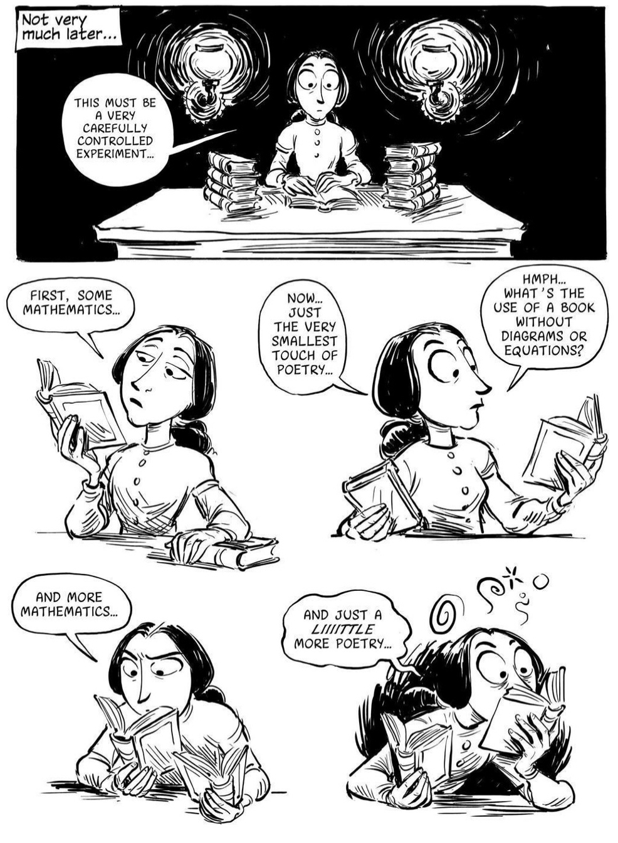(Padua 221)

5.
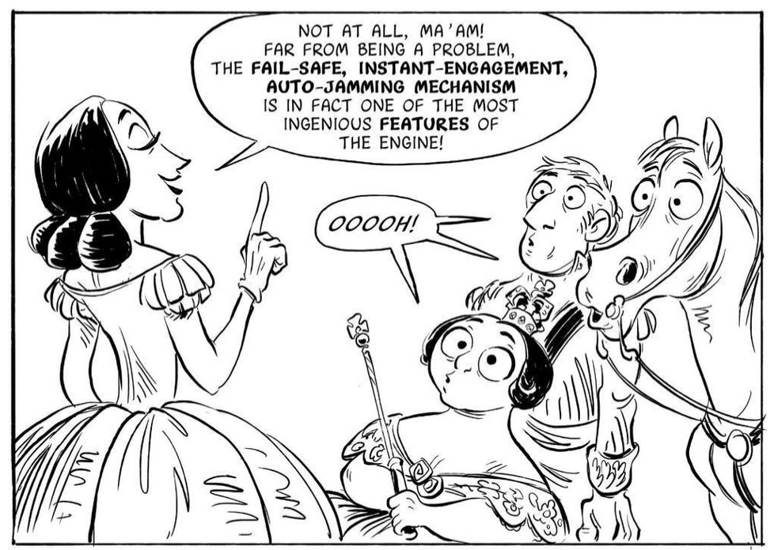 (Padua 67)

6.
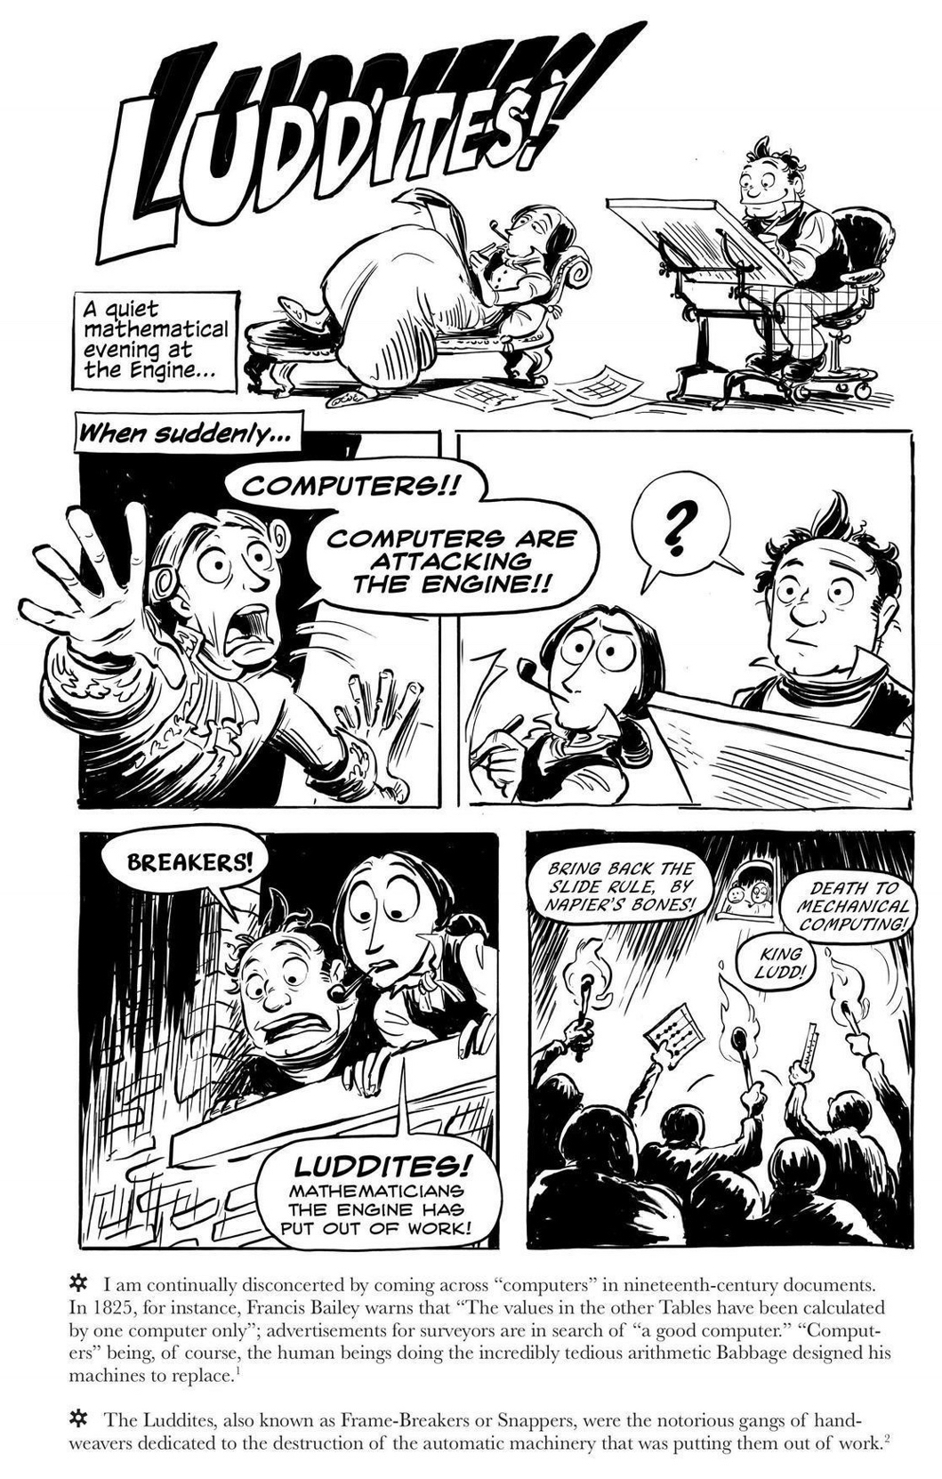(Padua 140)

Section III: Answer the question below using proper essay format: provide a brief introduction, develop your ideas in the body of the essay and then provide some concluding comments to wrap up the discussion. As a rough guideline, your essay should be no longer than three pages single-spaced. You should use the correct analytical terminology and, where possible, make direct links to the course texts, readings, and lectures. I do not expect you to quote the texts, readings, or lectures word for word, merely give reference, in your own words, to the key ideas/points/positions presented and/or discussed.

Hint: The answer to this question needs to be refined. Do not try to use everything you know and throw it out at me here. Instead, think about one single area, definition, or concept that can help you answer the question to the best of your ability. The essay should represent a refined, informed, opinion about the answer, not a hodgepodge of what we covered in the course. Apply your learning to the making of an answer to the question below.

1 question x 21 points = 21 (Maximum 900 words)

- Using direct reference to at least two different texts we have read this semester (one from before the mid-term and one from after the mid-term) to support your claim, discuss how the texts represent an individual’s encounter with technology and why understanding that representation might be important to our daily lives.

Have a great summer break and good luck with your future studies!!

