The exam has three sections: All are mandatory. The Exam is out of 72.
You may answer the questions in any order, but please precisely identify the question and section number in your answer.
Good Luck!!

Section I: Identify and define seven (7) of the terms below in their context of relevance to this course. I.e., briefly suggest for each what/who it is, major defining characteristic(s), and/or its conceptual importance to the topics we’ve been studying, and perhaps, an example. If you cite texts directly—you do not need to—be sure to clearly indicate where the citation can be found.

7 questions x 3 points each = 21 (Maximum 200 words for each question)

- Stuart Hall
- Erasure / The Other
- Aech
- Game vs. Play
- Persona
- OASIS
- Agrippa

Section II: Below are quotations from some of the texts we studied in the second half of the course. For each quotation, identify and explain the significance as it is related to any of the themes (or thematic contexts) we have discussed this half of the semester. You may refer to events or formal elements that occur outside the quote, but your answers should directly address the quote, and the particularities evident in the quote.

Hint: The quotations are not designed to trick you; each has relevance to, or is related to, one or more or the themes and central concepts we have covered in the course (either online or in class). Some themes include, but are not limited to, narrative structure, representation, personae, alternate reality, race, identity, friendship, and immortality. (Not all these themes will apply to every quote—these are merely guidelines—you will need to pinpoint the relationship of the quote to a theme or concept you identify). You might also look to how the quote references or alludes to other texts.

6 questions x 5 points = 30 (Maximum 350 words for each question)

- “I used a voice command to pull up my OASIS map, hoping to learn where the gate had transported me. But it turned out that not only was I no longer on Middletown, I was no longer in the OASIS at all. My locator icon was in the middle of a blank screen, which meant I was OTM—off the map. When I’d stepped into the gate, it had transported my avatar into a stand-alone simulation, a virtual location separate from the OASIS. It seemed the only way I could get back would be to clear the gate by completing the quest. But if this was a videogame, how was I supposed to play it? If this was a quest, what was my goal? I continued to play Galaga while pondering these questions.” (Cline 109)

- “When Aech first logged into the OASIS, she followed her mother’s advice and created a Caucasian male avatar. ‘H’ had been her mother’s nickname for her since she was a baby, so she'd decided to use it as the name of her online persona. A few years later, when she started attending school online, her mother lied about her daughter’s race and gender on the application. Aech was required to provide a photo for her school profile, so she’d submitted a photorealistic rendering of her male avatar’s face, which she’d modeled after her own features.” (Cline 320)

- “I quickly lost track of time. I forgot that my avatar was sitting in Halliday’s bedroom and that, in reality, I was sitting in my hideout, huddled near the electric heater, tapping at the empty air in front of me, entering commands on an imaginary keyboard. All the intervening layers slipped away, and I lost myself in the game within the game.” (Cline 105)

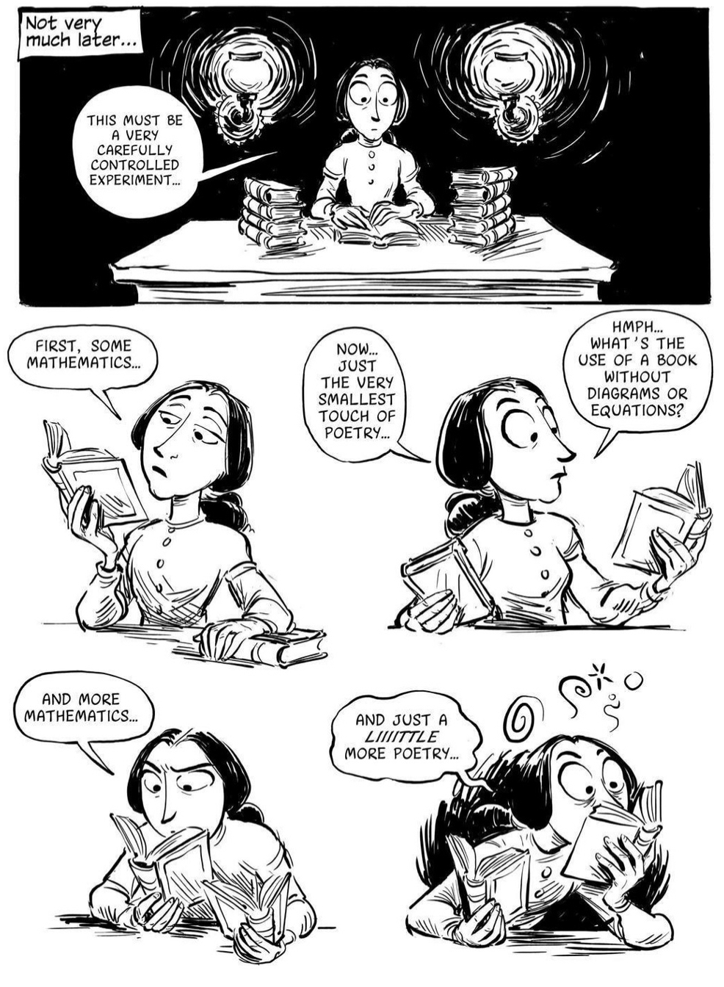(Padua 221)

5.
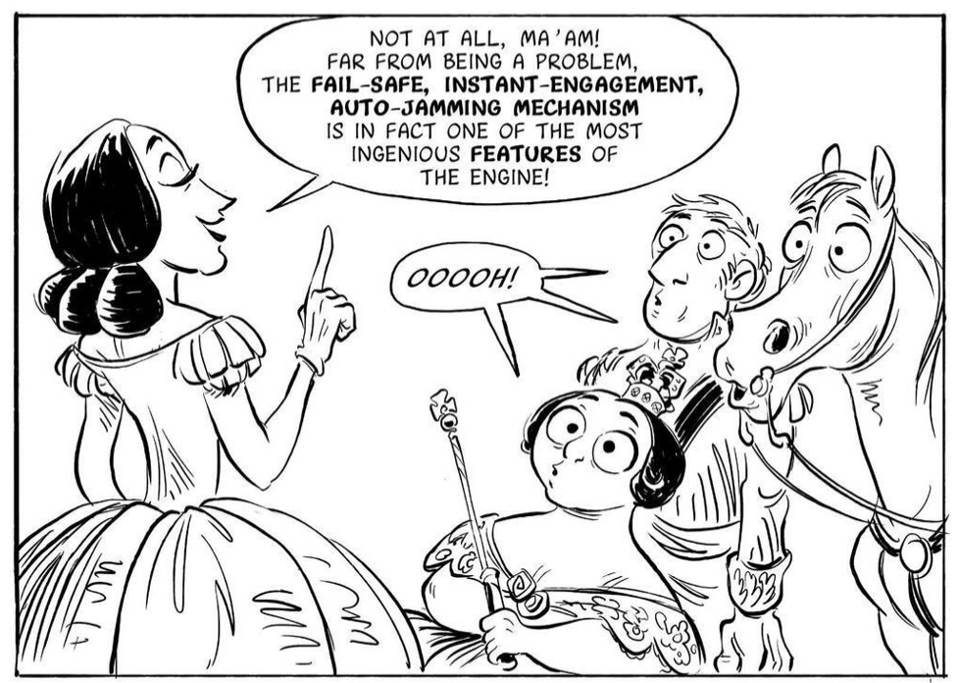 (Padua 67)

6.
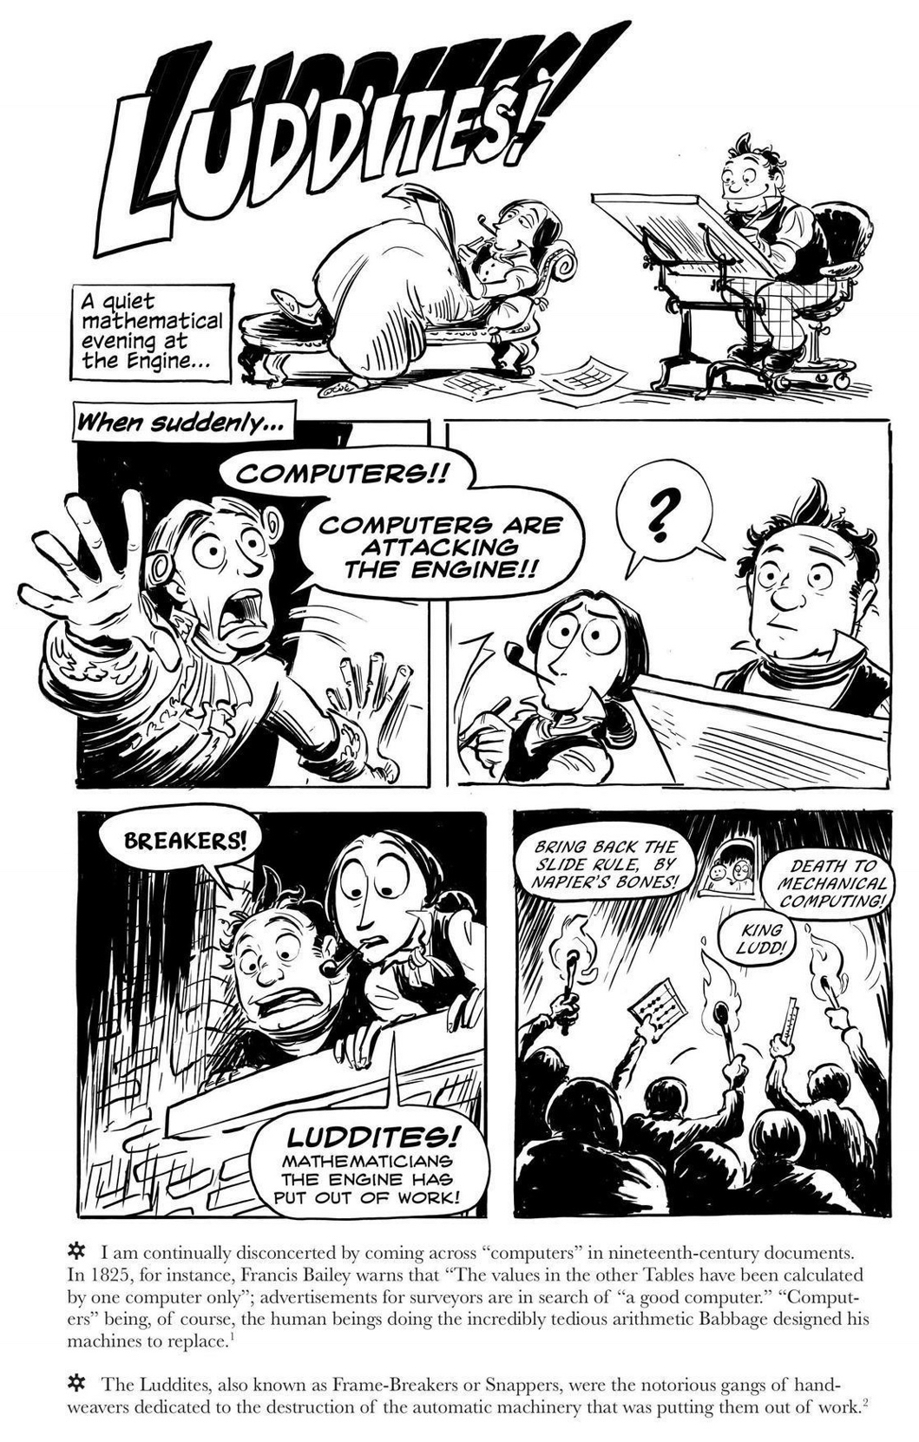(Padua 140)

Section III: Answer the question below using proper essay format: provide a brief introduction, develop your ideas in the body of the essay and then provide some concluding comments to wrap up the discussion. As a rough guideline, your essay should be no longer than three pages single-spaced. You should use the correct analytical terminology and, where possible, make direct links to the course texts, readings, and lectures. I do not expect you to quote the texts, readings, or lectures word for word, merely give reference, in your own words, to the key ideas/points/positions presented and/or discussed.

Hint: The answer to this question needs to be refined. Do not try to use everything you know and throw it out at me here. Instead, think about one single area, definition, or concept that can help you answer the question to the best of your ability. The essay should represent a refined, informed, opinion about the answer, not a hodgepodge of what we covered in the course. Apply your learning to the making of an answer to the question below.

1 question x 21 points = 21 (Maximum 900 words)

- Using direct reference to at least two different texts we have read this semester (one from before the mid-term and one from after the mid-term) to support your claim, discuss how the texts represent an individual’s encounter with technology and why understanding that representation might be important to our daily lives.

Have a great winter break and good luck with your future studies!!

