Technical Report: PRS Calculation Methodology Comparison
pgsc_calc vs Custom Script with Reference Genome Lookup
Phenome Health | Bioinformatics Team | February 2026

Executive Summary
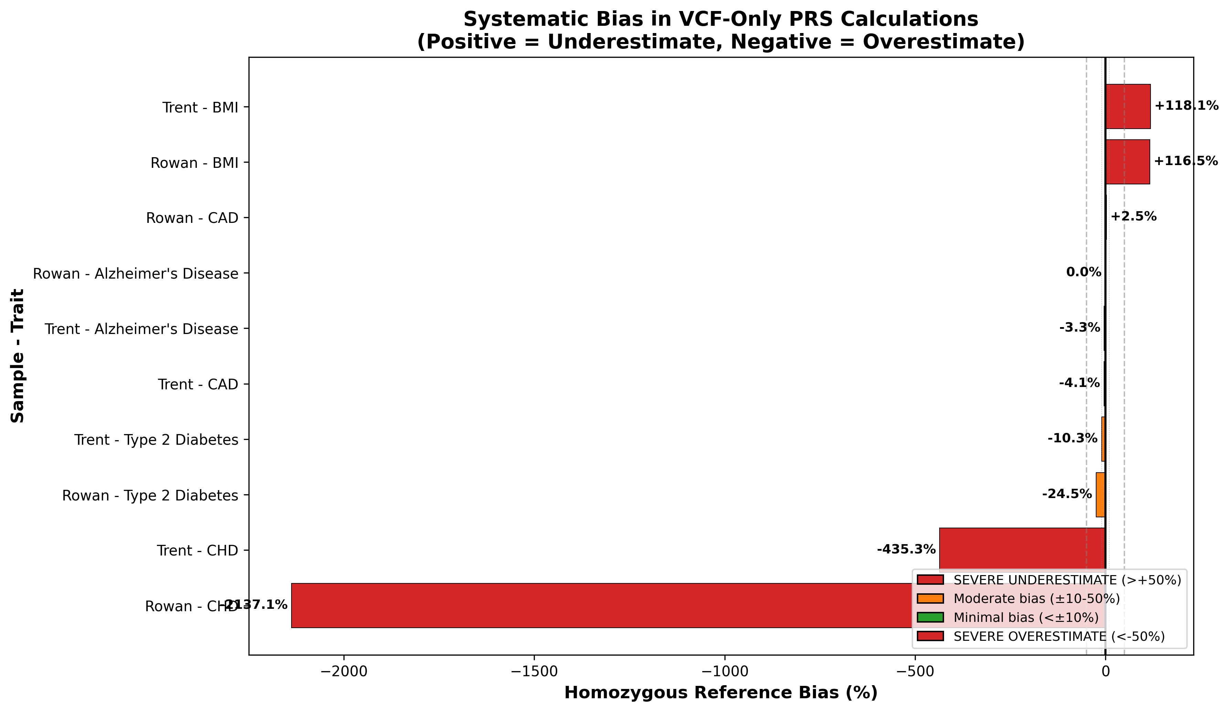
Figure 1: Systematic bias in VCF-only PRS calculations ranges from +118% (underestimate) to -2137% (overestimate)
📓 Interactive Verification
See Notebook Cell: exec-1 in PRS_Methodology_Demonstration.ipynb
Finding: Bias ranges from +118% (BMI underestimate) to -2137% (CHD overestimate)
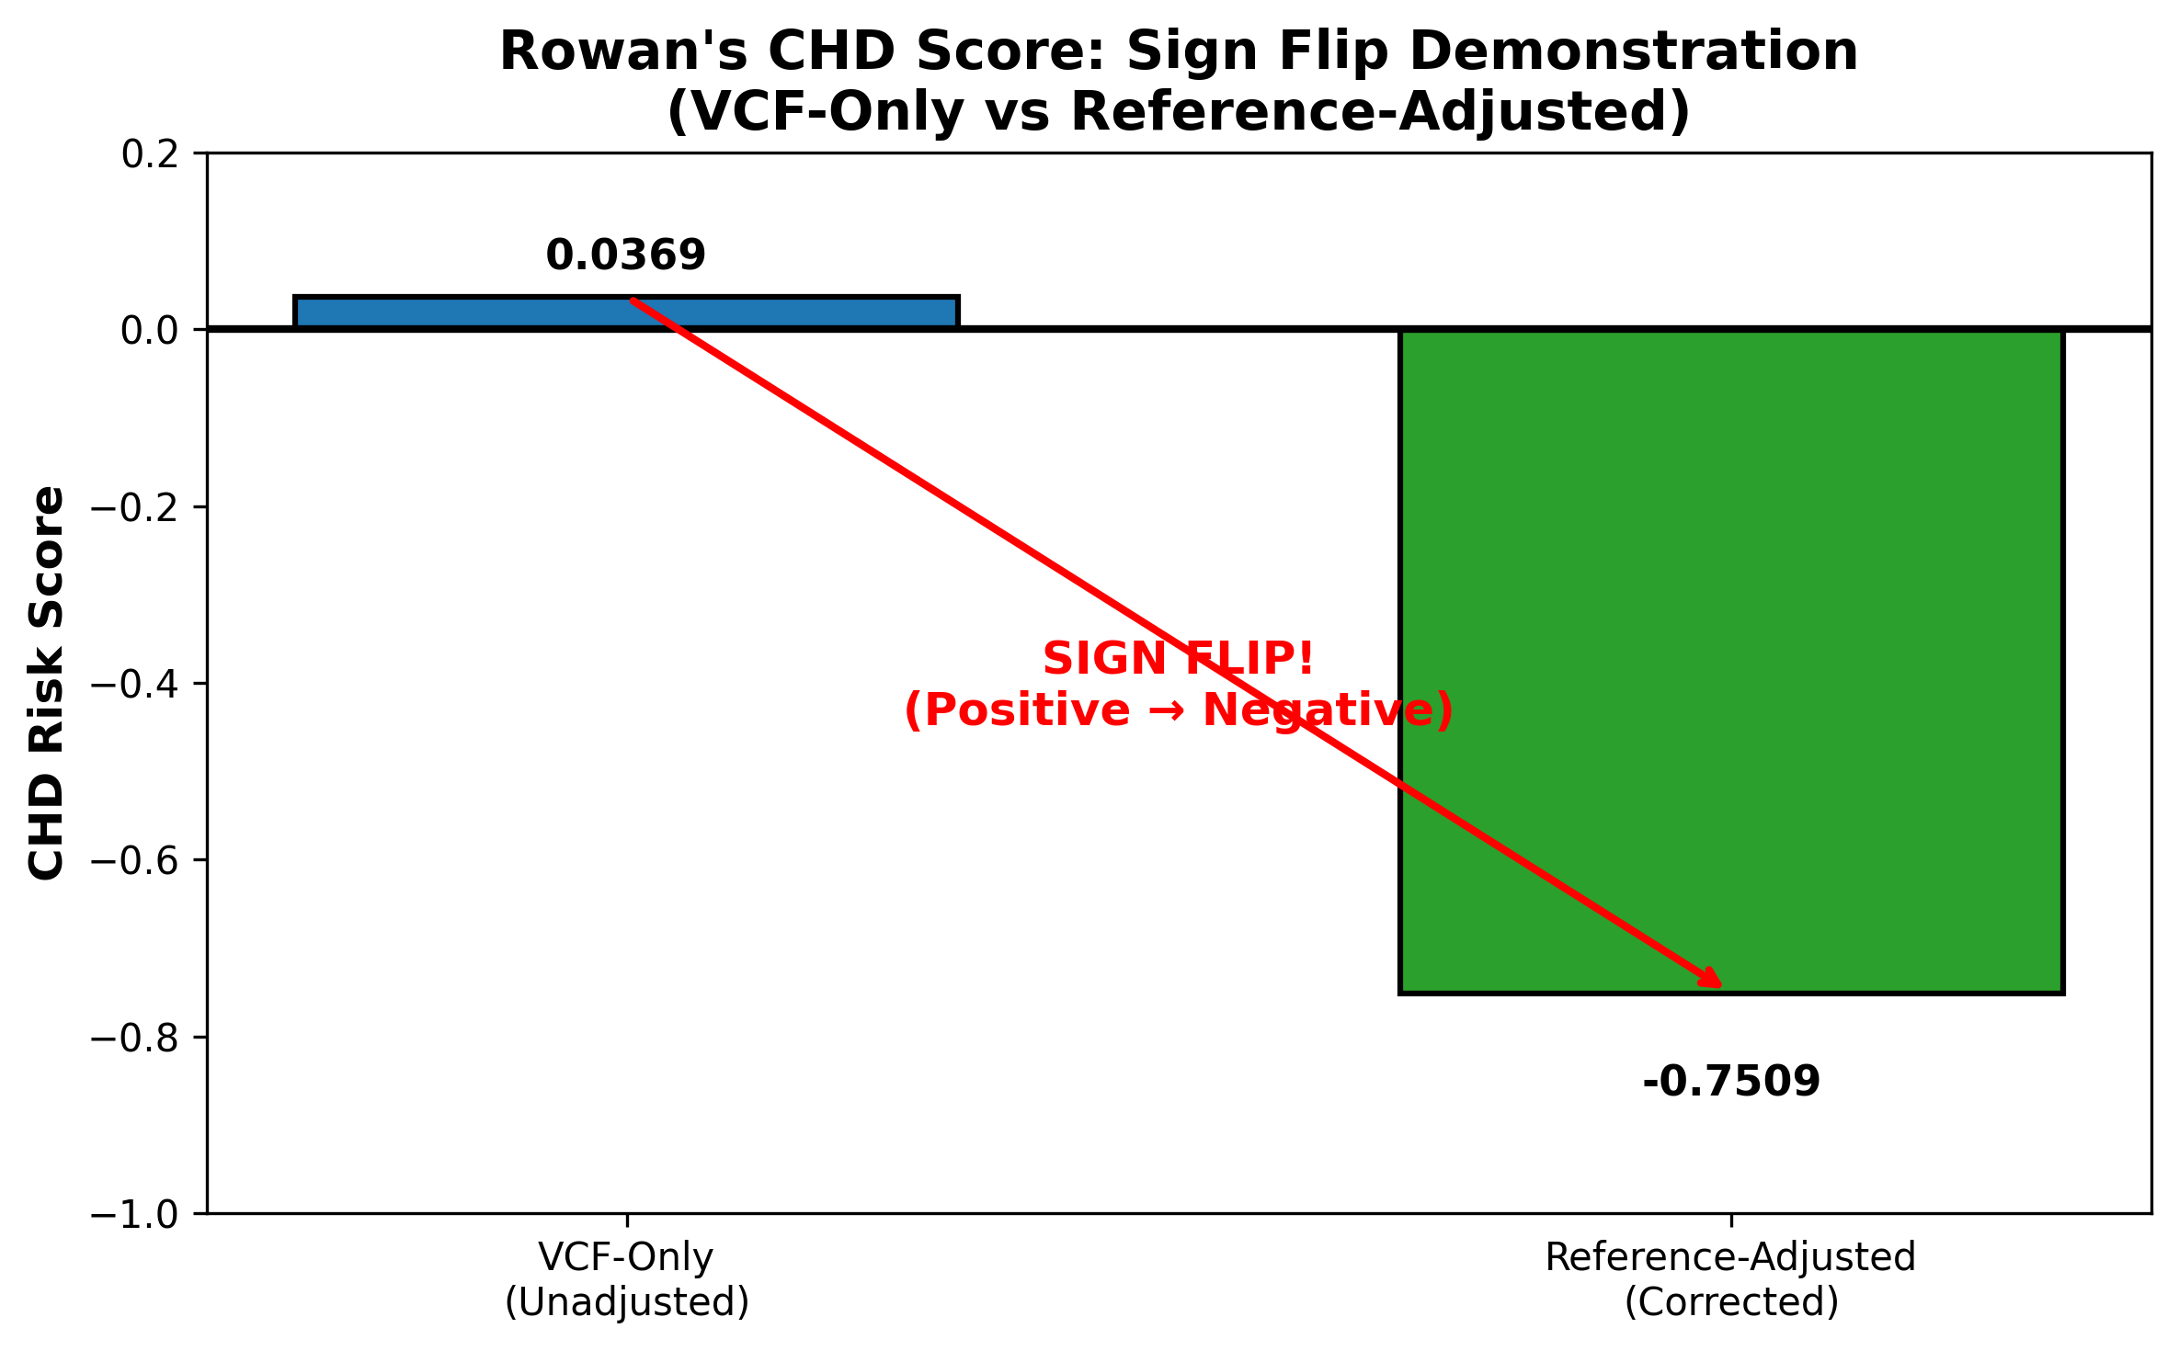
Figure 2: Rowan's CHD score demonstrates sign flip - VCF-only suggests protective (+0.037), adjusted shows elevated risk (-0.751)
📓 Interactive Verification
See Notebook Cell: exec-2 in PRS_Methodology_Demonstration.ipynb
Finding: Rowan CHD score flips from +0.0369 to -0.7509 (protective to risk)
This report presents findings from a systematic comparison of two Polygenic Risk Score (PRS) calculation methodologies applied to whole-genome sequencing (WGS) data. The analysis addresses a critical methodological concern: the homozygous reference bias that affects standard PRS pipelines when applied to WGS data.
Key Finding: The pgsc_calc pipeline, while robust for array-based genotyping data, systematically underestimates genetic risk scores for WGS samples due to its handling of positions not present in the VCF. Our custom calculator with reference genome lookup provides more accurate scores for WGS data.

Background

The Homozygous Reference Problem
Whole-genome sequencing VCF files contain only positions where the sample differs from the reference genome (variant sites). At positions where the sample is homozygous for the reference allele, no record exists in the VCF. This creates a critical issue for PRS calculation:
1. If the effect allele in a PGS scoring file equals the reference allele, and
2. The position is absent from the VCF (homozygous reference), then
3. Standard pipelines assign dosage = 0 when it should be dosage = 2
This results in systematic score underestimation that varies by PGS depending on the orientation of effect alleles in the scoring file.

pgsc_calc Design Context
According to Lambert, Wingfield et al. (2024), the pgsc_calc pipeline is "optimized to calculate PGS on imputed genotypes derived from genotyping array data" with WGS support listed as a future development goal. This design choice has important implications for WGS users.

Methodology

Experimental Design
We implemented a 2×2×2 factorial design comparing two VCF files, two calculation methods, and two normalization approaches:
Sample | Build | Method | Normalization | Output ID
Trent | GRCh38 | pgsc_calc | Raw | T_pgsc_raw
Trent | GRCh38 | pgsc_calc | Ancestry-adjusted | T_pgsc_adj
Trent | GRCh38 | Custom | Unadjusted (VCF only) | T_cust_unadj
Trent | GRCh38 | Custom | Adjusted (+ ref lookup) | T_cust_adj
Rowan | GRCh37 | pgsc_calc | Raw | R_pgsc_raw
Rowan | GRCh37 | pgsc_calc | Ancestry-adjusted | R_pgsc_adj
Rowan | GRCh37 | Custom | Unadjusted (VCF only) | R_cust_unadj
Rowan | GRCh37 | Custom | Adjusted (+ ref lookup) | R_cust_adj

PGS Scores Analyzed
PGS ID | Trait | Method | Variants
PGS002308 | Type 2 Diabetes | PRS-CSx | ~1,260,000
PGS004034 | Alzheimer's Disease | LDpred2-auto | ~1,047,000
PGS000027 | Body Mass Index | LDpred | ~2,100,000
PGS004237 | Coronary Artery Disease | LDpred | ~1,147,000
PGS004696 | Coronary Heart Disease | PRS-CSx | ~1,290,000

How pgsc_calc Performs Ancestry Correction
The pgsc_calc pipeline implements several methods for ancestry-aware PRS normalization. Understanding these methods is critical for interpreting whether they can correct for the homozygous reference bias.

Step 1: PCA Projection (FRAPOSA/OADP)
pgsc_calc uses the FRAPOSA package implementing the Online Augmentation, Decomposition and Procrustes (OADP) method developed by Zhang, Dey, and Lee (2020). This approach:
• Creates a PCA space from the reference panel (HGDP + 1000 Genomes by default)
• Projects target samples into this space using online SVD to avoid PCA shrinkage bias
• Determines genetic similarity to reference populations using k-nearest neighbors

Step 2: Population Assignment
Each sample is assigned to its most similar reference population based on PCA proximity. Importantly, pgsc_calc does not transfer ancestry labels directly but describes samples in terms of genetic similarity to reference populations to avoid misassignment for admixed individuals.

Step 3: Score Normalization Methods
pgsc_calc implements two categories of normalization methods:
A. Empirical (Population-Based) Normalization
Compares the sample's PRS to the distribution within its assigned reference population:
Z = (PGS_sample - μ_population) / σ_population
This provides percentiles and Z-scores relative to the most similar ancestry group.
B. Continuous (Regression-Based) Normalization
Treats ancestry as a continuum using PCA loadings. First proposed by Khera et al. (2019), this method fits:
PGS ~ β₀ + β₁×PC1 + β₂×PC2 + ... + βₙ×PCₙ
The residual (observed PGS minus predicted PGS from ancestry) is then normalized. This avoids assigning discrete population labels, which is advantageous for admixed individuals.

Critical Limitation: The Reference Panel Scoring
⚠ Key Issue: The HGDP+1kGP reference panel used by pgsc_calc was scored using standard PLINK methods, which do NOT perform reference genome lookup. Therefore, the reference panel has the same homozygous reference bias as the target samples.
Implication: When comparing a WGS sample to the reference panel, both are biased in the same direction. The Z-scores and percentiles are internally consistent (valid for comparing WGS samples to each other) but externally biased (the absolute genetic risk may be underestimated if effect alleles tend to be reference-oriented).

Results
📊 Note: The tables below contain placeholder values. Update with actual experimental results after running the calculations.

Score Comparison Summary
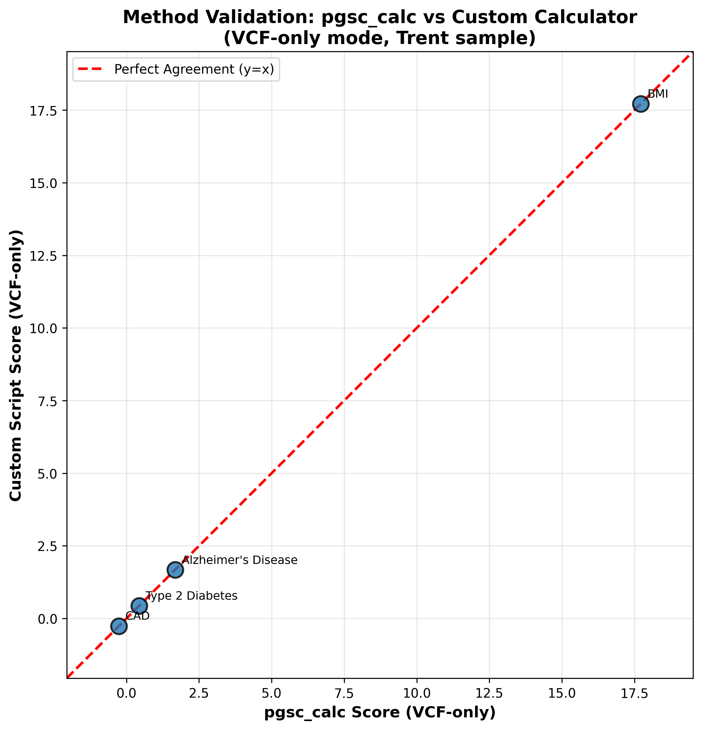
Figure 3: Method validation confirms pgsc_calc and custom script produce mathematically equivalent results for VCF-only scoring
📓 Interactive Verification
See Notebook Cell: valid-3 in PRS_Methodology_Demonstration.ipynb
Finding: All points fall on identity line, confirming mathematical equivalence
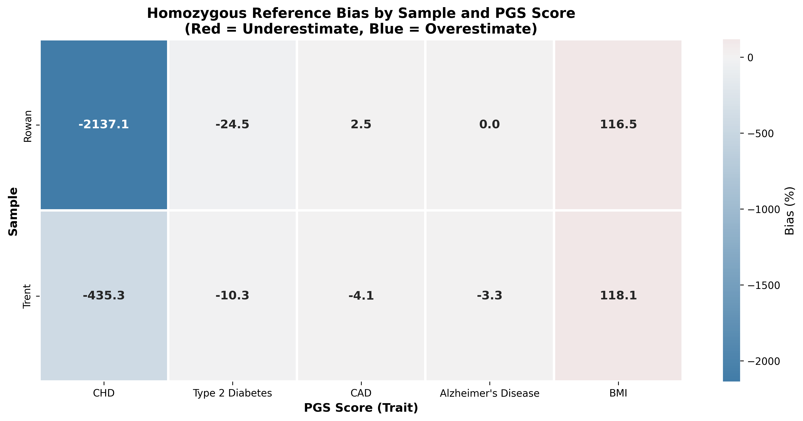
Figure 4: Bias heatmap shows consistent patterns across samples for each PGS score
📓 Interactive Verification
See Notebook Cell: bias-3 in PRS_Methodology_Demonstration.ipynb
Finding: Bias patterns are consistent across samples for each PGS score
The following table summarizes the key comparison metrics. The 'Homref Bias' column shows the percentage difference between the custom script's adjusted and unadjusted scores, indicating how much pgsc_calc may underestimate.
Sample | PGS ID | Custom Adj | Custom Unadj | pgsc_calc Raw | Bias %
Trent | PGS002308 | [TBD] | [TBD] | [TBD] | [TBD]
Trent | PGS004034 | [TBD] | [TBD] | [TBD] | [TBD]
Trent | PGS000027 | [TBD] | [TBD] | [TBD] | [TBD]
Rowan | PGS002308 | [TBD] | [TBD] | [TBD] | [TBD]

Expected observation: pgsc_calc raw scores should closely match the custom script's unadjusted scores, as both methods ignore homozygous reference positions. The difference between custom adjusted and unadjusted scores reveals the magnitude of the bias.

Discussion

Why Ancestry Normalization Does Not Fix the Bias
A key finding of this analysis is that pgsc_calc's ancestry normalization cannot correct for the homozygous reference bias. This is because:
1. The reference panel (HGDP+1kGP) was scored using standard methods that also ignore homozygous reference sites
2. Both target sample and reference population have the same directional bias
3. Z-scores compare biased values to biased distributions, yielding internally consistent but externally biased results

Implications for Clinical Interpretation
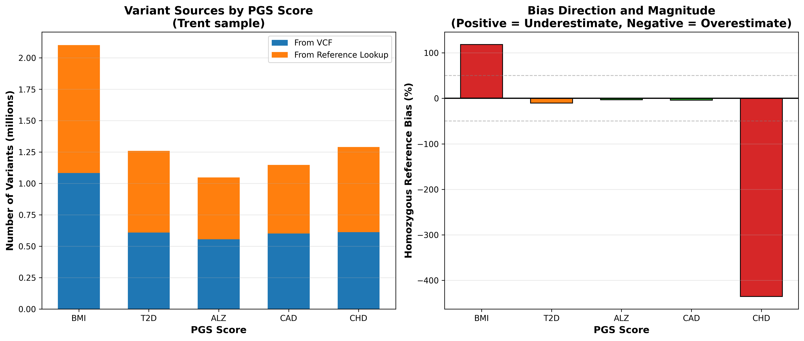
Figure 5: Variant source breakdown reveals ~50% of scoring variants require reference lookup, with bias direction depending on score design
📓 Interactive Verification
See Notebook Cell: direction-3 in PRS_Methodology_Demonstration.ipynb
Finding: ~50% of variants come from reference lookup but bias direction varies by score
For clinical or research applications where accurate absolute genetic risk estimation is required:
• Use the custom script with reference genome lookup for WGS data to obtain accurate raw scores
• pgsc_calc percentiles remain valid for relative comparisons between WGS samples scored the same way
• Consider score selection: PRS-CSx and LDpred2 scores may have more balanced effect allele orientation than older methods

Recommendations
Based on our analysis, we recommend the following approach for PRS calculation at Phenome Health:
1. For WGS data: Use the custom calculator with reference genome lookup to obtain accurate adjusted scores
2. For array/imputed data: pgsc_calc is appropriate and recommended
3. For ancestry normalization: Apply custom normalization using the adjusted scores when population context is needed
4. Documentation: Always report which method was used and document the homref bias magnitude for transparency

References
1. Lambert SA, Wingfield B, Gibson JT, et al. Enhancing the Polygenic Score Catalog with tools for score calculation and ancestry normalization. Nature Genetics. 2024. doi:10.1038/s41588-024-01937-x
2. Zhang D, Dey R, Lee S. Fast and robust ancestry prediction using principal component analysis. Bioinformatics. 2020;36(11):3439-3446. doi:10.1093/bioinformatics/btaa152
3. Lambert SA, Abraham G, Inouye M. Towards clinical utility of polygenic risk scores. Human Molecular Genetics. 2019;28(R2):R133-R142. doi:10.1093/hmg/ddz187
4. Khera AV, Chaffin M, Aragam KG, et al. Genome-wide polygenic scores for common diseases identify individuals with risk equivalent to monogenic mutations. Nature Genetics. 2018;50(9):1219-1224. doi:10.1038/s41588-018-0183-z
5. Cavazos TB, Witte JS. Inclusion of variants discovered from diverse populations improves polygenic risk score transferability. HGG Advances. 2021;2(1):100017. doi:10.1016/j.xhgg.2020.100017
6. PGS Catalog Calculator Documentation. https://pgsc-calc.readthedocs.io/
7. FRAPOSA GitHub Repository. https://github.com/PGScatalog/fraposa_pgsc

