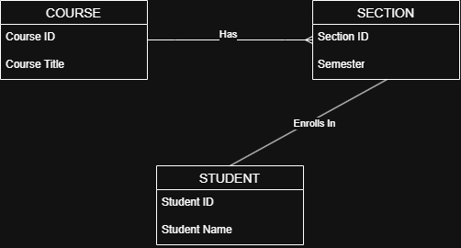
I have read and understood the MIS 600 syllabus, including the grading structure, the automatic drop policy, and the no-late-work policy.

