MySQL
Task 1.1:
DESCRIBE Order_T;
SHOW CREATE TABLE Product_T;
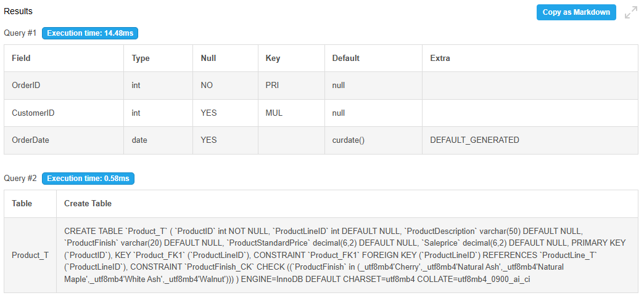
Task 1.2:
SELECT
TABLE_NAME AS TableName,
CONSTRAINT_NAME AS ForeignKeyName,
REFERENCED_TABLE_NAME AS ReferencedTable
FROM information_schema.KEY_COLUMN_USAGE
WHERE TABLE_SCHEMA = DATABASE()
AND REFERENCED_TABLE_NAME IS NOT NULL
ORDER BY TABLE_NAME, CONSTRAINT_NAME;
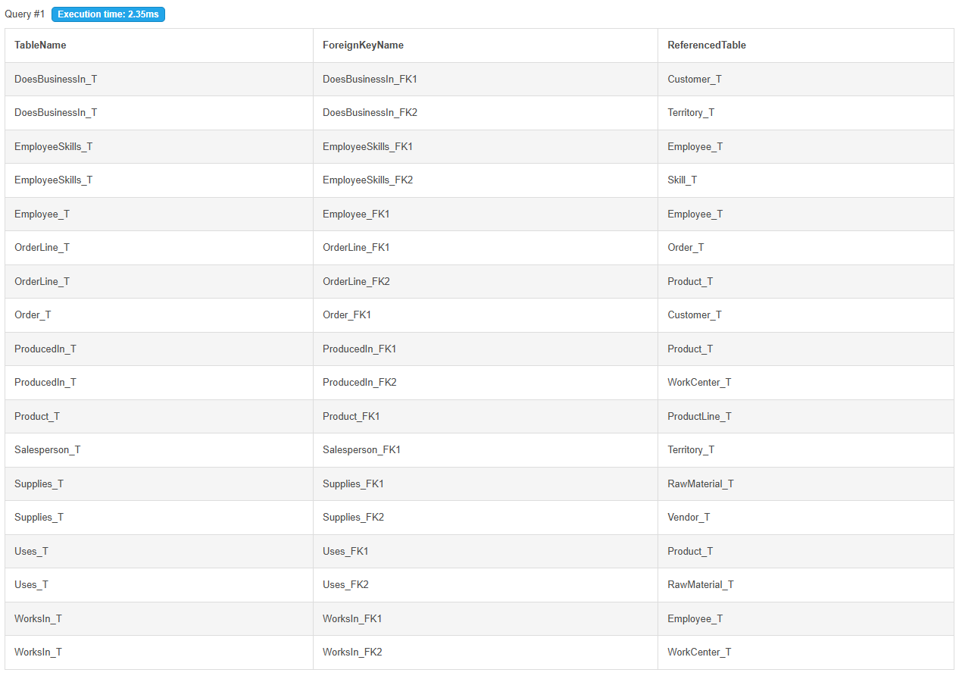

Task 2.1:
SELECT ProductID, ProductDescription, ProductStandardPrice
FROM Product_T
WHERE ProductStandardPrice < 300;
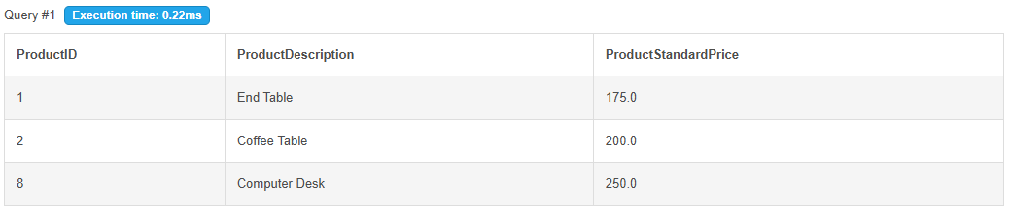

Task 2.2:
SELECT OrderID, OrderDate
FROM Order_T
WHERE OrderDate BETWEEN '2024-10-01' AND '2024-10-31'
ORDER BY OrderDate, OrderID;
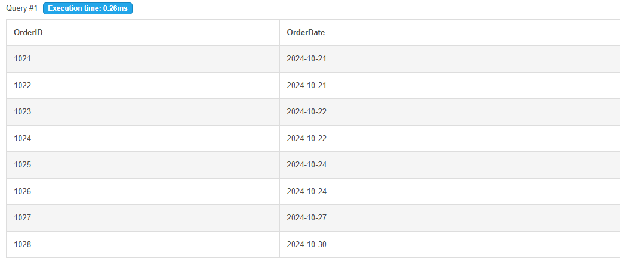

Task 2.3:
SELECT CustomerID, CustomerName
FROM Customer_T
WHERE CustomerName LIKE '%Furniture%'
OR CustomerName LIKE '%Furnishings%'
ORDER BY CustomerName;
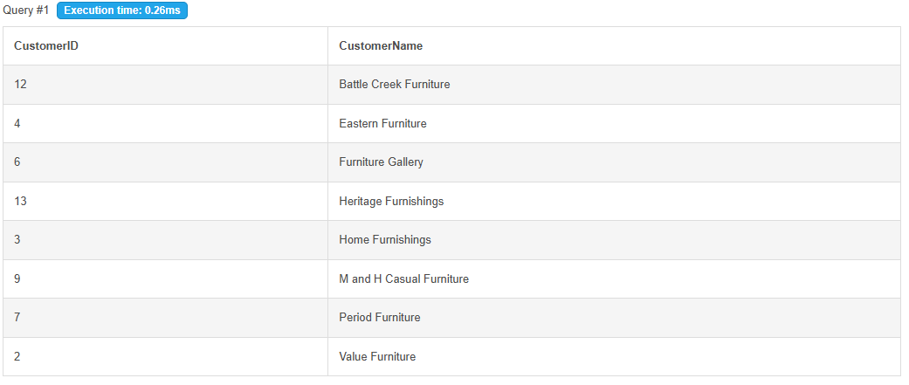

Task 2.4:
SELECT ProductDescription, ProductFinish, ProductStandardPrice
FROM Product_T
WHERE (ProductFinish = 'Cherry' OR ProductFinish = 'Walnut')
AND ProductStandardPrice > 250;
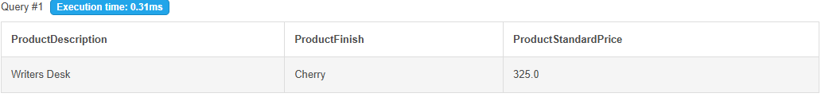

Task 2.5:
SELECT EmployeeID, EmployeeName
FROM Employee_T
WHERE EmployeeSupervisor IS NULL;
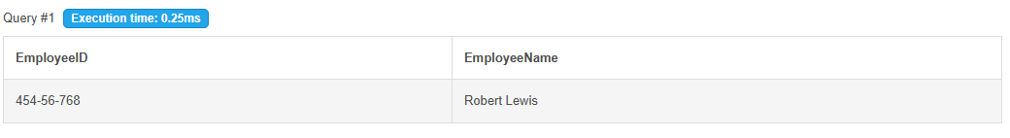

Task 3.1:
SELECT
ProductDescription,
ProductStandardPrice,
ProductStandardPrice * 0.85 AS DiscountPrice
FROM Product_T
ORDER BY ProductStandardPrice DESC;
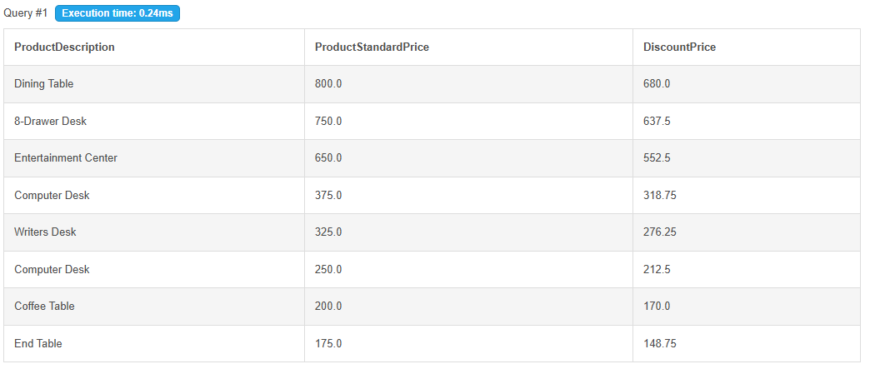

Task 3.2:
SELECT ProductDescription, ProductStandardPrice
FROM Product_T
ORDER BY ProductStandardPrice ASC
LIMIT 3;
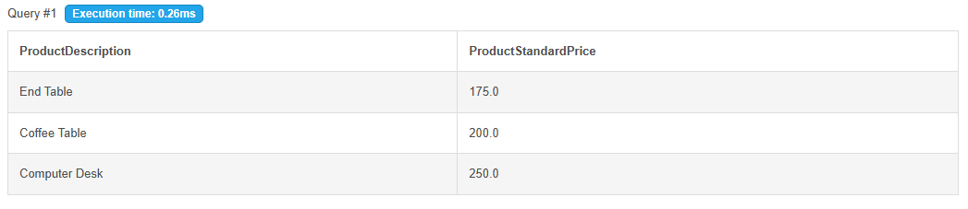

Task 3.3:
SELECT DISTINCT ProductFinish
FROM Product_T
ORDER BY ProductFinish;
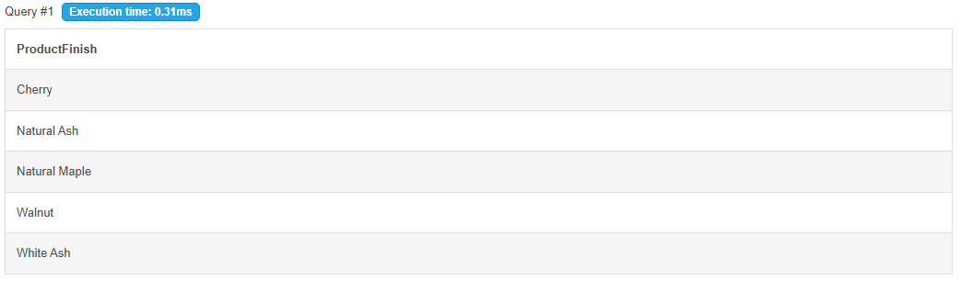

Task 4.1:
SELECT ProductID, SUM(OrderedQuantity) AS TotalUnits
FROM OrderLine_T
GROUP BY ProductID
ORDER BY TotalUnits DESC;
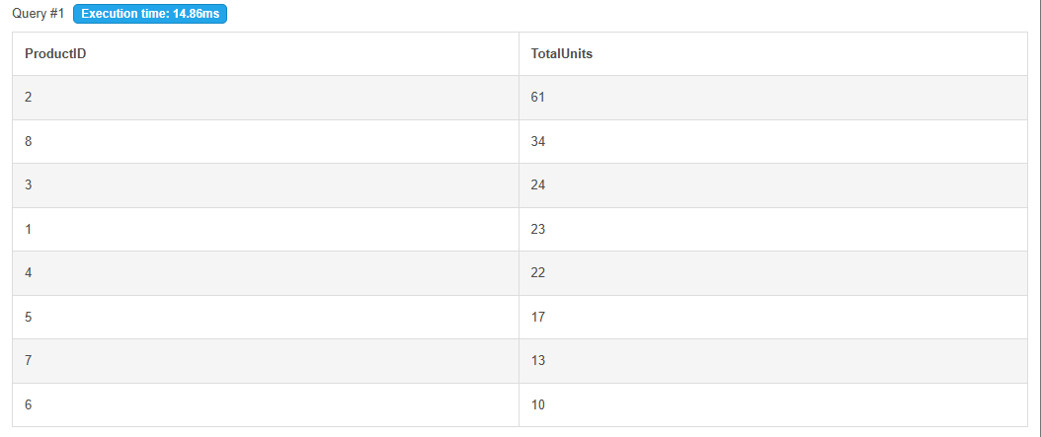

Task 4.2:
SELECT CustomerID, COUNT(*) AS NumOrders
FROM Order_T
GROUP BY CustomerID
HAVING COUNT(*) > 3
ORDER BY NumOrders DESC, CustomerID;
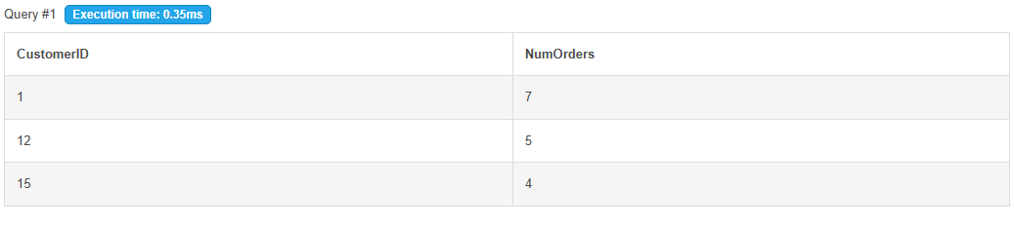

Task 4.3:
SELECT
ProductLineID,
ROUND(AVG(ProductStandardPrice), 2) AS AveragePrice
FROM Product_T
GROUP BY ProductLineID
HAVING AVG(ProductStandardPrice) > 400
ORDER BY ProductLineID;
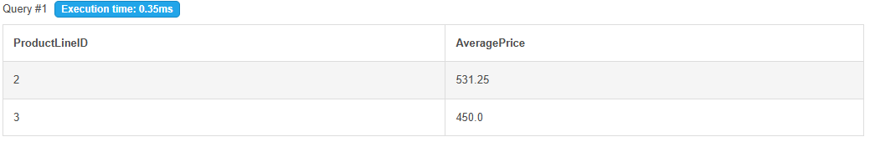

Task 4.4:
SELECT
YEAR(OrderDate) AS OrderYear,
COUNT(*) AS NumOrders,
COUNT(DISTINCT CustomerID) AS NumCustomers
FROM Order_T
GROUP BY YEAR(OrderDate)
ORDER BY OrderYear;
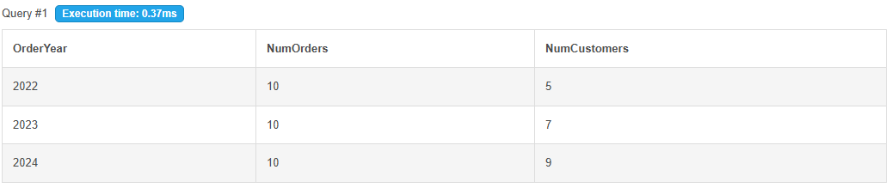

Task 4.5:
SELECT ProductFinish, COUNT(*) AS NumProducts
FROM Product_T
GROUP BY ProductFinish
HAVING COUNT(*) > 1
ORDER BY NumProducts DESC;
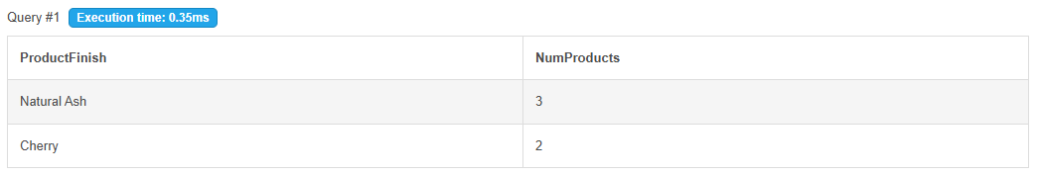

Task 5.1:
CREATE TABLE Review_T
(
ReviewID INT NOT NULL,
ProductID INT NOT NULL,
CustomerID INT NOT NULL,
Rating INT NOT NULL,
ReviewDate DATE DEFAULT (CURRENT_DATE),

CONSTRAINT Review_PK PRIMARY KEY (ReviewID),
CONSTRAINT Review_FK1 FOREIGN KEY (ProductID)
REFERENCES Product_T(ProductID),
CONSTRAINT Review_FK2 FOREIGN KEY (CustomerID)
REFERENCES Customer_T(CustomerID),
CONSTRAINT Review_CK1 CHECK (Rating BETWEEN 1 AND 5)
);

DESCRIBE Review_T;
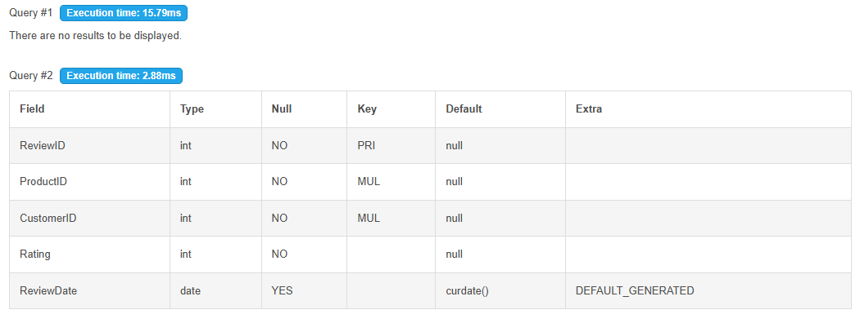
Task 5.2:
INSERT INTO Review_T
(ReviewID, ProductID, CustomerID, Rating, ReviewDate)
VALUES
(1, 7, 1, 5, '2026-09-20'),
(2, 2, 3, 4, '2026-09-21');

INSERT INTO Review_T
(ReviewID, ProductID, CustomerID, Rating)
VALUES
(3, 7, 9, 3);

SELECT *
FROM Review_T
ORDER BY ReviewID;
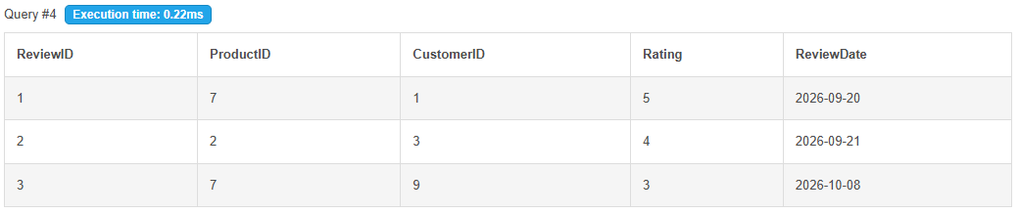
INSERT INTO Review_T (ReviewID, ProductID, CustomerID, Rating)
VALUES (4, 99, 1, 5);
INSERT INTO Review_T (ReviewID, ProductID, CustomerID, Rating)
VALUES (4, 5, 2, 6);
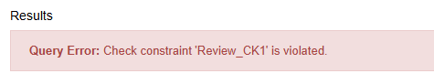
DELETE FROM Customer_T
WHERE CustomerID = 9;
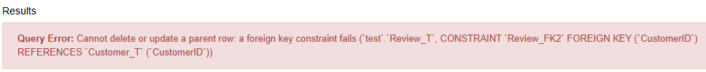

Task 5.3:
SELECT ProductID, ProductDescription, ProductStandardPrice
FROM Product_T
WHERE ProductFinish = 'Natural Ash'
ORDER BY ProductID;

UPDATE Product_T
SET ProductStandardPrice = ProductStandardPrice * 1.05
WHERE ProductFinish = 'Natural Ash';

SELECT ProductID, ProductDescription, ProductStandardPrice
FROM Product_T
WHERE ProductFinish = 'Natural Ash'
ORDER BY ProductID;
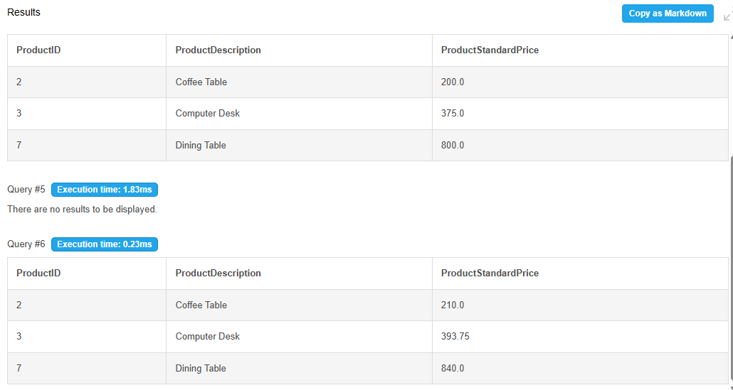

Task 5.4:
START TRANSACTION;

DELETE FROM Review_T
WHERE ReviewID = 2;

SELECT COUNT(*) AS NumReviews
FROM Review_T;

ROLLBACK;

SELECT COUNT(*) AS NumReviews
FROM Review_T;
