SQL Practice Assignment
MIS 600: Database Management Systems | Chapter 6 Assignment
Pine Valley Furniture Company Database | 16 Questions | 8 Points
Dr. Nawaf Aljohani
W. Frank Barton School of Business | Wichita State University | Fall 2026

Name: ________________________ Undergraduate / Graduate (circle one) Due: ____________
Part A  Look Around  Ch. 5, Round 1 | Q1 | Part B  Pick and Filter  Ch. 5, Round 2 | Q2 to Q3 | Part C  Shape the Output  Ch. 5, Round 3 | Q4 to Q5 | Part D  Summarize  Ch. 5, Round 4 | Q6 to Q7
Part E  Join Two Tables  Ch. 6, Round 1 | Q8 to Q10 | Part F  Many Tables  Ch. 6, Round 2 | Q11 to Q13 | Part G  Subqueries  Ch. 6, Round 3 | Q14 to Q16 | Part H  Graduate Step  Graduate students | Q17 to Q18

Instructions
1. Keep the ERD next to you. The ERD is on page 2. Print it or open it on a second screen. Find every table you need on it before you type.
2. Read my example first. Each question starts with my example: the question, how I answered it, my SQL, and a screenshot of my result.
3. Answer the Your Turn question. It asks for the same kind of thing. Run it in MySQL (our class database in Workbench, or DB Fiddle with the PVFC_SQL script) or in SQL Server (SSMS). Pick one system and stay with it.
4. Paste your SQL as text. Put it in your Word document under the question number. Do not paste the SQL as a picture.
5. Paste a screenshot of your result. Take it right after the query runs and put it under your SQL, the same way my examples show. It must show the result grid. For a long result, show the first rows.
6. Check before you move on. Compare your result with the Check line. If they differ, fix the query first.
7. Submit one Word document on Blackboard. Put your name and MySQL or SQL Server at the top.

Points and Rules
→ The questions cover Chapter 5, Rounds 1 to 4, and Chapter 6, Rounds 1 to 3, in the same order as the drills.
→ Each Your Turn question is worth 0.5 point, 8 points in all.
→ Part H (Questions 17 and 18) is required for graduate students. A missing Part H costs a graduate student 1 point.
→ Only Part A needs different code in MySQL and SQL Server. Its example shows both.
→ Generative AI is not allowed on this assignment. This is the course policy.

The ERD: Keep It Next to You
Pine Valley Furniture | tables, columns, keys, and the arrows that join them

Have the ERD Next to You for Every Question
→ Print this page, or open it on a second screen, before you start.
→ Before you type, find each table you need. The arrows show which columns join two tables.
→ Spell every table and column exactly as the ERD shows it, capitals included.
→ Exam 2 gives you the Pine Valley ERD too, so practice reading it now.

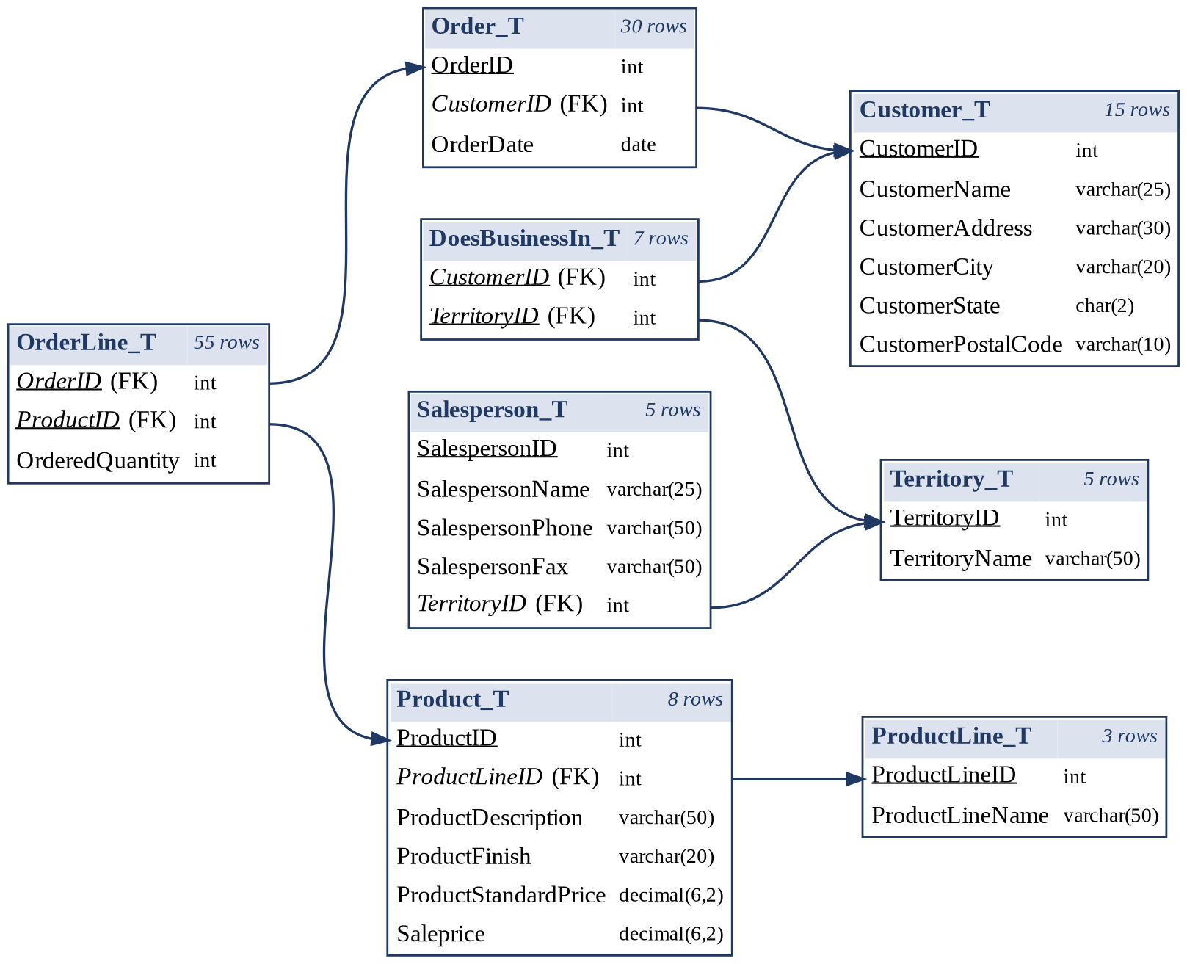
An underlined column is part of the primary key. An italic column marked (FK) is a foreign key. Its arrow points to the table it references. Every arrow is a join you can write.

Part A: Look Around
Chapter 5, Round 1 | Read how a table is built | Question 1 | 0.5 point

EX  1 | How is Product_T built? Show every column, its data type, and which column is the primary key.  Tables: Product_T  How I answered it  ERD. I find Product_T on the ERD first. It has 6 columns, and ProductID is underlined.  Command. A table's design is not stored as rows, so SELECT cannot show it. MySQL uses DESCRIBE. SQL Server uses sp_help.  Read it. Each result row describes one column of the table. PRI in the Key column marks the primary key.  MySQL  DESCRIBE Product_T;  SQL Server  EXEC sp_help 'Product_T';  Screenshot of the result  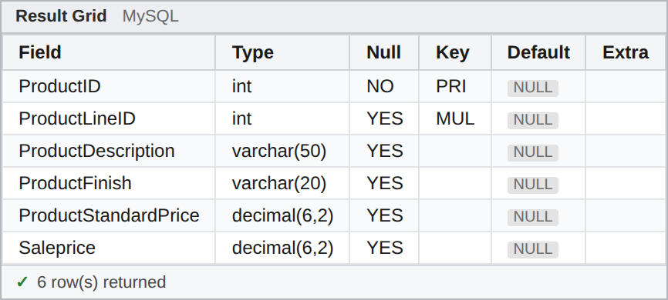  Result: 6 rows, one per column. ProductID shows PRI, and ProductStandardPrice is decimal(6,2). In SQL Server, sp_help shows several grids. The second grid lists the columns, and the grids near the bottom show the keys.

1 | YOUR TURN  How is OrderLine_T built? Show its design. Under your screenshot, write one sentence that names the column or columns in its primary key.  Tables: OrderLine_T  Check: 3 rows, one per column. Compare the key you find with the underlined columns on the ERD.

Part B: Pick and Filter
Chapter 5, Round 2 | Choose the columns and keep only the rows you want | Questions 2 to 3 | 1 point

EX  2 | Show the name and state of every customer in Florida or New Jersey whose name contains the word Furniture.  Tables: Customer_T  How I answered it  FROM. Customer_T holds both the names and the states.  WHERE. Two tests must both be true, so AND joins them. IN ('FL', 'NJ') checks the state against a list. LIKE '%Furniture%' finds the word anywhere in the name.  SELECT. Only the two columns the question asks for.  SELECT CustomerName, CustomerState  FROM Customer_T  WHERE CustomerState IN ('FL', 'NJ')  AND CustomerName LIKE '%Furniture%';  Screenshot of the result  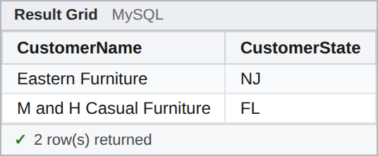  Result: 2 rows: Eastern Furniture (NJ) and M and H Casual Furniture (FL).

2 | YOUR TURN  Show the description, finish, and standard price of every product with a Natural Ash or White Ash finish that has the word Desk in its description.  Tables: Product_T  Check: 2 rows.

EX  3 | Which orders did we receive from October 21 to October 24, 2024? Show the order ID, the order date, and the customer ID.  Tables: Order_T  How I answered it  FROM. Order_T has one row per order, with its date.  WHERE. BETWEEN keeps a range, and both end dates count. I write each date in quotes as 'YYYY-MM-DD'.  SELECT. The three columns, in the order the question lists them.  SELECT OrderID, OrderDate, CustomerID  FROM Order_T  WHERE OrderDate BETWEEN '2024-10-21' AND '2024-10-24';  Screenshot of the result  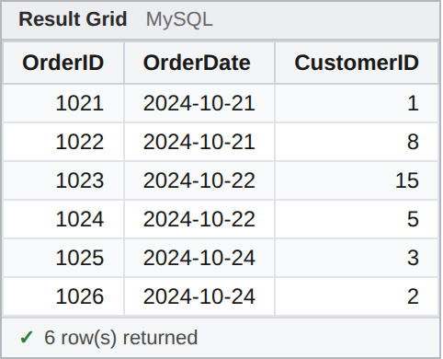  Result: 6 rows: orders 1021 to 1026.

3 | YOUR TURN  Which orders did customers 1 and 12 place during 2023? Show the order ID, the order date, and the customer ID.  Tables: Order_T  Check: 4 rows.

Part C: Shape the Output
Chapter 5, Round 3 | Calculate, rename, sort, and remove repeats | Questions 4 to 5 | 1 point

EX  4 | For each product, show the description, the standard price, the sale price, and how many dollars a shopper saves. Call the saving YouSave. Show the biggest saving first.  Tables: Product_T  How I answered it  FROM. Product_T has both prices.  SELECT. A column can be math. ProductStandardPrice - Saleprice gives the saving, and AS YouSave names the new column.  ORDER BY. ORDER BY runs last, after SELECT, so it can use the new name. DESC puts the biggest first.  SELECT ProductDescription, ProductStandardPrice, Saleprice,  ProductStandardPrice - Saleprice AS YouSave  FROM Product_T  ORDER BY YouSave DESC;  Screenshot of the result  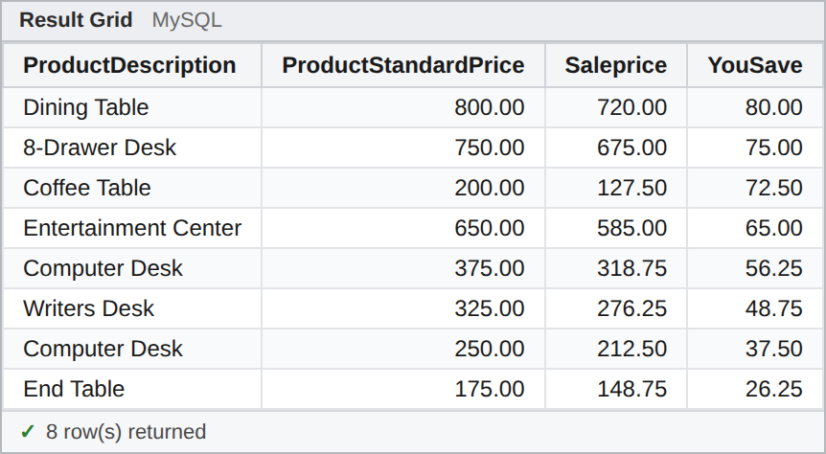  Result: 8 rows. The Dining Table comes first, with a saving of 80.00.

4 | YOUR TURN  For each product, show the description, the standard price, and the saving as a percent of the standard price. Call that column PercentOff. Show the biggest percent first. The percent is the saving divided by the standard price, times 100.  Tables: Product_T  Check: 8 rows. The Coffee Table comes first, at 36.25. If the End Table shows 90, put parentheses around the subtraction.

EX  5 | Which states do our customers come from? List each state once, in alphabetical order.  Tables: Customer_T  How I answered it  FROM. Customer_T has one row per customer, so a state repeats when two customers share it.  SELECT DISTINCT. DISTINCT removes the repeated rows from the result.  ORDER BY. Text sorts A to Z unless I add DESC.  SELECT DISTINCT CustomerState  FROM Customer_T  ORDER BY CustomerState;  Screenshot of the result  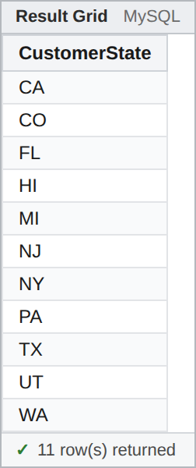  Result: 11 rows, from CA to WA. Without DISTINCT, you get 15 rows.

5 | YOUR TURN  Which combinations of product line and finish do we sell? List each pair of ProductLineID and ProductFinish once. Sort by ProductLineID, then by finish.  Tables: Product_T  Check: 5 rows. Without DISTINCT, you get 8.

Part D: Summarize
Chapter 5, Round 4 | Count, total, and average with GROUP BY and HAVING | Questions 6 to 7 | 1 point

EX  6 | For each product line, how many products does it have, and what is their average standard price? Show ProductLineID, NumProducts, and AvgPrice rounded to 2 decimals.  Tables: Product_T  How I answered it  FROM. Product_T has a ProductLineID on every product.  GROUP BY. One group per ProductLineID.  SELECT. COUNT(*) counts the rows in each group. AVG averages the prices, and ROUND(..., 2) keeps 2 decimals. Every column I show is either in GROUP BY or inside an aggregate.  SELECT ProductLineID, COUNT(*) AS NumProducts,  ROUND(AVG(ProductStandardPrice), 2) AS AvgPrice  FROM Product_T  GROUP BY ProductLineID;  Screenshot of the result  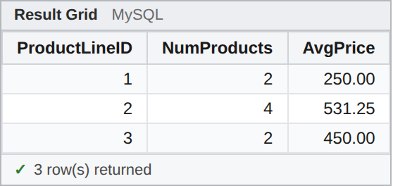  Result: 3 rows. Line 2 has 4 products, with an average price of 531.25.

6 | YOUR TURN  For each customer who has placed an order, show how many orders they placed and the date of their first order. Call the columns CustomerID, NumOrders, and FirstOrder. Show the customer with the most orders first.  Tables: Order_T  Check: 9 rows. Customer 1 comes first, with 7 orders and a first order on 2022-08-10.

EX  7 | Which products have sold more than 20 units in all? Show ProductID and TotalUnits, best seller first.  Tables: OrderLine_T  How I answered it  FROM. OrderLine_T has the units, one row per product on each order.  GROUP BY. One group per ProductID. SUM(OrderedQuantity) totals each group.  HAVING. WHERE runs before the groups exist, so it cannot test a total. HAVING tests each group after GROUP BY.  ORDER BY. TotalUnits DESC puts the best seller first.  SELECT ProductID, SUM(OrderedQuantity) AS TotalUnits  FROM OrderLine_T  GROUP BY ProductID  HAVING SUM(OrderedQuantity) > 20  ORDER BY TotalUnits DESC;  Screenshot of the result  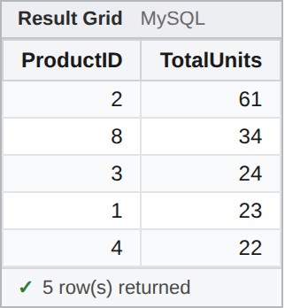  Result: 5 rows. Product 2 leads with 61 units.

7 | YOUR TURN  Which finishes have an average standard price above $300? Show ProductFinish and AvgPrice, rounded to 2 decimals, highest first.  Tables: Product_T  Check: 3 rows. White Ash comes first, at 750.00.

Part E: Join Two Tables
Chapter 6, Round 1 | Match rows from two tables on a shared column | Questions 8 to 10 | 1.5 points

EX  8 | Show each order placed in 2023 with the name of the customer who placed it, oldest first. Write the join in the WHERE clause.  Tables: Customer_T, Order_T  How I answered it  ERD. The arrow runs from Order_T.CustomerID to Customer_T.CustomerID. That pair is my join condition.  FROM. Both tables, with the short nicknames C and O.  WHERE. The join condition first, then AND the date test. Without the join condition, every order pairs with every customer.  SELECT. The columns the question asks for. ORDER BY sorts by date, oldest first.  SELECT O.OrderID, O.OrderDate, C.CustomerName  FROM Customer_T C, Order_T O  WHERE C.CustomerID = O.CustomerID  AND O.OrderDate BETWEEN '2023-01-01' AND '2023-12-31'  ORDER BY O.OrderDate;  Screenshot of the result  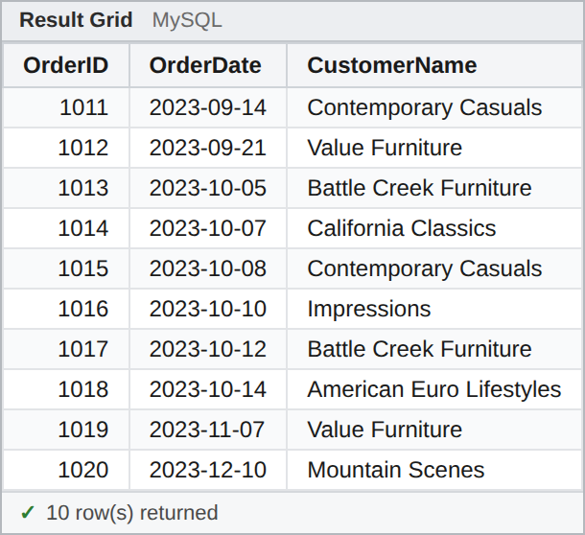  Result: 10 rows, orders 1011 to 1020. The first is order 1011, from Contemporary Casuals.

8 | YOUR TURN  Show the description and standard price of every product in the Scandinavia product line. Write the join in the WHERE clause, and test the line's name, not its ID.  Tables: Product_T, ProductLine_T  Check: 4 rows.

EX  9 | Show each salesperson with the name of their territory. Use INNER JOIN ... ON.  Tables: Salesperson_T, Territory_T  How I answered it  ERD. Salesperson_T.TerritoryID points to Territory_T.TerritoryID.  FROM. INNER JOIN names the second table, and ON holds the join condition right beside it. WHERE stays free for filters.  SELECT. One column from each table.  SELECT S.SalespersonName, T.TerritoryName  FROM Salesperson_T S  INNER JOIN Territory_T T ON S.TerritoryID = T.TerritoryID;  Screenshot of the result  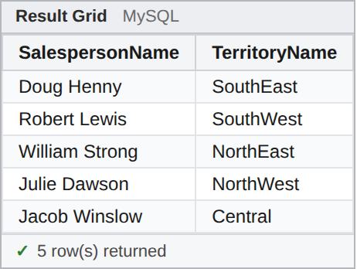  Result: 5 rows. Doug Henny covers SouthEast.

9 | YOUR TURN  Show every line of order 1026 with the product description, the quantity, and the standard price. Use INNER JOIN ... ON.  Tables: OrderLine_T, Product_T  Check: 3 rows. The Computer Desk line has 9 units.

EX  10 | Show all 15 customers with the number of orders each has placed. A customer who never ordered must show 0.  Tables: Customer_T, Order_T  How I answered it  FROM. Every customer must stay, so Customer_T goes on the left of LEFT JOIN. A customer with no orders still gets one row, with NULL in the Order_T columns.  GROUP BY. One group per customer.  SELECT. COUNT(O.OrderID), not COUNT(*). COUNT(*) counts rows, so a customer with no orders would show 1. COUNT(O.OrderID) skips the NULL and shows 0.  SELECT C.CustomerName, COUNT(O.OrderID) AS NumOrders  FROM Customer_T C  LEFT JOIN Order_T O ON C.CustomerID = O.CustomerID  GROUP BY C.CustomerName  ORDER BY NumOrders DESC;  Screenshot of the result  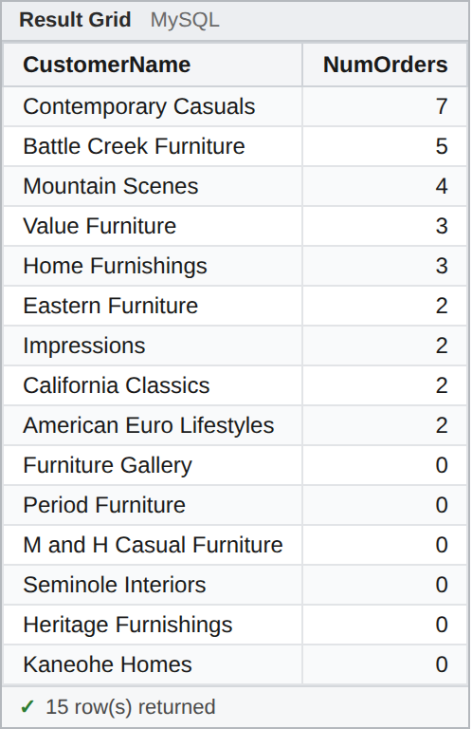  Result: 15 rows. Contemporary Casuals leads with 7, and six customers show 0.

10 | YOUR TURN  Show every territory with the number of customers who do business in it. A territory with no customers must show 0. Show the territory with the most customers first.  Tables: Territory_T, DoesBusinessIn_T  Check: 5 rows. SouthWest leads with 3, and NorthWest shows 0. If NorthWest is missing, check your join. If it shows 1, check what you count.

Part F: Many Tables
Chapter 6, Round 2 | Follow the arrows across three or four tables, or join a table to itself | Questions 11 to 13 | 1.5 points

EX  11 | Build the invoice for order 1006: customer name, order date, product description, quantity, standard price, and a LineTotal column.  Tables: Customer_T, Order_T, OrderLine_T, Product_T  How I answered it  ERD. Customer_T to Order_T to OrderLine_T to Product_T. Four tables means three arrows, so I need three ON conditions.  FROM. I add one table with each JOIN and write its ON right away.  WHERE. Keep only order 1006.  SELECT. LineTotal is the quantity times the standard price.  SELECT C.CustomerName, O.OrderDate, P.ProductDescription,  OL.OrderedQuantity, P.ProductStandardPrice,  OL.OrderedQuantity * P.ProductStandardPrice AS LineTotal  FROM Customer_T C  INNER JOIN Order_T O ON C.CustomerID = O.CustomerID  INNER JOIN OrderLine_T OL ON O.OrderID = OL.OrderID  INNER JOIN Product_T P ON OL.ProductID = P.ProductID  WHERE O.OrderID = 1006;  Screenshot of the result  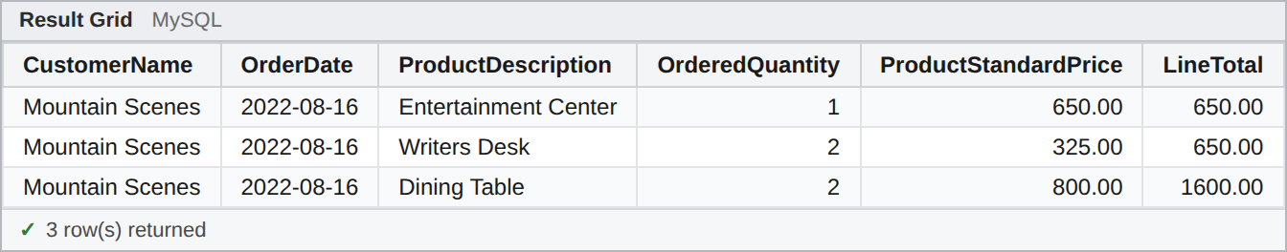  Result: 3 rows, all for Mountain Scenes. The line totals add up to 2900.00.

11 | YOUR TURN  Show every product Contemporary Casuals bought during 2023: the order ID, order date, product description, quantity, and a LineTotal column. Test the customer's name, not the ID. Sort by order ID.  Tables: Customer_T, Order_T, OrderLine_T, Product_T  Check: 4 rows. The line totals add up to 4150.00.

EX  12 | Show the total units each customer has bought, by customer name, most units first.  Tables: Customer_T, Order_T, OrderLine_T  How I answered it  ERD. Customer_T has the name and OrderLine_T has the units. Order_T sits between them, so I need all three tables.  FROM. Two JOINs, two ON conditions.  GROUP BY. One group per customer name. SUM adds up the units in each group.  ORDER BY. Most units first.  SELECT C.CustomerName, SUM(OL.OrderedQuantity) AS TotalUnits  FROM Customer_T C  INNER JOIN Order_T O ON C.CustomerID = O.CustomerID  INNER JOIN OrderLine_T OL ON O.OrderID = OL.OrderID  GROUP BY C.CustomerName  ORDER BY TotalUnits DESC;  Screenshot of the result  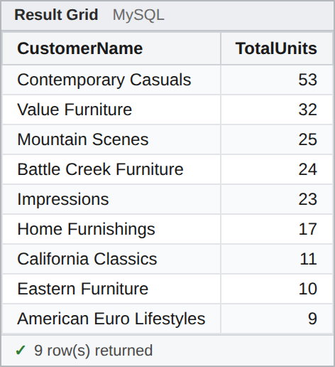  Result: 9 rows. Contemporary Casuals leads with 53 units.

12 | YOUR TURN  Show the total sales value of each product line, by line name, biggest first. Sales value is the quantity times the standard price. Call it SalesValue.  Tables: ProductLine_T, Product_T, OrderLine_T  Check: 3 rows. Scandinavia leads with 39100.00.

EX  13 | List the pairs of customers who are in the same state. Show each pair once, with the state.  Tables: Customer_T (twice)  How I answered it  FROM. Customer_T twice, with two nicknames, A and B. Without the nicknames, SQL cannot tell the two copies apart.  ON. A.CustomerState = B.CustomerState pairs customers from the same state.  ON, again. A.CustomerID < B.CustomerID stops a customer from pairing with itself and keeps each pair in one order only.  SELECT A.CustomerName AS Customer1, B.CustomerName AS Customer2,  A.CustomerState  FROM Customer_T A  INNER JOIN Customer_T B  ON A.CustomerState = B.CustomerState  AND A.CustomerID < B.CustomerID;  Screenshot of the result  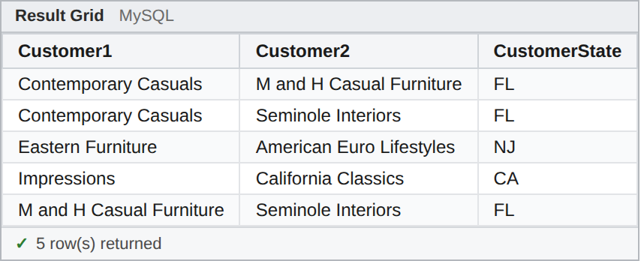  Result: 5 rows: three pairs in FL, one in CA, and one in NJ.

13 | YOUR TURN  List the pairs of products that have the same finish. Show each pair once, with the finish.  Tables: Product_T (twice)  Check: 4 rows. If you get 8, compare with Drill 7, Mistake B.

Part G: Subqueries
Chapter 6, Round 3 | Put one query inside another | Questions 14 to 16 | 1.5 points

EX  14 | Which products cost more than the average standard price? Show the description and price. Do not type the average yourself.  Tables: Product_T  How I answered it  Inside first. SELECT AVG(ProductStandardPrice) FROM Product_T returns one value, 440.625.  Outside. WHERE compares each price with that value. The inner query returns exactly one value, so > works.  Why not type it? If a price changes, the query still gives the right answer. A typed number would not.  SELECT ProductDescription, ProductStandardPrice  FROM Product_T  WHERE ProductStandardPrice >  (SELECT AVG(ProductStandardPrice) FROM Product_T);  Screenshot of the result  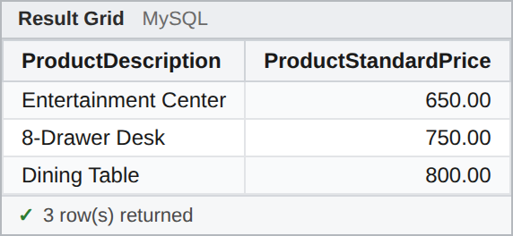  Result: 3 rows: Entertainment Center, 8-Drawer Desk, and Dining Table.

14 | YOUR TURN  Which products are in the same product line as the Dining Table? Show the description and finish. Do not type the line ID yourself.  Tables: Product_T  Check: 4 rows, and the Dining Table is one of them.

EX  15 | Which customers have placed at least one order? Show their names. Use IN with a subquery, not a join.  Tables: Customer_T, Order_T  How I answered it  Inside first. SELECT CustomerID FROM Order_T returns a list, one ID per order.  Outside. IN keeps each customer whose ID is on that list. A list needs IN. = works only when the inner query returns one value.  No join. I only show columns from Customer_T, so a subquery is enough.  SELECT CustomerName  FROM Customer_T  WHERE CustomerID IN (SELECT CustomerID FROM Order_T);  Screenshot of the result  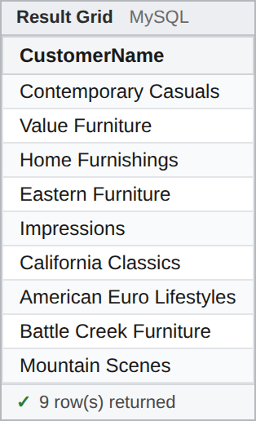  Result: 9 rows.

15 | YOUR TURN  Which products appear on at least one order line with 8 or more units? Show the description and finish. Use IN with a subquery.  Tables: Product_T, OrderLine_T  Check: 4 rows. Two of them are Computer Desks with different finishes.

EX  16 | Which customers have never placed an order? Use NOT EXISTS. Show CustomerID and CustomerName.  Tables: Customer_T, Order_T  How I answered it  Outside. Go through Customer_T one customer at a time.  Inside. Look for an order with this customer's ID. O.CustomerID = C.CustomerID links the inner query to the outer row. That link makes it a correlated subquery.  NOT EXISTS. Keep the customer only when the inner query finds nothing.  SELECT C.CustomerID, C.CustomerName  FROM Customer_T C  WHERE NOT EXISTS  (SELECT * FROM Order_T O WHERE O.CustomerID = C.CustomerID);  Screenshot of the result  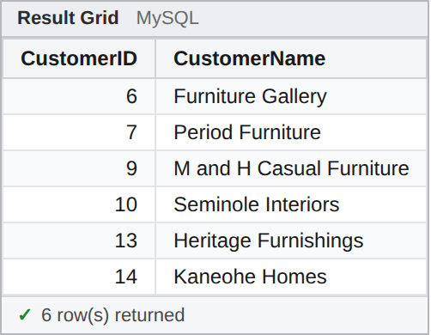  Result: 6 rows: customers 6, 7, 9, 10, 13, and 14.

16 | YOUR TURN  Which products has Value Furniture (customer 2) never ordered? Use NOT EXISTS. Show ProductID and ProductDescription.  Tables: Product_T, Order_T, OrderLine_T  Check: 2 rows.

Part H: Graduate Step
For graduate students | Correlated subqueries and derived tables | Questions 17 to 18 | required

EX  17 | Show the most expensive product in each product line: ProductLineID, description, and price.  Tables: Product_T (twice)  How I answered it  Outside. Go through Product_T one product at a time. Its nickname is P.  Inside. Find the highest price in that product's line only. P2.ProductLineID = P.ProductLineID links the two, so the inner query runs once per product.  Compare. Keep the product when its price equals that maximum.  SELECT P.ProductLineID, P.ProductDescription, P.ProductStandardPrice  FROM Product_T P  WHERE P.ProductStandardPrice =  (SELECT MAX(P2.ProductStandardPrice)  FROM Product_T P2  WHERE P2.ProductLineID = P.ProductLineID);  Screenshot of the result  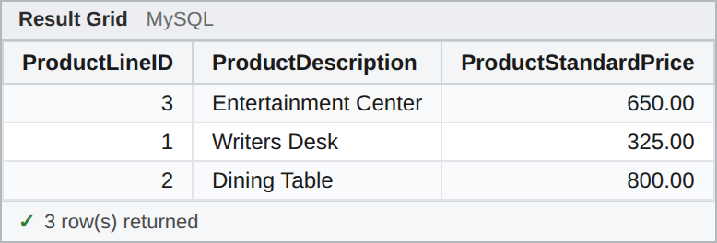  Result: 3 rows: Writers Desk (line 1), Dining Table (line 2), and Entertainment Center (line 3).

17 | YOUR TURN  For each customer who has ordered, show the most recent order: CustomerName, OrderID, and OrderDate. Use a correlated subquery.  Tables: Customer_T, Order_T  Check: 9 rows. Contemporary Casuals shows order 1030, placed on 2024-11-05.

EX  18 | Show each product priced above its own line's average price. Show the description, the price, and the line's average.  Tables: Product_T (twice)  How I answered it  Inside first. The query in FROM returns one row per product line with its average price. A query in FROM is a derived table, and it needs a nickname. Here it is A.  Join. Each product meets its own line's row in A, on ProductLineID.  WHERE. Keep the products priced above their line's average.  SELECT P.ProductDescription, P.ProductStandardPrice, A.AvgPrice  FROM Product_T P  INNER JOIN (SELECT ProductLineID,  AVG(ProductStandardPrice) AS AvgPrice  FROM Product_T  GROUP BY ProductLineID) A  ON P.ProductLineID = A.ProductLineID  WHERE P.ProductStandardPrice > A.AvgPrice;  Screenshot of the result  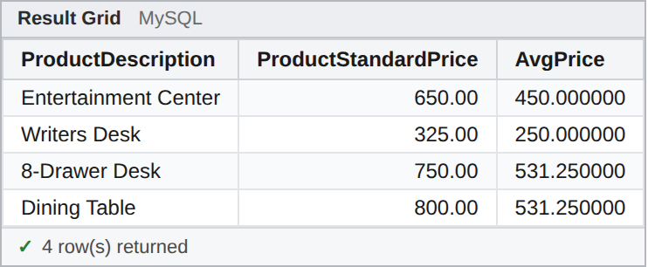  Result: 4 rows: Writers Desk, Entertainment Center, 8-Drawer Desk, and Dining Table.

18 | YOUR TURN  Which customers bought more units than the average customer? Show CustomerName and TotalUnits. Use a derived table for each customer's total units.  Tables: Customer_T, Order_T, OrderLine_T  Check: 5 rows. Contemporary Casuals leads with 53 units.

Before You Submit
→ The top of my document has my name and says MySQL or SQL Server.
→ Every Your Turn question has its number, my SQL as text, and a screenshot of my result under it.
→ Every result matches its Check line.
→ Graduate students: Questions 17 and 18 are done.

